UNIT II - FOOD PROCESSING

Lesson 8: Quality Grades, Inspections, and Brand Names in Meat Industry

Objective:

The student will be able to explain the relationship between quality grades, inspections, and brand names in the meat industry.

I. Study Questions

A. Who is responsible for inspecting and grading meat?

B. Why are some meat products not inspected?

C. What are the quality grades of meat?

D. What does a meat inspector look for in a meat inspection?

E. What is the difference between USDA quality grades and processors' brand names?

II. Reference

Martin, Phillip R. Food Science and Technology (Student Reference). University of Missouri-Columbia: Instructional Materials Laboratory, 1994. Unit II.

UNIT II - FOOD PROCESSING

Lesson 8: Quality Grades, Inspections, and Brand Names in Meat Industry

TEACHING PROCEDURES

A. Review

Review the factors that affect meat quality. These determine the grades which are explained in this lesson.

B. Motivation

Bring a complete package/label from a fresh cut of meat. Point out the inspection and quality grade stamp. Pre-test their knowledge of what these stamps indicate. Which stamp assures quality? Which stamp dictates price/pound?

C. Assignment

D. Supervised study

E. Discussion

1. Discuss who is responsible for inspecting and grading meat.

Who is responsible for inspecting and grading meat?

a. Inspection
1. Qualified USDA inspectors
2. Kosher inspectors - also must meet USDA standards
b. Grading - qualified USDA meat graders, paid for with other processing costs

2. Discuss why some meat products are not inspected.

Why are some meat products not inspected?

a. Laws do not require fish sold in the U.S. to be inspected.
b. Laws do not require meat processed "not for sale" to be inspected.
c. Squabs, gamebirds, rabbits, and most wild game are exempt from the law.

3. Discuss the quality grades of meat. See student reference for quality grade factors.

What are the quality grades of meat?

a. Beef - young
1. Prime
2. Choice
3. Select
4. Standard
b. Beef - old
1. Commercial
2. Utility
3. Cutter
4. Canner
c. Veal
1. Prime
2. Choice
3. Good
4. Standard
5. Utility
6. Cull
d. Pork
1. Acceptable
2. Utility
e. Sheep
1. Lamb
a. Prime
b. Choice
c. Good
d. Utility
2. Yearling mutton
a. Prime
b. Choice
c. Good
d. Utility
3. Mutton
a. Choice
b. Good
c. Utility
d. Cull
f. Poultry
1. Grade A
2. Grade B
3. Grade C

4. Discuss what a meat inspector looks for during a meat inspection.

What does a meat inspector look for in a meat inspection?

a. Unwholesome or adulterated carcasses
b. Sanitary processing
c. Honest labeling
d. Correct temperatures
e. Correct use of additives
f. Lab analysis

5. Discuss the difference between a USDA quality grade and processors' brand names.

What is the difference between USDA quality grades and processors' brand names?

a. Quality grade - shield shaped stamp with purple ink.
b. Different brand names may designate different grades, but they will be different from one company to another.

F. Other activities

1. Require each student to acquire an inspection/grading label and explain what it means.

2. Taste test different brand names of the same meat cut to determine the brand name/quality grade association.

3. Visit a packing house and observe the inspector/grader at work.

4. Show a video on meat inspection, meat judging, or meat evaluation. Several videos are available form Nasco Agricultural Sciences catalog, 1-800-558-9595.

5. Order National Live Stock & Meat Board Marbling photos. Study photos and correct quality grade associated with each. Also, measure the L.E.A. using a grid on a pork loin.

G. Conclusion

Beef, Pork, Lamb and Poultry products are inspected by USDA or Kosher inspectors. Quality grading is completed by qualified USDA meat graders. Some meat products are not inspected and these include fish, "Not for sale" meat, rabbits, gamebirds, etc. Beef grades include prime, choice, select, standard, commercial, utility, cutter, and canner. Pork is graded as acceptable and utility. Poultry grades are A, B, and C. Meat inspectors carefully examine a number of factors before placing their approval stamp on the carcass. Finally, brand names and quality grades are not the same.

H. Competency

Explain the relationship between quality grades, inspections, and brand names in the meat industry.

Related Core Competencies and Key Skills: None

I. Answers to Evaluation

1. c
2. a
3. c
4. a
5. b
6. d
7. a
8. c
9. b
10. Prime, Choice, Select, Standard, Commercial, Utility, Cutter, Canner

11. Purple

12. Sanitary processing; honest labeling; correct temp; lab analysis; correct use of additives

13. disjointing, broken bones, broken skin, bruised, pin feathers, conformation, fleshing, fat covering

UNIT II - FOOD PROCESSING Name ________________________

Lesson 8: Quality Grades, Inspections, and
Brand Names in Meat Industry Date _________________________

EVALUATION

Circle the letter that corresponds to the best answer.

1. Who is responsible for meat inspection?

a. U.S. Department of Health
b. National Live Stock and Meat Board
c. Food Safety and Inspection Services
d. State of Missouri

2. A young steer carcass might grade:

a. Prime
b. Good
c. Commercial
d. Utility

3. An old cow's carcass may grade:

a. Prime
b. Choice
c. Utility
d. Good

4. Pork quality grades are:

a. Acceptable and Utility
b. Prime and Choice
c. Grades A, B, or C
d. Good and Standard

5. Veal carcasses are quality graded on:

a. Size
b. Color
c. Texture
d. Parts

6. Which of the following is not a quality grade of a lamb?

a. Prime
b. Choice
c. Good
d. Cull

Match the stamp on the right with what it stands for on the left.
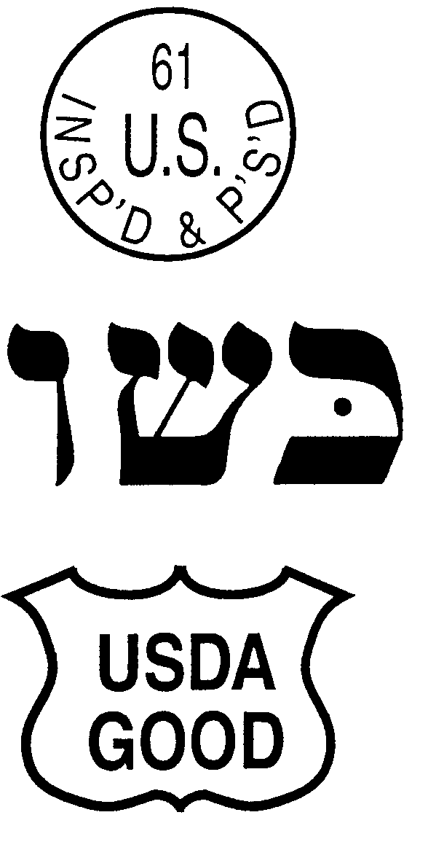
_____ 7. Inspected and passed A.

_____ 8. Quality grade stamp

_____ 9. Kosher stamp

B.

C.

Complete the following short answer questions.

10. List the eight carcass quality grades for beef.

11. What color ink is used for inspection and grading stamps?
12. List two factors a meat inspector looks for in a meat inspection.

13. Name one factor that could lower a poultry carcass from Grade A to a Grade B carcass.

