UNIT IV - FOOD SELECTION AND CONSUMER HEALTH

Lesson 2: Interpreting Food Labels

Objective

The student will be able to interpret a food label.

I. Study Questions

A. What are the parts of a food label?

B. What are the daily dietary requirements for people?

C. How does the food label reflect the nutritional content of foods?

D. What is the significance of "nutrient content claims" and "health claims"?

II. References

A. Martin, Phillip R. Food Science and Technology (Student Reference). University of Missouri-Columbia: Instructional Materials Laboratory, 1994. Unit IV.

B. Transparency Master

TM 2.1: Nutrition Labels

C. Activity Sheets

AS 2.1: Nutritional Status
AS 2.2: Identifying Information on a Food Label

UNIT IV - FOOD SELECTION AND CONSUMER HEALTH

Lesson 2: Interpreting Food Label

TEACHING PROCEDURES

A. Review

Lesson 1 of Unit IV discussed how sensory attributes of a package can influence consumer choice. This lesson looks specifically at one part of the package, the label. How does the label, its location or its contents, affect consumer selection?

B. Motivation

Bring to class labels from a cereal box, mayonnaise jar, orange juice container, and lunch meat package. Copy all labels so that the product name is covered up. Ask students to guess what these labels came from. Follow with a listing of what information is common for each product.

C. Assignment

D. Supervised study

E. Discussion

1. Discuss the parts of a food label.

What are the parts of a food label?

a. Principal display panel (PDP)
1. It must identify the food, either by real name (e.g., green beans) or a made-up name (e.g., Cheerios®).
2. If picture appears, it must look like the food.
3. Net contents or net weight must be included.
b. Information panel (IP)
1. The IP must include the name and address of the manufacturer.
2. A list of ingredients must be in order by descending weight.
3. Nutritional facts panel must be included except in a few instances.

2. Discuss the daily dietary requirements for people. The human body is composed of 60 percent water, 20 percent fat, and 20 percent carbohydrates, proteins, vitamins, and minerals.

What are the daily dietary requirements for people?

a. Bread, Cereal, Rice, Pasta Group - 6-11 servings
b. Fruit Group - 2-4 servings
c. Vegetable Group - 3-5 servings
d. Meat, Poultry, Fish, Dry Beans, Eggs, Nuts Group - 2-3 servings
e. Milk, Yogurt, Cheese Group - 2-3 servings
f. Fats, Oils, Sweets - use sparingly

3. Discuss how food labels reflect the nutritional content of foods.

How does the food label reflect the nutritional content of foods?

a. Total calories
b. Calories from fat
c. Total fat - grams and percent daily value
d. Saturated fat - grams and percent daily value
e. Cholesterol - grams and percent daily value
f. Sodium - grams and percent daily value
g. Total carbohydrate - grams and percent daily value
h. Dietary fiber - grams and percent daily value
i. Sugars - grams
j. Protein - grams
k. Vitamin A - percent daily value
l. Vitamin C - percent daily value
m. Calcium - percent daily value
n. Iron - percent daily value
o. Serving size - determined by comparison to a standard serving size; not necessarily the same serving size that is used in the "Food Pyramid"

4. Discuss with students the significance of nutrient content claims and health claims. Point out that before 1990 there were no standards for what the terms meant.

What is the significance of "nutrient content claims" and "health claims"?

In 1990 standards were established to define 'nutrient content claims' and 'health claims.'

a. Nutrient content claims - Words such as "lite," "high," and "low" are clearly defined.
b. Health claims
1. phrases that remind consumers that certain nutrients are important
2. monitored by government scientists
3. currently only seven different types of claims are allowed

F. Other activities

Collect several food labels. Make an answer key for each label based on its identity statement, net contents, and manufacturer's name and address. List on key, the product's ingredients and its nutritional information. Students then select a label and complete AS 2.1.

G. Conclusion

The daily dietary requirements include servings from the groups of bread, fruit, vegetables, meat, and milk. Fats and sweets should be consumed sparingly. While the number of servings may vary, all groups are necessary for a balanced diet. Food labels reflect the nutritional content of foods. Food labels contain the principal display panel and the information panel.

H. Competency

Interpret a food label.

Related Missouri Core Competencies and Key Skills: None

I. Answers to Evaluation

1. c
2. d
3. c
4. a
5. b
6. a
7. d
8. e
9. b
10. d
11. a
12. e
13. c

J. Answers to Activity Sheets

AS 2.1 - Instructor's discretion
AS 2.2 - Instructor's discretion

UNIT IV - FOOD SELECTION AND CONSUMER HEALTH Name__________________

Lesson 2: Interpreting Food Labels Date __________________

EVALUATION

Circle the letter of the best answer.

1. What are the two major parts of the food label?

a. Ingredients and net weight
b. Nutrition facts and percent daily value
c. Principal display panel and information panel
d. Weight and manufacturer's name

2. The net weight and name of the food appear on what location?

a. Side panel
b. Nutritional facts panel
c. Information panel
d. Principal display panel

3. On which panel do nutritional facts, ingredients, and name and address of manufacturer appear?

a. Side panel
b. Nutritional facts panel
c. Information panel
d. Principal display panel

4. What types of information are included on the nutritional facts panel?

a. Percent daily value and grams
b. Weight and manufacturer's name
b. Ingredients and net weight
c. Ingredients and grams

5. Of the food groups listed, which has the highest number of recommended servings?

a. Fruit group
b. Breads, cereal, rice, pasta group
c. Meat group
d. Vegetable group

6. Which ingredient is listed first on the food label?

a. The ingredient that weighs the most
b. The ingredient with the largest volume
c. The primary ingredient
d. The order of the listing of ingredients doesn't matter.

7. The Nutritional Labeling and Education Act of 1990 made changes in the food label. Which of the following statements is not correct?

a. The types of information included on the nutritional panel was changed.
b. Terms such as "lite" and "low fat" can only be used if the food product meets certain guidelines.
c. Guidelines for health claims were defined.
d. The food label must give the cost of the food product.

Match the group on the left with the correct number of servings on the right. One answer is used twice.

Food Group Daily Servings (number of)

____8. Dairy group a. 3-5

____9. Bread group b. 6-11

____10. Fruit group c. Sparingly

____11. Vegetable group d. 2-4

____12. Meat group e. 2-3

____13. Fats group

TM 2.1

Nutrition Labels
Spaghetti Noodle Pasta-Enriched-Dry Spaghetti Noodle Pasta-Enriched-Dry

MANDATORY LABEL VOLUNTARY LABEL

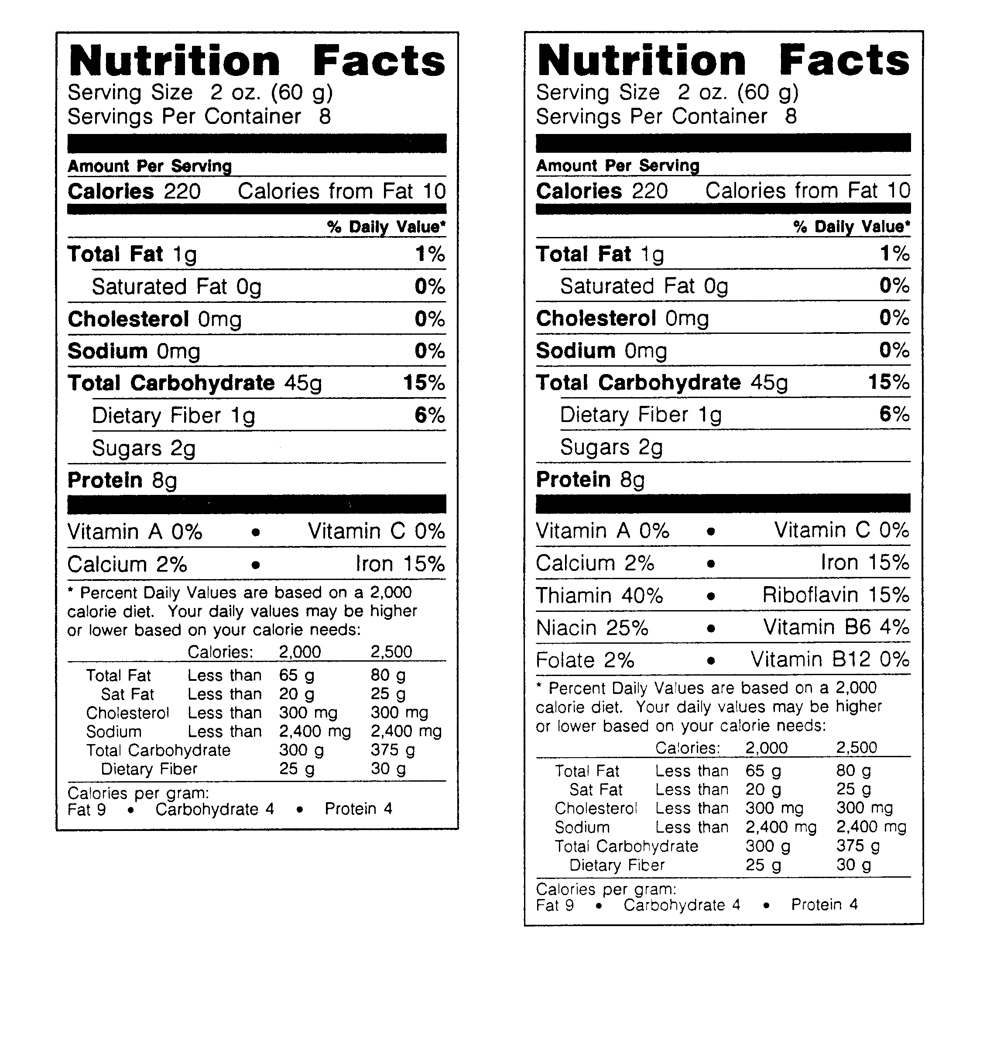

Unit IV - FOOD SELECTION AND CONSUMER HEALTH AS 2.1

Lesson 2: Interpreting Food Labels Name________________________

Nutritional Status

Objective: To illustrate the differences between a single day's diet and a five-day diet on overall nutritional status.

Activity Length: 30 minutes of class time to tabulate results

Materials and Equipment:

Nutritional labels from food consumed in one day
This should be gathered out of class. Each student should collect the "Nutrition Facts" panel from foods that would be eaten at breakfast, lunch, dinner and a snack (or two).
Calculator
Copy of USDA Handbook 8 (Composition of foods: raw, processed, prepared) or a nutrition textbook with food composition charts. Several fast food companies also have nutritional information on their products available at each store.

Procedure:

1. Fill in the blanks for chart 1 from the nutritional labels, information from Handbook 8, nutrition textbook, or other sources.
2. Fill in the information from labels for one day. Total the percentages for each nutrient. Determine the percentage of calories by dividing your number by 2000, and multiply the result by 100.
3. Get the nutritional information from five to seven other students. Fill in chart 2. Total the columns and average the percentages for each nutrient.

Key Questions:

1. In the single day analysis, what nutrients did you consume in excess amounts? What nutrients did you need to consume more of?

2. What happened when you combined the data from other students with yours? If you had eaten all of these meals, would your nutritional status be better or worse?

3. Using your single day analysis, choose one nutrient you consumed in excess amounts? What foods should you avoid in order to decrease your consumption of this nutrient?

4. Still using the single day analysis, choose one nutrient that you did not get enough of. What foods are good sources of this nutrient. (Use other nutritional labels or handbooks to get this information.)

Chart 1 - Your Values

Food | Calories | Total Fat | Cholesterol | Sodium | Total Carbohydrates | Dietary Fiber
Total

Chart 2 - Nutrient Percentages From Other Students
 | Calories | Total Fat | Cholesterol | Sodium | Total Carbohydrates | Dietary Fiber
Your values
Total
Average

Developed by Douglas L. Holt, Assistant Professor, Food Science and Human Nutrition, University of Missouri-Columbia

UNIT IV - FOOD SELECTION AND CONSUMER HEALTH AS 2.2

Lesson 2: Interpreting Food Label Name ________________________

Identifying Information on a Food Label

Objective: To identify information on a food label.

Product Name: ___________________________

List the following information obtained from your food label.

1. Identification statement:__________________________________________________

2. Net contents:____________________________________________________________

3. Name and address of manufacturer:_______________________________________

4. List of ingredients:_______________________________________________________

5. Nutritional information:__________________________________________________

6. Which ingredient occurs in the greatest amount? ____________________________

7. If additives are used, what are they?_______________________________________

8. List any artificial flavor(s).________________________________________________

