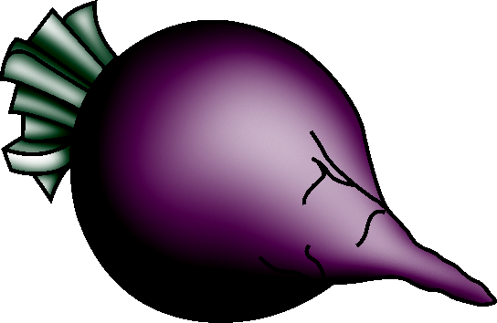 | Cool Season Root Crop
 | Beets
Days to Germination |  | - 5 to 16
Days to Maturity |  | - 40 to 50
Soil |  | - pH: 6.0 to 7.5  - Sensitive to acidic soil  - Well-drained, loose, sandy loam soil
Spacing |  | - Between plants: 2 in. to 4 in.  - Between rows: 12 in. to 18 in.
Harvest |  | - Beet greens are best at 4 in. to 6 in.  - A full-grown beet is roughly the size of a tennis ball, depending on the variety.
Postharvest |  | - Hydrocool by spraying or immersing vegetables in chilled water  - Can be stored for 4 to 6 months at 32°F and 100% relative humidity
Production Concerns |  | - Provide beets with consistent moisture, particularly during early development, but avoid overwatering.
Pests and Diseases |  | - Pests: Mexican bean beetles, leafhoppers, leaf miners, wireworms, mice, rabbits  - Diseases: Alternaria, Cercospora, Ramularia,  damping-off
Other Considerations |  | - Rotate crops to avoid Cercospora.

Banse, G. Growing Beets. Farm and Garden. http://www.farm-garden.com/growing-vegetables/beets.

Source accessed November 14, 2005.

 | Cool Season Root Crop
 | Carrots
Days to Germination |  | - 6 to 18
Days to Maturity |  | - 70 to 85
Soil |  | - pH: 6.5 to 7.0  - Well-drained, sandy loam soils
Spacing |  | - Between plants: 3 in.  - Between rows: 18 in. if cultivated by hand; 42 in. if field implements are used
Harvest |  | - Baby carrots: 4 in. to 5 in. long  - Mature carrots: 3/4 in. to 1 1/2 in. in diameter
Postharvest |  | - Can be stored for 7 to 9 months at 32°F to 34°F and 98% to 100% relative humidity
Production Concerns |  | - Provide 1 in. of water per week during growing season.
Pests and Diseases |  | - Pests: carrot rust fly larvae, wireworms, leafhoppers  - Diseases: leaf spot, soft rot, aster yellow
Other Considerations

Banse, G. Growing Carrots. Farm and Garden. http://www.farm-garden.com/growing-vegetables/carrots.

Jett, L. W. Vegetable Planting and Planning Calendar. University of Missouri Extension. http://muextension.missouri.edu/explore/agguides/hort/g06201carrot.htm.

Sources accessed November 9, 2005.

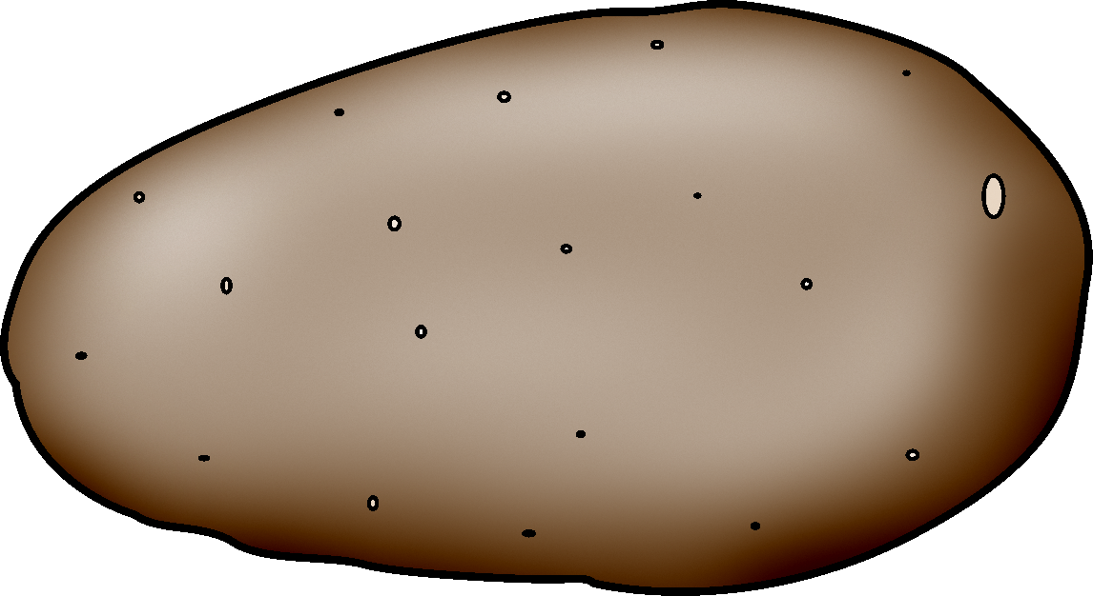 | Cool Season Root Crop
 | Potatoes
Days to Germination |  | - 10 to 14
Days to Maturity |  | - 100 to 120
Soil |  | - pH: 5.0 to 5.5  - Good drainage  - High phosphorus, nitrogen, and potassium content
Spacing |  | - Between plants: 6 in. to 12 in.  - Between rows: 30 in. to 36 in.
Harvest |  | - New potatoes: Check when plants are blossoming and harvest when potatoes reach the desired size.  - Mature potatoes: Harvest when leaves die back.  - Lighter, well-drained soils make harvesting easier.
Postharvest |  | - Brush off the soil, but do not wash potatoes.  - Cure potatoes in a dry, dark, cool place prior to prolonged storage.  - Mature potatoes can be stored for 5 to 10 months at 40°F to 50°F and 90% relative humidity.
Production  Concerns |  | - Provide uniform moisture throughout growing season.
Pests and  Diseases |  | - Pests: Colorado potato beetles, pocket gophers  - Diseases: speckle leaf, black leg, potato blight, early blight, late blight, ring rot
Other Considerations |  | - Potatoes can also be grown in trenches, hills, mulch, and structures such as vertical boxes and wire cages.  - Growing potatoes in mulch works well in areas with rocky or compact soil.  - Soil can dry out quickly when more surface area is exposed to the air, as in hills or wire cages. Monitor moisture levels closely.

Banse, G. Growing Potatoes. Farm and Garden. http://www.farm-garden.com/growing-vegetables/potatoes.

Jett, L. W. Vegetable Planting and Planning Calendar. University of Missouri Extension. http://muextension.missouri.edu/explore/agguides/hort/g06201potato.htm.

Vegetable Research and Information Center. “Seed Germination Temperatures.” University of California. http://vric.ucdavis.edu/veginfo/commodity/garden/veggarden/SeedGerminationTemp.pdf.

Sources accessed November 7, 2005.

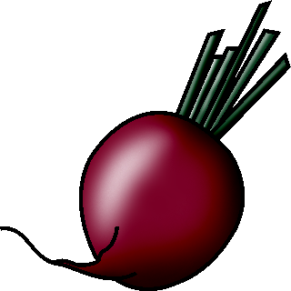 | Cool Season Root Crop
 | Radishes
Days to Germination |  | - 4 to 12
Days to Maturity |  | - 25 to 35
Soil |  | - pH: 6.5 to 7.0  - Cool, moist soil  - Maintain soil pH at 6.8 or higher to manage club root.
Spacing |  | - Between plants: 1 in. to 2 in. for smaller varieties; 6 in. for larger varieties  - Between rows: 18 in.
Harvest |  | - To harvest, grasp radishes by the top and pull them from the ground.  - Harvest radishes when they are 1/2 in. to 1 in. in diameter.
Postharvest |  | - Wash and dry radishes thoroughly.  - Hydrocooling improves shelf life and helps maintain crispness.  - Washing with chlorinated water helps reduce black spot.  - Radishes can be stored for 1 to 2 weeks at 32°F and 95% to 100% relative humidity.
Production Concerns |  | - Keep soil consistently moist to prevent radishes from becoming bitter and mealy.
Pests and Diseases |  | - Pests: cabbage maggots, flea beetles, aphids  - Diseases: generally free of disease
Other Considerations |  | - Can be grown within other crops

Banse, G. Growing Radishes. Farm and Garden. http://www.farm-garden.com/growing-vegetables/radishes.

Commercial Vegetable Production Guides. “Radish.” Oregon State University. http://oregonstate.edu/Dept/NWREC/radish.html.

Jett, L. W. Vegetable Planting and Planning Calendar. University of Missouri Extension. http://muextension.missouri.edu/explore/agguides/hort/g06201radish.htm.

Schrock, D. Vegetable Harvest and Storage. University of Missouri Extension. http://muextension.missouri.edu/explore/agguides/hort/g06226.htm.

Sources accessed November 14, 2005.

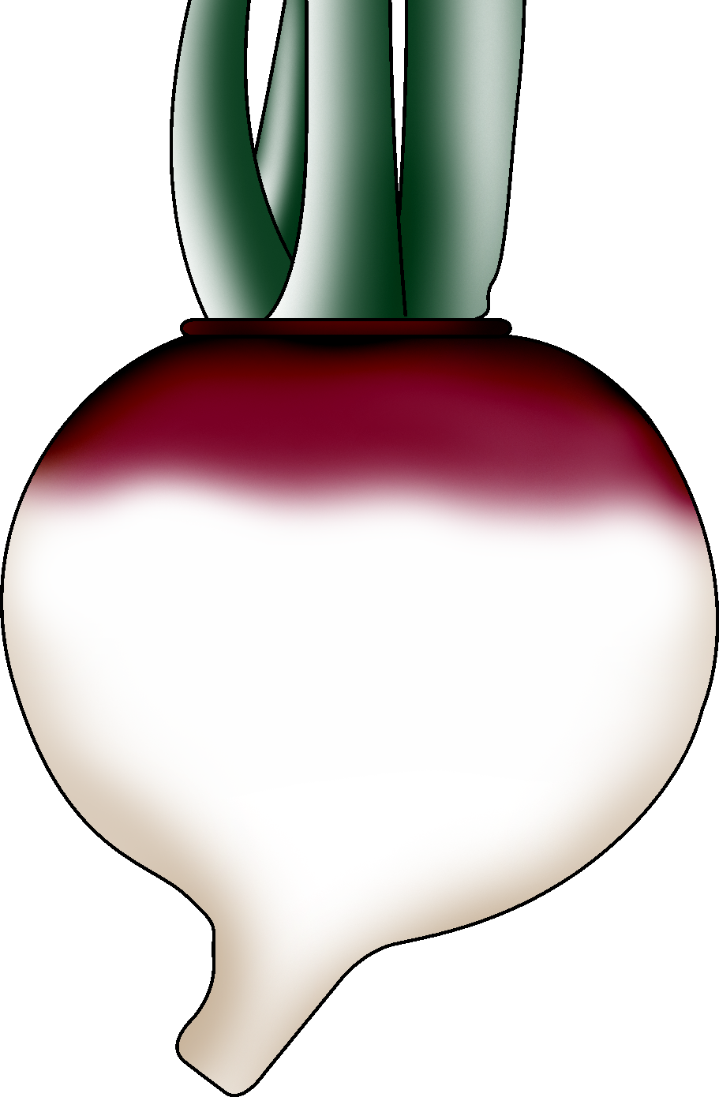 | Cool Season Root Crop
 | Turnips
Days to Germination |  | - 3 to 7
Days to Maturity |  | - 35 to 70
Soil |  | - pH: 6.0 to 6.8
Spacing |  | - Between plants: Sow seeds 1 in. apart; thin plants to  2 in. to 6 in. apart  - Between rows: 12 in.
Harvest |  | - Turnips can be harvested from the time they reach 1 in. in diameter. Once they are roughly the size of a tennis ball, they tend to become woody and tough.  - Harvest turnip greens when they are 4 in. to 6 in.
Postharvest |  | - Can be stored for 4 to 5 months at 32°F and 90% to 95% relative humidity
Production Concerns |  | - Provide plenty of water to help prevent woody stems.
Pests and Diseases |  | - Pests: aphids, beetles, slugs, snails, cutworms, root maggots  - Diseases: mildew, white blister disease
Other Considerations |  | - Turnips can withstand several light freezes.

Ed Hume Seeds. “Soil pH That Vegetables Prefer.” http://www.humeseeds.com/soilph.htm.

The Gardener’s Network. “How to Grow Turnips.” http://www.gardenersnet.com/vegetable/turnip.htm.

Jett, L. W. Vegetable Planting and Planning Calendar. University of Missouri Extension.
http://muextension.missouri.edu/explore/agguides/hort/g06201turnip.htm.

Organic Gardening Tips. “Turnip Gardening Tips and Advice.” http://www.organicgardentips.com/tips_on_how_to_grow_turnips.html.

Perkins-Veazie, P. “Turnip.” The Commercial Storage of Fruits, Vegetables, and Florist and Nursery Stocks. (draft, rev. 2004) U. S. Department of Agriculture/Agricultural Research Service. http://www.ba.ars.usda.gov/hb66/140turnip.pdf.

Schrock, D. Vegetable Harvest and Storage. University of Missouri Extension. http://muextension.missouri.edu/explore/agguides/hort/g06226.htm.

Sources accessed November 7, 2005.

Cool Season Root Crop
______________________
Days to Germination
Days to Maturity
Soil
Spacing
Harvest
Postharvest
Production Concerns
Pests and Diseases
Other Considerations

