Fruit and Vegetable Production

Lesson 3: Site Evaluation

Competency/Objective

Classify characteristics of selecting and planning for fruit and vegetable production.

Study Questions

1. What are soil considerations when evaluating a site?

2. What are topography considerations when evaluating a site?

3. What are accessibility considerations when evaluating a site?

4. What are climatic considerations when evaluating a site?

5. How do utilities affect evaluation of a site?

6. How does zoning affect evaluation of a site?

7. How does labor affect evaluation of a site?

References and Materials

1. Fruit and Vegetable Production Unit for Plant Science Core Curriculum (Student Reference). University of Missouri-Columbia: Instructional Materials Laboratory, 2006.

2. Figures/Transparency Masters

Fig. 3.1 Soil Texture Triangle
Fig. 3.2 pH Scale
Fig. 3.3 Essential Plant Nutrients
Fig. 3.4 Spring Frost Dates
Fig. 3.5 Fall Frost Dates

3. Activity Sheet

AS 3.1 Evaluating a Possible Production Site

Teaching Procedures

A. Review

Lessons one and two outlined the importance of financial and market planning to fruit and vegetable operations. Lesson three looks at how to evaluate a site to determine if it is suitable for production. There are environmental and nonenvironmental factors to consider. Environmental factors include soil, topography, accessibility, and climate. Nonenvironmental factors include utilities, zoning, and labor.

B. Motivation

Ask students to think about building a house. What things should be considered before construction begins? Some examples would be land, location, zoning, electricity, water, and workers to build it. Then discuss how some of these concerns must also be evaluated before selecting a site for fruit and vegetable production.

C. Assignment

D. Supervised Study

Lead students in collecting the information needed to answer and discuss the study questions. The instructor may choose to work on one study question at a time or have students consider all the study questions before the discussion. Another option is to have students work in a cooperative learning environment by forming groups and assigning different study questions to each group.

E. Discussion

Lead students in a discussion of the study questions. Supplement students’ responses and information with additional materials when needed.

1. What are soil considerations when evaluating a site?

Ask students what they know about soil. During the discussion, help students relate what they know about soil to how it affects fruit and vegetable production. Refer to Figure 3.1 Soil Texture Triangle, Figure 3.2 pH Scale, and Figure 3.3 Essential Plant Nutrients.

a. Soil is a living, naturally occurring, dynamic system at the interface of air and rock.
i. Soil forms when climate and organisms act on organic and geologic material in a specific landscape over time.
b. Soil texture refers to the percentage by weight of sand, silt, and clay in a soil.
i. Ease of tilling and root development are influenced by soil texture.
ii. Soil texture affects the amount of air and water the soil will hold and the rate of water movement through the soil.
iii. Nutrient supplies are also affected by soil texture.
c. Soil pH measures the acidity and alkalinity of the soil.
i. The pH scale ranges from 0 to 14, with 0 being the most acidic and 14 being the most alkaline or basic.
ii. The pH value gives an estimate of the balance between the plant nutrient elements in the soil and other non-nutrient elements.
iii. Soil pH affects available nutrient levels and should be monitored to reduce the likelihood of nutrient deficiencies.
- There are nine essential macronutrients and eight essential micronutrients needed for plant growth.
i. Macronutrients:
1. Calcium (Ca)
2. Magnesium (Mg)
3. Potassium (K)
4. Phosphorus (P)
5. Sulfur (S)
6. Nitrogen (N)
7. Carbon (C)
8. Hydrogen (H)
9. Oxygen (O)
ii. Micronutrients:
1. Boron (B)
2. Chlorine (Cl)
3. Cobalt (Co)
4. Iron (Fe)
5. Manganese (Mn)
6. Molybdenum (Mo)
7. Zinc (Zn)
8. Copper (Cu)
e. Fertile soil produces high-yielding, healthy crops. Soil fertility depends on the following:
i. Nutrient balance and quantity
ii. Soil texture
iii. Soil structure
iv. Rooting depth
v. Organic matter content
vi. Available water capacity
vii. Aeration (porosity)
viii.Length of growing season
ix. Physical support
1. Erosion control
2. Good plant residue management
f. Soil testing is one of the best ways to evaluate soil.
i. Soil testing can reveal the percentage of organic matter, pH, and available nutrients in soil.
ii. Test results can be used to guide the application of fertilizer and soil amendments.
iii. Soil testing can be used to monitor conditions and diagnose problems, which helps save time and money in the long run.

2. What are topography considerations when evaluating a site?

Ask students to explain what topography is. Why is topography an element considered in fruit and vegetable production?

a. Topography refers to the relative positions and elevations of the natural and fabricated features that describe the surface of an area. Topography affects the following:
i. Soil condition
ii. Types of plants that can grow well in the area
iii. How accessible the area is for machinery
b. Topography determines how wind and water move toward, over, and away from the area. The interaction between topography, wind, and water influences the following:
i. Soil erosion
ii. Soil drainage
iii. Water-holding capacity

3. What are accessibility considerations when evaluating a site?

Ask students what it means for an area to be accessible. Why would a production site need to be accessible? What are the different types of
elements that might need to be present for a planting site?

a. Accessibility refers to how readily a site can be reached and used. Considerations include the following:
i. Ease of getting into and out of the area with equipment and supplies to plant, maintain, and harvest the crop
ii. Utilities, such as water and electricity
iii. Existing roads
iv. Roads that will need to be built
b. Pick-your-own and CSA farms must also be accessible to the public. Producers evaluating a site for these operations must plan on additional factors.
i. Sufficient parking
ii. Clear roads and trails
iii. Barrier-free access to all services and facilities

4. What are climatic considerations when evaluating a site?

Ask students what type of climate zone they live in. Why is it important to know about the climate of an area? Can there be more than one climate in the same area? Refer to Figure 3.4 Spring Frost Dates and Figure 3.5 Fall Frost Dates.

a. Climate is all the atmospheric influences, usually considered over a number of years, that combine to influence the land forms, soils, vegetation, and land use of a region. Principal atmospheric influences include the following:
i. Temperature
ii. Moisture
iii. Wind
iv. Pressure
v. Evaporation
b. The climate helps determine what plants will thrive during the growing season.
c. Climate and region determine an area’s frost dates.
i. Frost dates are the estimated dates of the last frost in spring and the first frost in fall.
ii. The time between frost dates is the growing season in which plants can reach maturity and produce fruits and vegetables that are ready to harvest.
iii. Frost dates are based on historical data compiled by the USDA.
iv. Frost dates are estimates only—earlier and later frosts can occur.
d. A microclimate is an area in which the climate is different from the area around it.
i. Microclimates may be large or small.
ii. They may be natural or caused by human construction or activity.
iii. Producers can take advantage of microclimatic differences by the varieties of plants they choose and how they position their crops.

5. How do utilities affect evaluation of a site?

Ask students what utilities are. How are they used in everyday life? What possible uses would they have in fruit and vegetable production?

a. Utilities and services should be easily accessible.
i. The distance from utilities will affect the cost of bringing them to the site.
ii. Water should be available and plentiful, and water quality should also be considered.
iii. Electricity may be needed, depending on the equipment used.

6. How does zoning affect evaluation of a site?

Ask students what they know about zoning issues. Does zoning change between communities? How do you find out about zoning regulations in your area?

a. Zoning controls the physical development of land and dictates the kinds of uses allowed on individual properties.
i. Zoning laws determine where residential, industrial, recreational, and commercial activities can occur.
ii. Local governments usually control zoning.
b. Check with the local zoning board about the regulations concerning the specific site before starting production.
7. How does labor affect evaluation of a site?

Ask students if they were going to start a fruit or vegetable production site how they would do it. How would they set out the plants? How would they gather the products? How would they maintain the production site? Will they need help?

a. Labor needs depend on the type, size, and scale of production.
i. The producer should determine the availability of a labor force in the area.
ii. Labor may be automated or done by hand.
1. Hand labor is done by people working manually with crops.
2. Automated labor is done by people operating machines.

F. Other Activities

1. Have students contact the local zoning board and find out about regulations in the area.

2. Ask a local producer to explain to the students what factors he or she considered before selecting a fruit or vegetable production site.

G. Conclusion

When considering a site for fruit and vegetable production, a number of environmental and nonenvironmental factors should be considered. Environmental factors include soil, topography, accessibility, and climate. Nonenvironmental factors include utilities, zoning, and labor. Carefully considering these factors before selecting a site can help avoid problems in the future.

H. Answers to Activity Sheet

AS 3.1 Evaluating a Possible Production Site

Answers will vary.

I. Answers to Assessment

1. Students should list the following answers.
A. Silt
B. Clay
C. Sand
2. The pH scale measures the acidity and alkalinity of the soil.
3. Students should list three of the following answers.
A. Temperature
B. Moisture
C. Wind
D. Pressure
E. Evaporation
4. Producers can take advantage of microclimatic differences by the varieties of plants they choose and how they position their crops.
5. Zoning controls the physical development of land and dictates the kinds of uses allowed on individual properties. Zoning determines where residential, industrial, recreational, and commercial activities can occur.
6. Topography refers to the relative positions and elevations of the natural and fabricated features that describe the surface of an area.
7. Students should list three of the following answers.
A. Soil condition
B. Types of plants that can grow well in the area
C. How accessible the area is for machinery
D. Soil erosion
E. Soil drainage
F. Water-holding capacity
Unit I: Fruit and Vegetable Production Name: _______________________

Lesson 3: Site Evaluation Date: ________________________

ASSESSMENT

Short-Answer Questions: Write the answers in the space provided.

1. Soil texture refers to a soil’s percentage by weight of what three components?

A.

B.

C.

2. What does the pH scale measure?

3. What are three atmospheric influences that help determine climate?

A.

B.

C.

4. How can producers use microclimates to their advantage?

5. Why is zoning a consideration in selecting a production site?

6. What is the definition of topography?

7. What are three things that topography can affect in a production site?

A.

B.

C.

Figure 3.1

Soil Texture Triangle

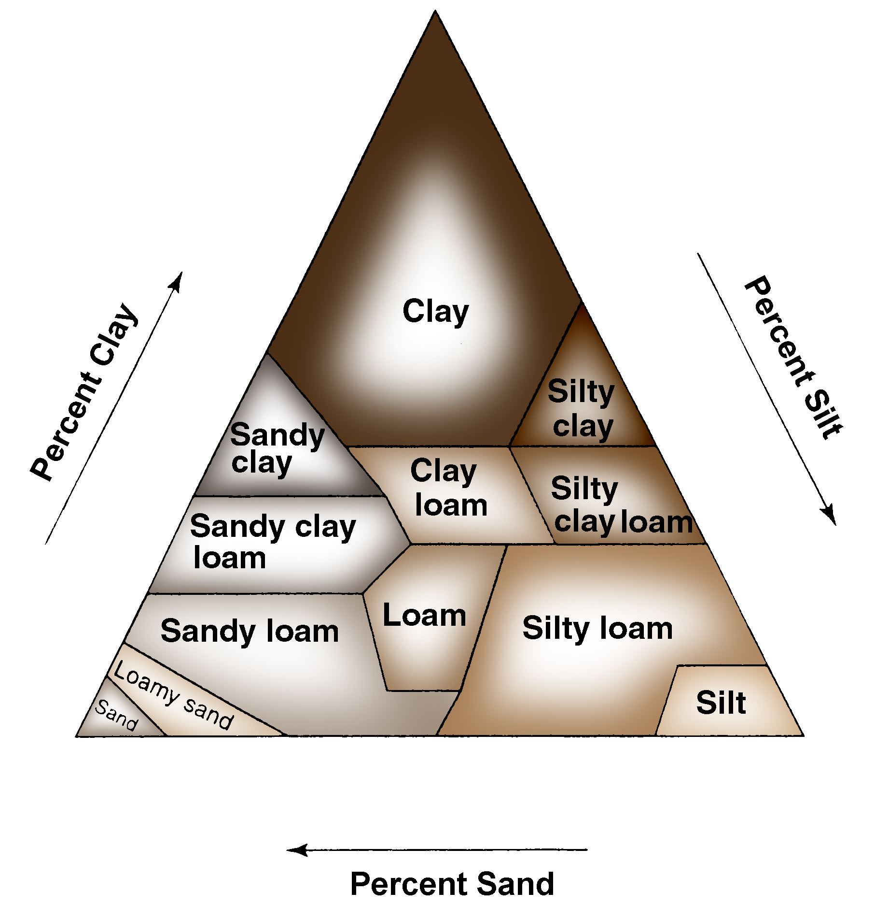

Figure 3.2

pH Scale

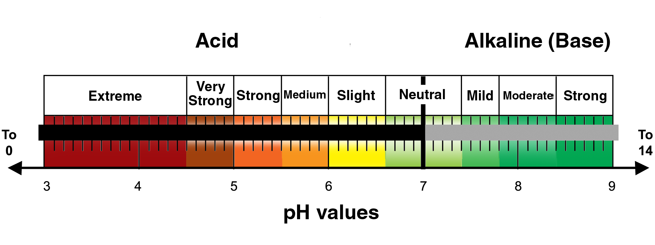

Figure 3.3

Essential Plant Nutrients

 | Nutrients | Source
Macronutrients | Ca Calcium  Mg Magnesium  K Potassium | Mineral solids
Macronutrients | P Phosphorus  S Sulfur | Mineral solids;  organic matter
Macronutrients | N Nitrogen | Organic matter (primarily)
Macronutrients | C Carbon  H Hydrogen  O Oxygen | Water and air
Micronutrients | B Boron  Cl Chlorine  Co Cobalt  Fe Iron  Mn Manganese  Mo Molybdenum  Zn Zinc  Cu Copper | Naturally in soil;  can be added with fertilizers

Figure 3.4

Spring Frost Dates

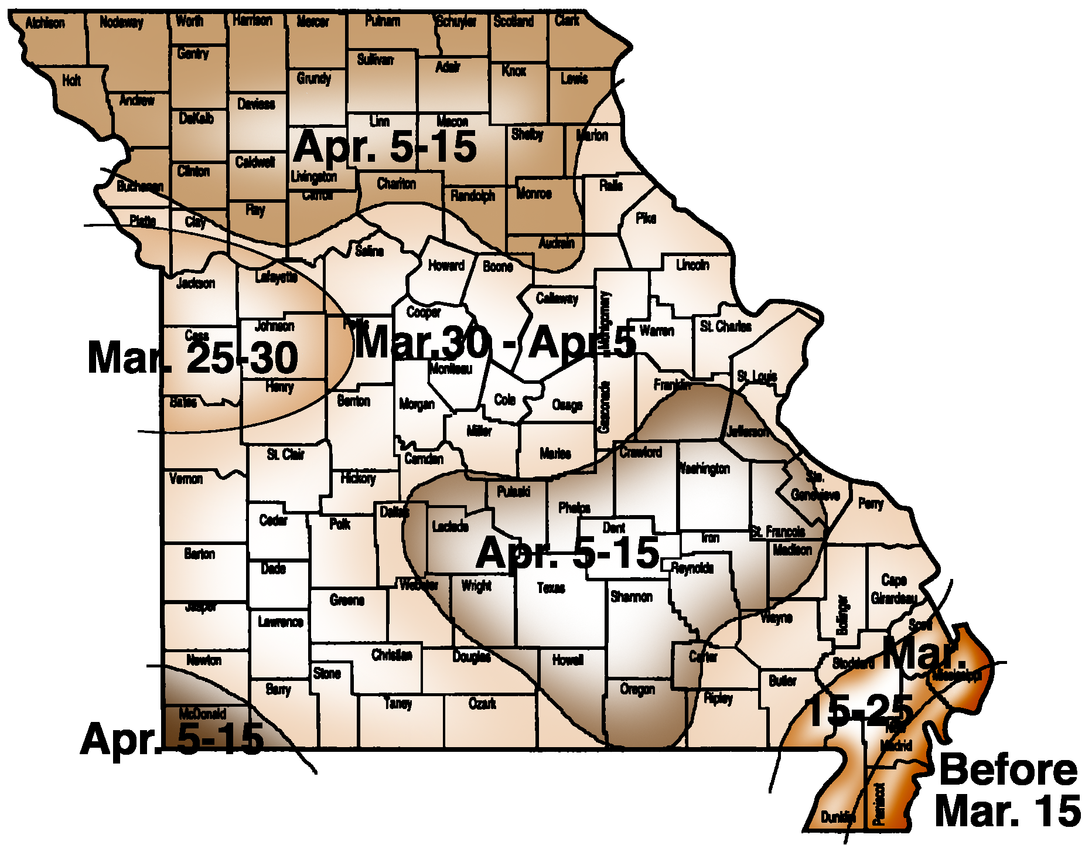

Figure 3.5

Fall Frost Dates

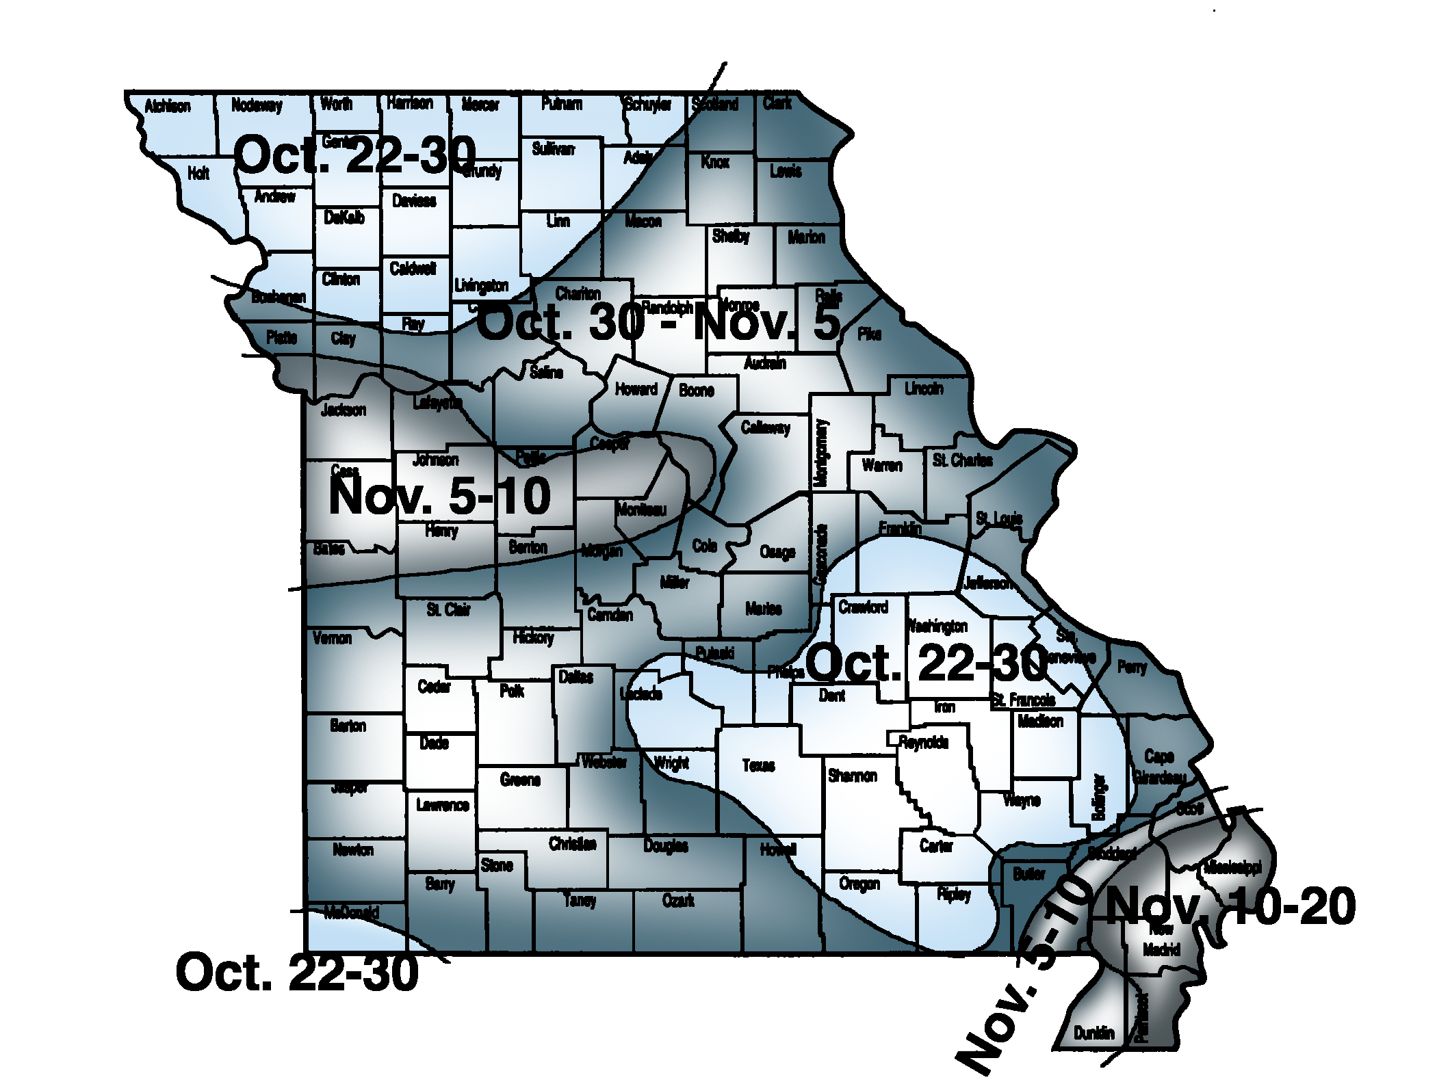

Unit I: Fruit and Vegetable Production AS 3.1

Lesson 3: Site Evaluation Name: _______________________

Evaluating a Possible Production Site

Objective: Identify a possible production site and evaluate it.

Directions: Work in small groups. Select a site for a possible fruit or vegetable production area. Evaluate the site based on the information discussed in the lesson. Answer the following questions about the site.

1. Where is the site located?

2. What are the dimensions of the site?

3. What crops would be best suited for the site?

4. Describe the appearance and texture of the soil.

5. Describe the topography of the area.

6. Is the area easily accessible? If so, how can the area be accessed? If not, what changes would be needed to provide better access to the site?

7. What is the climate of the area? Are there any microclimates in the site?

8. What utilities are available at the site? What additional utilities are needed?

9. Would this area be a good production site? Why or why not?

