Fruit and Vegetable Production

Lesson 3: Site Evaluation

Before deciding what to plant, it is important to evaluate the prospective site to determine if it is suitable. Several key environmental and nonenvironmental elements must be assessed. Evaluating a site requires forethought and effort, and long-term goals should be kept in mind to reach the desired results. Carefully considering each of the essential factors before selecting a site can help avoid problems in the future.

Environmental Evaluation Concerns

Soil

Soil is a living, naturally occurring, dynamic system at the interface of air and rock. Soil forms in response to forces of climate and organisms that act on organic and geologic material in a specific landscape over a period of time. Having the appropriate soil conditions is essential for optimum plant growth.

Texture is an important soil property because it is closely related to many aspects of soil behavior. Soil texture refers to the percentage by weight of sand, silt, and clay in a soil. The ease of tilling and plant root development within the soil are both influenced by soil texture. Texture affects the amount of air and water a soil will hold and the rate of water movement through the soil. Plant nutrient supplies are also affected by soil texture. Figure 3.1 shows the soil texture triangle, which illustrates the various combinations of silt, sand, and clay possible and identifies them by their textural name.
Figure 3.1 – Soil Texture Triangle
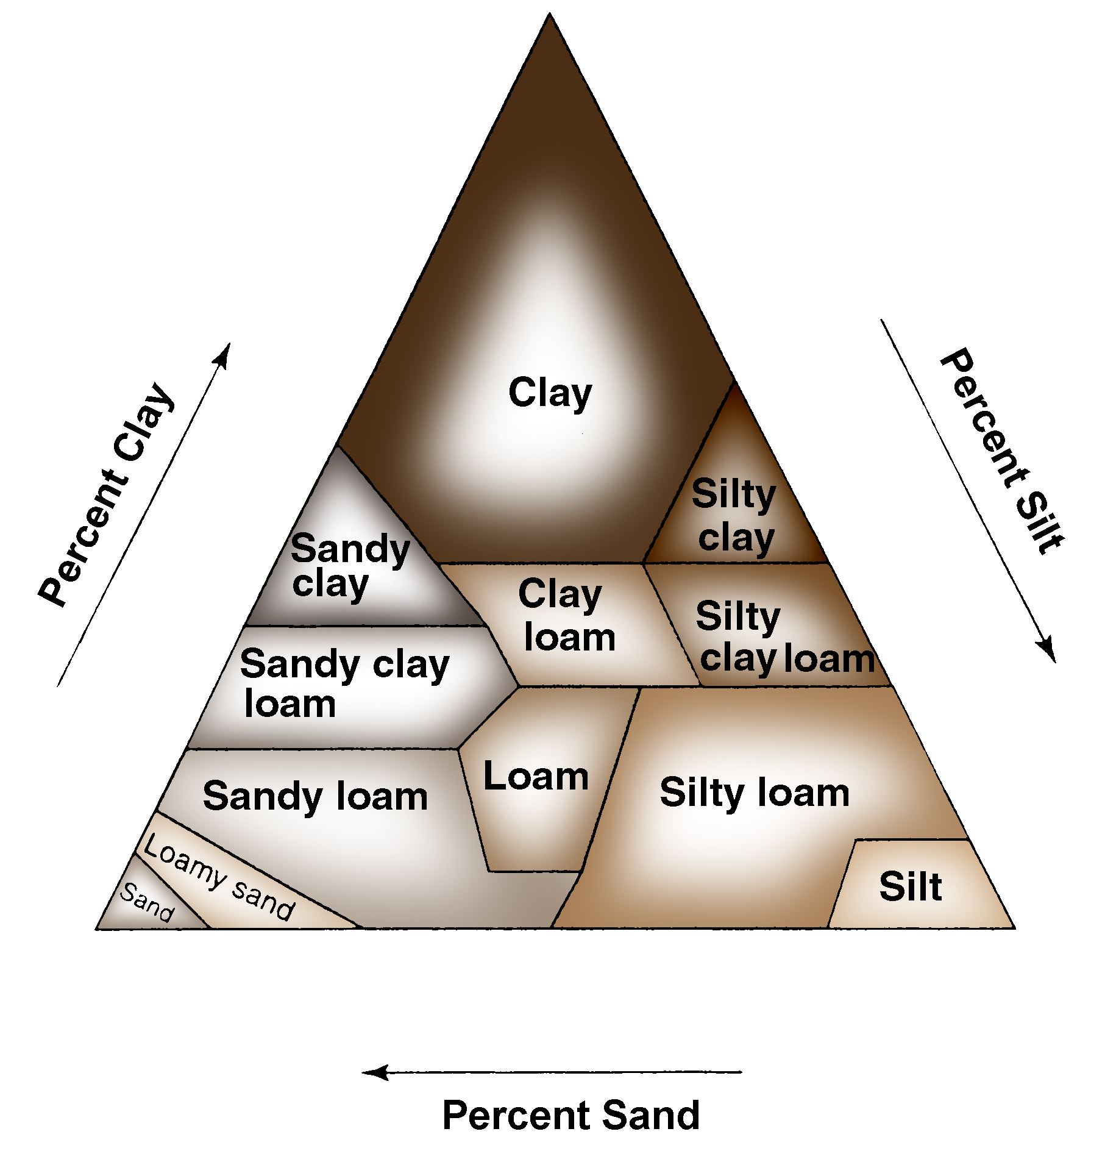
Soil pH is also important to consider. The pH scale measures acidity to alkalinity. The scale goes from 0 to 14, with 0 being the most acidic and 14 being the most alkaline or basic. (See Fig. 3.2.) Soil with a neutral pH is neither acidic nor alkaline. The pH value of the soil gives a quick estimate of the balance between the plant nutrient elements in the soil and other non-nutrient elements.
Figure 3.2 – pH Scale
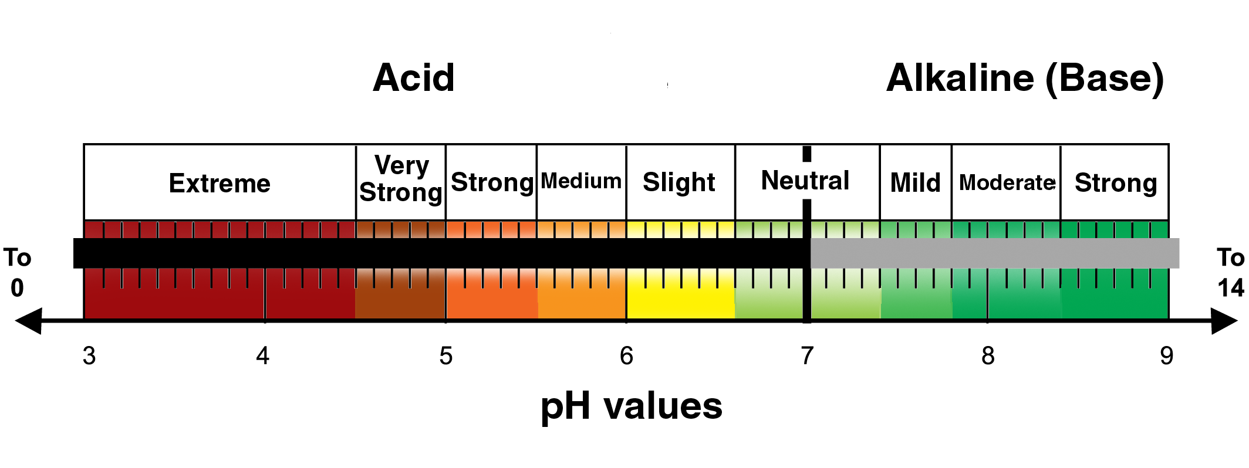

There are nine essential macronutrients and eight essential micronutrients needed for plant growth. Different pH levels affect available nutrient levels and should be monitored to reduce the likelihood of nutrient deficiencies. Table 3.1 lists the essential macronutrients and micronutrients and their sources.

Table 3.1 – Essential Plant Nutrients

 | Nutrients | Source
Macronutrients | Ca Calcium  Mg Magnesium  K Potassium | Mineral solids
Macronutrients | P Phosphorus  S Sulfur | Mineral solids;  organic matter
Macronutrients | N Nitrogen | Organic matter (primarily)
Macronutrients | C Carbon  H Hydrogen  O Oxygen | Water and air
Micronutrients | B Boron  Cl Chlorine  Co Cobalt  Fe Iron  Mn Manganese  Mo Molybdenum  Zn Zinc  Cu Copper | Naturally in soil;  can be added with fertilizers

A fertile soil produces high-yielding, healthy crops. Although a fertile soil has nutrient balance and quantity, nutrients alone are not sufficient to make a soil fertile. Soil fertility depends on soil texture, structure, rooting depth, organic-matter content, available water capacity, aeration (porosity), length of growing season, and physical support. Physical support includes such factors as erosion control and good plant residue management.

Organic matter is an important factor in soil evaluation because it supplies most of the nitrogen that is naturally present in the soil and may account for about half of the phosphorus. It also improves soil structure and aids in good soil aeration and healthy root development.

All crops require particular soil conditions for optimal yields. One of the best ways to evaluate the soil of a potential site is by performing a soil test. Soil testing can reveal the percentage of organic matter, pH, and amount of available nutrients in the soil. A soil test is a good guide for determining the proper amount of fertilizer and soil amendments for the site. Soil testing should be done when selecting a site and also should be performed periodically to monitor conditions and diagnose any problems. Amending the soil before crops are planted can help save time and money in the long run.

Topography

Topography refers to the relative positions and elevations of the natural and fabricated features that describe the surface of an area. Topography affects soil condition and what types of plants can grow well in the area and also is a significant factor in regard to accessibility for machinery.

Topography determines how wind and water move toward, over, and away from an area. This interaction between the topography and the wind and water significantly affects the soil erosion, soil drainage, and water-holding capacity of the site. Soils in low areas tend to be moist and poorly drained while soils in more sloping areas tend to be drier and well drained. On steeper slopes, topsoil may erode, exposing the subsoil or parent material.

To some extent, topography explains why similar enterprises are located in similar regions. Whatever the type of enterprise, the topography must be able to support the operation’s activities profitably.

Accessibility

Accessibility refers to how readily a site can be reached and used. It should be easy to get into and out of the area with all the equipment and supplies needed to plant, maintain, and harvest the crop. There should be access to any utilities that are needed, such as water and electricity. Consideration should also be given to where roads currently are and where they will need to be built on the property to provide access.

Traditionally, it was primarily the owners, operators, and workers who needed access to the farm. However, producers who are considering an operation such as a pick-your-own or CSA farm must also determine whether the site is accessible to the public. If consumers will be frequenting the farm, it is important that the farm have sufficient parking, clear roads and trails, and barrier-free access to all services and facilities.

Climate

Another environmental factor to consider when selecting a site is the climate. Climate is all the atmospheric influences, usually considered over a number of years, that combine to influence the land forms, soils, vegetation, and land use of a region. The principal atmospheric influences are temperature, moisture, wind, pressure and evaporation. The climate of the area will help determine what plants will thrive during the growing season.

Climate and region will determine the frost dates of the area. The frost dates are the estimated dates of the last frost in spring and the first frost in fall. The time between the frost dates is the growing season in which plants can reach maturity and produce fruits and vegetables that are ready to harvest. Frost dates are determined by the U. S. Department of Agriculture based on historical data. Because the dates are estimates, there is always a chance of unexpected early or late frost. Figure 3.3 shows the spring and fall frost dates for Missouri.
Figure 3.3 – Missouri Frost Dates
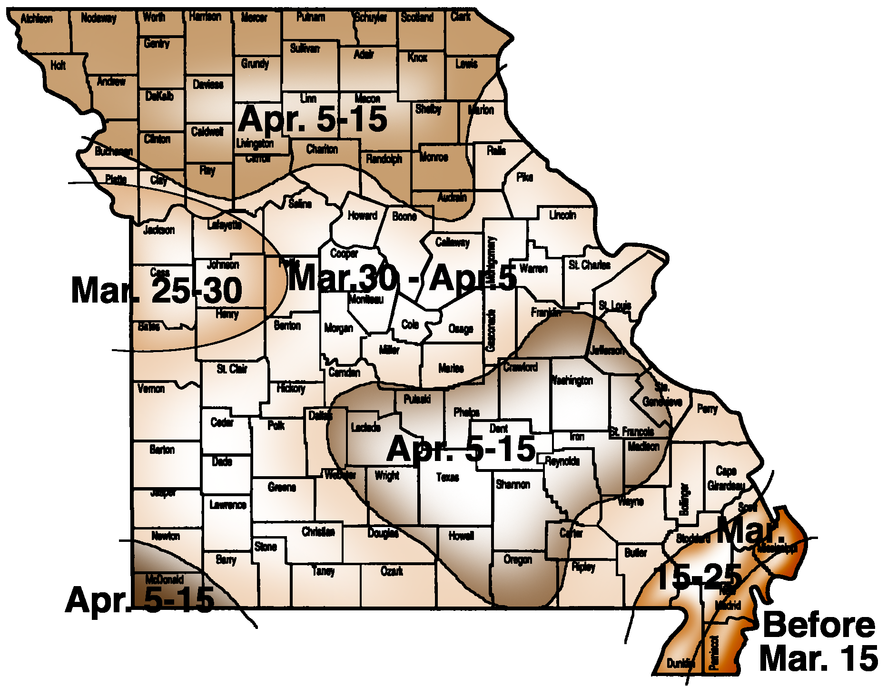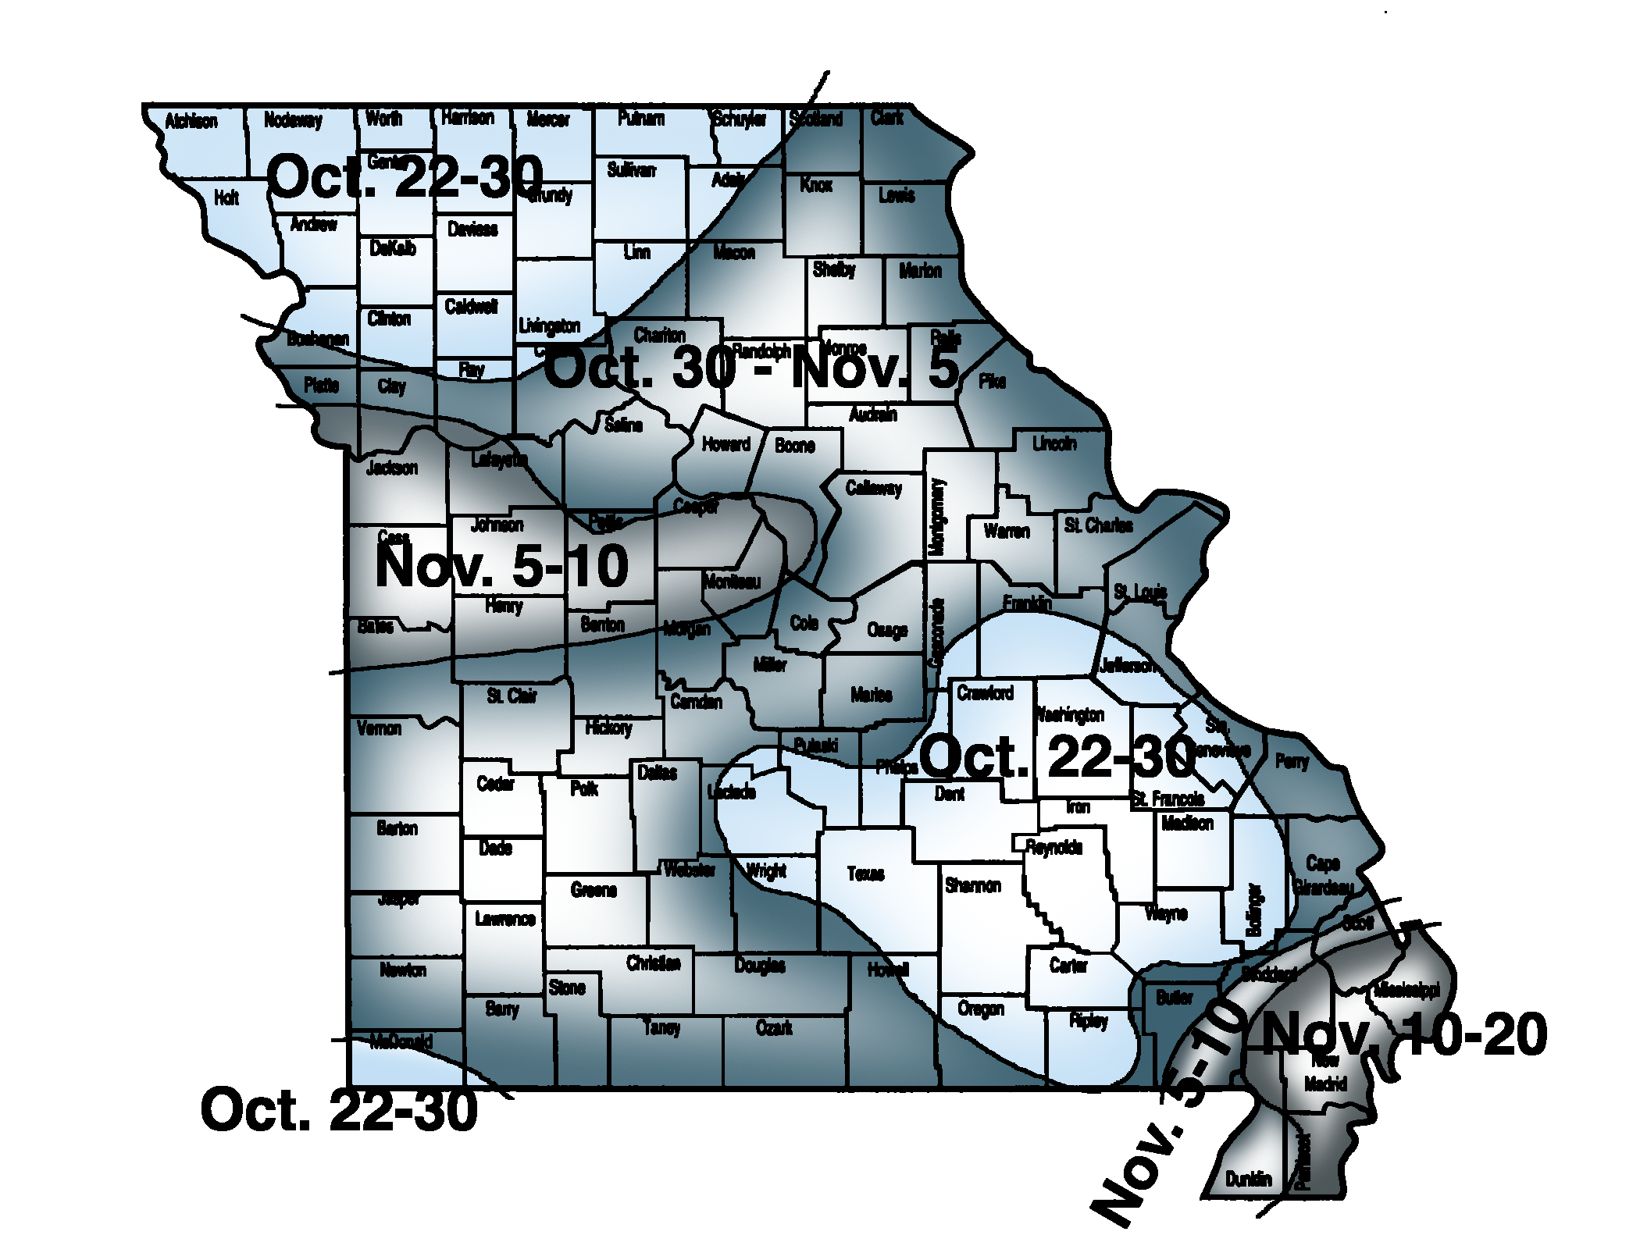

Within climates, there are also microclimates. A microclimate is an area in which the climate is different from the area around it. Microclimates may be large or small, and they may be naturally occurring or caused by human construction and activity. A valley, which is colder than the area around it, is an example of a large naturally occurring microclimate. A sheltered area next to a fence or building, which is warmer than the surrounding area, is an example of a small constructed microclimate. Producers can take advantage of microclimatic differences by the varieties of plants they choose and how they position their crops.

Nonenvironmental Evaluation Concerns

Utilities

A site should also be evaluated for the ease with which utilities and services can be provided. The distance to services and utilities should be considered because it will affect the cost of bringing them to the site. Water should be readily available and plentiful, and water quality should also be considered. Depending on what equipment will be used, electricity might also be needed.

Zoning

Zoning controls the physical development of land and dictates the kinds of uses allowed on individual properties. Zoning laws determine the areas in which residential, industrial, recreational, and commercial activities can occur. Local governments commonly control zoning. Prior to starting production, be sure to check with the local zoning board about the regulations concerning the specific site.

Labor

The type of labor needed will depend greatly on the type, size, and scale of production being considered. The availability of a labor force in the area should also be investigated. Depending on the crop and production scale, labor may be automated or done by hand. Hand labor is work done by people working manually with the crops. Automated labor is done by people operating machines.

Summary

When considering a site for fruit and vegetable production, a number of environmental and nonevironmental factors should be considered. Environmental factors include soil, topography, accessibility, and climate. Nonenvironmental factors include utilities, zoning, and labor. Carefully considering these factors before selecting a site can help avoid problems in the future.

Credits

Advanced Crop Science. University of Missouri-Columbia: Instructional Materials Laboratory, 2000.

Agricultural Structures. University of Missouri-Columbia: Instructional Materials Laboratory, 1999.

Cramer, C. “Microclimates.” Cornell Cooperative Extension. http://www.gardening.cornell.edu/weather/microcli.html (accessed March 24, 2006).

“From the Ground Down: An Introduction to Soil Surveys.” United States Department of Agriculture, Natural Resources Conservation Service. http://soils.missouri.edu/PDF_manuscripts/maries/Supplemental_Files/Introduction%20to%20Soil%20Surveys.pdf (accessed January 23, 2006).

“Frost Dates.” Lowe’s. http://www.lowes.com/lowes/lkn?action=howTo&p=LawnGarden/FrostDates.html&rn=RightNavFiles/rightNavHowTo (accessed January 25, 2006).

Garden Terms. http://www.gardenterms.com/index.htm
(accessed January 25, 2006).

Hansen, K. “Analyzing Farm Real Estate Purchases.” Northwest Missouri Extension News 3, no. 4 (April 2005). University of Missouri Extension. http://extension.missouri.edu/nwregion/ExtNews/April%2005/ag.htm (accessed January 23, 2006).

Nathan, M. “Fall—A Good Time to Have Your Garden Tested.” Missouri Environment and Garden Newsletter 7, no. 13 (November 16, 2001). University of Missouri-Columbia and Missouri Botanical Garden. http://agebb.missouri.edu/hort/meg/archives/v7n13/meg4.htm (accessed January 23, 2006).

Soil Science. University of Missouri-Columbia: Instructional Materials Laboratory, 1995.

“What Is Zoning?” FreeAdvice. http://real-estate-law.freeadvice.com/zoning/zoning_legalese.htm (accessed January 25, 2006).

