Fruit and Vegetable Production

Lesson 6: Fruit Production

Competency/Objective

Identify characteristics of small fruits and tree fruits.

Study Questions

1. What are plant considerations in fruit production?

2. What are small fruits?

3. What are tree fruits?

4. How are fruit trees produced?

5. What are the types of fruit trees?

6. What are the components of the fruit charts and what do they mean?

7. What are the important production characteristics of individual fruit crops?

References and Materials

1. Fruit and Vegetable Production Unit for Plant Science Core Curriculum (Student Reference). University of Missouri-Columbia: Instructional Materials Laboratory, 2006.

2. Figures/Transparency Masters

Fig. 6.1 Whip Grafting
Fig. 6.2 Sample Fruit Chart

3. Activity Sheet

AS 6.1 Exploring a Fruit Crop

Teaching Procedures

A. Review

Lesson five discussed cool, warm, and long season crops and key aspects of vegetable production. Lesson six will introduce students to small fruits, tree fruits, and various elements of fruit production.

B. Motivation

Ask students to use a phone book to identify fruit producers in the area. Ask them what types of fruit are produced in the area. Where are these fruits sold?

C. Assignment

D. Supervised Study

Lead students in collecting the information needed to answer and discuss the study questions. The instructor may choose to work on one study question at a time or have students consider all the study questions before the discussion. Another option is to have students work in a cooperative learning environment by forming groups and assigning different study questions to each group.

E. Discussion

Lead students in a discussion of the study questions. Supplement students’ responses and information with additional materials when needed.

1. What are plant considerations in fruit production?

Ask students what they know about fruit production. What are some things that need to be considered? Why are those things important?

a. Fruits are the matured ovaries of flowering plants that contain the seeds of the plant.
b. A fruit crop is a perennial crop that produces true (botanical) fruit that is edible and of economic value.
c. Different varieties and hybrids of fruits offer certain desirable characteristics, such as good size, flavor, and appearance and resistance to certain pests and diseases.
i. Variety: a plant that occurs naturally or through cultivation and differs from other members of its species by one or more characteristics
ii. Hybrid: a plant that results from interbreeding two distinct cultivars, varieties, or species
d. Qualities such as size, flavor, and appearance are especially important when choosing fruit crops because these traits play a large role in appealing to customers.

2. What are small fruits?

Ask students to explain what small fruits are. Why are small fruits important in fruit production?

a. Small fruit crops produce small, soft fruit, usually on vines, plants, or shrubs.
i. Small fruits are not all in the same botanical family.
ii. They require little space relative to the amount of fruit they produce.
iii. Small fruit crops typically bear fruit one or two years after planting.
iv. Pests are generally easier to control than on tree fruits.
v. Examples: blackberries, blueberries, grapes, raspberries, strawberries

3. What are tree fruits?

Ask students what fruit trees they have seen in the area. Why would someone grow fruit trees?

a. Tree fruits are edible fruit crops that grow on trees.
i. Trees are woody plants that usually have a single main trunk and produce new growth in the branches of their canopy.
1. Trees are distinct from shrubs, which typically have several stems instead of a single trunk and produce new growth from the ground.
2. The growth pattern of trees makes them well suited to grafting.

4. How are fruit trees produced?

Ask students if they know how most fruit trees are produced. What is grafting? Why is grafting important? Refer to Figure 6.1 Whip Grafting.

a. Grafting is a propagation method in which a bud, twig, or shoot—the scion—is taken from one plant and attached to a different but compatible plant, called the rootstock.
i. The grower can choose one tree for its ability to grow in a particular region or type of soil, its height, or disease resistance, and another for its fruit.
ii. Grafting allows the grower to combine the best traits of multiple plants and produce a better product.

5. What are the types of fruit trees?

Ask students if they know what the different types of fruit trees are. What are pome fruit trees? What are stone fruit trees? What are nut trees? Why is a nut considered a fruit?

a. Pome fruits
i. Pome fruits are members of the Pomoideae subfamily of the family Rosaceae.
ii. The fruit, a pome, forms from a flower with an inferior, compound ovary.
iii. The edible portion that surrounds the seeds is formed by the nonovarian parts of the flower.
iv. Pome fruits are generally well adapted to cool, temperate climates.
v. They typically have a long storage life if proper conditions are provided.
vi. Examples: apples and pears
b. Stone fruits
i. Stone fruits are members of the subfamily Prunoideae of the family Rosaceae.
ii. The fruit, a drupe, forms from a flower with a superior, simple ovary.
iii. The common name comes from the hard pit or “stone” in the center of the fruit.
iv. The stone is a specialized layer of ovary tissue called an endocarp that surrounds the seed.
v. Most stone fruits are native to warmer climates.
1. They are very susceptible to injury from low winter temperatures.
2. Stone fruits bloom early in the spring, which makes their flowers vulnerable to damage from spring frosts.
vi. Stone fruits are extremely perishable and have a very limited storage life.
vii. Examples: cherries, peaches, and plums
c. Nuts
i. A nut is a dry indehiscent fruit in which the seed remains unattached to the ovary wall, and the ovary wall—the shell—becomes very hard at maturity.
ii. Indehiscent means that the fruit does not open when it ripens.
iii. Nut crops are not all in the same botanical family, but they do have similar processing requirements, such as hulling and drying.
iv. They are typically high in protein and low in saturated fats.
v. Nut trees can do well in less desirable growing conditions, which makes them a good choice for land that is too rough or steep for field crops.
vi. Examples: black walnuts, Chinese chestnuts, and northern pecans

6. What are the components of the fruit charts and what do they mean?

Ask students what they would need to know about a specific crop if they were going to grow it. How could knowing this information help them with production? Refer to Figure 6.2 Sample Fruit Chart.

a. Different types of fruits will be discussed in this lesson using a chart format. Fruit chart components are discussed below.
i. Interval From Planting to Fruiting: The interval from planting to fruiting refers to the amount of time from planting until the first salable crop is produced.
ii. Season of Ripening: The season of ripening is a guideline for the time of year when the fruit will be ripe and ready to pick.
iii. Soil: This section of the chart explains what soil conditions are desirable for the plant to grow, such as the recommended soil pH, texture, and drainage.
iv. Spacing: Spacing requirements provide a guideline for how much space to leave between plants and rows to allow adequate room for growth, cultivation, and harvesting.
v. Harvest: The harvest section of the charts provides general guidelines to help determine when the crop is ready to be harvested and how to harvest the crop.
vi. Postharvest: Proper storage and handling procedures are listed in the postharvest portion of the chart.
vii. Production Concerns: Crop-specific information to facilitate proper growth and production is supplied in the production concerns section.
viii.Pests and Diseases: This section lists common pests and diseases that affect the specific crop.
ix. Structures and Equipment: This section provides a guide to what structures and equipment are needed for proper growth and production.
x. Other Considerations: This heading provides a place to include crop-specific concerns that are not associated with other areas of the chart.

7. What are the important production characteristics of individual fruit crops?

Ask students what fruit crops grow in the area. What types of fruit crops have students grown?

a. The instructor should choose fruit charts to discuss in class from those provided or use blank charts to develop charts for other crops as needed.
b. The instructor should distribute blank charts to students to fill out during class discussion or as part of their assigned work.
c. Charts for the following fruits are included with this unit. A blank chart for student charts and other fruits is included with each group.
i. Small fruits
1. Blackberries
2. Blueberries
3. Grapes
4. Raspberries
5. Strawberries
6. Others
ii. Pome fruit trees
1. Apples
2. Pears
3. Others
iii. Stone fruit trees
1. Cherries
2. Peaches
3. Plums
4. Others
iv. Nut trees
1. Black walnuts
2. Chinese chestnuts
3. Northern pecans
4. Others

F. Other Activities

1. Have samples of each of the different crops studied in class for the students to see and taste.

2. Have examples of different fruits and ask the students to identify them as pome or stone fruits.

G. Conclusion

Fruits are the matured ovaries of flowering plants that contain the seeds of the plant. Fruits can be divided into small fruits and tree fruits. Tree fruits can be divided further into pome fruits, stone fruits, and nuts.

The charts that accompany this lesson summarize a number of key elements needed to produce a successful fruit crop. Recommendations will vary depending on specific crops and growing conditions.

H. Answers to Activity Sheet

AS 6.1 Exploring a Fruit Crop

Answers will vary.

I. Answers to Assessment

1. Fruits are the matured ovaries of flowering plants that contain the seeds of the plant.
2. Students should list the following types of tree fruits. Examples of each type will vary.
A. Pome fruits
1. Apples
2. Pears
B. Stone fruits
1. Cherries
2. Peaches
3. Plums
C. Nuts
1. Black walnuts
2. Chinese chestnuts
3. Northern pecans
3. Students should provide three of the following answers.
A. Blackberries
B. Blueberries
C. Grapes
D. Raspberries
E. Strawberries
4. Students should provide two of the following answers.
A. Small fruits require little space relative to the amount of fruit they produce.
B. Crops typically bear fruit one or two years after planting.
C. Pests are generally easier to control on small fruits than they are on most tree fruits.
5. Size and appearance are especially important when choosing fruit crops because these qualities play a large role in appealing to customers.
6. Grafting is a propagation method in which a bud, twig, or shoot—the scion—is taken from one plant and attached to a different but compatible plant, called the rootstock.
Unit I: Fruit and Vegetable Production Name: _______________________

Lesson 6: Fruit Production Date: ________________________

ASSESSMENT

Short-Answer Questions: Write the answers in the space provided.

1. What is a fruit?

2. List the three types of tree fruits and an example of each.

A.

B.

C.

3. List three different small fruits.

A.

B.

C.

4. What are two advantages of producing small fruits compared to tree fruits?

A.

B.

5. Why are qualities such as size and appearance especially important when choosing fruit crops?

6. What is grafting?

Figure 6.1
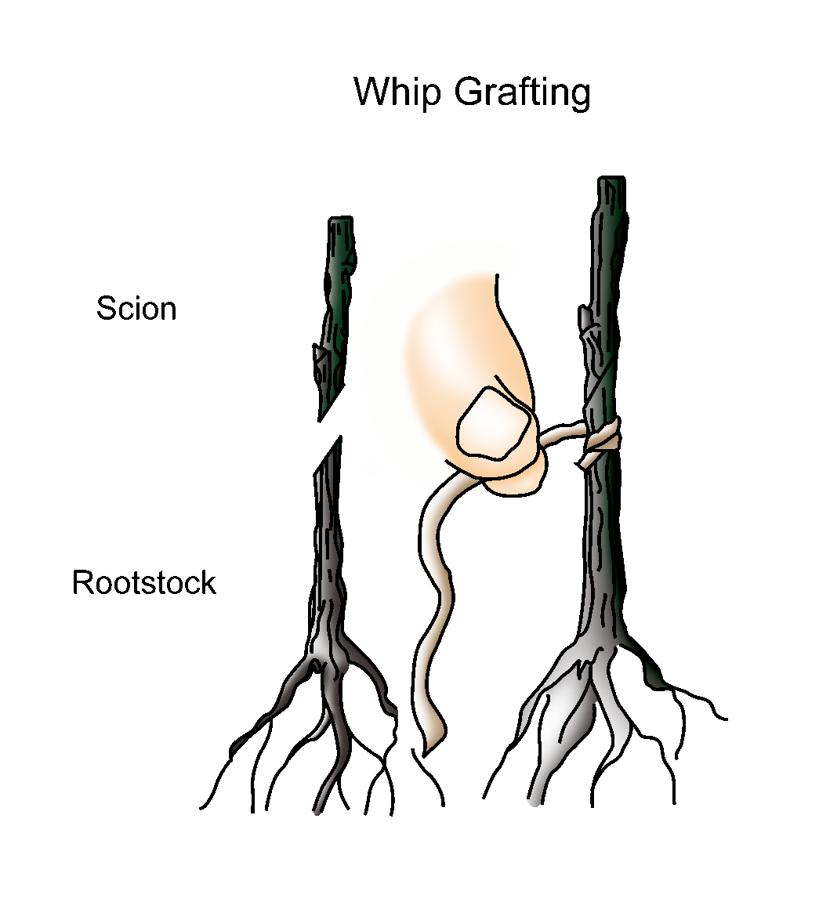

Whip Grafting

Figure 6.2
Sample Fruit Chart

Stone Fruit Trees
______________________
Interval From Planting to Fruiting
Season of
Ripening
Soil
Spacing
Harvest
Postharvest
Production Concerns
Pests and
Diseases
Structures and Equipment
Other Considerations

Unit I: Fruit and Vegetable Production AS 6.1

Lesson 6: Fruit Production Name: _______________________

Exploring a Fruit Crop

Objective: Identify key growing elements for a fruit crop.

Directions: Each student will receive a blank fruit chart. The instructor will assign each student a fruit to research. Students will complete the chart for the assigned fruit. Textbooks, seed catalogs, magazines, the Internet, and other sources may be used as references. After the chart is completed, students will present their findings to the class. Students will turn in their completed chart and a bibliography of their sources following their presentations.

