Fruit and Vegetable Production

Lesson 6: Fruit Production

Fruits are the matured ovaries of flowering plants that contain the seeds of the plant.

Although this definition is simple, people often have different ideas about what fruits are. For example, botanically, a tomato is the fruit of a tomato plant, but for a customer in a grocery store, it is probably a vegetable. A workable definition for fruit and vegetable production is that a fruit crop is a perennial crop that produces true (botanical) fruit that is edible and of economic value. Including the fact that they are perennial crops recognizes that production concerns for crops such as blackberries, pecans, and apples are more similar to each other than they are to production concerns for annual crops such as tomatoes and melons.

Plant Considerations

Growers must consider what varieties and hybrids of fruits will work well in their particular area and climate when deciding what crops to grow. A variety is a plant that occurs naturally or through cultivation and differs from other members of its species by one or more characteristics. A hybrid is a plant that results from interbreeding two distinct cultivars, varieties, or species. Varieties and hybrids offer certain desirable characteristics, such as good size, flavor, and appearance and resistance to certain pests and diseases. Fruit growers must pay particular attention to the size, flavor, and appearance of fruit when choosing the crops they will plant because these qualities play a large role in appealing to customers.

Small Fruits

Small fruit crops are grouped together because they produce small, soft fruit, usually on vines, plants, or shrubs; however, not all small fruit crops are in the same botanical family. Examples include blackberries, blueberries, grapes, raspberries, and strawberries.

Small fruit crops require little space relative to the amount of fruit they produce and typically bear fruit one or two years after planting. Pests are generally easier to control on small fruits than they are on most tree fruits.

Tree Fruits

Tree fruits are edible fruit crops that grow on trees. Trees are woody plants that usually have a single main trunk and produce new growth in the branches of their canopy. This makes trees distinct from shrubs, which typically have several stems instead of a single trunk and produce new growth from the ground. This growth pattern also makes trees well suited to grafting, which is an important aspect of fruit tree production. Figure 6.1 shows a simple form of grafting called whip grafting.
Figure 6.1 – Whip Grafting

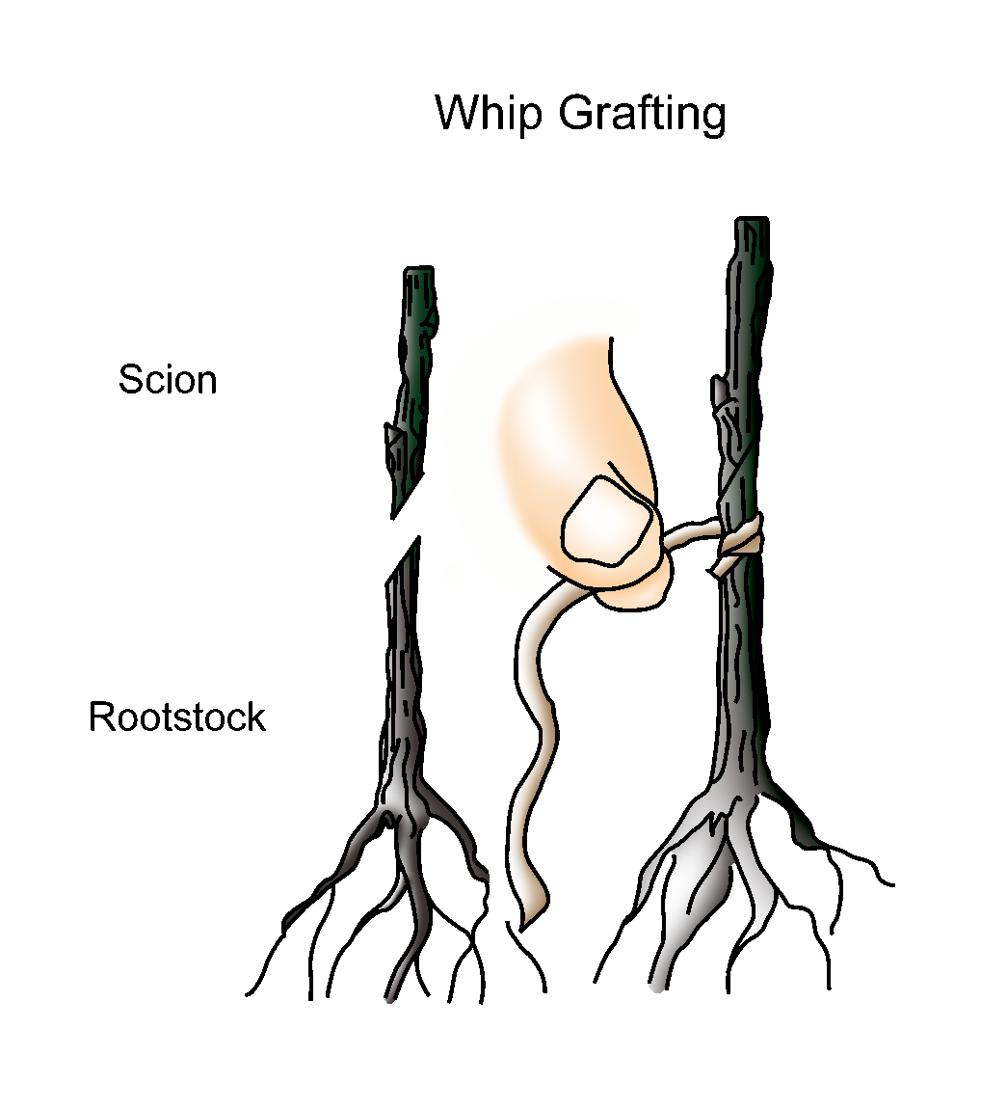

Grafting is a propagation method in which a bud, twig, or shoot—the scion—is taken from one plant and attached to a different but compatible plant, called the rootstock. The grower can choose one tree for its ability to grow in a particular region or type of soil, its height, or disease resistance, and another for its fruit. Grafting allows the grower to combine the best traits of multiple plants and produce a better product.

There are three primary types of tree fruit crops: pome fruits, stone fruits, and nuts. Each is discussed in the rest of this section.

Pome Fruits

Pome fruits are members of the Pomoideae subfamily of the family Rosaceae. The fruit, called a pome, forms from a flower with an inferior, compound ovary. The fleshy, edible portion of the fruit that surrounds the seeds is formed by the nonovarian parts of the flower. Pome fruits are generally well adapted to cool, temperate climates. Pome fruits typically have a long storage life if proper conditions are provided. Apples and pears are examples of pome fruits.
Stone Fruits

Stone fruits are members of the subfamily Prunoideae of the family Rosaceae. The fruit, called a drupe, forms from a flower with a superior, simple ovary. Stone fruits get their common name from the hard pit or “stone” in the center of the fruit. The stone is a specialized layer of ovary tissue called an endocarp that surrounds the seed. Cherries, peaches, and plums are examples of stone fruits.

Most stone fruit crops are native to warmer climates and therefore are very susceptible to injury from low winter temperatures. Stone fruits also bloom early in the spring, which makes their flowers vulnerable to damage from spring frosts. Stone fruits are extremely perishable, so they have a very limited storage life. This makes managing stone fruit crops more complex than pome fruits because growers must typically grow more varieties to extend their growing season and produce a profitable crop.

Nuts

A nut is a dry indehiscent fruit in which the seed remains unattached to the ovary wall, and the ovary wall—the shell—becomes very hard at maturity. Indehiscent means that the fruit does not open when it ripens. Some examples of nut fruits are black walnuts, Chinese chestnuts, and northern pecans.

Nut crops are not all in the same botanical family, but they do have similar processing requirements, such as hulling and drying. Nut crops are also typically high in protein and low in saturated fats. Nut trees can do well in less desirable growing conditions, which makes them a good choice for land that is too rough or steep for field crops.

Fruit Chart Components

Different types of fruits will be explored in this lesson using a chart format.
(See Fig. 6.2.) The chart addresses some of the most important factors that must be considered when deciding what fruits to grow. Descriptions of each heading are given following the sample chart. Recommendations will vary depending
on such factors as the local climate and region and the specific varieties of fruits grown.

Figure 6.2 – Sample Fruit Chart

Stone Fruit Trees
______________________
Interval From Planting to Fruiting
Season of Ripening
Soil
Spacing
Harvest
Postharvest
Production Concerns
Pests and Diseases
Structures and Equipment
Other Considerations

- Interval From Planting to Fruiting: The interval from planting to fruiting refers to the amount of time from planting until the first salable crop is produced.

- Season of Ripening: The season of ripening is a guideline for the time of year when the fruit will be ripe and ready to pick.

- Soil: This section of the chart explains what soil conditions are desirable for the plant to grow, such as the recommended soil pH, texture, and drainage.

- Spacing: Spacing requirements provide a guideline for how much space to leave between plants and rows to allow adequate room for growth, cultivation, and harvesting.

- Harvest: The harvest section of the charts provides general guidelines to help determine when the crop is ready to be harvested and how to harvest the crop.

- Postharvest: Proper storage and handling procedures are listed in the postharvest portion of the chart.

- Production Concerns: Crop-specific information to facilitate proper growth and production is supplied in the production concerns section.

- Pests and Diseases: This section lists common pests and diseases that affect the specific crop.

- Structures and Equipment: This section provides a guide to what structures and equipment are needed for proper growth and production.

- Other Considerations: This heading provides a place to include crop-specific concerns that are not associated with other areas of the chart.

Summary

Fruits are the matured ovaries of flowering plants that contain the seeds of the plant. Fruits can be divided into small fruits and tree fruits. Tree fruits can be divided further into pome fruits, stone fruits, and nuts.

The charts that accompany this lesson summarize a number of key elements needed to produce a successful fruit crop. Recommendations will vary depending on specific crops and growing conditions.

Credits

Classifying Fruit. Fairchild Tropical Botanic Garden. http://www.fairchildgarden.org/EduProfDev/Fruit_classification.html (accessed April 18, 2006).

Greenhouse Operation and Management. University of Missouri-Columbia: Instructional Materials Laboratory, 2002.

Northern Nut Growers Association, Inc. http://www.icserv.com/nnga/question.htm (accessed February 13, 2006).

Relf, D., and J. Williams. Small Fruit in the Home Garden. Virginia Cooperative Extension. http://www.ext.vt.edu/pubs/envirohort/426-840/426-840.html (accessed February 8, 2006).

Rieger, M. Introduction to Fruit Crops. Mark Rieger’s Fruit Crop Home Page. University of Georgia Department of Horticulture. http://www.uga.edu/fruit/ (accessed February 13, 2006).

Rothenberger, R. R., and C. J. Starbuck. Grafting. University of Missouri Extension. http://muextension.missouri.edu/xplor/agguides/hort/g06971.htm (accessed April 17, 2006).

Small Scale Fruit Production. College of Agricultural Sciences at Pennsylvania State University. http://ssfruit.cas.psu.edu/chapter5/chapter5a.htm (accessed February 13, 2006).

Sternum, N. “Grafting Fruit Trees.” DoItYourself.com. http://doityourself.com/info/graftingfruittrees.htm (accessed February 13, 2006).

Stone Fruit Resources. New York State Agricultural Experiment Station. Cornell University. http://www.nysaes.cornell.edu/pp/extension/tfabp/stone.shtml (accessed February 13, 2006).

UC IPM Online. University of California Agriculture and Natural Resources. http://ucipm.ucdavis.edu/index.html (accessed April 17, 2006).

Wikipedia. Nut (Fruit). http://en.wikipedia.org/wiki/Nut_(fruit) (accessed February 13, 2006).

