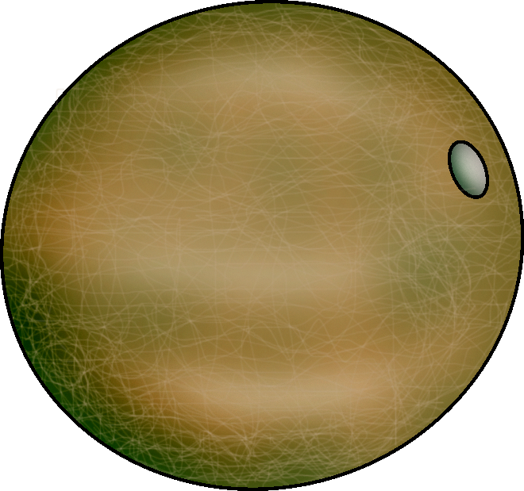 | Long Season Crop
 | Cantaloupes
Days to Germination |  | - 7 to 14
Days to Maturity |  | - 80 to 90
Soil |  | - pH: 6.0 to 6.5  - Well-drained sandy or silt loam soil
Spacing |  | - Between plants: 60 in.  - Between rows: 48 in. if cultivated by hand; 60 in. if field implements are used
Harvest |  | - Cantaloupes are ripe when they separate easily from the vine and the skin takes on a slightly yellowish appearance.  - Cantaloupes that will be shipped long distances can be picked just prior to ripening.
Postharvest |  | - Ripe cantaloupes can be held for 5 to 14 days at 32°F to 36°F.  - Cantaloupes are highly perishable.
Production Concerns |  | - Cantaloupes are frequently planted in hills, but this is not necessary and may not be practical when growing large quantities.
Pests and Diseases |  | - Pests: aphids, cucumber beetles, squash bugs  - Diseases: Fusarium wilt, anthracnose, Alternaria leaf spot, bacterial wilt, powdery mildew, gummy stem blight, damping-off, root rot/vine decline, root knot
Other Considerations
Commercial Vegetable Production Guides. “Melons: Cantaloupe, Muskmelon, Honeydew, Crenshaw, Casaba, Etc.” Oregon State University. http://oregonstate.edu/dept/NWREC/melon.html#storage.

The Gardener’s Network. “Cantaloupes and Melons.” http://www.gardenersnet.com/vegetable/cantlope.htm.

Jett, L. W. Vegetable Planting and Planning Calendar. University of Missouri Extension. http://muextension.missouri.edu/explore/agguides/hort/g06201cantaloupe.htm.

Motes, J., W. Roberts, J. Edelson, J. Damicone, and J. Duthie. Cantaloupe Production. Oklahoma Cooperative Extension Service. http://pods.dasnr.okstate.edu/docushare/dsweb/Get/Document-1405/F-6237web.pdf.

Reimer Seeds. “Cantaloupe and Melon Seeds.” http://www.reimerseeds.com/cantaloupes-melons_442.aspx.

Sources accessed November 28, 2005.

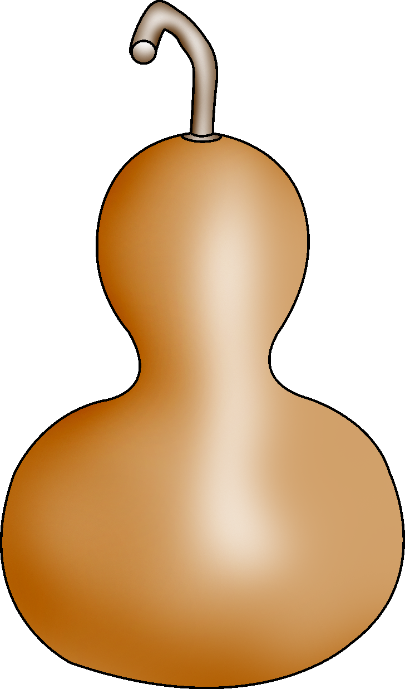 | Long Season Crop
 | Gourds
Days to Germinations |  | - 10 to 15
Days to Maturity |  | - 100 to 180
Soil |  | - pH: 6.5 to 6.8  - Sunny, well-drained site
Spacing |  | - Between plants: 24 in.  - Between rows: 60 in.  - Hills: 48 in. to 60 in. apart with rows 84 in. apart
Harvest |  | - Harvest gourds when the stems are dry and brown and before frost.
Postharvest |  | - Clean gourds with soap and water, dry, and apply rubbing alcohol to the surface.  - Curing Cucurbita and Lagenaria gourds is a two-step process. The first step, surface drying, takes approximately a week. This is followed by internal drying, which can take from 4 weeks to several months, depending on the variety.  - Luffa sponges are prepared by removing the seeds, soaking and removing the skin, and bleaching the sponge to achieve the desired appearance.
Production Concerns |  | - Because of their long growing season, gourds should be started indoors 4 weeks before planting outdoors.  - Gourds are often grown on a trellis or arbor. Gourds vary greatly in weight and size. Be sure the structure will support the weight of the gourds.
Pests and Diseases |  | - Pests: aphids, cucumber beetles, squash bugs, squash vine borers  - Diseases: angular leaf spot, bacterial wilt, mosaic viruses, powdery mildew
Other Considerations |  | There are three main types of gourds:  - Cucurbita: ornamental gourds  - Lagenaria: large, utilitarian gourds  - Luffa: vegetable sponges
Grassbaugh, E., S. Metzger, and M. Riofrio. Growing and Curing Gourds in the Home Garden. Ohio State University Extension. http://ohioline.osu.edu/hyg-fact/1000/1630.html.

Schultheis, J. R. Growing Gourds. North Carolina Cooperative Extension Service. http://www.ces.ncsu.edu/depts/hort/hil/hil-29.html.

Yankee Gardener. http://www.yankeegardener.com/seeds/hartseed5.html.

Sources accessed November 28, 2005.

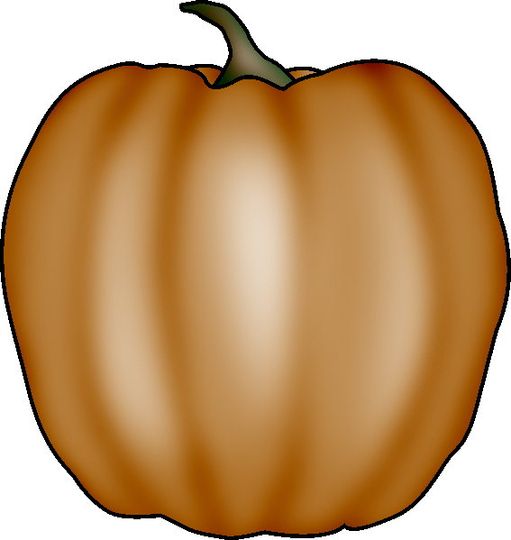 | Long Season Crop
 | Pumpkins
Days to Germination |  | - 6 to 10
Days to Maturity |  | - 95 to 120
Soil |  | - pH: 5.5 to 6.5  - Moderate potassium and phosphorus and high nitrogen content
Spacing |  | - Between plants: 12 in. to 18 in.  - Between rows: 72 in.
Harvest |  | - Pumpkins are ready to harvest when they are a deep solid color and the vine has begun to shrivel.  - Harvest pumpkins before the first hard frost.  - Leave 3 in. to 4 in. of stem attached to the pumpkin.
Postharvest |  | - Can be held for 2 to 3 months at 50°F to 55°F and 50% to 75% relative humidity
Production Concerns |  | - Water pumpkins regularly throughout growing season and keep plants evenly moist.  - Watering plants early in the day and keeping water off foliage helps prevent mildew.
Pests and Diseases |  | - Pests: squash vine borers, cucumber beetles  - Diseases: bacterial wilt, anthracnose, downy mildew, powdery mildew
Other Considerations |  | - Do not plant pumpkins until the danger of frost has passed and the soil has warmed.
Banse, G. Growing Pumpkins. Farm and Garden. http://www.farm-garden.com/growing-vegetables/pumpkins.

Commercial Vegetable Production Guides. “Pumpkin and Winter Squash.” Oregon State University. http://oregonstate.edu/Dept/NWREC/pumpkin.html.

Jett, L. W. Vegetable Planting and Planning Guide. University of Missouri Extension. http://muextension.missouri.edu/explore/agguides/hort/g06201pumpkin.htm.

Urban Programs Resource Network. “Growing Pumpkins.” University of Illinois Extension. http://www.urbanext.uiuc.edu/pumpkins/growing.html.

Sources accessed November 16, 2005.

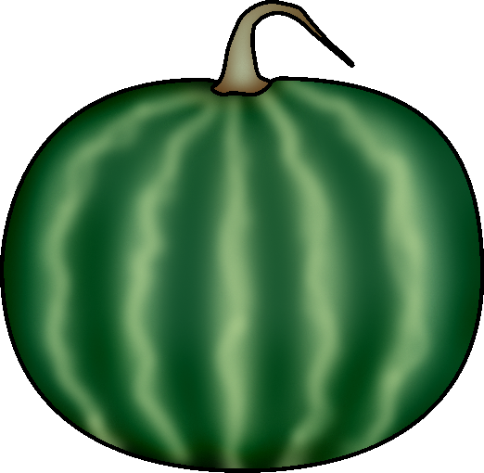 | Long Season Crop
 | Watermelons
Days to Germination |  | - 7 to 14
Days to Maturity |  | - 85 to 95
Soil |  | - pH: 5.0 to 8.0  - Well-drained sandy or sandy loam soil
Spacing |  | - Between plants: 96 in.  - Between rows: 96 in. if hand cultivated; 120 in. if field implements are used
Harvest |  | Timing is important because sweetness does not increase after harvest. Indications of ripeness include the following:  - Ground spot (the portion of the melon in contact with the soil) turns from white to yellow  - Tendrils near the fruit become brown and dry  - Rind has a shiny appearance  - Thumping produces a hollow sound—less effective on varieties with firmer flesh
Postharvest |  | - Can be stored for 2 weeks at 52°F to 60°F and 85% to 90% relative humidity  - Not suited for long storage  - Will lose flavor and color if stored below 50°F
Production Concerns |  | - Adequate water early in the season improves vine growth and yield.
Pests and Diseases |  | - Pests: aphids, cucumber beetles  - Diseases: Alternaria leaf spot, anthracnose, downy mildew, Fusarium wilt
Other Considerations |  | - Fruit disorders: misshapen melons, blossom-end rot, bursting, white heart, hollow heart, sunburn, rind necrosis
Heirloom Seeds. “Seed Germination Soil Temperatures.” http://www.heirloomseeds.com/germination.html.

Jett, L. W. Frequently Asked Vegetable Questions. University of Missouri Extension. http://muextension.missouri.edu/explore/agguides/hort/g06400.htm#Watermelon.

Jett, L. W. Vegetable Planting and Planning Calendar. University of Missouri Extension. http://muextension.missouri.edu/explore/agguides/hort/g06201watermelon.htm.

Marr, C. W., and N. Tisserat. Commercial Vegetable Production: Watermelon. Kansas State University. http://agebb.missouri.edu/mac/links/linkview3.asp?catnum=240&linknum=4131.

Roberts, W., J. Motes, J. Damicone, J. Duthie, and J. Edelson. Watermelon Production. Oklahoma Cooperative Extension Service. http://agebb.missouri.edu/mac/links/linkview3.asp?catnum=240&linknum=5834.

Sources accessed November 17, 2005.

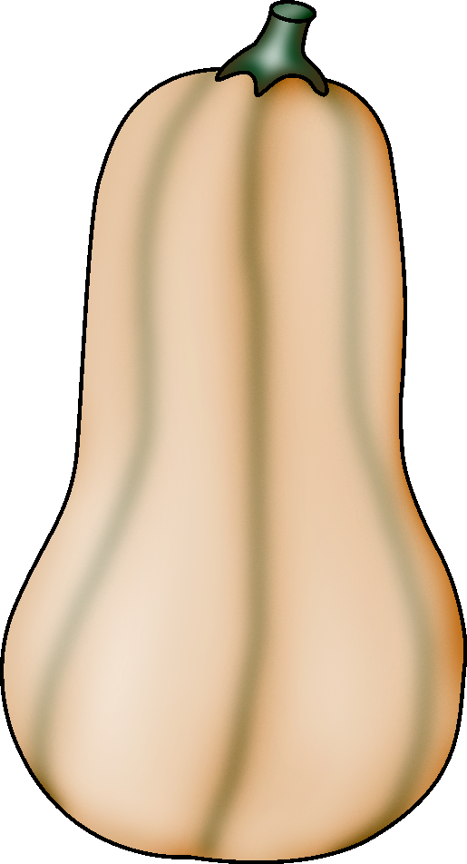 | Long Season Crop
 | Winter Squash
Days to Germination | - 6 to 10
Days to Maturity | - 80 to 120
Soil | - pH: 5.5 to 6.5  - Fertile, well-drained soil
Spacing | - Between plants: 60 in.  - Between rows: 48 in. if cultivated by hand; 60 in. if field implements are used
Harvest | - Winter squash are ready to harvest when their stems begin to shrivel.  - Cut squash off the plant and leave 2 in. of stem attached to the fruit.
Postharvest | - Curing is often recommended for many types of winter squash to harden the skin and extend storage life. To cure, store squash for 10 to 20 days at 75°F to 80°F.  - Fully cured squash can be held 84 to 150 days at 50°F to 55°F and 50% to 70% relative humidity.  - Do not cure acorn squash. Acorn squash can be held 5 to 8 weeks at 50°F.
Production Concerns | - Keep squash evenly moist throughout the growing season.  - Monthly application of a complete organic fertilizer is recommended to improve plant health and yield.
Pests and Diseases | - Pests: aphids, cucumber beetles, squash vine borers, squash bugs  - Diseases: bacterial wilt, anthracnose, downy mildew, powdery mildew
Other Considerations | - Squash plants are not hardy and are susceptible to frost in the spring and fall.
Banse, G. Growing Winter Squash. Farm and Garden. http://www.farm-garden.com/growing-vegetables/wintersquash.

Boyhan, G. E., D. M. Granberry, and W. T. Kelley. Squash. University of Georgia Cooperative Extension Service. http://pubs.caes.uga.edu/caespubs/pubcd/C527.htm.

Commercial Vegetable Production Guides. “Pumpkin and Winter Squash.” Oregon State University. http://oregonstate.edu/Dept/NWREC/pumpkin.html.

The Gardener’s Network. “How to Grow Squash.” http://www.gardenersnet.com/vegetable/squash.htm.

Jett. L. W. Vegetable Planting and Planning Calendar. University of Missouri Extension. http://muextension.missouri.edu/explore/agguides/hort/g06201squash.htm.

Sources accessed November 16, 2005.

Long Season Crop
______________________
Days to Germination
Days to Maturity
Soil
Spacing
Harvest
Postharvest
Production Concerns
Pests and Diseases
Other Considerations

