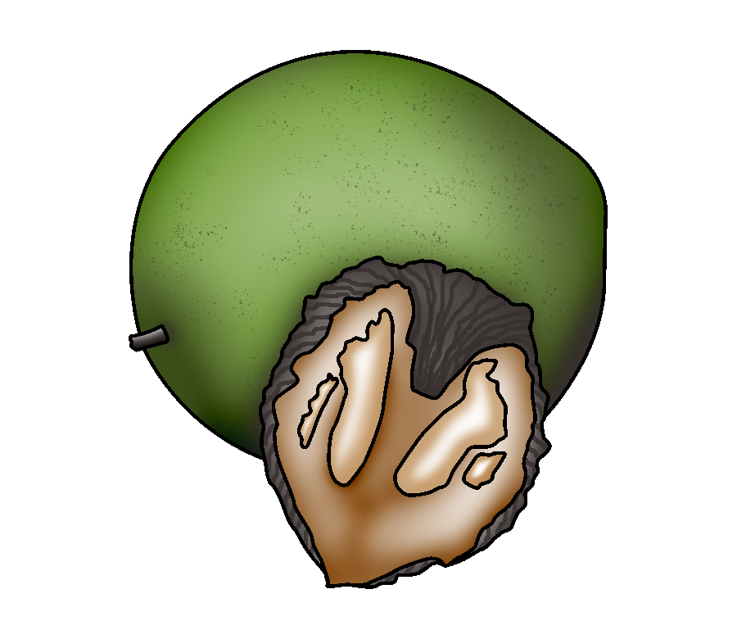 | Nut Trees
 | Black Walnuts
Interval From Planting to Fruiting | - Grafted trees: 5 years to first nut production; 10 years to commercial production  - Seedling trees: 10 years to first nut production; up to 20 years for commercial production
Season of Ripening | - Mid September to late October, depending on cultivar
Soil | - pH: 6.5 to 7.5  - Well-drained soil
Spacing | - Between trees: 30 ft  - Between rows: 30 ft
Harvest | - Harvest walnuts when the hull is green and can be indented with the thumb.
Postharvest | - Hull and wash walnuts immediately upon harvest. Dry hulled nuts at ambient temperature for 4 to 6 weeks before cracking.  - After cracking, allow nuts to dry for a day or two before refrigerating.  - Frozen nuts can last up to two years.
Production Concerns | - Hull and clean walnuts while husks are still green.  - Allowing nuts to remain in the husk degrades nut quality.
Pests and Diseases | - Pests: weevil, nut casebearer  - Diseases: anthracnose leaf disease
Structures and Equipment | - Stake grafted trees when young. Protect young trees from deer browse and deer rub.  - Tree shakers and hullers are used in commercial production.
Other Considerations | - Use space between rows for grasses, winter wheat, vegetables, blackberries, blueberries, or raspberries.

Garrett, H. E., W. B. Kurtz, and J. P. Slusher. Walnut Agroforestry. University of Missouri Extension. http://muextension.missouri.edu/explore/agguides/forestry/g05020.htm (accessed December 27, 2005).

Growing Eastern Black Walnuts as an Orchard Crop in Missouri (tentative title, publication forthcoming). University of Missouri Center for Agroforestry. www.centerforagroforestry.org (accessed May 2, 2006).

Pastoret, J. Home Production of Black Walnut Nutmeats. University of Missouri Extension. http://outreach.missouri.edu/explore/qa/images/blackwalnut.pdf (accessed December 27, 2005).

Schroeder, C. B., E. D. Seagle, L. M. Felton, J. M. Ruter, W. T. Kelley, and G. Krewer. Introduction to Horticulture. 4th ed. Upper Saddle River, NJ: Pearson Education, Inc., 2004.

Warmund, M. Fruit and Nut Cultivars for Home Planting. University of Missouri Extension. http://muextension.missouri.edu/explore/agguides/hort/g06005.htm (accessed December 27, 2005).

 | Nut Trees
 | Chinese Chestnuts
Interval From Planting to Fruiting | - Grafted trees: 3 years to first nut production; 6 to 9 years to commercial production  - Seedling trees: 5 years to first nut production; 8 to 12 years for commercial production
Season of Ripening | - Mid September to mid October, depending on cultivar
Soil | - pH: 5.5 to 6.5  - Well-drained, loamy to sandy loam soils
Spacing | - Between trees: 35 ft  - Between rows: 35 ft
Harvest | - Chestnuts are gathered from the ground after they have fallen naturally off the tree.  - Harvest nuts every day to prevent molding and decay.
Postharvest | - Store chestnuts at 32°F in sealed plastic bags to retard molding.  - If weevils are present, harvest chestnuts promptly, follow with hot water treatment (122°F for 30 minutes), and refrigerate immediately to kill immature larvae and prevent weevil emergence.
Production  Concerns | - Train trees using a modified central leader system.  - Ensuring that trees have adequate water promotes growth and reduces stress, particularly in the first year.
Pests and Diseases | - Pests: rabbits, voles, deer, yellowneck caterpillars, weevils, nut curculios  - Diseases: chestnut blight, Phytophthora root rot
Structures and Equipment | - Stake grafted trees when young.  - Protect young trees from deer browse and deer rub.
Other Considerations | - Young trees must be protected from sunscald.

Chinese Chestnuts. University of Kentucky Cooperative Extension Service. http://www.uky.edu/Ag/NewCrops/introsheets/chestnuts.pdf (accessed December 20, 2005).

Hunt, K., M. Gold, W. Reid, and M. Warmund. Growing Chinese Chestnuts in Missouri. University of Missouri Center for Agroforestry. http://extension.missouri.edu/explorepdf/agguides/agroforestry/af1007.pdf (accessed December 20, 2005).

“Pests and Disease.” Empire Chestnut Company. http://www.empirechestnut.com/faqpests.htm (accessed December 20, 2005).

Rieger, M. “Chestnuts.” Mark Rieger’s Fruit Crop Home Page. University of Georgia Department of Horticulture. http://www.uga.edu/fruit/chestnut.htm (accessed May 3, 2006).

 | Nut Trees
 | Northern Pecans
Interval From Planting to Fruiting | - Grafted cultivars require 10 to 13 years to produce 5 pounds of nuts per tree, or approximately 250 pounds per acre.
Season of Ripening | - Mid September to late October, depending on cultivar
Soil | - pH: 6.0 to 7.5  - Deep, well-drained soil
Spacing | - Between trees: 40 ft  - Between rows: 40 ft
Harvest | - As pecans dry, their shuck turns brownish black and curls away from the shell.  - Pecans are fully dry and ready to harvest when they fall from the trees. When the first pecans begin falling, the trees or limbs can be shaken to speed harvesting. More than one shaking may be required.
Postharvest | - Pecans can be stored at room temperature for approximately four months before becoming rancid.  - For best results, shell pecans and store the kernels in the freezer. Frozen pecan kernels can remain fresh for 2 years or more.
Production Concerns | - Pecan trees will grow without irrigation in most parts of Missouri but must have an adequate water supply. Even mild drought conditions will reduce pecan size and quality.
Pests and Diseases | - Pests: weevils, nut casebearers  - Diseases: scab, downy spots
Structures and Equipment | - Tree shakers and nut harvesters are used in commercial production.
Other Considerations | - Train trees using a central leader system. Prune trees up eight feet to allow equipment to travel underneath.  - Trees become quite large and must be thinned out once limbs are about to touch between trees.  - Nitrogen is needed (100 lb/acre) for higher yields.
Fulbright, D. W., ed. Nut Tree Culture in North America Vol. 1. Northern Nut Growers Association, Inc. Saline, MI: McNaughton and Gunn, Inc., 2003.

Reid, W. Growing Pecans in Missouri. University of Missouri Center for Agroforestry. http://extension.missouri.edu/explorepdf/agguides/agroforestry/af1002.pdf (accessed December 7, 2005).

Rieger, M. “Pecan.” Mark Rieger’s Fruit Crop Home Page. University of Georgia Department of Horticulture. http://www.uga.edu/fruit/pecan.htm (accessed May 3, 2006).

Schroeder, C. B., E. D. Seagle, L. M. Felton, J. M. Ruter, W. T. Kelley, and G. Krewer. Introduction to Horticulture. 4th ed. Upper Saddle River, NJ: Pearson Education, Inc., 2004.

Nut Trees
______________________
Interval From Planting to Fruiting
Season of Ripening
Soil
Spacing
Harvest
Postharvest
Production Concerns
Pests and Diseases
Structures and Equipment
Other Considerations

