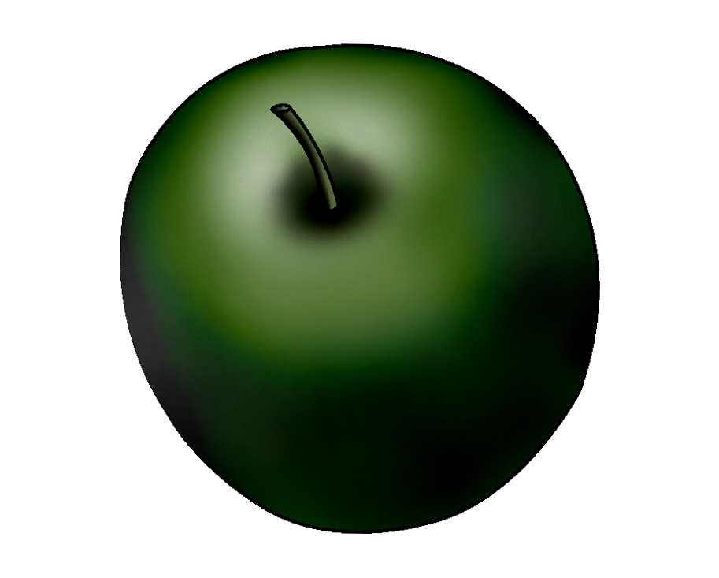 | Pome Fruit Trees
 | Apples
Interval From Planting to Fruiting | - 2 to 6 years
Season of Ripening | - July through October
Soil | - pH: 6.0 to 6.5  - Well-drained, light-textured soil
Spacing | - Depends on scion and rootstock
Harvest | - Fruit softens as it matures. Harvest apples based on intended length of storage.  - In Missouri, most apples are harvested from mid September through October.
Postharvest | - Can be stored several months at 32°F and 80% to 90% relative humidity, depending on variety
Production Concerns | - Spring frosts and winter freezes are the main limiting factors.
Pests and Diseases | - Pests: European red mites, codling moths, San Jose scale, plum curculios  - Diseases: cedar apple rust, fire blight, powdery mildew, scab
Structures and Equipment | - Stakes
Other Considerations | - Liberty, Red Delicious, and Golden Delicious are varieties that can be grown with success in Missouri.

Avery, J., P. Byers, M. Kaps, L. Kovacs, and M. Odneal. Growing Fruit for Home Use. State Fruit Experiment Station. Missouri State University-Mountain Grove. http://mtngrv.missouristate.edu/Publications/GFFHUweb.pdf (accessed January 30, 2006).

National Information System for the USDA Regional IPM Centers. “Crop Profile for Apple in Missouri.” http://www.ipmcenters.org/cropprofiles/docs/Moapple.html (accessed December 17, 2005).

Rieger, M. “Apple.” Mark Rieger’s Fruit Crop Home Page. University of Georgia Department of Horticulture. http://www.uga.edu/fruit/apple.htm (accessed April 24, 2006).

U. S. Apple Association. http://www.usapple.org/ (accessed April 24, 2006).

Warmund, M. R. Home Fruit Production: Apples. University of Missouri Extension. http://muextension.missouri.edu/explore/agguides/hort/g06021.htm (accessed December 17, 2005).

Willenberg, B., and K. Hughes. Home Storage of Fruits and Vegetables in Root Cellars. University of Missouri Extension. http://muextension.missouri.edu/explore/miscpubs/mp0562.htm (accessed April 24, 2006).

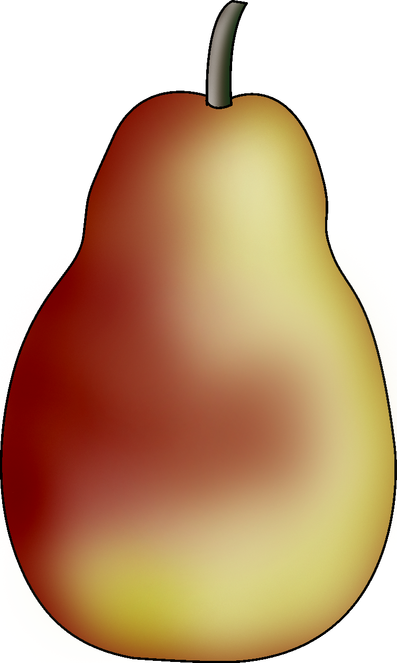 | Pome Fruit Trees
 | Pears
Interval From Planting to Fruiting | - 5 to 8 years
Season of Ripening | - Mid July through mid October
Soil | - pH: 6.0 to 6.5
Spacing | - Between trees: 20 ft  - Between rows: 26 ft
Harvest | - Pears should be firm and not fully ripe at harvest.  - Seeds turn from white to dark brown when the fruit reaches maturity.
Postharvest | - Pears can be stored for 2 to 4 months at 32°F and 90% to 95% relative humidity.  - Ripen pears at 60°F to 70°F before using or selling.
Production  Concerns | - Warm, wet springs increase the likelihood of fire blight.
Pests and  Diseases | - Pests: scale, stinkbugs, pear psylla  - Diseases: fire blight, bot canker, flyspeck
Structures and
Equipment
Other  Considerations | - Trees are usually pruned using a central leader system.  - Pear trees are generally not pruned as much after the third year.

Avery, J., P. Byers, M. Kaps, L. Kovacs, and M. Odneal. Growing Fruit for Home Use. State Fruit Experiment Station. Missouri State University-Mountain Grove. http://mtngrv.missouristate.edu/Publications/GFFHUweb.pdf (accessed January 30, 2006).

Kolbe, M. H. Growing Pears in North Carolina. North Carolina State University and the
U. S. Department of Agriculture. http://www.ces.ncsu.edu/depts/hort/consumer/agpubs/ag-80.pdf (accessed December 12, 2005).

Lerner, B. R., and M. N. Dana. Storing Fruits and Vegetables at Home. Purdue University Cooperative Extension Service. http://www.hort.purdue.edu/ext/HO-125.pdf (accessed April 25, 2006).

Rieger, M. “Pears.” Mark Rieger’s Fruit Crop Home Page. University of Georgia Department of Horticulture. http://www.uga.edu/fruit/pear.htm#general_culture (accessed April 25, 2006).

Schroeder, C. B., E. D. Seagle, L. M. Felton, J. M. Ruter, W. T. Kelley, and G. Krewer. Introduction to Horticulture. 4th ed. Upper Saddle River, NJ: Pearson Education, Inc., 2004.

Willenberg, B., and K. Hughes. Home Storage of Fruits and Vegetables in Root Cellars. University of Missouri Extension. http://muextension.missouri.edu/explore/miscpubs/mp0562.htm (accessed April 24, 2006).

Pome Fruit Trees
______________________
Interval From Planting to Fruiting
Season of Ripening
Soil
Spacing
Harvest
Postharvest
Production Concerns
Pests and Diseases
Structures and Equipment
Other Considerations

