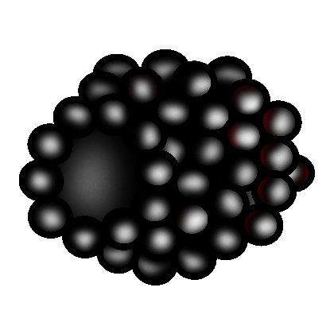 | Small Fruits
 | Blackberries
Interval From Planting to Fruiting |  | - 1 year
Season of Ripening |  | - Early June through late July
Soil |  | - pH: 5.5 to 6.5  - Well-drained soil
Spacing |  | - Between plants: 2 ft to 8 ft  - Between rows: 8 ft to 12 ft
Harvest |  | - Harvest blackberries when fruit is sweet but still firm.  - Blackberries are typically harvested by hand in Missouri, either by pickers or pick-your-own customers. Mechanical harvesters are generally used in larger operations.
Postharvest |  | - Can be held for 2 to 3 days at 31°F to 32°F and 90% to 95% relative humidity  - Highly perishable
Production Concerns |  | - Pruning is key to production.  - Blackberries are very sensitive to water stress.
Pests and Diseases |  | - Pests: aphids, rednecked cane borers, raspberry crown borers, raspberry cane borers, strawberry weevils, psyllids, white grubs  - Diseases: anthracnose, Botrytis blossom, Septoria cane and leaf spot, fruit rot, orange rust, spur blight, root rot, powdery mildew
Structures and Equipment |  | - Trellis for some varieties
Other Considerations |  | - There are thorny and thornless blackberry cultivars.

Ames, G. K. Growing Blackberries in Missouri. State Fruit Experiment Station. Missouri State University-Mountain Grove. http://mtngrv.missouristate.edu/Publications/b39.pdf (accessed January 3, 2006).

Avery, J., P. Byers, M. Kaps, L. Kovacs, and M. Odneal. Growing Fruit for Home Use. State Fruit Experiment Station. Missouri State University-Mountain Grove. http://mtngrv.missouristate.edu/Publications/GFFHUweb.pdf (accessed January 30, 2006).

Jauron, R. “Harvesting and Storing Small Fruits.” Horticulture and Home Pest News,
IC-487(13) (June 7, 2002). Iowa State University. http://www.ipm.iastate.edu/ipm/hortnews/2002/6-7-2002/smallfruit.html (accessed April 25, 2006).

Rieger, M. “Blackberries and Raspberries.” Mark Rieger’s Fruit Crop Home Page. University of Georgia Department of Horticulture. http://www.uga.edu/fruit/rubus.htm (accessed April 25, 2006).

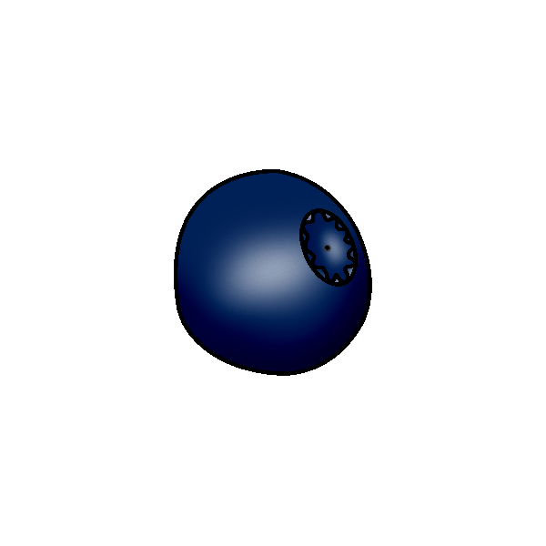 | Small Fruits
 | Blueberries
Interval From Planting to Fruiting | - 2 to 3 years
Season of Ripening | - Late May to mid July
Soil | - pH: 4.3 to 4.9  - Sandy loam soil with high organic matter content
Spacing | - Between plants: 4 ft to 8 ft  - Between rows: 8 ft to 14 ft
Harvest | - Berries are harvested in June, July, and early August.  - Berries turn blue 3 to 4 days before reaching peak flavor and sweetness. Berries that have a reddish tinge are not yet ripe.
Postharvest | - Blueberries can be stored 14 days at 32°F and 90% to 95% relative humidity.  - Cellophane covers reduce water loss from fruit.
Production Concerns | - Plants are very sensitive to too much water and too little water because of their shallow root systems. Good drainage is essential, and plants should be mulched and watered regularly.
Pests and Diseases | - Pests: blueberry maggots, blueberry tip borers, cherry fruitworms, cranberry fruitworms, plum curculios, birds  - Diseases: cane gall, mummy berry, Botrytis blossom blight, powdery mildew, twig blights, leaf spots
Structures and Equipment
Other Considerations | - Plants usually do not need to be pruned for the first three years. Prune dormant plants during the fourth year.

Avery, J., P. Byers, M. Kaps, L. Kovacs, and M. Odneal. “Growing Blueberries for Home Use.” State Fruit Experiment Station. Missouri State University-Mountain Grove. http://mtngrv.missouristate.edu/MS-18/blueberry.htm (accessed January 4, 2006).

Avery, J., P. Byers, M. Kaps, L. Kovacs, and M. Odneal. Growing Fruit for Home Use. State Fruit Experiment Station. Missouri State University-Mountain Grove. http://mtngrv.missouristate.edu/Publications/GFFHUweb.pdf (accessed January 30, 2006).

“Blueberries.” Small Scale Fruit Production. Pennsylvania State University College of Agricultural Sciences. http://ssfruit.cas.psu.edu/chapter9/chapter9a.htm (accessed January 4, 2006).

Gao, G. Growing Blueberries in the Home Garden. Ohio State University Extension. http://ohioline.osu.edu/hyg-fact/1000/1422.html (accessed January 4, 2006).

Kuepper, G. L., and S. Diver. Blueberries: Organic Production. National Sustainable Agriculture Information Service. http://attra.ncat.org/attra-pub/blueberry.html (accessed January 4, 2006).

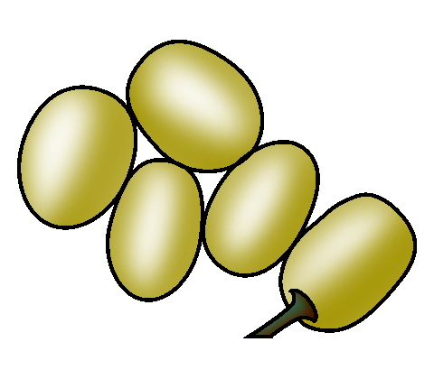 | Small Fruits
 | Grapes
Interval From Planting to Fruiting | - 3 years
Season of Ripening | - Mid August through early October
Soil | - pH: 5.5 to 6.5  - Adequate soil drainage is important
Spacing | - Between plants: 8 ft  - Between rows: 10 ft
Harvest | - Size and color are two indicators of maturity.  - Grapes harvested for table use can be picked when they taste good. Grapes for wine have specific ranges for sugar content, pH, and acidity that determine quality and acceptability.
Postharvest | - With forced-air cooling, can be stored up to 6 months at 32°F and 85% relative humidity, depending on variety
Production Concerns | - Grapes require more significant and regular pruning than any other fruit crop.
Pests and Diseases | - Pests: grape berry moths, mealybugs, leafhoppers, flea beetles  - Diseases: black rot, powdery mildew, downy mildew, crown gall
Structures and Equipment | - Some type of trellising system is needed and plants must be trained to it.
Other Considerations | - Grapes can do well in a variety of soil conditions.  - Grapes are pruned when they are dormant. Late winter is the preferred season for pruning.

Avery, J., P. Byers, M. Kaps, L. Kovacs, and M. Odneal. Growing Fruit for Home Use. State Fruit Experiment Station. Missouri State University-Mountain Grove. http://mtngrv.missouristate.edu/Publications/GFFHUweb.pdf (accessed January 30, 2006).

Bachman, J., and R. Earles. Postharvest Handling of Fruits and Vegetables. National Sustainable Agriculture Information Service. http://attra.ncat.org/attra-pub/postharvest.html#postharvest (accessed April 27, 2006).

Byers, P., ed. Growing Grapes in Missouri. State Fruit Experiment Station. Missouri State University-Mountain Grove. http://mtngrv.missouristate.edu/Publications/grapepub.pdf (accessed December 20, 2005).

Drake, B. H. Selecting, Serving, and Storing Ohio Grapes. Ohio State University Extension. http://ohioline.osu.edu/hyg-fact/5000/5518.html (accessed December 20, 2005).

Rieger, M. “Grapes.” Mark Rieger’s Fruit Crop Home Page. University of Georgia Department of Horticulture. http://www.uga.edu/fruit/grape.htm (accessed April 27, 2006).

Warmund, M. Home Fruit Production: Grape Culture. University of Missouri Extension. http://muextension.missouri.edu/explore/agguides/hort/g06085.htm (accessed December 20, 2005).

Warmund, M. Home Fruit Production: Grape Training Systems. University of Missouri Extension. http://muextension.missouri.edu/xplor/agguides/hort/g06090.htm (accessed December 20, 2005).

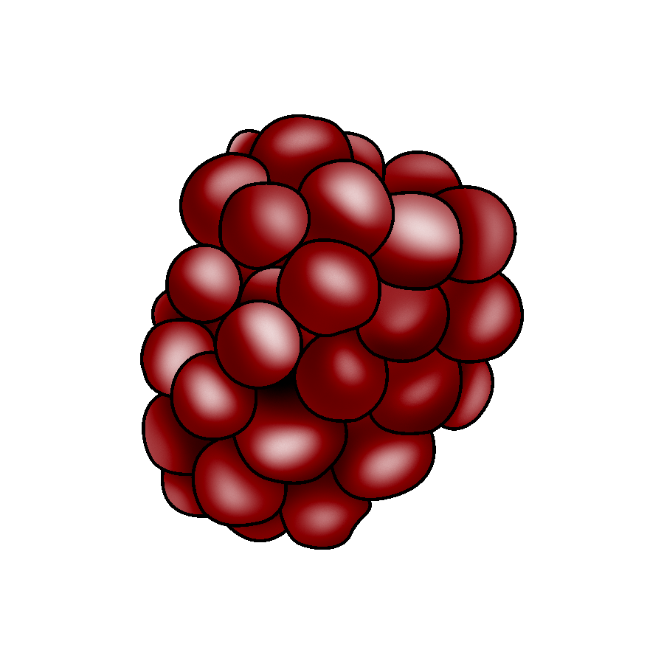 | Small Fruits
 | Raspberries
Interval From Planting to Fruiting | - 5 months to 1 year
Season of Ripening | - June through early July for summer bearing varieties  - August through October for fall bearing varieties
Soil | - pH: 5.5 to 6.5  - Well-drained soil with high organic matter content
Spacing | - Between plants: 2 ft to 6 ft  - Between rows: 8 ft to 12 ft
Harvest | - Harvest raspberries when fruit is firm, has good color, and separates easily from the plant.  - Raspberries are typically harvested by hand in Missouri, either by pickers or pick-your-own customers. Berries should be harvested directly into shallow sale containers to minimize handling and damage.
Postharvest | - Can be held for 2 to 3 days at 32°F and 90% to 95% relative humidity  - Highly perishable
Production Concerns | - Black and purple varieties grow more heartily and require more pruning than red varieties.  - Raspberries are very sensitive to water stress, and well-drained soil is necessary to avoid root rot.  - Pruning essential to production.
Pests and Diseases | - Pests: raspberry crown borers, rednecked cane borers, strawberry bud weevils  - Diseases: anthracnose, Septoria cane and leaf spot, rust, blight, powdery mildew, fruit rot
Structures and Equipment | - Trellis in “T”, “I”, or “V” formation
Other Considerations | - Training and pruning are usually the most expensive and time-consuming production concerns. The trellis system and training strategy must be matched to the variety of raspberry being grown.
Avery, J., P. Byers, M. Kaps, L. Kovacs, and M. Odneal. Growing Fruit for Home Use. State Fruit Experiment Station. Missouri State University-Mountain Grove. http://mtngrv.missouristate.edu/Publications/GFFHUweb.pdf (accessed January 30, 2006).

Bachman, J., and R. Earles. Postharvest Handling of Fruits and Vegetables. National Sustainable Agriculture Information Service. http://attra.ncat.org/attra-pub/postharvest.html#postharvest (accessed April 27, 2006).

Byers, P. Growing Raspberries in Missouri. State Fruit Experiment Station. Missouri State University-Mountain Grove. http://mtngrv.missouristate.edu/Publications/b43.pdf (accessed December 15, 2005).

Warmund, M. Fruit and Nut Cultivars for Home Planting. University of Missouri Extension. http://muextension.missouri.edu/explore/agguides/hort/g06005.htm#Raspberries (accessed December 15, 2005).

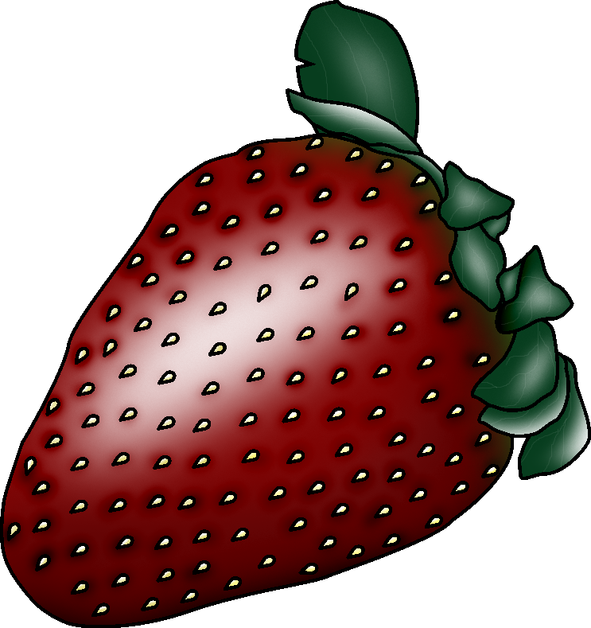 | Small Fruits
 | Strawberries
Interval From Planting to Fruiting | - 2 months to 1 year
Season of Ripening | - May through mid October
Soil | - pH: 5.5 to 6.5  - Well-drained soil
Spacing | - Between plants: 30 in. to 36 in.  - Between rows: 42 in. to 48 in.
Harvest | - Strawberries are ripe when they are fully red.  - Harvest ripe strawberries daily and dispose of moldy berries to prevent rot from spreading.  - Harvest berries directly into sale containers to minimize handling and damage.
Postharvest | - Can be held 5 to 7 days at 32°F and 95% relative humidity  - Highly perishable
Production Concerns | - Strawberries need to be planted in a location that provides full sun.
Pests and  Diseases | - Pests: tarnished plant bugs, leaf rollers, mites, strawberry weevils or clippers, nematodes, slugs  - Diseases: black root rot, red stele root rot, leaf spot, leaf scorch, Verticillium wilt, gray mold, leather rot
Structures and Equipment
Other Considerations | - Strawberries should receive at least 1 in. of water per week during the growing season.  - Weed control is particularly important in strawberry production. Weeds reduce plant establishment, plant density, budding, and fruit size, as well as make harvesting difficult.

Avery, J., P. Byers, M. Kaps, L. Kovacs, and M. Odneal. Growing Fruit for Home Use. State Fruit Experiment Station. Missouri State University-Mountain Grove. http://mtngrv.missouristate.edu/Publications/GFFHUweb.pdf (accessed January 30, 2006).

Courter, J. W., G. E. Ackee, S. Calgary, C. M. Sabot, and C. C. Zech. Tips on Picking and Using Strawberries. Illinois Cooperative Extension Service. http://www.ag.uiuc.edu/~vista/html_pubs/STRWBRY/berry.html (accessed December 30, 2005).

Domoto, P., M. Gleason, and D. Lewis. Production Guide for Commercial Strawberries. Iowa State University Extension. http://www.extension.iastate.edu/Publications/PM672D.pdf (accessed December 30, 2005).

Rieger, M. “Strawberry.” Mark Rieger’s Fruit Crop Home Page. University of Georgia Department of Horticulture. http://www.uga.edu/fruit/strawbry.htm (accessed May 1, 2006).

Warmund, M. Home Fruit Production: Strawberry Cultivars and Their Culture. University of Missouri Extension. http://muextension.missouri.edu/explore/agguides/hort/g06135.htm (accessed December 30, 2005).

Small Fruits
______________________
Interval From Planting to Fruiting
Season of Ripening
Soil
Spacing
Harvest
Postharvest
Production Concerns
Pests and Diseases
Structures and Equipment
Other Considerations

