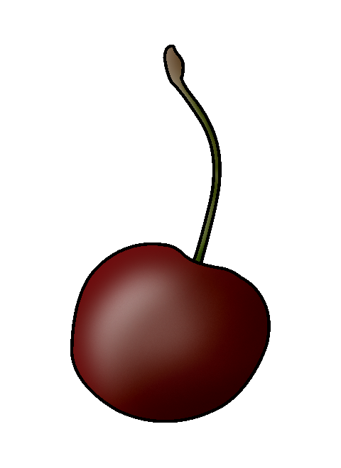 | Stone Fruit Trees
 | Cherries
Interval From Planting to Fruiting | - 3 to 5 years
Season of  Ripening | - June through July
Soil | - pH: 5.5 to 7.5
Spacing | - Between trees: 20 ft  - Between rows: 20 ft
Harvest | - Trees are usually picked only once per season, except Rainier cherry trees, which are picked at least three times in a season.  - Cherries that are overripe, immature, or too small are used for processing or discarded.
Postharvest | - Sweet cherries can be held for 2 to 3 weeks at 30°F to 31°F and 90% to 95% relative humidity.  - Sour cherries can be held for 3 to 7 days at 32°F and 90% to 95% relative humidity.
Production Concerns | - Sweet and sour varieties both have relatively high chilling requirements that prevent production in warmer climates.  - Excessive rain and high humidity can contribute to fungal disease, rot, and cause some varieties of fruit to crack.
Pests and Diseases | - Pests: plum curculios, fruit flies, birds  - Diseases: brown rot, crown gall, cherry leaf spot, black knot
Structures and Equipment
Other Considerations | - Trees are usually pruned using the central leader or open center pruning method.  - The best time to prune is in late winter though early spring.
Avery, J., P. Byers, M. Kaps, L. Kovacs, and M. Odneal. Growing Fruit for Home Use. State Fruit Experiment Station. Missouri State University-Mountain Grove. http://mtngrv.missouristate.edu/Publications/GFFHUweb.pdf (accessed January 30, 2006).

Crassweller, R. “Peach and Cherry Production.” http://hortweb.cas.psu.edu/courses/hort432/lecturenotes/peacherry.html (lecture, Pennsylvania State University, University Park, PA, accessed January 14, 2006).

Hanson, J., D. Rada, and B. Rouse. The Importance of Postharvest Handling. University of Maryland College of Agriculture and Natural Resources. http://www.agnr.umd.edu/MCE/Publications/Publication.cfm?ID=105 (accessed March 6, 2006).

Kemper Center for Home Gardening. “Pruning Cherry, Plum, and Peach Trees.” Missouri Botanical Garden. http://www.mobot.org/gardeninghelp/hortline/messages/3506.shtml (accessed March 6, 2006).

Rieger, M. “Cherries.” Mark Rieger’s Fruit Crop Home Page. University of Georgia Department of Horticulture. http://www.uga.edu/fruit/cherry.htm (accessed March 6, 2006).

Schroeder, C. B., E. D. Seagle, L. M. Felton, J. M. Ruter, W. T. Kelley, and G. Krewer. Introduction to Horticulture. 4th ed. Upper Saddle River, NJ: Pearson Education, Inc., 2004.

The Trade and Environment Database. “Mexican Markets Open to U. S. Sweet Cherries.” http://www.american.edu/TED/cherrymx.htm (accessed January 14, 2006).

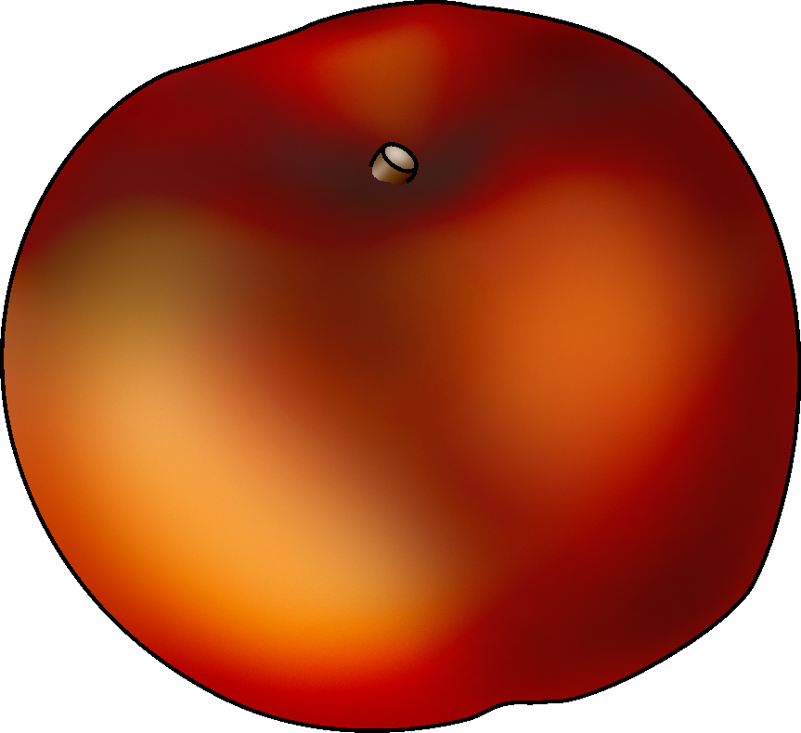 | Stone Fruit Trees
 | Peaches
Interval From Planting to Fruiting | - 2 to 3 years
Season of Ripening | - Early July to mid September
Soil | - pH: 6.0 to 6.5  - Well-drained soil
Spacing | - Between trees: 20 ft  - Between rows: 20 ft
Harvest | - Trees are usually picked 3 or 4 times at intervals of 2 or 3 days.  - Peaches are harvested when the background color turns from green to yellow and the fruit are mature but firm.
Postharvest | - Can be stored up to 2 weeks at 31°F to 32°F and 90% to 95% relative humidity
Production Concerns | - Most peach varieties overbear fruit. Natural or hand thinning, depending on the variety, is necessary to prevent small peaches and broken branches.
Pests and Diseases | - Pests: borers, oriental fruit moths, plum curculios, tarnished plant bugs, stink bugs  - Diseases: bacterial leaf spot, brown rot, peach leaf curl, canker
Structures and Equipment
Other Considerations | - Peach cultivars are either freestone or semifreestone.  - Peach trees can be readily pruned into an open vase form.
Avery, J., P. Byers, M. Kaps, L. Kovacs, and M. Odneal. Growing Fruit for Home Use. State Fruit Experiment Station. Missouri State University-Mountain Grove. http://mtngrv.missouristate.edu/Publications/GFFHUweb.pdf (accessed January 30, 2006).

Hanson, J., D. Rada, and B. Rouse. The Importance of Postharvest Handling. University of Maryland College of Agriculture and Natural Resources. http://www.agnr.umd.edu/MCE/Publications/Publication.cfm?ID=105 (accessed March 6, 2006).

Rieger, M. “Peaches.” Mark Rieger’s Fruit Crop Home Page. University of Georgia Department of Horticulture. http://www.uga.edu/fruit/peach.htm (accessed March 6, 2006).

Schroeder, C. B., E. D. Seagle, L. M. Felton, J. M. Ruter, W. T. Kelley, and G. Krewer. Introduction to Horticulture. 4th ed. Upper Saddle River, NJ: Pearson Education, Inc., 2004.

Warmund, M. R. Home Fruit Production: Peach and Nectarine Culture. University of Missouri Extension. http://muextension.missouri.edu/explore/agguides/hort/g06030.htm (accessed January 10, 2006).

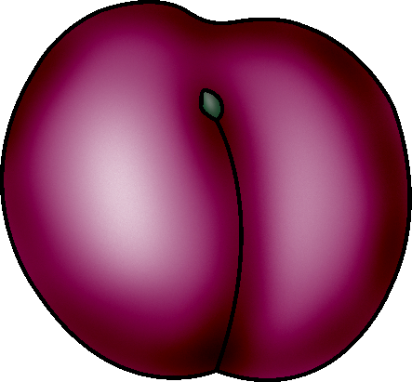 | Stone Fruit Trees
 | Plums
Interval From Planting to Fruiting | - 3 to 5 years
Season of Ripening | - August through September
Soil | - pH: 5.5 to 6.5  - Well-drained soil
Spacing | - Between trees: 20 ft  - Between rows: 20 ft
Harvest | - Plums harvested for fresh market sale should have good color and be firm but not hard.  - Plums harvested for drying can be more mature than fresh market plums.
Postharvest | - Can be stored 2 to 4 weeks at 31°F to 32°F and 90% to 95% relative humidity  - Hydrocool for best storage life
Production Concerns | - Fertilize trees annually in early spring.  - Thinning is necessary for some varieties to ensure that the remaining fruit reaches the proper size.
Pests and Diseases | - Pests: European red mites, plum curculios  - Diseases: black knot, leaf spot, brown rot
Structures and Equipment
Other  Considerations | - Can be pruned with a modified central leader or open center system
Avery, J., P. Byers, M. Kaps, L. Kovacs, and M. Odneal. Growing Fruit for Home Use. State Fruit Experiment Station. Missouri State University-Mountain Grove. http://mtngrv.missouristate.edu/Publications/GFFHUweb.pdf (accessed January 30, 2006).

Fauser, C. “Plum Good!” Quality for Keeps (July 2004). University of Missouri Extension. http://outreach.missouri.edu/stcharles/qfk.nl/July04/plum.html (accessed January 6, 2006).

Funt, R. C. Plums: A Guide to Selection and Use. Ohio State University Extension. http://ohioline.osu.edu/hyg-fact/1000/1404.html (accessed January 6, 2006).

Rieger, M. “Plums.” Mark Rieger’s Fruit Crop Home Page. University of Georgia Department of Horticulture. http://www.uga.edu/fruit/plum.htm (accessed March 7, 2006).

Schroeder, C. B., E. D. Seagle, L. M. Felton, J. M. Ruter, W. T. Kelley, and G. Krewer. Introduction to Horticulture. 4th ed. Upper Saddle River, NJ: Pearson Education, Inc., 2004.

Stone Fruit Trees
______________________
Interval From Planting to Fruiting
Season of Ripening
Soil
Spacing
Harvest
Postharvest
Production Concerns
Pests and Diseases
Structures and Equipment
Other Considerations

