Unit I: Grasslands and Grassland Plants Name

Lesson 3: Botanical Characteristics Date

Evaluation

Circle the letter that corresponds to the best answer.

1. Which of the following is not a type of leaf arrangement?

a. Alternate
b. Opposite
c. Parallel
d. Whorled

2. What is the name of the part of the grass plant that projects upward where the blade and sheath connect?

a. Apex
b. Ligule
c. Node
d. Sheath

3. The distance between which of the following shows one year’s growth?

a. Bud scale scars
b. Leaf petiole scars
c. Lenticels
d. Nodes

4. Which of the following is part of a grass plant?

a. Collar
b. Lapel
c. Seam
d. Hem

5. Where does new growth start on woody plants?

a. Bud scale scar
b. Lenticels
c. Node
d. Terminal bud scar

6. Which of the following leaf types is pictured?
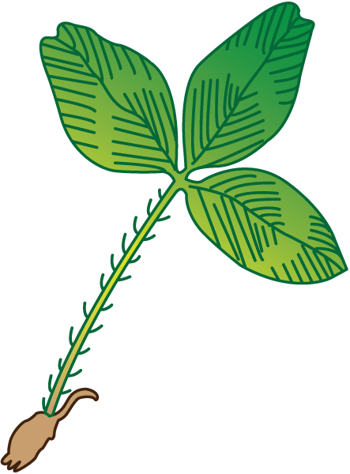
a. Palmate
b. Bipinnate
c. Trifoliate
d. Pinnate

7. What is the large bud at the end of a woody plant stem called?

a. Terminal bud
b. Axillary bud
c. Lenticel bud
d. Nodular bud

8. The arrow is pointing to what part of the leaf?
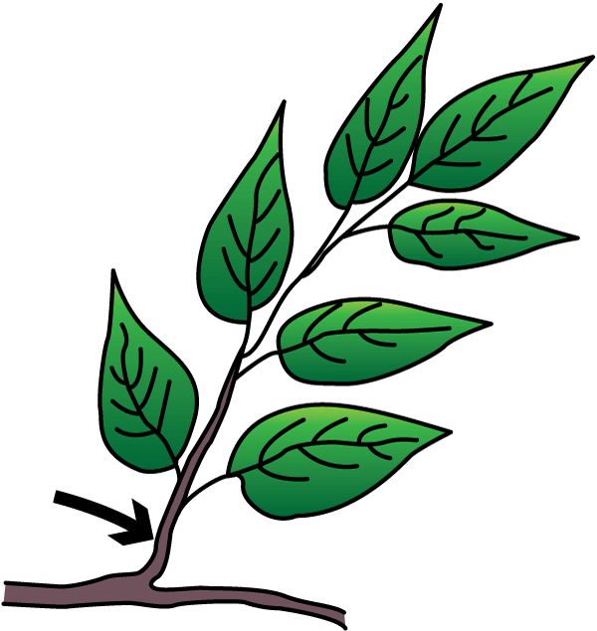
a. Base
b. Blade
c. Midrib
d. Petiole

9. Which of the following inflorescence types is pictured?
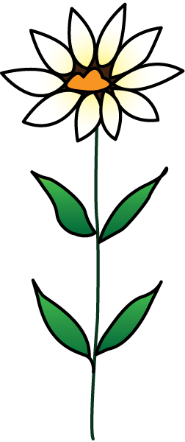
a. Spike
b. Terminal
c. Panicle
d. Umbel

10. What is the name of the type of root system pictured?
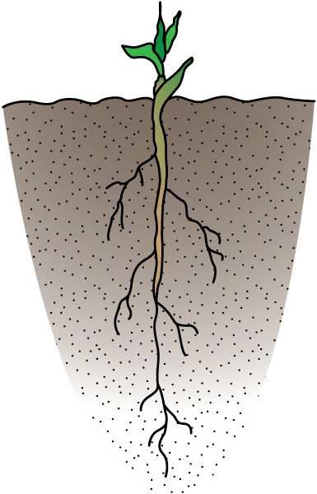
a. Fibrous
b. Tap
c. Stolons
d. Rhizomes

