Unit I: Grasslands and Grassland Plants Name

Lesson 3: Botanical Characteristics Date

Evaluation

Circle the letter that corresponds to the best answer.

1. Which of the following is not a type of leaf arrangement?

a. Alternate
b. Opposite
c. Parallel
d. Whorled
Correct answer is c.

2. What is the name of the part of the grass plant that projects upward where the blade and sheath connect?

a. Apex
b. Ligule
c. Node
d. Sheath
Correct answer is b.

3. The distance between which of the following shows one year’s growth?

a. Bud scale scars
b. Leaf petiole scars
c. Lenticels
d. Nodes
Correct answer is a.

4. Which of the following is part of a grass plant?

a. Collar
b. Lapel
c. Seam
d. Hem
Correct answer is a.

5. Where does new growth start on woody plants?

a. Bud scale scar
b. Lenticels
c. Node
d. Terminal bud scar
Correct answer is d.

6. Which of the following leaf types is pictured?
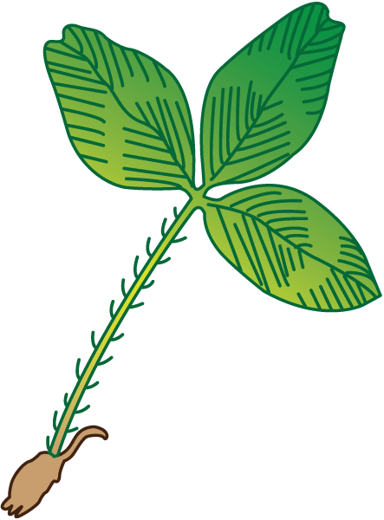
a. Palmate
b. Bipinnate
c. Trifoliate
d. Pinnate
Correct answer is c.

7. What is the large bud at the end of a woody plant stem called?

a. Terminal bud
b. Axillary bud
c. Lenticel bud
d. Nodular bud
Correct answer is a.

8. The arrow is pointing to what part of the leaf?
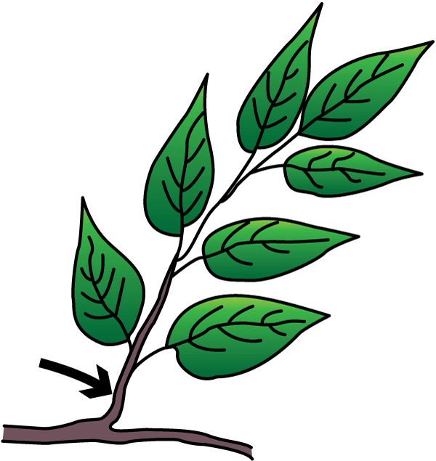
a. Base
b. Blade
c. Midrib
d. Petiole
Correct answer is d.

9. Which of the following inflorescence types is pictured?
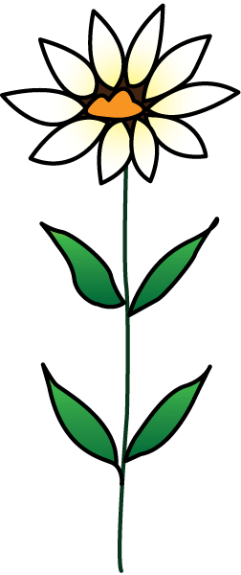
a. Spike
b. Terminal
c. Panicle
d. Umbel
Correct answer is b.

10. What is the name of the type of root system pictured?
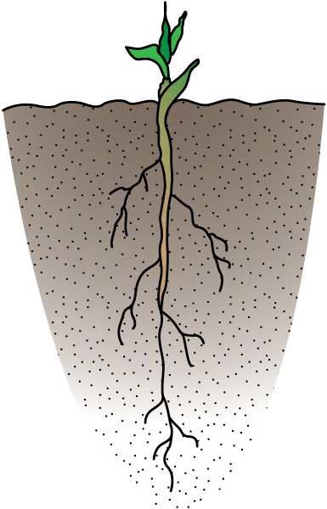
a. Fibrous
b. Tap
c. Stolons
d. Rhizomes
Correct answer is b.

