Unit III: Grassland Management Practices AS 2

Lesson 5: Grassland Management Plan Name

Evaluating a Grassland
Objective: Evaluate a grassland and make suggestions to improve productivity.
Directions: Read the following scenario and use the information provided to answer the questions. This information should allow you to make recommendations about how to alter management practices to improve productivity. Round all calculations to the nearest pound.
A producer near Springfield, Missouri, has a cow/calf operation. The herd includes 60 cows with an average weight of 1,100 pounds each. The cows have superior milking ability. There are two bulls with an average weight of 1,800 pounds each. The producer’s calving and breeding season is concentrated in summer. The producer has a problem with low conception rates, which results in a poor calf crop (65%). The producer uses continuous grazing management. The limestone dealer guarantees 400 pounds of effective neutralizing material per ton of agricultural limestone.
Forage Production (for the entire farm):
 |  |  |  | Lbs. of Dry Matter Available
Pasture | Acres | Production | Distribution | Spring | Summer | Fall
Fescue/clover | 40 | 3.5 T | .6, .2, .2 | 168,000 | 56,000 | 56,000
Orchardgrass/lespedeza | 50 | 3 T | .5, .3, .2 | 150,000 | 90,000 | 60,000
Caucasian bluestem | 60 | 4 T | 0, .7, .3 | 0 | 336,000 | 144,000
Alfalfa/  orchardgrass | 40 | 4 T | .5, .3, .2 | 160,000 | 96,000 | 64,000
Stockpiled fescue | 60 | 3 T | .5, .1, .4 | 180,000 | 36,000 | 144,000
Wheat | 50 | 4 T | .6, 0, .4 | 240,000 | 0 | 160,000
Total | 300 |  |  | 898,000 | 614,000 | 628,000

Description of the Grassland:
The pasture is surrounded by fence. Visual estimates indicate that the pasture is approximately 55% fescue, 20% white clover, 15% red clover, and 10% orchardgrass. The cattle have generally grazed the plants in the entire pasture to the same height over the entire field, leaving about 5 inches of growth. The growth is thick and vigorous. The forage in the grassland is leafy and not producing seeds. The pasture is largely clear of weeds and brush, with only a very small amount of cover vegetation. The nearest crop field is 600 feet away, and the nearest wooded area is almost that far.
University Extension Date: 5/1/97
University of Missouri-Columbia Serial No. 9999
Lab No. G9000

University Extension

Soil Test Recommendations

For: MO Grassland Contest Example

Field ID: Hilltop Sample No. 1
Acres 20
Limed: unknown Not irrigated
SOIL TEST INFORMATION  Delta Lab Portageville | Ratings  Very Low Low Medium High Very High Excess
pHs 5.5  Phosphorus 18 Lbs/a P  Potassium 210 Lbs/a K  Calcium 1035 Lbs/a Ca  Magnesium 350 Lbs/a Mg | * * * * * * * * * * * * * * * * * *  * * * * * * * * * * * * * *  * * * * * * * * * * * * * * * * * * * * * * * * *  * * * * * * * * * * * * * * * * * * * * * * * * * * * *  * * * * * * * * * * * * * * * * * * * * * * * * * * * *
O. matter 2.2 % N. Acidity 1.5 meq/100g C.E.C. 5.8 meq/100g
NUTRIENT REQUIREMEMNTS (Lbs/a) |  |  |  |  |  |  | LIMESTONE  suggestions
Cropping options Yield |  | N | P2O5 | K2O | Zn | S | LIMESTONE  suggestions
004 COOL SEASON GRASS EST |  | 30 | 55 | 0 |  |  | ENM
007 WARM SEASON GRASS EST |  | 0 | 35 | 0 |  |  | 245
019 COOL SEASON GR PAST 150 CD/A |  | 90 | 35 | 20 |  |  | EMG
027 WARM SEASON GR PAST 150 CD/A |  | 60 | 20 | 20 |  |  | 0
Some herbicide labels list restrictions based on soil pH in water. Your sample has an estimated pH in water of 6.0. Use this value as a guide to the label. If you wish to have soil pH in water analyzed, contact your dealer or local Extension specialist listed below.
To determine limestone needed in tons/acre, divide your ENM requirement by the guarantee of your limestone dealer.
For COOL SEASON GRASS EST apply 245 lbs ENM.
For WARM SEASON GRASS EST apply 245 lbs ENM.
Soils testing high in P or K should be retested annually to determine when maintenance fertilizer should be applied.
When N requirement for cool season grass exceeds 90 lbs per acre, apply two-thirds in the period December through February and the remainder in August.
For warm season grass production, apply 60 lbs nitrogen per acre in early June.

Limestone Dealer Guarantee = 400 lbs ENM per ton

Area Specialist:
FARMER COPY
University Extension Date: 5/1/97
University of Missouri-Columbia Serial No. 9999
Lab No. G9000

University Extension

Soil Test Recommendations

For: MO Grassland Contest Example

Field ID: Hilltop Sample No. 1
Acres 20
Limed: unknown Not irrigated
SOIL TEST INFORMATION  Delta Lab Portageville | Ratings  Very Low Low Medium High Very High Excess
pHs 5.5  Phosphorus 18 Lbs/a P  Potassium 210 Lbs/a K  Calcium 1035 Lbs/a Ca  Magnesium 350 Lbs/a Mg | * * * * * * * * * * * * * * * * * *  * * * * * * * * * * * * * *  * * * * * * * * * * * * * * * * * * * * * * * * *  * * * * * * * * * * * * * * * * * * * * * * * * * * * *  * * * * * * * * * * * * * * * * * * * * * * * * * * * *
O. matter 2.2 % N. Acidity 1.5 meq/100g C.E.C. 5.8 meq/100g
NUTRIENT REQUIREMEMNTS (Lbs/a) |  |  |  |  |  |  | LIMESTONE  suggestions
Cropping options Yield |  | N | P2O5 | K2O | Zn | S | LIMESTONE  suggestions
006 OVERSEEDING LEGUMES |  | 0 | 55 | 0 |  |  | ENM
003 CLOVER, CLOV-GRASS EST |  | 20 | 55 | 0 |  |  | 440
017 CLOVER, CL-GRASS PAST 150 CD/A |  | 0 | 35 | 20 |  |  | EMG
 |  |  |  |  |  |  | 0
Some herbicide labels list restrictions based on soil pH in water. Your sample has an estimated pH in water of 6.0. Use this value as a guide to the label. If you wish to have soil pH in water analyzed, contact your dealer or local Extension specialist listed below.
To determine limestone needed in tons/acre, divide your ENM requirement by the guarantee of your limestone dealer.
For OVERSEEDING LEGUMES apply 440 lbs ENM.
For CLOVER/CLOVER-GRASS EST apply 440 lbs ENM.
Soils testing high in P or K should be retested annually to determine when maintenance fertilizer should be applied.
Do not use nitrogen on spring seedings of legumes after May 1st, because of potential weed competition.

Limestone Dealer Guarantee = 400 lbs ENM per ton

Area Specialist:
FARMER COPY
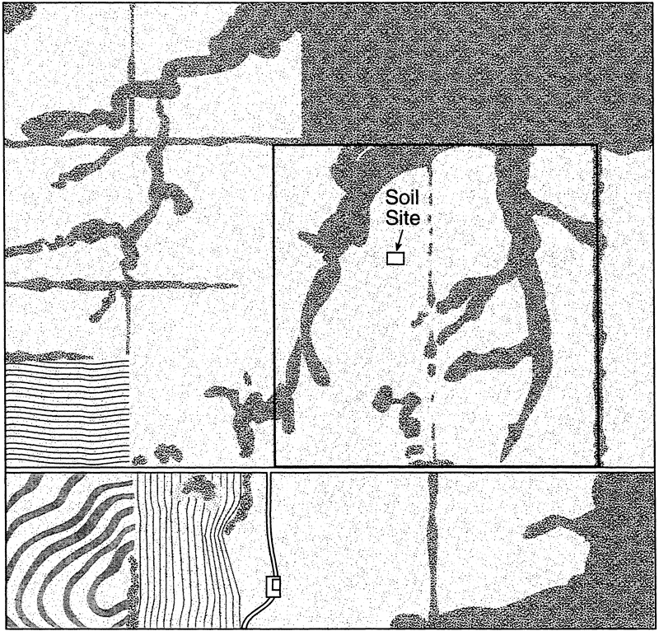
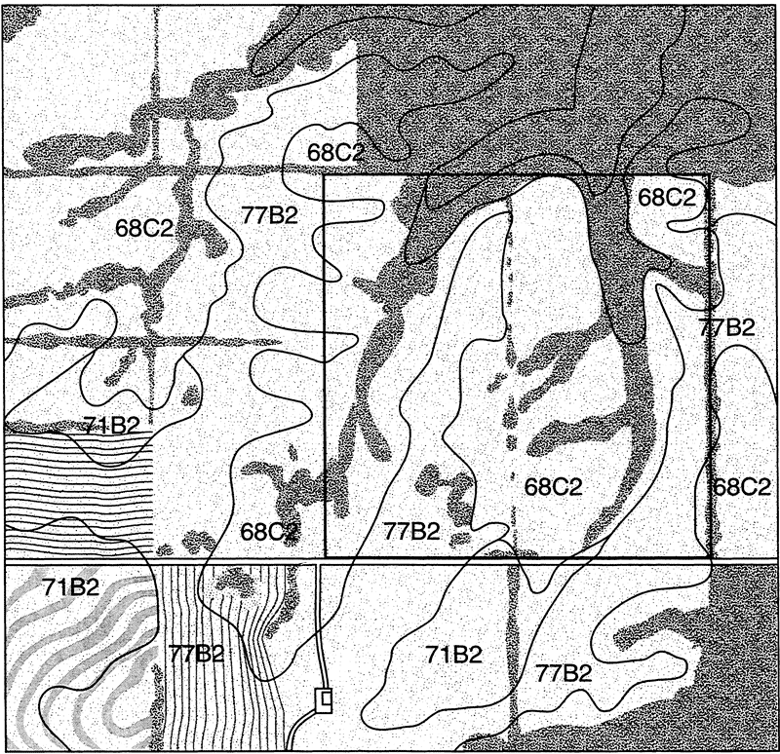
Moniteau Series Soil Map Unit 38

Depth class: Very deep Drainage class: Poorly drained Landform: Flood plains
Position on the landform: High Parent material: Loess and stream alluvium Permeability: Moderately slow
Slope range: 0 to 2 percent Land Capability Classification: 4W

Soil Depths Available Water Capacity Permeability
(Inches) (In/in range) (In/hr range)
0-7 0.21-0.23 0.60-2.0
7-14 0.20-0.22 0.60-2.0
14-67 0.18-0.20 0.20-0.6

Taxonomic class: Fine-silty, mixed, mesic Typic Endoaqualfs

Typical Pedon

Moniteau silt loam, occasionally flooded, 200 feet north and 300 feet west of the southeast corner of sec. 29, T. 49 N., R. 11 W; Millersburg quadrangle lat. 38 degrees 59 minutes 34 seconds N. and long. 92 degrees 10 minutes 7 seconds W.

Ap=0 to 7 inches; brown (10YR 4/3) silt loam, with common fine faint dark grayish brown (10YR 4/2) mottles, and few fine distinct mottles in pores; weak fine granular and weak very fine subangular blocky structure; friable; many very fine roots; strongly acid; abrupt smooth boundary.
Ex=7 to 14 inches; light brownish gray (10YR 6/2) silt loam; weak fine platy structure parting to moderate very fine subangular blocky; brittle; firm; few fine iron and manganese concretions; few very fine roots; very strongly acid; clear smooth boundary.
Btg1=14 to 32 inches; dark grayish brown (10YR 4/2) silty clay loam, with very dark grayish brown (10YR 3/2) faces of peds, and few medium faint brown (10YR 4/3) mottles; weak fine prismatic structure parting to moderate fine subangular blocky; firm; few faint and few distinct clay films; few silt coats; few very fine roots; very strongly acid; gradual smooth boundary.
Btg2=32 to 51 inches; mixed dark grayish brown (10YR 4/2) and grayish brown (10YR 5/2) silt loam, with few vertical very dark grayish brown (10YR 3/2) faces of peds, and few fine faint brown (10YR 4/3) mottles; weak fine prismatic structure parting to moderate fine subangular blocky; firm; common distinct and few faint clay films; common silt coats; few very fine roots; very strongly acid; gradual smooth boundary.
Btg3=51 to 67 inches; mixed dark grayish brown (10YR 4/2), grayish brown (10YR 5/2), and brown (10YR 4/3) silt loam; weak fine prismatic structure parting to weak fine subangular blocky structure; firm; common faint and distinct clay films; few faint silt coats; few very fine roots; very strongly acid.

Range in Characteristics

Depth to the base of the argillic horizon ranges from 36 to 60 inches or more. The particle-size control section averages between 27 and 35 percent clay and 5 to 15 percent fine sand or coarser. The base of the albic horizon is less than 24 inches.

Drainage and Permeability

Poorly drained. Runoff is slow. Permeability is moderately slow. In undisturbed areas, there is an apparent water table that has an upper limit of 0.0 to 1.0 foot during November to May in most years.

Use and Vegetation

Most areas are used for cultivated crops or pasture. Native vegetation is mixed hardwoods.

Keswick Series Soil Map Unit 68C2

Depth class: Very deep Drainage class: Moderately well drained Landform: Uplands
Position on the landform: Side slope Parent material: Loess and underlying glacial till Permeability: Slow
Slope range: 5 to 9 percent Land Capability Classification: 3E

Soil Depths Available Water Capacity Permeability
(Inches) (In/in range) (In/hr range)
0-7 0.17-0.22 0.60-2.0
7-32 0.11-0.15 0.60-0.2
32-60 0.12-0.16 0.20-0.6

Taxonomic class: Fine, montmorillonitic, mesic Aquertic Chromic Hapludalfs

Typical Pedon

Keswick silt loam, 5 to 9 percent slopes, eroded, 1400 feet east and 1600 feet south of the northwest corner of sec. 27, T. 49 N., R. 11 W; Hallsville quadrangle lat. 39 degrees 0 minutes 11 seconds N. and long. 92 degrees 8 minutes 10 seconds W.

Ap=0 to 7 inches; brown (10YR 4/3) silt loam, pale brown (10YR 6/3) dry; few masses of Bt1 in lower part; moderate medium subangular blocky structure parting to moderate fine subangular blocky; friable; many fine roots; strongly acid; clear smooth boundary.
2Bt1=7 to 13 inches; strong brown (7.5YR 5/6) clay; many medium prominent red (2.5YR 4/6) iron masses; moderate medium subangular blocky structure parting to moderate fine subangular blocky; firm; common faint clay films on faces of peds; common fine roots; common fine and medium sand grains; very strongly acid; clear smooth boundary.
2Bt2=13 to 20 inches; brown (7.5YR 5/4) clay; many medium prominent red (2.5YR 4/6) iron masses; common fine distinct light brownish gray (10YR 6/2) iron depletions; moderate medium subangular blocky structure parting to moderate fine subangular blocky; firm; common faint clay films on faces of peds; common fine roots; common fine and medium sand grains; very strongly acid; clear smooth boundary.
2Btg1=20 to 32 inches; grayish brown (10YR 5/2) clay loam, many medium prominent strong brown (7.5YR 5/6) and common medium prominent yellowish red (5YR 5/6) iron masses; weak medium prismatic structure parting to moderate medium subangular blocky; firm; common faint clay films on faces of peds, few very fine roots; common fine sand grains; very strongly acid; gradual smooth boundary.
2Btg2=32 to 44 inches; gray (10YR 5/1) clay loam, common medium prominent strong brown (7.5YR 5/6) iron masses; weak medium prismatic structure parting to weak medium subangular blocky; firm; common faint clay films on faces of peds, few very fine roots; common fine sand grains; very strongly acid; diffuse boundary.
2Btg3=44 to 60 inches; grayish brown (2.5YR 5/2), clay loam, common medium prominent strong brown (7.5YR 5/6) iron masses; weak medium prismatic structure parting to weak medium subangular blocky; very firm; few faint clay films on faces of peds; common fine sand grains; very strongly acid.

Range in Characteristics

Masses of soft calcium carbonate are typically deeper than 48 inches. Typically, a pebble band is above a depth of 10 to 20 inches.

Drainage and Permeability

Moderately well drained. Runoff is medium to rapid. Permeability is slow. Where more permeable soils formed in loess are upslope, Keswick soils commonly have seepy spots in wet seasons; but in years of average rainfall this is not a hazard to use of the soil.

Use and Vegetation

Most areas are pasture or open woods. Some areas are used for cropland. Corn, oats and meadows are grown. Native vegetation is deciduous trees.

Leonard Series Soil Map Unit 71B2

Depth class: Very deep Drainage class: Poorly drained Landform: Uplands
Position on the landform: Parent material: Permeability: Slow
Side slopes & heads Loess & underlying glacial till
of drainageways or pedisediment
Slope range: 2 to 6 percent Land Capability Classification: 3E

Soil Depths Available Water Capacity Permeability
(Inches) (In/in range) (In/hr range)
0-7 0.22-0.24 0.60-2.0
7-12 0.11-0.13 0.06-0.2
12-40 0.10-0.12 0.06-0.2
40-78 0.11-0.14 0.06-0.2

Taxonomic class: Fine, montmorillonitic, mesic Vertic Epiaqualfs

Typical Pedon

Leonard silty clay loam, 2 to 6 percent slopes, eroded, 2650 feet east and 1600 feet north of the southwest corner of sec. 4, T. 51 N., R. 11 W

Ap=0 to 7 inches; very dark grayish brown (10YR 3/2) silty clay loam, grayish brown (10YR 5/2) dry; weak fine granular structure; friable; common very fine roots; neutral; abrupt smooth boundary.
Btg1=7 to 12 inches; dark gray (10YR 4/1) silty clay; few fine prominent yellowish red (5YR 4/6) and common fine distinct yellowish brown (10YR 5/6) mottles; moderate fine subangular blocky structure; firm; few very fine roots; common distinct clay films on faces of peds; very strongly acid; clear smooth boundary.
Btg2=12 to 20 inches; dark gray (10YR 4/1) silty clay; many fine distinct yellowish brown (10YR 5/6) mottles; weak fine subangular blocky structure; firm; few very fine roots; many distinct clay films on faces of peds; very strongly acid; gradual smooth boundary.
Btg3=20 to 26 inches; gray (10YR 5/1) silty clay loam, few fine prominent yellowish red (5YR 5/6) and many fine prominent strong brown (7.5YR 4/6) mottles; weak fine subangular blocky structure; firm; few very fine roots; many distinct clay films on faces of peds; strongly acid; clear smooth boundary.
2Btg4=26 to 40 inches; gray (10YR 5/1) silty clay loam, few fine prominent yellowish red (5YR 4/6) mottles; weak medium prismatic structure parting to weak medium subangular blocky; firm; 15.0 percent sand; many distinct clay films on faces of peds, strongly acid; clear smooth boundary.
2Btg5=40 to 78 inches; gray (10YR 5/1), silty clay loam, common fine prominent strong brown (7.5YR 4/6) mottles; weak medium prismatic structure parting to weak fine subangular blocky; firm; 15.0 percent sand; few faint clay films in root channels and few iron-manganese stains; strongly acid.

Range in Characteristics

Depth to the paleosol is 12 to 30 inches. The lower part of the solum has about 10 percent or more sand. These soils have deep wide cracks during dry seasons, usually summer months.

Drainage and Permeability

Poorly drained. Runoff is medium. Permeability is slow. In undisturbed areas there is a perched water table that has an upper limit of 0.5 to 1.5 feet during November to April in most years.

Use and Vegetation

Most areas are used for cultivated crops or hay and pasture. Native vegetation is mixed trees and grasses.

Mexico Series Soil Map Unit 77B2

Depth class: Very deep Drainage class: Somewhat poorly drained Landform: Uplands
Position on the landform: Parent material: Permeability: Very slow
Broad interfluves and divides Loess and underlying pedisediment
Slope range: 1 to 3 percent Land Capability Classification: 3E

Soil Depths Available Water Capacity Permeability
(Inches) (In/in range) (In/hr range)
0-9 0.22-0.24 0.60-2.0
9-14 0.12-0.16 0.20-0.6
14-25 0.08-0.12 0.00-0.06
25-43 0.12-0.16 0.06-0.2
43-79 0.12-0.18 0.00-0.06

Taxonomic class: Fine, montmorillonitic, mesic Vertic Epiaqualfs

Typical Pedon

Mexico silt loam, 1 to 3 percent slopes, 500 feet east and 2200 feet south of the northwest corner of sec. 9, T. 49 N., R. 11 W; Hallsville quadrangle; lat. 39 degrees 2 minutes and 11 seconds N. and long. 92 degrees 9 minutes and 25 seconds W.

Ap=0 to 9 inches; very dark grayish brown (10YR 3/2) silty loam, grayish brown (10YR 5/2) dry; weak medium granular structure; very friable; many fine and very fine roots; neutral; clear smooth boundary.
BE=9 to 14 inches; grayish brown (10YR 5/2) silty clay loam; few fine prominent red (2.5YR 4/6) iron masses; moderate fine subangular blocky structure; very friable; common faint clay depletions; common fine and very fine roots; very strongly acid; clear smooth boundary.
Btg1=14 to 25 inches; dark grayish brown (10YR 4/2) silty clay; many fine prominent red (2.5YR 4/6) iron masses; moderate medium subangular blocky structure parting to moderate fine subangular blocky; firm; common faint clay films on faces of peds; few fine and common very few fine roots; very strongly acid; gradual smooth boundary.
Btg2=25 to 32 inches; grayish brown (2.5YR 5/2) silty clay; many coarse prominent strong brown (7.5YR 4/6) iron masses; moderate medium subangular blocky structure; firm; common fine iron and manganese stains; few faint clay films on faces of peds; few very fine roots; very strongly acid; gradual smooth boundary.
Btg3=32 to 43 inches; grayish brown (10YR 5/2) silty clay loam; common fine prominent strong brown (7.5YR 4/6) iron masses; moderate medium subangular blocky structure; firm; few faint clay films on faces of peds; common fine iron and manganese stains; few very fine roots; very strongly acid; clear smooth boundary.
2Btg4=43 to 79 inches; gray (10YR 5/1) silty clay loam; many fine prominent strong brown (7.5YR 4/6) iron masses; weak medium prismatic structure parting to weak medium subangular blocky; firm; few faint clay films on faces of peds; very few very fine roots; few very fine sand grains; strongly acid.

Range in Characteristics

At least one subhorizon contains more than 52 percent clay. Some pedons have 2 Btg or 2 BCg horizons. Depth to the top of the lithologic discontinuity is 30 to 60 inches.

Drainage and Permeability

Somewhat poorly drained. Runoff is medium. Permeability is very slow. In undisturbed areas, a perched water table has an upper limit of 0.0 to 1.5 feet during November to May in most years.

Use and Vegetation

Most areas are used to grow corn, soybeans, and small grains. Native vegetation is prairie grasses and mixed hardwoods.
Evaluation of Grassland Condition:

1. What is the pasture type?
a. Tall fescue (90% or more)
b. Mixed cool-season grass (10% legumes or less)
c. Cool-season grass dominant (10 to 25% legumes or other grasses)
d. Cool-season grass and legumes (26 to 60% legumes)
e. Legumes dominant (75% legumes or more)
f. Warm-season grasses dominant (other species 25% or less)

2. What is the average growth stage of the dominant forage species?
a. Vegetative
b. Boot or bud
c. Heading or bloom
d. Mature
e. Dormant

3. What best describes the grazing pressure and condition of the pasture?
a. Overgrazed
b. Spot grazed
c. Evenly grazed
d. Undergrazed

4. Is weed or brush control needed other than by grazing or soil fertility management?
a. Yes
b. No

5. What soil pH_{s} is recommended for this pasture?
a. 4.5 - 5.0
b. 5.1 - 5.5
c. 5.6 - 6.0
d. 6.1 - 6.5
e. 6.6 - 7.0
f. 7.1 - 7.5

6. What fertilizer rate is recommended for this pasture? (Use the correct crop option identification number to answer this question.)

7. What limestone rate is recommended for this pasture in tons per acre?

Soil Evaluation:

Identify the soil series using the maps. Use the information provided in the series description to answer the following questions.

8. What is the surface texture?
a. Sand
b. Sandy loam
c. Loam or silt loam
d. Clay loam or silty clay loam

9. What is the chert and gravel content of the surface layer? (Indicated in the narrative description of the soil.)
a. <15% (no coarse fragment modifier such as sand, silt, or clay)
b. 15 - <35% cherty or gravelly
c. 35 - <60% very cherty or very gravelly
d. >60% extremely cherty or extremely gravelly

10. What is the slope? (If slope ranges do not match, use the average slope.)
a. 0 - <2% nearly level
b. 2 - <5% gently sloping
c. 5 - <9% sloping
d. 9 - <14% strongly sloping
e. 14 - <25% steep
f. >25% very steep

11. What is the depth of soil (or zone) limiting rooting depth?
a. 40 - 60+ inches deep or very deep
b. 20 - <40 inches
c. 10 - <20 inches shallow
d. 0 - <10 inches very shallow

12. What is the drainage class?
a. Very poorly drained
b. Poorly drained
c. Somewhat poorly drained
d. Moderately well drained
e. Well drained
f. Somewhat excessively drained
g. Excessively drained

13. What is the depth of the surface layer?
a. 0 - 2 inches
b. 3 - 6 inches
c. 7 - 10 inches
d. 10+ inches

14. What is the permeability of the most limiting layer or to 60 inches?
Inches/Hour Class
a. <0.06 very slow
b. 0.06 - <0.2 slow
c. 0.2 - <0.6 moderately slow
d. 0.6 - <2.0 moderate
e. 2.0 - <6.0 moderately rapid
f. 6.0 - <20.0 rapid
g. >20.0 very rapid

15. What is the available water capacity to the most limiting layer or to 60 inches?
Note: To find the available water capacity, multiply the number of inches in each layer of soil by the average of the inches of available water capacity in each layer. Then find the sum of the layers or to 60 inches.
a. 0 - <3 very low
b. 3 - <6 low
c. 6 - <9 moderate
d. 9 - <12 high
e. 12+ very high

16. What is the land capability class?
a. Class I
b. Class II
c. Class III
d. Class IV
e. Class V
f. Class VI
g. Class VII
h. Class VIII

17. What are the major factors, if any, that keep the area out of Class I?
a. S (stoniness, shallowness, droughtiness)
b. W (wetness and/or flooding)
c. E (erosion)
d. None
Forage Adaptation:

Use Table 1 titled “Species Compatibility to Pasture Suitability Groups for Pasture and Hayland Planting,” found in Pasture and Hayland Planting Standard (512), from Section IV, Part B: Conservation Practices, of the NRCS Field Office Technical Guide (available at the local NRCS office or at http://www.nrcs.usda.gov/technical/efotg/) to answer the following question. Put an “X” in the appropriate blank to indicate whether or not the forage is adapted to the soil drainage class.

18. Forage Adapted Not Adapted
a. Alfalfa _____________ _____________
b. Annual lespedeza _____________ _____________
c. Caucasian bluestem _____________ _____________
d. Red clover _____________ _____________
e. White or ladino clover _____________ _____________
f. Big bluestem _____________ _____________
g. Tall fescue _____________ _____________
h. Indiangrass _____________ _____________
i. Orchardgrass _____________ _____________
j. Switchgrass _____________ _____________

Wildlife Habitat Evaluation:

19. What is the extent of the border?
a. No border within fenced area
b. Border along one side
c. Border along two sides
d. Border along three sides
e. Border around entire field

20. What is the percent of the field covered by winter or escape cover (including brushy draws, brush piles, fallen logs, etc.)?
a. No cover is present.
b. One to 10% of the field has winter/escape cover.
c. The field is less than 10 acres in size.

21. What is the percent canopy coverage of shrubs and herbaceous vegetation 6 to 18 inches tall?
a. Less than 25% coverage
b. 26 to 75% coverage
c. More than 76% coverage

22. What is the grazing pressure?
a. Heavy
b. Moderate
c. Light
d. Rotational

23. What is the percent of the ground covered or shaded by both native and introduced legumes?
a. 5% or less
b. 6 to 50%
c. 51% or more

24. What is the distance from the center of the field to the edge of the nearest crop field?
a. Over 500 feet to the crop field
b. 250 to 499 feet to a chiseled or disked crop field
c. Less than 249 feet to a chiseled or disked crop field
d. 250 to 500 feet to a crop field with no fall tillage or with a crop of winter wheat
e. Less than 249 feet to a crop field with no fall tillage or with a crop of winter wheat

25. What is the field size? (Percentage of the field within 250 feet of dense woody cover or ungrazed woodland.)
a. Less than 25%
b. 26 to 50%
c. 51 to 75%
d. 76 to 100%

26. How would you summarize the usefulness of this pasture for wildlife?

Matching Livestock and Forage:

27. When does this livestock herd have the highest forage quality requirement?
a. Spring
b. Summer
c. Fall
d. Winter
e. High year round

28. Does this pasture’s growth cycle match the seasonal peak nutritional needs of this livestock herd under present management?
a. Yes
b. No

29. How many pounds of forage dry matter does this herd need to consume per day in each season?
a. Spring
b. Summer
c. Fall

30. Is forage availability adequate for this herd in each season? (Find the seasonal dry matter intake requirements; then use the forage efficiency rates for the grazing system to find the total amount of dry matter needed.)
Season Adequate Not Adequate
a. Spring (100 days) _____________ _____________
b. Summer (100 days) _____________ _____________
c. Fall (100 days) _____________ _____________

Pasture Improvement:

31. What changes should be made in livestock management?
a. Continue present management
b. Reduce livestock numbers
c. Change calving season to a different time of year
d. Shorten the calving season to a period of less than 90 days
e. Provide higher quality pasture for heifers and steers
f. Switch to a management intensive rotational grazing system

32. What type of additional forage is needed to improve this forage program?
a. Cool-season grass
b. Warm-season grass
c. Legumes
d. Grass/legume mixture
e. No additional forages needed – use existing pasture

Answers to questions 33, 34, and 35 are based on the answer selected for question 32.

33. How should this forage be planted?
a. Plant on clean, firm seedbed
b. No-till plant in a killed sod
c. Overseed or interseed in a closely grazed sod
d. No additional forages needed – use existing pasture

34. What fertilizer rate is recommended for this forage?

35. What limestone rate is recommended for this forage in tons per acre?

