UNIT I: The GREENHOUSE INDUSTRY

Lesson I: Scope and Development of the Greenhouse Industry

This unit examines the greenhouse industry from two broad perspectives: its growth and development and its various career opportunities. Lesson 1 defines the four areas of horticulture and then traces the historical progress of the greenhouse industry. It addresses developments in the industry and examines the economic importance of greenhouse-grown cultivation in Missouri, the United States, and in several countries throughout the world.

Areas of Horticulture

The term “horticulture” was originally derived from the words “garden” and “cultivate.” The word has evolved to mean “the cultivation of plants.” Horticulture is made up of four areas. Floriculture is the cultivation of flowers (cut flowers, bedding plants, foliage plants, and potted plants). Olericulture entails growing vegetables. Ornamental horticulture involves growing plants solely for their beauty (annuals, perennials, shrubs, ground cover, landscaping). (Floriculture is actually an aspect of ornamental horticulture, but it is considered here as a separate field because greenhouses typically focus on producing flowers.) The last area is pomology - growing fruit and nuts.

History of the Greenhouse Industry

Cultivating various types of plants is an age-old custom. Humanity’s connection with plants began in ancient Greece with Theophrastus (377-288 BC) who had a keen interest in the natural world. His investigations resulted in discovering that plant roots absorb nutrients. Without actually knowing their scientific names, he discerned the differences between monocotyledons and dicotyledons (discussed in Unit III, Lesson 1). He also experimented with pruning roots and thereby concluded that this procedure encouraged flowering and fruit development.

Centuries later during the Roman Empire, Varro (116-20 BC) adapted Theophratus’ insights and discovered that using legumes in the soil improves its quality. He demonstrated that fruit could be stored after harvest when placed in straw and stored in a cool place. In 77 AD, Dioscorides wrote De Materia Medica in which he described roots, stems, leaves, and flowers in great detail. This was considered the authoritative text on plant science for the next 1,500 years.

Greenhouses, however, did not appear until 30 AD, thanks to Roman emperor Tiberius whose doctor prescribed that he eat one cucumber daily. Although glass was not even invented at that time, Tiberius’ gardeners could grow cucumbers out of season by placing the seeds in large pots and covering them with sheets of mica, a transparent mineral. This rudimentary form of a greenhouse was known as a specularium.

By the 13th century, interest in plant growth took an unfortunate turn when a Dominican monk, Albertus Magnus, was charged with witchcraft for tampering with the natural order by trying to force blooms out of season.

The first working greenhouse was built in 1599 in Holland. Throughout Europe, fascination with exotic fruit (oranges, pineapples, and dates) prompted further interest in constructing more hothouses that could nurture such delicacies. During the 17th century, the French built “orangeries” to cultivate the newly exported treat, oranges. At the French palace Versailles, a huge orangery was built that was 500 feet long, 42 feet wide, and 45 feet high. Its southern exposure flooded the growing plants with heat and light.
In 1737, wealthy Bostonian, Andrew Faneuil, built the first U.S. greenhouse, mostly to cultivate fruit. Many years later, George Washington, who loved pineapples, built a “pinery” at Mt. Vernon.
But it was during the 19th century in England that production of greenhouses expanded most fully. Glass was then easily available for constructing these buildings, which were exclusively owned by the wealthy. By 1825, greenhouses were common.

During the 1950s, improvements in transportation allowed growers to reach broader markets. New building materials became available. In 1960, greenhouses were made from film plastic and galvanized steel. Noteworthy botanical greenhouses were built during that decade: the Missouri Botanical Garden (1960), Hamburg Botanic Gardens (Germany, 1963), and the Exhibition Plant Houses at Edinburgh (Scotland, 1967). By 1980, floriculturists in the Netherlands became renown for concentrating on specific or related crops, relying on automated production, and selling crops by the auction market system

Advancements in the Greenhouse Industry

Significant technological advancements within the greenhouse industry have occurred recently. Upgraded growing structures, new coverings, and state-of-the-art equipment enable greenhouse owners to increase production, which translates into higher profits. Advancements in growing methods promote healthier, abundant crops. Developments in plant varieties contribute new colors, forms, and resistance to disease. Scientists engaged in biotechnology have produced dramatic results in improving plant production through genetic engineering. Thanks to biotechnological research, consumers can anticipate purchasing improved fruits and vegetables. See Table 1.1.

Table 1.1 - Improvements in Fruits and Vegetables Through Biotechnology

Fruit or Vegetable | Improvement
Bananas | Resistant to fungus
Garlic | Increased capacity to lower cholesterol
Melons | Smaller, seedless; single-serving size
Peanuts | Improved balance of protein
Peas | Remain sweeter; higher crop yields
Strawberries | Increased levels of natural acids that fight cancer
Tomatoes | Higher levels of cancer-fighting antioxidants

Economic Importance of the Greenhouse Industry

Because the greenhouse industry relies on a workforce and provides products that consumers use, its economic impact is felt locally, nationally, and globally. In 1999, Missouri floriculturists grossing $10,000 or more contributed $41.6 million to the state’s economy. Floriculture growers grossing $100,000 or more earned approximately $34.3 million. Table 1.2 lists the specific crops included in this amount.
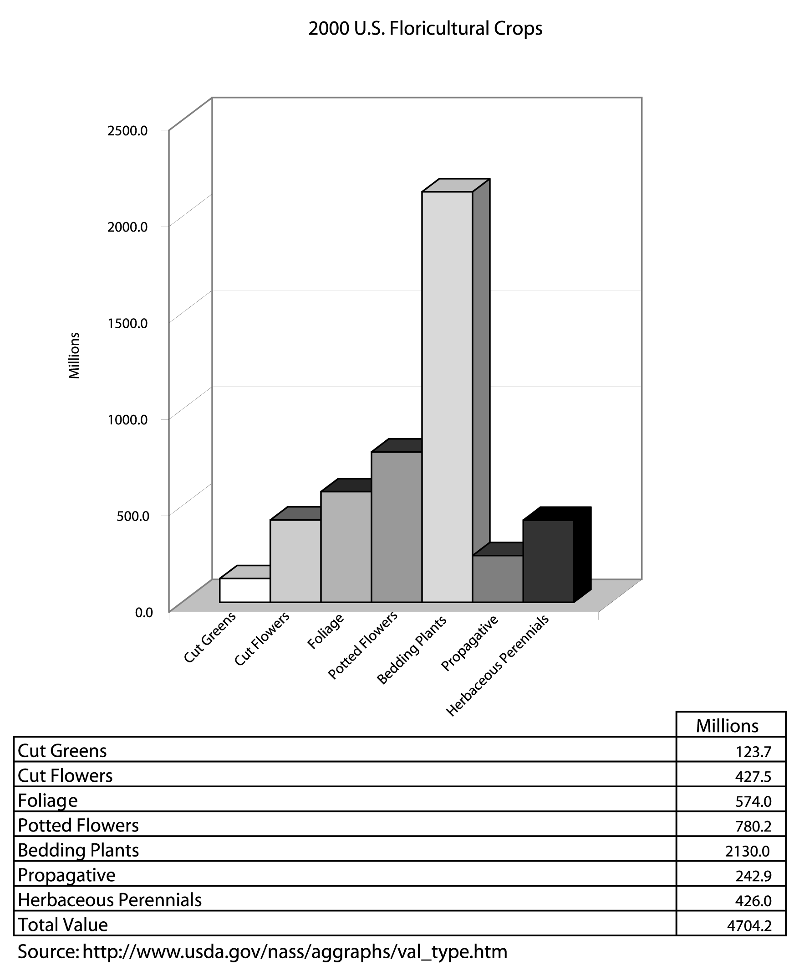

Table 1.2 - 1999 Missouri Floriculture Crops

Crop | Wholesale Value
Cut Flowers | $ 281,000
Foliage Plants | 2,192,000
Potted Flowering Plants | 11,711,000
Bedding and Garden Plants | 20,085,000
TOTAL | $34,269,000

Compared to the rest of the nation in horticultural production (including sales from greenhouse operations, nurseries, landscaping outlets, and other dealers), Missouri ranks as follows:

- 26th - Floriculture
- 28th - Ornamental horticulture
- 28th - Pomology
- 31st - Commercial vegetables
In the United States, the 2000 wholesale value of floriculture producers grossing $100,000 or more was nearly $4.7 billion (including the value of propagative materials). See Figure 1.1.

Figure 1.1 - 2000 U.S. Floriculture Crops
Five states contributing the most to that amount are California (20%), Florida (18%), Michigan, Texas, and Ohio. In Texas, nursery and greenhouse industries are the second highest agricultural enterprise.

Half of the wholesale value of all reported crops comes from bedding and garden plants production. States contributing the most to this crop sector are California, Michigan, Texas, Ohio, and Florida. This segment is made up of potted bedding and garden plants, bedding and garden flats, and flowering hanging baskets. The percentages of these three crops are indicated in Figure 1.2.

Figure 1.2 - 2000 U.S. Bedding and Garden Plant Sector

Cultivation of potted flowering plants increased 3% from 1999. California was the predominant producer, contributing 18% of total sales. Top sellers were poinsettias, orchids, azaleas, and chrysanthemums.

Foliage plant production increased by 12% from 1999, with Florida capturing 69% of the total market. Within this market sector, 85% of total sales were for potted foliage plants.

However, in 1999, cut flowers suffered a 1% decrease in production and a 23% decline in the number of growers nationwide. Providing 67% of the total value for cut flowers, California dominated this market. Favorite flowers in this crop are roses, lilies, and gladioli.

In the herbaceous perennials group, 25% of the total production is hardy garden mums. Propagative materials are used to grow various types of plants; annual bedding and garden plants accounted for 44% of this market. There was a 2% decrease in production of cut greens from 1999. Florida contributed 81% to this market.

The floriculture market throughout the world provides income, employment, and marketing opportunities. The Netherlands exports tulip flowers and bulbs and is the international leader in floriculture enterprises. But bulbs exported from the Netherlands are not a direct threat to the U.S. economy because they are sold here and generate income.
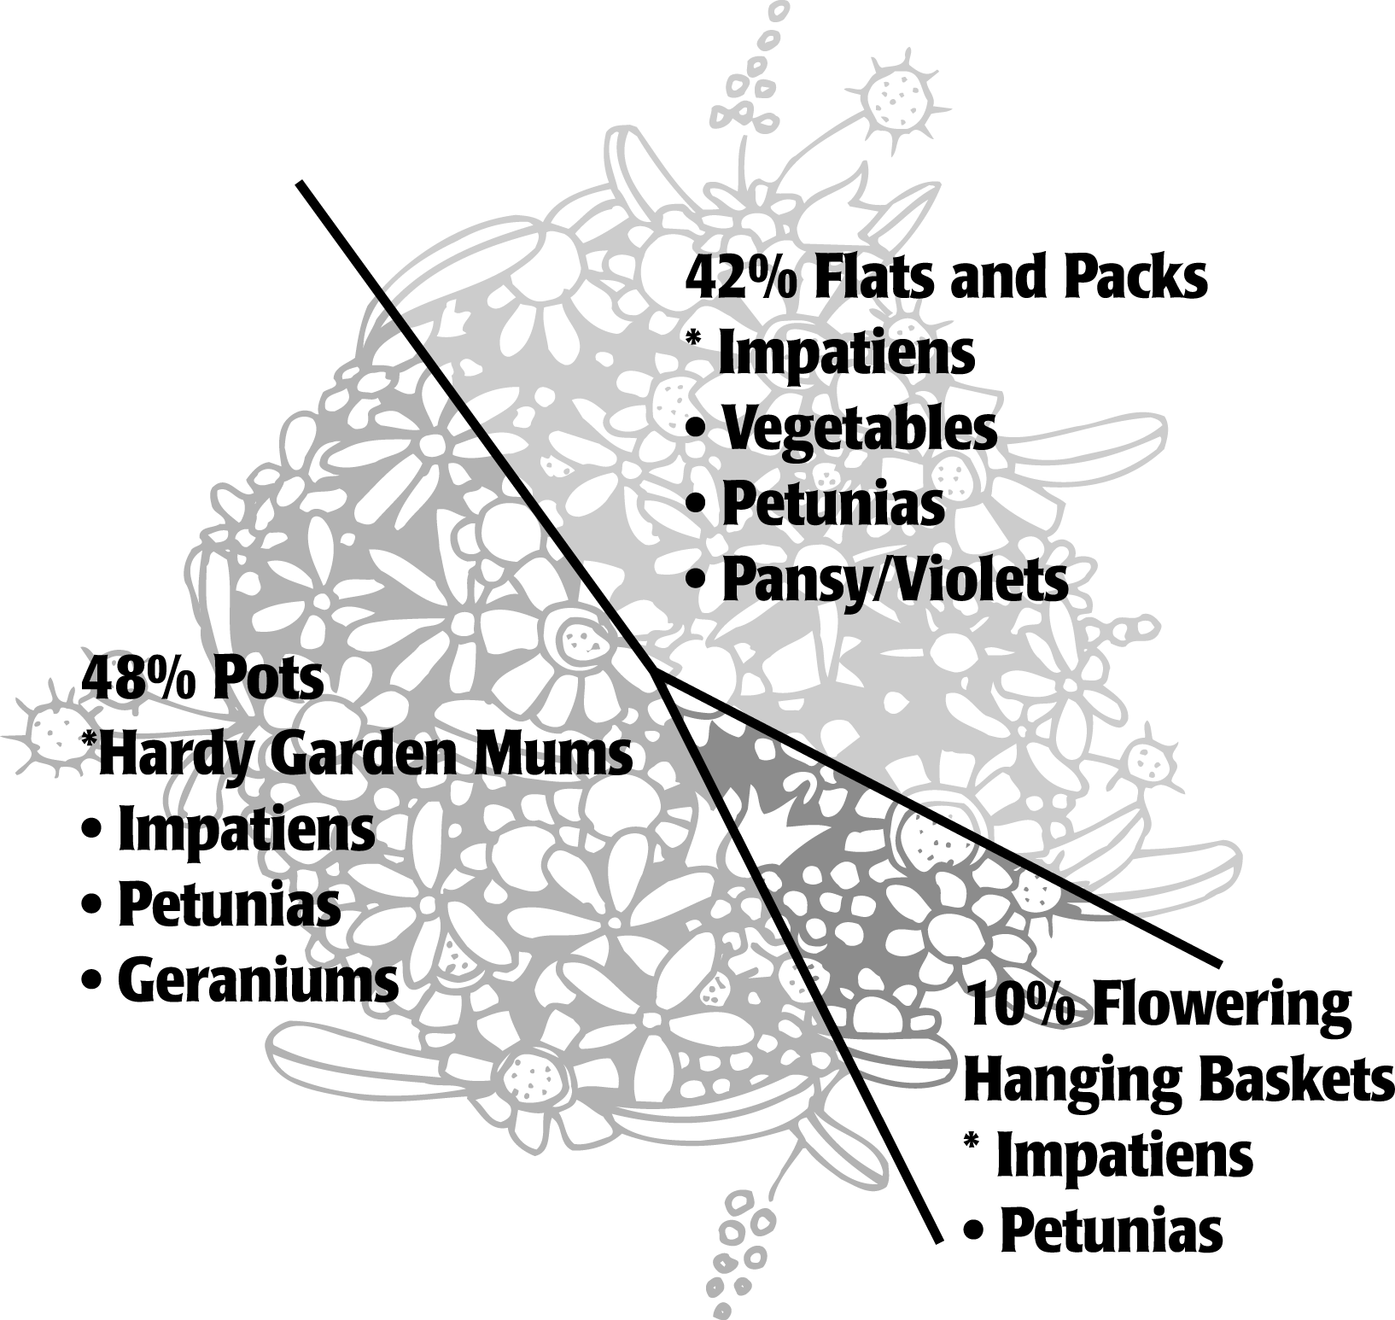

In Central and South America (Mexico, Costa Rica, Colombia, and Brazil) the climate is favorable, which facilitates simple greenhouse construction. Several government-sponsored subsidies are available that help the greenhouse owner. There is plentiful access to a labor force. Cut flowers (e.g., roses and carnations), flower seeds, and foliage plants are cultivated in these countries.

Kenya has been involved in floriculture since the early 1970s. It produces mainly flowers (especially roses) and seeds for geraniums, petunias, and impatiens. Because of the climate, greenhouses require no supplementary heat. Labor is cheap and abundant. Australia and New Zealand produce orchids.
Summary

The greenhouse industry comprises four horticultural areas: floriculture, olericulture, ornamental horticulture, and pomology. Of these four areas, the floriculture market typically is the most prevalent, but any of the others also can contribute to the greenhouse industry. Spanning centuries, interest has developed in growing plants. The greenhouse industry has benefited from technological advancements over time and its future is bright. Thanks to improvements in building materials and equipment, greenhouse operations have become more sophisticated. And because of the contributions of plant scientists who are researching biotechnological enhancements in fruit and vegetables, the consumer can anticipate more nutritious and higher quality food in the future. The greenhouse industry sustains a significant portion of the economy of Missouri, the United States, and several countries around the world.

Credits

Biondo, Ronald J. and Dianne A. Noland. Floriculture: From Greenhouse Production to Floral Design. Danville, IL: Interstate Publishers, Inc. 2000.

Boodley, James W. The Commercial Greenhouse, 2nd ed. Albany, NY: Delmar Publishers, 1996.

Clark, David G. “Floriculture Biotechnology.” <http://hort.ifas.ufl.edu/people/clark.htm> accessed 2/20/02.

“Floriculture.” Missouri Agricultural Statistics Service. Missouri Farm Facts, 2000.

“Floriculture Crops.” USDA National Agricultural Statistical Service <http://www.usda.gov/nass/aggraphs/ws_tenyr.
htm> accessed 2/20/02.

“Floriculture Crops 2000 Summary.” USDA National Agricultural Statistics Service, Agricultural Statistics Board, April 2001. <http://usda.mannlib.cornell.edu/reports/nassr/
other/zfc-bb/> accessed 2/21/02.

Giacomelli, Gene A. “Controlled Environment Agricultural Center.” Agricultural & Biosystems Engineering Department, University of Arizona. <http://ag.arizona.edu/ceac/research/archive/
structures.htm#glazings> accessed 2/25/02.

Greenhouse Operation and Management (Student Reference). University of Missouri-Columbia: Instructional Materials Laboratory, 1990.

“A History of Greenhouses.” <http://www.lldkids.com/documents/
history_greenhouse.html> accessed 2/19/02.

“History of Greenhouses.” Idaho Freedom. <http://www.idahofreedom.com/construction/
gh1001.html> accessed 2/19/02.

Lee, Jasper S., Series Editor. Introduction to Horticulture: Science and Technology, 2nd ed. Danville, IL: Interstate Publishers, Inc., 1997.

Phytotronics, Inc. <http://www.phytotronics.com/new.htm> accessed 2/20/02.

“Plant Pathology.” New York State Agricultural Experiment Station. Cornell University, Geneva, NY. <http://www.nysaes.cornell.edu/pp/> accessed 2/20/02.

Schnelle, Michael A. and John M. Dole. “Greenhouse Structures and Coverings.” Oklahoma Cooperative Extension Service OSU Extension Facts F-6700. <http://www.agweb.okstate.edu/pearl/hort/
greenhouses/f6700.htm> accessed 2/25/02.

USDA National Agricultural Statistics Service. 1997 Census of Agriculture - Census of Horticultural Specialties (1998) Volume 3, Special Studies, Part 2.

“Value of Sales at Wholesale.” USDA National Agricultural Statistics Service <http://www/usda.gov/nass/aggraphs/val_type.
htm> accessed 2/20/02.

“What Is Horticulture?” <http://www/missouri.edu/~jortds/hom0ehort/
intro.html> accessed 1/15/02.

