UNIT I: The GREENHOUSE INDUSTRY

Lesson 2: Career Opportunities in the Greenhouse Industry

This lesson first differentiates among the responsibilities of the grower (producer), wholesaler, and retailer; each offers potential employment. Lesson 2 then describes specific duties of various types of greenhouse workers, which may suggest career paths of interest. This lesson also explains the management structures of small and large greenhouse operations, which may help the job seeker. Also described are reasons for continuing education and for participating in agricultural educational opportunities, such as Supervised Agricultural Experience (SAE) activities.

Responsibilities of Grower, Retailer, and Wholesaler

Before selecting a career in the greenhouse industry, it is important to understand its basic elements: growers (producers), retailers, and wholesalers. The focus and tasks of each of these sectors vary and reflect different career opportunities. Growers cultivate one or more crops for sale to the wholesaler. Growers are skilled in cultivation, irrigation, and other cultural practices. In small operations, growers usually delegate marketing responsibilities to the wholesaler. Retailers sell greenhouse crops directly to the public and may also raise some of the plants. Because they deal with consumers, retailers have to be located in accessible marketing areas: grocery stores, florist shops, malls, etc. Wholesalers sell crops and related products directly to retailers and often sell plants from growers on consignment.

Career Opportunities

Successfully running a greenhouse depends upon effective coordination of specialized skills and consistent effort. The number of employees and career opportunities varies depending upon the scope of the operation. If the greenhouse is fairly large, several types of jobs are required. Employees in large operations can investigate diverse careers, which are described here and are intended to be generic. Actual greenhouse operations may use different job titles, descriptions, and duties.

As an entry-level position, the assistant grower helps the grower perform tasks as assigned. This may involve working with the maintenance crew, shipping and delivering plants, or aiding with various cultural practices. The grower’s responsibilities are multifaceted. Among his or her tasks are preparing the growing medium for bulbs, seeds, and cuttings; grafting plants; and transplanting seedlings and rooted cuttings. The grower also ensures that crops are irrigated as required. An important feature of the grower’s job is to fertilize plants according to specific needs. Some growers are authorized to apply pesticides as well. Occasionally, he or she responds to customers’ questions about caring for their plants.

The greenhouse service technician maintains all of the greenhouse’s physical facilities and supervises the maintenance crew. Among the technician’s duties are overseeing the mechanical integrity of the irrigation, electrical, and drainage systems. If any construction work is needed to repair or build greenhouse structures, the technician is in charge.

The greenhouse operation relies on the production specialist to stay up-to-date on technical developments that affect plant cultivation. Understanding plant science is critical to this career. The specialist schedules when to plant different crops and manages space allocation within the greenhouse, which contributes to crop yield.

Another position within the greenhouse operation is the marketing manager who oversees sales operations of the mature crops. Major responsibilities include customer relations, which involves contacting existing clients and seeking potential patrons, and postharvest crop assessment (grading and storing plants and flowers). The marketing manager also prepares each crop for shipment.

Ultimately, the success of a greenhouse operation depends on the vision and expertise of the owner/ manager. This individual is responsible for organizing and prioritizing the flow of work, maintaining financial records, and developing the marketing plan. The owner selects the types and quantities of plants to grow and selects and orders growing supplies (fertilizer, seeds, etc.). It is this individual’s responsibility to hire, supervise, and evaluate the staff. In addition, the owner may also respond to customers’ questions.

Organizational Structure of a Greenhouse Operation

Just like workers in other businesses, employees in the greenhouse industry are part of an overall organizational structure. Understanding the management structure and knowing one’s position within the “chain of command” are conducive to making informed career decisions.

In small greenhouse operations, one owner/ manager oversees all aspects of the business, although there may be several assistants. The owner specializes in all greenhouse operations. In large greenhouse operations, the owner may be the manager or a board of directors. Multiple greenhouse specialists contribute to different aspects of the operation. Each department (e.g., marketing, maintenance, plant production) has its own manager and group of employees. The interrelationships among various facets of a large greenhouse operation are displayed in Figure 1.3.

Figure 1.3 - Organizational Structure of a Large Greenhouse Operation
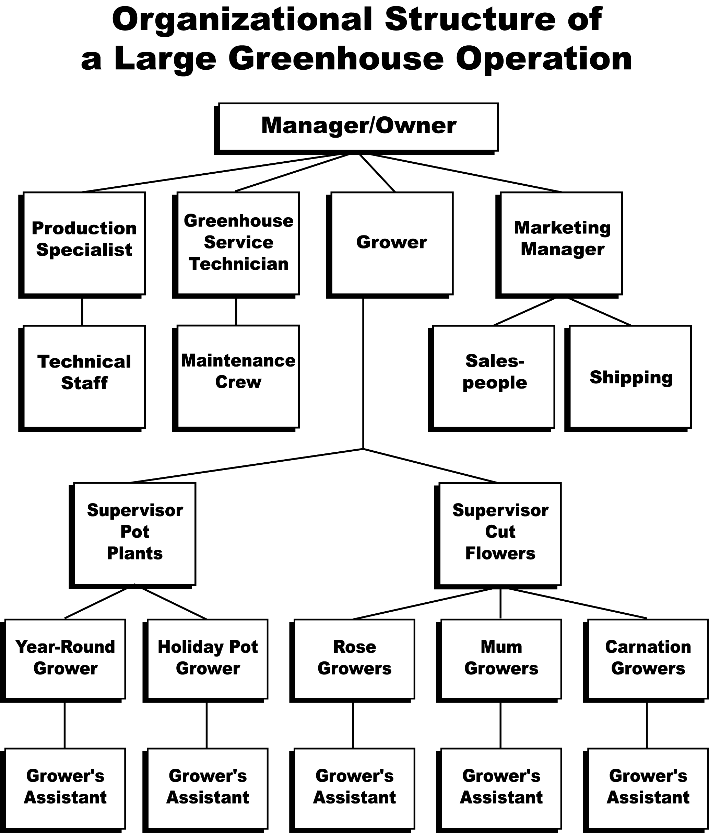

Continuing Education

To progress within the greenhouse industry, whether in wholesale, retail, or a specific job as described above, additional training and education pave the way. There are several avenues for acquiring knowledge and expertise. By reading professional literature, such as greenhouse-related journals, publications from university Extensions, documents from county services, etc., the greenhouse employee can gain valuable insights. Becoming a member of a greenhouse-related organization and attending its meetings create a network of colleagues and a source of up-to-date information. It is also important to remain current on all technological advances in the greenhouse industry by interacting with coworkers, supervisors, and greenhouse specialists. If an interest develops in a highly specialized area, taking advanced courses for a degree or enrichment fosters success.

Agricultural Education Opportunities

The greenhouse industry offers a variety of opportunities for agricultural education programs. Workplace readiness skills evolve as students develop successful work habits and job-related proficiency. Individuals accept responsibility and establish a solid work ethic, which means being prompt, communicating clearly and honestly, cooperating with coworkers and supervisor, and taking pride in one’s work. By working in greenhouse operations, students can gain skills in record keeping, critical thinking, and decision making.

Working in the greenhouse industry also offers the opportunity for hands-on, real-world experience through on-the-job training. Management skills and job-seeking aptitude increase. It is also possible to earn a salary while learning. Especially meaningful is having guidance from individuals who are experienced in greenhouse operations.

Supervised Agricultural Experience (SAE) programs offer unique occasions for personal growth. In the entrepreneurship program, students run their own business. They plan and organize all aspects of an enterprise and are financially responsible for the operation. This means that they own all necessary materials needed to run the enterprise and keep financial records in order to assess how well their investment is performing. In entrepreneurial projects sponsored by
GrowNative! (www.conservation.state.mo.us/
programs/grownative), individuals or chapters grow plugs or produce seeds of native plants.
Examples of entrepreneurial programs include growing bedding plants in school greenhouse for sale and raising poinsettias for sale.

In the placement program, students are placed in an agricultural business that interests them (e.g., wholesale greenhouse). This can be a paid position or an unpaid internship. The placement program occurs outside of regular school hours. Examples include working in a florist shop or for a nursery on weekends.

In a directed work experience students, instructors, and parents help plan an activity that meets the interests of the student. This is an unpaid position. An example is working in the school’s greenhouse.

Agriscience research projects offer great opportunities for those interested in researching how things work. There are two types of programs available: experimental and analytical. An experimental research activity focuses on a specific, measurable objective and adheres to the scientific process. This activity involves several steps and requires a time commitment. It relates to a significant scientific or agricultural principle, issue, or question. An instructor supervises the students as they progress in this activity. Some examples of an experimental research program are listed below:

- Comparing the effect of different amounts of light on plant growth
- Comparing two types of fertilizer on plant development
- Analyzing the effectiveness of different display techniques on amount of plant sales in a nursery
- Demonstrating the effect of various levels of soil acidity on plant growth

An analytical activity does not use experimental methods. Rather, the focus is on collecting information from different sources and then evaluating the data. The goal is to create a finished product. Some examples of analytical activities include identifying suitable plants for a perennial garden for a senior center and creating a landscaping ad campaign directed toward new home owners.

Students can earn awards and participate in interesting activities that relate to the greenhouse industry. Career Development Events sponsor contests in floriculture, nursery/landscape, and agricultural sales. Proficiency awards are granted in horticulture, turf and landscape management, floriculture, fruit and/or vegetable production, and specialty crops.

A final opportunity the greenhouse industry offers agricultural education is in school and community service. Building Our American Communities grants and partnerships with groups like chambers of commerce and garden clubs offer the chance to accomplish something valuable for others. Individuals may provide landscaping on school grounds or make plant arrangements for special school occasions, such as banquets and graduation. Other projects that would benefit the school or community are listed below:

- Create a hummingbird habitat
- Plant a garden with all-native Missouri plants
- Create a garden to attract songbirds and butterflies
- Create a garden that is made up of shade-loving plants
- Grow native plants for a highway project on behalf of the State of Missouri
- Grow plants as a wholesale product to retail operation

Summary

Career opportunities abound in the greenhouse industry. Positions are available in various sectors: at wholesale and retail levels and as a grower, greenhouse technician, production specialist, or marketing manager. Understanding the organizational structure of a greenhouse operation may influence one’s career selection. By working hard and refining work skills, it is possible to advance to any level, including manager/owner. The greenhouse industry offers many opportunities for agricultural education. SAE programs offer valuable hands-on experience.

Credits

Boodley, James W. The Commercial Greenhouse, 2nd ed. Albany, NY: Delmar Publishers, 1996.

Garton, Bryan L. and Scott Stone. Agricultural Education, University of Missouri-Columbia. Joint State Staff in Agricultural Education Agricultural Education Program Planning Handbook for Missouri Schools. pp. 109-111, 1997.

Greenhouse Operation and Management (Student Reference). University of Missouri-Columbia: Instructional Materials Laboratory, 1990.

“Greenhouse Positions.” New Haven Gardens. <http://www.nhg.com/empgh.htm> accessed 2/27/02.

“Greenhouse Production and Management.” <http://www-afa.adm.ohio-state.edu/
u-majprs/GREENHSE.HTML> accessed 2/27/02.
“Key #2 - SAE” <www.ffa.org/programs/
lps/html/sae.html> accessed 5/6/02.

“Landscaping, Groundskeeping, Nursery, Greenhouse, and Lawn Service Occupations.” Yahoo! Careers. <http://careers.yahoo.com/
employment/oco/ocos172.html> accessed 2/27/02.

“Nursery and Greenhouse Operators and Managers.” Career Path. <http://careerpath.tvo.
org/jobmatters/display.phtml?banner_id=theme&
job_id=54> accessed 2/27/02.

“Nursery and Greenhouse Workers.” Career Path. <http://careerpath.tvo.org/jobmatters/
display.phtml?job_id=59&theme=1> accessed 2/27/02.

“Nursery and Greenhouse Workers.” <http://www.edinetconnect.com/cat/careers/
nurserysw.html> accessed 2/18/02.

“Welcome to SAE Central.” North Carolina State University. <http://www.cals.ncsu.edu/
agexed/aee322/index.html> accessed 3/14/02.

