UNIT II: The GROWING STRUCTURE

Lesson 1: Greenhouse Parts, Structures, and Coverings

This lesson addresses site selection, types of greenhouse structures, basic construction of a growing structure, and interior components of a greenhouse. Additional information concerns other structures and areas that are part of most commercial greenhouse operations as well as the exterior layout of buildings and work areas.

Site Selection

One of a greenhouse owner’s primary considerations is selecting a suitable site for the growing structure. The greenhouse, even as an indoor structure, is still affected by outdoor elements, such as the direction and intensity of wind, sun, snow, and frost. A region’s climate that typically has winter blizzards, spring tornadoes, or summer and fall hurricanes may adversely impact the success of a greenhouse operation.
By studying historical weather patterns, the owner can assess the amount of precipitation, sunlight, and temperature variability in the proposed site.

An optimal location has high, natural light levels and moderate temperatures. Some sites, however, could increase energy and maintenance costs, making them not suitable for a greenhouse. A growing structure in a cold location requires additional heating to sustain plant growth. Sites with extremely high temperatures and humidity increase the costs of ventilation and fans. If a structure is located in high elevations, it is subject to windchill and must compensate by increasing heat. A greenhouse located in a valley protected from harsh winds may be exposed to frost, which also necessitates additional heating.

The topography of the site affects where a growing structure is built. (Topography refers to the shape of the land, e.g., hilly, steep, rocky, flat.) The surface of the ground should be level. A 0-5% slope is recommended. Placing a growing structure on a flat surface is efficient because it facilitates easy adjustments to various mechanical controls in the greenhouse, which is economical. A level surface provides good drainage and reduces the cost of grading the land. Selecting where to place the greenhouse depends on location. The optimal site is where the greenhouse receives the most morning sunlight, thereby promoting the plant food production process (photosynthesis). For example, in Maryland, the optimal direction for a growing structure is toward the south or southeast. The next best option is placing the structure to the southwest, which provides sunlight later in the day. In Missouri, the ridge of the greenhouse should run north and south to permit the light to enter from a sidewall, not an endwall. Winter light is maximized and shadows are reduced. For states whose latitude is 40º north or above, an east-west direction is best.

It is also important to shelter the structure from winter wind. A windbreak, composed of trees, shrubs, or annual or perennial crops, provides a protective barrier that lessens and redirects the force of winter wind. It is usually placed to the north of the greenhouse. To prevent shading the greenhouse, the distance between the windbreak and greenhouse should be two and a half times the maximum tree height. All major obstacles - trees and large buildings - must clear the growing structure.

Another critical factor in site selection is the availability of resources. The site must have an ample supply of water either from the city or a well. During peak use, the greenhouse requires approximately 2 quarts per day per square foot. To ensure water quality, a laboratory or county Extension agent can test for correct pH, alkalinity, and level of soluble salts. Electricity, natural gas, and sewer services have to be hooked up, which may involve connection fees. Greenhouses also need convenient access to materials for growing plants (growing media, fertilizers, pesticides, etc.). The greenhouse owner must determine if labor is available to perform both routine and harvest-time duties. Basic services such as waste removal are required. To maintain a competitive edge, the greenhouse owner needs access to sources of information, such as local university Extensions or a nearby testing/advising service.

Land is a major factor in site selection. A greenhouse owner’s fundamental concern usually is the cost of the property (purchase price and taxes). Another consideration is selecting land that is close to the main roads so that delivery trucks and customers can easily drive to the greenhouse. For example, a parking area may be necessary. The land should also be near utilities. The ideal site has potential for expansion.

Land selection directly impacts marketing. A retail operation that is visible from the road encourages customers to stop by whenever they wish. For wholesale operations, proximity to markets and suppliers is important. In order to succeed competitively, the greenhouse owner must have easy access to suppliers, raw goods, and customers.

Finally, site selection involves various legal considerations. Permits, licenses, and zoning regulations govern where a greenhouse may be built and often even dictate what type of building materials may be used. Retail greenhouses should be zoned for business. Selecting an appropriate site also involves how the greenhouse operation affects its neighbors. If the proposed site is near a school, hospital, or residential community, the greenhouse must cooperate with the zoning rules of these entities. If water from the site drains into parks, farms, or ecological areas, the land may be subject to various state and federal regulations. Some states require the owner to obtain certification to purchase restricted-use pesticides. (See Unit VI, Lesson 3, for details.) In addition, the greenhouse owner must also be aware of relevant mandates from the Occupational Safety and Health Administration that ensure employee safety.

Types of Greenhouse Structures

The two basic types of greenhouse structures are freestanding (detached) and connected (attached). Freestanding structures can be constructed in several frame styles. The even span (gabled) frame is commonly used. The angle and width of its roof are equal. This frame type can be lengthened. It has more usable space than other types and promotes good air circulation and maintains even temperatures in the greenhouse. The uneven span frame, with one roof side longer than the other, is used if the land’s slope is not too steep. This structure is placed on hillsides with southern exposure. It captures more of the low light during winter than the even span greenhouses.

The high gothic arch frame provides ample headroom and is used primarily to grow potted crops and spring flowering annuals. The Quonset frame, developed during World War II, is extremely simple to build and efficiently designed, but its circular frame lowers the sidewall height, which limits headroom and storage space. The design of the A-frame provides more space along the sidewalls, which promotes good air circulation. Figure 2.1 illustrates each of these frame types.

Figure 2.1 - Frame Types
Freestanding structures are easy to maintain. Because there is space between these buildings, shoveling snow from the rooftops can be done with minimal difficulty. Regulating the temperature and ventilating the air are also easier to perform. As a result, plants are not exposed to erratic temperature fluctuations or harsh blasts of cold air. Another advantage of freestanding structures is uniform light with minimal shadows. However, this type of structure costs more to construct because it requires additional sidewalls and occupies more space than a single connected structure. It is also less energy efficient because more surfaces are exposed to the outdoor elements.

The framing styles of connected structures are similar to those listed above, but they are joined by a common roof, typically a ridge and furrow construction. The furrows form gutters. (See Figure 2.2.) The interior walls create separate zones for crops.

Figure 2.2 - Ridge and Furrow Construction

Connected structures occupy less land and have no sidewalls; therefore, fewer materials are needed for construction. Because there are no walls where the gutters are, more interior space is available than in several freestanding structures. Less energy is required to heat and cool the greenhouse because the exposed wall surface area is reduced.

But being connected to another building makes it harder to apply insecticides that produce vapors, gas, smoke, or fumes and to zone heat to specific plants. Another drawback is that the gutters collect snow, making removal very difficult. To avoid excessive accumulation that can collapse the greenhouse, the owner may have to add expensive heat lines to induce melting. Gutters also create shadows, thereby diminishing light intensity. As a result, plants may ripen later than expected. This delay in harvest time can affect the grower’s market opportunities.

The lean-to is a common example of the connected structure. It is attached to an existing building that generally faces east or south. Confined to a width of about 7-12 feet, this is the least expensive growing structure. Heat, water, and electricity come from the adjacent building. It is often used for forcing bulbs and starting seeds. However, lean-to greenhouses have limited space and less roof support. Figure 2.3 illustrates a lean-to greenhouse.

Figure 2.3 - Lean-To Greenhouse

Several innovations in energy-efficient growing structures have been developed in Europe. The Netherlands developed an energy-efficient growing structure called the “Venlo greenhouse.” The galvanized steel superstructure supports a gable roof. It has a self-supporting glazing bar system. The bars are placed opposite each other, so less material is needed and more light is available. The structure is rust free, requires no maintenance, and lasts for years. The polycarbonate sides and endwalls provide thermal insulation and regulate the temperature inside the greenhouse. High-light glass glazing transmits light very well and promotes high-quality growing environments for the plants. The roof vents are controlled thermostatically or by computer. They cut energy costs by using natural ventilation to cool the greenhouse.
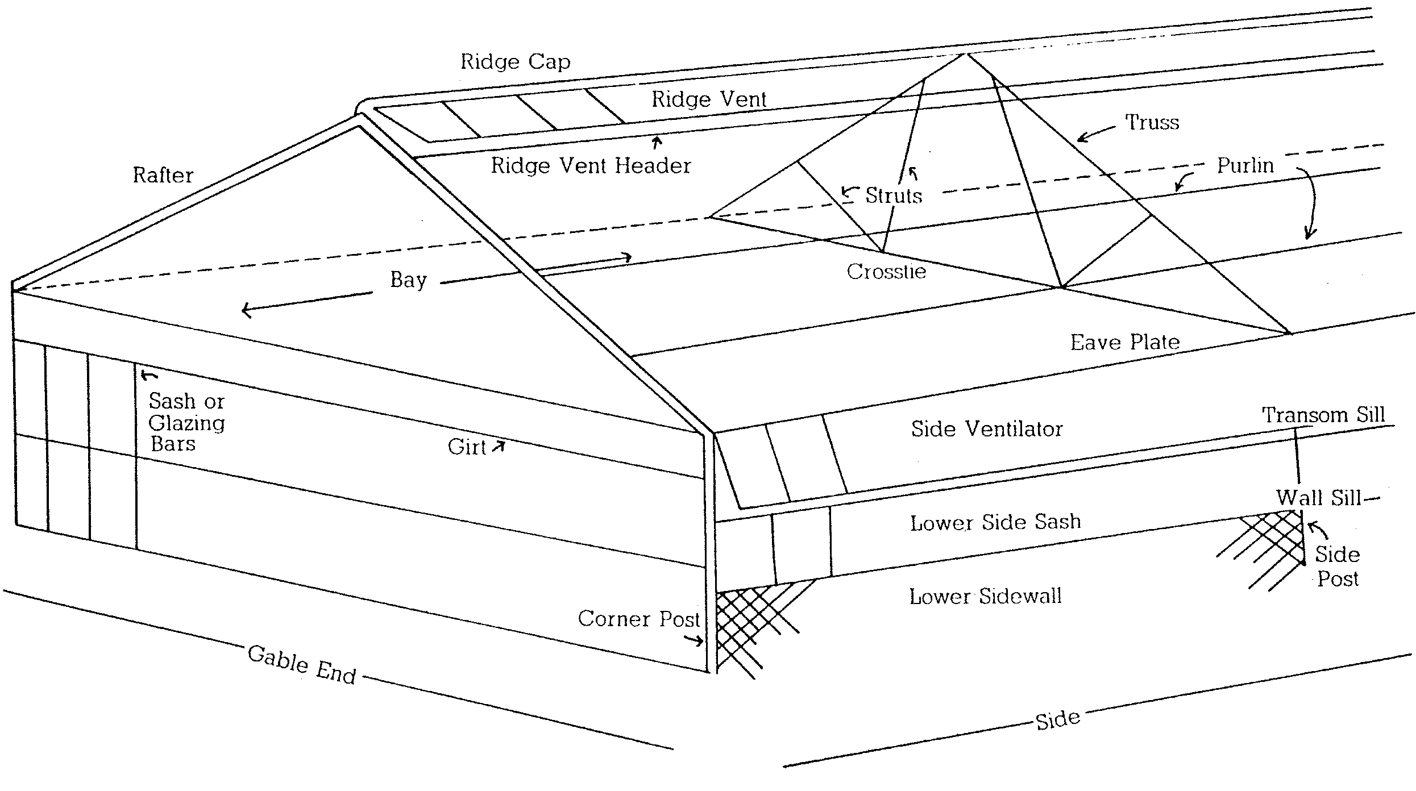

Also from the Netherlands is the “Rovero” greenhouse. It has a retractable roof that can be closed, half closed, or opened as needed. The roof covering is made of clear or diffused polyethylene. The sidewalls and endwalls are motorized and have 8-mm-polycarbonate roll-up curtains. The entire Rovero greenhouse environment is fully computer controlled.
Originally developed in France (as single span) and Spain (as multispan) are field-scale tunnels and conventional tunnel designs.
From “National Polytunnels” in Lancashire, England, cantilevered roof vent units are used. The vents are positioned on top of each roof span; the winch mechanisms can open five vents in a row.
Another innovation is a folding roof that can fold back into the gutter. One model, “Max Air,” comes from National Polytunnels. An additional model is from Polybuild (Surrey, England) in cooperation with the Dutch company HCT.

Construction of a Growing Structure

The basic components of a greenhouse are illustrated in Figure 2.4.
Figure 2.4 - Parts of a Greenhouse

The owner has several decisions to make concerning how to frame the greenhouse: cost of construction and maintenance, strength of the structure, choice of covering materials, and amount of light blocked.

The framing materials may be used alone or in combination. If wood is used, it must resist decay. Some trees (e.g., ash, birch, cottonwood, hickory, and pine) are naturally resistant to decay even when untreated and have an average expected life of 15 years. Other trees such as redwood must be treated with either an oil-based or a waterborne, salt-type preservative that is safe for plants. The wood must NOT be treated with chemicals that emit toxic fumes to plants (e.g., creosote and pentachlorophenol, known as PENTA). Painting preservative-treated wood with light-reflecting, white, water-based paint provides further protection.

A better choice of framing material is aluminum alloy because it is flexible, durable, affordable, and long lasting. It is a versatile metal, able to conform to various shapes and thicknesses, and can be molded into the desired framing structures.

Steel or iron can also be used for the support structures. Wood and iron create a solid framework that provides strength and stability.

Selecting covering materials entails several factors: style of greenhouse; durability in withstanding snow, wind, and extreme temperatures; cost of construction and maintenance; type of framing that can support the cover; and availability of materials. Other considerations are how the covering affects the interior environment in terms of heat retention, light penetration, light diffusion, condensation potential, and static electricity charge.

Heavy, tempered glass is traditionally used because it is strong, inexpensive to maintain, offers excellent light transmission, and is long lasting. But it requires a heavier, more costly framing structure and is also breakable.

Polyethylene film is another type of covering. It is lightweight, flexible, easy to install, and can be supported by a lightweight frame. This film transmits light as well as glass and has the added advantage of using a lighter frame for support. However, plastic film is susceptible to weather damage, accumulates dust so repeated rinsing is needed, and requires frequent replacement.

Other options for covering greenhouses are rigid plastic panels, typically made from polycarbonate, fiber-reinforced polyester (FRP; fiberglass), and polymethyl methacrylate acrylic (PMMA). To prevent ultraviolet light from deteriorating the rigid covering, a stabilizer is required. Unfortunately, the stabilizer compromises the strength of polycarbonate. PMMA is tough, light, and durable in the weather. However, it turns yellow and loses its strength under extended exposure to the outdoors. Of all the plastic coverings, FRP lasts the shortest amount of time and requires frequent replacement. FRP transmits approximately 80-90% of the light that glass does.
In general, rigid plastic covers are lightweight, sturdier than film, and durable. However, they can be damaged by the elements over time, which means they must be replaced every 10-20 years.

Interior Parts of a Greenhouse

The interior layout depends on two major factors: how the greenhouse is used (for wholesale or retail purposes) and what type of crop is grown. For a wholesale operation, the arrangement of equipment and buildings should facilitate the work flow so materials and labor can move smoothly through the production process. Maximizing all available space increases production and profit. By arranging plants close together, narrowing the width of the aisles, and placing the benches close together, the owner can use all available space. Hanging plants from the ceiling saves space and promotes a 1/3 increase in sales.

A retail operation also requires an efficient flow of materials but additionally focuses on whether customers can move easily throughout the greenhouse and have access to the merchandise. Important features include placing special displays and the cash register in a convenient location and creating an aesthetic shopping environment. Wide aisles and generously spaced plants invite browsing and promote sales.

The three common layout designs for benching are lengthwise, crosswise, and peninsular as seen in Figure 2.5.

Figure 2.5 - Interior Layout of a Greenhouse
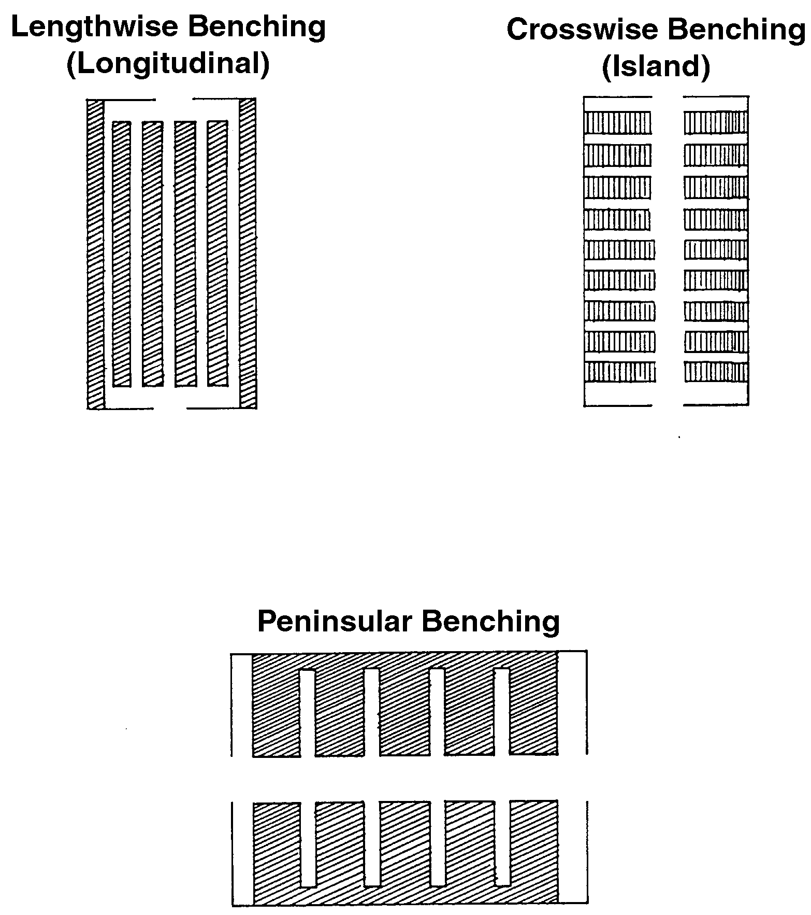
Lengthwise benching is used for cut flowers grown in ground beds and potted plants. The long benches force workers to walk all the way to the end to get to the other side. This reduces efficiency. However, this type of benching supports water and heating lines without hindering walkways.

Crosswise benching uses space more efficiently because the center aisle allows access to each individual bench. This layout is useful for bedding plants and container-grown plants.

Peninsular benching is used for various container-grown plants, starter plants, flowering annuals, and other plants designed for home garden beds. This layout is best suited for retail operations because it provides easy access to plants and more area for growing plants.

The flooring must accommodate equipment and work flow and provide proper drainage. Bare ground is not acceptable because of the risk of pathogens and difficulty in providing drainage. Flooring can be constructed from concrete, including drain basins and slope toward drains, or it can be made from gravel. A weed mat covered with gravel is porous enough to allow the water to drain.

Benches must be sturdy enough to support the amount of plants. Raised benches should provide air movement between the plants, allow water drainage, and separate the plants to prevent spreading diseases and insects. The three types of benches are fixed, movable, and rolling. The movable benches can be put outdoors in favorable weather and used for double-crop production. (One crop is placed on the floor and second bench is moved outdoors.) Rolling benches maximize use of floor space, use less aisle space, and are intended for wholesale use only.

Benches are made from wood, concrete, metal, or plastic. Wood promotes good air circulation but decays eventually. Concrete is very durable but is hard to move and usually expensive. Metal does not require maintenance but is expensive and has rough edges that must be smoothed. Plastic is very light and easy to clean but is expensive and may not be available in the desired size.

Other Structures and Areas in Commercial Greenhouse Operations

In addition to the greenhouse itself, the greenhouse owner can use three other types of outdoor growing structures: coldframes, hotbeds, and lath houses, as illustrated in Figure 2.6.

Figure 2.6 - Other Outdoor Growing Structures

The coldframe is covered with transparent glazing material. The sun is its only source of heat. The top is opened during the day and closed at night. Coldframes are used to harden and protect plants from frost and to store bulbs during winter.
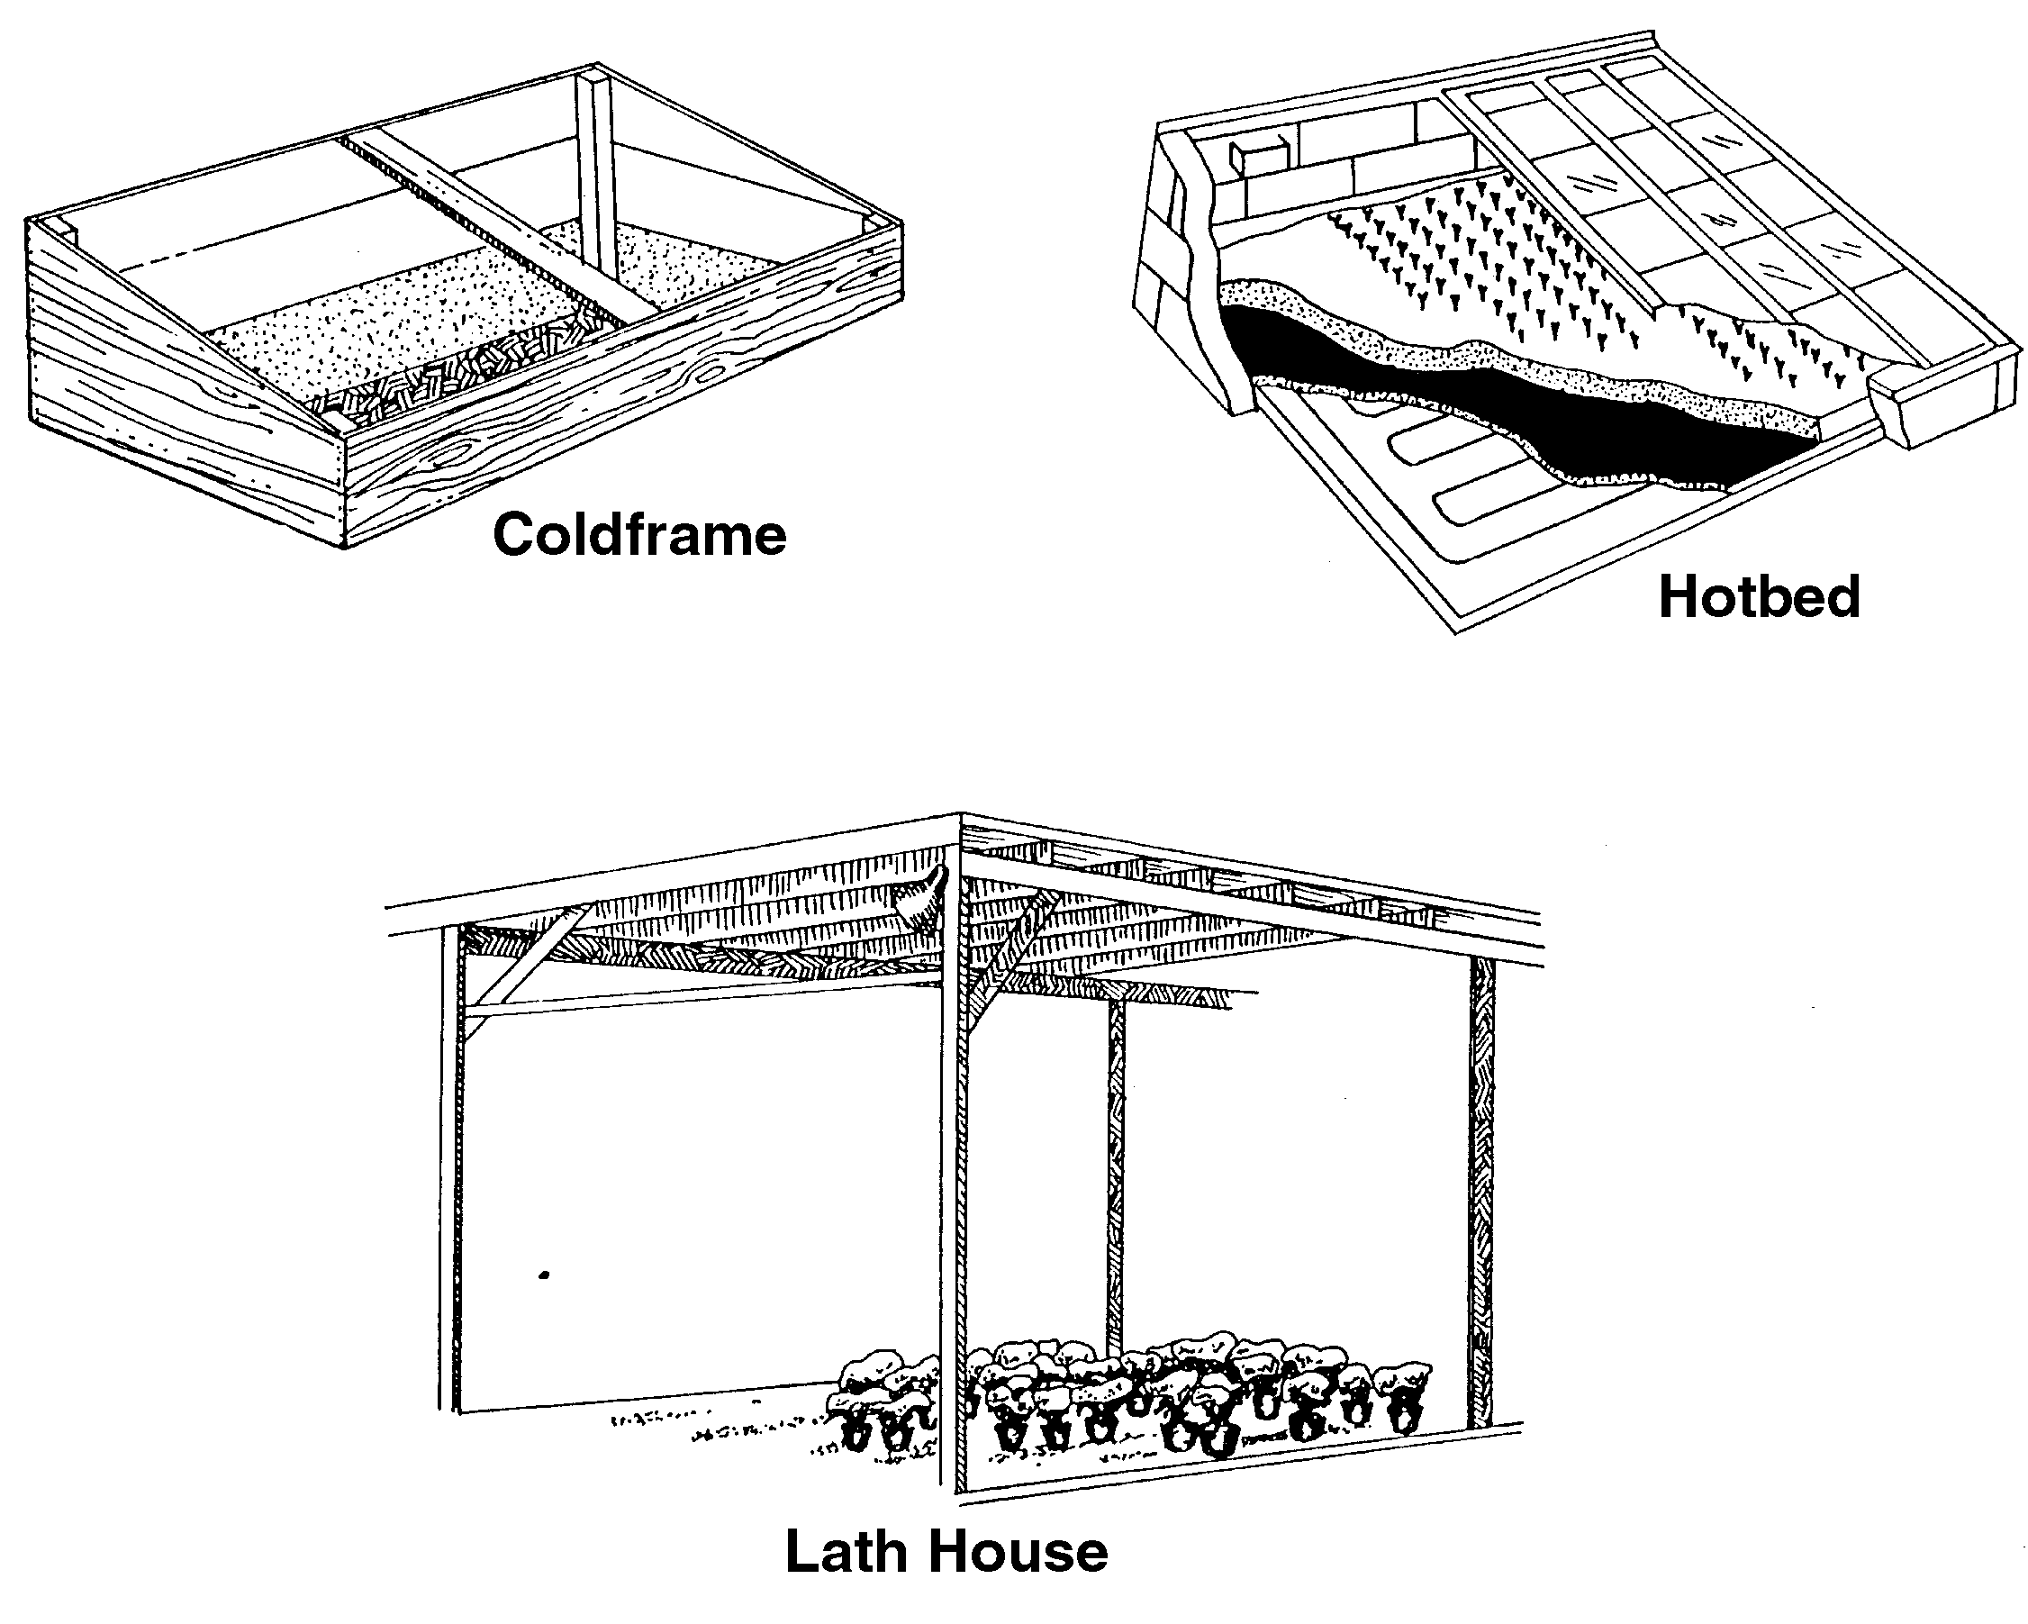

The hotbed also has a transparent covering, but its heat source is steam, hot water, or electricity. Hotbeds are used to start seedlings and cuttings.

The lath house is covered with wooden slats (laths) or shade fabric and supported by vertical poles. The pieces of laths are spaced about 1 inch apart to reduce light intensity and provide shelter from the wind. The sun is the sole source of energy. This structure is used during the summer where the temperature is warm or year-round in warm climates to propagate tropical plants and plants needing shade.

Additional areas used in most commercial greenhouse operations include workspaces for soil mixing and propagation, storage areas, roadways, and loading and shipping areas. Retail operations typically have parking lots, display areas, rest rooms, offices, break room, and kitchen area.

Summary

Building a growing structure for a greenhouse operation presents the owner with several important decisions. Site selection involves climate, topography, available resources, land, marketing decisions, and legal issues. There are several different types of growing structures to choose from, depending upon the scope of the operation.

Credits

“The Best in Dutch Venlo Technology.” <http://www.roughbros.com/html/venlo.html> accessed 5/7/02.

Boodley, James W. The Commercial Greenhouse, 2nd ed. Albany, NY: Delmar Publishers, 1996.

Duncan, G.A. and J.N. Walker. “Preservative Treatment of Greenhouse Wood.” <http://www.
ca.uky.edu/agc/pubs/aen/aen6/aen6.htm> accessed 1/14/02.

“Greenhouse Management - Site Analysis.”
<http://www.sfasu.edu/ag/horticulture/hrt321/
3.%20HRT%/20Site%20Analysis%20.htm> accessed 1/4/02.

“Greenhouse/Nursery Layout and Site Selection.” <http://envhort.ucdavis.edu/ehweb/enh125/
general/SiteSelect.htm> accessed 12/18/01.

Greenhouse Operation and Management (Student Reference). University of Missouri-Columbia: Instructional Materials Laboratory, 1990.

“Greenhouse Structures.”
<http://aggie-horticulture.tamu.edu/
greenhouse/guides/green/struc.html> accessed 12/17/01.

Hall, Karen. “Greenhouse Site Selection & Regulation.” Cornell Cooperative Extension. <http://aem.Cornell.edu/special_programs/
hortmgt/pres/2000_Greenhouse_Conference/
Hall.ppt> accessed 1/15/02.

Herren, Ray V. and Roy L. Donahue. The Agriculture Dictionary. Albany, NY: Delmar Publishers Inc., 1991.

Kessler, J.R., Jr. “Hobby Greenhouse Operations and Practices.” Auburn University. <http://www.aces.edu/department.extcomm/
publications/anr/anr-1153/anr-1153.html> accessed 12/19/01.

“Products” <http://www.bosch-inveka.nl/
english/content-producten.htm> accessed 5/7/02.

“Retractable Roof Greenhouses.” Rovero. <http://igcusa.com/rovero.htm> accessed 5/7/02.

Ross, David S. “Planning and Building a Greenhouse.” Center for Agricultural & Natural Resources Development, West Virginia University. Adapted from Fact Sheet 645 - University of Maryland, Extension Service, Department of Agricultural Engineering. <http://www.wvu.edu/~agexten/hortcult/
greenhou/building.htm> accessed 1/14/02.

“Where in Your Market Will You Locate Your Business?” <http://www.aces.edu/department/
extcomm/publications/anr/anr-691/anr-691.html> accessed 12/19/01.

