UNIT II: The GROWING STRUCTURE

Lesson 2: Environmental Control

Various environmental factors influence greenhouse operations. This lesson addresses types of environmental controls found in the greenhouse. It examines how temperature is monitored and controlled; how to keep a greenhouse warm, ventilated, and cool during appropriate times; and how to control the humidity. Equipment used in irrigation is also discussed as well as the effect of carbon dioxide and light levels.

Types of Environmental Controls

Several natural elements must be controlled in a greenhouse: temperature, humidity, water, light, carbon dioxide, pests, and diseases. These factors can be manipulated through one of three basic methods: manual, automated, or an integrated control system. If a greenhouse owner manually controls a thermostat, he or she has to physically move the setting. If that thermostat is automatically controlled, the setting is triggered mechanically; the greenhouse owner would not touch it at all.

The integrated control system provides analog and computer systems and multiple sensors throughout the greenhouse. It senses and controls air and soil temperature, light intensity, relative humidity, and carbon dioxide levels. It also records data for evaluating and troubleshooting and provides data for planning future crops.

Monitoring and Controlling Temperature

Before selecting a temperature control system, a greenhouse owner has to consider the cost of equipment, which includes installation and maintenance. To enhance plant growth, the system must also provide uniform control throughout the greenhouse by minimizing hot and cold spots and providing horizontal airflow.

The temperature control system regulates temperature extremes to suit the needs of the entire operation. To be reliable, this system should have a backup emergency generator and an alarm that signals when a power failure occurs so that the owner will know when any outages threaten the operation.

Selecting the type of fuel to run the temperature control system depends on cost, availability, storage requirements, and means of transporting the fuel to the greenhouse.

Several kinds of devices are used to monitor and control air temperature: thermometer, high/low thermometer that measures during the day and night, or thermostats that provide on-off control and step control (stages). Aspirated thermostats (drawing air by suction) read the temperature of air blown across the thermostat and are a more accurate control than standard thermostats. Thermistors are electronic semiconductors that sense even subtle temperature changes and signal the controller. Figure 2.7 illustrates these monitoring devices.

Figure 2.7 - Devices to Monitor Temperature

The monitoring devices should be level with the plants throughout the greenhouse, shaded from direct sunlight, and away from cooling fans.

Keeping a Greenhouse Warm During Cold Weather

Heat loss occurs in three ways. Through conduction, energy is lost through the materials that cover the greenhouse. Air infiltration permits heat to escape through leaks in the greenhouse’s coverings, doors, and windows. Radiation occurs when warm objects emit energy that passes through the air to colder objects but does not warm the surrounding air to any degree. To protect plants in the greenhouse, all lost heat must be replenished. Heat should be energy efficient, reliable, and safe.

Heat is measured in Btu - British thermal units; 1 Btu raises 1 lb of water 1ºF. A typical boiler needs 33,475 Btu. This guideline may affect the owner’s selection of fuel in terms of cost and availability.
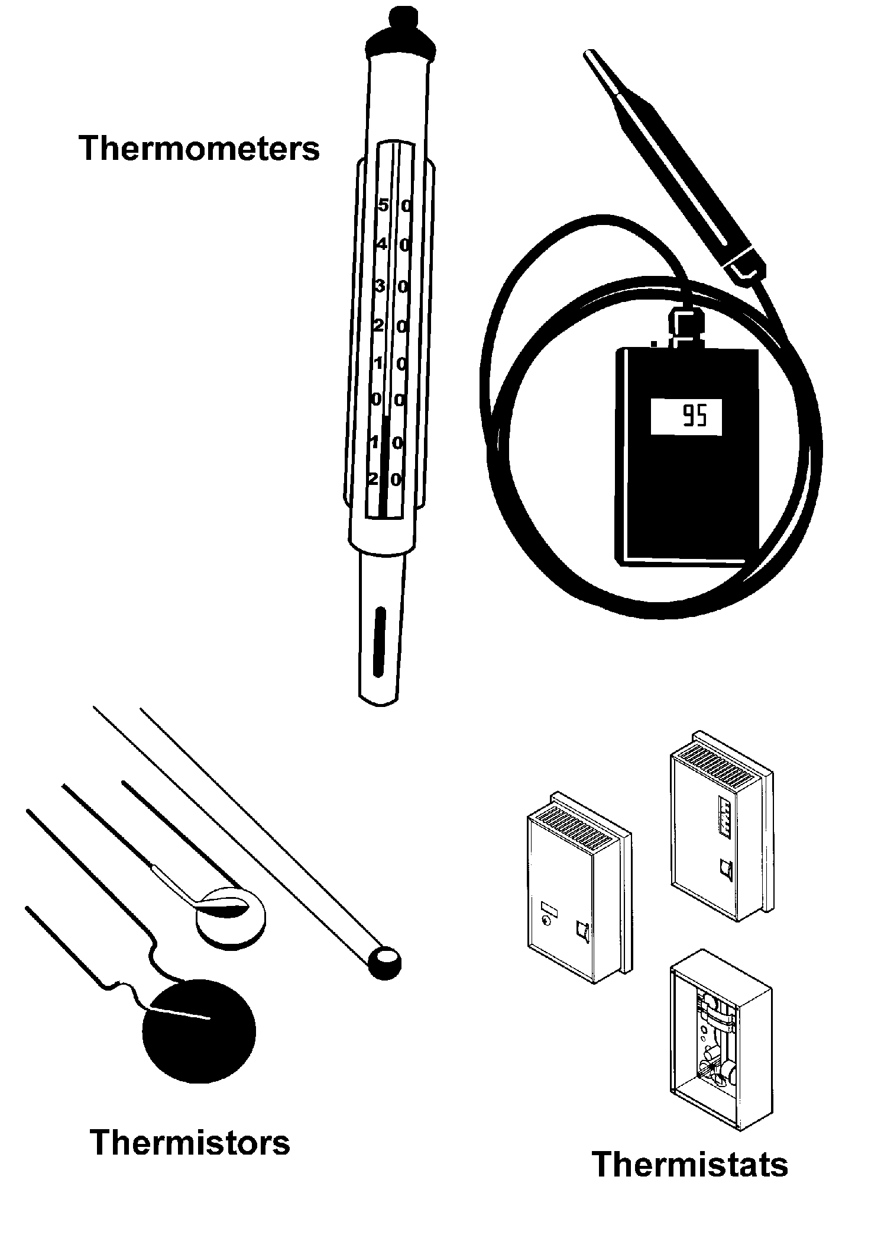

Solar energy provides only some heat. The greenhouse collects and stores the energy from the sun that passes through the covering during the day. This heat warms the plants and other objects inside the greenhouse. The heat that is radiated back does not have enough energy to pass back through the covering (causing the “greenhouse effect”). Heat is retained at night (the amount retained varies with the type of covering). Solar heat alone is not sufficient for greenhouses in most northern climates. An additional source of heat must be provided.

Heating equipment includes unit heaters, central heaters, and radiant (infrared) heat. Infrared light warms surfaces (plants, soil, benches, etc.), not the air. Air is warmed only by heat radiated from surfaces. Emergency generators also provide heat. Generators, fueled by gas or fuel, provide supplemental power if an outage cuts off the electric fans that are essential to most heating and cooling systems.

There are three basic types of heat distribution. In forced hot air, the heat comes from burning several types of fuel, such as natural gas. The heat is distributed throughout the greenhouse and ventilated outside to prevent buildup of air pollutants. Mounted on the ground or overhead are horizontal discharge unit heaters that push the air through perforated polyethylene tubing that hangs above plants. In addition, vertical discharge unit heaters fans are mounted overhead and they move the air downward. The unit heaters use horizontal airflow (HAF) fans that help distribute the heat evenly.

Hot water is piped through the greenhouse by metal piping that is placed along walls and under benches. The temperature is variable. A circulating pump moves the water.

Steam heat distributes steam through the greenhouse by metal pipes, but the temperature is not as variable as with hot water. Steam heat carries more heat and moves farther than hot water heating.
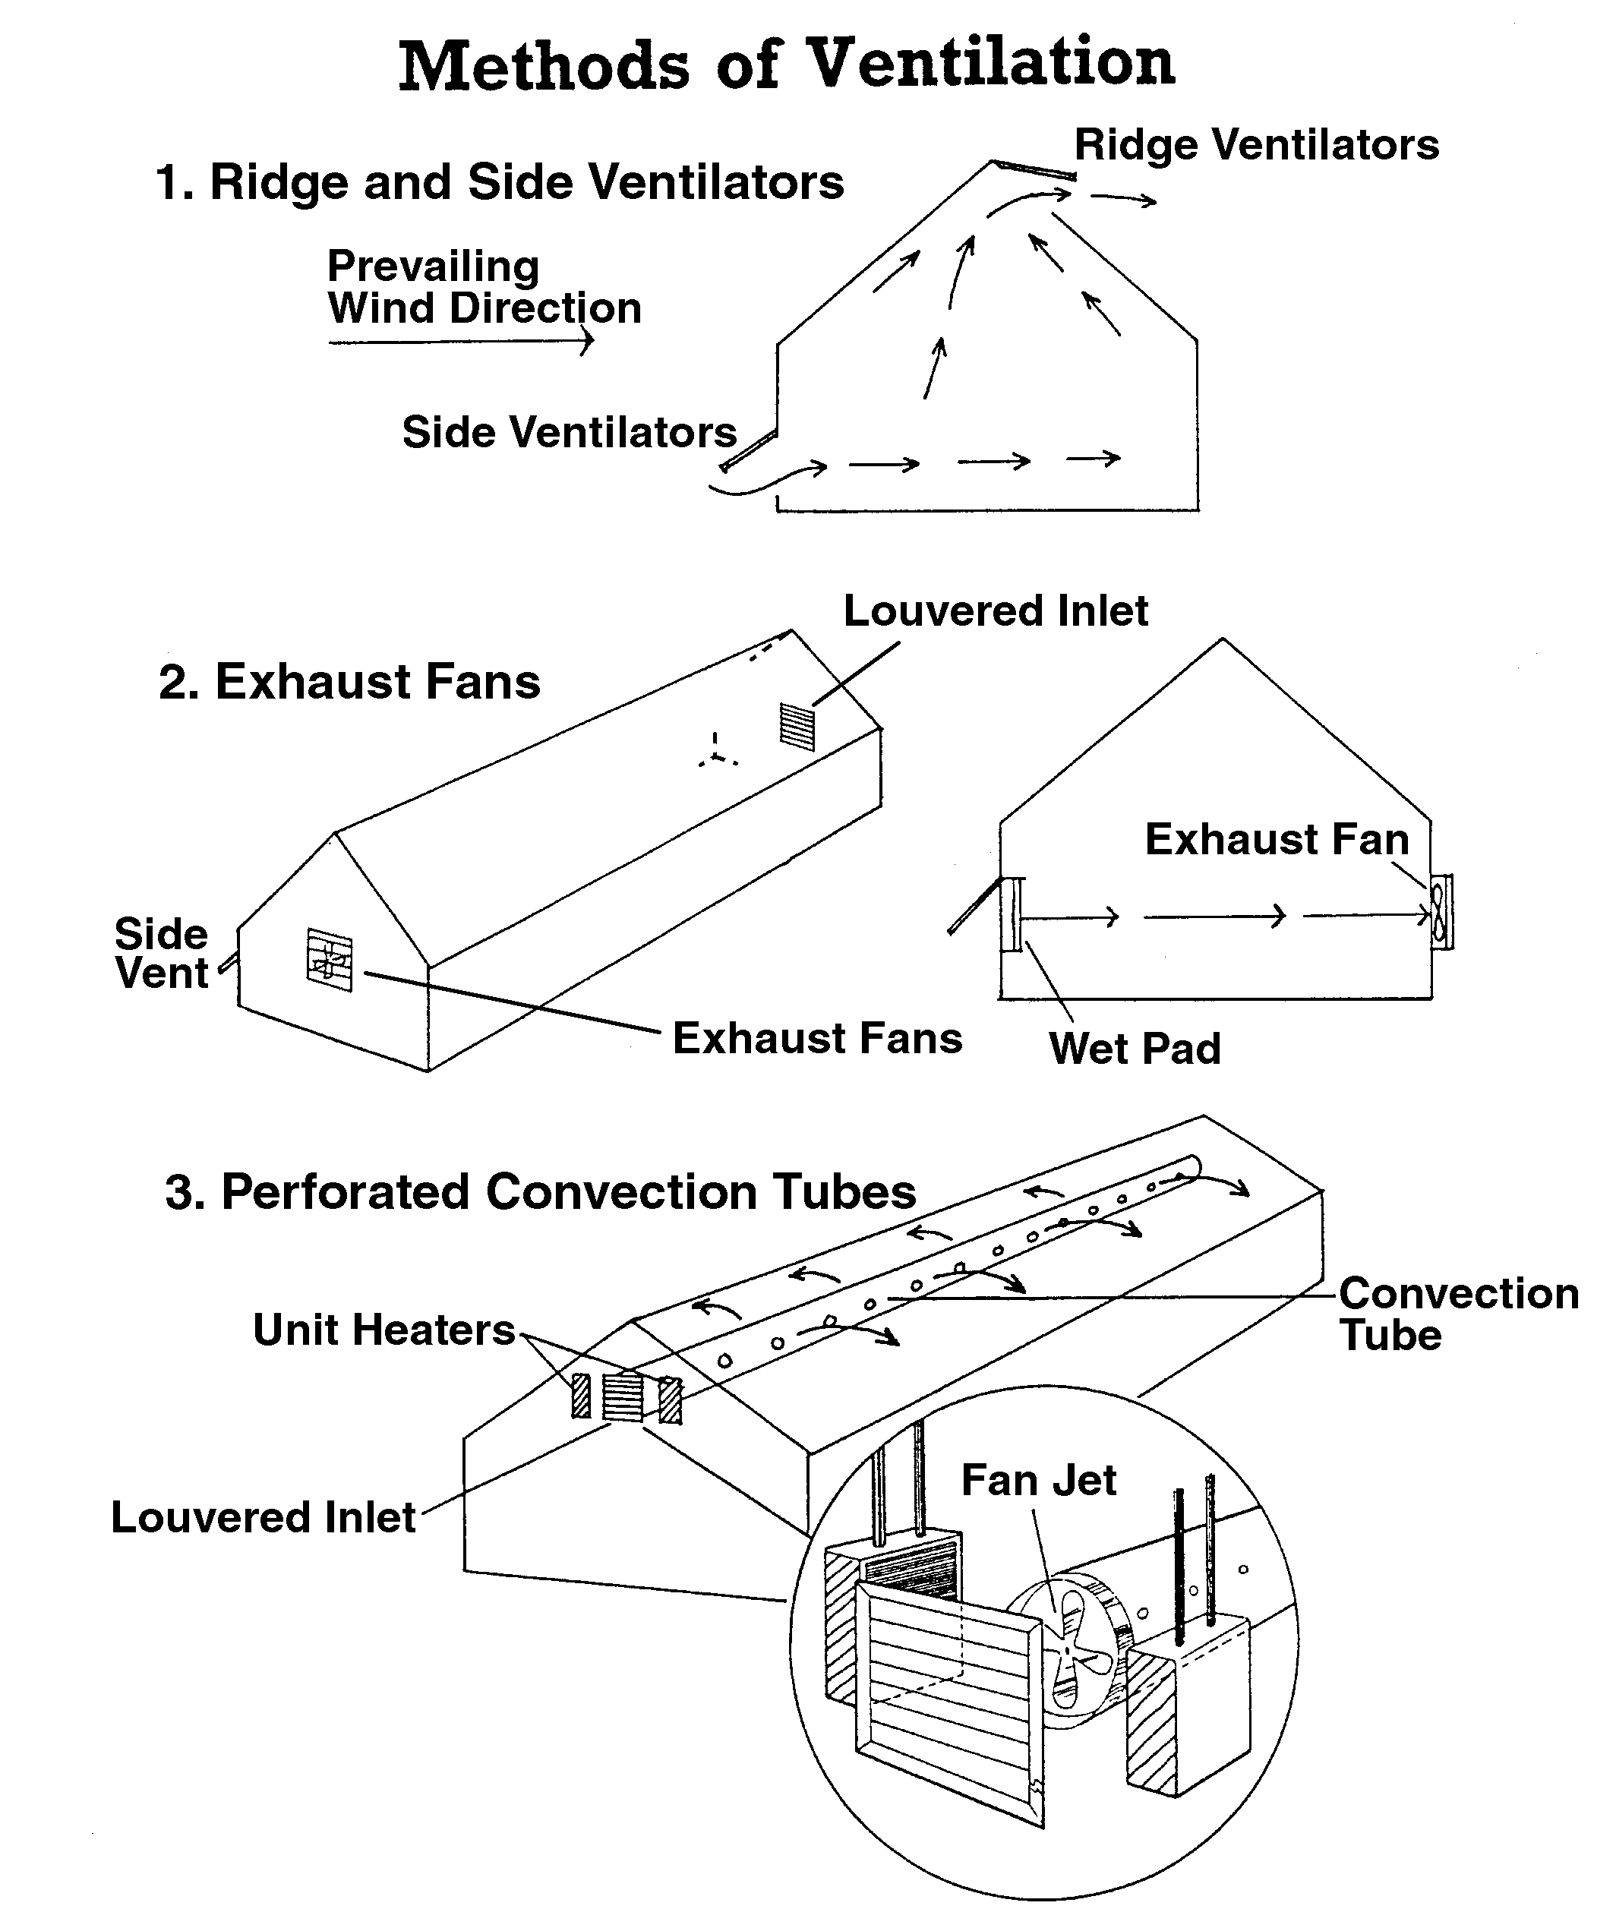
Coal, kerosene oil, propane/natural gas, wood, and electricity are examples of fuel sources that can heat a greenhouse. Price and availability are determining factors. Electricity is generally not an efficient fuel for most commercial greenhouse operations.

Ventilating a Greenhouse

Venting is important. Any heating system that burns fuel can be lethal to humans. When oxygen is deleted from the air, this shortage creates carbon monoxide - a gas that is fatal to humans. Impurities in fuel (e.g., ethylene gas and sulfur dioxide gas) and incomplete combustion can create other toxic fumes. To ensure safety, fuel-burning heat sources must be vented to the outdoors through a chimney. A ventilation system must be installed to bring fresh air into the greenhouse. Air circulation is essential to the heating process. Air-mixing fans push the rising hot air back down to the plants.

The purpose of greenhouse ventilation is to bring fresh air into the greenhouse and reduce temperature and relative humidity. Excessive humidity causes condensation. If condensation is left on plants, the risk of plant disease increases. Ventilation helps replenish carbon dioxide (CO₂), a necessary ingredient in plant growth that is consumed by plants during photosynthesis.

Types of ventilation include ridge and side vents that have a chimney effect and operate automatically or manually. Exhaust fans on sidewalls and endwalls draw in fresh air and are most beneficial in late spring, summer, and early autumn. Motorized louvers let in fresh air. Fans mix air with inside air then distribute air through a convection tube. The convection tube (running the length of the greenhouse overhead) distributes air through the perforated openings. See Figure 2.8.

Figure 2.8 - Methods of Ventilation

Cooling a Greenhouse During Warm Weather

The simplest way to cool a greenhouse during warm weather is to provide an even flow of cool air and reduce light intensity. The methods of providing cool air include ventilators/ vents, forced air ventilation, and fan and pad systems. In the fog system, water is forced through tiny nozzles to create a fine mist, and the evaporated water cools the air. Mechanical air conditioning systems are not efficient cooling methods for most commercial greenhouse operations

Shade fabric helps reduce light intensity. The fabric is available in a woven polyethylene cloth and also in a knitted polyaluminum cloth called “Aluminet”; both can be obtained from greenhouse suppliers. The weave densities determine how much light is shaded out. The densities range from 20 to 90%. The percentage approximates how much the light intensity is decreased. For example, a 55% shade fabric blocks or excludes approximately 55% of the ambient (surrounding) light. The owner selects the desired density for the operation. The fabric reduces heat best when the cloth is draped on the outside of greenhouse but it should be arranged so it does not interfere with ventilation.

Shade paint also helps diminish light. It is a diluted, weak-binding latex paint that is sprayed on the outside of the glazing, usually twice yearly.
Typically, it wears off gradually during the summer and fall. But it can also be washed off easily with soap and water. The paint should be removed before winter to prevent light reduction during that time of year.

Another method for reducing light is to install wooden, plastic, or plastic-coated blinds and to mount them on the outside of the greenhouse, just like the shade fabric. Alternatively, adjustable blinds can be mounted inside. A final technique for reducing light intensity is to install thermal screens on ceilings and walls.

Controlling Greenhouse Humidity

Relative humidity (RH) measures how much water is dissolved in the air at a specific temperature. It is the ratio of how much moisture is actually in the air at a given temperature compared to the maximum amount possible without condensation. RH is expressed as a percentage. The ideal range of RH for most greenhouse plants is 45-85%. Greenhouse peppers thrive at 75%RH; African orchids prefer 40-60% RH. For roses, the ideal RH is 80%.

If the RH is above 85%, water may condense on plants and increase the risk of fungal pathogens and diseases. (However, cut tulips and cut daffodils should be stored at over 90% RH.) If the RH is below 45%, stunted plant growth or leaf burn may occur. More watering is required. (Yet succulents and cacti do best in 5-15% RH.)
To maintain proper RH, the greenhouse owner can use shading to reduce temperature and light as well as cooling pads (evaporative cooling). By keeping the greenhouse filled with plants, humidity is maintained because plants generate RH. Do not water plants late in the day and ensure that the greenhouse floor drains well.

To maintain the proper humidity level, install a fan in the greenhouse and set its timer to start operating at 9:00 p.m. or 10:00 p.m. for 30-60 minutes. This exchanges moist, warm, inside air with moist, cool, outside air. This enables the heating system to warm the air to its set point, which reduces the level of water in the greenhouse.

Open the roof ventilators to let the hot air escape. (Maximize the exchange of air by having wide roof ventilators and a double row of sidewall ventilators.) This prevents moisture from increasing and also prevents water vapor from condensing on plants, which can cause the spread of diseases.

Installing fans for ventilation during late spring, summer, or early fall introduces cooler outside air into the greenhouse. This helps sustain the proper humidity level. During late autumn, winter, and early spring, introduce air into the greenhouse through perforated polyethylene tubes. This prevents harsh, extremely cold outside air from harming plants. When cold air leaves the tubes, it mixes with warm greenhouse air, thereby preventing plants from suddenly getting chilled. Exhaust fans exchange greenhouse air with outside air.

Irrigation Equipment

Irrigation methods use either manual or automatic equipment. Manual irrigation systems use handheld hoses and wands. Automated irrigation systems use the following equipment:

- Mist systems
- Spaghetti tubes controlled by timers
- Drip emitters
- Ooze tubes
- Water loop
- Capillary mat system
- Ebb and flood system
- Boom system
- Spray stake/nozzle system
- Fertigators

See Unit IV, Lesson 3, for a discussion of how equipment and systems are used to irrigate greenhouse crops.

Controlling Carbon Dioxide

Carbon dioxide is essential for plant survival. Plants consume CO₂ during photosynthesis, so the CO₂ levels drop during this process. If the greenhouse is tightly closed, it does not allow any exchange of air. Lost CO₂ must be replenished. Ventilation and light restore some carbon dioxide, but a CO₂ generator is especially effective in enriching the greenhouse.

Carbon dioxide generators provide a maximum amount of CO₂ with a minimum amount of heat as a by-product. The generator has a timer that regulates when to introduce CO₂ into the greenhouse. The recommended time to add CO₂ is at sunrise or when artificial lighting is turned on. The time to discontinue CO₂ enrichment is during dark hours. The amount of CO₂ that should be added into the greenhouse is quantified in units called “parts per million” (ppm). The average recommended level of CO₂ is 1,000-2,000 ppm.

The CO₂ generator operates by burning propane or natural gas. A thermocouple monitors the pilot light. If the pilot flame goes out, a safety valve closes to prevent unburned fuel from releasing into greenhouse. It is best to purchase a large generator rather than a small one. Large generators allow the greenhouse owner to set a shorter cycle time. A shorter cycle time adds CO₂ into the greenhouse more efficiently.

Controlling Light Levels

The amount of light intensity needed in a greenhouse depends on the plant. Intensity of available light is measured in foot-candles (f.c.), which range from 500 f.c. on an overcast winter day to 10,000 f.c. on a clear summer day. (Unit IV, Lesson 1, provides more details on foot-candles.) Environmental factors that affect light intensity are geographic location, season, time of day, pollution, and cloud cover.

Light intensity can be read by a light meter or a computerized photocell. Light intensity can be increased or decreased to meet the plant’s requirements.

Light intensity/day length can be increased with supplemental lights such as fluorescent lights or high-intensity discharge lights. Using black material to block plants from light decreases light intensity/day length. Putting plants under a bench reduces exposure to light. Spraying a shading compound on the growing structure and placing a shade cloth above plants or over the growing structure also decrease light intensity.

Summary

Temperature, heat, ventilation, relative humidity, irrigation, levels of carbon dioxide, and light intensity must be regulated within the greenhouse. Careful monitoring of these environmental controls helps promote crop yield and profit for the greenhouse operation.

Credits

“Aluminet Thermal & Shade Screens.” Greenfire, Inc., 1998. <http://www.greenhfire.net/hot/
G106.html> accessed 5/13/02.

Ball, Vic, Editor. Ball Red Book Greenhouse Growing, 14th ed., Reston, VA: Reston Publishing, Inc., 1985.

Boodley, James W. The Commercial Greenhouse, 2nd ed. Albany, NY: Delmar Publishers, 1996.

“Greenhouse Climate Control.” <http://envhort.ucdavis.edu/ehweb/enh125/
GrhEnv/HeatCool.htm> accessed 12/18/01.

“Greenhouse Management - Cooling.”
<http://www.sfasu.edu/ag/horticulture/hrt321/
6.%20%20HRT20321%20Cooling.htm> accessed 1/4/02.

“Greenhouse Management - Heating.”
<http:// www.sfasu.edu/ag/horticulture/hrt321/
5.% 20%20HRT20321%20Heating.htm> accessed 1/4/02.

Greenhouse Operation and Management (Student Reference). University of Missouri-Columbia: Instructional Materials Laboratory, 1990.

Herren, Ray V. and Roy L. Donahue. The Agriculture Dictionary. Albany, NY: Delmar Publishers Inc., 1991.

“Horticulture 321 - CO₂ - Light - Temperature.” <http://www/sfasu.edu/ag/horticulturehrt
…1%20CO2,%20Temperature%20and%20Light.htm> accessed 5/8/02.

Kessler, J.R., Jr. “Hobby Greenhouse Operations and Practices.” Auburn University. <http://www.aces.edu/department.extcomm/
publications/anr/anr-1153/anr-1153.html> accessed 12/19/01.

“Principles of Carbon Dioxide Enrichment.” <http://www.litemanu.com/prinsco2.html> accessed 5/8/02.

