UNIT III: Plant Science Basics

Lesson 1: Plant Parts, Structures, and Functions

As the greenhouse owner develops experience growing various crops, he or she can identify how the needs of each plant differ. This increased awareness may be supplemented further by learning about the structures and functions of plant parts. Lesson 1 provides fundamentals of plant science. It describes the parts of plant cells and types of specialized plant tissues. The functions and types of seeds, roots, stems, leaves, and flowers are identified. Distinctions between monocots, dicots, monoecious, and dioecious plants are also summarized. The background information presented here supports the more detailed description of plants’ life processes discussed in the next lesson.

Structure of a Plant Cell

The basic structural unit of plants is the cell, as illustrated in Figure 3.1.

Figure 3.1 - Basic Structure of a Plant Cell

Although the outward shapes of plant cells may vary, the interior structure of cells is generally the same. The cell wall is composed of a primary wall, which develops first and is located where cells grow and divide actively. Within the primary wall, a secondary wall forms. It helps the cell wall become more rigid and eventually develops into the woody part of the plant during the growing process. With the addition of a second cell, the cell walls meet. The layer formed between these new cells is the middle lamella.

The plasma membrane (outer membrane) surrounds the cell and is located just inside the cell wall. It contains proteins, carbohydrates, phosphorous, and fat molecules. The plasma membrane controls the entrance and exit of all substances (e.g., water) from the cell and relays information about environmental conditions to the cell nucleus.

Cytoplasm, also called protoplasm, is the liquid within the plant cell. It is where most of the plant’s life processes occur. Cytoplasm is made up of organelles, which are specialized cells bound in a membrane sack. Three important types of organelles are mitochondria, plastids, and vacuoles.
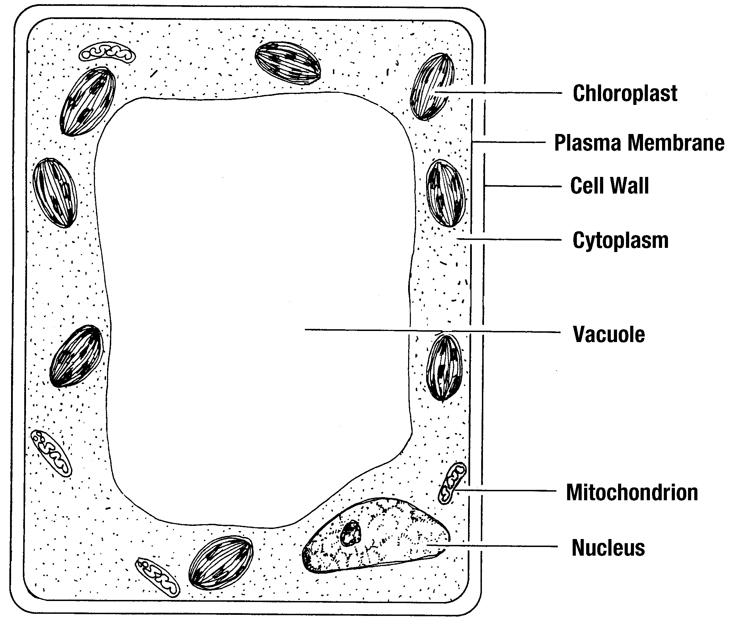

Small and dense, mitochondria control many cellular chemical reactions, among the most significant, the production of energy needed for growth. This energy develops during respiration, which is discussed in the next lesson.

Plastids contain chloroplasts and chromoplasts. A chloroplast is the green pigment - chlorophyll - that is essential for photosynthesis, which is explained in Lesson 2. The red, orange, and yellow pigments found in chromoplasts give petals their color.
Vacuoles are large, fluid-filled areas within the cell that store water, dissolved minerals, and other materials. Individual vacuoles enlarge and join together to form a large, central vacuole when the plant nears maturity. The central vacuole becomes the cell’s main storage area.

A crucial organelle is the nucleus, the cell’s control center. It contains all of the plant’s genetic material (DNA and RNA) within the chromosomes. This determines the plant’s physiological characteristics and appearance. The genetic makeup within the chromosomes transmits these inherited traits to succeeding generations.

Differences Between Monocots and Dicots

Plants with one seed leaf (one cotyledon) are monocots. In monocots, the leaves have parallel veins and the vascular bundles are scattered within the stem. Parts of a monocot flower are displayed in multiples of three. Corn and grass are examples of monocots.
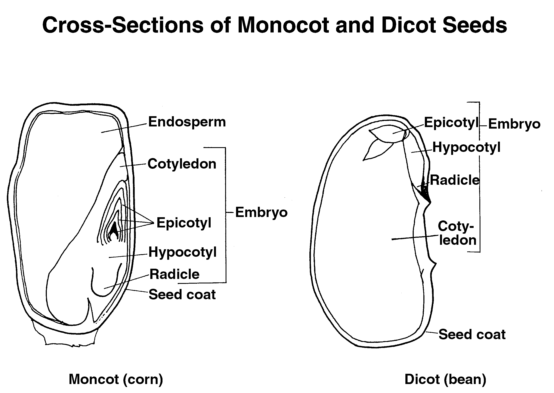

Figure 3.2 - Cross-Sections of Monocot and Dicot Seeds

If a plant has two seed leaves (two cotyledons), it is a dicot. In contrast to a monocot, its leaves have branched veins and the vascular bundles are arranged in a circular pattern. Flower parts come in multiples of four and five. The dicot does not have an endosperm. Instead, the two cotyledons that surround the embryo on both sides function as a food storage area for the new plants.
Figure 3.2 illustrates the interior structure of monocot and dicot seeds. The monocot (corn) is on the left side; the dicot (bean) is on the right.

To summarize the distinctions between monocot and dicot plants, see Figure 3.3.
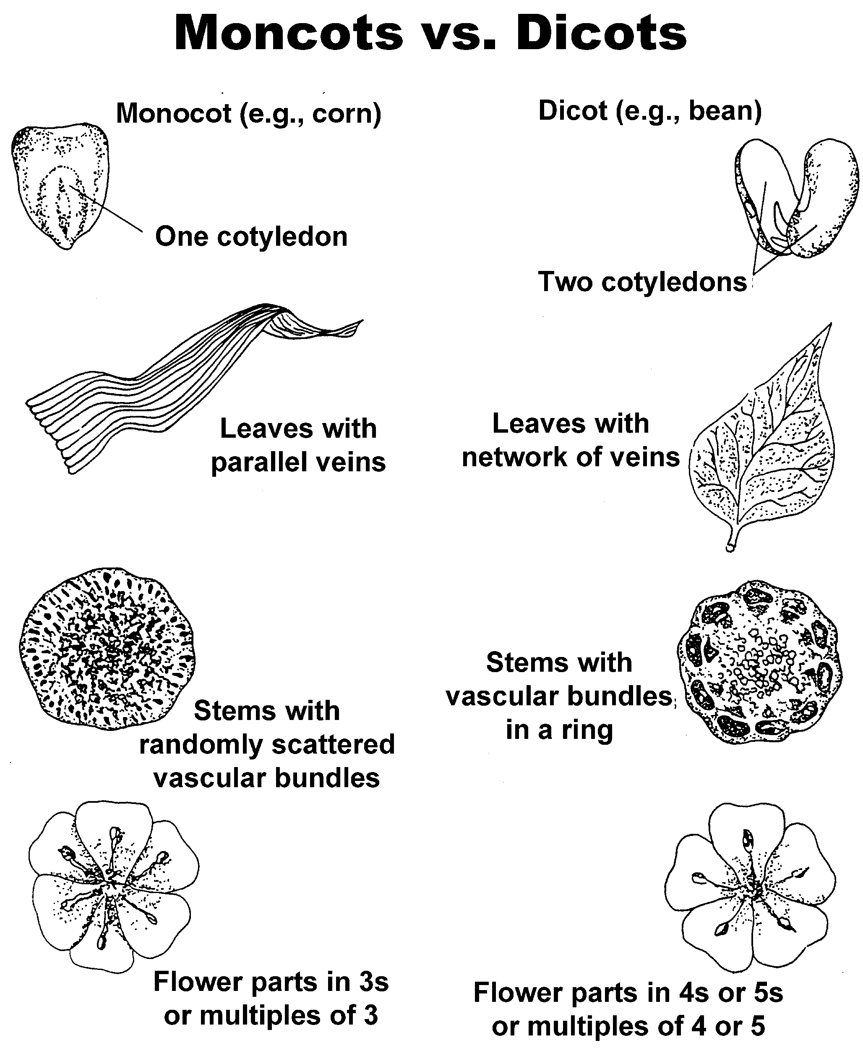

Figure 3.3 - Monocots vs. Dicots
Specialized Plant Tissues

When cells combine and function together, they form tissues. In plants, the two primary types of tissues are meristem and permanent. In meristem tissues, new growth occurs because the cells are rapidly dividing. Three specialized meristem tissues support this process: apical, cambium, and intercalary zone. In apical meristem tissues, growth occurs at the tips of the roots and stems, which lengthens the height of the plant. See Figure 3.4.

Figure 3.4 - Parts of a Plant
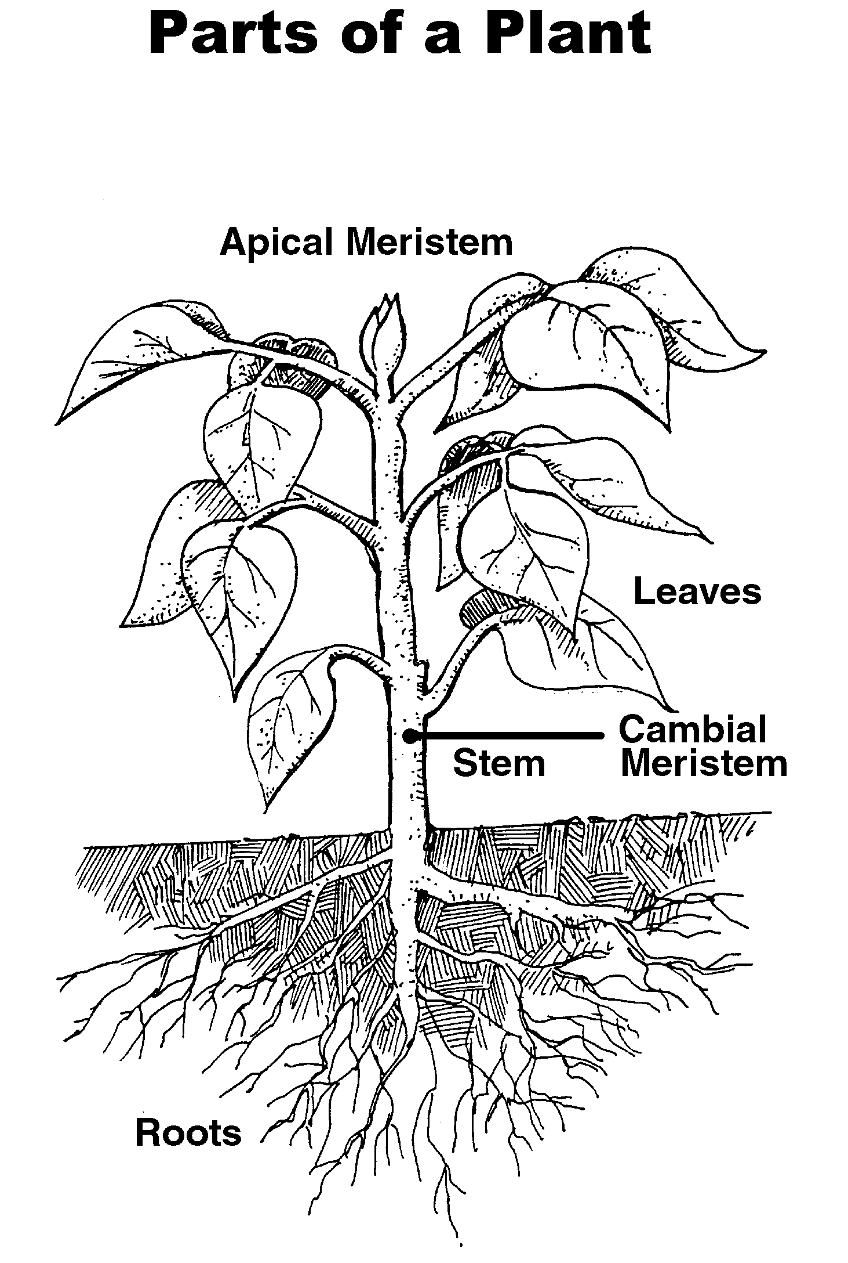
Located in the stems, cambium meristem tissues increase the plant’s diameter. The intercalary zone meristem tissues lengthen the plant. These tissues are located just above the nodes (swollen areas at the joints of stems where buds and leaves originate) in plants that have a single seed leaf (cotyledon).

The mature cells in permanent tissues do not actively divide. The specialized permanent tissues are the epidermis and the vascular system. As the outside covering, the epidermis supports and protects cells within the plant. Its primary purpose is to regulate the movement of gas and water into and out of the cells.

The vascular system creates a path that transmits essential nutrients from the roots through the stem to the leaves. It is made up of two specialized tissues: xylem and phloem. Xylem moves dissolved minerals and water upward through the plant. Phloem moves food, created during photosynthesis, from the leaves to the stem and roots and then provides a storage area for the food. This source of nutrition enhances growth in the meristem tissues, and the food then becomes accessible to all cells immediately.

Parts and Functions of Seeds

The five basic parts of plants are seeds, roots, stem, leaves, and flowers. A seed is a young plant in its earliest stage of development. It has a supply of food that remains dormant until favorable environmental conditions, such as sunlight and rainfall, permit germination. The three basic parts of monocot seeds are the seed coat, embryo, and endosperm.

The tough exterior surface of the seed coat protects the embryo from drying out or sustaining injury. The embryo is the immature plant within the seed. The embryo is composed of the cotyledon, epicotyl, hypocotyl, and radicle. A cotyledon is the first leaf that develops, called the seed leaf. In monocots, one cotyledon protects the epicotyl. In dicots, two cotyledons protect the epicotyl and provide food storage for new plants.
The epicotyl (plumule) is the embryo’s growth bud located above the cotyledons. When the seed germinates, it is the first shoot to appear.

The hypocotyl, located below the cotyledon, is the first true stem. As the seed develops, the hypocotyl gets longer and the cotyledons and epicotyl become visible.

At the end of the hypocotyl is the radicle (root tip), the plant’s first root, which is the first part of the plant that emerges from the germinated seed. It anchors the plant in the soil while absorbing essential nutrients and water.

The purpose of an embryo’s endosperm is to store food for the growing plant and to provide immediate nourishment until the plant can sustain itself through photosynthesis. Endosperms are found only in monocot seedlings.

Functions and Types of Roots

The functions of roots are to hold plants securely to the soil and to absorb water and nutrients that are essential for growth. Specialized functions of roots include synthesizing hormones for plant growth, storing carbohydrates, and providing aerial support for plants such as climbing roots (ivy).

Roots have tiny root hairs – single cell, hairlike extensions whose growth is influenced by moisture. More hairs are produced under dry condition; fewer hairs are produced under moist conditions. Root hairs are found near the tip of the roots and absorb water and minerals from the soil. To ensure greater absorption for the plant, they expand the root area. The five types of roots are fibrous, taproot, adventitious, aerial, and aquatic, as illustrated in Figure 3.5.
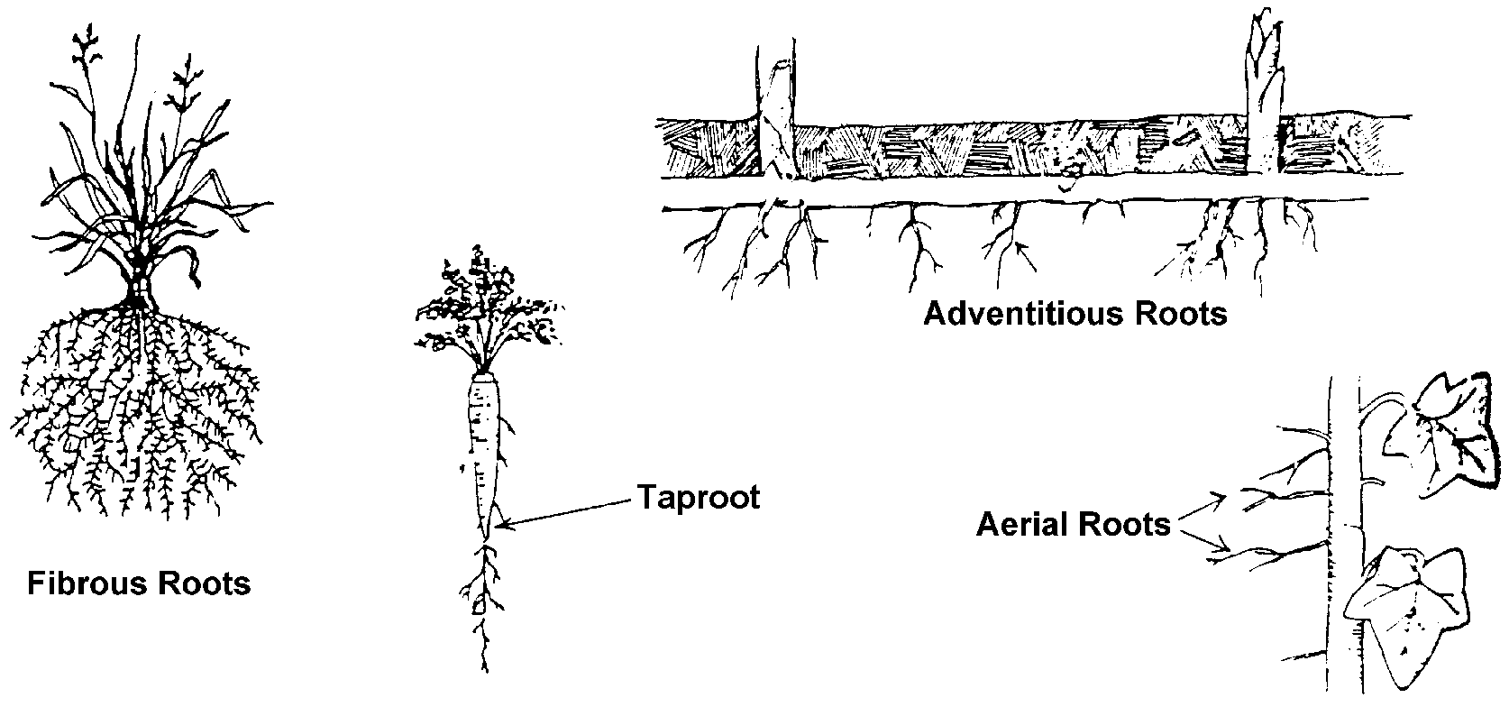

In plants with fibrous roots, there is no central anchored root. Instead, delicately branched secondary roots grow; the root system is shallow and wide. Because fibrous roots cover a wide area, they can absorb water and minerals very well and also hold the soil effectively, thereby reducing erosion. Monocots, e.g. grass, typically have fibrous roots.

The taproot, or primary or true root, is a large, central root that penetrates deeply into the soil. Other roots radiate from it. It anchors the plant securely in the soil and stores food. Taproots are commonly found in dicots, such as carrots.

Adventitious roots develop in places other than nodes and can form on cuttings and stems. Raspberries and blackberries are good examples of plants with adventitious roots. Aquatic roots absorb nutrients and oxygen from water such as in water lilies.

There are two types of aerial roots. The clinging air roots grow horizontally from the stem and fasten the plant to a support structure. English ivy has aerial roots. Absorptive air roots, as found in orchids, have a thick outer covering of dead tissue. The roots absorb and store water.
Figure 3.5 - Types of Roots

Functions, Structures, and Types of Stems

The stem supports other parts of the plant, namely, the branches, leaves, flowers, and fruit. By providing height, the stem exposes the plant to the sun so photosynthesis can occur. Some stems are directly responsible for capturing light. The vascular system in stems moves dissolved minerals, water, and photosynthesized food. Modified stems can also store food, minerals, and water in some plants, such as Irish potatoes and cacti.
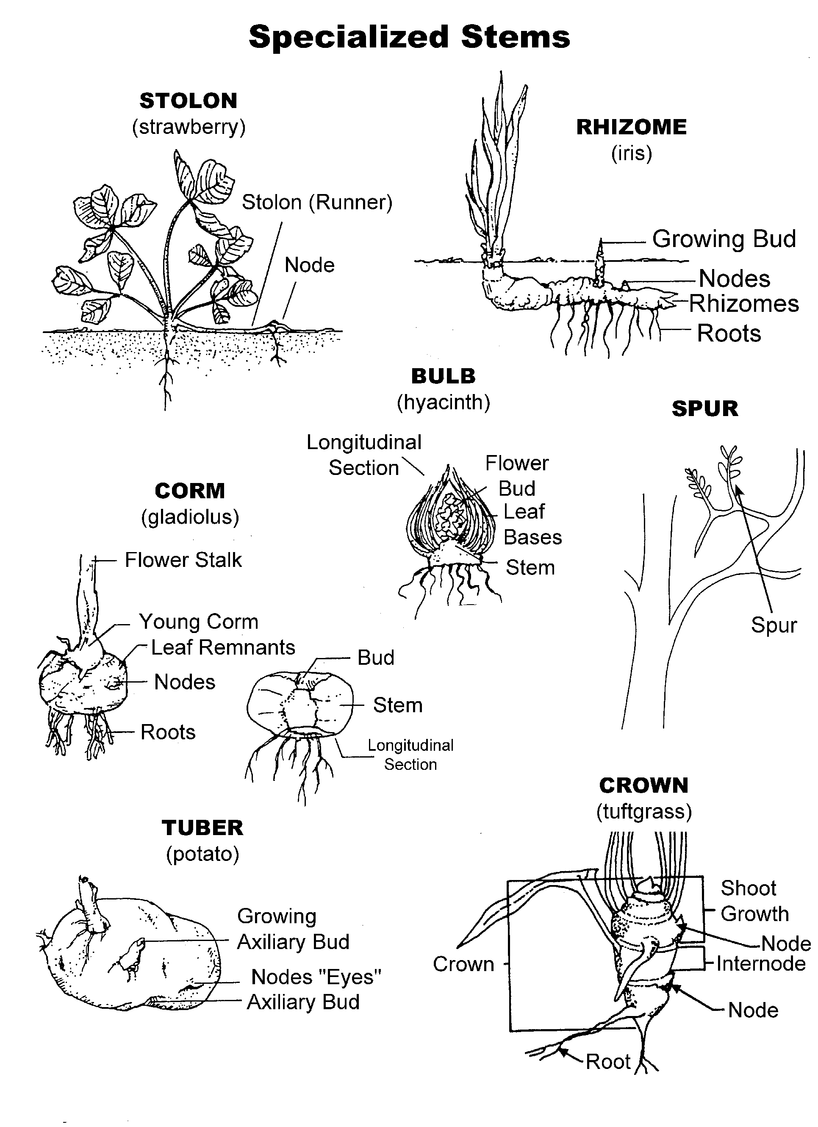

Figure 3.6 - Specialized Stems

In vascular plants, the two basic types of stems are monocots and dicots. The distinction between them is based on how the vascular bundles (xylem and phloem tissues) are arranged. In monocots, the vascular bundles are scattered throughout the inner part of the stem called the cortex. In dicots, the vascular bundles are arranged in a ring. Within the center of the stem, there is a region made up of specialized tissues (parenchyma cells) called the pith. Monocots do not have pith. Dicots, on the other hand, have pith in the center of the stem.

Specialized stems grow above or below the ground, not upright or vertically as other stems. These modified stems include corms, tubers, bulbs, crowns, spurs, rhizomes, and stolons. See Figure 3.6.

Corms grow underground and have thickened, dense stems; they are found only in some monocots such as gladiolus and crocus. The stems of tubers grow underground and are swollen; they can store food for plants such as yams and white potatoes. Bulb stems are compressed, thickened stems and have modified leaves that wrap around the stem to form the bulb. Examples of plants that grow from bulbs are onions and tulips.

The compressed stems in crowns are similar to those in bulbs. The leaf and flower buds grow on the crown just above the ground. Some plants produced from crown stems are asparagus and ferns. Spurs are short stems that form on branches of woody plants, such as pears and apple trees.
Rhizome stems are thick and grow horizontally underground. They produce roots on the lower surface and send leaves and shoots aboveground. Iris and bamboo are examples. Stolons, or runners, grow horizontally aboveground, with the roots forming at the nodes. Strawberries have stolons.

Functions, Structure, and Types of Leaves

Figure 3.7 - Cross-Section of a Leaf
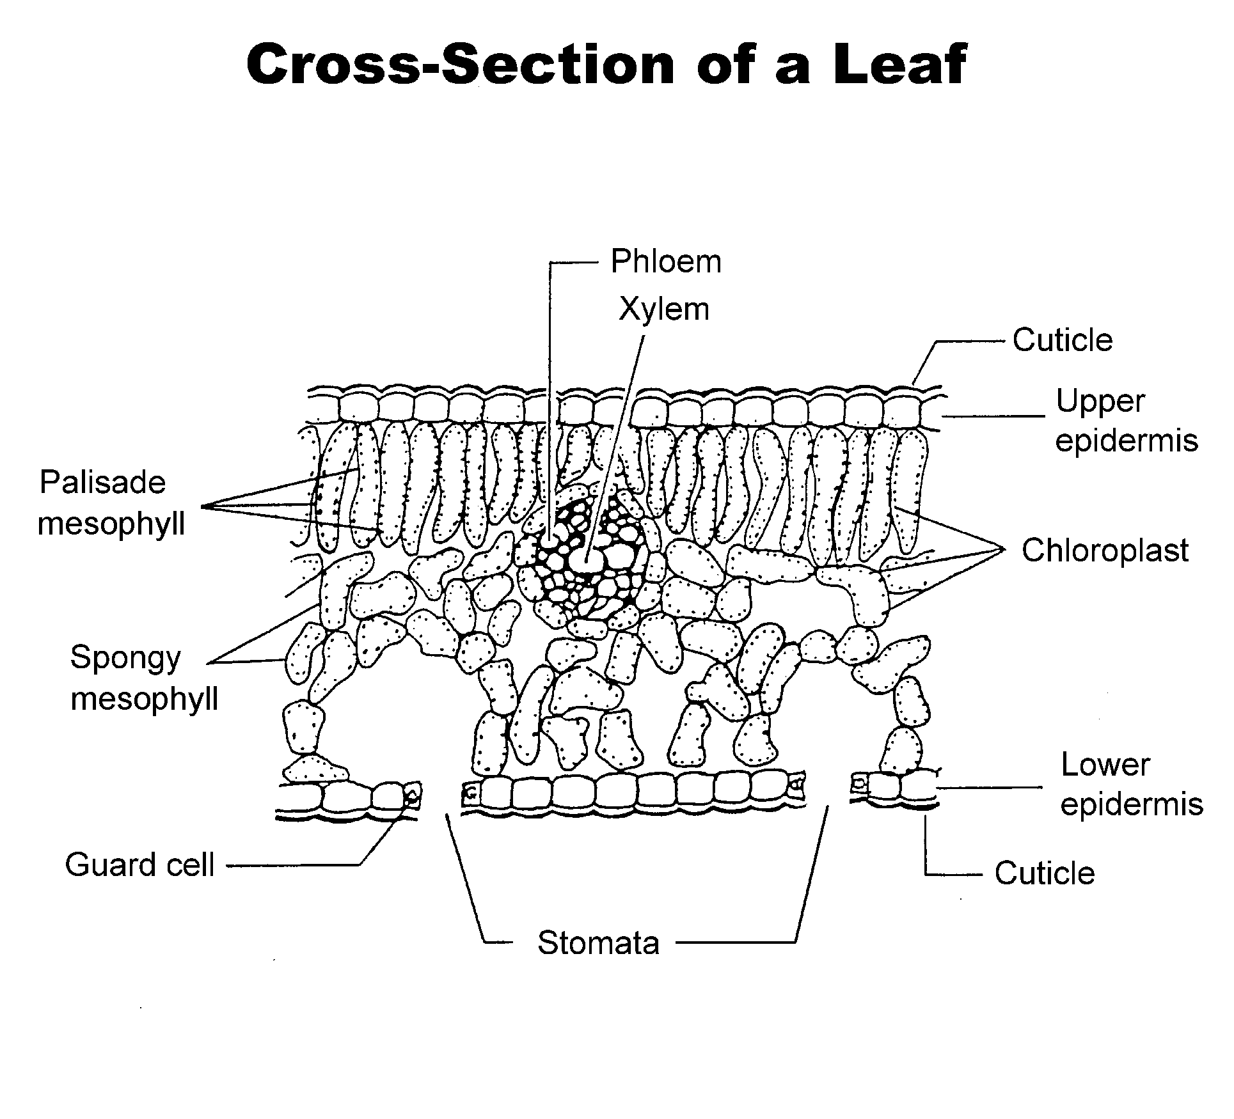
The functions of leaves are to manufacture food through photosynthesis and to protect the vegetative and floral buds. Bud scales (catphylls) are actually modified leaves that protect buds during its dormancy, typically in winter. Juniper and mangoes are examples. Floral bracts (hyposophylls) protect flowers and the seed area while the plant develops; they may be leafy (e.g., poinsettia) or fleshy (e.g., globe artichoke). Another function of leaves is to store food. Cotyledons store food while the seed germinates and until the plant matures and begins photosynthesis.

The internal structure of the leaf is illustrated in Figure 3.7. On the upper and lower surfaces of the leaf is the epidermis, which is made up of the cuticle. The cuticle is a waxy substance covering the epidermis that protects the leaf by keeping water inside the plant. Stomata are tiny openings in the epidermis, usually found on the underside of the leaves. These pores facilitate the exchange of carbon dioxide, oxygen, and water vapor. Submerged plants, such as water lilies, do not have stomata. Guard cells surround each side of the stomata and open and close these pores in response to the amount of light or water available. If the plant does not have the necessary ingredients to produce food (sufficient light or water), the guard cells close the stomata.

The mesophyll layer is made up of palisade cells and a spongy layer. The palisade mesophyll contains vertical, elongated cells that are under the upper epidermis. Palisade cells provide strength to the leaf. Leaf cells contain chloroplasts (chlorophyll), the primary site for

photosynthesis. Between the palisade mesophyll and the lower epidermis is the spongy layer. It is a mass of irregularly shaped cells that has air spaces
between each cell. The spongy layer gives the leaf flexibility. It also contains chloroplasts. The vascular bundle is within the spongy layer. Phloem tissues move food from photosynthesized cells to the rest of the plant. Xylem tissues move water and dissolved minerals to photosynthesized cells in leaves and the stems.

Figure 3.8 - Leaf Shapes

There are several types of modified leaves. Xeromorphic foliage (leaves adapted for plants that grow in arid conditions) has a thick-walled epidermis covered with a waxy cuticle. This protects the plants (e.g., cacti). Thorns also protect the plants (e.g., honey locusts) with short, hard leaves that have sharp points. Prickles, growing from the epidermis, can be easily removed (e.g., roses).
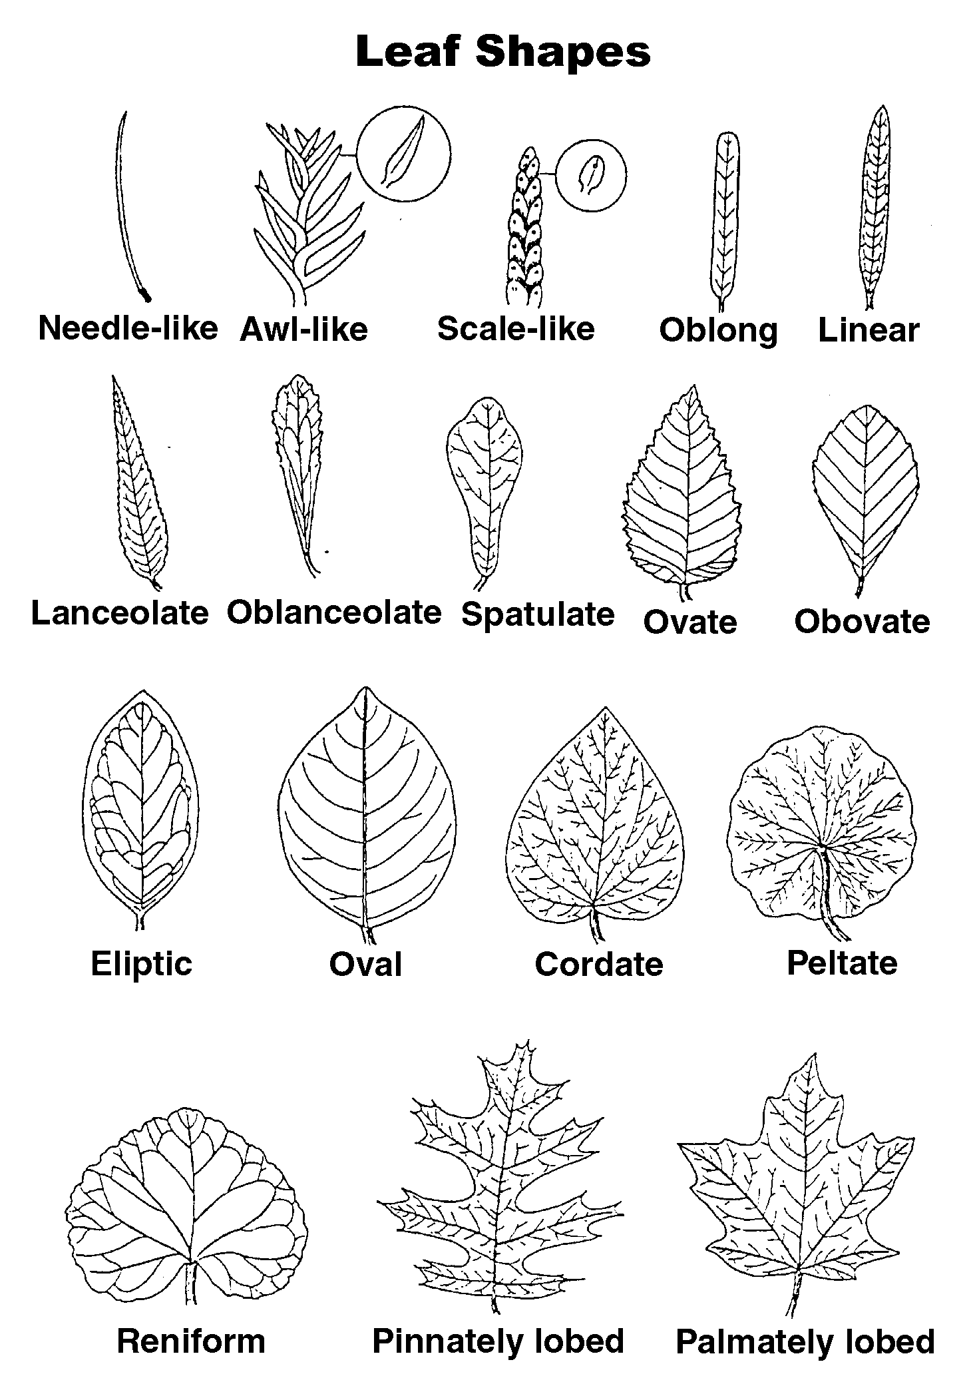

Tendrils are thin, stringy leaves that act as twine to support the plant (e.g., peas and grapevines). Sacs are pouchlike leaves that hold water and capture insects, such as in the Venus flytrap.

A final modification is found in submerged foliage (hydrophytes) - aquatic plants like water lilies. Both the cell walls and cuticles are thin. Because these are underwater plants, the leaves do not have to conserve moisture. The chambers in the spongy mesophyll trap internally generate gases, enabling leaves of hydrophytes to float.

Being familiar with the many sources of available plants helps the greenhouse owner select the best crops for his or her operation. Identifying various features of leaves, such as their shapes, is part of this decision-making process. Figure 3.8 depicts some leaf shapes, along with their technical terminology.

Leaves can also be identified by their edges, known as “margins.” This refers to whether the outside edge of the leaf is toothed, smooth, lobed, or in a combined pattern. See Figure 3.9.

Figure 3.9 - Leaf Margins

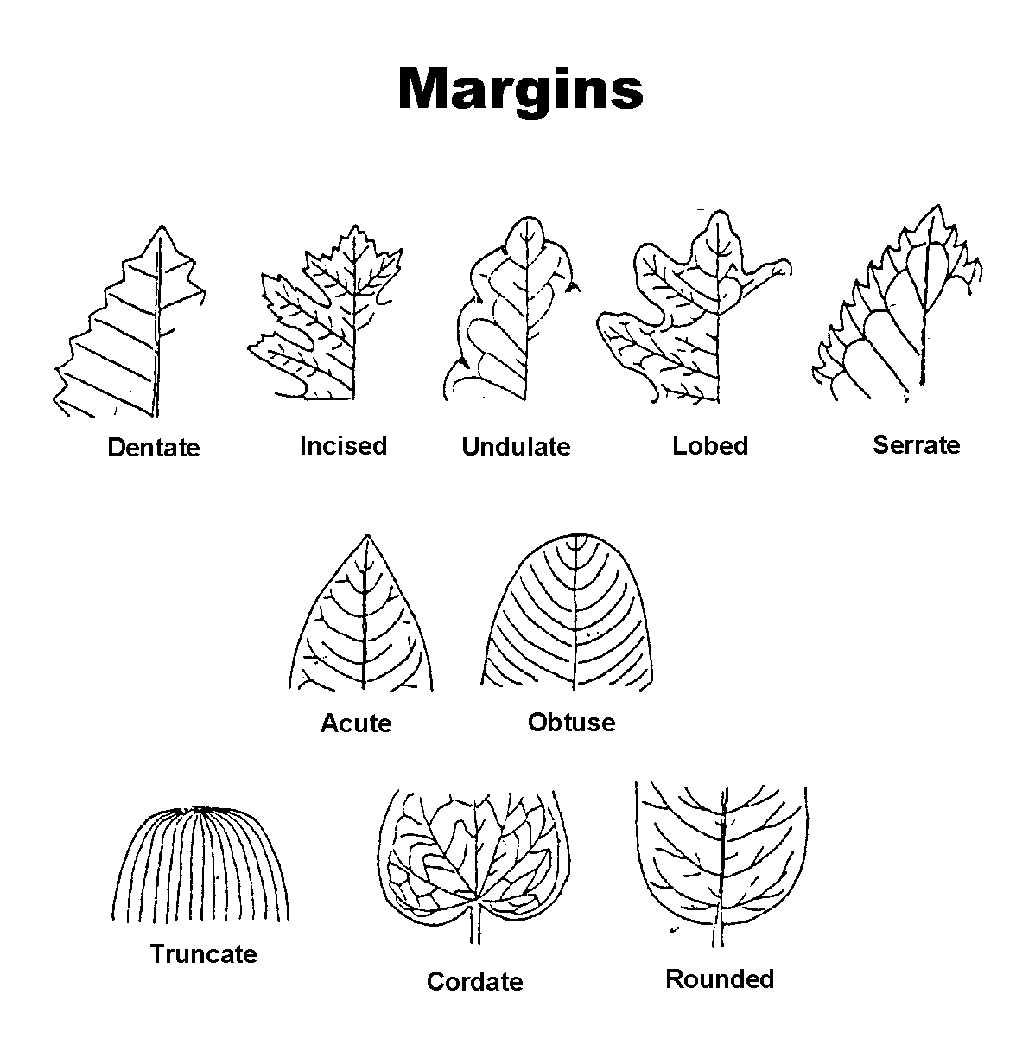

Another factor to consider is how leaves are arranged. The three basic leaf arrangements are alternate (in a staggered pattern), opposite (in pairs), and whorl (around stem at each node). Leaves are also categorized as simple and compound. Figure 3.10 illustrates these arrangements.

Figure 3.10 – Leaf Attachments

Functions, Parts, and Types of Flowers
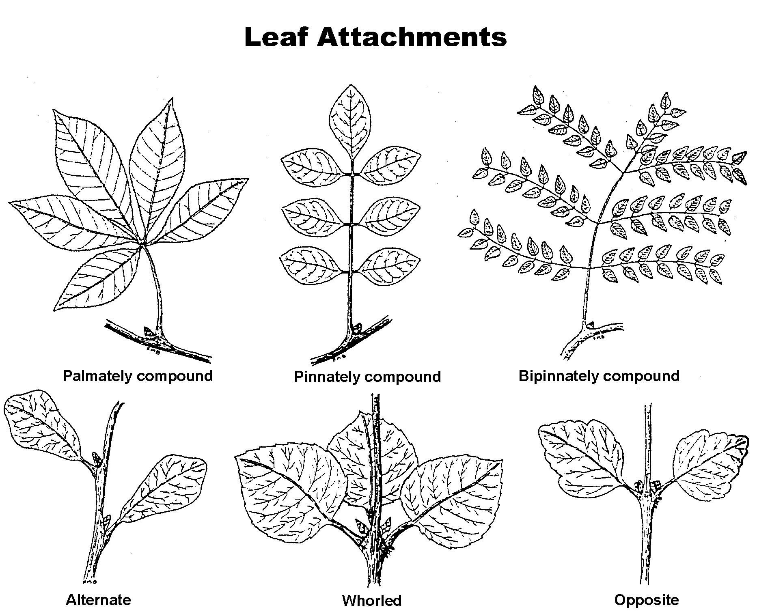

The primary function of flowers is to produce seeds - essential for the propagation of the species- that eventually develop into fruit. The major parts of a flower are illustrated in Figure 3.11.

The sepal (collectively known as “calyx”) protects the emerging flower. It is the outer covering of the flower bud. Sepals protect stamens and pistils when they are in the bud stage.
The stamen contains the male reproductive parts (androecium) of the flower and is composed of two structures: the anther that produces pollen grains and the filament that supports the anther.

The brightly colored and fragrant petals (collectively called “corolla”) attract pollinating

insects. Petals protect stamens and pistils in the bud stage and usually fall soon after pollination.
The pistil contains the female reproductive parts (gynoecium): the stigma, style, and ovary. The stigma receives and contains the grains of pollen. The style connects the stigma to the ovary and supports the stigma so that it may be pollinated.
Found at the bottom of the pistil, the ovary is an enlarged structure that produces ovules, which develop into seeds if they are fertilized.

The types of flowers are determined by how they grow. Flowers can grow either individually as solitary plants or as a bunch or cluster, called “inflorescence.” Three types of inflorescence are head (e.g., daisy), spike (e.g., gladiolus), and umble (e.g., onion).

Flowers are “complete” if they contain both male and female parts with all four parts of a flower present. These flowers are usually self-pollinating. In contrast, incomplete flowers have one or more flower parts missing. The flower is either male or female and must therefore cross-pollinate.
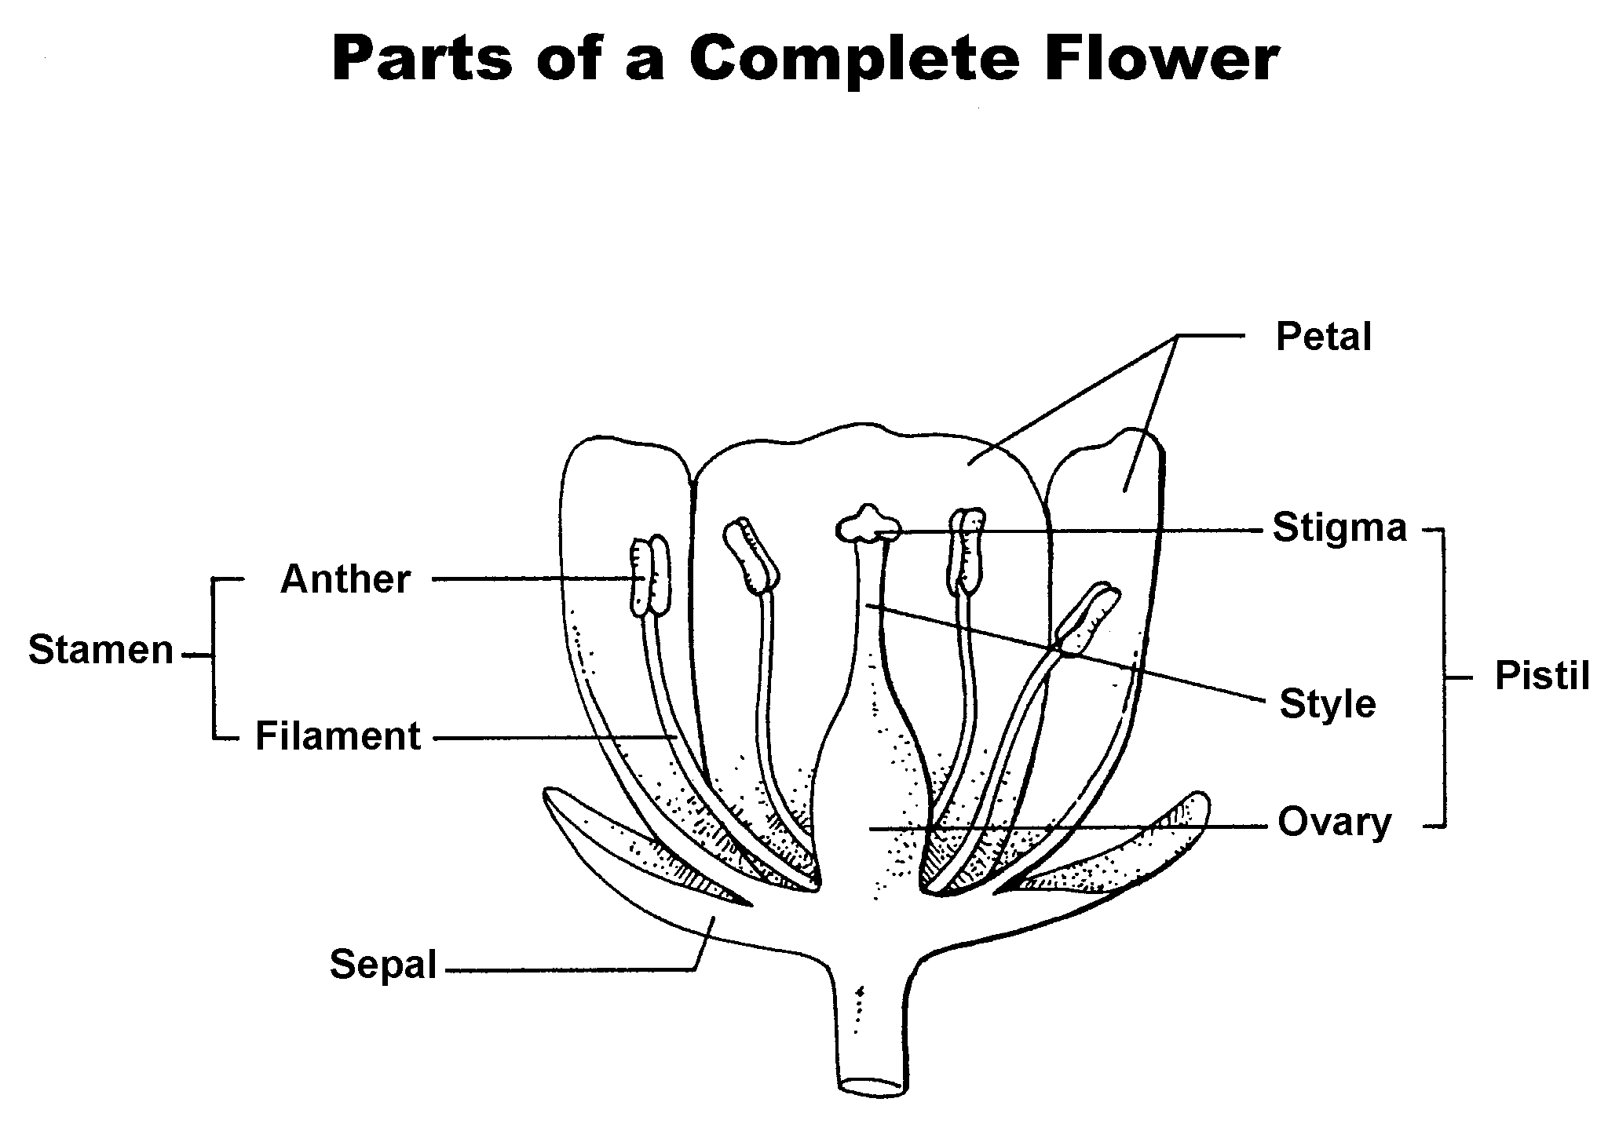
Figure 3.11 - Parts of a Complete Flower

Monoecious vs. Dioecious Plants

Monoecious plants have both male and female flowers on different parts of the same plant. Pollination can occur on the same plant, such as with cucumbers and corn. However, dioecious plants are either male or female. Pollination requires both a male and a female plant in proximity. Holly and asparagus are dioecious plants.

Summary

Understanding plant parts, structures, and functions is critical to a successful greenhouse operation. A basic study of plant anatomy can assist the greenhouse owner as he or she plans which plants to grow. This lesson described specific components of plant cells and tissues and also detailed the functions and types of seeds, roots, stems, leaves, and flowers. This information provides the basis for Lesson 2 - Plant Processes.

Credits

Acquaah, George. Horticulture: Principles and Practices. Upper Saddle River, NJ: Prentice Hall, 1999.

Boodley, James W. The Commercial Greenhouse, 2nd ed. Albany, NY: Delmar Publishers, 1996.

Cooper, Elmer L. Agriscience: Fundamentals & Applications. 2nd ed. Albany, NY: Delmar Publishers, 1995.

Greenhouse Operation and Management (Student Reference). University of Missouri-Columbia: Instructional Materials Laboratory, 1990.

Herren, Ray V. and Roy L. Donahue. The Agriculture Dictionary. Albany, NY: Delmar Publishers Inc., 1991.

