UNIT III: Plant Science Basics

Lesson 2: Plant Processes

Lesson 2 applies information from the previous lesson to the five basic life processes that plants undergo during growth: photosynthesis, respiration, absorption, translocation, and transpiration. Each of these processes is discussed below.

Photosynthesis

Photosynthesis is vital to life on Earth. It affects oxygen content in the environment, supplies food to animal life, and provides fossil fuels. The yield of more than 90% of all horticultural plants is realized through photosynthesis. Figure 3.12 illustrates the sequence of events in which a green plant uses sunlight to convert carbon dioxide and water into simple sugars, thereby releasing oxygen.

Figure 3.12 - Photosynthesis

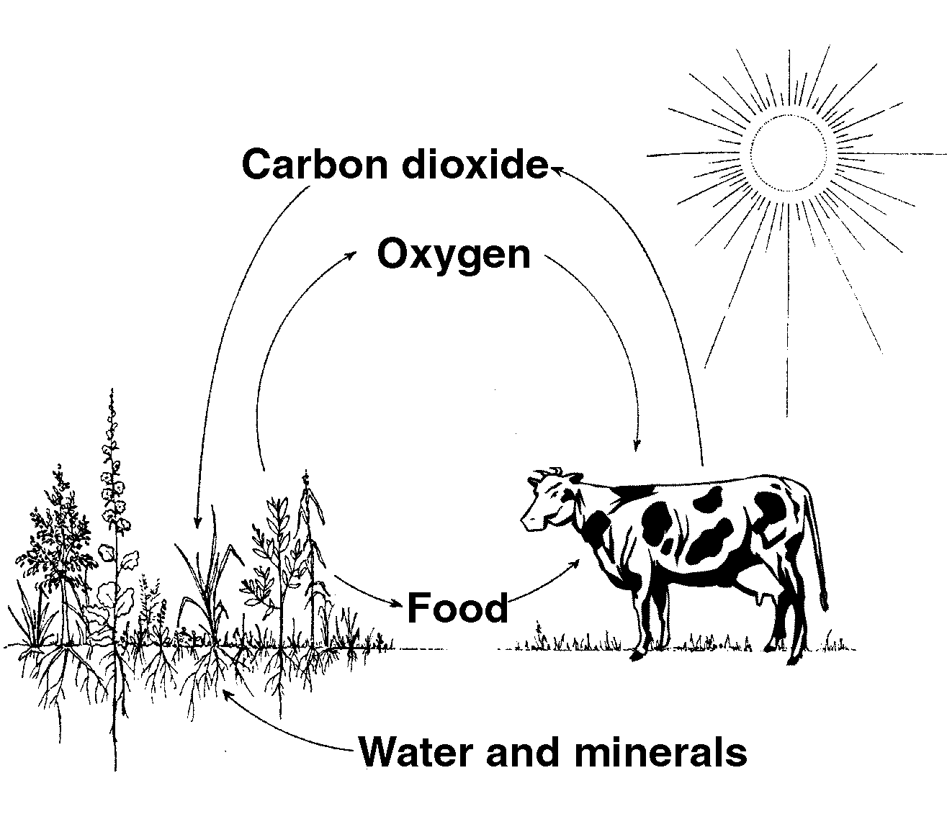
The process of photosynthesis is expressed by the following formula:

6 CO₂ + 6 H₂O chlorophyll > C₆H₁₂O₆ + 6 O₂
light energy
CO₂ from the air enters the plant through the stomata, which are mainly on the leaves. Hair roots absorb water from the soil; the water then moves up to the leaves via the xylem tissues. Sunlight shines upon the chlorophyll (chloroplasts) in the mesophyll cells, which are found in the stem and leaves. As a result, energy from the sun is absorbed. This triggers a chemical reaction between hydrogen in the water and carbon dioxide. Glucose, a simple sugar, is created and transported through the phloem tissues to other parts of the plant. Oxygen is then released through the stomata.

Several environmental factors affect photosynthesis. Temperature influences the rate at which chemical reactions occur within the plant. The optimal temperature is 65-85ºF (18-27ºC). High temperatures can force respiration to rise. Low temperatures delay flowering and slow growth. If the water supply is limited, the stomata close down. This diminishes the availability of carbon dioxide and therefore decreases the rate of photosynthesis.

Light’s intensity and duration also impact photosynthesis. If the light is extremely intense, the rate of photosynthesis may decline due to a lack of CO_{2.} When photosynthesis occurs rapidly, plant cells consume and reduce the amount of CO₂. To compensate for this loss, greenhouse owners frequently use an artificial supplement called a carbon dioxide fertilizer, which is made by burning propane or methane or by using liquid CO₂.

Another important environmental factor is the plant’s photoperiod - the length of daylight available per day. Plants grow faster with an extended exposure to light; growth slows if light is indirect and of shorter duration. A final factor that influences photosynthesis is the plant’s growth and development. The rate of photosynthesis in a young, emerging leaf is typically slower than in mature leaves.

Respiration

Respiration, occurring within the plant’s cells, is the reverse process of photosynthesis. Oxygen from the air is used to metabolize molecules into carbon dioxide and water. Glucose breaks down and releases energy needed for plant growth, absorption, translocation, and other metabolic processes. Respiration enables plant cells to release energy that is used in many chemical reactions within cells. Water and carbon dioxide are released into the air. Respiration does not rely on daylight; it also occurs at night. Table 3.1 summarizes the contrasts between photosynthesis and respiration.

Table 3.1 - Photosynthesis vs. Respiration

Photosynthesis | Respiration
Produces food | Uses food for plant energy
Stores energy | Releases energy
Occurs in cells with chloroplasts | Occurs in all cells
Releases oxygen | Uses oxygen
Uses water | Produces water
Uses carbon dioxide | Produces carbon dioxide
Occurs in sunlight | Occurs in sunlight and darkness

Absorption

Absorption is the process in which hair roots take up water and dissolved minerals from the growing medium through osmosis - the movement of molecules across a cell’s membrane from a higher concentration to a lower concentration. Water moves from the roots and through the plant via the xylem vessels.

Translocation

During this process, water and nutrients move within the plant. Translocation occurs within the vascular system. Xylem tissues pull water upward from the roots; phloem tissues move food (glucose) from leaves to the root system and the rest of the plant

Transpiration

Through transpiration, the plant loses water primarily through evaporation from the leaf surfaces (sometimes from stems and petals). This process occurs when the stomata open to take in CO₂. Guard cells regulate transpiration. Pressure in the plant cells is reduced. Some environmental factors affecting the rate of transpiration are light, temperature, humidity, and wind. An increase in temperature accelerates the rate of transpiration, produces more carbon dioxide, and causes greater CO₂ concentration in the leaves. As a result, the stomata close at high temperatures. Low humidity slows the rate of transpiration. Wind prevents water vapor from accumulating on leaves and therefore increases transpiration.

Summary

Five processes are instrumental to plant growth: photosynthesis, respiration, absorption, translocation, and transpiration. Of all the plant processes, photosynthesis is fundamental to the survival of all living things. The remaining processes serve the plant’s development by releasing energy within the cell (respiration); transporting water and dissolved minerals to the roots (absorption); moving water, dissolved minerals, and glucose within the plant (translocation); and dissipating water through evaporation (transpiration). By understanding these vital plant processes, the greenhouse owner can maximize the efficiency and productivity of the operation.
Credits

Acquaah, George. Horticulture: Principles and Practices. Upper Saddle River, NJ: Prentice Hall, 1999.

Cooper, Elmer L. Agriscience: Fundamentals & Applications, 2nd ed. Albany, NY: Delmar Publishers, 1995.

Greenhouse Operation and Management (Student Reference). University of Missouri-Columbia: Instructional Materials Laboratory, 1990.

