UNIT III: Plant Science Basics

Lesson 3: Plant Classifications and Nomenclature

A rich diversity of plants is available for greenhouse operations. In deciding which crops to grow, the greenhouse owner must understand basic traits of plants and be able to identify them. Lesson 3 classifies plants according to their characteristics and purpose and explains how plants are categorized. Refer to Lesson 1 in this unit for details about plant parts, structures, and functions.

Plant Characteristics

The two aboveground stem types are herbaceous and woody. The word herbaceous is derived from “herbs,” which may be associated with aromatic plants such as oregano and basil that flavor food. In this context, however, herbaceous refers to plants that have soft, nonwoody stems. They are often green and will not survive the winter. Corn, several other vegetables, and assorted potted plants have herbaceous stems.
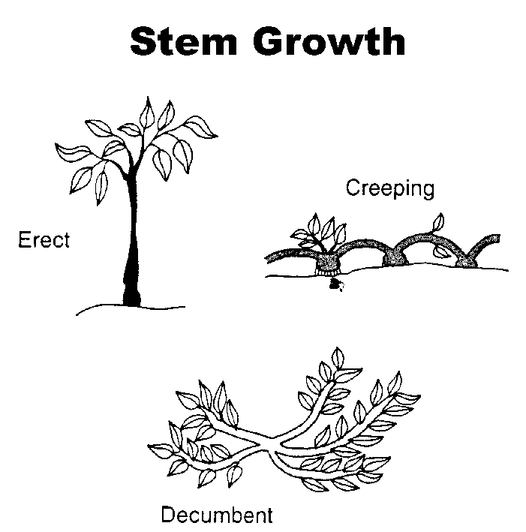

Woody stems are found in trees and some shrubs. As the single, main trunk in trees, the stem branches out from the upper part of the plant. As part of a shrub that does not have a trunk, the woody stem grows from the ground level. These types of trees and shrubs have secondary tissues that provide strength. Because woody stems are very tough, they can survive harsh winters. Buds of woody plants survive aboveground during the winter.

Stem growth is classified according to the stem’s position on the ground. Climbing (creeper) stems are vines that grow on the ground without additional support. There are three types of climbing stems. Twiners, such as found in sweet potatoes, have stringy stems. Adventitious roots, found on English ivy, grow on the aerial parts of the plant. Tendrils are coiling, cylindrical structures, such as found in garden peas.

Erect stems, found in trees and cultivated bushes, require no artificial support. They stand 90º to the ground and may sway slightly in response to strong winds. Decumbent stems (e.g., peanuts) are dramatically inclined toward the ground with the plant’s tips raised. Figure 3.13 illustrates the three modes of stem growth.

Figure 3.13. - Stem Growth

Fruit is characterized as either fleshy or dry. Fleshy fruit is soft and has internal seeds. Two major types of fleshy fruits are pomes and drupes. The ripened tissue of pomes (e.g., pears and apples) develops into a core; the seeds are embedded within the fruit. Drupes have a large, hard seed inside, called a stone, and a fairly thin outside skin. Examples of drupes are peaches, cherries, and plums. Dry fruit has one seed whose covering becomes brittle and hard when the fruit ripens. Sunflowers, peas, and nuts are dry fruits.

To accommodate the scope of the retail or wholesale operation, the greenhouse owner selects plants based upon their life cycle. Annuals grow quickly and complete their life cycle in 1 year. Most vegetables (except rhubarb, parsley, and asparagus) are annuals. Climate and season of the year are associated with two types of annuals. After the last spring frost, summer annuals (e.g., petunias, marigolds, and tomatoes) are planted and continue to grow until fall. Cold temperature and frost harm these annuals. In contrast, fall is when winter annuals are sown. These cold- tolerant plants mature during early spring. Examples of winter annuals are spinach, broccoli, and pansies. In Missouri, examples of winter annuals include kale, turnips, collards, and rutabaga.

The life cycle of biennials is within 2 years. Leaves, stems, and roots grow during the first year and become dormant during the winter. Flowers and fruit emerge in spring and then die. Cabbage, beets, hollyhocks, and sweet williams are common biennials that are grown as annuals in Missouri.

Perennials continue to grow from year to year. Herbaceous perennials with aboveground stems die during the winter; new leaves and shoots emerge at springtime. Woody perennials (vines, trees, or shrubs) are alive all year, but growth is slowed or enters dormancy.

Foliage refers to leaves or needles. Deciduous trees, such as maple, ash, and birch, lose their foliage. This loss may be sudden or gradual and is in response to change in temperature. Evergreens (e.g., spruce and pine trees) retain their needles throughout the year. Perennials (both herbaceous and woody) may be either deciduous or evergreen.

Another characteristic to consider is the plant’s hardiness. This trait refers to how well the plant can sustain diverse environmental factors, particularly very low temperatures. A hardy plant can withstand temperature extremes; half-hardy plants tolerate moderately low temperatures but not periods of severe freezing. These plants need protection from frost. Some fruit trees (e.g., apple, pear, peach, and cherry) can thrive in cold temperature zones such as in the Midwest and West and are considered hardy tree fruits. In contrast, tropical and subtropical fruit trees (e.g., orange and grapefruit trees) require a warm climate such as in Florida or California.

A tender plant is sensitive to extreme temperatures and cannot withstand severe frost. The seeds of tender annuals do not survive winters that have prolonged periods of below-zero temperatures.

Plant Purpose

Whether used in retail or wholesale operations, plants are grown for a particular purpose. They may be cultivated as edible crops or developed as ornamentals. Raising edible crops (fruits and vegetables) in an environmentally controlled greenhouse ensures steady production throughout the year. Thanks to the regulated temperature, humidity, and lighting, crops thrive and mature on an ongoing basis. This stimulates sales. Understanding the plants’ traits and growth cycles helps the greenhouse owner select which edible crops will maximize production. (The next unit provides additional information about what plants need for successful development.)

Ornamentals (flowers, shrubs, and foliage plants) are grown purely for their beauty. The purpose for growing these plants is to enhance landscape, whether at home or for various businesses.

Scientific System of Classification and Naming

The science of identifying, naming, and classifying organisms is known as “taxonomy.” Plant taxonomy is composed of seven basic categories, arranged from the most general to the most specific. Figure 3.14 lists this structure.

Figure 3.14 - Major Classification
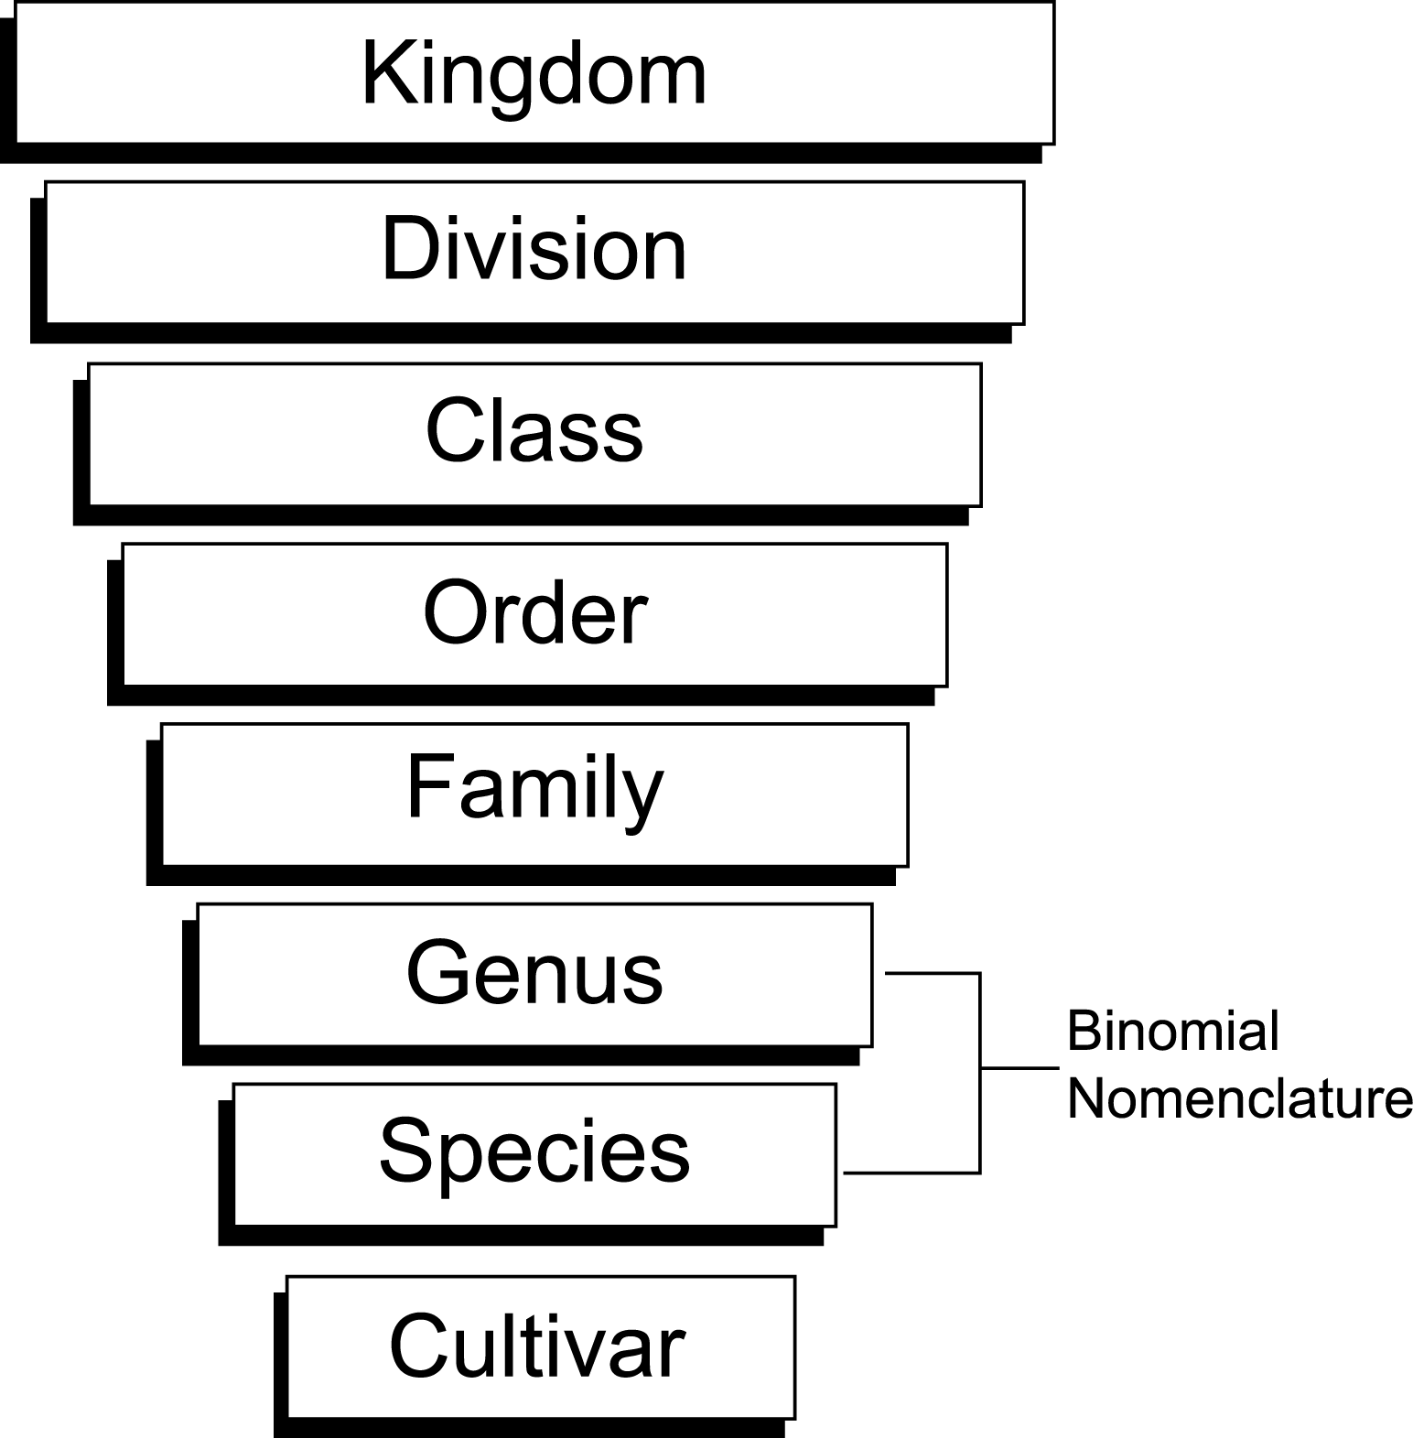

Some of the taxonomy’s basic categories can be subdivided: subphylum, subclass, suborder, and subspecies. Table 3.2 lists the taxonomy of the petunia, including its subphylum.

Table 3.2 - Taxonomy of the Petunia

Kingdom | Plantae
Phylum | Embryophyta
Subphylum | Angiosperm
Class | Dicotyledonae
Order | Tubiflorea
Family | Solanaceae
Genus | Petunia
Species | hybridea

Botanists (plant scientists) use a binomial nomenclature (two-part name) to identify plants. Developed over 200 years ago by Swedish botanist Carolus Linnaeus, this Latin-based system gives each plant a unique name that is understood throughout the world. Binomial nomenclature creates a universal language for plant identification. No confusion arises from using multiple common names for a single plant.
Binomial nomenclature is made up of the genus and species. Genus is the first part of the binomial. The first letter is capitalized and the entire word is written in italics. It identifies the plant group that shares similar characteristics. The second part is the species name, written in all lowercase letters and italicized. The species provides additional information about the plant, such as its geographic location, origin, and physical characteristics.

A plant can be identified further by its cultivar. The word “cultivar” is a combination of the words “cultivated” and “variety.” Botanists and agronomists (specialists in soils and crop sciences) develop the cultivar; it does not originate naturally in the wild. A cultivar is a subcategory within the species. Hybridization occurs among cultivars of the same species. To indicate a cultivar, the word is usually capitalized and written with single quotation marks or is preceded by the abbreviation “cv.” In the sample taxonomy above, the cv is ‘Blue Moon’.

Summary

By learning key characteristics of plants, the greenhouse owner can determine which plants are suited for his or her operation. Stem types, stem growth, type of fruit, life cycle, foliage, and hardiness are specific traits that affect the owner’s decision. Another factor to consider is whether the plants are used as edible crops or as ornamentals. In order to communicate effectively with other horticulturists, the greenhouse owner must be able to identify each plant without causing confusion. This is accomplished by understanding how plants are categorized and named and by using binomial nomenclature. All individuals who work with plants understand this two-part, Latin-based naming system.
Credits

Acquaah, George. Horticulture: Principles and Practices. Upper Saddle River, NJ: Prentice Hall, 1999.

Cooper, Elmer L. Agriscience: Fundamentals & Applications, 2nd ed. Albany, NY: Delmar Publishers, 1995.

“Fruit Types.” <http://www.resnet.wm.edu/~mcmath/bio205/
fruits.html> accessed 2/4/02.

Gerrish, Jim. “Winter Annual Forages.” Missouri Agricultural Experiment Station, MU College of Agriculture, Food and Natural Resources. <http://aes.missouri.edu/fsrc/news/archives/
n100v9n4a.stm> accessed 5/10/02.

Herren, Ray V. and Roy L. Donahue. The Agriculture Dictionary. Albany, NY: Delmar Publishers Inc., 1991.

Lee, Jasper S., Series Editor. Introduction to Horticulture: Science and Technology, 2nd ed. Danville, IL: Interstate Publishers, Inc., 1997.

