Unit IV: Plant Growth

Lesson 1: Environmental Effects

This unit discusses five aspects of plant growth. Lesson 1 examines the environmental effects of light, temperature, indoor gases, and air quality on plants grown in a greenhouse. Also discussed are plant processes that were detailed in Unit III, Lesson 2. The remaining lessons describe the effect of growing media, irrigation, nutrients, and fertilizer on plant growth.

Light in the Greenhouse

To successfully grow plants in a greenhouse, sufficient light must be available for photosynthesis to occur. Typically, indoor plants require a high concentration of light, but this depends on the species. Greenhouse crops get their source of light either directly from the sun (solar heating) or artificially through high-intensity-discharge (HID) lamps. The advantage of lamps is that they provide light during winter and on cloudy days, and they extend the length of “daylight” for the plants. HID lamps in particular are the most efficient type of supplemental lighting in greenhouses because 27% of the electrical energy is converted to light. These lamps are available in various power ratings. If correctly spaced in the greenhouse, they provide 600-1,000 foot-candles of light (explained below) for a reasonable price.

Light is broadly characterized by its intensity, duration, and quality, as explained below.

Light Intensity

Light intensity refers to brightness and quantity; it is measured in foot-candles (f.c.). One foot-candle equals the amount of light that hits a surface 1 foot away from a standard wax candle. At noon on a clear sunny day, the f.c. value is 10,000. Plants vary in how much light intensity they need, as summarized in Table 4.1. Tropical foliage plants, impatiens, African violets, and ferns favor low f.c. levels, whereas lilies, roses, geraniums thrive at high f.c. levels.

Table 4.1 - Light Intensity Requirements of Plants as Measured in Foot-Candles

Plants’ Required Light Intensity | Foot-Candles
Low | 500-1,2500
Medium | 1,250-2,500
High | More than 2,500

Time of day, location of the window, and season of the year determine the level of light intensity in a greenhouse. The sun’s intensity is greatest at noon. By about 10 a.m. and again at 4 p.m., the longest shadows are cast, so light is less intense. Plants near a southern window receive prolonged exposure to light. A northern exposure offers less light. Because the sun is closer to the Earth during the summer, the light is more intense. During the winter, less direct light is available.

A sufficient amount of light intensity enhances photosynthesis and promotes growth. A healthy plant has thick stems, increased height, a developed leaf area, plentiful roots and flowers, large flowers, rich pigment, and short internodes. (Internodes are parts of the stem or other plant parts that are located between two nodes.) But any extremes in light intensity affect whether plants can thrive in the greenhouse.

If the light intensity is too low, photosynthesis diminishes. This stunts the plant’s growth and creates long internodes that weaken the stems. Flowering is delayed or may stop completely. There is less pigment and leaf area. If light shines on just one side of the plant, the plant bends toward the source of light (phototropism). Its stems also curve to the light, but the roots turn away.

If light intensity is more than 2,500 f.c., it exceeds the plant’s photosynthetic requirements. This accelerates respiration within the cells. As a result, the available food supply (glucose) is substantially depleted. Consequently, the plant’s growth is stunted. Typical adverse effects are reduced pigment, small leaves and flowers, and scorched or dried leaves and flowers. In addition, the flowers become yellow and bleached.

Light Duration

The amount of light received throughout the day - the photoperiod - affects the plant’s growth rate. As stated in the previous unit, plant growth results from photosynthesis; photosynthesis occurs only in the presence of light. Light duration and light intensity are interrelated. The quantity of available light varies with the greenhouse’s latitude and the season of the year. As indicated above, during the summer, light is more intense. The days are long and the nights are short. The photoperiod for summertime plants is long. The reverse is true for plants cultivated during winter: the days are short and nights are long.

The greenhouse owner can increase light duration by using artificial lights and decrease the amount of light by placing dark cloths over the growing structure or above the crop

Plants react to the length and timing of light and darkness (photoperiodic responses) during their major developmental stages: flower bud initiation, bulb and tuber formation, bract coloration, and plantlet formation. Flowering plants are categorized into four types based on their photoperiodic responses: short day (long night), long day (short night), intermediate day, and day neutral. These responses measure the duration of darkness rather than the amount of light the plant receives.
Each type of plant has a certain “critical period” during which it must receive a specific amount of darkness. During this time, plants are also exposed to brief interruptions of light. The most effective time for this “pulse” of light to occur is midway through the period of darkness. Each species has a specific time when this pulse of light is advantageous to its growth cycle.

Under continuous light, short-day (long-night), plants (e.g., poinsettias) do not bloom. A very precise, limited amount of light is required. Long-day (short-night) plants (e.g., asters) typically flower in the summer. Dahlias, another example, produce the desired flowers, not tubers, when nights are short. Intermediate-day plants, such as certain grasses, do not bloom if the days are either too short or too long. A final category, day-neutral plants, responds only to the developmental needs of the plant, not to the photoperiod. Corn, cucumbers, and tomatoes belong in this group.

Light Quality

Quality of light refers to the spectrum of color - wavelength - as measured in nanometers (nm). Figure 4.1 shows the wavelength of light with respective nanometer values and the corresponding rays for each band of color. The sequence of the colors is determined by the wavelength of light. Wavelengths longer than red are called “infrared”; wavelengths shorter than violet are “ultraviolet.”

Figure 4.1 - Radiant Light Spectrum
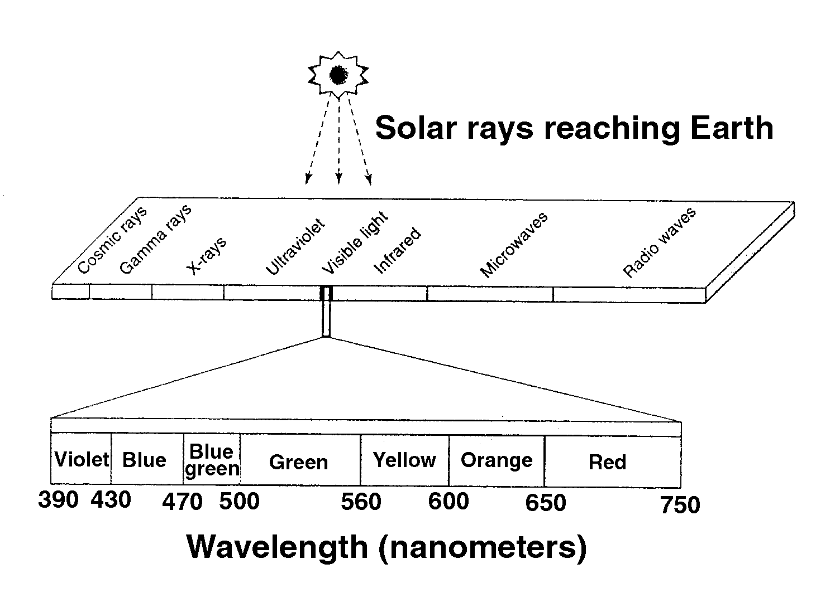
Ultraviolet (UV) light has a very short wavelength and is invisible. UV light is very damaging; excessive levels stifle photosynthesis and injure parts of the plant. Plants grown in high altitudes receive too much UV radiation; as a result, their growth is stunted. Installing appropriate coverings that screen out damaging rays compensates for excessive UV light.

White (visible) light is actually a combination of all the colors in the spectrum. Photosynthesis uses only selected wavelengths.

If plants are grown only under blue light, photosynthetic activity is extremely high. The plants are shorter, darker, and have hardened tissues. Blue light stimulates stem length and strength, increased branching, and color in the leaves and flowers.

The wavelength of green light provides very low photosynthetic activity. This is because chlorophyll - a green pigment essential to photosynthesis - absorbs all visible wavelengths except green. Green is reflected and thus is easily detected.

Red light provides very high photosynthetic activity. Plants grow readily, stems elongate, and seeds germinate rapidly. In addition, red light is the most effective wavelength for interrupting the critical period in long-day plants.

Far-red light (higher nanometer value than red light) promotes flowering in short-day plants and inhibits flowering of long-day plants. Infrared light is invisible. Its heat causes overheating within plant cells; consequently, the stomata close and photosynthesis ceases.

Temperature

Each plant’s ability to grow depends on specific temperature levels. If the temperature is below the minimum level, growth slows, flowering is delayed, and the color of leaves and flowers intensifies. If the temperature is above the maximum level, general growth is inhibited and causes premature smaller flowers, smaller leaves, reduced stem diameters, and diminished coloring. The optimum temperature is the level at which growth is the greatest. Temperature also influences the developmental processes described below.

Seed germination is greatly affected by temperature. Typically, the optimum air temperature is 60-70ºF (15-21ºC). Heating the bottom of the benches that support the plants increases the rate of germination. Each crop varies in its heat requirements for germination. The greenhouse owner can maximize the operation by identifying the correct temperature for each crop.

Temperature is an important factor in photosynthesis. The minimum temperature varies among plant species. The maximum temperature is usually 95ºF (35ºC). The growth rate increases as the temperature rises until 95ºF is reached. When the temperature exceeds 95ºF, the growth rate drops quickly and then stops completely because enzymes are deactivated. (Enzymes are large, complex proteins that activate chemical reactions within cells.) The optimum temperature in most plants is 50-75ºF (10-24ºC).
Other plant processes respond to temperature. Respiration increases with the rise of temperature. This depletes the food supply needed to fuel cellular metabolism. At extremely low temperatures (32-34ºF) (0-1ºC), the respiration rate slows enough to keep plants, cut flowers, fruits, and vegetables fresh for extended periods. This gives the greenhouse owner more time to display crops in retail operations.

The rate of transpiration increases as the temperature of the leaf rises. The leaves are sensitive to warm or cold air currents and drafts, cold air radiating from the greenhouse’s sides on cold nights, and condensation (moisture on leaves that is colder than the air).

Gaseous Elements

Several gases found inside the greenhouse affect plant growth. Oxygen is essential for plant respiration. Adequate amounts occur naturally. Carbon dioxide is a key ingredient in photosynthesis. CO₂ promotes plant growth and flowering. Through plant respiration and the decay of organic matter, sufficient amounts of CO₂ occur naturally in the greenhouse. However, if the fans are turned off, hindering air circulation, the amount of CO₂ is limited. The greenhouse owner can adjust inadequate levels of CO₂ by installing a CO₂ generator. (Refer to Unit II, Lesson 2.)

Water vapor (humidity) is also important to the greenhouse’s internal climate. The optimum relative humidity (RH) in most greenhouses is 45-85%. High RH (over 85%) promotes fungal diseases; low RH can increase transpiration and stunt plant growth. Low RH produces shorter plants, fewer new shoots, less leaf growth, smaller flowers, and stiff upright stems. The greenhouse owner can increase the relative humidity by installing a humidifier and placing trays of water under the benches.

The greenhouse may contain detrimental air pollutants that impair plant growth and crop yield and also harm personnel. Some of these harmful gases are listed in Table 4.2.

Table 4.2 - Greenhouse Air Pollutants

Air Pollutants
Ammonia
Asbestos
Chlorine
Ethylene
Fluoride
Mercury

Natural gas
Nitrogen dioxide
Peroxyacetyl nitrate
Pesticides
Sulfur dioxide
Wood preservatives

Soil with organic matter that is pasteurinzed through steam releases ammonia, which is detrimental to plants. Asbestos particles suspended in the air damage the lungs. Any ceiling tiles or building materials containing asbestos should be replaced. If released from an aerosol can, chlorine and fluorine destroy ozones. (Ozone is a form of oxygen found above the Earth’s surface that filters out harmful ultraviolet rays.)

Ethylene is a toxic gas found most often in greenhouses. It is produced when exhaust gases from unit heaters accumulate but cannot escape. Greenhouses heated with natural gas also produce pollution. Both of these pollutants can be eliminated with an ample exchange of outside air into the greenhouse. Mercury is found in various control devices in the greenhouse, e.g., high-intensity-discharge lamps. If such a device breaks and the mercury spreads over the floor, contamination may occur.

Nitrogen dioxide from outside automobile exhaust fumes can adversely affect greenhouse-grown plants if there is improper ventilation. Pesticides intended to rid plants of diseases may be toxic if excessive and concentrated amounts are applied. Wood preservatives containing creosote and pentachlorophenol are also toxic to plants.

Summary

Light, temperature, gaseous elements, and air quality are environmental factors that influence plant growth within the greenhouse. Identifying plants’ unique environmental requirements and devising specific approaches to meet them help ensure healthier and more profitable crops for the greenhouse owner.

Credits

Acquaah, George. Horticulture: Principles and Practices. Upper Saddle River, NJ: Prentice Hall, 1999.

Boodley, James W. The Commercial Greenhouse, 2nd ed. Albany, NY: Delmar Publishers, 1996.

Cooper, Elmer L. Agriscience: Fundamentals & Applications. 2nd ed. Albany, NY: Delmar Publishers, 1995.

Farabee, M.J. “Photosynthesis.” <http://gened.emc.maricopa.edu/bio/bio181/
BIOBK/BioBookPS.html> accessed 2/1/02.

Greenhouse Operation and Management (Student Reference). University of Missouri-Columbia: Instructional Materials Laboratory, 1990.

Herren, Ray V. and Roy L. Donahue. The Agriculture Dictionary. Albany, NY: Delmar Publishers Inc., 1991.

Koning, Ross E. “Light Relations.” Plant Physiology Website. 1994. <http://koning.ecsu.
ctstateu.edu/plants_human/ light.html> accessed 1/31/02.

“Photoperiodism and Phytochrome.” <http://www.ultranet.com/~jkimball/
BiologyPages/P/Photoperiodism.html> accessed 1/31/02.

“Radiant Energy.” <http://www.ultranet.com/~jkimball/
BiologyPages/R/RadiantEnergy.html> accessed 1/31/02.

“Seed Germination.” <http://149.152.32.5/Plant_Physiology/Seedgerm.htm> accessed 1/31/02.

“The Study of Biological Rhythms - Photoperiodism.” <http://www.mrs.umn.
edu/~goochv/BioRhyt/Lectures/photoperiodism/
photoperiodism.html> accessed 1/31/02.

