Unit IV: Plant Growth

Lesson 2: Growing Media and Containers

Growing media - the materials in which plants are cultivated - are fundamental to successful crop production. Plants depend upon soil-based media or specialized mixtures (“soilless” media) for development. This lesson focuses on the importance of growing media and highlights the qualities of soilless mixes. Information about types and materials of growing containers is also presented.

Importance of Growing Media

As the material in which plants grow, the growing medium provides essential nutrients to the roots by absorbing minerals and water. Its key functions are to secure the roots so the plant is upright and to facilitate the exchange of oxygen and CO₂, required for plant growth. In order to promote growth, the medium should hold enough water at the roots (water-holding capacity) and be able to drain properly.

Loose, well-aerated medium results when there is enough air space at the roots. This is known as “porosity”: tiny openings (pore spaces) between solid particles. The total amount of pore space determines how well the growing medium can retain air and water. Levels of available oxygen are a function of porosity: inadequate pore space means that a shortage of oxygen develops when too much water is supplied. The size and distribution of individual pores determine the rate of gas exchange and drainage. This influences the effectiveness of the growing medium. The ideal medium has a mixture of large and small pore spaces.
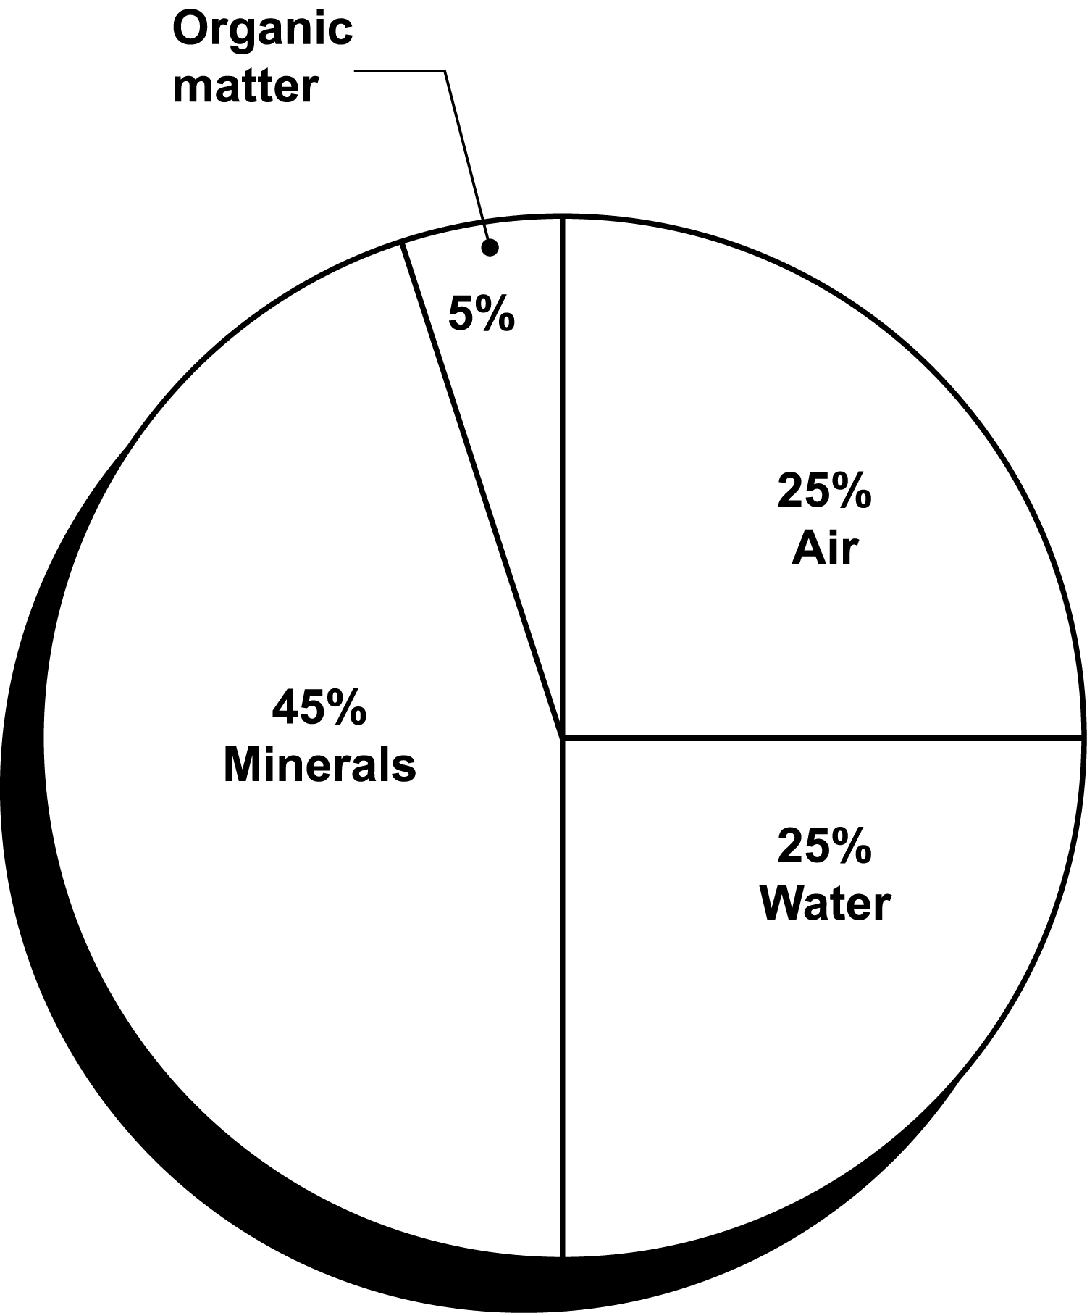

The growing medium’s temperature impacts the activity of microorganisms (e.g., soil bacteria, fungi, insects) and the absorption rate of water and fertilizer. When the temperature ranges from above 32ºF (0ºC) to slightly over 110ºF (44ºC), the greatest amount of activity occurs. At that point, microorganisms convert organic nitrogen fertilizers in the soil to forms that can be readily absorbed. (See Lesson 5 in this unit.)

Desirable features in the growing medium are that it be loose and well aerated, have a suitable pH level and cation exchange capacity, and drain well. (These chemical characteristics are discussed in further detail below.) The medium should be able to hold enough water for plant growth and be free of unwanted seeds, weeds, insects, and pathogens.

Physical characteristics of the growing medium are composition, texture, and structure. The composition of an ideal soil-based growing medium is 45% minerals, 5% organic matter, 25% water, and 25% air (pore spaces), as seen in Figure 4.2. Actual field soil can be amended so that it achieves this composition. (Refer to the section on pasteurization.)

Figure 4.2 - Composition of Soil-Based Growing Medium

The mineral components of naturally occurring soil are sand, silt, and clay. Sand is the largest particle. Silt particles, formed by water breaking down minerals, are smaller than sand. Clay, the smallest particle, fills the gaps between the other particles. Organic matter is made up of decayed plant and animal residue. The air portion of soil is made up of oxygen, carbon, and hydrogen.

Soil texture refers to the size, distribution, and proportion of sand, silt, and clay particles. Water retention and air porosity are related to the soil’s texture. Soil containing mostly sand (large particles) is composed of large pores. Soil with a majority of small, finely textured particles (clay) has small pores that resist the flow of water and therefore increase the soil’s water-holding capacity.

If the soil contains equal amounts of all three particles, it is a “loam.” However, pure loam is not found in the field. Usually, one of the mineral particles predominates. Soils are therefore identified according to the proportion of mineral content: “sandy clay,” “silty clay loam,” etc. The classification of various soil types is depicted in a triangle, as shown in Figure 4.3. The combination of particles determines whether the soil texture is fine, medium, or coarse.

Figure 4.3 - Soil Texture Triangle
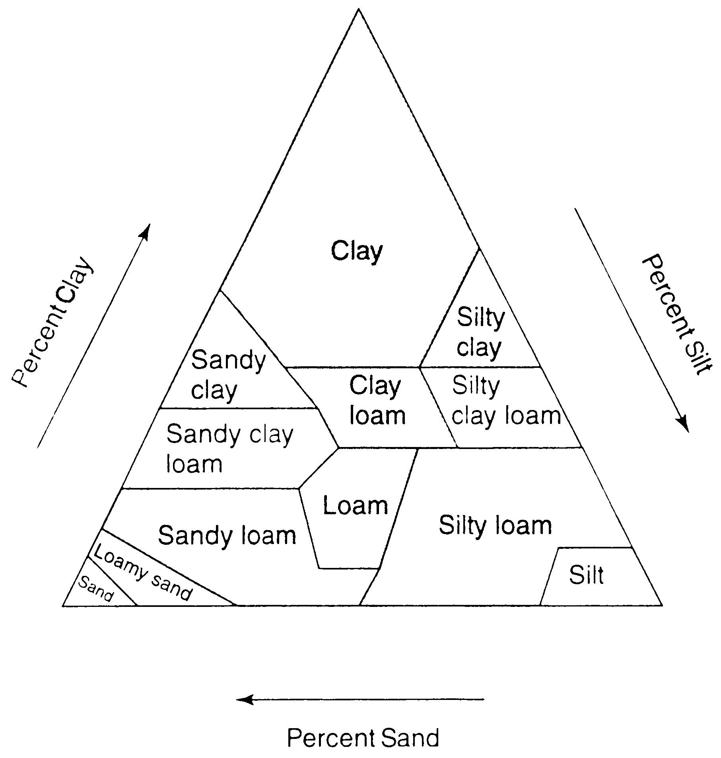
Soil structure refers to how the three types of
particles are combined and arranged. This factor affects water-holding capacity, porosity, soil’s ability to transmit water into the plant (permeability), and the rate of water absorption into the roots (infiltration). An aggregate of sand particles promotes drainage. However, soil with too much sand does not hold moisture. A combination of mostly clay particles retains water and keeps the soil moist. But too much clay hardens the soil surface, preventing needed drainage. Rearranging the soil’s structure alters its texture. The amount of these three particles can be changed until the desired result is achieved. Adding organic matter, for example, improves soil structure because it increases pore space.

Two important chemical characteristics of the growing medium are pH and cation exchange capacity (CEC). A soil’s pH measures the level of alkalinity or acidity and ranges from 0 to 14. A value of 7 is neutral; above 7 is alkaline (base); below 7 is acidic. See Figure 4.4

Figure 4.4 - pH Scale

The pH is the concentration of the hydrogen ion: an electron with an electrical charge. It determines whether the soil can receive nutrients. The pH for most soils ranges from 4.0 to 8.5. Most greenhouse crops need a pH level ranging from 5.5 to 6.5. The pH of the greenhouse’s growing medium ranges in levels of acidity and alkalinity. Different plants thrive in various levels of acidity. For example, the color of a hydrangea differs with the type of soil: it is pink in acidic soil and blue in alkaline soil.

In soil with a high pH (alkaline), many nutrients separate from their solution, depriving the plant of sustenance. Nutrients in acidic soil may become overly concentrated and harmful to the plant. The growing medium’s pH level must suit the needs of each plant.

Cation exchange capacity (CEC) measures the soil’s ability to hold nutrients; it gauges soil fertility. Fertile soil attracts and retains essential nutrients, promoting plant growth. A cation is a positively charged ion in a solution. The soil’s clay, silt, and organic particles have negative charges that attract and hold cations. A clay particle in soil has a large surface area, making the cation’s absorption more efficient. The amount of exchangeable cations is expressed in milliequivalents (meq) per 100 grams (g) of soil at pH 7 (neutral). For greenhouse media, the best CEC level is 6-15 meq/100 g.
Pasteurizing Field Soil
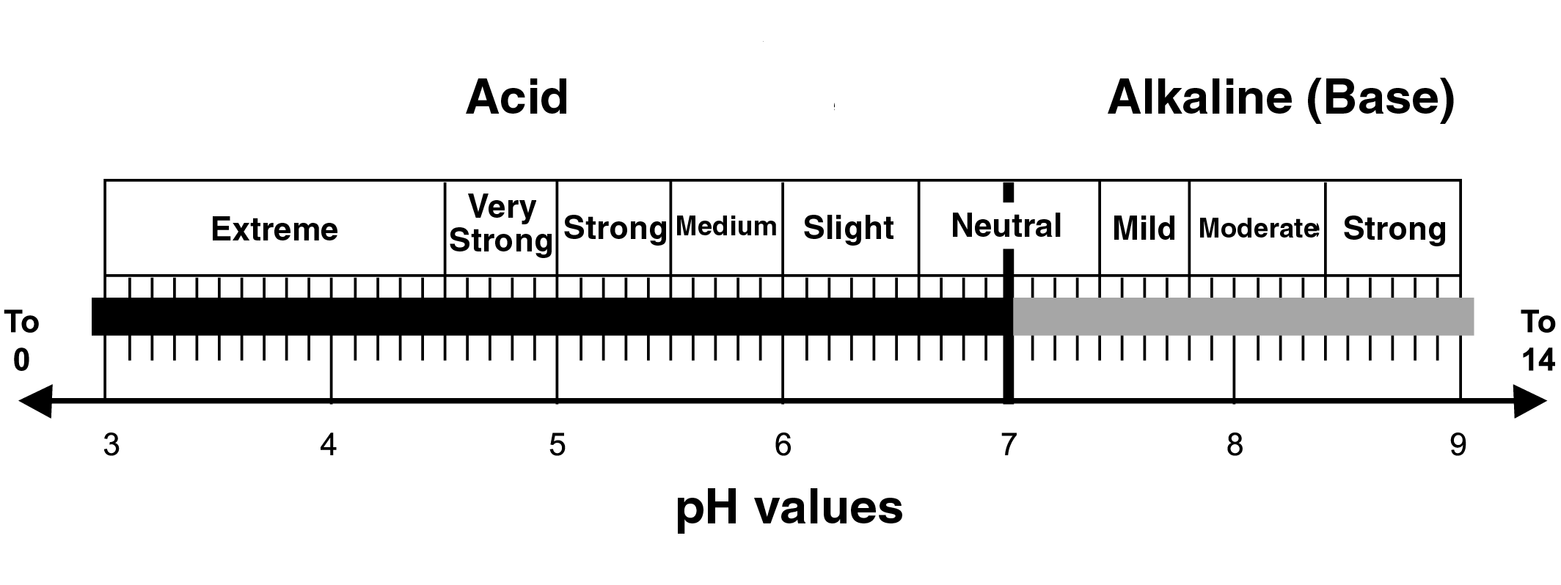
For greenhouse plants, using just field soil is inefficient and ineffective. The texture of outdoor, naturally occurring soil tends to be dense and bulky; therefore, it drains poorly and does not aerate properly. The nutrients in field soil vary in quantity and quality, making precise duplication difficult. The soil may also contain weeds, insects, excessive amounts of pesticides, or diseases that can harm the growing plant. Another drawback is that hauling soil from the field into the greenhouse is heavy work and can be quite expensive.

However, field soil can be used to cultivate greenhouse plants if it is amended to create the desired characteristics. This change is accomplished through pasteurization, a process whereby only harmful organisms are killed. The goal is to kill as many weed seeds as possible and to destroy all pathogenic bacteria and fungi. During pasteurization, organisms that are beneficial to plant growth are not eliminated.

The three methods of pasteurization are steam, chemical, and electrical. Steam pasteurization applies heat to the soil. The soil must be thoroughly mixed after steaming. (Fertilizers cannot be pasteurized; they should be added after steaming.) Air is introduced into the steam and administered at 140ºF (60ºC) for 30 minutes. It is important to regulate the temperature. Excessively high temperatures kill the beneficial organisms that destroy the disease-causing organisms and would increase the level of toxic substances in the soil. Steam pasteurization allows planting to resume as soon as the soil cools. Another advantage is that this method increases drainage and aerates the soil because the heat causes the small soil particles to stick together. It is also an inexpensive process.

Chemical pasteurization, less effective than steam, produces highly toxic fumes. In some cases, all workers and plants must clear the area for 24 hours to several weeks. The gases used during this process are effective only if the soil is the correct temperature, which depends on the chemical used. Some of the chemicals used include chloropicrin (tear gas), which attacks weed seeds, fungi, and nematodes (tiny round worms that attack plant roots); and basamid (DMTT). The soil should be 60ºF (15.5ºC) or warmer, preferably 70ºF (21ºC). All crops must be removed from the greenhouse.

After application, the soil needs 10-21 days’ exposure to fresh air before it can be used for planting. Individuals applying chloropicrin should wear airtight masks to avoid inhalation. Vapam, applied between 50ºF (10ºC) and 90ºF (21ºC), also kills weeds, fungi, and nematodes and requires removing all plants from the greenhouse. In order for vapam to spread evenly throughout the soil, it must be watered thoroughly. The treated soil needs 2-3 weeks of fresh air before planting can resume.

It is important to note that chemical pasteurization has the potential to endanger the environment. Greenhouse owners should stay up-to-date on acceptable usage of chemical fumigants.

Electrical pasteurization, typically not used in commercial greenhouses, handles only small amounts of soil. It is neither an efficient nor a cost-effective process.

Disinfecting tools, used pots and flats, plant supports, and benches can prevent contamination inside the greenhouse. Steaming clay and wooden containers rids these items of pathogens. Plastic pots, however, should be fumigated with appropriate chemicals. The shoes of anyone entering the greenhouse can spread pathogenic soil, thereby endangering the growing plants. Standing on the benches must be forbidden. Another useful policy is placing a fiber mat inside a shallow tray filled with a disinfectant solution and requiring people to wipe off their shoes on the mat.
Advantages of Soilless Growing Medium

As the name indicates, soilless growing medium contains no naturally occurring field soil. It is preferred for use in greenhouse operations for several reasons. It is lightweight, making shipping inexpensive. Its capacity for drainage and porosity prevents roots from rotting. Because its composition is consistent, reproducing uniform amounts of high-quality mixtures is easy and efficient. Soilless medium is also free of unwanted seeds, weeds, insects, and pathogens. The greenhouse owner can buy ready-to-use bags of soilless medium or custom mix the medium as needed for individual plants. As a nonreactive (inert) medium, it contains very low amounts of nutrients. Soilless growing medium does not require pasteurization because during manufacturing, the elements are processed at very high temperatures.

Ingredients in Soilless Mixes and Soil Amendments

Soilless mixes are composed of organic elements and mineral soil amendments. Organic materials provide beneficial ingredients to the media. Rich in nutrients, they improve the soil’s physical structure. In addition, organic matter increases the medium’s water-holding capacity, aeration, drainage, and cation exchange.

Organic soilless mixes are composed of peat, wood residues, and coir. Peat is made from peat moss, sphagnum moss, humus, decomposed plants, and decayed animal residue. Fibrous peat moss can hold 15-20 times its weight in water. This water-holding capacity is further enhanced by adding perlite and vermiculite (discussed below) as well as other materials. Peat moss also is valuable because it has ample quantities of pore space that hold air and water essential for plant growth. By total volume, the porosity of peat moss is 85-98%. (For greenhouse-grown plants, the desired total pore space by volume is not less than 50%.)
Sphagnum moss peat is fairly acidic, but adding finely crushed limestone adjusts the pH level. Another component is humus, which is decomposed organic matter. Rich in nutrients, as humus decays it releases nitrogen, sulfur, phosphorous, and carbon dioxide into the soil. As CO₂ is released, it combines with water and creates weak acids in the soil that break down other minerals. (The nutrients found in minerals are detailed in Lesson 4 of this unit.)

Additional ingredients of soilless media may include decomposed plants (e.g., rotted leaves) and decayed animal matter (e.g., manure), but if contaminated or overly concentrated, these additions to the medium would require pasteurization to be usable.

Wood residues are by-products of the lumber industry and are valuable amendments of soilless media. Although wood loses nitrogen through decomposition, supplementary applications of nitrogen make wood residues a productive addition to the growing medium. Leaf mold from maple, sycamore, and oak improves drainage, aeration, and water-holding properties of the medium. Composted sawdust also may be added but caution is required. If it is obtained directly from the sawmill, high levels of nitrogen must be supplied; these levels must be stabilized before incorporating the sawdust into the medium. Another issue is that the medium’s pH may change. Finally, cedar and walnut trees produce toxins in the sawdust. Bark from hardwoods (e.g., oak and maple) and softwoods (e.g., pine trees) contribute nutrients to the medium. However, just as with sawdust, care is advised. Certain trees (e.g., walnut and cherry) contain toxins that inhibit growth.

Coir is the fibrous outer layer of the coconut husk, a by-product of the coconut industry. Thanks to its excellent air porosity and water retention, coir helps the growing medium absorb moisture easily and drain quickly.

Mineral (inorganic) materials offer several advantages to the growing medium. They improve the physical structure of soil-based media and increase aeration and drainage. Four types of inorganic materials are usually found in soilless mixes. Sand is finely ground stone; the type used with growing media comes from mountain rocks. Thanks to its large particle size, sand provides good porosity and aeration by admitting large quantities of air into the growing medium. It promotes drainage but cannot hold sufficient quantities of water for the emerging plant. Its weight can support the growing plant.

Perlite (volcanic rock) expands and becomes porous when heated to approximately 1,800ºF (982ºC). It has a neutral pH, holds three to four times its weight in water, and improves drainage and aeration. Although it is low in nutrients, perlite is ideal as a seed-germinating medium for rooting cuttings

Vermiculite (mica compound) when heated to about 1,400ºF (760ºC) develops a layered structure that helps retain water and fertilizer. When moist, vermiculite does not expand, thereby reducing its water-holding capacity. It absorbs fertilizer and contains sources of magnesium and potassium that the plants can access through their roots. Horticultural vermiculite comes in a range of sizes suitable for various plants. However, in its raw form, vermiculite can contain hazardous dust that is harmful to greenhouse personnel.

Calcined clay, heated to 1,300ºF (704ºC), forms heavy, porous particles made up of many smaller water-holding pores. The clay’s high cation exchange capacity indicates that nutrients are retained in the medium. This specialized clay also adds volume to the medium and improves the soil structure.

Other materials may be used in soilless media. Polystyrene foam (a by-product of Styrofoam in beads or flakes) is light and improves aeration. It does not absorb water and has a low pH. Its CEC is low. Rock wool is formed when a mixture of basalt, coke, and limestone is melted at 2,700-2,900ºF (1,482-1,600ºC). Its water-holding capacity is great: it holds 3-4% solid matter and 96-97% pore space. When saturated, it drains 15-17%, which promotes root growth. But rock wool deteriorates very slowly and is not biodegradable. As a result, the question of responsible disposal arises. Environmental agencies of several countries forbid dumping rock wool in landfills. Whether its use in the United States will persist is currently not known; the greenhouse owner should stay apprised of any regulatory changes.

Selecting Growing Containers

When selecting growing containers, the greenhouse owner considers how the plant grows: its height, width, shape, and requirements for root space. Another factor is the intended market. Retail operations generally use larger pots than wholesale businesses.

Basic Types of Containers

Various types of containers are available for specific purposes. (The next section describes the
Figure 4.6 - Identifying Cell Packs
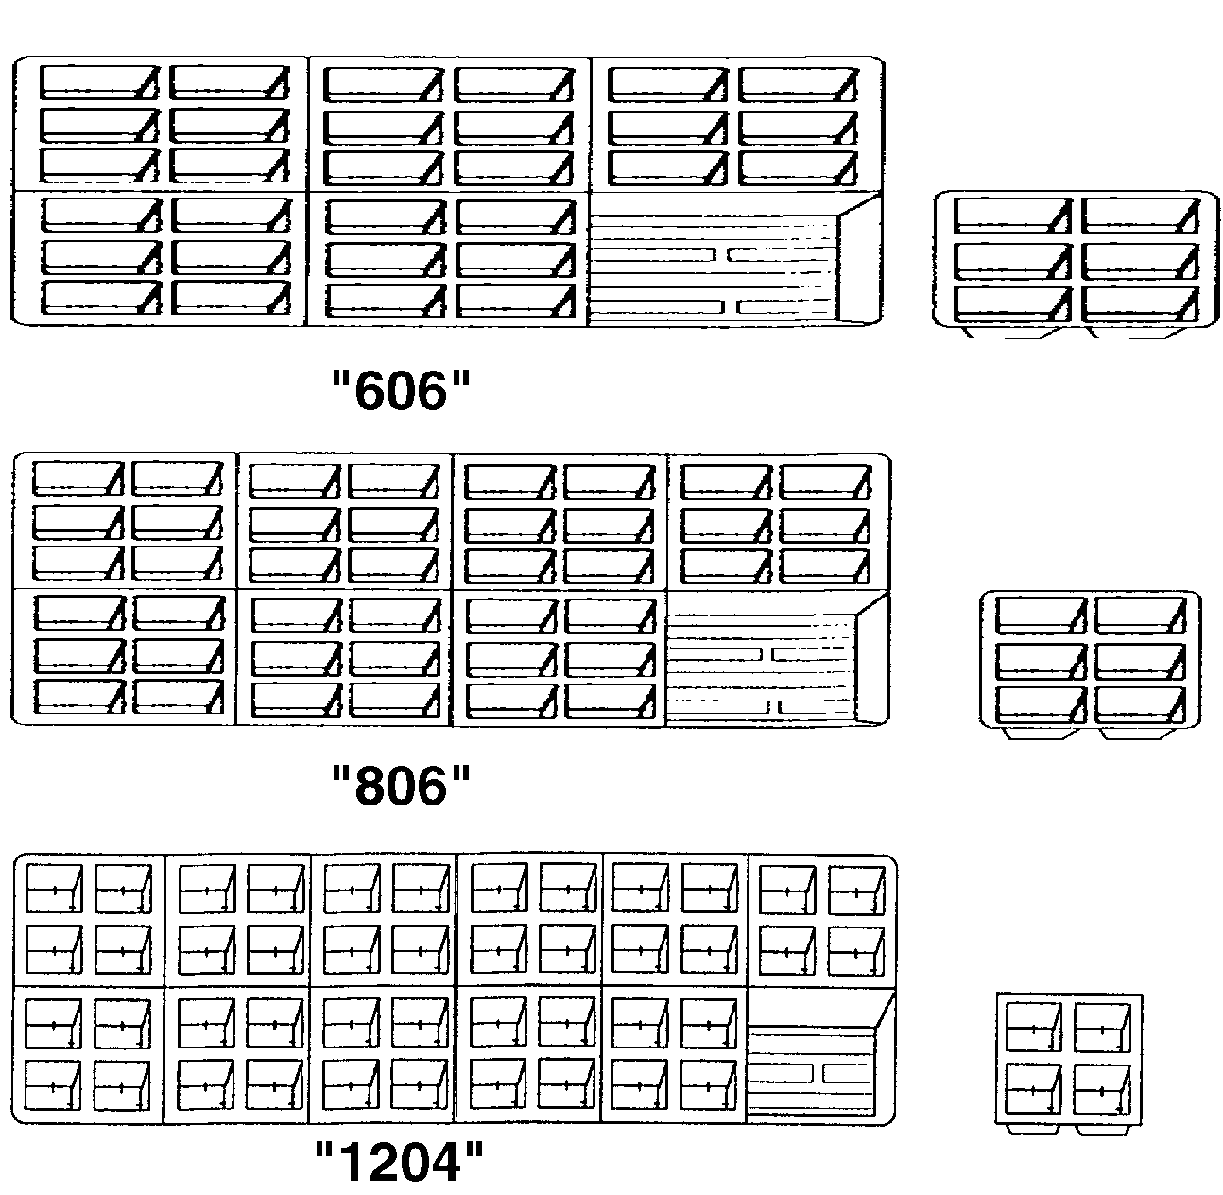

composition and differentiating features of the materials used for plant containers.) Rooting containers are usually made from peat, an organic material. Peat pots are filled with growing media.

Peat pellets are self-contained growing units that expand when watered. Seeds and cuttings are pressed directly into the pellet; no additional

growing medium is required. When the plant develops, the pellet is transplanted into the soil. Peat strips are containers made up of 6-12 square peat pots that are joined together, forming an individual unit. Plants are grown in each pot. Figure 4.5 illustrates three types of rooting containers made from peat. Rooting containers also can be made from plastic flats, metal flats, plastic foam cubes, or rock wool fibers.

Figure 4.5 - Peat Containers
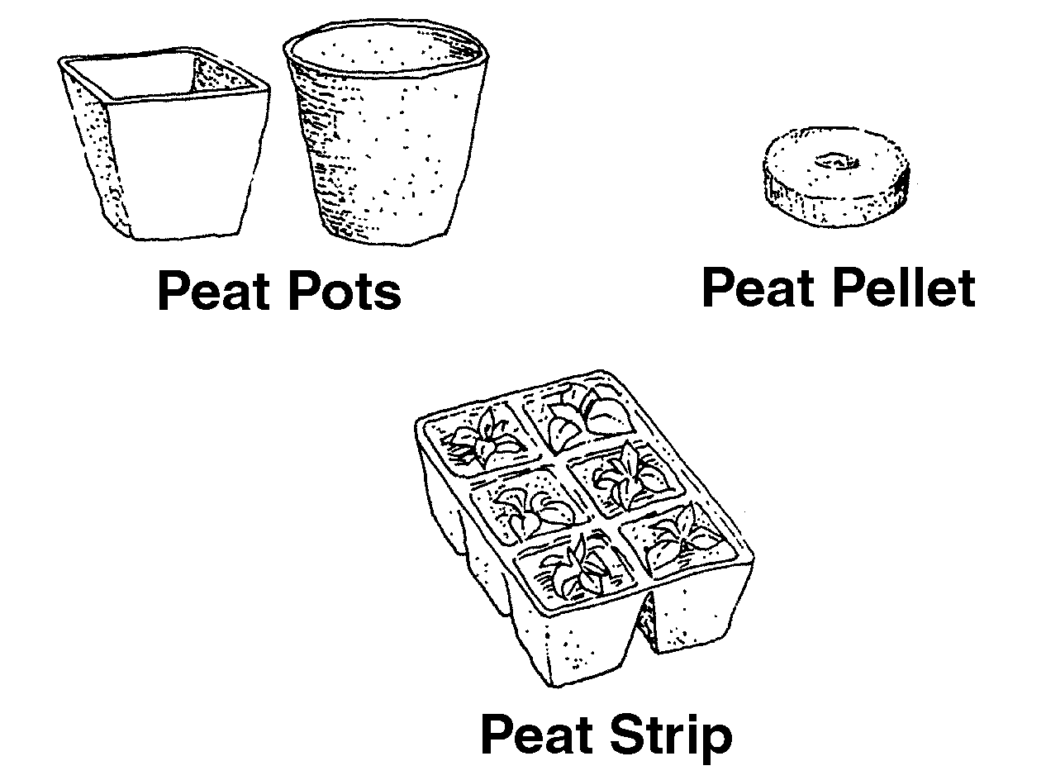
Bedding plant containers, made of plastic, produce essential crops for the retail greenhouse owner. Multicell packs, typically containing 36, 48, or 72 cells per flat, are usually used to produce spring flowering annuals. See Figure 4.6 as shown above.

Plant packs usually contain one to six cells per unit and six to eight units per flat. Most bedding and garden vegetable plants are grown in these containers. Individual pots, usually made of plastic, come in assorted sizes; 2-4 inches is the most common. These pots are used to produce larger bedding plants.

Foliage and flowering plant containers range from 2 to 12 inches or larger. The width and depth of standard pots are equal. This type of pot is best for plants that are not top heavy. The height of an azalea pot is 3/4 of its width, making it ideal for shorter plants with spreading foliage. Its wide base provides stability for top-heavy plants. The height of a rose pot is 1 1/2 times its width. It is ideal for plants with large, deep root systems. In a bulb pan, the width is twice the depth and is best for shallow-rooted plants. Hanging baskets are suitable for many types of plants, especially those whose foliage drapes over the container, such as English ivy. Figure 4.7 illustrates these pots.
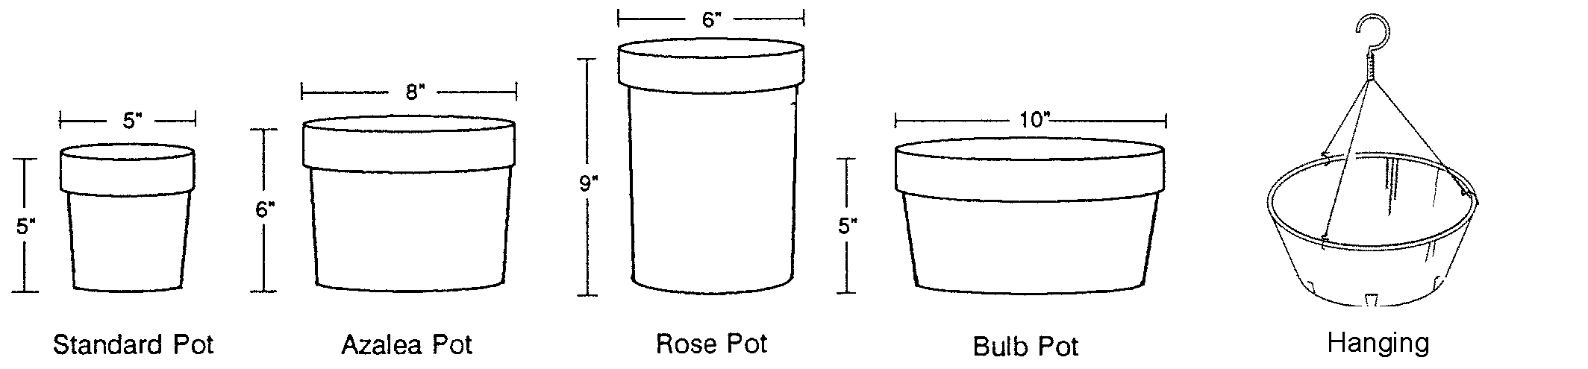
Figure 4.7 - Container Shapes
Common Materials for Growing Containers

Plastic is the most common material used for plant containers. Round plastic pots, grouped together, effectively circulate air. Square containers maximize space efficiently; the greenhouse owner can group them close together on benches. However, less air circulates among square pots, which can lead to diseased leaves.

Plastic containers offer several advantages. They are lightweight, making lifting and shipping easy, and inexpensive. New plastic pots are sterile and can be used immediately; used containers must be sterilized with liquid chemicals. Plants grown in plastic containers are less likely to have fertilizer residue or algae buildup and require less watering. Finally, these containers come in a wide selection of sizes, shapes, and colors.

But there are some disadvantages to using plastic. The first problem is that they are not porous, which means that the material does not “breathe.” As a result, the root system has less aeration and the growing medium can become waterlogged. Another drawback is that plastic containers can crack and become brittle with age. Also, using plastic pots presents an environmental concern of how to dispose of them in a responsible manner.

For centuries, clay has been used as a plant container. It is porous; aeration and gas exchange between the plant and the environment optimize growth. Clay pots drain very well, which prevents the growing medium from becoming waterlogged. They are also sturdy, less likely to tip, durable, and can be steam sterilized and reused. The disadvantages are that plants dry out faster and require watering more frequently. Fertilizer residue and algae accumulate in clay pots. In addition, they are heavy to lift and ship, and they break easily. Clay pots also tend to be relatively more expensive than plastic or peat pots.

Peat pots are made from peat moss that is pressed into sheets and formed into shapes. Seedling roots grown in peat pots penetrate directly through the container into the soil. The entire peat container can be transplanted into the soil, thereby reducing stress and lessening damage to the roots. Unfortunately, peat pots do not last very long and they can dry out quickly and become difficult to rewet.

Summary

Having high-quality growing media is essential to successful crop development. Soilless mixes are preferred, but field soil may be used if it is pasteurized to achieve desirable characteristics. Water-holding capacity, aeration, and drainage are key factors that determine whether plants thrive. A medium’s pH and cation exchange capacity are additional considerations. Organic matter, minerals, and other materials contribute amendments that offer unique assets. Various types of plant containers in different materials accommodate specific needs for greenhouse-grown plants.

Credits

Acquaah, George. Horticulture: Principles and Practices. Upper Saddle River, NJ: Prentice Hall, 1999.

“Air, Water and Media…Putting Them All Together.” <http://aggie- horticulture.tamu.
edu/greenhouse/guides/green/air.html> accessed 12/17/01.

Boodley, James W. The Commercial Greenhouse, 2nd ed. Albany, NY: Delmar Publishers, 1996.

Cooper, Elmer L. Agriscience: Fundamentals & Applications, 2nd ed. Albany, NY: Delmar Publishers, 1995.

Greenhouse Operation and Management (Student Reference). University of Missouri-Columbia: Instructional Materials Laboratory, 1990.

“Growing Media.” <http://aggie-horticulture.tamu.edu/greenhouse/guides/green/
media.html> accessed 12/17/01.

“Growing Media & pH.” <http://aggie-horticulture.tamu.edu/greenhouse/guides/green/
ph.html> accessed 12/17/01.

Herren, Ray V. and Roy L. Donahue. The Agriculture Dictionary. Albany, NY: Delmar Publishers, Inc., 1991.

“Horticultural Coir Ltd.” <http://www.coirtrade.
com/coir.html> accessed 2/12/02.

Lee, Jasper S., Series Editor. Introduction to Horticulture: Science and Technology, 2nd ed. Danville, IL: Interstate Publishers, Inc., 1997.

Nelson, Paul V. Greenhouse Operation and Management, 3rd ed. Reston, VA: Reston Publishing Company, Inc., 1985.

Pasian, Claudio C. “Ohio State University Extension Fact Sheet - Physical Characteristics of Growing Mixes.” <http://ohioline.osu.edu/
hyg-fact/1000/1251.html> accessed 12/19/01.

