Unit IV: Plant Growth

Lesson 3: Irrigation

Plants cannot survive without water. Of all the cultural practices that the greenhouse owner performs, irrigation contributes most directly to the growth and healthy development of plants. Lesson 3 addresses general factors affecting irrigation in the greenhouse, explains how often to water crops, provides guidelines for watering plants correctly, and describes several irrigation methods.

Irrigating Greenhouse Crops

Proper irrigation practices and quality water are critical to crop success.

Water’s major role in plant growth is to dissolve and translocate nutrients throughout the plant, as detailed in Plant Processes (Unit III, Lesson 2). Plant cells help support the structure of the plant when they are filled with water.

The growing medium (see Unit IV, Lesson 2) can create moisture stress in plants under certain circumstances. If the medium’s capacity for absorption, retention, and drainage is inadequate, the plant suffers. As the medium’s pores (capillaries) absorb and attempt to retain water, the force of gravity tries to drain water from the container. This conflicting interaction is resolved by the porosity and depth of the medium. A growing medium with large particles is porous; this facilitates drainage after irrigation. The depth of the medium relates to the height of the planting container. Water in tall containers is easily pulled through the medium; drainage is complete. In shorter containers, the medium’s capillaries resist the force of gravity; therefore, water is retained in the container.

Figure 4.8 demonstrates how the relationship between the medium’s porosity and depth influences absorption, retention, and drainage.

Figure 4.8 - Interaction Between Growing Medium’s Porosity and Depth
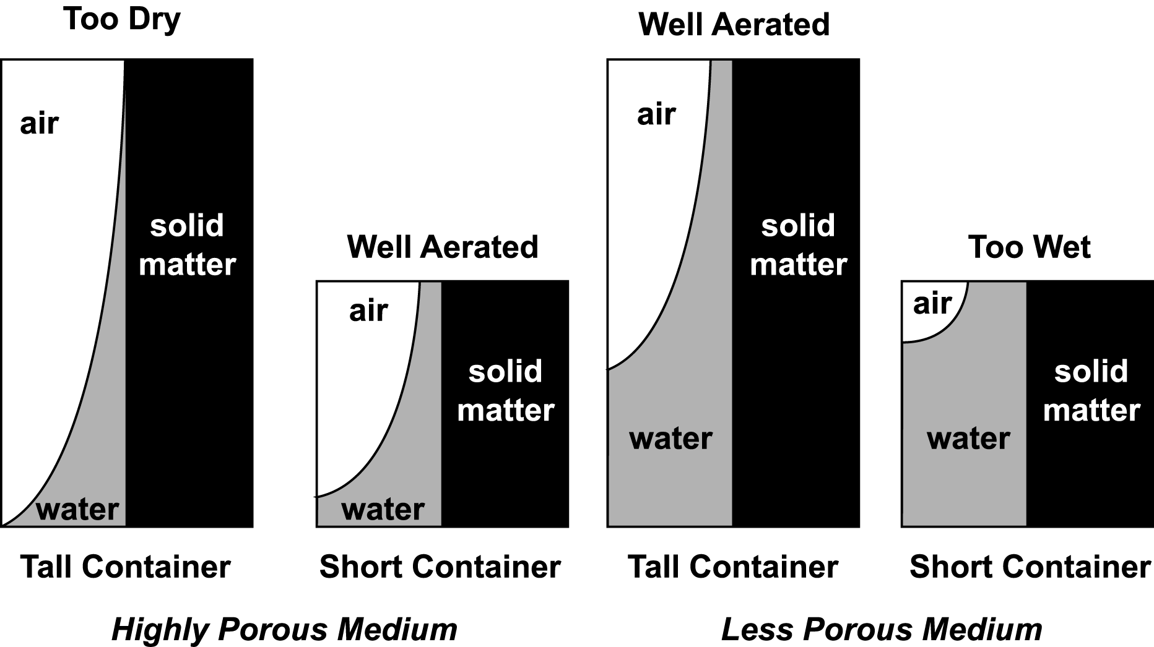

Air temperature is another factor in moisture stress. During the hottest part of the day, air in the greenhouse may reach 120ºF (49ºC) or higher. At this point, the rate of transpiration accelerates and the relative humidity decreases substantially, depleting water from plant cells. Excessive air movement also increases transpiration because it prevents water vapor from accumulating on the leaves. Monitoring and regulating air temperature control the effects of transpiration in greenhouse-grown plants.

Basic concerns about irrigation include providing uniform watering, minimizing the amount of water/fertilizer runoff, minimizing the amount of water on foliage, and considering the integration of a fertilizer injection system directly into the irrigation system.

Water contains chemicals that can harm plants. For example, fluorine is often added to public water systems to prevent tooth decay. The amount added is 1 part per million (ppm). Yet, fluoride (the compound made from fluorine) in a concentration of just 5 parts per billion reduces leaf size by 25-35%. A concentration of 0.25 ppm fluoride causes necrosis in leaf tips. Softened water contains high levels of sodium that destroy soil structure, causing poor drainage. An accumulation of only 1 ppm sodium in some plants (e.g., carnations) causes the petals to stick together so they cannot open up properly.

Frequency of Crop Irrigation

Determining how often to irrigate greenhouse-grown crops depends on various factors: water-holding capacity of the growing medium, container type, internal environment of the greenhouse (humidity, temperature, and light), season of the year, and the plant itself (species, size, and stage of growth). The soil depth of the plant’s roots is also a consideration.

A critical factor is knowing when to irrigate plants. The greenhouse owner can visually discern when the plant starts to wilt, dries up, or fades. If the weight of the container is unusually light, it indicates that the plant needs water. Placing a dry stick in the medium for a period of time and periodically removing it also reveal when to water the plant. If the stick stays dry, water the plant. If the growing medium clings to the stick, do not water.

Knowing the amount and frequency of irrigation for greenhouse crops prevents two detrimental consequences: underwatering and overwatering. Underwatering creates moisture stress if the plant is deprived of water. Then the cells shrink and the plant wilts. At this point, the stomata (pores in the leaf surface) close up to prevent any further loss of moisture. But they also restrict carbon dioxide from entering into the leaf, hindering photosynthesis and stunting plant growth. When roots have no access to water and dissolved minerals, they cannot transmit needed moisture to the leaves, stem, and emerging flower. The plant then develops shorter internodes, smaller leaves, and harder and tougher plant tissue.

Overwatering is also harmful, especially for seedlings. If overly saturated, the root system is unable to exchange gases; consequently, the amount of available oxygen is severely limited. As a result, the root tissue is damaged and the risk of disease increases significantly. Plants wilt and develop spindly, leggy stems; overall growth slows.

Basic Guidelines for Irrigation

Successful irrigation results from adhering to a few fundamental guidelines. Use the appropriate growing medium for each crop to ensure adequate absorption, water retention, and drainage. Because plants differ in how much water they require, the greenhouse owner should regulate the amount and frequency of irrigation accordingly.

Watering plants thoroughly leaches (flushes) soluble salts and excess nutrients that can harm the root system if they accumulate in the growing medium.

The proper method for watering is to irrigate the entire area around the roots, ensuring that the root system never dries out completely. Control the flow of water to prevent water from spilling over the top of the container. Irrigate plants until water drains from the bottom of the pot. The best time to irrigate is early in the day to replenish the water that evaporated from leaves and flowers. To prevent disease, do not directly moisten the foliage and flowers because this induces decay. Also, prevent pathogenic contamination by keeping the end of hoses off of the floor.

Delivering Water to Plants

As mentioned briefly in Unit II, Lesson 2, the two basic irrigation systems are manual and automated. This lesson expands upon various irrigation techniques and explains how the equipment is used in each method.

The manual method uses handheld hoses and wands. This method is widely used in small greenhouse operations. However, it is labor intensive, costly, and difficult to water plants uniformly.

There are three basic automatic systems: overhead, surface, and subsurface. Overhead delivery systems use sprinklers to spray water over bedding plants and expose the foliage directly to water. This method is still used in some established greenhouses. However, the sprinklers have several disadvantages. If the irrigation system contains nutrients, the sprinklers deposit salt residues on the leaves. When overhead systems irrigate plants, the water might gather in puddles and oversaturate the growing medium. In addition, evaporation results from using overhead sprinkler systems. There is an increased risk of disease when the foliage is wet.

A better option is the boom irrigation system that waters bedding plants, potted plants, and seedlings. A water wand hangs above plants and travels across the greenhouse, spraying water onto plants. Spray stake/nozzle systems are mounted near plants and spray plants from above and from the sides. This custom-built system accommodates the greenhouse’s specific dimensions, uses space efficiently, and delivers fertilizer during irrigation (“fertigation”). Compared to manual irrigation techniques (e.g., hoses), boom systems save 40% in water.

Surface delivery systems, used to irrigate cut flowers and row crops, apply water to the entire soil surface under the foliage. A uniform, optimal amount of water is applied to the base of the plant. As a result, the leaves do not get wet, reducing the rate of evaporation from the foliage and soil. The growing medium does not become waterlogged and nutrients do not leach into the soil. Drip emitters have small tubes with weights attached that are placed in individual pots. They slowly dispense drops of water directly to the medium. Drip irrigation also prevents exposing roots to pathogens that are spread by moving water. The drip irrigation system uses less water, making it an economical option, and this system has been shown to increase yields. Soaker hoses, oozing water from tiny holes, are put at the bottom of the plant. Closely planted flowerbeds are effectively irrigated with bubblers, which are similar to drip emitters but deliver a higher rate of water.

In subsurface (subirrigation) delivery systems, water is applied directly to the growing medium without wetting the foliage. Water is applied under the pots. The two basic methods are the capillary mat system and ebb and flood system. In the capillary mat system, plant containers are placed on top of a soaked, synthetic mat that rests on a level bench in the greenhouse. The bench is protected with a sheet of plastic. Dripping water runs off the bench and thereby prevents soluble salts from accumulating on the mat. The best pots to use are plastic; clay loses moisture through the sidewalls.

First, a drip tube uniformly waters the mat. The greenhouse owner places the plants on the mat and waters them from above using a hose. This creates a column of water that extends from the growing medium to the mat. Through capillary action, water is drawn upward from the saturated mat through the drainage hole into the growing medium of each plant.

The size of the medium’s pore spaces affects how high the water rises. In finely textured soil with tiny capillaries, water rises to the highest level. Capillary action occurs because the water rises to a given height in “tubes” (capillaries), which have very narrow diameters. The pore spaces in the growing medium function as capillary tubes and carry the water from the mat to the roots. Figure 4.9 illustrates how pore size affects capillary action. Water rises to the highest level in the smallest capillary tube (A) and to the lowest level in the largest capillary tube (C).
Figure 4.9 - Capillary Action of Water in Growing Medium

However, capillary action also affects the quality of the growing medium. Through water evaporation, soluble salts are lifted from the bottom of the pot and deposited in undesired concentrations on top of the growing medium. To get rid of these harmful chemicals, the greenhouse owner should periodically water the plants from above. This leaches the excess salts from the top of the container and balances their distribution throughout the medium.

In the ebb and flood system, flats of plants rest on specially constructed, raised, waterproof benches. Each bench must be absolutely level and have a trench for the nutrient solution and several pipes to carry a certain number of gallons of water per minute. The amount of water depends on the size of the greenhouse operation. The irrigation solution (water and nutrients) is pumped from a central storage tank into the bench and spreads quickly and evenly over the growing medium. It remains on the bench for a few minutes and then drains back into the storage tank for recycling. The advantages of the ebb and flood system are that it never wets the foliage, which promotes disease, and that it can be applied any time day or night. A computer can regulate the entire operation. Ebb and flood is a completely closed recirculating system that does not contaminate the groundwater. The Environmental Protection Agency (EPA) requires the prevention of groundwater contamination from runoff due to irrigation. The ebb and flood system uses concrete floors so this mandate can be satisfied
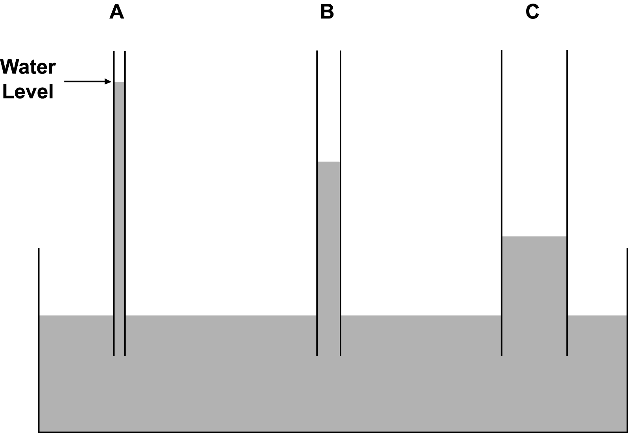
Summary

The key to developing a healthy crop is having a well-run irrigation system that meets the specific needs of each plant. Knowing how and when to water, avoiding moisture stress and overwatering, and determining the best irrigation method help the greenhouse owner maximize yield and profit.

Credits

Acquaah, George. Horticulture: Principles and Practices. Upper Saddle River, NJ: Prentice Hall, 1999.

Alama, M. and I. Broner. “Subsurface Microirrigation - Crops.” Colorado State University Extension no. 4.716. <http://www.ext.colostate.edu/pubs/crops/04716.
html> accessed 2/13/02.

Boodley, James W. The Commercial Greenhouse, 2nd ed. Albany, NY: Delmar Publishers, 1996.

Broner, I. “Irrigation Schedule: Crops.” Colorado State University Extension no. 4.708. <http://www.ext.colostate.edu/pubs/crops/04798.
html> accessed 2/13/02.

Broner, I. “Irrigation Scheduling: The Water Balance Approach.” Colorado State University Extension no. 4.707. <http://www/ext.colostate.edu/pubs/crops/04707.html> accessed 2/13/02.

Cooper, Elmer L. Agriscience: Fundamentals & Applications, 2nd ed. Albany, NY: Delmar Publishers, 1995.

“DIG Irrigation Products - Drip and Microsprinklers for Home & Garden.” <http://www.digcorp.com/diy/introduc.htm> accessed 2/14/02.
Greenhouse Operation and Management (Student Reference). University of Missouri-Columbia: Instructional Materials Laboratory, 1990.

Herren, Ray V. and Roy L. Donahue. The Agriculture Dictionary. Albany, NY: Delmar Publishers, Inc., 1991.

Lee, Jasper S., Series Editor. Introduction to Horticulture: Science and Technology, 2nd ed. Danville, IL: Interstate Publishers, Inc., 1997.

Nelson, Paul V. Greenhouse Operation and Management, 3rd ed. Reston, VA: Reston Publishing Company, Inc., 1985.

“Water Efficiency Practices for Agricultural Irrigation.” Environmental Fact Sheet - WD-WSEB-26-5, New Hampshire Department of Environmental Services, Concord, NH. <http://www.des.state.nh.us/factsheets/ws/ws-26-htm> accessed 2/12/02.

