Unit IV: Plant Growth

Lesson 5: Fertilizer

Fertilizer nurtures healthy plant growth. Because each plant requires different macro- and micronutrients, the amount and formulation of fertilizer vary accordingly. This lesson highlights features of a fertilizer management plan, identifies sources and forms of fertilizer, details aspects of a fertilizer analysis, and describes techniques for applying fertilizer.

Fertilizer Management Plan

The purpose of a fertilizer management plan is to prevent and correct nutritional deficiencies. A well-managed program makes plants more resistant to disease and improves their appearance. It also ensures efficient, maximum growth, which increases the greenhouse operation’s profits. To ensure abundant, healthy crops, this program should quantify the amount and frequency of fertilizer given and match specific types of fertilizer to the unique nutritional needs of each plant. Fertilizer requirements vary per species and development at key stages: seedling/cutting, vegetative (foliage growth), and flowering.

Fertilizer Sources

Plant fertilizer is derived from organic and inorganic sources. Organic fertilizer, from once-living matter, is made from natural components (e.g., animal manure, decayed plants, and decomposed microorganisms) and processed elements (e.g., bone meal, fish emulsion, and sewage sludge). When these materials decay, only small amounts of nutrients are released into the medium. The precise amount is unknown, making uniform application difficult. To make certain that the soil receives enough nutrients, large quantities are required. For example, to equal the fertility provided from 100 pounds of inorganic fertilizer, 1 ton of cow manure must be added. This is costly, necessitates ample storage facilities, and requires personnel capable of managing this large quantity. Also, as organic residues break down, the rate of decomposition is extremely slow and variable. A gradual, irregular breakdown of organic sources does not foster healthy development. Plants require a steady supply of nourishment.

Inorganic fertilizer comes from synthesized mineral salts. Its concentration is greater than that of organic fertilizer. Therefore, overfertilization must be avoided to prevent injuring the roots and burning leaf tissue. Inorganic fertilizer releases nutrients rapidly and is readily available to the plant. It disseminates evenly throughout the growing medium

Available Forms of Fertilizer

Fertilizer is available in several forms. Slow-release formulations offer significant advantages. Because greenhouse-grown crops are frequently watered, nutrients are leached from the growing medium. But thanks to industrial processes that coat particles of slow-release fertilizers, the rate of releasing nutrients into the medium is prolonged. Plants thus receive a steady food supply. In addition, this form of fertilizer is less likely to burn the plant. A commonly used slow-release fertilizer is Osmocote, in which fertilizer particles are covered with a plastic coating. The thickness of this coating depends upon the fertilizer analysis (discussed below). The plant’s roots gradually absorb a small amount of the Osmocote fertilizer solution.

Granular forms can be mixed into or applied on top of the growing medium; some are dissolved in water before application. They are available as stakes or tablets and placed directly into the medium.

Liquid or dry forms of fertilizer can be injected into the irrigation system (fertigation); the amount used is measured in parts per million (ppm).

Fertilizer Analysis

The proportion of nutrients in the fertilizer formulation (called fertilizer analysis) is the percent by weight of each element, as analyzed by chemical laboratories. This helps the greenhouse owner select the appropriate fertilizer formulation for specific plants. The quantity of fertilizer used is based on this chemical analysis. A “complete” fertilizer contains three macronutrients: nitrogen (N), phosphorous (P), and potassium (K). The fertilizer label lists the percent of each of these elements in the following sequence: N-P-K. For example, a bag of fertilizer labeled 20-17-16 denotes 20% nitrogen, 17% P₂O₅, and 16% K₂O₅. Other nutrients may be included.

Calculating the Amount of Fertilizer

In their original formulations, dry and liquid fertilizers are concentrated and must be mixed with water at a specified ratio. It is important to check the dilution ratio of each fertilizer and then calculate the amount needed for the mixture. The fertigation equipment has to be calibrated so it delivers the proper dilution ratio.

Concentration rates are calibrated in parts per million, as calculated by the following formula:

desired ppm # oz
percent of = 100 gallons water
active ingredient X 75

- Multiply the percent of active ingredient in the fertilizer by 75 (a constant).

- Divide this number by the ppm needed. This number represents the number of ounces of fertilizer per 100 gallons of water necessary to produce the proper concentration.

To mix smaller amounts of fertilizer, use a proportion. First determine the correct number of ounces per 100 gallons, as indicated above. Then use the following formula:

# oz = ____?______
100 gallons of water calibration ratio

- To find the unknown number of ounces (?), divide by the total calibration ratio. For example if the calibration ratio is 1:13, the denominator is 14.

- Cross-multiply to solve for ? (the unknown number of ounces). The result represents the number of ounces of fertilizer to add to 1 gallon of water in order to create a solution with the correct ppm.

Applying Fertilizer

When applying fertilizer, it is essential to follow directions for a given formulation carefully, especially concerning the amount and frequency of fertilization. Insufficient fertilizer applied infrequently creates nutritional deficiencies. Excessive fertilizer applied too often is detrimental to the plant. As a general rule, the growing medium must be moist before applying fertilizer. If fertilizer is applied to a dry medium, it injures the roots.

When dry granular or liquid fertilizers are dissolved in water and applied to plants, the nutrients rapidly leach from the growing medium and are immediately absorbed by the plant’s roots. Because they act so quickly, these formulations may require reapplications. But caution is required; the greenhouse owner must not apply too much of these fertilizers.

Applying low concentrations of fertilizer with each watering is a common technique. When watering, provide a balanced fertilizer to meet the needs of each plant. If the irrigation promotes sufficient drainage, no fertilizer salts will accumulate, which could harm the growing medium. A constant feed system that supplies nutrients at every watering or every other watering is generally the best irrigation method.

Another method of applying fertilizer is to use a hose-siphoning device. A siphon is positioned between the water outlet and hose. A narrow tube extending from the siphon is placed in the fertilizer solution. Through the force of suction, fertilizer is drawn from the solution into the tube and the stream of water. See Figure 4.12. This method is easy and inexpensive. The calibration ratio usually ranges from 1:12 to 1:16.

Figure 4.12 - Hose-Siphoning Device Used to Apply Fertilizer

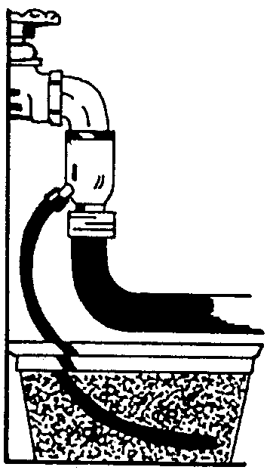
Another type of device is the dosmatic injector, as illustrated in Figure 4.13.
Figure 4.13 - Dosmatic Injector

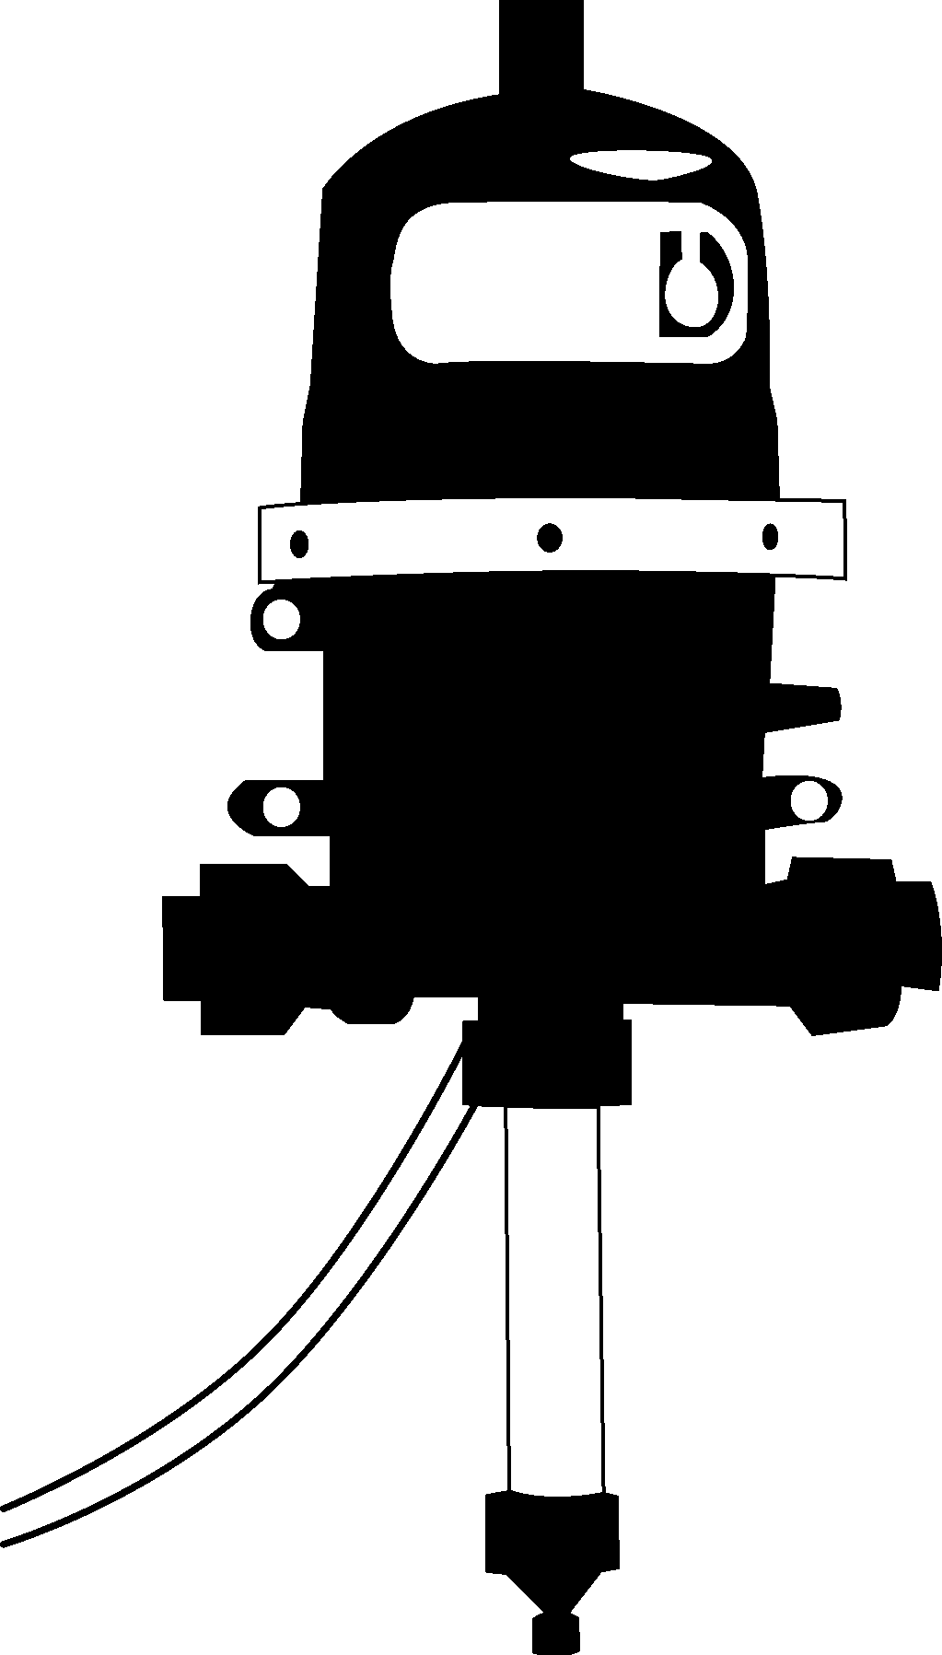

Summary

Maintaining an effective fertilizer management plan helps the greenhouse owner cultivate healthy, productive crops. Different formulations are available to accommodate nutritional needs of each plant. Calculating the correct ratio of concentrated fertilizer to water is critical. When applying fertilizer it is important to follow directions on the label. Over- or underfertilization harms the plant. Several methods for applying fertilizer are available.

Credits

Boodley, James W. The Commercial Greenhouse, 2nd ed. Albany, NY: Delmar Publishers, 1996.

Cooper, Elmer L. Agriscience: Fundamentals & Applications, 2nd ed., Albany, NY: Delmar Publishers, 1995.

Greenhouse Operation and Management (Student Reference). University of Missouri-Columbia: Instructional Materials Laboratory, 1990.

Lee, Jasper S., Series Editor. Introduction to Horticulture: Science and Technology, 2nd ed. Danville, IL: Interstate Publishers, Inc., 1997.

Nelson, Paul V. Greenhouse Operation and Management, 3rd ed. Reston, VA: Reston Publishing Company, Inc., 1985.

