Unit V: Plant Propagation

Lesson 1: Sexual Propagation

The two lessons in this unit investigate sexual and asexual methods for propagating plants. Lesson 1 examines sexual propagation: legal issues, its environmental conditions, dormancy period, and stages of germination. In addition, this lesson discusses procedures for planting seeds, distinguishes between the germination of monocots and dicots, and describes when and how to transplant seedlings. Caring for seedlings after germination and transplanting is also described.

Sexual Propagation

Sexual propagation uses seeds to produce new plants. In order for germination to occur, environmental conditions must be ideal. These conditions are discussed below.

For sexual propagation to be successful, it is important to select high-quality seeds that are free of disease and insects, broken seeds, weeds, or other seeds. Hybrid seeds are expensive but they offer significant advantages: greater resistance to disease, generally more vigorous plants, and higher yields. To store seeds, keep them dry and cool. Put them in paper packets inside sealed, clean, dry glass jars.

Direct seeding means that the seeds are planted outdoors; no transplanting is involved. The seeds are placed in the same container that will be used for sales. Inside seeding is planting the seeds in the greenhouse and later transplanting the developed plant, either to a larger container or outside. The growing media should be clean, free of debris and disease, loose, and finely textured.

Environmental Conditions for Seed Germination

Four principal environmental conditions play key roles in germination. Adequate amounts of moisture allow the seeds to absorb water. After the seeds are sown, the best way to moisten the growing medium is to apply a fine spray and cover the medium to retain moisture.

Temperature requirements vary among warm weather and cool-weather crops. The general range is 68-86ºF. It is important that the medium’s temperature remains constant. If the medium is too cool, use supplemental heating.

Light requirements vary. For seeds that need light to germinate, sow them shallowly and do not cover them (e.g., lettuce). Most ornamental bedding plants (e.g., begonias and petunias) depend on light for germination. For some seeds, light may inhibit germination, so no light is required. Sow these seeds more deeply and place them in a dark area (e.g., geraniums).

Air (oxygen) is essential because germination is an aerobic process. Dormant seeds do not require much oxygen, but as the plant develops, the need for oxygen increases. A deficit of oxygen hinders respiration. The growing medium must have good porosity to ensure proper aeration.

Sexual propagation involves legal considerations. In an effort to encourage biotechnological development, the U.S. government passed the Plant Variety Protection Act. This law gives scientists or breeders of new varieties exclusive marketing rights to their seeds for 18 years. This law and subsequent amendments restrict the actions of the buyers of these more resilient seeds, namely, a grower cannot sell surplus seeds. For more information, contact the Commissioner, Plant Variety Protection Office, Agricultural Marketing Service, National Agricultural Library Bldg., Room 0, 10301, Baltimore Blvd., Beltsville, MD 20705-2351.

In addition to federal regulations, a greenhouse operator must follow state laws. In the state of Missouri, all who handle nursery stock, even if they give it away, must be inspected and certified. The inspector is looking for signs of insect and disease infestation. Fees for this service are based on the size of the greenhouse as measured in square feet under glass. For more information, contact State Entomologist, Missouri Department of Agriculture, P.O. Box 630, Jefferson City, MO 65102-0630 - Phone: (573) 751-5507; Fax: (573) 751-0005.

Dormancy

Dormancy is the resting stage for seeds that prevents them from germinating until specific environmental conditions are favorable for growth. For example, the dormancy period for annual seeds that bloom in the fall lasts until spring. Otherwise, if the seeds germinate too soon, the frost would kill the emerging plants.
Seeds of many greenhouse-grown plants do not have a dormancy period and can be planted at any time. However, some plants, such as geraniums, have a hard, protective seed coat that prevents immediate germination. To offset the effects of dormancy, the seed coat undergoes scarification. This is a process in which the seeds are scraped or scratched to increase water absorption. A manual method for scarifying is to rub the seed coat with sandpaper or to nick a portion of it. A chemical approach is to soak the seeds in sulfuric acid to soften the seed coat.

Some seeds require a different technique: stratification. Seeds are planted in a moist growing medium at 32-50ºF for several weeks. Conversely, to induce germination for other types of plants, exposure to heat is required to weaken the seed coating so water absorption is possible.

Germination Process

As soon as seeds absorb water through the growing medium, the germination process begins. When the water penetrates into the seed, a growth hormone develops that eventually moves into cellular layers. This triggers the production of enzymes that stimulate various chemical reactions within the cells. New cells and tissues are produced. The radicle is the first to appear from the seed. Next is the plumule (coleoptile), the emerging plant’s first shoot. With the appearance of leaves on the seedling, photosynthesis begins and the plant supplies its own food.

Steps for Planting Seeds

The first step for planting seeds is to fill the container 3/4 inch from the top with moistened germination mixture. Be sure the pot has drainage holes. Level off the medium and tap to settle. Make shallow holes or rows according to directions on the seed packet. Place seeds in the holes or rows. Label the pot or flat with the plant type, variety, and date of sowing. Cover seeds with a dry medium, generally twice as much as the seeds’ diameter. Plastic, multicell packs are frequently used for planting seeds.

Provide seeds with a fine mist of water and keep them warm. Cover the container with clear plastic or glass in order to retain the moisture. Observe daily for signs of too much or too little moisture and for excess heat. Watch for germination.

Differences in Germinating Monocots and Dicots

Monocots undergo hypogeous germination (cotyledon remains underground). First the seed swells as moisture is absorbed. Finally, the seed coat ruptures. The radicle grows down and the first internode and epicotyl grow up. After the epicotyl emerges, new leaves form and food production starts. The new root system grows just beneath the medium above the first internode. Figure 5.1 illustrates this process.
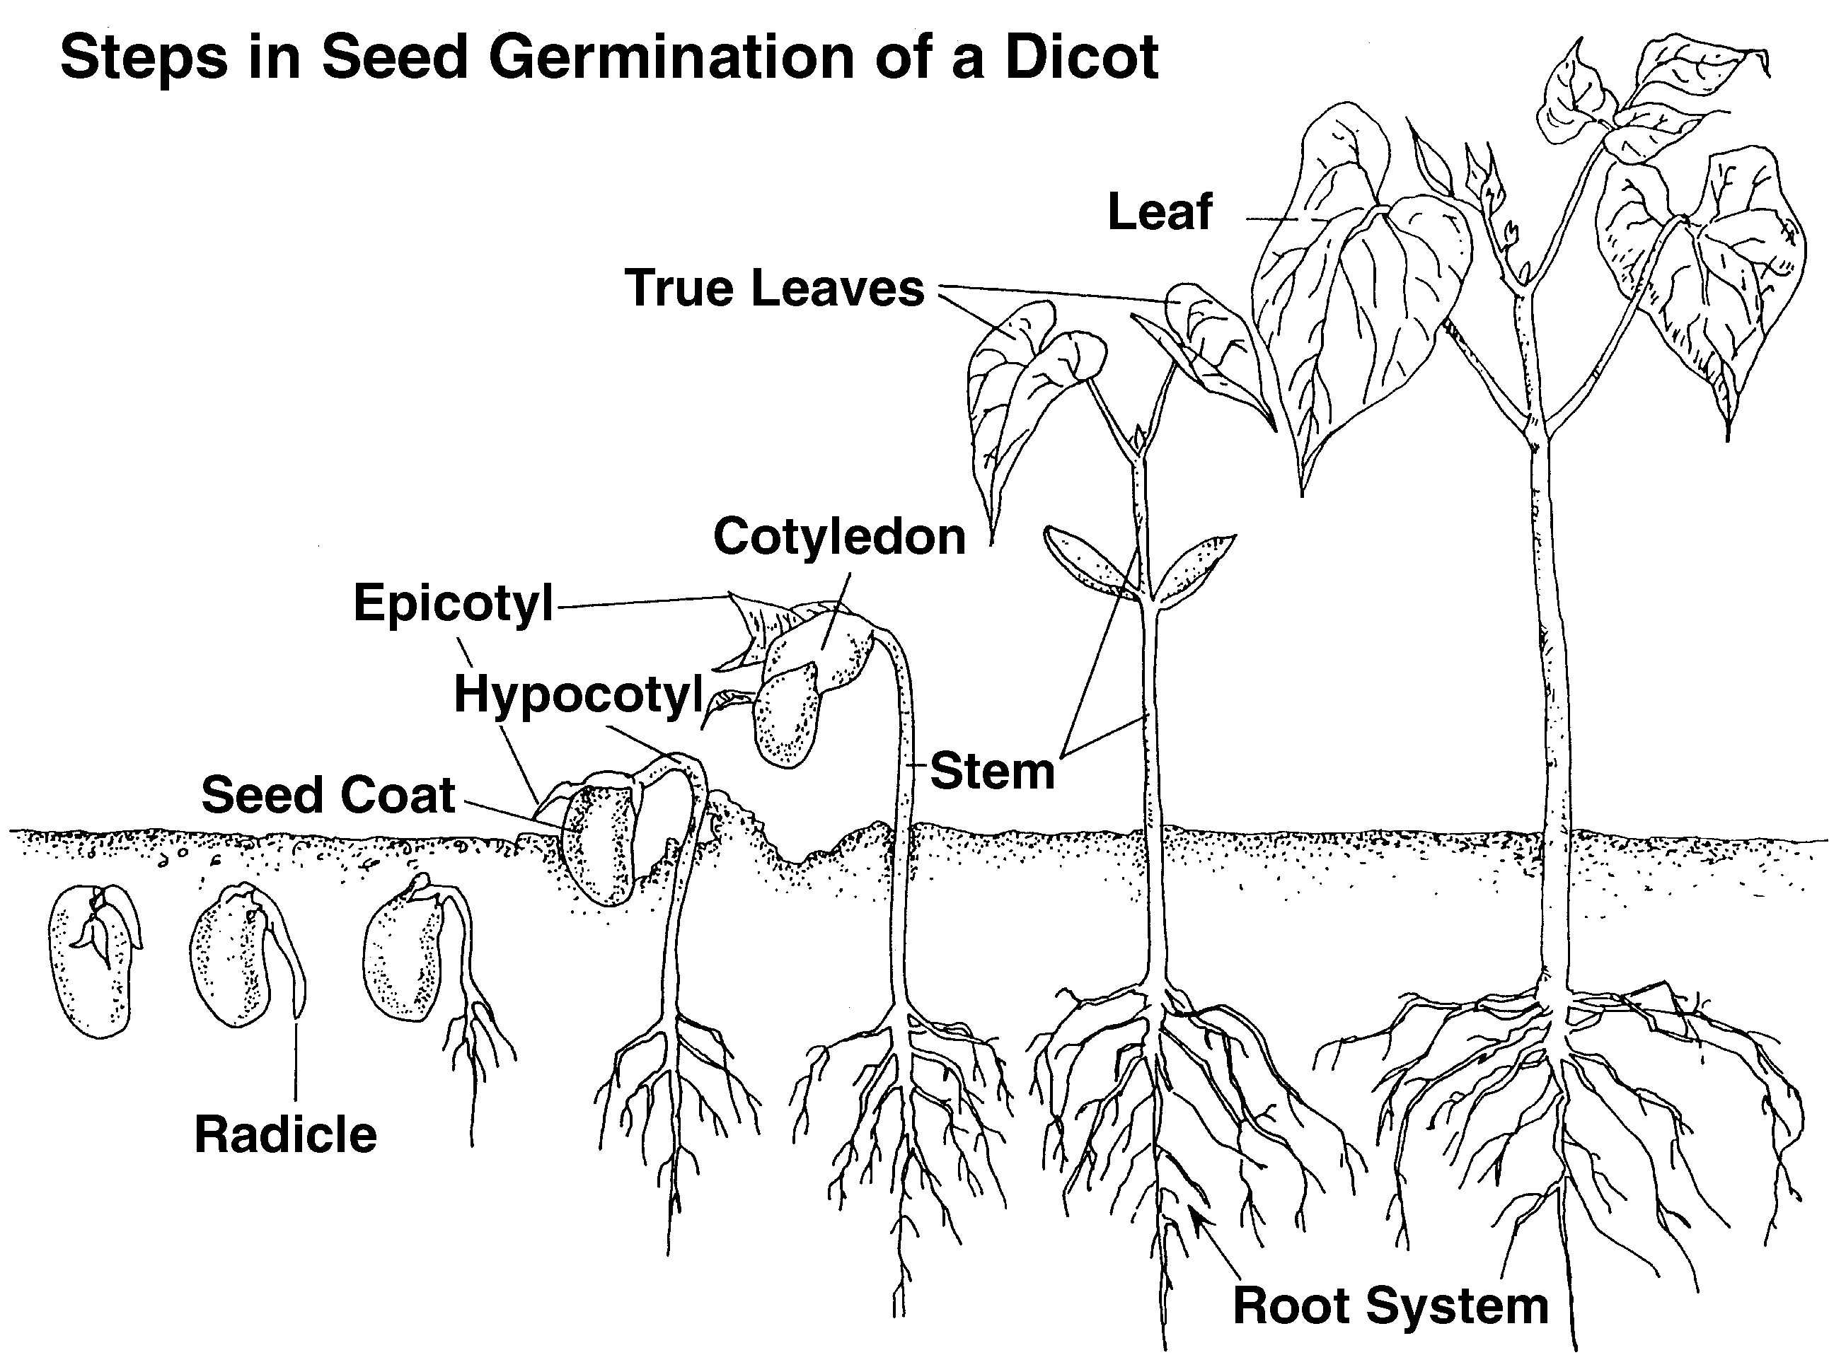
Figure 5.1 - Steps in Seed Germination of a Monocot
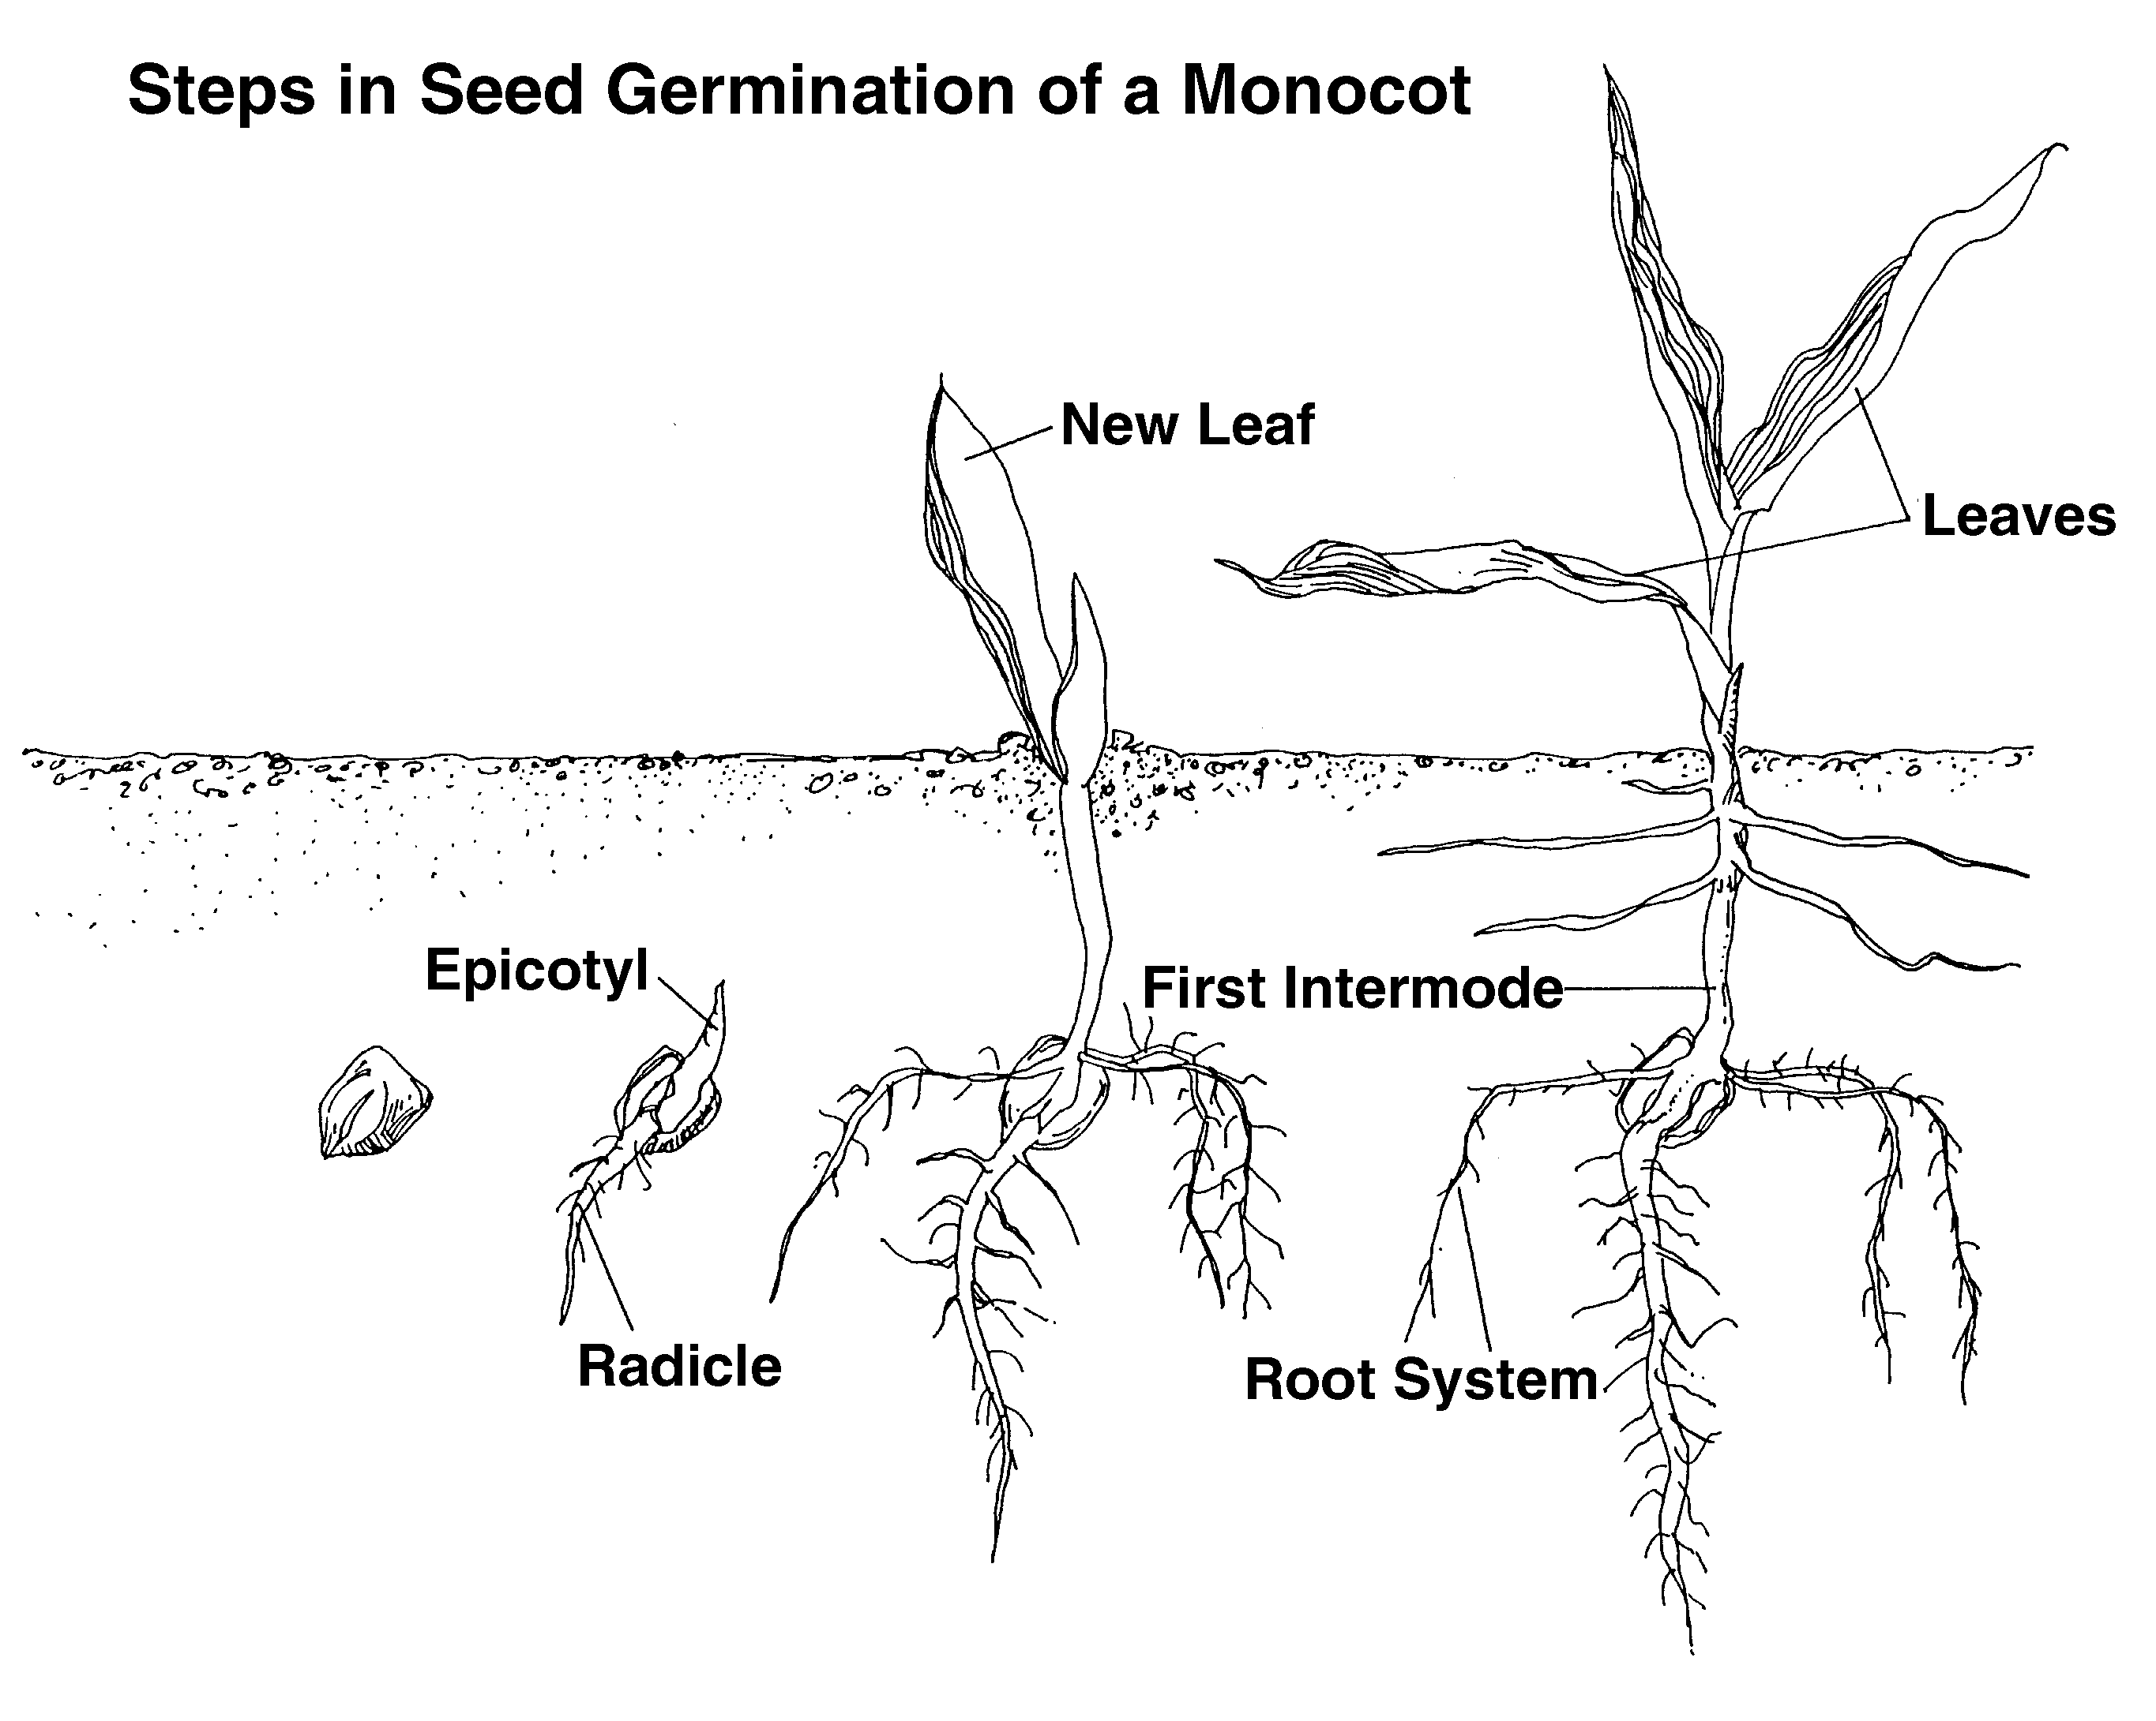
Dicots undergo epigeous germination (cotyledon emerges aboveground). As with monocots, the seed swells as moisture is absorbed. The seed coat splits and the radicle emerges and grows down. The hypocotyl elongates, forms an arch, and pulls the cotyledon upward. When the hypocotyl reaches light, elongation ceases and the hypcotyl straightens up and pulls the cotyledon out of the medium. The cotyledon opens, turns green, and provides food until the true leaves develop. The first true leaves unfold from the epicotyl, exposing the growth bud. The cotyledon dies, dries up, and falls off. See Figure 5.2.

Figure 5.2 - Steps in Seed Germination of a Dicot

Caring for Seedlings After Germination

Once the seedlings begin to emerge, remove the plastic or glass covering. Move the plant to a brightly lit area. The growing temperature should be 10ºF cooler than the temperature for the germination period. Monitor the amount of water the plant receives and keep the growing medium moist but not soggy. Be sure to allow the medium to dry completely between waterings and ensure that seedlings do not wilt at any time.

Promptly fertilize plants that were grown in soilless media. Apply a water-soluble fertilizer in a 20-20-20 formulation (1/4 of the recommended strength) a few days after germination. Twice a week thereafter, apply the appropriate amount of nitrogen for each crop in a diluted solution. Always observe the plant’s reaction to the fertilizer; too much is harmful.

The emerging plant needs protection from diseases. The best preventative steps are to use a soilless mix or pasteurized field soil and to sterilize containers. Always provide ample air circulation and permit the medium to dry out between waterings.

Despite precautions, diseases may develop and endanger the growing plants. Fungi cause damping-off, a disease that rots stems at the base of the medium. If the infection is limited, the best approach is to get rid of the plants and medium. If the infection is widespread, drench the entire area with a fungicide.

Transplanting Seedlings

The best time to transplant seedlings is after the first set of true leaves develops. If transplanting is delayed, the seedlings become overcrowded and spindly and the plant’s health suffers. Because transplanting traumatizes the seedling, the plant must be prepared. This is accomplished through hardening-off. The seedling is put in a cooler environment and watered less frequently for a period of time. The length of the hardening-off period varies with each plant.

After the hardening-off period, the seedling is watered and carefully lifted out of its present container with a small trowel, fork, or knife. Some of the medium should be kept around the roots, and the roots must never dry out. After the container is filled with a moist growing medium, dig a hole in the middle to receive the seedling. This hole should be slightly larger than in the other pot. The extra depth in the new pot gives the seedling room to grow. Add growing medium and gently pat around the base of the seedling. Give the transplanted seedling a final watering to prevent wilting.

Throughout the transplanting process, it is extremely important to be gentle when handling seedlings because they are fragile. As the plant is inserted into the growing medium, carefully hold the seedling by its leaves, not stem.

Caring for Seedlings After Transplanting

After seedlings are transplanted, they need special care. Direct light and intense heat are harmful, so it is important to keep seedlings in the shade or under fluorescent lighting for a few days and also to keep them away from heat.

Summary

Sexual propagation is the development of new plants from seeds. These seeds must be nurtured under specific environmental conditions. The dormancy period that several seeds undergo can be overcome by manual or chemical methods in order to enhance water absorption in the seed coat. Monocots and dicots undergo different stages during germination. Carefully nurturing seedlings after germination, during transplanting, and after transplanting ensures healthy crops.

Credits

Boodley, James W. The Commercial Greenhouse, 2nd ed. Albany, NY: Delmar Publishers, 1996.

Cooper, Elmer. Agriscience: Fundamentals & Applications, 2nd ed. Albany, NY: Delmar Publishers, 1995.

“General Information About 35 U.S.C. 161 Plant Patents.” United States Patent and Trademark Office. <http:www.uspto.gov/web/offices/pac/plant/index.html> accessed 5/3/02.

Greenhouse Operation and Management (Student Reference). University of Missouri-Columbia: Instructional Materials Laboratory, 1990.

Herren, Ray V. and Roy L. Donahue. Delmar’s Agriscience Dictionary. Albany, NY: Delmar Publishers, 1999.

Lee, Jasper S., Series Editor. Introduction to Horticulture, 3rd ed. Danville, IL: Interstate Publishers, Inc., 2000.

“United States of America Plant Patent Amendments Act of 1998.” http://www.upov.int/eng/nprlaws/usa/USA-Law-1998.pdf> accessed 5/3/02

