Unit V: Plant Propagation

Lesson 2: Asexual Propagation

The greenhouse owner can increase the amount of plants available for sale by using different methods of asexual propagation. This lesson compares the principles and techniques of budding, cutting, division, grafting, layering, and tissue cultures.

Asexual Propagation

In asexual (vegetative) propagation, a new plant is created from the buds, leaves, stems, or roots of a parent plant. It is a popular means of reproduction because it is a faster process than sexual (seed) propagation and it produces identical characteristics of the original plant. Frequently, plants grown from seeds cannot produce viable seeds. Asexual propagation is a less expensive method than sexual propagation. The reason asexual propagation works is that each plant cell contains all the genetic information needed to divide and reproduce itself.

General Considerations for Asexual Propagation

To ensure successful propagation, the greenhouse owner needs adequate supplies and equipment, a suitable growing environment, and an effective tracking system. Tools include sharp knives to cut parts from plants, divide plants, and make wounds in plant materials. Dibbles (sticks) are used to dig holes in the growing medium; puffer dusters and spray bottles are used to apply the rooting compound. Keeping propagation benches above the floor helps prevent exposure to pathogens.

Within the greenhouse environment, sanitation is mandatory. All tools and knives must be sterile and disinfected before use and after each cutting. Cuttings should be put in a sterile container until they are ready for planting. After each use, it is important to sterilize rooting solutions. To ensure further cleanliness, discard any excess plant debris. To help plants flourish, use a soilless growing medium composed of vermiculite and perlite. This pathogen-free medium promotes drainage and aeration while retaining sufficient amounts of nutrients and water. Lighting for the cuttings is an important factor. During winter, for example, more light is required than during the heat of the summer. When too much light floods the greenhouse, the cuttings need shade. Cuttings also need balanced temperature (see below). The bottom temperature is generated from heating pipes or electric cables and is placed below the propagation benches. It generally should be 5-10ºF higher than air temperature.

In order to keep track of the increase in plants, the greenhouse owner should maintain careful records. By labeling each plant accurately, the greenhouse owner can identify the plant’s name and variety, date of propagation, and any special treatment received.

Asexually reproduced plants, except tubers, are federally protected. The Plant Patent Law of 1930 is similar to the Plant Variety Protection Act, passed in 1970, which regulates sexually propagated plants and tubers. A plant patent gives breeders the right to sell their plants and it controls who may propagate and sell subsequent plants and plant parts. This is referred to as a licensing agreement. A plant patent lasts 20 years. In 1998, the Plant Patent Act was amended. The revised Act explicitly protects the owner of a plant patent against unauthorized sale of plant parts that could be used to propagate the plant. It also expands protections on par with those for sexually propagated plants as covered by the Plant Variety Protection Act. For further information, contact the Assistant Commissioner for Patents, Washington, DC 20231.
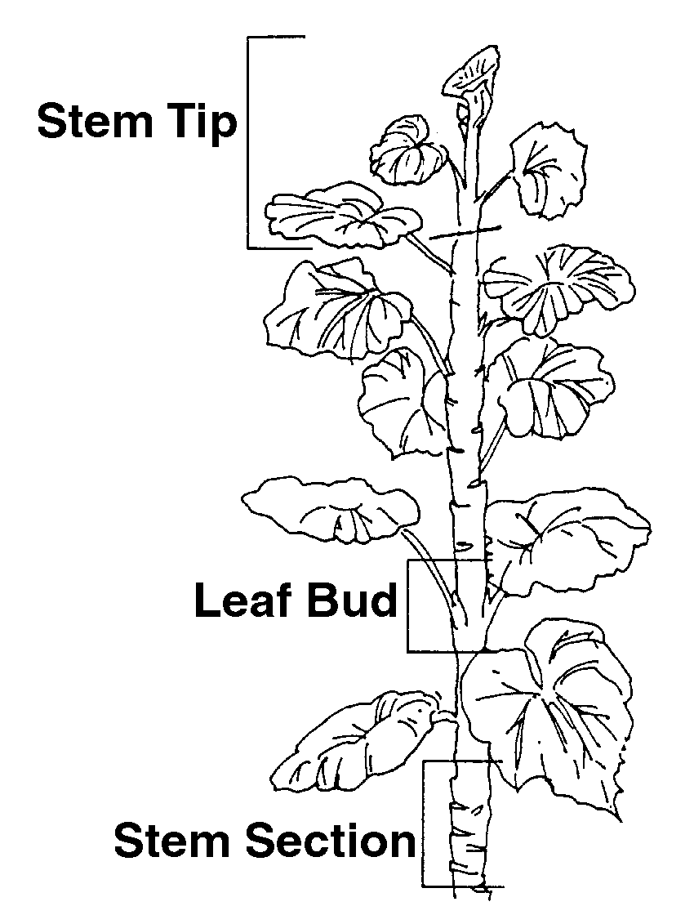

In the state of Missouri, those who sell, transport, or give away nursery stock (perennials, woody stem plants, perennials, bulbs, roots, crowns, corms, rhizomes, and tubers) must be licensed. Twice a year, a state entomologist examines the nursery stock for infestations from pests and diseases. Fees for this service are based on the size of the greenhouse as measured in square feet under glass. For further information, contact the State Entomologist, Missouri Department of Agriculture, P.O. Box 630, Jefferson City, MO 65102-0630 - Phone: (573) 751-5507; Fax: (573) 751-0005.

Methods of Asexual Propagation

Six basic methods of asexual propagation are described below: budding, cutting, division, grafting, layering, and tissue culture.

Budding is similar to grafting (explained below) and is used most often to produce roses. A single bud from one plant (used as the scion) is inserted into the bark of another variety. But most greenhouse owners sell rose bushes that plant propagators have already grafted through bud grafting.

Cuttings, used predominantly with floriculture crops, are sections from the parent plant that are rooted in the growing medium to form a new plant. As illustrated in Figure 5.3, cuttings may be taken from three parts of the plant: stem tip, leaf bud, and stem section
Figure 5.3 - Cutting Locations

Stem tip cuttings are taken from a section or tip of the stem. This method of propagation is suited to herbaceous greenhouse plants such as carnations and chrysanthemums and various soft wood, hardwood, and semihardwood plants. Leaf cuttings are taken from a piece of the leaf or from the entire leaf, including the leaf vein or leaf bud. Leaf bud cuttings are taken from the leaf blade, petiole (stem of the leaf), and axillary bud (found in the angle between the leaf and the main stem). The cut from a stem section includes a bud and its attached leaf. Although this technique takes longer than stem tip cuttings, it produces many cuttings even with only a limited number of plants. See Figure 5.4.

Figure 5.4 - Cuttings
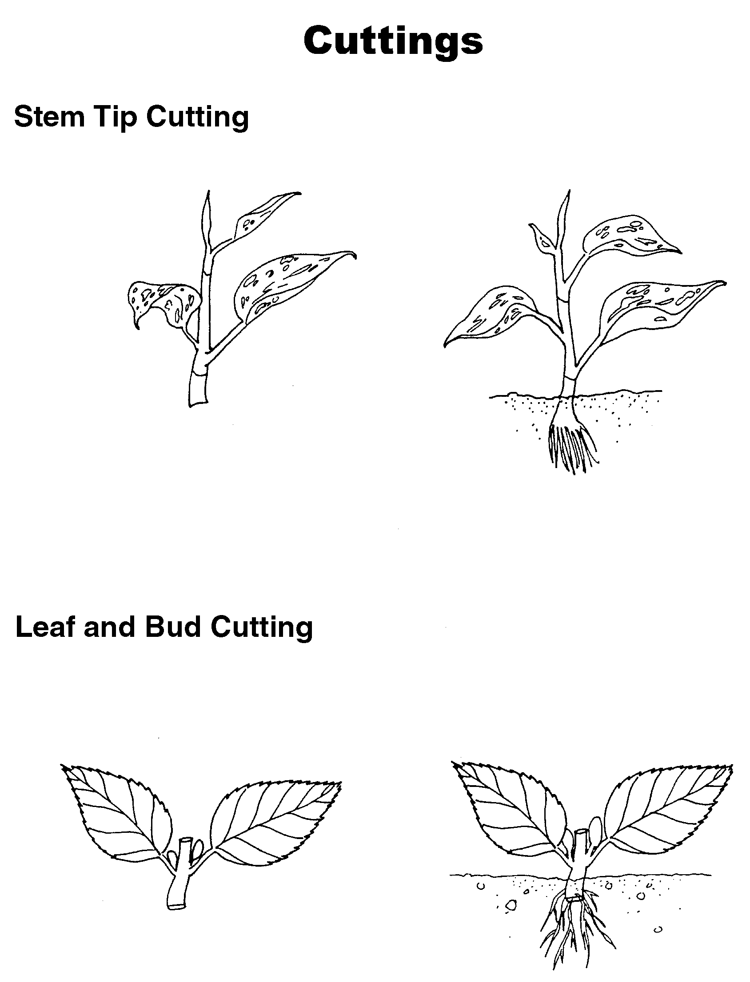
Before proceeding, the first step is to assemble clean tools, containers, and a suitable growing medium. The cutting sites, as illustrated in Figure 5.3, determine where the cut is made. For example, stem tip cuts are made with a sharp knife that removes a 2-4-inch section at the top of the plant, just below a node. The leaves are removed from the lower third to half of the cutting.
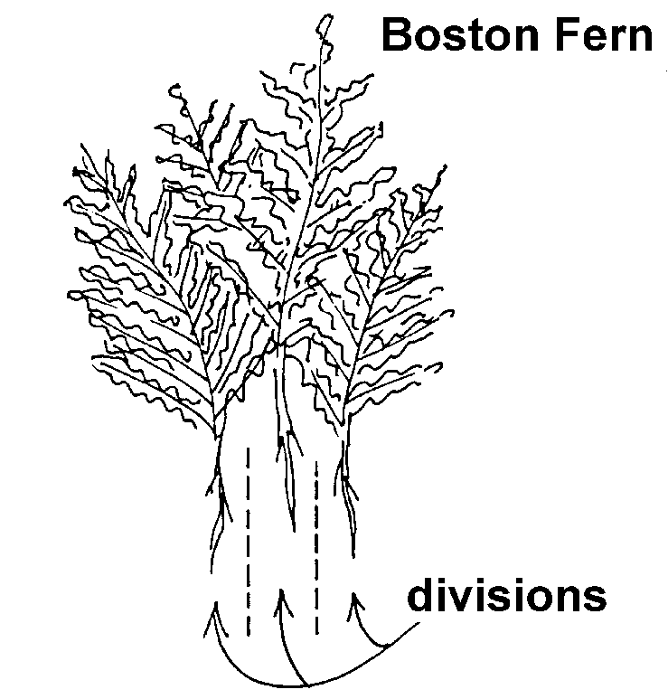
Treating the base of the cuttings with a rooting hormone enhances growth. The cuttings should be planted in a moist, soilless growing medium and placed in a high-humidity environment to reduce moisture loss. Cuttings thrive in temperatures between 65 and 75ºF (18-23ºC) and with a bottom heat of 75-85ºF (23-29ºC).

By stimulating vigorous root growth, rooting hormones increase the percentage of successfully propagated cuttings. These synthetic hormones help plants root more quickly and uniformly. They are formulated as powders and solutions. A puffer duster sprays the hormone powder on the stem. Dusting is preferred over solutions because it enables the greenhouse owner to apply precise amounts to the base of the stem. Excessive quantities of rooting powder can rot the stem and prevent root development. In rooting hormones formulated as solutions, the base of the cutting is dipped into the hormone mix for a short period of time.

These routes for administering rooting hormones could pose a threat to the plant under certain circumstances. Pathogenic organisms can spread from diseased cuttings to healthy cuttings through the powder or solution. When applying powders, use of the puffer duster prevents infection from spreading. When rooting hormones are applied via solutions, it is wise to use only fresh ingredients and to discard all leftovers. Spraying cuttings with the solution is a safer method than dipping them.

Plant division is another method of asexual propagation. Clumps of a plant are separated into small groups. Each group has its own roots, stems, buds, and leaves or the potential to develop these parts. For plants that produce multiple crowns (e.g., Boston ferns) or offshoots, division is the easiest method of propagation. Examples of plants that naturally propagate through division are tulips, daffodils, and gladioli. See Figure 5.5.

Figure 5.5 - Division

Grafting is a propagation method in which buds, twigs, or shoots (the scion) are taken from one plant and inserted into the stems or roots of a similar plant (the rootstock), matching the cambiums in the process. Whip (or tongue) grafts join scion rootstock, whereas cleft and bark grafts join small scions to large rootstocks. This propagation technique is not prevalent in most greenhouse operations; it is used most often for developing trees. However, some flowers are grafted, such as lilacs, camellias, and azaleas. Refer to Figure 5.6.
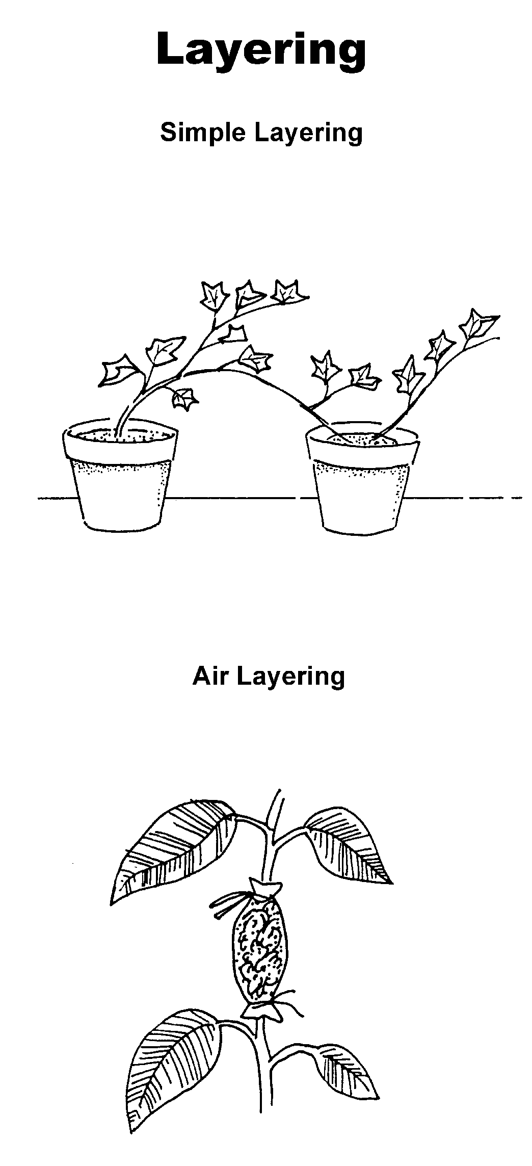

Figure 5.6 - Grafting

Layering is a method for propagating plants in which new roots are established while the stem stays attached to the parent plant. As the root system develops, it derives support from the parent plant until it is self-sufficient. Many houseplants are easily propagated by this method. There are several kinds of layering. Of all the types described here, the only ones commonly used in a greenhouse are simple layering and air layering (see Figure 5.7).

Figure 5.7 - Layering

In simple layering, a superficial cut is made to a portion of the stem to stimulate new root growth. The wounded stem is then buried, but the tip of the stem is left exposed. Foliage plants (e.g., English ivy and rhododendrons) are commonly propagated by this method.

Air layering is also used to propagate foliage plants, such as ficus. This technique requires cutting around the stem. The wound is dusted with a hormone to induce rooting and is covered with some moist sphagnum moss, which is covered with clear plastic and then secured in place.

Tip and simple layering are similar. The terminal (end) tip is wounded, treated, and buried. However, the terminal tip is buried in the growing medium. As the tips develop, they first grow downward and eventually move upward, creating a bend. New roots develop at this juncture and the emerging tips appear above the growing medium. Raspberries, blackberries, and blueberries, which have flexible stems, are crops that are propagated by tip layering.

In serpentine (compound) layering, sections of the stem are alternately buried in the growing medium and exposed to the surface. This creates multiple sites for rooting. The buried portion of the stem is slightly wounded and treated with a rooting hormone.

Woody plants, such as fruit trees and roses, are propagated through mound layering. This involves cutting back the stem and burying the stem while it is dormant. Trench layering is also designed for propagating woody plants. After the stem has been wounded and treated with a rooting hormone, the entire plant is bent and buried in the growing medium. Only the tip is left above ground.

Tissue culture, also referred to as micropropagation, is a highly technical method in which one or more cells from the tissue of a plant are used to produce a new plant. Tiny pieces of the plant are grown in artificial media under sterile conditions. Plant development is carefully controlled through selected chemicals and growth regulators. This allows mass production of plants in a short period of time. Compared to other asexual methods of propagation used to produce a large number of crops, tissue culture is especially cost-effective and efficient.

Summary

Asexual propagation is an effective technique for increasing crop production in the greenhouse. Adequate supplies, a suitable growing environment, and an effective labeling system are essential. Each propagation method - budding, cutting, division, grafting, layering, and tissue cultures - offers unique features that can boost the greenhouse owner’s inventory. Foliage and ornamental plants are propagated by herbaceous cuttings, division, and simple and air layering. The greenhouse owner can promote successful, healthy plant development by applying correct amounts of rooting hormones.

Credits

Boodley, James W. The Commercial Greenhouse, 2nd ed. Albany, NY: Delmar Publishers, 1996.

Cooper, Elmer L. Agriscience: Fundamentals & Applications, 2nd ed. Albany, NY: Delmar Publishers, 1995.

Greenhouse Operation and Management (Student Reference). University of Missouri-Columbia: Instructional Materials Laboratory, 1990.

Lee, Jasper S., Series Editor. Introduction to Horticulture, 3rd ed. Danville, IL: Interstate Publishers, Inc., 2000.

“2002 Missouri Certified Nursery and Greenhouse Directory.” Missouri Plant Law (Sections 263.010-263.180). Plant Industries Division, Missouri Department of Agriculture. <http://www.mda.state.mo.us/pd/
NurseryBook.pdf> accessed 5/10/02.

