Unit VI: Plant Health

Lesson 1: Greenhouse Pests and Diseases

The very features that nourish greenhouse crops - warmth, moisture, humidity, and controlled lighting - also encourage destructive pests and support diseases. This unit examines various issues concerning plant health. Lesson 1 identifies greenhouse pests, describes their effects on plants, outlines causes of diseases, and gives examples of infections that attack plants.
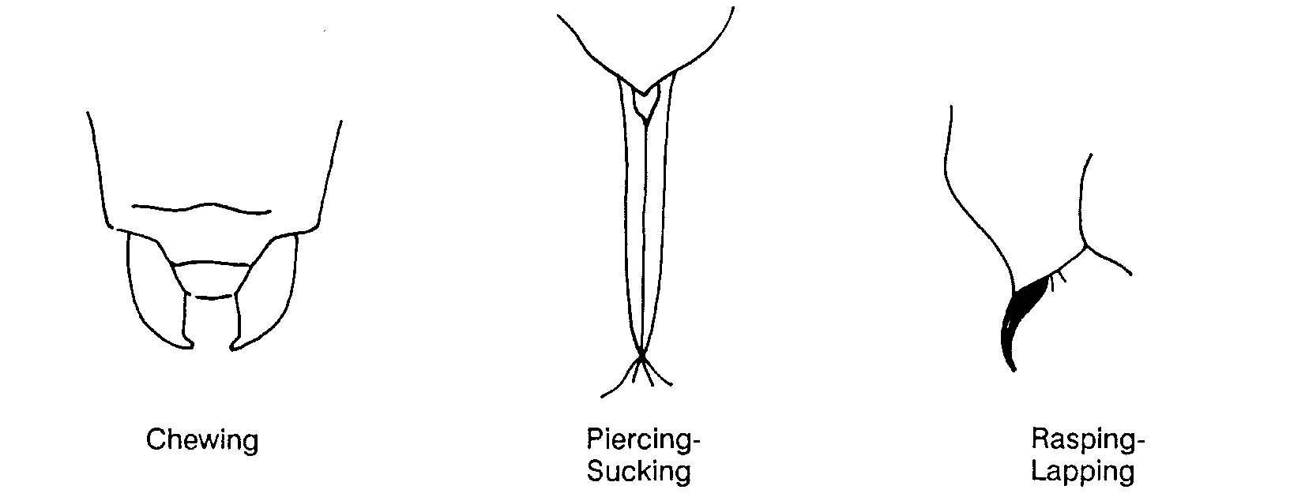

Descriptions of Pests

A greenhouse pest is any life-form that causes injury or loss to plants. The major pests are insects, arachnids (eight-legged invertebrates, e.g., mites, spiders, millipedes, and centipedes), nematodes, rodents, mollusks, weeds, and disease-causing organisms. Of those listed, insects and mites pose the greatest threat to greenhouse crops. These pests gain access to cultivated crops through open doors, when new produce arrives, and through ventilation ducts.

Effects of Insects and Mites
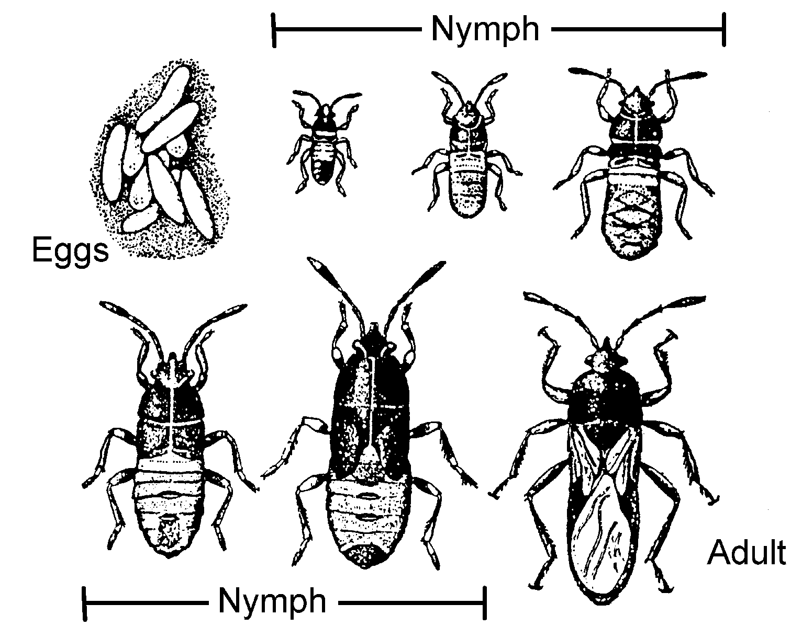
By attacking the plant’s vascular system, leaves, and roots, insects and mites interfere with vegetative functions and reduce the rate of development. A defining characteristic of these pests is how they feed on plants, which is determined by the shape and movement of their mouth parts, as shown in Figure 6.1. Chewing insects like grasshoppers devour leaves and roots and destroy the plant’s tissues. Piercing-sucking and rasping-lapping pests puncture the plant and then suck out life-sustaining sugary sap from the phloem cells. Vector pests introduce diseases.

Figure 6.1 - Types of Mouth Parts

Identifying the specific stage of the pests’ life cycle helps determine when to apply the appropriate treatment. Some pests invade crops as adults; others are destructive as larvae or nymphs. This growth process, known as metamorphosis, can be gradual or complete. During gradual metamorphosis, the pest undergoes three phases: egg, nymph, and adult. The insect molts several times during the nymph stage until it reaches adulthood, as illustrated in Figure 6.2.

Figure 6.2 - Gradual Metamorphosis

Egg, larva, pupa, and adult are the four stages of complete metamorphosis (see Figure 6.3).

Figure 6.3 - Complete Metamorphosis
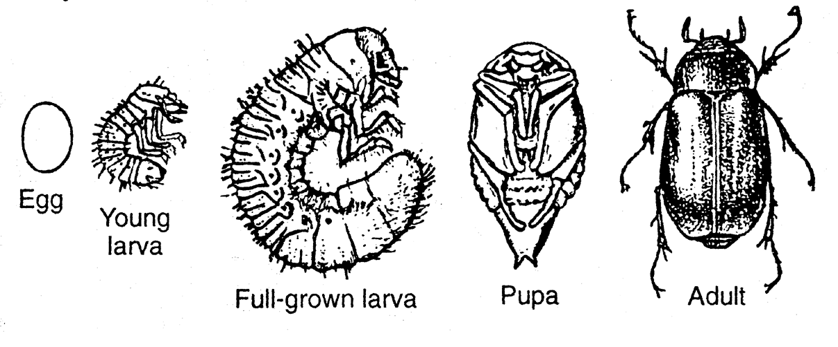
Aphids are common pests in the greenhouse. The species most prevalent is the green peach aphid that not only harms leaves but also spreads bacteria and viral diseases. Adults are 1/25-1/8 inch (1-3 mm) long. Their piercing-sucking mouth parts suck plant sap from the phloem cells. This stunts and distorts new shoots. Tiny yellow spots appear on the foliage, and a sugary substance develops called “honeydew” (not to be confused with melon). The honeydew nourishes black sooty mold. Because females can reproduce as many as 100 offspring within 3 days, aphids are an ever-present threat to ornamentals and vegetable crops. (See Figure 6.4.)

Figure 6.4 - Aphid
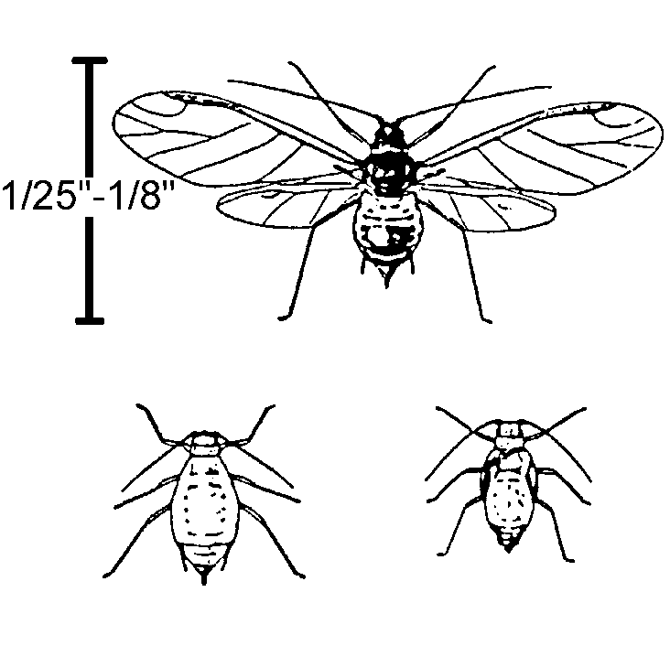
It is during its larval, not adult, stage that fungus gnats damage plants. At 1/4 inch (6 mm), these larvae, which live in the soil, use their chewing mouth parts to demolish roots, root hairs, and crowns of bulbs or plants. The harmful results are evident in seedlings: stunted growth, lack of plant vigor, wilted leaves, leaf drop, and yellow foliage. The female adult spends her 10-day life span producing 300 eggs, which are laid in moist, fertile soil. Figure 6.5 illustrates the life stages of the fungus gnat.

Figure 6.5 - Fungus Gnat
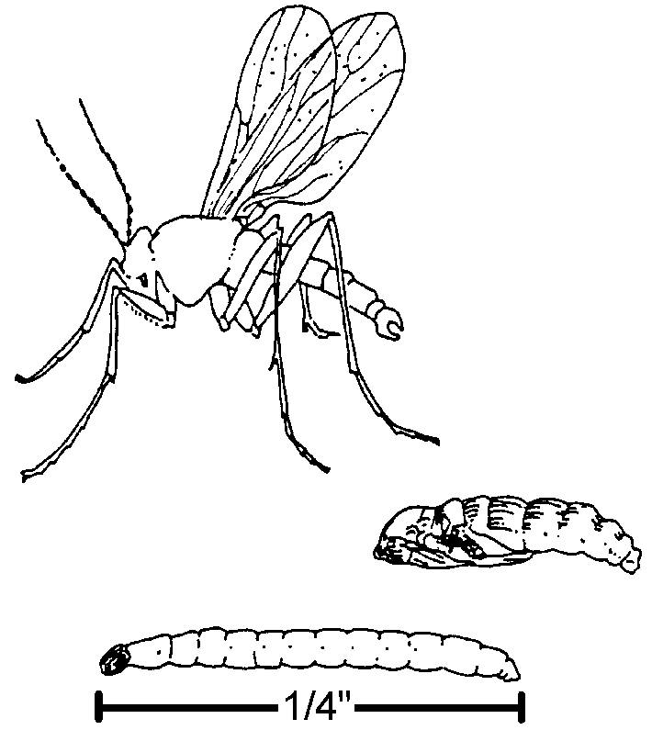

Adult mealybugs are 1/8-3/8 inch (3-4 mm) long. They use their piercing-sucking mouth parts to drain the sap, resulting in diminished plant vigor, yellow and deformed foliage, and leaf drop. Covered with a waxy, white powder, mealybugs lay their eggs in leaf axils and under leaves. When the egg clusters develop, they look like tiny cotton balls. Figure 6.6 shows an adult mealybug.

Figure 6.6 - Mealybug
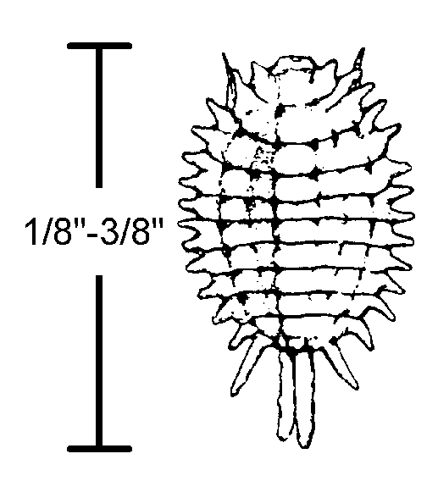

Other pests that use piercing-sucking mouth parts are scale insects. Adults are 5/16 inch (8 mm); some have a round, hard shell that has a waxy, rubbery coating. Hard-coated scale insects exude honeydew. When a plant is attacked by scale, symptoms include a lack of vigor, stunted growth, and yellowed leaves. See Figure 6.7.

Figure 6.7 - Scale
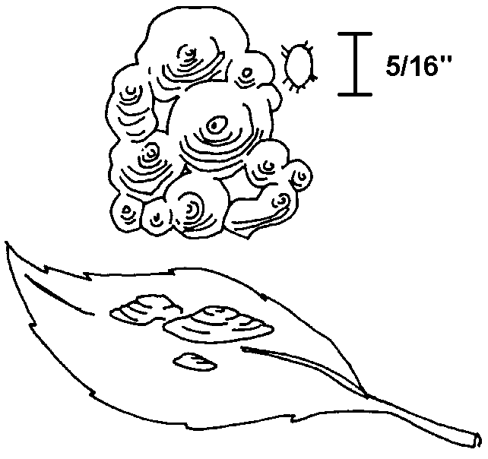
When it is warm outside, huge quantities of thrips may gather and fly into the greenhouse at the first opportunity. Adults are only 1/25 inch (1 mm); they use their rasping-lapping mouth parts to scrape leaf surfaces and petals and then drink the sap that is released. New growth and flowers become malformed, flower petals get streaked and turn brown, and eventually the leaves and flowers drop off. When thrips invade, they can spread viral diseases among plants. Figure 6.8 shows the life cycle of thrips.

Figure 6.8 - Thrips

Whiteflies look like tiny moths and feed on popular greenhouse plants: poinsettias, chrysanthemums, and bedding plants. Adults are 1/16 inch (2 mm) and have piercing-sucking mouth parts. Evidence of damage from whiteflies is tiny yellow spots on foliage. They also can spread disease among plants by emitting honeydew. See Figure 6.9.

Figure 6.9 - Whitefly

Many species of mites (arachnids) injure plants. Mites are very tiny - less than 1/50 inch (0.50 mm) long - and have piercing-sucking mouth parts. Spider mites (illustrated in Figure 6.10) are especially prevalent in the greenhouse. Like their namesake, these arachnids weave miniscule webs on the plant that turn the leaves brown. When mites attack, the foliage develops tiny yellow spots, a bronze hue, and it curls up. When the beauty of a plant is marred, the greenhouse owner suffers economic loss. Mites are difficult pests to control because their resilience makes them able to adapt to various temperatures and humidity levels.
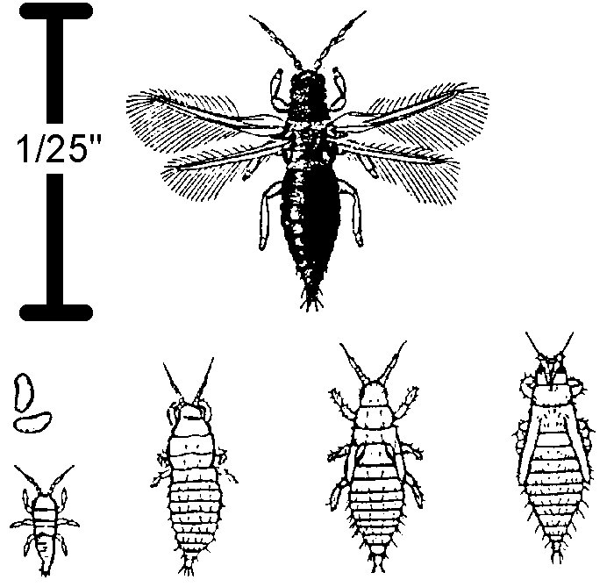
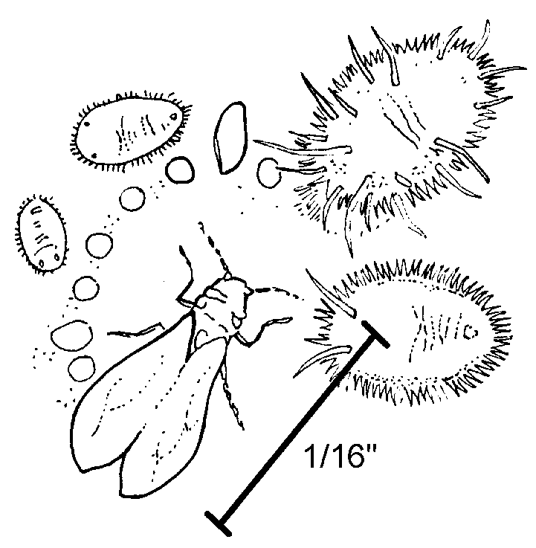

Figure 6.10 - Spider Mite

Effects of Other Pests

Nematodes are wormlike invertebrates that live in the soil. Many are plant parasites. Those that are harmless to crops are still a threat because they penetrate root cells, giving fungi and bacteria an opportunity to enter.

Although rodents, birds, and other mammals don’t typically enter an enclosed greenhouse, if they do gain access, they harm plants by eating plant parts and digging up the soil. Mollusks such as snails and slugs use their chewing mouth parts to feed on leaves and young stems. With voracious appetites, these pests can devour all the foliage on greenhouse plants if they are not controlled. Creating damage exclusively at night, snails and slugs leave a slimy trail everywhere they go. Figure 6.11 depicts these additional pests.

Figure 6.11 - Other Pests

Weeds are any unwanted plants that grow out of place. The problem with weeds is that they compete with cultivated plants for space, light, water, and nutrients. Additionally, they may support pests and diseases that can infect cultivated plants. The greenhouse owner’s profit margin is substantially diminished if weeds are allowed to choke out emerging crops.
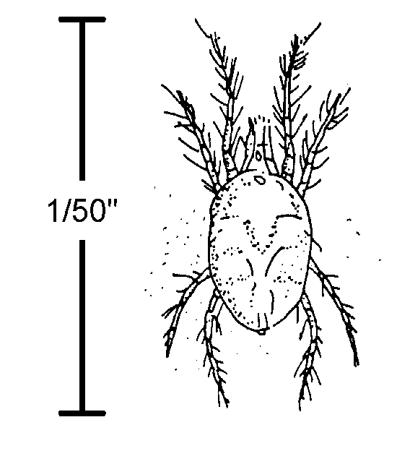

Causes and Sources of Disease

There are two basic causes of plant diseases: cultural and parasitic. Cultural diseases result from incorrect applications of chemicals in the growing medium or on the plants, nutritional deficiencies, and physical damage to plant parts. The greenhouse’s internal environment may also promote disease. For example, if the humidity is too high, pathogenic spores can germinate. Poor drainage in plant containers also invites disease.

Microorganisms cause parasitic diseases. The parasites are contagious and can sweep rapidly through the greenhouse, devastating valuable crops. Pathogenic microorganisms include viruses, bacteria, and fungi. Viruses cause the most difficult type of disease to control and treat. Plants suffer from stunted growth or die. Viruses usually attack the plant’s vascular system. This means that the crop yield and the quality of the produce are substantially reduced. Sucking insects as well as unsterile equipment and tools used during asexual propagation transmit viral infections throughout the greenhouse.

Harmful bacteria enter the plant through openings in the epidermis, flowers, stem, and leaves. Bacteria rob the nutrient solution of life-supporting oxygen.
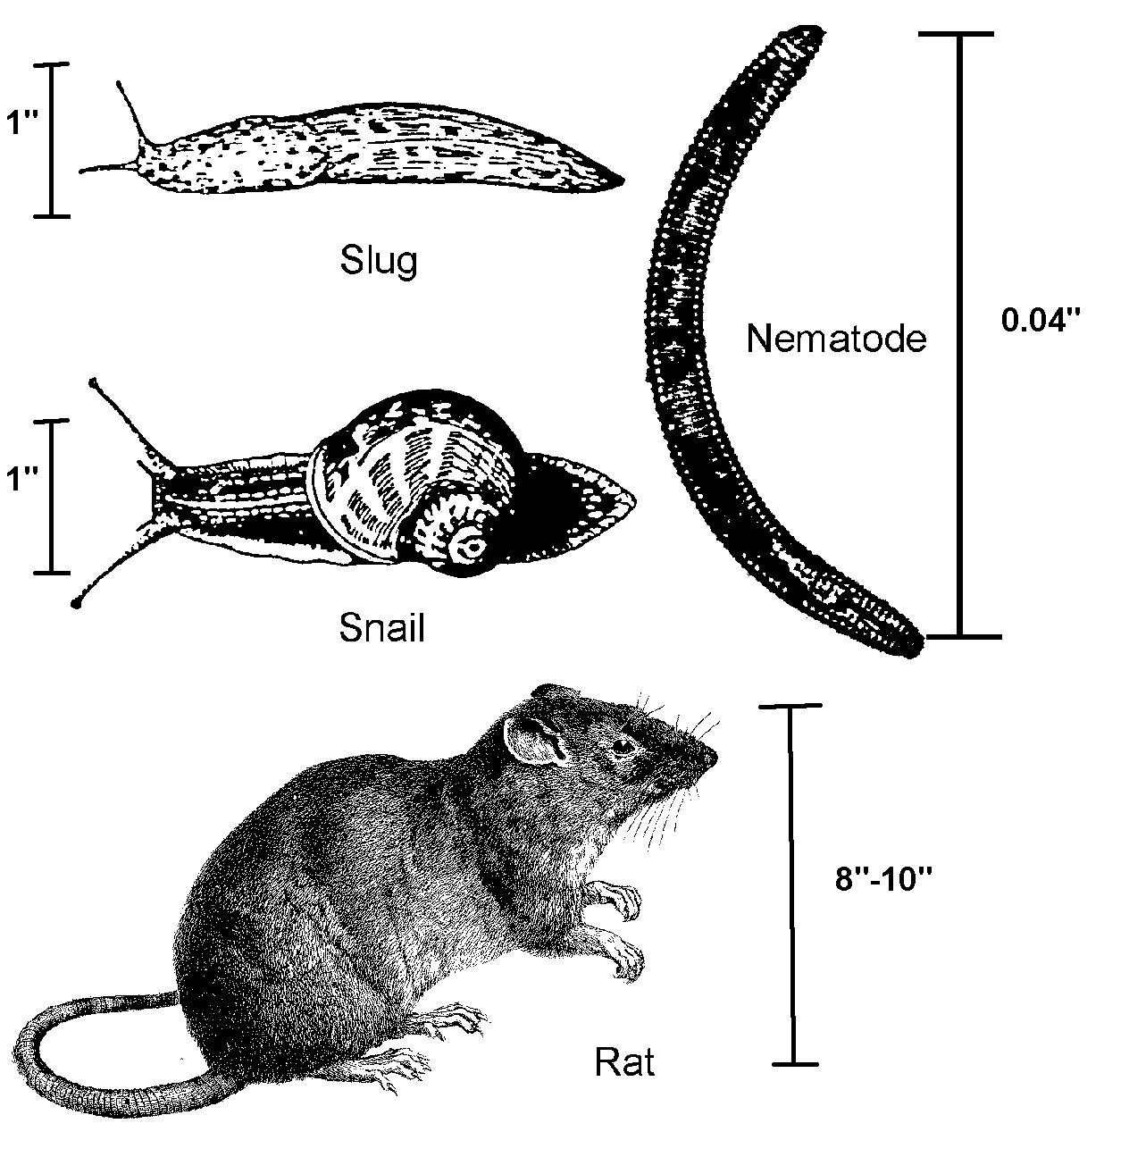

Fungi are the most common cause of plant disease. Fungal spores grow on and inside of plants and they spread via water, air, and insects. If an ornamental plant is pruned with clippers that have been exposed to a fungus, the plant gets infected as well. Any wounded plant part is vulnerable to fungal attack.

The greenhouse may contain several potential sources of disease. Infected or poorly drained soil hosts a variety of pathogens. Debris from previous crops may already be infected and could spread disease-bearing organisms via the air. Polluted water or air and pathogenic plant tissues from cuttings may also harbor diseases.

Common Diseases

Greenhouse crops frequently suffer from damping-off. This disease is caused by a complex of organisms that most often includes the soilborne fungi Phytophthora or Rhizoctonia. Damping-off usually attacks seedlings. The fungi originate in the soil or seed itself. At preemergence, the seed is destroyed before germination. At postemergence, the seedling falls over and is destroyed at the soil level.

Fungi also cause Botrytis blight (gray mold). This is a costly disease because it ruins popular crops such as roses, azaleas, geraniums, and poinsettias. It thrives in a cool, humid environment, which is readily provided in the greenhouse. Plant symptoms are gray spots on the foliage. The tissue under the spots turns soft, then brown, then becomes completely rotten.

Bacteria or fungi cause leaf spot and other foliar diseases. If bacteria are the cause, the plant must be discarded; if fungi are the cause, the plant can be treated. These diseases also develop in a humid environment. Plants with leaf spot have discolored and distorted leaves.

Root rot is caused by bacteria or Pythium and Phytophthora fungi. Houseplants die most frequently of this disease. Root rot results from overwatering. Overwatering causes damage to the roots and this enables fungi to invade the plant. Consequently, there is a decrease in both the uptake of water and in the root hairs’ ability to transmit dissolved nutrients into the plant. When plants get root rot, the roots become brown or black and there are less of them. They become slimy and have a foul odor. The leaves yellow, wilt, and finally drop off.

Summary

The greenhouse environment unfortunately can support a variety of pests. By understanding their life cycle, the greenhouse owner can plan effective treatments for eradication. Viruses, bacteria, and fungi are responsible for causing diseases such as damping-off, Botrytis blight, and root rot.

Credits

Acquaah, George. Horticulture: Principles and Practices. Upper Saddle River, NJ: Prentice Hall, 1999.

Boodley, James W. The Commercial Greenhouse, 2nd ed. Albany, NY: Delmar Publishers, 1996.

Cooper, Elmer L. Agriscience: Fundamentals & Applications, 2nd ed. Albany, NY: Delmar Publishers, 1995.

Greenhouse Operation and Management (Student Reference). University of Missouri-Columbia: Instructional Materials Laboratory, 1990.

Lee, Jasper S., Series Editor. Introduction to Horticulture, 3rd ed. Danville, IL: Interstate Publishers, Inc., 2000.

Nelson, Paul V. Greenhouse Operation and Management, 3rd ed. Reston, VA; Reston Publishing Company, Inc., 1985.

