Unit VI: Plant Health

Lesson 3: Pesticide Use and Safety

As potent weapons in the arsenal against pests, chemical deterrents can systematically destroy vermin from plants. However, personnel authorized to apply pesticides must be keenly aware of the environmental consequences to greenhouse employees, crops, and even to the equipment. This lesson first addresses pesticide use: label information, forms of pesticides, application methods, and modes of action. The discussion then focuses on basic safety issues, beginning with a definition of toxicity levels. Lesson 3 continues to examine safety by defining storage and disposal procedures, personal protection measures, and first aid for accidental poisoning. Finally, sources of pesticide-related information and pesticide certification procedures are provided.
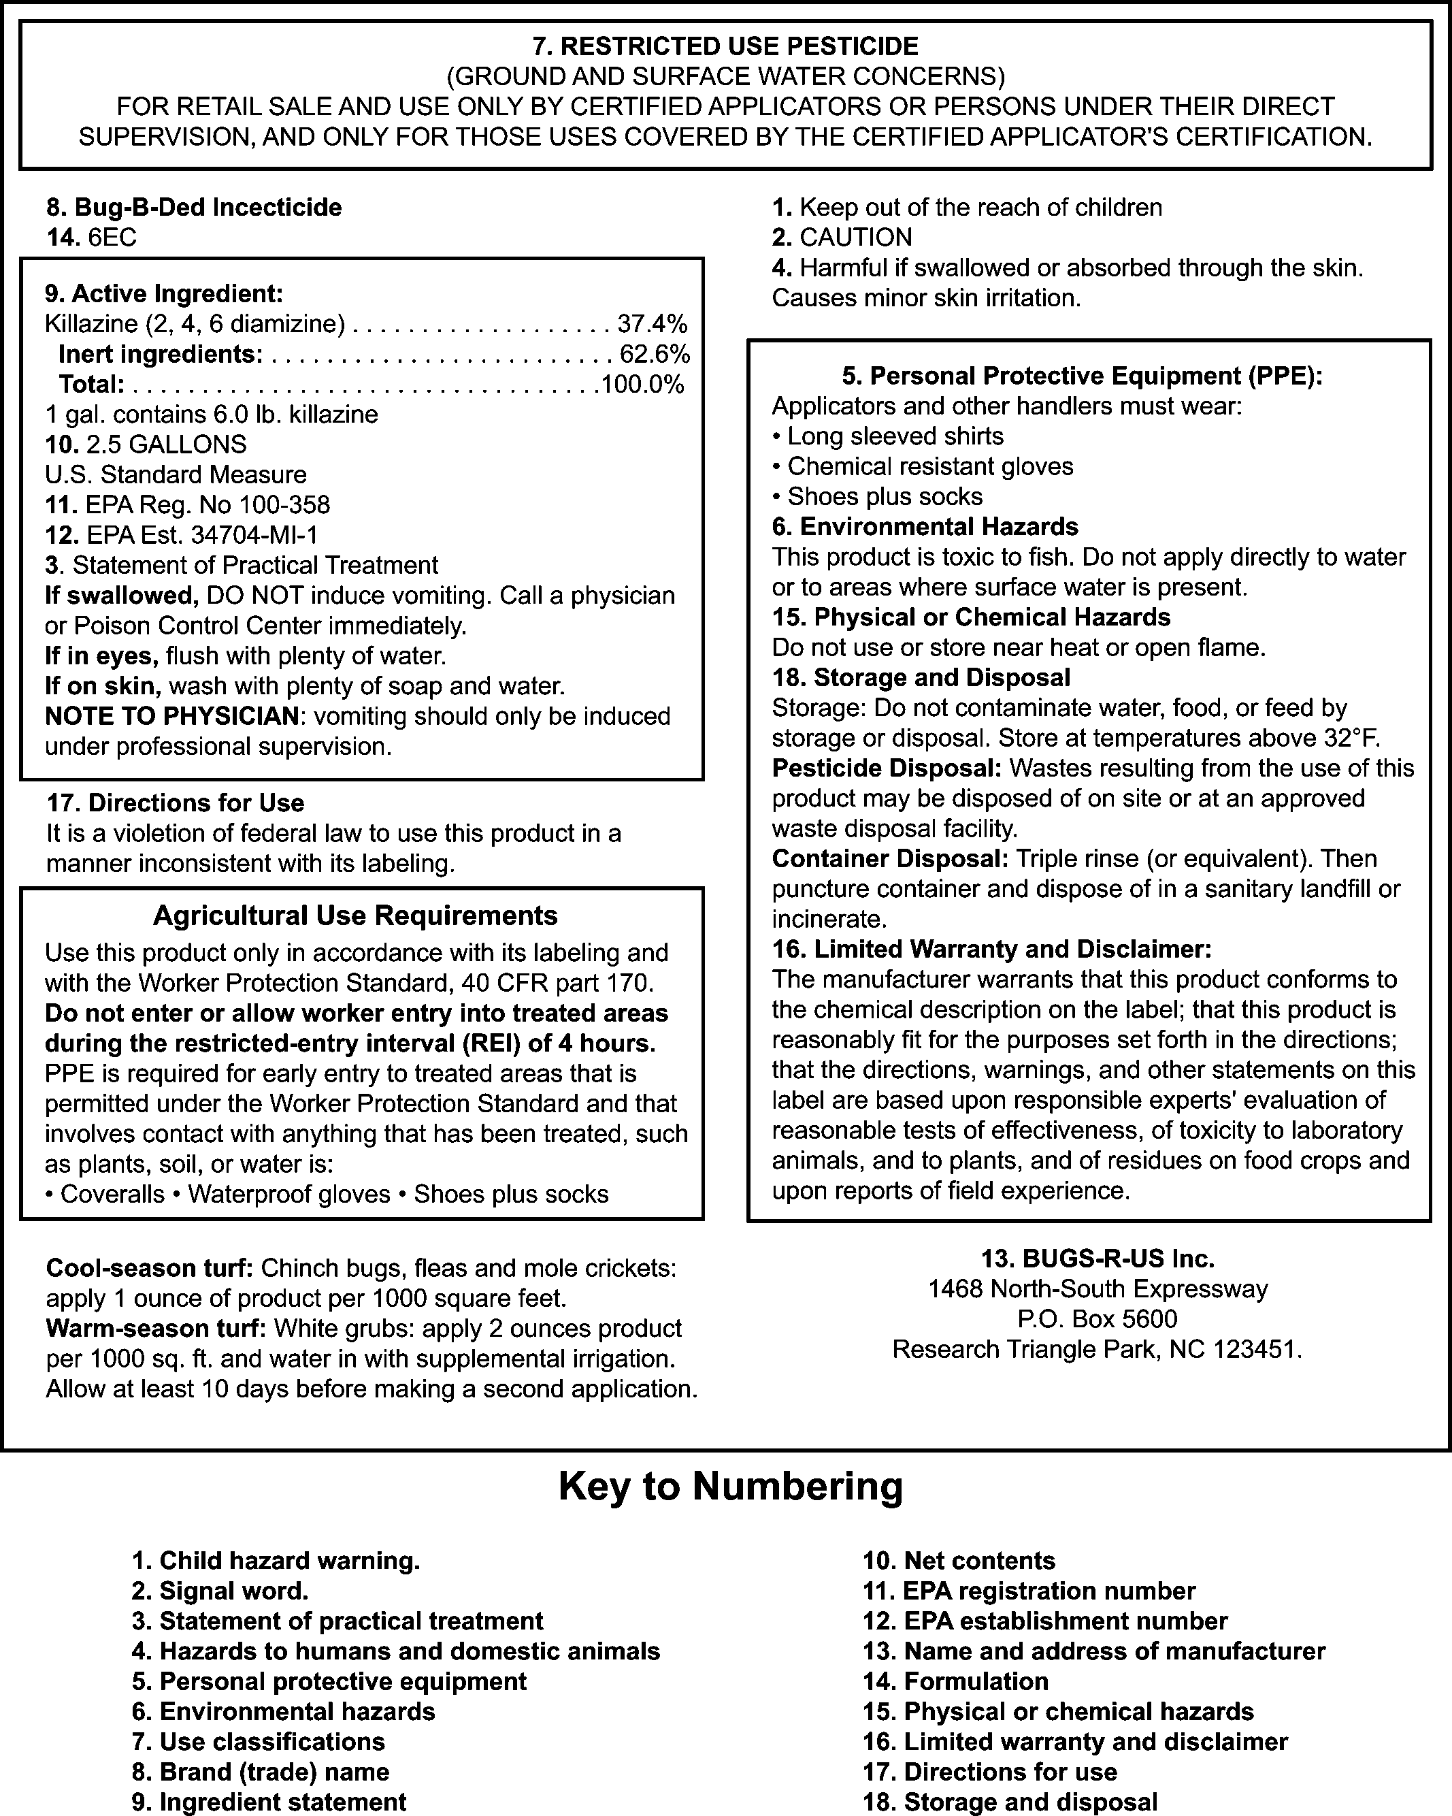

Pesticide Label

One of the most crucial features of a pesticide is its label. Essentially a legal document, the label prescribes acceptable methods of usage, storage, and disposal; it controls how the product is sold and distributed. If poisoning occurs, doctors refer to the label for treatment data.

Authorized pesticide users must scrupulously read and adhere to all label information and directions concerning usage, storage, and disposal. The label warns users where the product could enter the unprotected body. Additional information identifies required personal protective clothing and correct use of equipment. The label also lists environmental, physical, or chemical hazards and indicates toxicity to certain plants or animals. Other information includes the pesticide’s EPA classification and a safe reentry time that states when employees can enter the greenhouse without protective clothing and equipment. Figure 6.12 displays a sample pesticide label.
Figure 6.12 - Sample Pesticide Label

Pesticide Toxicity Levels

Each chemical listed on a pesticide label contributes key ingredients that target designated pests. The cumulative effect of all chemicals in a specific pesticide is its toxicity level. Pesticide toxicity levels are measured in terms of LD (lethal dose). The calculations of LDs are based on test mammal populations. An LD₅₀ refers to the amount of pesticide required to kill 50% of a test population within 2 weeks. LD₅₀ is expressed in milligrams per kilogram of the test animal’s body weight. The lower the LD₅₀ value, the higher the pesticide’s toxicity. Low LD₅₀ values indicate that small amounts of the pesticide provide a lethal dose.

A pesticide’s toxicity may be transmitted by the following means: oral (ingested), inhaled (breathed), and dermal (absorbed through skin).

Toxicity levels are communicated by signal words on pesticide labels. “Caution” means the product is slightly toxic and has an LD₅₀ of 500-5,000. “Warning” denotes a moderately toxic product; its LD₅₀ is 50-500. “Danger” or “Danger - Poison” is the most toxic level. The words are printed in red and accompanied by a skull and crossbones drawing. Its LD₅₀ is 0-50. After the signal word on every pesticide label, the following statement must appear in large print: “Keep Out of Reach of Children.”

Forms of Pesticides

Pesticides are either liquid or dry. The liquid forms are aerosols, emulsifiable concentrates, encapsulated, or flowable. Table 6.4 summarizes how each form is designated and used.

Table 6.4 - Liquid Forms of Pesticides

Form of Liquid | Designation | Usage
Aerosols | A | Pressured cans or aerosol bombs
Emulsifiable concentrates | EC | Mixed with water in spray tank
Encapsulated | Pesticide sealed in microcapsules | Time release - mixed with water
Flowable | For L | Mixed with water

Dry pesticides come in several forms: bait, dust, granular, soluble powder, wettable powder, and dry flowable, as summarized in Table 6.5.

Table 6.5 - Dry Forms of Pesticides

Form of Liquid | Designation | Usage
Bait | B | Pesticide-laden substance that lures pests
Dust | D | Pesticide and inert ingredients ground into dust; applied dry
Granular | G | Same composition as dust, but larger particles; applied dry
Soluble powder | S or SP | Finely ground ingredients; dissolved in water
Wettable powder | W or WP | Mixes with water in spray tank; must be constantly agitated to keep mixed
Dry flowable | DF | Dry granules of pesticide; less dust than powders

Application Methods

Pesticides can be applied at key stages in the plant’s growth cycle. Seeds, bulbs, corms, and

tubers benefit from applications of pesticides to control soilborne pathogens that rot seeds or induce damping-off. To rid the growing media of nematodes and other soilborne pests, granular and dust forms of pesticides are effective. If pruning creates a wound in the plant, apply a liquid or dust pesticide directly to prevent further damage to a plant’s foliage. To prevent crops from decaying during storage, apply a postharvest pesticide.
Figure 6.13 depicts equipment used to apply pesticides

Figure 6.13 - Types of Sprayers Used to Apply Pesticides
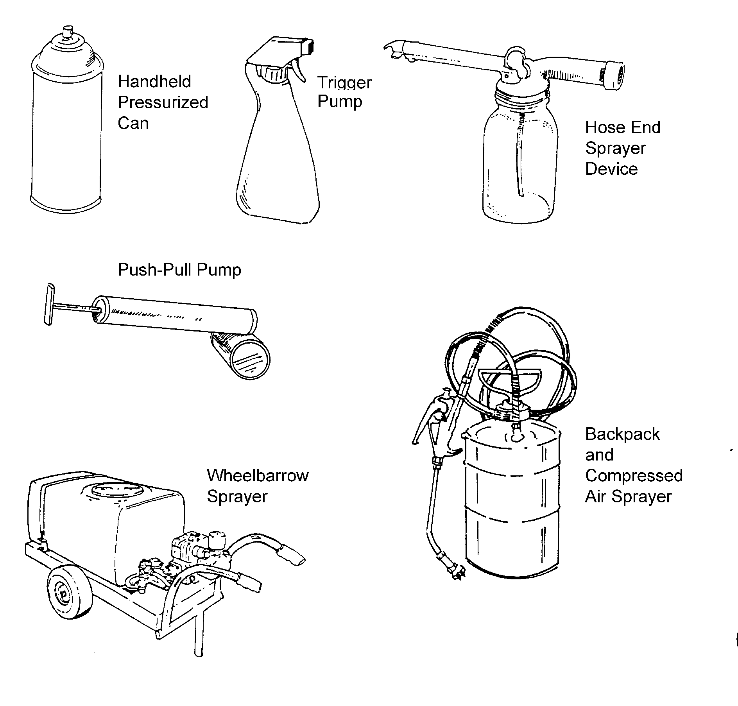
Aerosol generators and foggers fill the greenhouse with a mist of pesticides that are either broken down by very fine nozzles under high pressure (cold fogger) or are vaporized by a generator that uses heat.

Authorized personnel maintain a pesticide application log to denote where the pesticide is applied, the active ingredients in the product, its EPA registration number, and dates of application and safe reentry. The log also notes the types of Personal Protection Equipment required. See Figure 6.14 for a sample pesticide application log.
Figure 6.14 - Sample Pesticide Application Log

Procedure | Application #1 | Application #2
Area Treated: Location & Description
Product Name
EPA Registration Number
Active Ingredient: Common or Chemical Name
Date of Application: Month/Day/Time
Entry Restricted Until: Month/Day/time
Requirement to Post When Area Is Treated? Yes/No
Requirement to Give Oral Notification? Yes/No
PPE Requirements for Handlers
Early Entry PPE Required for Workers
Other Label Requirements to Protect Workers and Others

Modes of Action for Pesticides

Pesticides act in distinct ways. Biological controls, as mentioned in Lesson 2, use living organisms to kill plant pests. Biopesticides are created from cultured microorganisms and plants and are used in aerial sprays to control diverse soilborne diseases as well as harmful bacteria and fungi.

Several products can eliminate pests. Contact pesticides are fatal to the insects’ nervous and respiratory systems and immediately kill them upon exposure. Fumigants are poisonous gases released in a sealed greenhouse and kill insects as they breathe or absorb the chemicals. All employees must vacate the premises when these chemicals are released. Growth regulators that have intense concentrations of specific hormones adversely affect pest development.

Researchers have developed pest deterrents from pheromones. These are natural chemicals that some female insects produce to attract male insects. Scientists manipulate this attraction by using pheromones to lure the male insects into traps where they die. Alone, the females are unfertilized; consequently, the targeted insect population plummets.

Protectants prevent fungal pests from entering or damaging the surface of plants and should be uniformly applied over the entire plant. Stomach poisons kill pests when the insects eat or swallow the treated plant. Systemics are pesticides that the plant absorbs and then translocates to all its parts via the vascular system. The pest is killed as it feeds on the plant.

Pesticide Safety Issues

Because chemical pesticides are powerful substances, they must be handled with extreme caution. Pesticides are potentially lethal to human and animals. Used irresponsibly, pesticides contaminate air, water, and food and they pollute the environment. It is important to adhere to all federal, state, and local laws and guidelines and ensure personal safety and protection of others.

In 1992, the EPA issued the Worker Protection Standard (WPS). This regulation covers pesticides used in agriculture: farms, forests, nurseries, and greenhouses. The goal of the WPS is to reduce the risk of pesticide-related illness and injury. Employers of people handling pesticides are required to provide information on pesticide exposure, protection against exposure, and ways to alleviate exposure to pesticides.
For employees, WPS information provides safety training, safety posters, and access to specific information on pesticides used on-site. This regulation also keeps the pesticide handler and other employees from inadvertent exposure. The WPS regulation requires decontamination sites and emergency assistance for a worker or handler who is poisoned or injured by a pesticide.

General Pesticide Storage and Disposal Procedures

Adhering to correct pesticide storage procedures is an important aspect of pesticide safety. Read and follow the pesticide label for storage instructions and be aware of general pesticide storage safety guidelines. Store in the original containers, making sure labels are visible and marked with the date of purchase. Pesticides should not be stored near food, medicine, or other supplies. Keep chemicals away from flammable materials and routinely check containers for leaks or damage. Ensure that cleanup materials are close by.

To dispose of pesticides and pesticide containers, read and follow the label for instructions and precautions. General pesticide disposal guidelines stipulate that pesticides should not be flushed down drains, into sewers, or in waterways. Follow proper disposal procedures for old or unwanted products. Observe mandates from the U.S. Department of Agriculture and the EPA. For specific, local pesticide laws and guidelines, contact the State Department of Natural Resources.

Personal Protection Measures

The first step in personal protection is to obtain proper education and permits for pesticide use. Use Personal Protective Equipment (PPE), which may consist of any or all of the following: goggles, respirator, long sleeves rolled over long rubber gloves, hat, rubber boots, and overalls or coveralls secured with a band over boots.
The following guidelines concern how to apply pesticides safely:

- Select the safest, least toxic substance possible.
- Use approved products only for intended purpose.
- Mix only the amount needed.
- Apply with extreme caution.
- Use proper equipment and clothing.
- Review label carefully.
- Know and follow proper application procedures.
- Know how to handle accidental poisoning.
- Do not eat, drink, or chew anything during or immediately after application.
- Ensure adequate ventilation and clear the area of people, animals, and items.
- Clean all equipment and clothing.
- Thoroughly wash skin with cleaner and water.

Handling Accidental Pesticide Poisoning

If a greenhouse worker accidentally ingests a pesticide, first observe the victim’s symptoms, which vary according to the type and amount of pesticide, length of exposure, interval between exposures, and the employee’s general health.

External irritants affecting outer tissues may cause pesticide poisoning. Symptoms include stinging in the eyes, ears, throat, nose, mouth, or other external tissues. Internal poisons are absorbed into the body through the mouth or skin and may cause injury to internal body organs.

If either type of pesticide poisoning occurs, immediately follow basic first aid procedures. Act quickly and remove the victim from the contaminated area. Also remove his or her contaminated clothing. Generously flood the affected area with water. Contact a doctor or the poison control center and administer first aid as directed.

Sources of Pesticide Information and Recommendations

The greenhouse owner should maintain current information about the pesticides used in the greenhouse. Reliable sources include university Extension offices, federal and state departments of agriculture, and pesticide suppliers.

Certifications Required to Use Pesticides

In Missouri, certification is required for anyone who wants to use pesticides. Users are designated as certified applicators and operators. These are the various categories: Commercial Applicators, Certified Noncommercial Applicators, Public Operators (government employees), Private Applicator Licenses, Pesticide Technician Licenses, and Pesticide Dealer Licenses.

Applicants seeking certification must pass state pesticide certification examinations that are part of the General Standard of Competence (CORE) examination and at least one category exam that reflects the applicant’s specialized technical expertise. In order to take these exams, the applicant must first send the Certified Applicator and Pesticide Dealer Application to the Missouri Bureau of Pesticide Control. To help prepare for these tests, the applicant may buy a study manual from the University of Missouri Extension Publications (800-292-0969).

The applicant has to satisfy additional requirements after passing the exams based on the type of license desired. Specific information is available from the Missouri Department of Agriculture, Plant Industries Division, Bureau of Pesticide Control, P.O. Box 630, Jefferson City, MO 65102. Phone: 573-751-5504; Fax: 573-751-0005.

Specific information relating to certification expiration and recertification is summarized in Table 6.6.

Table 6.6 - Certification Expiration and Recertification

Type of Certificate | Date of Expiration | Recertification Process
Certified Commercial Applicator | Annually | $50 license fee (as of 2002; check with Bureau of Pesticide Control for updates); submit signed renewal card before expiration
Certified Noncommercial Applicator | Annually | $25 license fee (as of 2002; check with Bureau of Pesticide Control for updates); submit signed renewal card before expiration
Certified Public Operator | Every 3 years | No license fee (as of 2002; check with Bureau of Pesticide Control for updates); submit signed renewal card

By law, every 3 years all Certified Applicators and Operators must renew their certifications. Individuals may take the exams again or enroll in an approved recertification program. Sample facilities offering training are the University of
Missouri Cooperative Extension Service (available every January) and various businesses, groups, and associations. The Bureau of Pesticide Control must approve all recertification programs

before granting credit. It also provides guidelines for these training programs.

Missouri has reciprocal relationships with several states, as listed in Table 6.7. These agreements enable out-of-state applicants to apply for a license without having to pass Missouri’s certification examinations.

Table 6.7 - States Having Reciprocal Relationships With Missouri

State | Type of Agreement
Agricultural Aviation Board of Mississippi | Categories 1A, 2, 5, and 6
Arkansas | All categories except for ornamental, turf pest control, and structural pest control categories
Illinois | All categories administered by the Illinois Department of Agriculture (no agreement with the Illinois Department of Public Health)
Iowa | All categories
Kansas | All categories
Louisiana | All categories except for the structural pest control categories
Nebraska | All categories

Summary

Pesticides are valuable tools for protecting crops from insects, weeds, and other pests. However, because they are made from powerful combinations of chemicals, pesticides must be used wisely. This requires paying careful attention to all instructions and information on the label, observing signal words, following all safety precautions, and understanding how to administer first aid if needed. In the state of Missouri, only certified persons may apply pesticides. Specific procedures and examinations are required to earn certification. Several states have a reciprocal agreement with Missouri’s Bureau of Pesticide Control, as cited in Missouri’s regulations.

Credits

Acquaah, George. Horticulture: Principles and Practices. Upper Saddle River, NJ: Prentice Hall, 1999.

Cooper, Elmer L. Agriscience: Fundamentals & Applications, 2nd ed. Albany, NY: Delmar Publishers, 1995.

Fishel, Fred. “Integrated Pest Management in Missouri’s Urban Environment” Integrated Pest Management - MU Guide. University of Missouri-Columbia Extension. <http://muextension.missouri.edu/xplor/agguides/pests/ipm1004.htm> accessed 2/21/02.

Greenhouse Operation and Management (Student Reference). University of Missouri-Columbia: Instructional Materials Laboratory, 1990.

Lee, Jasper S., Series Editor. Introduction to Horticulture, 3rd ed. Danville, IL: Interstate Publishers, Inc., 2000.

Nelson, Paul V. Greenhouse Operation and Management, 3rd ed. Reston, VA: Reston Publishing Company, Inc., 1985.

“Pest Management - Pesticides - Certified Applicator and Operators.” <http://www.mda.
state.mo.us/d7c.htm>accessed 3/11/02.

“The Worker Protection Standard for Agricultural Pesticides - How to Comply.” EPA Publication 735-B-93-001. <http://www/cdc/gov/niosh/nasd/docs/
ep00200.htm> accessed 5/15/02.

