GREENHOUSE OPERATION AND MANAGEMENT

Unit I: The Greenhouse Industry

Lesson 1: Scope and Development of the Greenhouse Industry

Competency/Objective:

Identify the scope and development of the greenhouse industry.

Study Questions

1. What are the four areas of horticulture?

2. How has the greenhouse industry developed throughout history?

3. What are recent changes in the greenhouse industry?

4. What is the economic importance of the greenhouse industry?

References/Supplies/Materials

1. Greenhouse Operation and Management (Student Reference). University of Missouri-Columbia: Instructional Materials Laboratory, 2002.

2. Transparency Masters

TM 1.1 1999 Missouri Floriculture Crops
TM 1.2 2000 U.S. Floriculture Crops
TM 1.3 2000 U.S. Bedding and Garden Plant Sector

3. Activity Sheets

AS 1.1 Growing Possibilities
AS 1.2 Investigating a New Product in the Greenhouse Industry
AS 1.3 Global Greenhouses

4. Local Yellow Pages (several copies)

5. “Floriculture Crops 2000 Summary.” USDA National Agricultural Statistics Service, Agricultural Statistics Board, April 2001. <http://usda.mannlib.cornell.edu/reports/nassr/other/zfc-bb/> accessed 2/21/02.

6. “Floriculture Crops.” USDA National Agricultural Statistical Service. <http://www.usda.gov/nass/aggraphs/ws_tenyr.htm> accessed 2/20/02.

7. USDA National Agricultural Statistics Service. 1997 Census of Agriculture - Census of Horticultural Specialties (1998) Volume 3, Special Studies, Part 2.

8. “Value of Sales at Wholesale.” USDA National Agricultural Statistics Service, <http://www/usda.gov/nass/aggraphs/val_type.htm> accessed 2/20/02.

9. Greenhouse Grower, Greenhouse Business, Grower Talks, Greenhouse Product News

Teaching Procedures

IMPORTANT NOTE: Please refer to the Suggested Time Frame for Teaching (page xxxv) and to Planning for Unit IV Activities (page xxxvii) for information about initiating four activities in selected lessons in Unit IV. It is recommended that preparation begin during Unit I, Lesson 1.

A. Introduction

This unit examines facets of the greenhouse industry and identifies available career opportunities. In this lesson students discover how greenhouse production relates to four divisions within the field of horticulture. Lesson 1 also describes the history, developments, and economic importance of the greenhouse industry. Be sure to note that there is a discussion of recording-keeping procedures in Unit VII, Lesson 2.

B. Motivation

Divide the class into cooperative groups and give each group a copy of the Yellow Pages. (Yellow Pages from neighboring communities also can be used for contrast.) Have students identify local growers who produce flowers, vegetables, landscaping supplies, etc. If possible, invite an owner/manager to class to discuss how his/her business has changed over the years and contributed to the local economy.

C. Assignment of Study Questions

Be sure the classroom has many different types of potted plants, in varying stages of development.

D. Supervised Study

Lead students in collecting the information needed to answer and discuss the study questions. Instructor may choose to work on one study question at a time or have students answer all the study questions before the discussion. Another option is to have students work in a cooperative learning environment and have groups work on different study questions.
E. Discussion

Lead students in a discussion of the study questions. Supplement students’ responses and information with additional materials when needed.

1. What are the four areas of horticulture?

Ask students if they have ever heard the word “horticulture” and if so, in what context. Explain that its original meaning is derived from two words: “garden” and “cultivate.” However, today horticulture is broadly defined as the cultivation of plants. Write “horticulture” on the board and ask students to name the types of plants that may be cultivated. Record and organize their responses into the four categories listed below. Point out that a greenhouse owner may produce crops from any of the four horticultural groups.

A. Horticulture – cultivation of plants and vegetables
B. Floriculture - flowers (cut flowers, bedding plants, foliage plants, potted plants)
C. Olericulture - vegetables
D. Ornamental horticulture - plants grown for their beauty (annuals, perennials, shrubs, ground cover, landscaping)
E. Pomology - fruit and nuts

2. How has the greenhouse industry developed throughout history?

Ask students to estimate when the first greenhouse was built. During the discussion, consider
how environmental factors, transportation, building materials, and available markets have
affected the growth and development of the greenhouse industry. Also remind the class how
references to centuries relate to actual years. For example, the 16th century refers to 1500-1599.

A. Roman emperor Tiberius (30 AD) built “specularia.”
B. In 13th century, Dominican monk Albertus Magnus tried to force blooms out of season.
C. By 1599, the first practical greenhouse was built in Holland.
D. “Orangeries” were constructed in France during the 17th century.
E. Andrew Faneuil built the first U.S. greenhouse in 1737.
F. During the 19th century in England, greenhouse construction developed most fully. By 1825, greenhouses were common.
G. By 1950, improvements in transportation allowed growers to reach broader markets. New materials became available for constructing greenhouses.
H. In 1960, greenhouses were made from film plastic and galvanized steel. Noteworthy botanical greenhouses were built during that decade: Missouri Botanical Garden (1960), Hamburg Botanic Gardens (Germany, 1963), and the Exhibition Plant Houses at Edinburgh (Scotland, 1967).
I. By 1980, floriculturists in the Netherlands became renown for concentrating on specific or related crops, relying on automated production, and selling crops by the auction market system.
3. What are recent changes in the greenhouse industry?

Ask students who have had experience raising livestock or crops to identify advanced techniques or procedures used to promote efficient growth. Relate these developments to greenhouse-grown crops. Have students complete AS 1.1. Before students begin working on AS 1.2, talk about RootShield and PlantShield and explain how these products have helped greenhouse personnel produce healthy plants. If possible, apply one of these fungicides to a plant in the classroom that exhibits root disease. Encourage students to explore facets of the greenhouse industry that have developed over the years.

A. Growing structures
B. Coverings
C. Equipment
D. Growing methods
E. Plant varieties (colors, forms, resistance to disease)
F. Biotechnology

4. What is the economic importance of the greenhouse industry?

Engage students in a discussion about the economic importance of the greenhouse industry. Guide them to the discovery that this industry provides employment and income locally, nationally, and worldwide and that the greenhouse business has evolved over time. Remind the class of the businesses they identified during the Motivation. Ask them to name floriculture crops or greenhouse-grown vegetables that are produced in their community. How have these crops helped the local economy?

Display a map of the United States. Have students infer what types of crops are grown throughout the country. Point out the significance of regional differences in climate and environmental factors. Also display a globe or world map. Ask students to interpret the impact of the global greenhouse industry upon the United States and especially upon Missouri.

A. Missouri - 1999 statistics for wholesale floriculture production (TM 1.1)
1. Value from growers grossing $10,000 or more - $41.6 million
2. Value from growers grossing $100,000 or more - $34.3 million
3. Bedding/garden plants and potted flowering plants - major floriculture crops
4. Compared nationwide - based on combination of greenhouse sales, nurseries, landscaping outlets, etc.
a. 26th nationwide in floriculture production
b. 28th nationwide in ornamental horticulture production
c. 28th nationwide in pomology production
d. 31st nationwide in production of commercial vegetables
B. United States
1. In 2000, the wholesale value of floriculture production grossing $100,000 or more in sales was nearly $4.7 billion. See TM 1.2. Five states contributing the most to that amount are California (20%), Florida (18%), Michigan, Texas, and Ohio.
2. Bedding and garden plants production represents 50% of the wholesale value of all reported crops and is made up of the following crops: (TM 1.3)
a. Potted bedding and garden plants (48% of total)
b. Bedding and garden flats (42% of total)
c. Flowering hanging baskets (10% of total)
3. Potted flowering plants
a. 3% increase in production from 1999
b. California - 18% of total sales
c. Top sellers - poinsettias, orchids, azaleas, and chrysantheums
4. Foliage plant
a. 12% increased production from 1999
b. Florida - 69% of total market
c. 85% of total sales - potted foliage plants
5. Cut flowers
a. 1% decreased production from 1999
b. 23% drop in number of growers from 1999
c. California - 67% of total market
d. Top sellers: roses, lilies, gladioli
6. Herbaceous perennials - with hardy garden mums as 25% of this market
7. Propagative materials - used to grow various types of plants; 44% of all propagative materials used for annual bedding and garden plants.
8. Cut greens
a. 2% decreased production from 1999
b. Florida - 81% of total market
C. World (major exporters) Have students complete AS 1.3.
1. The Netherlands
a. Exports tulip flowers and bulbs
b. Is the international leader in floriculture enterprises.
2. Central and South America (Mexico, Costa Rica, Colombia, and Brazil)
a. Favorable climate
b. Government-sponsored subsidies for the industry
c. Access to labor force
d. Produce cut flowers (e.g., roses and carnations), flower seeds, foliage plants
3. Kenya, Africa - floriculture producer since early 1970s
a. Flower producer (mainly roses) and seeds for geranium, petunia, and impatiens
b. Simple greenhouses; require no supplementary heat
c. Cheap, abundant labor
4. Australia and New Zealand - orchids

F. Other Activities and Strategies

1. Show the class video(s) on growing plants in a greenhouse. Three videos are available from CATER (Career & Technical Education Resources), 2 London Hall, University of Missouri-Columbia: How to Grow Plants in a Greenhouse: Bedding Plant Production, Volume I (AG V162); Foliage Plant Production, Volume II (AG V163); Potted Plant Production, Volume III (AG V164).

2. Have students investigate how the auction market system operates in the Netherlands when selling greenhouse-grown crops.

3. Ask students to identify and summarize the contributions of famous plant scientists and researchers by searching the Internet and referring to science/history textbooks, magazines, and biographies, and other resources.

G. Conclusion

Horticulture comprises four fields: floriculture, olericulture, ornamental horticulture, and pomology. For centuries, people have been interested in cultivating these types of plants. As building materials and means of transportation developed, the greenhouse industry has become increasingly sophisticated. The greenhouse industry has developed thanks to state-of-the-art equipment, improved coverings, and biotechnology. The greenhouse industry contributes employment and economic support to the state of Missouri, the United States, and several countries throughout the world.

H. Answers to Activity Sheets

AS 1.1 Growing Possibilities

Instructor’s discretion

AS 1.2 Investigating a New Product in the Greenhouse Industry

Instructor’s discretion

AS 1.3 Global Greenhouses

Instructor’s discretion

I. Answers to Assessment

1. C
2. B
3. D
4. E
5. A
6. D
7. A
8. D
9. C
10. A
11. D
12. The student may list any three of the following:
A. Growing structures
B. Coverings
C. Equipment
D. Growing methods
E. Plant varieties (colors, forms, resistant to disease)
F. Biotechnology

Unit I: The Greenhouse Industry Name________________________________

Lesson 1: Scope and Development Date___________________________
of the Greenhouse Industry

ASSESSMENT

Matching: The terms on the left-hand side refer to the cultivation of certain types of plants, which are listed on the right side. Write the correct letter in the space provided.

____ 1. Floriculture A. fruits and nuts

____ 2. Horticulture B. plants and vegetables

____ 3. Olericulture C. flowers and foliage plants

____ 4. Ornamental horticulture D. vegetables

____ 5. Pomology E. shrubs and other plants for landscaping

Multiple Choice: Circle the letter of the best answer.

6. When and where did greenhouse construction develop completely and become common?

A. 30 AD, Rome
B. 16th century, Holland
C. 18th century, America
D. 19th century, England

7. What is the wholesale value for Missouri greenhouse operations grossing $100,000 or more in 1999?

A. $34.3 million
B. $41.6 million
C. $34.7 billion
D. $4.7 billion

8. Which of the following are the two major floriculture crops in Missouri?

A. Cut flowers and potted flowering plants
B. Foliage plants and bedding/gardening plants
C. Cut flowers and foliage plants
D. Potted flowering plants and bedding/gardening plants
9. How does Missouri rank among all 50 states in floriculture production?

A. 31st
B. 28th
C. 26th
D. 16th

10. What is the correct ranking of the top five states involved in U.S. floriculture sales, from the highest to lowest amount contributed?

A. California, Florida, Michigan, Texas, and Ohio
B. Michigan, Ohio, Florida, Texas, and California
C. Florida, California, Texas, Michigan, and Ohio
D. Texas, Florida, California, Ohio, and Michigan

11. Who is the international leader in floriculture production?

A. Australia/New Zealand
B. Central America
C. Kenya
D. The Netherlands

Short-Answer Question: Write the answer in the space provided.

12. What are three recent changes in the greenhouse industry?

A.

B.

C.
TM 1.1

1999 Missouri Floriculture Crops

Crop Wholesale Value

Cut Flowers $ 281,000

Foliage Plants 2,192,000

Potted Flowering Plants 11,711,000

Bedding and Garden Plants 20,085,000

TOTAL $34,269,000

Wholesale value for operations grossing $100,000 in sales
“Floriculture.” Missouri Farm Facts, 2000.

TM 1.2
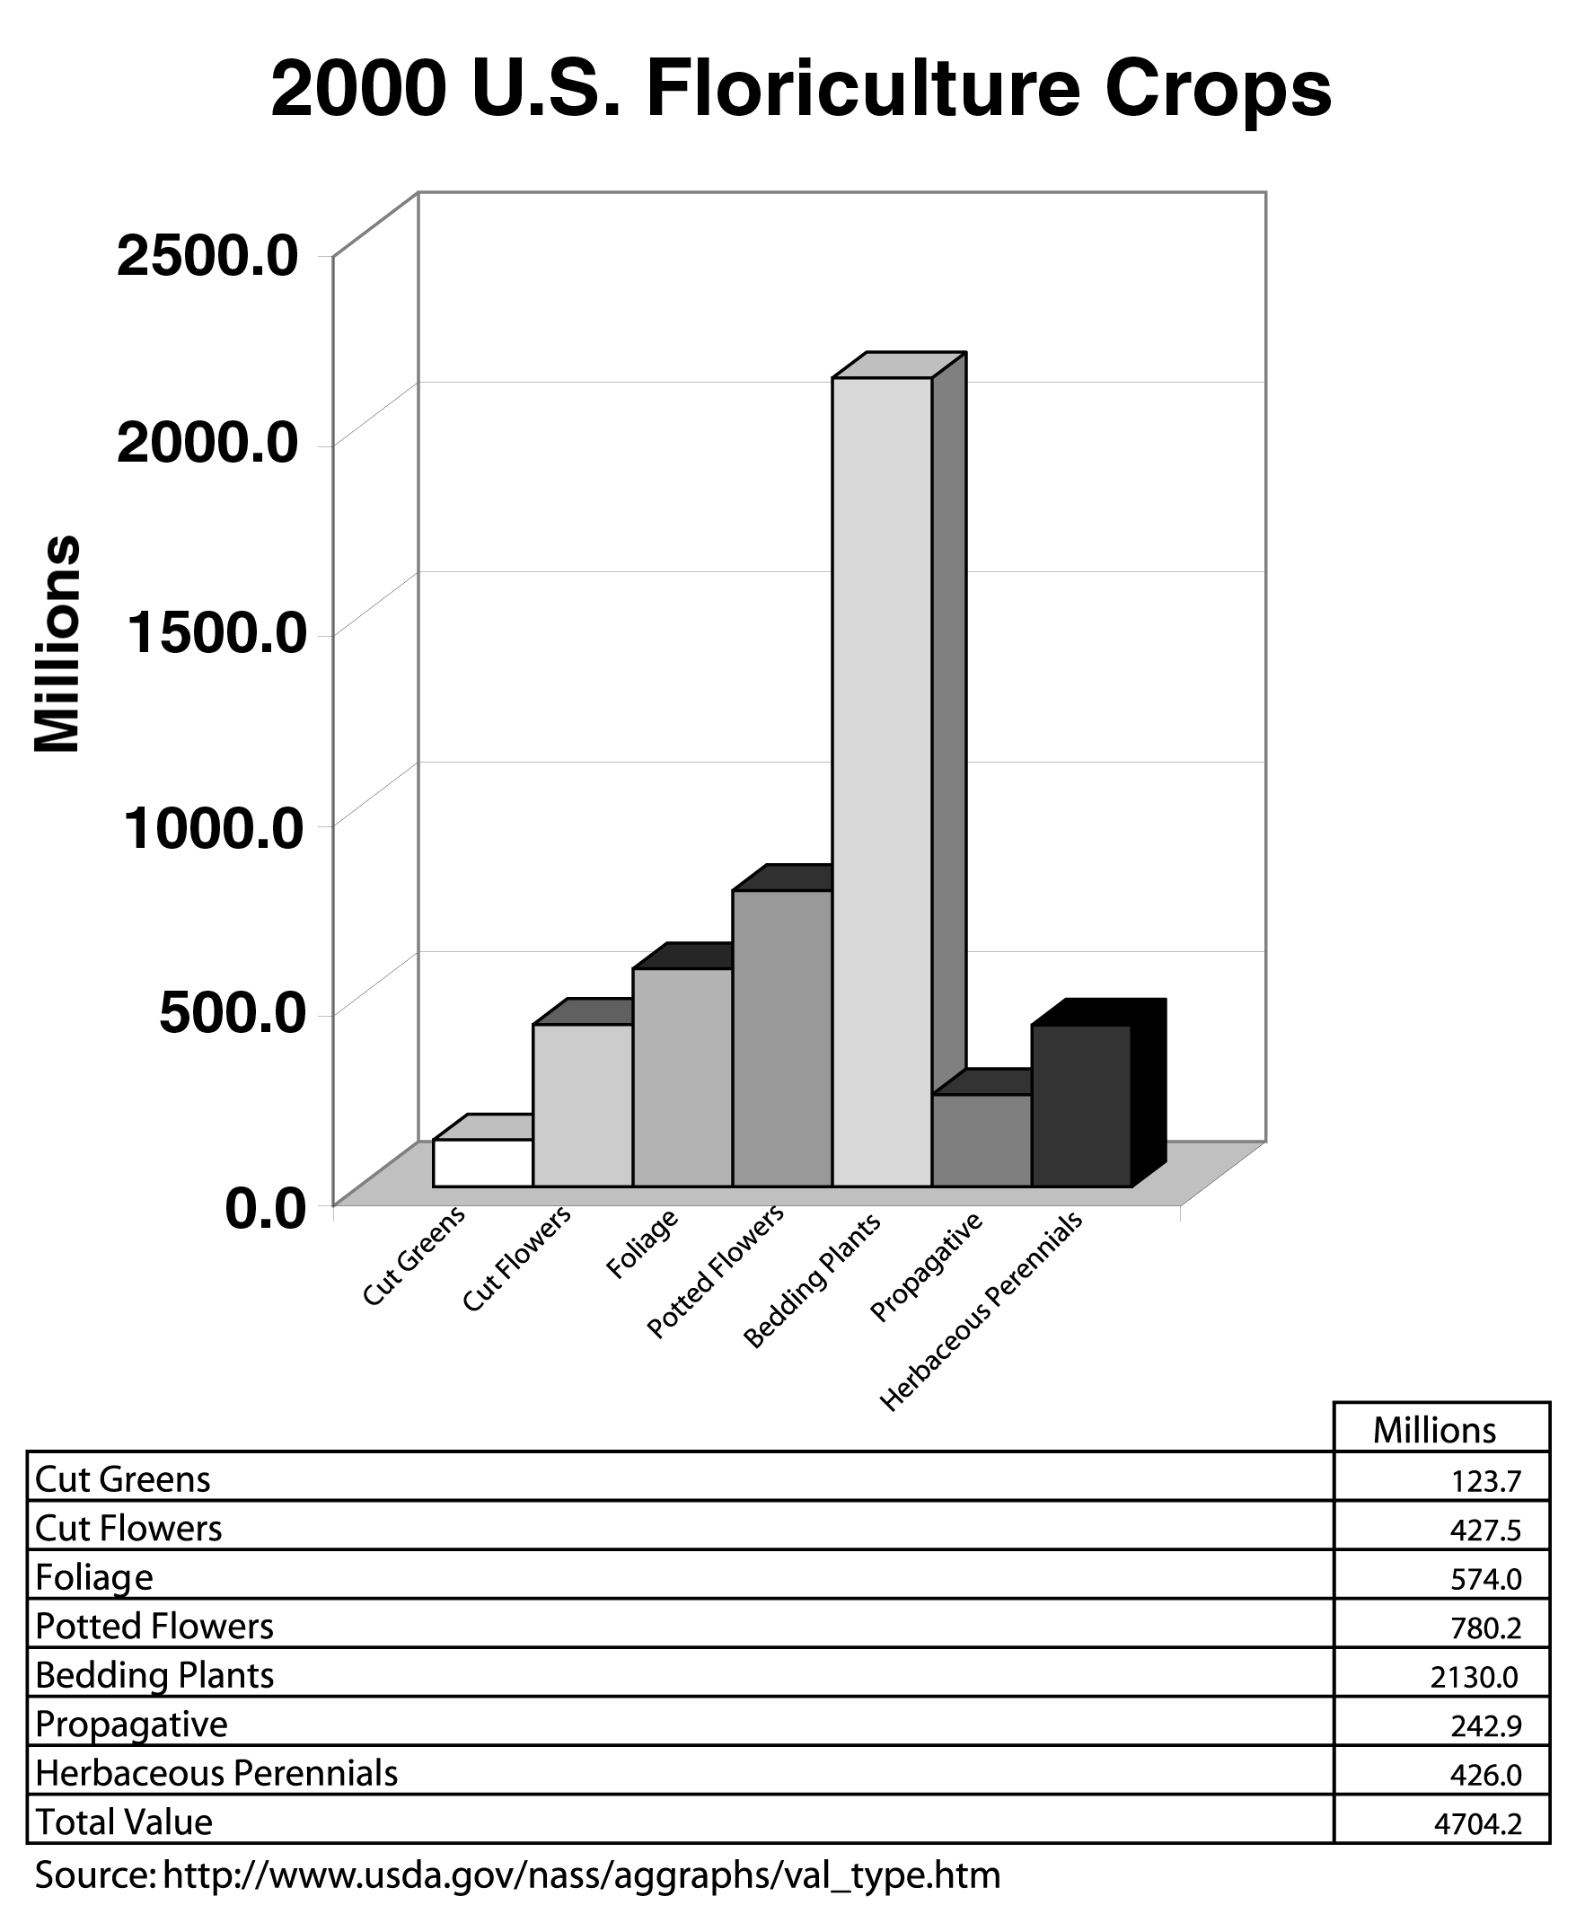
Wholesale value for operations grossing $100,000 or more in sales
“Floriculture Crops.” USDA National Agricultural Statistics Service,
<http://www.usda.gov/nass/aggraphs/ws_tenyr.htm> accessed 2/20/02

TM 1.3

2000 U.S. Bedding and Garden Plant Sector

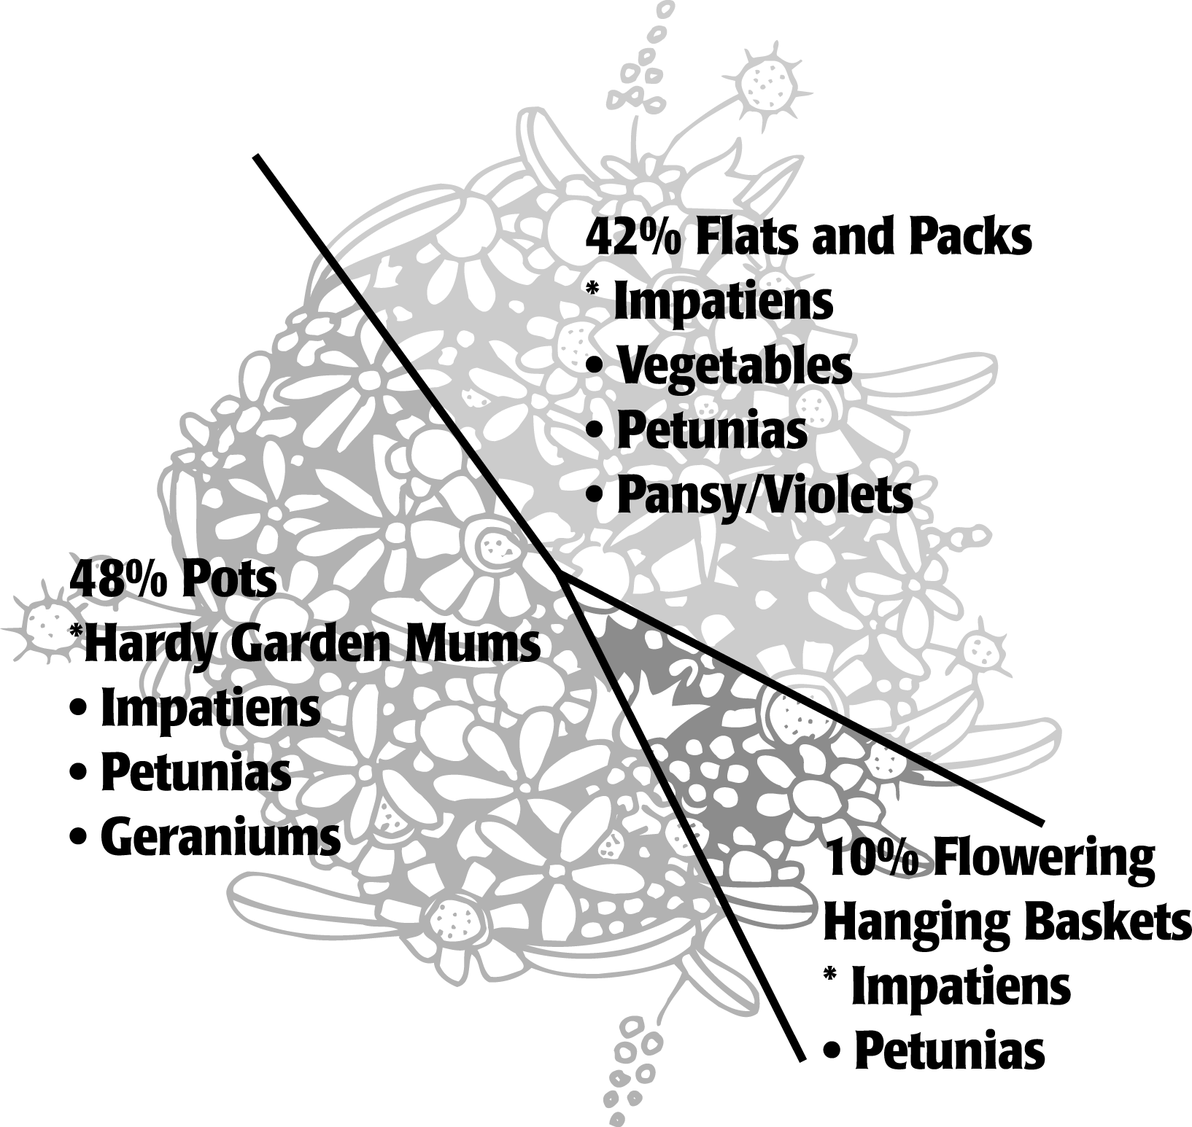

“Floriculture Crops 2000 Summary.” National Agricultural Statistics Service, Agricultural Statistics Board, USDA, April 2001. <http://usda.mannlib.cornell.edu/reports/nassr/other/zfr-bb/> accessed 2/21/02.

UNIT I: THE GREENHOUSE INDUSTRY AS 1.1

Lesson 1: Scope and Development Name_____________________
of the Greenhouse Industry

Growing Possibilities

Objective: Appraise biotechnological advancements in the greenhouse industry.

Directions: Work in small cooperative groups. Select one of the biotechnological advancements listed below. Access the Internet, university Extension publications, trade journals, or any other reliable resources for information. As you evaluate how the biotechnological advancement affected the greenhouse industry, consider the questions listed below but do not limit your focus to them. Present your findings to the class. (Suggested approaches are giving a PowerPoint presentation, displaying graphs or other visual aids, making an oral presentation, creating a model, etc.)

Biotechnological Advancements

- Improving performance and handling during production and after harvest
- Incorporating selected pathogen-resistant genes into new plants
- Producing leaves that stay greener longer
- Delaying leaves’ aging process
- Stimulating plant growth
- Improving tolerance to herbicides
- Reducing amount of pesticide application required
- Developing strategies for managing disease to increase production
- Improving quality and taste of fruits and vegetables

Suggested Web Sites

Clark, David G. “Floriculture Biotechnology.” <http://hort.ifas.ufl.edu/people/clark.htm> accessed 2/20/02.

Giacomelli, Gene A. “Controlled Environment Agricultural Center.” Agricultural & Biosystems Engineering Department, University of Arizona. <http://ag.arizona.edu/ceac/research/archive/
structures.htm#glazings> accessed 2/25/02.

1. How has this advancement affected the greenhouse environment? Does it also affect the outside environment?

2. Does it have any adverse consequences?

3. How does this biotechnological advancement help the greenhouse industry?

4. How does it affect plant growth?

5. How does this technique affect working conditions in the greenhouse?

6. How does it impact trade relations and/or economic status among states and countries? Is it profitable?

7. What is the justification for using this advancement in an average greenhouse operation?

UNIT I: THE GREENHOUSE INDUSTRY AS 1.2

Lesson 1: Scope and Development Name_____________________
of the Greenhouse Industry

Investigating a New Product in the Greenhouse Industry

Objective: Identify one new product currently used in the greenhouse industry and evaluate how well it performs.

Directions: Refer to recent professional greenhouse journals such as Greenhouse Grower, Greenhouse Product News, Grower Talks, and Greenhouse Business and search the Internet in order to identify a new product used in the greenhouse industry. Respond to the following questions. Share your findings with the class. For example, demonstrate the product, create a diorama or illustration of it, give a PowerPoint presentation, etc.

1. What is the purpose of this product?

2. Does it replace an older, similar device?

3. What new features does it have?

4. How does the product work?

5. Do greenhouse personnel need special training in order to use it?

6. Where can this product be obtained?

UNIT I: THE GREENHOUSE INDUSTRY AS 1.3
Lesson 1: Scope and Development Name_____________________
of the Greenhouse Industry

Global Greenhouses

Objective: Compare and contrast greenhouse operations in two different countries.

Directions: Work in small groups of three or four students. Select two countries that export greenhouse-grown crops. Use the Internet, books, magazines, and science and social studies textbooks to answer the following questions. Relate your findings to the class in a PowerPoint presentation, poster, collage, oral presentation, or any other format that answers the questions.

Country #1___________________________ Country #2_____________________________

Exported Greenhouse Crops

#1_____________________________ #2_____________________________

1. What are the distinguishing features of the climate, topography, and environmental factors in each country?

2. How do these factors affect the construction of a greenhouse (building materials, site selection, etc.)?

3. How much of each country’s economy depends upon this major greenhouse crop?

4. Where do these countries export their crops? Are those markets increasing or declining?

5. What forms of assistance are available to the greenhouse owners in each country?

- How much labor is available for greenhouse operations in each country? What training or benefits are provided?

7. How and where are the crops sold?

