GREENHOUSE OPERATION AND MANAGEMENT

Unit I: The Greenhouse Industry

Lesson 2: Career Opportunities in the Greenhouse Industry

Competency/Objective:

Outline career paths and SAE (Supervised Agricultural Experience) opportunities available in the
greenhouse industry.

Study Questions

1. How do the responsibilities of grower, retailer, and wholesaler differ?

2. What career opportunities are available in the greenhouse industry?

3. How is the structure of a greenhouse operation organized?

4. How does continuing education enhance career opportunities in the greenhouse industry?

5. What opportunities does the greenhouse industry offer the agricultural education program?

References/Supplies/Materials

1. Greenhouse Operation and Management (Student Reference). University of Missouri-Columbia: Instructional Materials Laboratory, 2002.

2. Transparency Master

TM 1.4 Organizational Structure of a Large Greenhouse Operation

3. Activity Sheets

AS 1.4 Greenhouse Careers: Which One? How to Succeed?
AS 1.5 Getting Involved in the Greenhouse Industry

4. Help wanted ads in trade journals: Greenhouse Grower, Greenhouse Business, Grower Talks, Greenhouse Product News

5. “Greenhouse Positions.” New Haven Gardens. <http://www.nhg.com/empgh.htm>.

6. “Jobs in Horticulture” <hortjobs.com>

7. “Nursery and Greenhouse Worker.” <http://www.edinetconnect.com/cat/careers/nurserysw.html>

8. Yahoo! Careers. “Landscaping, Groundskeeping, Nursery, Greenhouse, and Lawn Service Occupations.” <http://careers.yahoo.com/employment/oco/ocos172.html>

9. GrowNative! <www.conservation.state.mo.us/programs/grownative>

10. “Key #2 - SAE” <www.ffa.org/programs/lps/html/sae.html>

11. “Welcome to SAE Central” <www.cals.ncsu.edu/agexed/sae/toolbox/index.html>

12. Garton, Bryan L. and Scott Stone. Agricultural Education, University of Missouri-Columbia. Joint State Staff in Agricultural Education Agricultural Education Program Planning Handbook for Missouri Schools. pp. 109-111, 1997.

TEACHING PROCEDURES

A. Review

After defining the four fields included in horticulture, the previous lesson surveyed the past and recent developments in the greenhouse industry and assessed its economic importance to Missouri, the United States, and the world. This lesson focuses on various careers available in this industry and styles of management structures, and it justifies why continuing education is valuable to someone interested in pursuing a career in the greenhouse industry. Lesson 2 also describes opportunities that the greenhouse industry offers agricultural education programs - SAE (Supervised Agricultural Experience) in particular.

B. Motivation

Ask the class if anyone has planted a garden or raised a crop. Find out if they have participated in FFA or 4-H activities that involved growing vegetables or flowers. Then ask them to describe activities they enjoyed performing while working with plants. As you record their responses on the board, continue the discussion by asking students to identify the types of greenhouse-related jobs that appeal to them the most.

C. Assignment of Study Questions

D. Supervised Study

Lead students in collecting the information needed to answer and discuss the study questions. Instructor may choose to work on one study question at a time or have students answer all the study questions before the discussion. Another option is to have students work in a cooperative learning environment and have groups work on different study questions.

E. Discussion

Lead students in a discussion of the study questions. Supplement students’ responses and information with additional materials when needed.

1. How do the responsibilities of grower, retailer, and wholesaler differ?

Explain that the greenhouse industry is generally divided into three sectors: growers, retailers, and wholesalers. Career opportunities exist in all categories.

A. Grower
1. Produces one or more crops for sale to wholesaler
2. Is skilled in cultivation, irrigation, and other cultural practices
3. Usually delegates marketing to wholesaler if operation is small
B. Retailer
1. Sells greenhouse crops to public
2. Is found in various marketing areas: grocery stores, florist shops, malls, etc.
C. Wholesaler
1. Sells crops and related products to retailer
2. Sells plants from growers on consignment

2. What career opportunities are available in the greenhouse industry?

The broad categories listed above may suggest specific career opportunities. Ask students to
identify the types of tasks required to run a greenhouse. Write their responses on the board and
organize them under the job titles listed below. Remind the class that these job titles,descriptions,
and duties may vary in different greenhouse operations. The following list should be used only as
an example. Have the class complete AS 1.4.

A. Assistant grower (entry level)
1. Helps grower as directed
2. May work in maintenance, shipping, and/or delivery
B. Grower
1. Prepares growing medium for bulbs, seeds, and cuttings
2. Grafts plants and transplants seedlings and rooted cuttings
3. Irrigates plants as required
4. Fertilizes plants according to specific needs
5. Responds to customers’ questions, as needed
C. Greenhouse service technician
1. Maintains physical facilities in greenhouse
2. Supervises maintenance crew
3. Oversees irrigation, electricity, and drainage systems; in charge of construction, etc.
D. Production specialist
1. Stays up-to-date on technical developments
2. Schedules when crops should be planted
3. Manages space allocation within greenhouse
E. Marketing manager
1. Oversees sales operations
2. Handles customer relations (both existing and potential customers)
3. Assesses postharvest crops: grades and stores plants and flowers
4. Prepares each crop for shipment
F. Manager/owner
1. Organizes and prioritizes work flow
2. Maintains financial records; develops marketing plan
3. Selects types and quantities of plants to be grown
- Selects and orders growing supplies (fertilizer, seeds, etc.)
5. Hires, supervises, and evaluates staff
6. Responds to customers’ questions

3. How is the structure of a greenhouse operation organized?

Ask students why it is important to understand how employees fit within the industry’s
organization. How does the management structure affect their choice of jobs within that
industry? Display TM 1.4 as an example of how a large greenhouse operation may be organized.

A. Small greenhouse operations
1. One manager/owner oversees all aspects of the business.
2. Several assistants may help the manager.
3. Owner/manager specializes in all greenhouse operations.
B. Large greenhouse operations
1. Manager may or may not be the owner.
2. Multiple greenhouse specialists contribute to different aspects of the operation.
3. Each department (e.g., marketing, production) has its own manager.
4. Employees work in various departments.

4. How does continuing education enhance career opportunities in the greenhouse industry?

Refer to the activities mentioned in the Motivation. Now ask students how they could make them
more challenging. What would they need to know and do in order to advance? Explain that
the term “continuing education” applies to more than just schoolwork.

A. Reading professional literature (trade journals, publications from county Extension services, etc.)
B. Joining greenhouse-related organizations
C. Participating in meetings sponsored by professional groups
D. Keeping up-to-date in latest advances in greenhouse operations
E. Sharing technological information with coworkers, supervisors, and greenhouse experts
F. Taking advanced courses in area(s) of interest

5. What opportunities does the greenhouse industry offer the agricultural education program?

Engage the class in a discussion about various agriculture-related activities that they have participated in, as sponsored by 4H and FFA. Agricultural education embraces many opportunities for growth. Mention that Supervised Agricultural Experience is a dynamic program that helps students gain practical knowledge and apply skills they’ve learned in the classroom to the real world. As you generate a discussion about the benefits of SAE, ask students to infer how these opportunities apply to employment in the greenhouse industry. Have the class complete AS 1.5.

A. Workplace readiness for students
1. Develop successful work habits and skills
a. Responsibility
b. Work ethic (being prompt, communicating clearly and honestly, cooperating with coworkers and supervisor, taking pride in one’s work, etc.)
c. Record-keeping skills
d. Critical-thinking skills
e. Decision-making skills
2. Provide real-world experience
a. On-the-job training
b. Gain management skills
c. Develop job-seeking skills
d. May earn a salary while learning
e. Receive guidance from individuals experienced in greenhouse operations
B. Supervised Agricultural Experience opportunities
1. Entrepreneurship program
a. Students plan, organize, and operate enterprise and are financially responsible for own horticulture-related business.
b. Students own all necessary materials needed to run the operation and keep financial records in order to assess how well their investment is performing.
c. Students participate in entrepreneurial projects sponsored by GrowNative! (www.conservation.state.mo.us/programs/grownative). Individuals or chapters grow plugs or produce seeds of native plants.
d. Examples include growing bedding plants in school greenhouse and raising poinsettias for sale.
2. Placement program
a. Students are placed in an agricultural business that interests them.
b. This can be a paid position or an unpaid internship.
c. Placement program occurs outside of regular school hours.
d. Examples include working in a florist shop and in a nursery on weekends.
3. Directed work experience
a. Students, instructors, and parents help plan activity.
b. This is an unpaid position.
c. Examples include working in the school greenhouse.
C. Agriscience research projects
1. Experimental activity
a. Key features
i. Has a specific, measurable objective
ii. Follows scientific process
iii. Involves several steps and requires time commitment
iv. Relates to significant scientific/agricultural principle, issue, or question
v. Supervised by instructor
b. Examples:
i. Comparing effect of different amounts of light on plant growth
ii. Comparing two types of fertilizer on plant development
iii. Analyzing effectiveness of different display techniques on amount of plant sales in a nursery
iv. Demonstrating effect of various levels of soil acidity on plant growth
2. Analytical (nonexperimental) activity
a. Key features
i. Collecting information from different sources then evaluating the data
ii. Creating a finished product
b. Examples:
i. Planning a perennial garden for a senior center
ii. Constructing a landscaping ad campaign directed toward new home owners
D. Award/activities
1. Career Development Events
a. Floriculture
b. Nursery/landscape
c. Agricultural sales
2. Proficiency awards
a. Horticulture
b. Turf and landscape management
c. Floriculture
d. Fruit and/or vegetable production
e. Specialty crops
3. School/community service
a. Building Our American Communities grant
b. Partnerships with groups, such as chambers of commerce and garden clubs
c. Providing landscaping on school grounds
d. Providing arrangements/plants for special school occasions, such as banquets and graduation
e. Examples: For school grounds or a community center, create a hummingbird habitat, plant a garden with all-native Missouri plants, create garden to attract songbirds and butterflies, create garden made up of shade-loving plants
F. Other Activities and Strategies

1. Show the class the following video, available from CATER (Career & Technical Education Resources), 2 London Hall, University of Missouri-Columbia: Growing Futures - Career Opportunities in the Green Industry (AG V157).

2. Take students to a local, commercial greenhouse, nearby florist, or nursery. Have them ask the owner/manager about the types of jobs needed to run the operation. Have students observe one of the growers or production specialists and ask questions about their jobs. As an alternative, ask members of the greenhouse industry to visit the class to discuss how their businesses are run. Before the guests arrive, have students prepare interview questions.

3. Ask a representative from the community college level to talk about Postsecondary Agriculture Students (PAS), which is similar to FFA.

G. Conclusion

Before identifying a career in the greenhouse industry, it is important to distinguish between growers, retailers, and wholesalers. Each of the various positions within the industry offers unique opportunities. Typically, small greenhouse operations have a simple management structure, with the owner/manager assuming most of the responsibilities, whereas larger organizations have multiple layers of managers and workers. By continuing one’s education through diverse means, a greenhouse worker can advance within the profession. The greenhouse industry offers many programs in agricultural education, especially SAE.

- Answers to Activity Sheets

AS 1.4 Greenhouse Careers: Which One? How to Succeed?

(For each of the following, information about continuing training/education is at the instructor’s
discretion.)
- Greenhouse service technician
- Production specialist
- Grower
- Marketing manager

AS 1.5 Getting Involved in the Greenhouse Industry

Instructor’s discretion.

I. Answers to Assessment

1. B
2. A
3. B
4. C
5. A
6. C
7. B, K
8. C, G, J
9. E
10. F, H
11. D, I, L
12. A
13. Small greenhouse operations: Students may list any two of the following:
A. One manager/owner oversees all aspects of the business.
B. Owner/manager specializes in all greenhouse operations.
C. Several assistants may help the manager.
Large greenhouse operations: Students may list any two of the following:
A. Manager may or may not be the owner.
B. Each department (e.g., marketing, production) has its own manager.
C. Employees work in various departments.
D. Multiple greenhouse specialists contribute to different aspects of the operation.
14. The student may list any four of the following:
A. Reading professional literature (journals, publications from county extension service, etc.)
B. Joining greenhouse-related organizations
C. Participating in meetings sponsored by professional groups
D. Keeping up-to-date in latest advances in greenhouse operations
E. Sharing technological information with coworkers, supervisors, and greenhouse experts
F. Taking advanced courses in area(s) of interest
15. Instructor’s discretion
UNIT I: THE GREENHOUSE INDUSTRY Name _______________________

Lesson 2: Career Opportunities Date_______________________
in the Greenhouse Industry

ASSESSMENT

Match the three parts of the greenhouse industry with their tasks. Write the correct letter in the space provided.

_____ 1. Sells directly to the public A. Grower

_____ 2. Is skilled in cultural practices B. Retailer

_____ 3. Is located in shopping areas C. Wholesaler

_____ 4. Sells to retail businesses

_____ 5. May delegate marketing responsibilities

_____ 6. Sells plants on consignment

Match the job titles listed on the left with the description of their responsibilities. Some job titles have multiple descriptions. Write the correct letter(s) in the space provided.

_____ 7. Greenhouse service technician A. Keeps current on plant technology

_____ 8. Grower B. Takes care of maintenance

_____ 9. Assistant grower C. Irrigates and fertilizes plants

_____ 10. Marketing manager D. Hires, supervises, evaluates staff

_____ 11. Manager/owner E. Helps grower

_____ 12. Production specialist F. Supervises sales

G. Prepares growing medium

H. Handles customer relations

I. Plans workload of greenhouse workers

J. Transplants seedlings

K. Supervises electrical and irrigation systems

- Selects and orders growing supplies

Short-Answer Questions: Write the answers in the space provided.

13. What are two differences in the organizational structure of small and large greenhouse
operations?

Small Greenhouse Operations Large Greenhouse Operations

A. A.

B. B.

14. What are four ways to continue education and/or training in the greenhouse industry?

A.

B.

C.

D

15. For each type of SAE program listed below, what are five activities related to the greenhouse industry? (Select activities that were not mentioned in the Student Reference.)

Placement Program Entrepreneurship Program Agriscience Projects

A. A. A.
B. B. B.

C. C. C.

D. D. D.

E. E. E.

TM 1.4

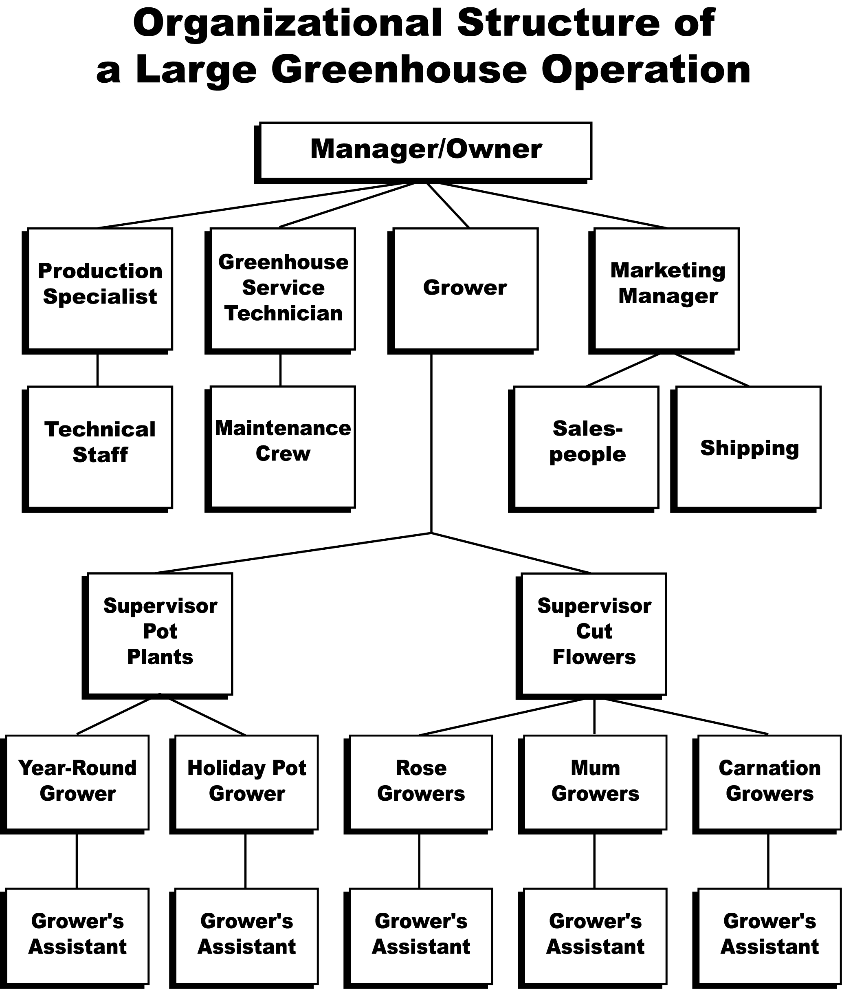

UNIT I: THE GREENHOUSE INDUSTRY AS 1.4

Lesson 2: Career Opportunities Name__________________________
in the Greenhouse Industry

Greenhouse Careers: Which One? How to Succeed?

Objective: Appraise which greenhouse career is appropriate and infer how continuing education would enhance this career.

Directions: Read the scenarios below that describe various interests and skills of several individuals. Assume that everyone wants to expand his or her skills by working in a greenhouse. Identify which greenhouse-related career suits each person. Then suggest a type of training or form of continuing education that would help this person improve his or her skills in the greenhouse industry. Discuss your choices with the class.

- Betty likes to work with her hands. On her farm, she built a sheep shed and repaired it as needed.
She also installed a watering system for the lambs.

Career __________________________________________________________________

Continuing Training/Education__________________________________________________

- Isabella’s favorite class is science, with a special interest in chemistry. She enjoys investigating
how things work. At home, she exposed her oregano and basil plants to different fertilizers.

Career __________________________________________________________________

Continuing Training/Education__________________________________________________

- Ron’s tomatoes, herbs, and roses won awards at FFA contests. He would like to cultivate
orchids, tropical foliage, and ferns. Hydroponics also interests him.

Career __________________________________________________________________

Continuing Training/Education__________________________________________________

- Thaddeus has had his own lawn service throughout high school. He maintains all financial
records and keeps in touch with his clients. Currently, he is seeking new customers.

Career __________________________________________________________________

Continuing Training/Education__________________________________________________

UNIT I: THE GREENHOUSE INDUSTRY AS 1.5

Lesson 2: Career Opportunities Name______________________
in the Greenhouse Industry

Getting Involved in the Greenhouse Industry

Objective: Devise an SAE (Supervised Agricultural Experience) activity for a job in the greenhouse industry.

Directions: Select one of the following careers and identify a task required in that area. First assess your interests and skills and then develop an SAE activity that exposes you to this job. If possible, organize placement in that job.

Assistant grower Marketing manager
Grower Manager/owner
Greenhouse service technician Wholesaler
Production specialist Retailer

Career __________________________ Specific Job_____________________________

Assessing Personal Interests and Skills

To identify a specific job within a career that interests you, review the Student Reference, search the Internet for additional information, or read greenhouse-related publications. Then respond to the following questions.

1. Why does this job appeal to you?

2. What personal skills or traits do you have that would complement this job?

3. What demands would this job make upon your time, talents, and efforts?

4. How would you handle these challenges?

5. Does this job lead to other careers that interest you?

6. What types of questions and requirements would an employer have for someone who is seeking this position? Role-play as the employer and then as the employee.

Developing an SAE Activity

With the guidance of your instructor, create an SAE activity that accommodates your interests.

1. Find a greenhouse operation that offers the type of work that interests you.

2. Identify a supervisor at the greenhouse who is willing to give you hands-on experience.

3. List several tasks that are required for the job you selected.

4. Outline a procedure for performing these tasks.

5. Create a self-assessment tool for the job you are pursuing.

If you are placed in a job related to greenhouses, complete the following section.

Recording Your Progress

Track your experiences in your new job in the greenhouse industry. Listed below are some suggestions for recording your SAE activity.

- Compile a scrapbook, including
- Your time sheet and wage statements (if applicable)
- Photographs of each stage of the job and of your coworkers and supervisor
- Articles related to this career

- Prepare a PowerPoint presentation of your experience for the class

- Relate your experiences orally to the class using visual aids

- Demonstrate to the class one or more of the skills you acquired

