GREENHOUSE OPERATION AND MANAGEMENT

Unit II: Growing Structures

Lesson 1: Greenhouse Parts, Structures, and Coverings

Objective/Competency:

Distinguish types of greenhouses by materials, structure, and layout.

Study Questions

1. What are the primary considerations in selecting a site for a greenhouse operation?

2. What are different types of greenhouse structures?

3. What is the basic construction of a growing structure?

4. What are the interior parts of a greenhouse?

5. What other structures and areas are part of most commercial greenhouse operations?

6. What are some considerations for the interior layout of buildings and work areas?

References/Supplies/Materials

1. Greenhouse Operation and Management (Student Reference). University of Missouri-Columbia: Instructional Materials Laboratory, 2002.

2. Transparency Masters

TM 2.1 Frame Types
TM 2.2 Ridge and Furrow Construction
TM 2.3 Lean-To Greenhouse
TM 2.4 Parts of a Greenhouse
TM 2.5 Interior Layout of a Greenhouse
TM 2.6 Other Outdoor Growing Structures

3. Activity Sheet

AS 2.1 Plan Your Own: Part I

4. A current copy of Hummert’s Horticultural Supply Catalog
5. Stuppy Greenhouse Manufacturing Inc. <http://www.stuppy.com/stuppy_site_map.html>

TEACHING PROCEDURES

A. Introduction

This unit involves the growing structure, environmental controls, and energy conservation and environmental protection. Lesson 1 describes the physical aspect of the greenhouse itself: what the building looks like, what materials are used, and what the floor plan is. The greenhouse owner must resolve how climate, topography, resources, zoning, and economics affect the growing structure before building can occur.

B. Motivation

Have the students discuss both the environmental and human factors that influence a greenhouse
operation. How or why would the selection of the site be important? Why is the availability of
resources such as roads, water, and labor a vital consideration?

C. Assignment of Study Questions

Encourage students to keep the activity sheets for Lessons1-3 as a reference for the Unit II Activity.

D. Supervised Study

Lead students in collecting the information needed to answer and discuss the study questions. The instructor may choose to work on one study question at a time or have students answer all the questions before the discussion. Another option is to have students work in cooperative learning environment and have groups work on different study questions.

E. Discussion

Lead students in a discussion of the study questions. Supplement students’ responses and information with additional materials when needed.

1. What are the primary considerations in selecting a site for a greenhouse operation?

A profitable greenhouse operation does not just plop down on an empty spot of land. There are many environmental and human-related factors to consider: climate, topography, accessibility to resources, marketing, and zoning.

A. Climate
1. Desirable locations
a. High, natural light levels
b. Moderate climate
2. Locations that could increase energy and maintenance costs
a. Very cold locations
b. Locations with very high temperatures and humidity
c. High elevations (wind)
d. Valleys (frost)
B. Topography
1. Location of the greenhouse
a. Optimal site is where the greenhouse receives the most morning sunlight, thereby promoting the plant food production process (photosynthesis).
b. Specific location depends on geography. For example, in Maryland, the best site for a greenhouse is toward the south or southeast; the next best option is toward the southwest.
c. In Missouri, the ridge of the greenhouse should run north and south to permit the light to enter from a sidewall, not an endwall. Winter light is maximized and shadows are reduced.
d. For states whose latitude is 40º north or above, an east-west direction is best.
2. Surface
a. Level
b. Able to provide good drainage
3. Creation of windbreak to shelter structure from winter wind
4. Prevention of obstacles in front of greenhouse
a. Should be clear of large trees or structures
b. May shade the greenhouse
C. Availability of resources
1. Water
a. Ample supply
b. High quality
2. Utilities (e.g., electricity, natural gas)
3. Materials (e.g., soils, fertilizers, pesticides)
4. Labor for regular operation and during harvest
5. Services (e.g., waste removal services)
D. Land considerations
1. Costs (e.g., purchase price, taxes)
2. Proximity to roads and utilities
3. Neighbors and how they may be affected by the operation
4. Expansion potential
E. Marketing considerations
1. Proximity to markets
2. Competition
F. Legal considerations
1. Permits and licenses
2. Zoning regulations

2. What are different types of greenhouse structures?

The three styles of growing structures are freestanding, connected, and attached. Freestanding greenhouses come in five frame styles. Connected is a string of greenhouses sharing a roof. Attached greenhouses share a wall with another building.

A. Freestanding (detached) structures
1. Frame styles (TM 2.1)
a. Even span (gabled)
b. Uneven span (placed on hillside/southern exposure)
c. Gothic arch
d. Quonset
e. A-frame
2. Advantages:
a. Easy to maintain (e.g., snow removal from roof)
b. Uniform light (minimal shadows)
3. Disadvantages:
a. More costly to construct (more sidewalls)
b. Occupy more space (several freestanding structures vs. single connected structure)
c. Less efficient (more surface exposed to elements)
B. Connected structures (TM 2.2)
1. Framing styles similar to freestanding structures; connected by a common roof
2. Advantages:
a. Occupies less land
b. Greater spans of interior space
c. Less energy required to heat and cool
3. Disadvantages:
a. Gutters collect snow.
b. Gutters create shadows.
C. Lean-to structures (attached) (TM 2.3)
1. Attaches to common wall of an existing building (facing east or south)
2. Advantages:
a. Lower construction cost
b. Heat from adjacent building
3. Disadvantages:
a. Limited space
b. Less roof support
D. Innovative European energy-efficient growing structures
1. “Venlo greenhouse” from the Netherlands - galvanized steel superstructure
a. Gable roof
b. Self-supporting glazing bar system
i. Bars opposite each other - less materials needed, more available light
ii. Rust free, no maintenance, lasts for years
iii. Strong and stable
c. Polycarbonate sidewalls and endwalls
i. Provide thermal insulation
ii. Regulate temperature
d. High-light glass glazing
i. Transmits light very well
ii. Promotes high-quality growing environment for crops
e. Roof vents
i. Controlled thermostatically or by computer
ii. Cut energy costs by using natural ventilation
2. “Rovero” greenhouse from the Netherlands
a. Retractable roof
b. Roof’s positions
i. Closed
ii. Half closed
iii. Open
c. Roof covering - clear or diffused polyethylene
d. Sidewall and endwall
i. Motorized
ii. 8-mm-polycarbonate roll-up curtain
e. Greenhouse environment - fully computer controlled
3. Field-scale and conventional tunnel greenhouses; originally developed in France (single span) and Spain (multispan)
4. Cantilevered roof vent units (from “National Polytunnels,” Lancashire, England)
a. Positioned on top of each roof span
b. Winch mechanism able to open five vents in a row
5. Folding roof - folds back into gutter
a. “Max Air” model from National Polytunnels
b. Model from Polybuild (Surrey, England, and Dutch company HCT)

3. What is the basic construction of a growing structure?

The greenhouse structure is composed of two basic parts: the frame and the covering. Construction options are limited and must be considered not only in terms of cost but also durability, reliability, frequency of repair or replacement, and adaptability to expansion.

A. Greenhouse framing
1. Framing considerations
a. Cost (construction and maintenance)
b. Strength
c. Choice of covering material
d. Amount of light blocked
2. Framing materials
a. Wood
i. Must be decay resistant (e.g., redwood or other wood treated with waterborne, salt-type preservatives that are safe for plants)
ii. Must NOT be treated with chemicals that emit fumes toxic to plants (e.g., creosote)
iii. Can be painted with light-reflecting, white, water-based paint for further protection
b. Aluminum alloy
i. Flexible
ii. Durable
iii. Affordable
c. Steel or iron
B. Greenhouse covering
1. Considerations
a. Style of greenhouse
b. Durability (ability to withstand snow, wind, and extreme temperatures)
c. Cost (construction and maintenance)
d. Type of framing required for support
e. Availability of materials
f. Interior environment created
i. Heat retention
ii. Light penetration
iii. Light diffusion
iv. Condensation potential
v. Static electricity charge
2. Types of covering materials
a. Glass
i. Usually heavy, tempered glass
ii. Advantages:
(a) Strong
(b) Inexpensive to maintain
(c) Excellent light transmission
(d) Long lasting
iii. Disadvantages: requires a heavier, more costly framing structure, breakable
b. Polyethylene (PE) film
i. Advantages:
(a) Lightweight
(b) Flexible
(c) Easy to install
(d) Can be supported by a lightweight frame
(e) Transmits light as well as glass
ii. Disadvantages:
(a) Susceptible to weather damage
(b) Needs repeated rinsing to get rid of dust
(c) Must be replaced every 2-4 years
c. Rigid panels
i. Common materials
(a) Polycarbonate - examples: Lexan, Verolite (double walled and similar to Lexan), Dyan-Glas, and Green-Lite
(b) Fiber-reinforced polyester (FRP) (fiberglass) - flammable (requires fire insurance)
(c) Polymethyl methacrylate (PMMA) acrylic
ii. Advantages:
(a) Lightweight
(b) Sturdier than film,
(c) Durable (replace 10-20 years)
iii. Disadvantage: can be damaged by elements over time
4. What are the interior parts of a greenhouse?

A key concern in the layout of a greenhouse is the type of market it serves. Is this operation wholesale or retail? This answer impacts the decision of bench layout, bench construction, and flooring. Encourage students to discuss why this is true.

A. Interior layout
1. Type of layout depends primarily on greenhouse purpose
a. Wholesale
b. Retail
2. Aisles - wide enough to accommodate equipment and people
3. Common layout designs (TM 2.5)
a. Lengthwise benching
b. Crosswise benching
c. Peninsular benching
B. Flooring
1. Considerations
a. Must be able to accommodate equipment and work flow
b. Must include proper drainage
c. Bare ground not acceptable
i. Risk of pathogens
ii. Difficult to provide proper drainage
2. Materials
a. Concrete
i. Include drain basins
ii. Slope toward drains
b. Gravel
i. Weed mat covered with gravel
ii. Porous enough to allow water to drain
C. Benches
1. Considerations
a. Retail or wholesale
b. Sturdy enough to hold plants
c. Provide air movement and water drainage
2. Types
a. Fixed
b. Moveable
i. Can be moved outdoors
ii. Used for double-crop production (one crop on floor, second bench moved outdoors)
c. Rolling
i. Maximizes use of floor space
ii. Uses less aisle space
iii. For wholesale use only
3. Materials
a. Wood
b. Concrete
c. Metal
d. Plastic

5. What other structures and areas are part of most commercial greenhouse operations?

A greenhouse does not exist alone as a growing environment. Coldframes, hotbeds, and lath houses are additional ways to grow crops in a managed setting. The three use a combination of structure and nature. Other areas that may be a part of a greenhouse operation include offices, rest rooms, and loading zones. If the operation is retail, there are parking lots and display areas.

A. Other growing structures
1. Coldframes
a. Outdoor growing structure with transparent covering
b. Heated only by the sun
c. Top opened during the day, closed at night
d. Used to harden and protect plants from frost; winter storage of bulbs
2. Hotbeds
a. Outdoor growing structure with transparent covering
b. Heated by steam, hot water, or electricity
c. Used to start seedlings and cuttings
3. Lath houses
a. Outdoor growing structures covered with lath or shade fabric supported by vertical poles
b. Reduce light intensity
c. Used in summer in temperature climates or year-round in warm climates
B. Additional areas
1. Work spaces (e.g., soil mixing and propagation areas)
2. Storage areas
3. Roadways
4. Loading and shipping areas
5. Parking areas
6. Display areas
7. Offices
8. Break room/kitchen area
9. Rest rooms

6. What are some considerations for the interior layout of buildings and work areas?

The orientation of the greenhouses and the other buildings is essential to an efficient greenhouse operation. AS 2.1 instructs students how to design a layout of a greenhouse operation using the information contained in this lesson.

A. Wholesale or retail operations have different types of work areas.
B. Generally, a good layout provides the following:
1. Efficient work flow (does not interfere with customer visits)
2. Efficient labor practices
3. Maximum use of space
4. Minimal impact on the environment (e.g., water runoff, pollution)
5. Optimal orientation for greenhouses (e.g., south or southeast)
6. Expansion possibilities
7. Regulatory compliance

F. Other Activity and Strategy

Invite a commercial builder to discuss the practical details of building a greenhouse. Ask this individual to bring samples of exterior coverings. Ask how greenhouses are priced. What are the advantages of pre-engineered packages versus entirely new construction? Is it better to plan expansions and equipment upgrades before construction begins on the initial building?

G. Conclusion

A greenhouse is a complex system. Although it is a protected environment for growing plants, the greenhouse is influenced by the climate and topography around it. The shape, framing, and covering materials are dictated by cost, durability, and type of operation.

H. Answers to Activity Sheet

Instructor’s discretion

I. Answers to Assessment

1. C
2. D
3. D
4. A. Must be able to accommodate equipment and work flow
B. Must include proper drainage
C. Bare ground not acceptable
5. A. Coldframes
B. Hotbeds
C. Lath houses
6. The student may list any one of the following advantages
A. Excellent light transmission
B. Long lasting
The student may list any one of the following disadvantages
A. Breakable
B. Requires a heavier frame structure
7. The student may list any one of the following advantages
A. Lightweight material
B. Sturdier than film
C. Durable
The student may list any one of the following disadvantages
A. Can be damaged by the elements
B. Must be replaced frequently
8. D
9. B
10. C
11. E
12. A
UNIT II: GROWING STRUCTURES Name______________________________
Lesson 1: Greenhouse Parts, Structures, and Coverings Date___________________

ASSESSMENT

Multiple Choice: Circle the letter of the best answer.

1. What are the basic parts of the greenhouse structure?

A. Frame and layout
B. Covering and ventilation
C. Frame and covering
D. Flooring and covering

2. What are three interior parts of a greenhouse?

A. Display area, flooring, and layout
B. Benches, layout, and loading area
C. Flooring, Quonset, and benches
D. Layout, benches, and flooring

3. What is the correct direction of the ridges in a greenhouse built in Missouri that allows light to enter from the sidewalls?

A. East and west
B. North northeast
C. South and southwest
D. North and south

Short-Answer Questions: Write the answers in the space provided.

4. What are three major considerations in determining the layout of flooring in a greenhouse?

A.

B.

C.

5. What are three other types of growing structures?

A.

B.

C.

6. What is an advantage and disadvantage of glass as a covering material?

Advantage Disadvantage

7. What is one advantage and one disadvantage of polycarbonate as a covering material?

Advantage Disadvantage

Matching. The terms on the left refer to freestanding frame styles, which are pictured on the right side. Write the correct letter in the space provided.
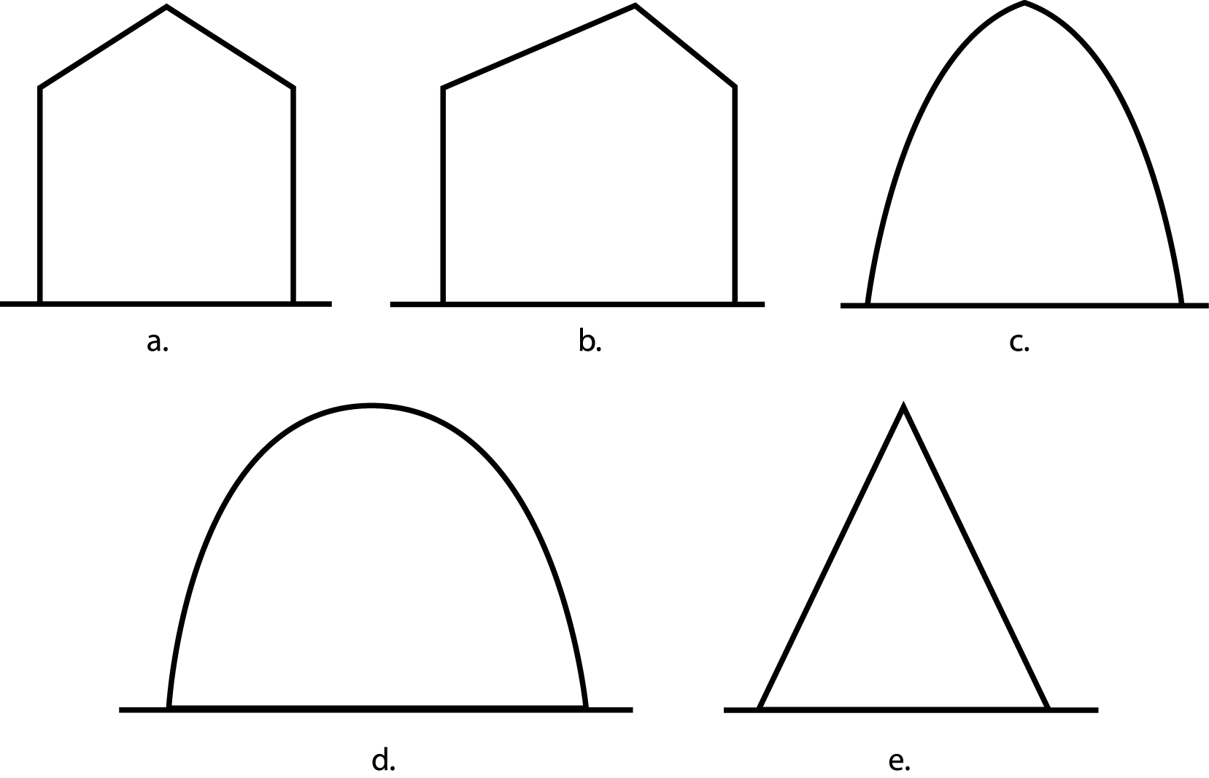
8. Quonset

9. Uneven span

10. Gothic arch

11. A-frame

12. Even span

TM 2.1
Frame Types

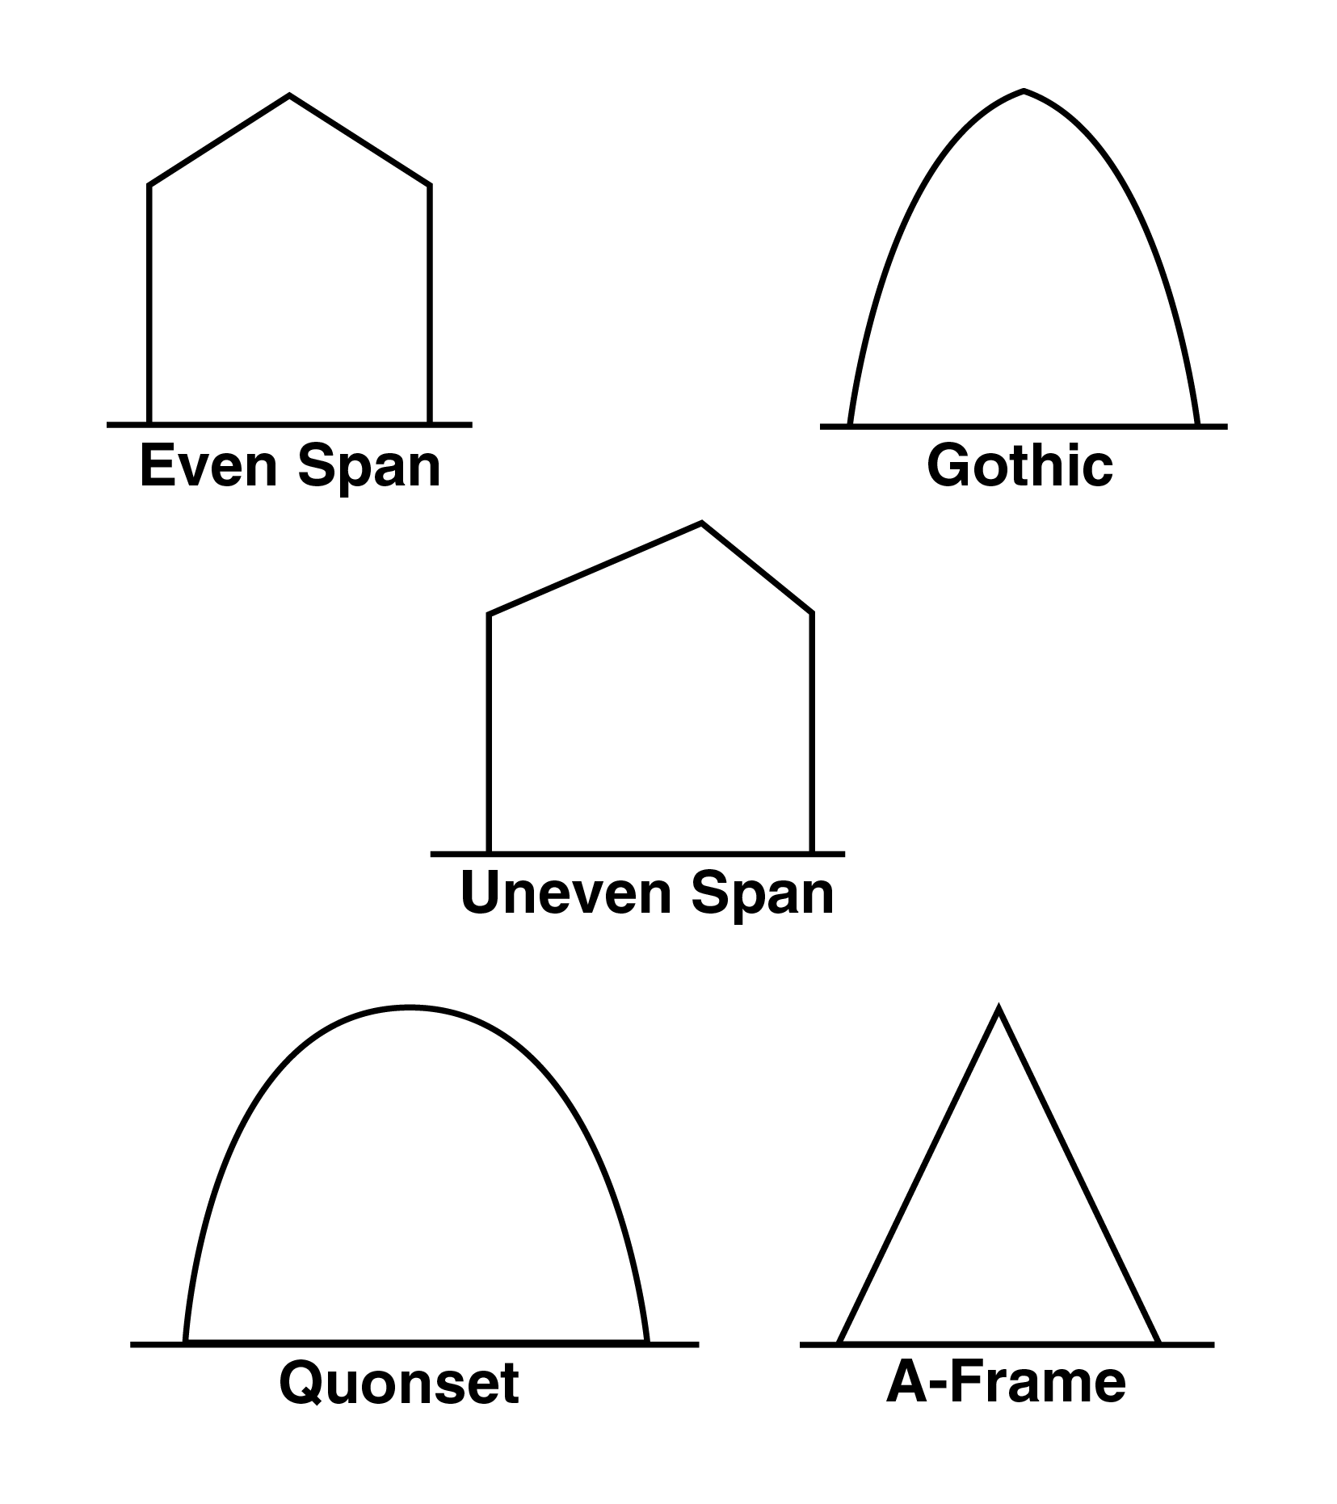

TM 2.2

Ridge and Furrow Construction

TM 2.3
Lean-To Greenhouse

TM 2.4
Parts of a Greenhouse
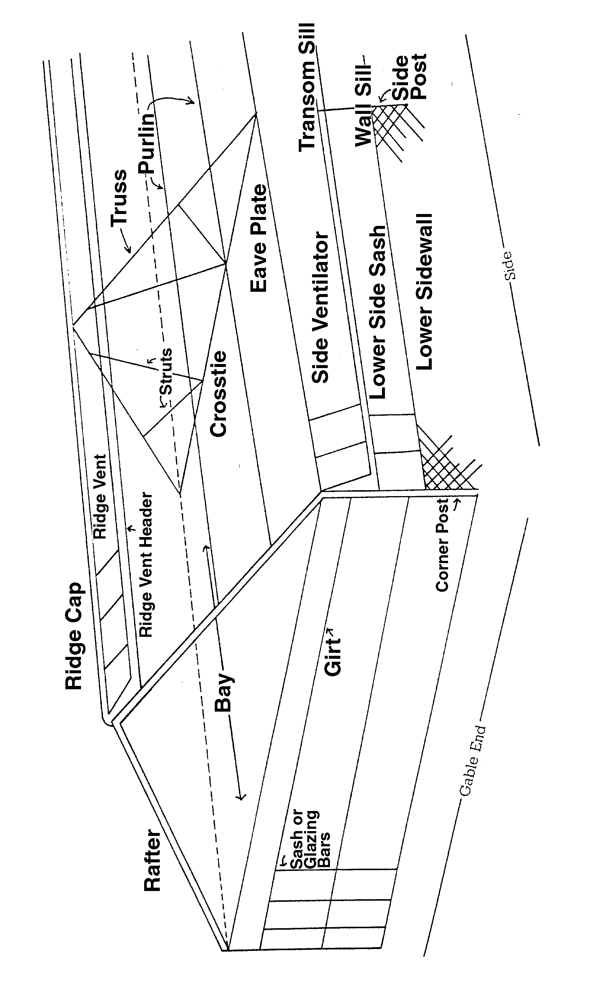

TM 2.5
Interior Layout of a Greenhouse

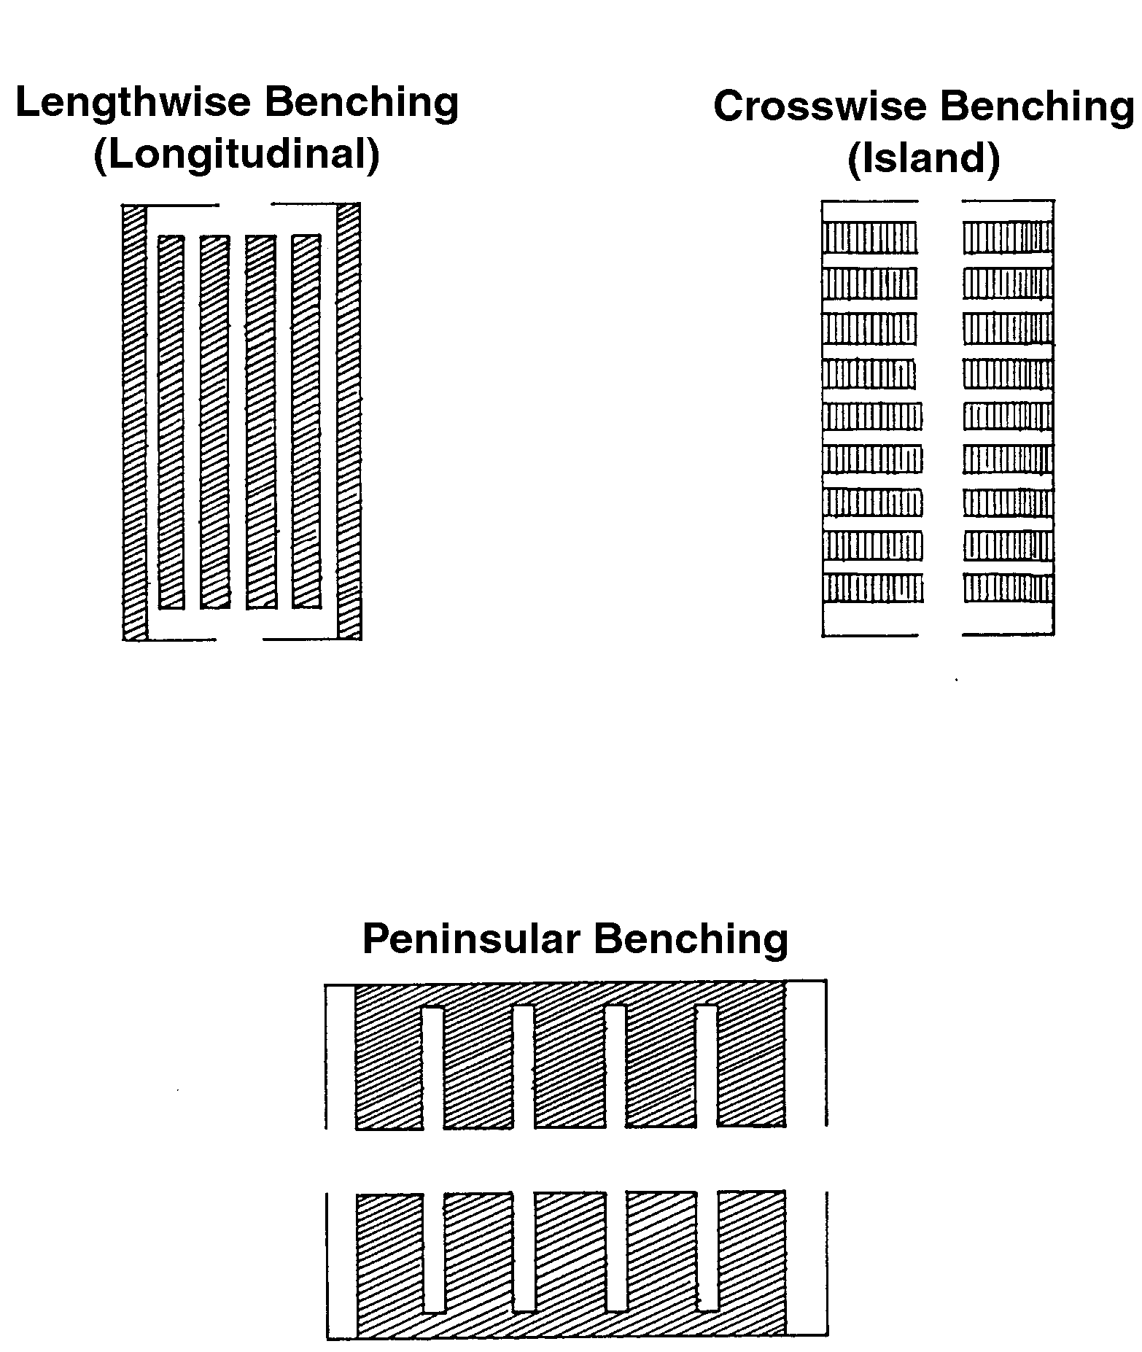

TM 2.6
Other Outdoor Growing Structures
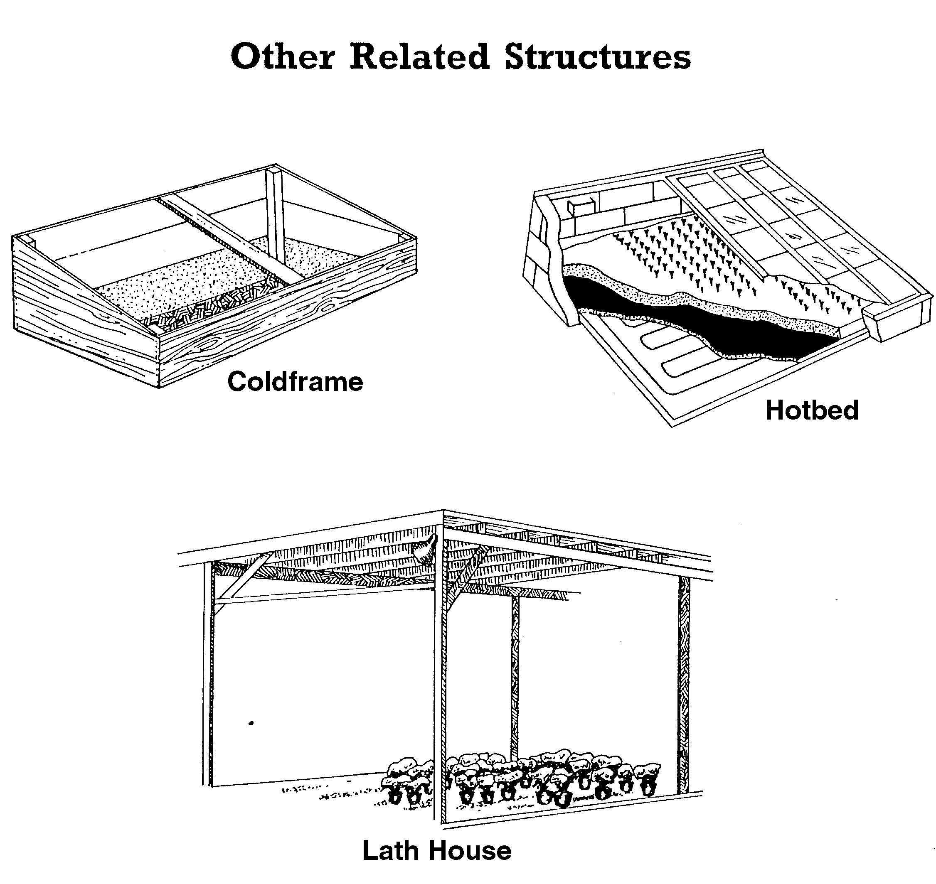

UNIT II: GROWING STRUCTURES AS 2.1

Lesson 1: Greenhouse Parts, Structures, and Coverings Name______________

Plan Your Own: Part I

Objective: Develop a greenhouse structure.

Directions: Select one of the following topics. Work in a small cooperative group to answer the questions related to the selected topic. Use textbooks, the Internet, professional greenhouse magazines, and other resources to gather information, sketches, and pictures. Remember to discuss cost, complexity of setup, repair and upgrade. Keep this activity sheet; it will be helpful in Lessons 2 and 3 of this unit and in the unit activity.

Group One: Site Selection

- Where are you building your greenhouse: on top of a hill, in a valley, etc.? Why?

- What is the direction of the growing structure?

- What types of energy costs are required with this site?

- What sort of infrastructure is available at this site?

- How accessible is this site for materials delivery?

- Are utilities readily obtainable?

Group Two: Legal

1. How much does the land cost?

2. What is the expansion potential?

3. Are there any neighbors? How does the business affect them?

4. Is this a wholesale or retail operation?

5. How close is the competition? How close is your customer base?

6. What are the zoning regulations for your land?

7. What permits or licenses do you need to build the greenhouse?

Group Three: Design

1. What type of structure is this? Why?

2. How easy or complex is it to set up, repair, and upgrade?

3. What framing material are you going to use? Why?

- 4. What type of covering material are you going to use? Why?

5. What are the initial costs and costs of repair? How often does the covering need to be repaired or replaced?

6. Is the material flammable?

Group Four: Layout

1. What is the interior layout?

2. What material is used on the flooring? Why?

3. What material is used for the benches? Why?

4. What type of bench is used? Why?

5. Are there any other types of growing structures? If yes, what kind and why?

6. What other work areas are needed?

7. Do these choices reflect a good layout for a commercial greenhouse operation?

