GREENHOUSE OPERATION AND MANAGEMENT

Unit II: Growing Structures

Lesson 2: Environmental Control

Objective/Competency:

Describe how environmental factors in a greenhouse are controlled.

Study Questions

1. What types of environmental controls may be found in a greenhouse?

2. How is the temperature in a greenhouse monitored and controlled?

3. How can a greenhouse be kept warm during cold weather?

4. Why must a greenhouse be ventilated?

5. How is a greenhouse kept cool during warm weather?

6. How is greenhouse humidity controlled?

7. What equipment is used to irrigate plants in a greenhouse?

8. How are carbon dioxide and light levels controlled in a greenhouse?

References/Supplies/Materials

1. Greenhouse Operation and Management (Student Reference). University of Missouri-Columbia: Instructional Materials Laboratory, 2002.

2. Transparency Masters

TM 2.7 Devices to Monitor Temperature
TM 2.8 Methods of Ventilation

3. Activity Sheet

AS 2.2 Plan Your Own: Part II

4. Ball, Vic, Editor. Ball Red Book Greenhouse Growing, 14th ed., Reston, VA: Reston Publishing, Inc., 1985.

5. A current copy of Hummert’s Helpful Hints

TEACHING PROCEDURES

A. Review

Students are starting to look beyond the obvious and consider unseen aspects in the design of a greenhouse. Lesson 2 explores elements of the environment that personnel should control to produce optimal crops.

B. Motivation

1. Once the greenhouse owner assesses the land, climate, and resources, the actual structure is built. But it is just a shell to be converted into a controlled environment to raise crops. Ask the students what environmental elements have to be manipulated to raise the best crops in the shortest amount of time.

2. To demonstrate elements of a greenhouse environment on a reduced scale, have students work in small cooperative groups to create terrariums. Encourage each group to select a different type: desert, tropical forest, etc. Use small glass fish tanks or wide-mouth glass containers. Other materials needed are gravel, charcoal chips, small rocks, and a selection of small plants and ground cover, such as moss. As students develop their terrariums, discuss how light, water, and temperature affect the growth of plants.

C. Assignment of Study Questions

D. Supervised Study

Lead students in collecting the information needed to answer and discuss the study questions. The instructor may choose to work on one study question at a time or have students answer all the questions before the discussion. Another option is to have students work in cooperative learning environment and have groups work on different study questions.

E. Discussion

Lead students in a discussion of the study questions. Supplement students’ responses and information with additional materials when needed.

1. What types of environmental controls may be found in a greenhouse?

There are seven environmental factors to adjust inside the greenhouse. The methods of
control are discussed here. Subsequent units detail why these factors need monitoring.

A. Natural elements to control in a greenhouse
1. Temperature
2. Humidity
3. Water
4. Light
5. Carbon dioxide
6. Pests
7. Disease
B. Basic methods of control
1. Manual
2. Automated
3. Integrated control system
a. Analog and integrated control systems
b. Multiple sensors throughout greenhouse
c. Sense and control elements such as air and soil temperature, light intensity, relative
humidity, and carbon dioxide levels
d. Record data for evaluation and troubleshooting
e. Provide data for planning future crops

2. How is the temperature in a greenhouse monitored and controlled?

Have students anticipate how plant development is influenced by temperature. What would result if the temperature becomes too cold or too warm?

A. Primary considerations in selecting temperature control systems
1. Cost of equipment
a. Installation
b. Maintenance
2. Ability to provide uniform control
a. Minimize hot and cold spots throughout greenhouse
b. Can be enhanced with horizontal airflow
3. Capacity
a. Ability to handle temperature extremes
b. Ability to meet needs of the entire operation
4. Reliability
a. Power failure alarm that alerts a power outage
b. Emergency generator in case of power failure
5. Fuel
a. Cost
b. Availability
c. Type of storage required
d. Type of transportation required
B. Monitoring and control methods (TM 2.7)
1. Thermometers (measure air temperature)
2. High/low thermometers (measure day and night air temperatures)
3. Thermostats
a. On-off control of air temperature
b. Step control (stages) of air temperature
4. Aspirated thermostats
a. Read temperature of air blown across thermostat
b. More accurate control than standard thermostat
5. Thermistors
a. Electronic semiconductora used in computerized greenhouses
b. Sense even subtle temperature changes; signal controller
C. Proper placement of monitoring devices
1. At level of the plants throughout the greenhouse
2. In an area shaded from direct sunlight and cooled fans

3. How can a greenhouse be kept warm during cold weather?

Discuss with students why heat is important to greenhouse-grown crops. What are desired qualities in sources of heat? Are some sources more conducive to specific crops?

A. Heating considerations
1. Heat loss occurs in three ways.
a. Conduction
b. Infiltration
c. Radiation
2. Lost heat must be replenished to protect plants.
3. There are several desirable heat source features.
a. Energy efficiency
b. Reliable
c. Safety
4. Heat is measured in Btu.
B. Solar energy
1. Solar energy provides only some heat.
a. Greenhouse collects and stores the heat energy from the sun that passes through the covering during the day.
b. This heat warms the plants and other objects inside the greenhouse.
c. The heat that is radiated back does not have enough energy to pass back through the covering (greenhouse effect).
d. Heat is retained at night. (The amount retained varies with the type of covering.)
2. Solar heat alone is not sufficient heat for greenhouses in most northern climates.
3. An additional source of heat must be provided.
C. Heating equipment
1. Unit heaters
2. Central heaters
3. Radiant (infrared) heat
a. Infrared lights heat surfaces (plants, soil, benches, etc.) not the air.
b. Air is warmed only by heat radiated from surfaces.
4. Emergency generators
a. Powered by gas or fuel
b. Necessary if there is a power outage that cuts power to the electric fans, which are essential parts of most heating systems
c. Necessary to keep cooling in greenhouse operation
D. Heat distribution
1. Forced hot air
a. Hot air - from burning several fuels, such as natural gas
i. Distributed throughout the greenhouse
ii. Ventilated to the outside to prevent buildup of air pollutants
b. Horizontal discharge unit heaters
i. Mounted on the ground or overhead
ii. Push air through perforated polyethylene tubing that hangs above plants
c. Vertical discharge unit heaters fans
i. Mounted overhead
ii. Move air downward
d. Unit heaters - use HAF (horizontal airflow) fans to distribute heat evenly
e. Fans at the peak of the greenhouse pushing down the hot air that rises
2. Hot water
a. Water is piped through greenhouse by metal piping that is placed along walls and under benches.
b. Temperature is variable.
c. A circulating pump moves the water.
3. Steam
a. Piped through greenhouse by metal pipes
b. Temperature not as variable as hot water
c. Carries more heat and moves farther
E. Fuel options
1. Coal
2. Kerosene oil
3. Propane/natural gas
4. Wood
5. Electric (not an efficient fuel for most commercial greenhouse operations)
F. Venting
1. Any heating system that burns fuel can be lethal to humans.
a. Oxygen is depleted from the air.
b. Oxygen shortage creates carbon monoxide - a gas that is fatal to humans.
2. Impurities in fuel and incomplete combustion can create other toxic fumes.
a. Ethylene gas
b. Sulfur dioxide gas
3. Safety measures are needed.
a. Fuel-burning heat sources must be vented to the outdoors through a chimney.
b. Ventilation system must be installed to bring fresh air into the greenhouse.
G. Circulation
1. Circular air movement is an essential part of heating process.
2. Air-mixing fans push the hot air that rises back down to plants.
4. Why must a greenhouse be ventilated?

Have students discuss why ventilation is important in a greenhouse. Have the students contemplate the lack of fresh air. What effect would it have on the plants?

A. Purpose of greenhouse ventilation
1. Brings fresh air into greenhouse
2. Reduces temperature
3. Reduces relative humidity
a. Excessive humidity causes condensation on plants.
b. Condensation left on plants increases risk of disease.
4. Replenishes carbon dioxide (CO₂)
a. CO₂ is necessary for plant growth.
b. Plants consume CO₂ during photosynthesis process.
B. Types of ventilation (TM 2.8)
1. Ridge and side vents
a. Chimney effect
b. May be automated or manually operated
2. Exhaust fans on sidewalls and endwalls
a. Draws in fresh air
b. Most beneficial in late spring, summer, and early autumn
3. Perforated convection tube heater/fan system
a. Motorized louvers let in fresh air.
b. Fans mix air with inside air then distribute air through a convection tube.
c. Convection tube running the length of the greenhouse overhead distributes air through the perforated openings.

5. How is a greenhouse kept cool during warm weather?

Ask students why cool air and reduced light are important in maintaining the greenhouse environment. Which factors from Lesson 1 of this unit also apply?

A. Basic measures
1. Provide even flow of cool air
2. Reduce light intensity
B. Methods of providing cool air
1. Ventilators, vents
2. Forced air ventilation
3. Fan and pad systems
4. Fog system
a. Water is forced through tiny nozzles to create fine mist.
b. Evaporating water cools the air.
5. Mechanical A/C system - inefficient cooling method for most commercial greenhouse operations
C. Methods of reducing light intensity
1. Shade fabric
a. Fabric is available in various types of fabrics.
i. Woven polyethylene cloth from greenhouse supplier
ii. “Aluminet” - knitted polyaluminum
b. Weave density of fabric determines the amount of light that is shaded out.
i. Fabric is selected according to its percent of density.
ii. Weave densities range from 20 to 90%.
iii. The percent approximates how much the light intensity is decreased. For example, a 55% shade fabric blocks about 55% of the ambient (surrounding) light.
c. The best way to reduce heat is to drape the cloth on the outside of the greenhouse. Be sure to maintain ventilation.
2. Shade paint
a. Diluted, weak-binding latex paint
b. Sprayed on outside of glazing, usually twice yearly
c. Should wear off gradually over the summer and fall
d. Wash off with soap and water to prevent light reduction in winter
3. Blinds
a. Wooden, plastic, or plastic-coated aluminum slats
b. Mounted outside greenhouse like shade fabric
c. Mounted inside blinds - adjustable
4. Thermal screens - installed on ceilings and walls

6. How is greenhouse humidity controlled?

Specific plants thrive at specific ranges of humidity. Ask students to describe how humidity influences plants they cultivated at home.

A. Relative humidity (RH)
1. How much water is dissolved in the air at a specific temperature
2. Measured as a percentage
B. Range
1. Ideal RH for most plants is 45-85% - examples:
a. Greenhouse peppers - 75% RH
b. African orchids - 40-60% RH
c. Roses - 80% RH
2. Too high
a. Above 85% RH (However, cut tulips and cut daffodils are best stored at over 90% RH.)
b. Water condensing on plants and increasing risk of fungal pathogens and disease
3. Too low
a. Below 45% RH (Note: For succulents and cacti, 5-15% RH is the ideal range.)
b. May stunt plant growth or cause leaf burn
c. Requires more watering
C. Methods of maintaining proper RH
1. Use shading to reduce temperature and light.
2. Use cooling pads (evaporative cooling).
3. Keep greenhouse filled with plants. (They generate RH.)
4. Do not water plants late in the day. Ensure that floor of greenhouse drains well.
5. Hook up a fan in the greenhouse and set it to start running at 9:00 p.m. or 10:00 p.m. for 30-60 minutes.
a. Exchanges moist, warm, inside air with moist, cool, outside air
b. Enables heating system to warm air to its set point, which reduces level of water in the greenhouse
6. Open the roof ventilators to let hot air escape. Maximize exchange of air by having wide roof ventilators and a double row of sidewall ventilators.
a. Prevents a buildup of moisture
b. Prevents water vapor from condensing on plants, which can cause spread of disease
7. Install fans for ventilation.
a. Introduce cooler outside air into the greenhouse during late spring, summer, or early fall.
b. During late autumn, winter, and early spring, air is introduced into greenhouse through perforated polyethylene tubes.
i. This prevents harsh, extremely cold outside air from harming plants.
ii. When cold air leaves tubes, it mixes with warm greenhouse air and this prevents plants from suddenly getting chilled.
c. Exhaust fans exchange greenhouse air with outside air.

7. What equipment is used to irrigate plants in a greenhouse?

Ask students to describe equipment they have used to water their own plants. Unit IV, Lesson 3, details how equipment and systems are used to irrigate greenhouse crops and it describes different irrigation systems.

A. Manual method
1. Handheld hose
2. Wand
B. Automated method
1. Delivery through mist systems
2. Spaghetti tubes, which are controlled by timers
3. Drip emitters
4. Ooze tubes
5. Water loop
6. Capillary mat system
7. Ebb and flood system
8. Boom system
9. Spray stake/nozzle system
10. Fertigators
8. How are carbon dioxide and light levels controlled in a greenhouse?

Carbon dioxide is vital for plants. Plants use CO₂ to produce energy during photosynthesis. The greenhouse owner can manipulate the amount of CO₂ to control a crop’s growth cycle. Light must also be controlled carefully. More details are provided in Units III and IV.

A. Carbon dioxide
1. Essential for plant survival
2. Consumed by plants during photosynthesis
3. Deficiency of CO₂ - if greenhouse is tightly closed, allowing no exchange of air
4. Lost CO₂ to be replenished by a CO₂ generator
a. Generators provide a maximum amount of CO₂ with a minimum of heat as a by-product.
b. A timer regulates when to introduce CO₂ into the greenhouse.
i. Add CO₂ when photoperiod begins or at sunrise.
ii. Discontinue CO₂ enrichment during dark hours.
iii. Average recommended level of CO₂ is 1,000-2,000 ppm (parts per million).
c. Generator operates by burning propane or natural gas.
d. A thermocouple monitors the pilot light.
e. If pilot flame goes out, a safety valve closes to prevent unburned fuel from releasing into greenhouse.
f. Larger generators allow the greenhouse owner to set a shorter cycle time. A shorter cycle time adds CO₂ into the greenhouse more efficiently.
B. Light
1. Required light intensity depends on plant.
2. Intensity of available light is measured in foot-candles, ranging from 500 f.c. on an overcast winter day to 10,000 f.c. on a clear summer day.
3. Light intensity can be affected by several environmental factors.
a. Geographic location
b. Season
c. Time of day
d. Pollution
e. Cloud cover
4. Light intensity can be read in two ways.
a. Light meter
b. Computerized photocell
5. Light intensity can be increased or decreased to meet plant’s requirements.
a. Light intensity/day length can be increased with supplemental lights.
i. Fluorescent lights
ii. High-intensity discharge (HID) lights
b. Light intensity/day length can be decreased by several means.
i. Blocking plants from light with black material
ii. Putting plant under a bench to reduce exposure to light
iii. Spraying a shading compound on growing structure
iv. Placing a shade cloth above plants or over the growing structure

F. Other Activity and Strategy

Have students go through greenhouse supply catalogs to find examples of environmental control systems. Which are appropriate for your area? Which systems would be appropriate for someone specializing in olericulture in Florida or floriculture in North Dakota?

G. Conclusion

The interior of a greenhouse is a blank slate. Although the size and shape affect the interior, so do environmental factors such as temperature, light intensity, humidity, and carbon dioxide. These considerations affect the design of a growing environment.

H. Answers to Activity Sheet

Instructor’s discretion

I. Answers to Assessment

1. D
2 C
3. C
4. D
5. D
6. C
7. B
8. D
9. The student may list any three of the following:
A. Geographical location
B. Season
C. Time of day
D. Pollution
E. Cloud cover
10. The student may list any four of the following:
A. Temperature
B. Humidity
C. Carbon dioxide
D. Pests
E. Diseases
11. Increases chances of fungi attacking plant
12. Between 45 and 85%
13. A. Ridge and side vents
B. Exhaust fans
C. Perforated convection tube heater/fan
UNIT II: GROWING STRUCTURES Name__________________

Lesson 2: Environmental Controls Date___________________

ASSESSMENT

Multiple Choice: Circle the letter of the best answer.

1. What are four considerations in selecting a temperature control system?

A. Humidity level, installation, uniformity, and conduction
B. Cost analysis, fuel, reliability, and light intensity
C. Uniformity, storage requirements, location, and cost of equipment
D. Capacity, reliability, uniformity, and fuel

2. How can light intensity be reduced?

A. Horizontal airflow
B. Ooze tube
C. Thermal screen
D. Thermistors

3. What methods can distribute heat?

A. Hot air/steam, thermal screens, and infrared heat
B. Radiant heat, fire tube, and fog system
C. Forced hot air, hot air, and steam
D. Thermal screens, fire tube, and solar energy

4. What is one purpose of ventilation?

A. Deplete oxygen
B. Collect dust
C. Replenish carbon monoxide
D. Replenish carbon dioxide

5. What does a high/low thermometer measure?

A. Seasonal temperature inside the greenhouse
B. Indoor/outdoor temperature
C. Air blown across the thermostat
D. Day and night temperature
6. When does a CO₂ generator introduce carbon dioxide in the greenhouse?

A. During dark hours
B. At noon
C. Sunrise
D. At midday

7. What are three types of equipment used to irrigate plants using the automatic method?

A. Ebb and flood, handheld wand, and capillary mat
B. Ooze tube, drip emitters, and water loop
C. Tube system, subirrigation, and overhead
D. Spray stake, boom system, and tube system

8. What is a fan and pad system used for?

A. Heating
B. Catching insects
C. Increasing carbon dioxide
D. Cooling

Short-Answer Questions: Write the answers in the space provided.

9. What are three environmental elements that affect light intensity?

A.

B.

C.

10. What are four environmental factors that a greenhouse owner should monitor?

A.

B.

C.

D.

11. What damage can high humidity inflict on plants?

12. What is the ideal range of relative humidity for most plants?

13. What are the three types of ventilation systems?

A.

B.

C.

TM 2.7

Devices to Monitor Temperature

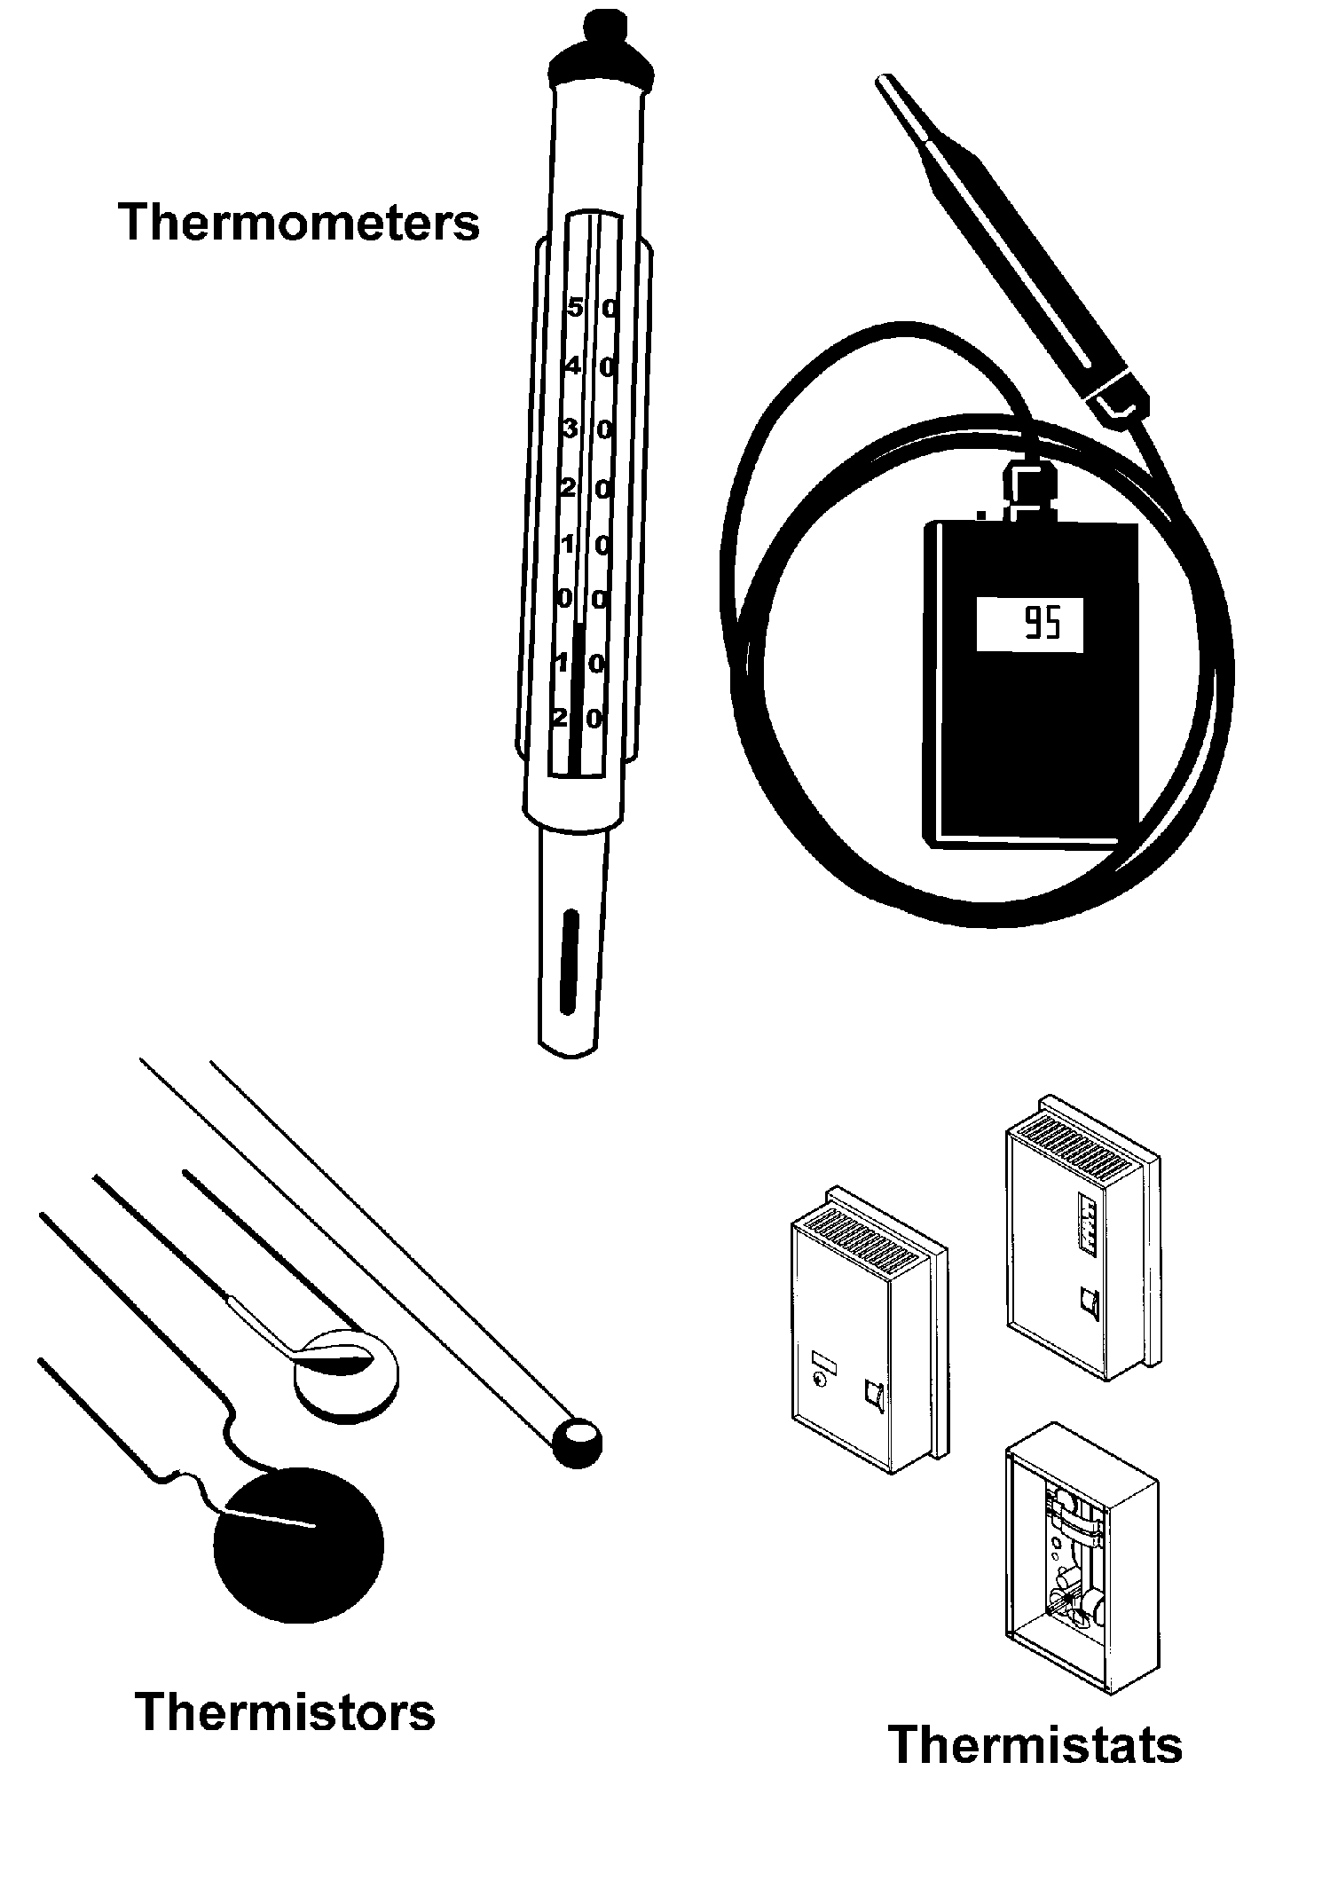

TM 2.8
Methods of Ventilation

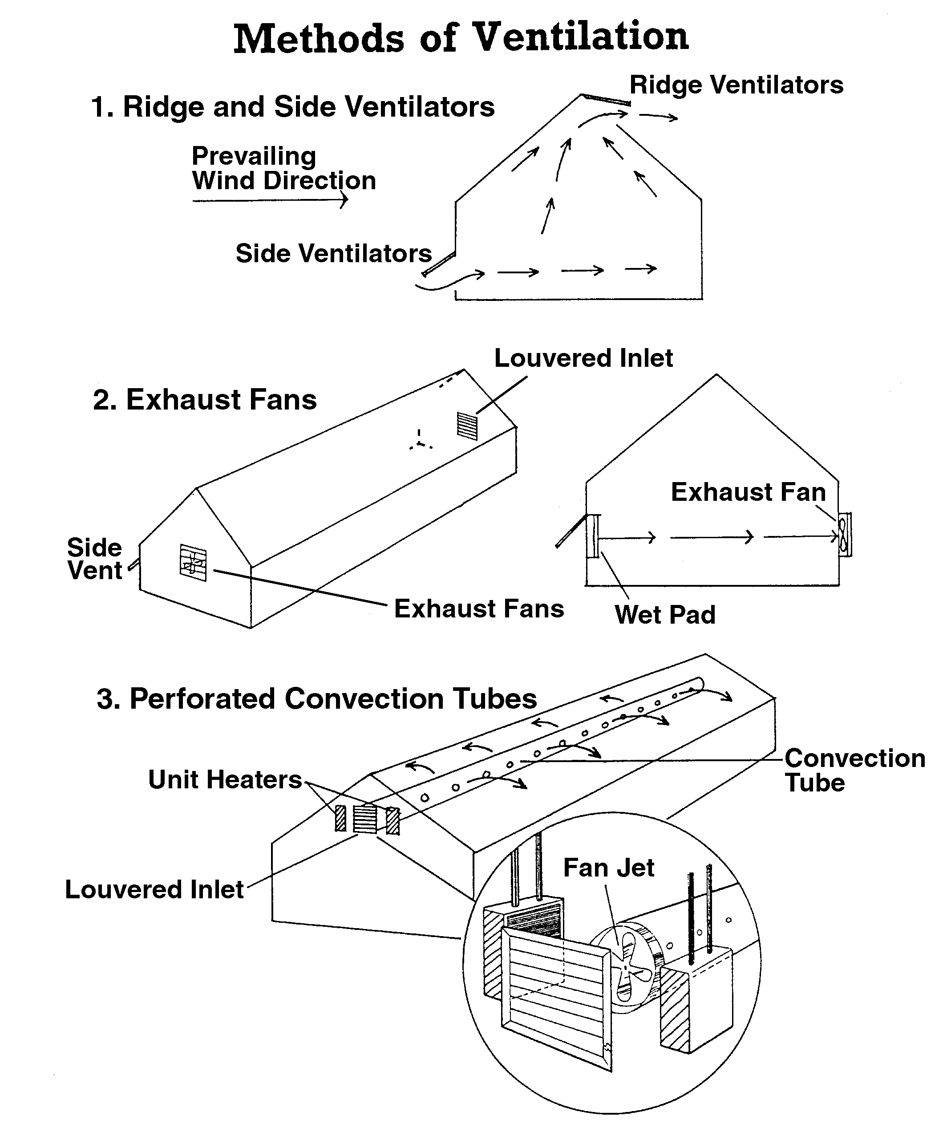

UNIT II: GROWING STRUCTURES AS 2.2

Lesson 2: Environmental Controls Name__________________

Plan Your Own: Part II

Objective: Integrate environmental controls into a strategic plan of a greenhouse.

Directions: Select one of the following topics. Work in a small cooperative group to answer the questions related to the selected topic. Build upon information from AS 2.1 to answer how you would control the greenhouse environment. Remember to discuss cost, complexity of setup, repair, and upgrade. Share your answers with the rest of the class.

Group One: Heat

- How do you plan to monitor the temperature in your greenhouse? Why?

- How do you intend to keep the greenhouse at the optimal temperature during the cold months?

- What type of distribution system are you using?

Group Two: Cooling

1. How do you plan to monitor the temperature in your greenhouse? Why?

2. What method of cooling are you using: one or more than one means to control temperature?

3. How are you ventilating the greenhouse? Why this method?

Group Three: Humidity

1. How do you plan to monitor the relative humidity in your greenhouse?

2. How do you plan on regulating the humidity?

3. Does this system have more than one function?

Group Four: Light

1. How do you plan to monitor light intensity? Why this approach?

2. How do you plan to control the light intensity: one approach or multiple methods?

3. What is the cost of your solution?

Group Five: Carbon Dioxide

1. How do you plan to monitor carbon dioxide in the greenhouse?

2. How will you control, augment, and release the amount of carbon dioxide?

3. Why is it important to control CO₂?

Group Six: Irrigation

1. Which method of irrigation will work best?

2. How will you integrate fertilizer injections?

3. What happens to the runoff water?

