GREENHOUSE OPERATION AND MANAGEMENT

Unit III: Plant Science Basics

Lesson 1: Plant Parts, Structures, and Functions

Competency/Objective:

Distinguish plant parts, structures, and functions.

Study Questions

1. What is a plant cell?

2. What are general differences between monocots and dicots?

3. What are the basic types of specialized plant tissues?

4. What is a seed?

5. What are the functions and types of roots?

6. What are the functions, structures, and types of stems?

7. What are the functions, structure, and types of leaves?

8. What are the functions, parts, and types of flowers?

9. What are the differences between a monoecious and a dioecious plant?

References/Supplies/Materials

1. Greenhouse Operation and Management (Student Reference). University of Missouri-Columbia: Instructional Materials Laboratory, 2002.

2. Transparency Masters

TM 3.1 Basic Structure of a Plant Cell
TM 3.2 Cross-Sections of Monocot and Dicot Seeds
TM 3.3 Monocot vs. Dicot Seeds
TM 3.4 Parts of a Plant
TM 3.5 Types of Roots
TM 3.6 Specialized Stems
TM 3.7 Cross-Section of a Leaf
TM 3.8 Leaf Shapes
TM 3.9 Leaf Margins
TM 3.10 Leaf Attachments
TM 3.11 Parts of a Complete Flower

- Activity Sheets

AS 3.1 Plant Parts, Structures, and Functions Work Sheet
AS 3.2 Stem Poster
AS 3.3 Leaf Poster
AS 3.4 Identifying Monocot and Dicot Plants

TEACHING PROCEDURES

A. Introduction

Unit III examines plant science basics by first providing fundamental information about plant science. Parts and functions of plants and flowers are illustrated down to the cellular level. The next lesson explains plant processes and the final lesson in this unit describes how plants are classified and named.

B. Motivation

Ask students why understanding plants’ structures and functions is vital to having a successful greenhouse operation. Compare a greenhouse owner to a doctor: Why does a doctor need to understand human anatomy in order to care for patients? What situations could occur in the greenhouse that would necessitate understanding plant parts and how they function?

C. Assignment of Study Questions

Be sure to have illustrations of a variety of plants displayed throughout the classroom.

AS 3.1 is a work sheet to guide students as they learn about plant parts, structures, and functions. They should answer each question as the relevant material is covered. Students may work in small groups or alone and they should consult the Student Reference and the transparency masters.

D. Supervised Study

Lead students in collecting the information needed to answer and discuss the study questions. The instructor may choose to work on one question at a time or have the students answer all of the study questions before the discussion. Another option is to have students work in a cooperative learning environment and have groups work on different study questions.

E. Discussion

Lead students in a discussion of the study questions. Supplement students’ responses and
information with additional materials when needed.

1. What is a plant cell?

The elements making up the plant cell are discussed. As you cover this material, remind students to answer the appropriate questions on AS 3.1.

A. Basic structural unit of plants (TM 3.1)
B. Cell structure
1. Cell wall
a. Primary wall (first to develop)
b. Middle lamella (layer between walls of two cells)
c. Secondary wall (woody part of plant that develops inside primary wall)
2. Plasma membrane (outer membrane)
a. Surrounds the cell, just inside the cell wall
b. Molecules of proteins, carbohydrates, phosphorous, fat
c. Functions
i. Controls entrance and exit of substances from the cell
ii. Relays information about environmental conditions to cell nucleus
3. Cytoplasm
a. Liquid within cell
b. Contains organelles
c. Site of most life processes
d. Organelles within cytoplasm
i. Mitochrondria
(a) Small, dense
(b) Control many chemical reactions in cell
(c) Provide site for respiration
ii. Plastids
(a) Contain chloroplasts (green pigment, known as chlorophyll)
(b) Contain chromoplasts (red, orange, and yellow pigment)
iii. Vacuoles
(a) Large, fluid filled
(b) Store water, dissolved minerals, and other materials
(c) Mature and join to form large, central vacuoles
4. Nucleus
a. Control center of cell
b. Location for genetic material (chromosomes)
c. Functions
i. Controls physiological characteristics of plant
ii. Controls appearance of plant
iii. Passes characteristics to offspring

2. What are general differences between monocots and dicots?

Plants have either one or two cotyledon (seed leaves). About 50,000 monocot plants exist; there are 200,000 dicots. Ask students why they think this occurs. TM 3.2 illustrates cross-sections of monocot and dicot seeds. TM 3.3 depicts the differences between monocot and dicot plants.

A. Monocot plants
1. One cotyledon
2. Leaves with parallel veins
3. Vascular bundles scattered within stem
4. Flower parts in multiples of three (e.g., three stamens, six petals)
5. Examples: corn, grass
B. Dicot plants
1. Two cotyledons
2. Leaves with branched veins
3. Vascular bundles in circular pattern
4. Flower parts in fours or fives (or multiples of fours and fives)
5. Examples: most flowering plants, deciduous trees

3. What are the basic types of specialized plant tissues?

The combination of cells functioning together is referred to as tissue. Two main types of plant tissue are meristem and permanent. Meristem tissue actively divides to form new growth for the plant, whereas the permanent tissue is made up of mature cells.

A. Meristem tissues (cells that actively divide to form new growth)
1. Apical meristem tissues (TM 3.4)
a. Located at tips of roots and stems
b. Increase plant length
2. Cambium meristem tissues
a. Located in stems
b. Increase plant diameter
3. Intercalary zone meristem tissues
a. Located just above nodes in monocot plants
b. Increase stem height
B. Permanent tissues (mature cells that do not actively divide)
1. Epidermis tissues (outside covering)
2. Vascular system tissues (path from roots to stems to leaves)
4. What is a seed?

Ask students to identify the five basic parts of a plant. If possible, have illustrations of all plant parts available to show the class. One of the basic plant parts in the earliest stage is the seed.

A. Seed
1. Contains an embryo (miniature plant)
2. Dormant until environmental conditions permit germination
B. Basic seed parts
1. Seed coat
a. Tough exterior surface
b. Protects embryo from drying out or from injury
2. Embryo
a. Cotyledon
i. Seed leaves
ii. Monocots - one cotyledon (protects the epicotyl)
iii. Dicots - two cotyledons (protect the epicotyl and provide food storage for new plants)
b. Epicotyl (plumule)
i. Growth bud of embryo located above cotyledons
ii. Develops into shoot that emerges from germinating seed
c. Hypocotyl
i. Stem section located below the cotyledon
ii. First tree stem
iii. Lengthens plant; cotyledons and epicotyl emerging from germinating seed
d. Radicle
i. Root tip, located at end of hypocotyl
ii. First root of plant
iii. First part to emerge from germinating seed
iv. Holds plant in soil, absorbing water and nutrients
3. Endosperm
a. Food storage tissues
b. Nourish the developing embryo upon germination
c. Only in monocots

5. What are the functions and types of roots?

Another basic part is the plant’s root system. There are five types of roots, all of which absorb water and nutrients for the plant.

A. Primary functions
1. Anchor plant
2. Absorb water and nutrients
B. Specialized functions
1. Synthesize hormones for plant growth
2. Store carbohydrates
3. Aerial support in come cases - climbing roots, such as ivy
C. Root features
1. Root hairs
a. Single-cell, hairlike extensions
i. More hairs are produced under dry conditions.
ii. Fewer hairs are produced under moist conditions.
b. Located near tip of roots
c. Functions
i. Absorb water and minerals from soil
ii. Expand root area for greater absorption
2. Radicle roots
a. Emerge from the seed
b. Grow into true roots or die in formation of fibrous roots
D. Types of roots (TM 3.5)
1. Taproot (primary or true root)
a. Large central roots from which lateral roots grow
b. Excellent anchorage and food storage
c. Penetrates deep into soil
d. Common in dicots
e. Example: carrot
2. Fibrous roots
a. No central root
b. Finely branched secondary roots spread shallow and wide
c. Excellent in absorbing water and minerals
d. Hold soil and prevent erosion
e. Common in monocots
f. Example: grass
3. Aerial roots (two types)
a. Clinging air roots
i. Grow out horizontally from stem
ii. Fasten plant to a form of support
iii. Example: English ivy
b. Absorptive air roots
i. Thick outer covering of dead tissue
ii. Roots absorb and store water
iii. Example: orchids
4. Adventitious roots
a. Develop in places other than nodes
b. Can form on cuttings and rhizomes
c. Example: blackberries
5. Aquatic roots
a. Develop adventitious roots in shallow water from the submerged shoots
b. Absorb nutrients and oxygen from water
c. Example: water lilies
6. What are the functions, structures, and types of stems?

Ask students what stems do for plants. Have them complete AS 3.2.

A. Functions
1. Support other plant parts (e.g., branches, leaves, flowers, fruit)
2. Capture light for photosynthesis
3. Move water, minerals, and food manufactured during photosynthesis to other parts of plant
4. In some cases, store water, food, and nutrients (e.g., Irish potato, cactus)
B. Basic stem structure
1. Monocots
a. Vascular bundles (xylem and phloem tissues) scattered throughout the cortex
b. No pith (parenchyma cells) in center
2. Dicots
a. Vascular bundles arranged in a ring
b. Pith in center
C. Modified stems (not upright and vertical) (TM 3.6)
1. Corms
a. Underground
b. Thickened stems
c. Examples: gladiolus, crocus
2. Tubers
a. Underground
b. Swollen stems
c. Food storage
d. Examples: yam, white potato
3. Bulbs
a. Compressed, thickened stems
b. Modified leaves wrap around the stem to form the bulb
c. Examples: onion, tulip
4. Crowns
a. Similar to bulb’s compressed stem
b. Leaf and flower buds that grow on crown, just above the ground
c. Examples: asparagus, fern
5. Spurs
a. Short stems that form on branches of woody plants
b. Examples: pear, apple
6. Rhizomes
a. Horizontal, underground
b. Produce roots on lower surface
c. Send leaves and flow shoots aboveground
d. Examples: iris, bamboo
7. Stolons
a. Horizontal, aboveground
b. Roots forming at nodes
c. Examples: Bermuda grass, strawberry

7. What are the functions, structure, and types of leaves?

Discuss the variety of shapes, margins, and arrangements Ask students why a particular plant might have a leaf shaped in a certain way, e.g., a cactus. Have them complete AS 3.3.

A. Functions
1. Manufacture food through photosynthesis
2. Protect vegetative and floral buds
a. Bud scales (catphylls)
i. Modified leaves
ii. Protect buds during winter
iii. Examples: juniper, mango
b. Floral bracts (hyposophylls)
i. Protect buds during development
ii. May be leafy (poinsettia) or fleshy (globe artichoke)
3. Store food
a. Cotyledons (seed leaves) store food while seed germinates.
b. Cotyledons store food until plant matures and begins photosynthesis.
B. Basic leaf structure (TM 3.7)
1. Epidermis (upper and lower)
a. Cuticle
i. Waxy substance covering the epidermis of stems and leaves
ii. Usually thicker on the top side of leaf
iii. Keeps water in plants
b. Stomata
i. Openings in epidermis (usually on underside of leaves)
ii. Allow for exchange of gases (carbon dioxide, oxygen, water vapor)
iii. Not present in submerged plants, such as some water lilies
c. Guard cells
i. Located on each side of stomata
ii. Open and close the stomata
2. Mesophyll layer
a. Palisade mesophyll
i. Elongated cells under the upper epidermis
ii. Contains chloroplasts
iii. Primary site of photosynthesis
b. Spongy mesophyll
i. Between palisade mesophyll and lower epidermis
ii. Mass of irregularly shaped cells
iii. Contains chloroplasts
iv. Air space between cells
v. Site of photosynthesis and gas exchange
3. Vascular bundles (located in spongy mesophyll)
a. Phloem tissues move food from site of photosynthesis to rest of plant.
b. Xylem tissues move water and minerals to photosynthesizing cells in leaves and stems.
C. Modified leaves
1. Xeromorphic foliage
a. Thick-walled epidermis covered with a waxy cuticle
b. Protects plant in arid climates
c. Example: cactus
2. Thorns
a. Short, hard leaves with sharp points
b. Protect plant
c. Example: honey locust
3. Tendrils
a. Thin, stringy leaves
b. Twine to support plant
c. Examples: pea, grapevine
4. Sacs
a. Pouchlike
b. Hold water and capture insects
c. Example: Venus flytrap
5. Submerged foliage (hydrophytes)
a. Thin cell walls
b. Gas chambers trapping internally generated gases, enabling leaves to float
c. Example: water lily
6. Prickle
a. Grows from epidermis
b. Can be easily removed
c. Example: rose
D. Leaf shapes (TM 3.8)
E. Leaf margins (TM 3.9)
F. Leaf tips, bases, and attachments (TM 3.10)

8. What are the functions, parts, and types of flowers?

Ask students to characterize various flowers in terms of shape and function. Have illustrations of diverse flowers displayed in the classroom.

A. Basic functions
1. Reproductive organs of flowering plants (angiosperms)
2. Produce seeds and fruit
B. Basic parts of complete flower (TM 3.11)
1. Sepals (calyx)
a. Vegetative part
b. Outer covering of flow bud
c. Protect stamens and pistils in bud stage
2. Stamens - male reproductive parts (androecium)
a. Anther (produces pollen grains)
b. Filament (supports the anther)
3. Petals (corolla)
a. Vegetative part
b. Bright color/fragrance to attract pollinating insects
c. Protect stamens and pistils in bud stage
d. Usually drop shortly after pollination
4. Pistil - female reproductive parts (gynoecium)
a. Stigma receives and holds pollen grains.
b. Style connects stigma with ovary and supports the stigma so that it may be pollinated.
c. Ovary is the enlarged portion at base of pistil and is the site for fertilization. It produces ovules that develop into seeds.
C. Basic types of flowers
1. Solitary (individual flower)
2. Inflorescence (bunch or cluster)
a. Head, e.g., alstroemeria
b. Spike, e.g., gladiolus
c. Umbel, e.g., amaryllis
D. Complete and incomplete flowers
1. Complete flowers
a. Contain both male and female parts
b. All four parts of a flower present
c. Usually self-pollinating
d. Example: rose
2. Incomplete flowers
a. One or more flower parts missing
b. Flower either male or female
c. Must cross-pollinate
d. Example: apple

9. What are the differences between a monoecious and dioecious plant?

Classify illustrated flowers as either monoecious or dioecious.

A. Monoecious plants
1. Both male and female flowers on different parts of the same plant
2. Pollination occurring on same plant
3. Examples: cucumber, corn
B. Dioecious plants
1. Plant is either male or female.
2. Pollination requires both a male and a female plant in proximity.
3. Examples include holly and asparagus.
F. Other Activity and Strategy

For a rudimentary illustration of a cell, fill a balloon with water and place it in a cardboard box just a little bit bigger than the balloon. The cardboard box is the cell wall; the balloon is the plasma membrane. It is porous and the liquid inside is the cytoplasm.

G. Conclusion

In this introduction to plant science, the five basic plant parts and functions are identified: seeds, roots, stem, leaves, and flowers.

H. Answers to Activity Sheets

AS 3.1 Plant Parts, Structures, and Functions Work Sheet

1. A. Chloroplast
B. Plasma membrane
C. Cell wall
D. Cytoplasm
E. Vacuole
F. Mitochondrion
G. Nucleus
2. A. Control entrance and exit of substances into and out of cell
B. Relays information about environmental condition to cell nucleus
3. A. Mitochondria - One of the following: control many chemical reactions in cell; site of respiration
B. Plastids - One of the following: contain chloroplasts; contain chromoplasts
C. Vacuoles - One of the following: store water, dissolved minerals, and other materials; mature and join to form large, central vacuoles
4. A. Controls physiological characteristics of plant
B. Controls appearance of plant
C. Passes characteristics to offspring
5. A. Meristem
B. Permanent
6. A. Meristem - actively divides to form new growth
B. Permanent - mature cells that do not actively divide
7. A. Apical - increase plant length
B. Cambium - increase plant diameter
C. Intercalary zone - increase stem height
8. A. Epidermis - outside covering
B. Vascular system - path from roots to stem to leaves
9. A. Seed coat - protects embryo from drying out or from injury
B. Embryo - miniature plant
C. Endosperm - nourishes embryo
10. Endosperm
11. A. Cotyledon
B. Epicotyl
C. Hypocotyl
D. Radicle
12. Cotyledon
13. A. Monocot
B. Dicot
14. A. Synthesize hormones for plant growth
B. Store carbohydrates
C. Provide aerial support
15. A. Taproot
B. Fibrous
C. Aerial
D. Adventitious
E. Aquatic
16. Parenchyma cells
17. Floral bracts - protect buds during development
18. A. Phloem
B. Xylem
C. Cuticle
D. Upper epidermis
E. Chloroplast
F. Lower epidermis
G. Cuticle
H. Stomata
I. Guard cell
J. Spongy mesophyll
K. Palisade mesophyll
19. A. Manufacture food through photosynthesis
B. Protect vegetative and floral buds
20. Submerged plants
21. Thick-walled epidermis covered with waxy cuticle
22. Sac
23. Petals - protect stamen and pistil in bud stage; attract pollinating insects
24. Female reproductive parts
25. Types of inflorescence flowers
26. A. Contain male and female parts
B. All four parts of flower are present
C. Usually self-pollinating

AS 3.2 Stem Poster

Instructor’s discretion

AS 3.3 Leaf Poster

Instructor’s discretion
AS 3.4 Identifying Monocot and Dicot Plants

Instructor’s discretion

I. Answers to Assessment

1. C
2. C
3. B
4. A. Stamen
B. Petal
C. Pistil
D. Sepal
5. A. Epidermis
B. Mesophyll layer
C. Vascular bundles
6. A. Cell wall
B. Plasma membrane
C. Cytoplasma
D. Nucleus
7. Monoecious
8. Stores food until plant matures and begins photosynthesis
9. A. Seeds
B. Roots
C. Stems
D. Leaves
E. Flowers
10. Food storage tissue only in monocot plants
11. A. Anchor plants
B. Absorb water and nutrients
C. Synthesize hormones
D. Store carbohydrates
E. Provide aerial support

UNIT III: PLANT SCIENCE BASICS Name________________________

Lesson 1: Plant Parts, Structures, Date________________________
and Functions

ASSESSMENT

Multiple Choice: Circle the letter of the best answer.

1. What grows horizontally underground and produces roots on the lower surface?

A. Bulbs
B. Corms
C. Rhizomes
D. Spurs

2. What does the cambium meristem tissue increase?

A. Stem height
B. Plant length
C. Plant diameter
D. Stem diameter

3. What is a modified stem with a thick, compressed stem whose leaves and flower buds grow just above the ground?

A. Corm
B. Crown
C. Stolon
D. Tuber
4. What are the four parts of this flower?

A.

B.

C.

D.
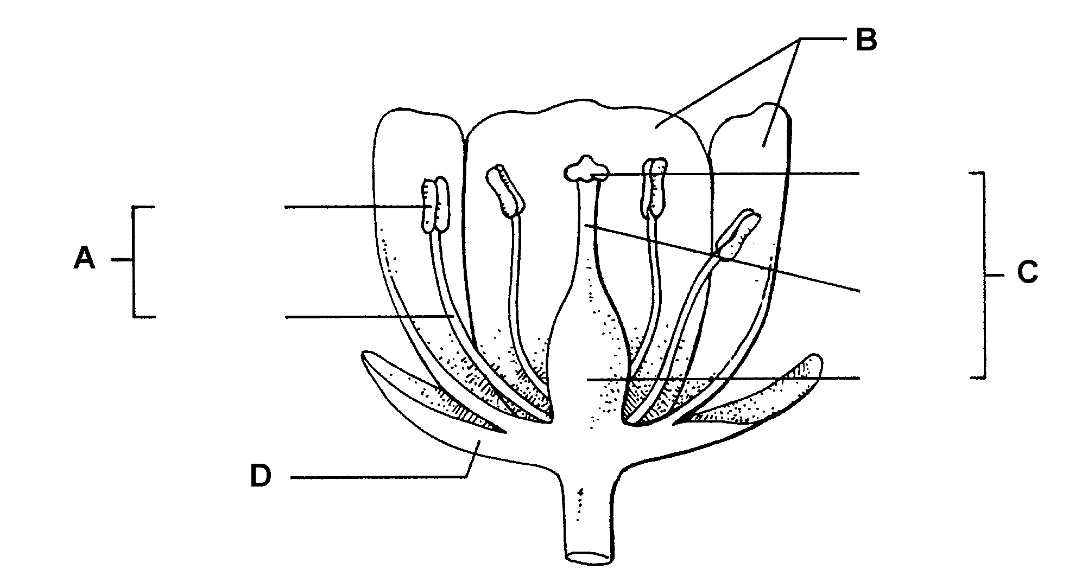

Short-Answer Questions: Write the answers in the space provided.

5. What are the three basic structures of leaves?

A.

B.

C.

6. What are the four elements of the cell structure?

A.

B.

C.

D.

7. If male and female flowers on the same plant are in different places, what kind of plant is it?

8. What is the function of the cotyledon?

9. What are the five basic parts of a plant? Draw and label each part.

A.

B.

C.

D.

E.

10. What is the endosperm and where is it located?

11. What are five functions of roots?

A.

B.

C.

D.
E.

TM 3.1

Basic Structure of a Plant Cell

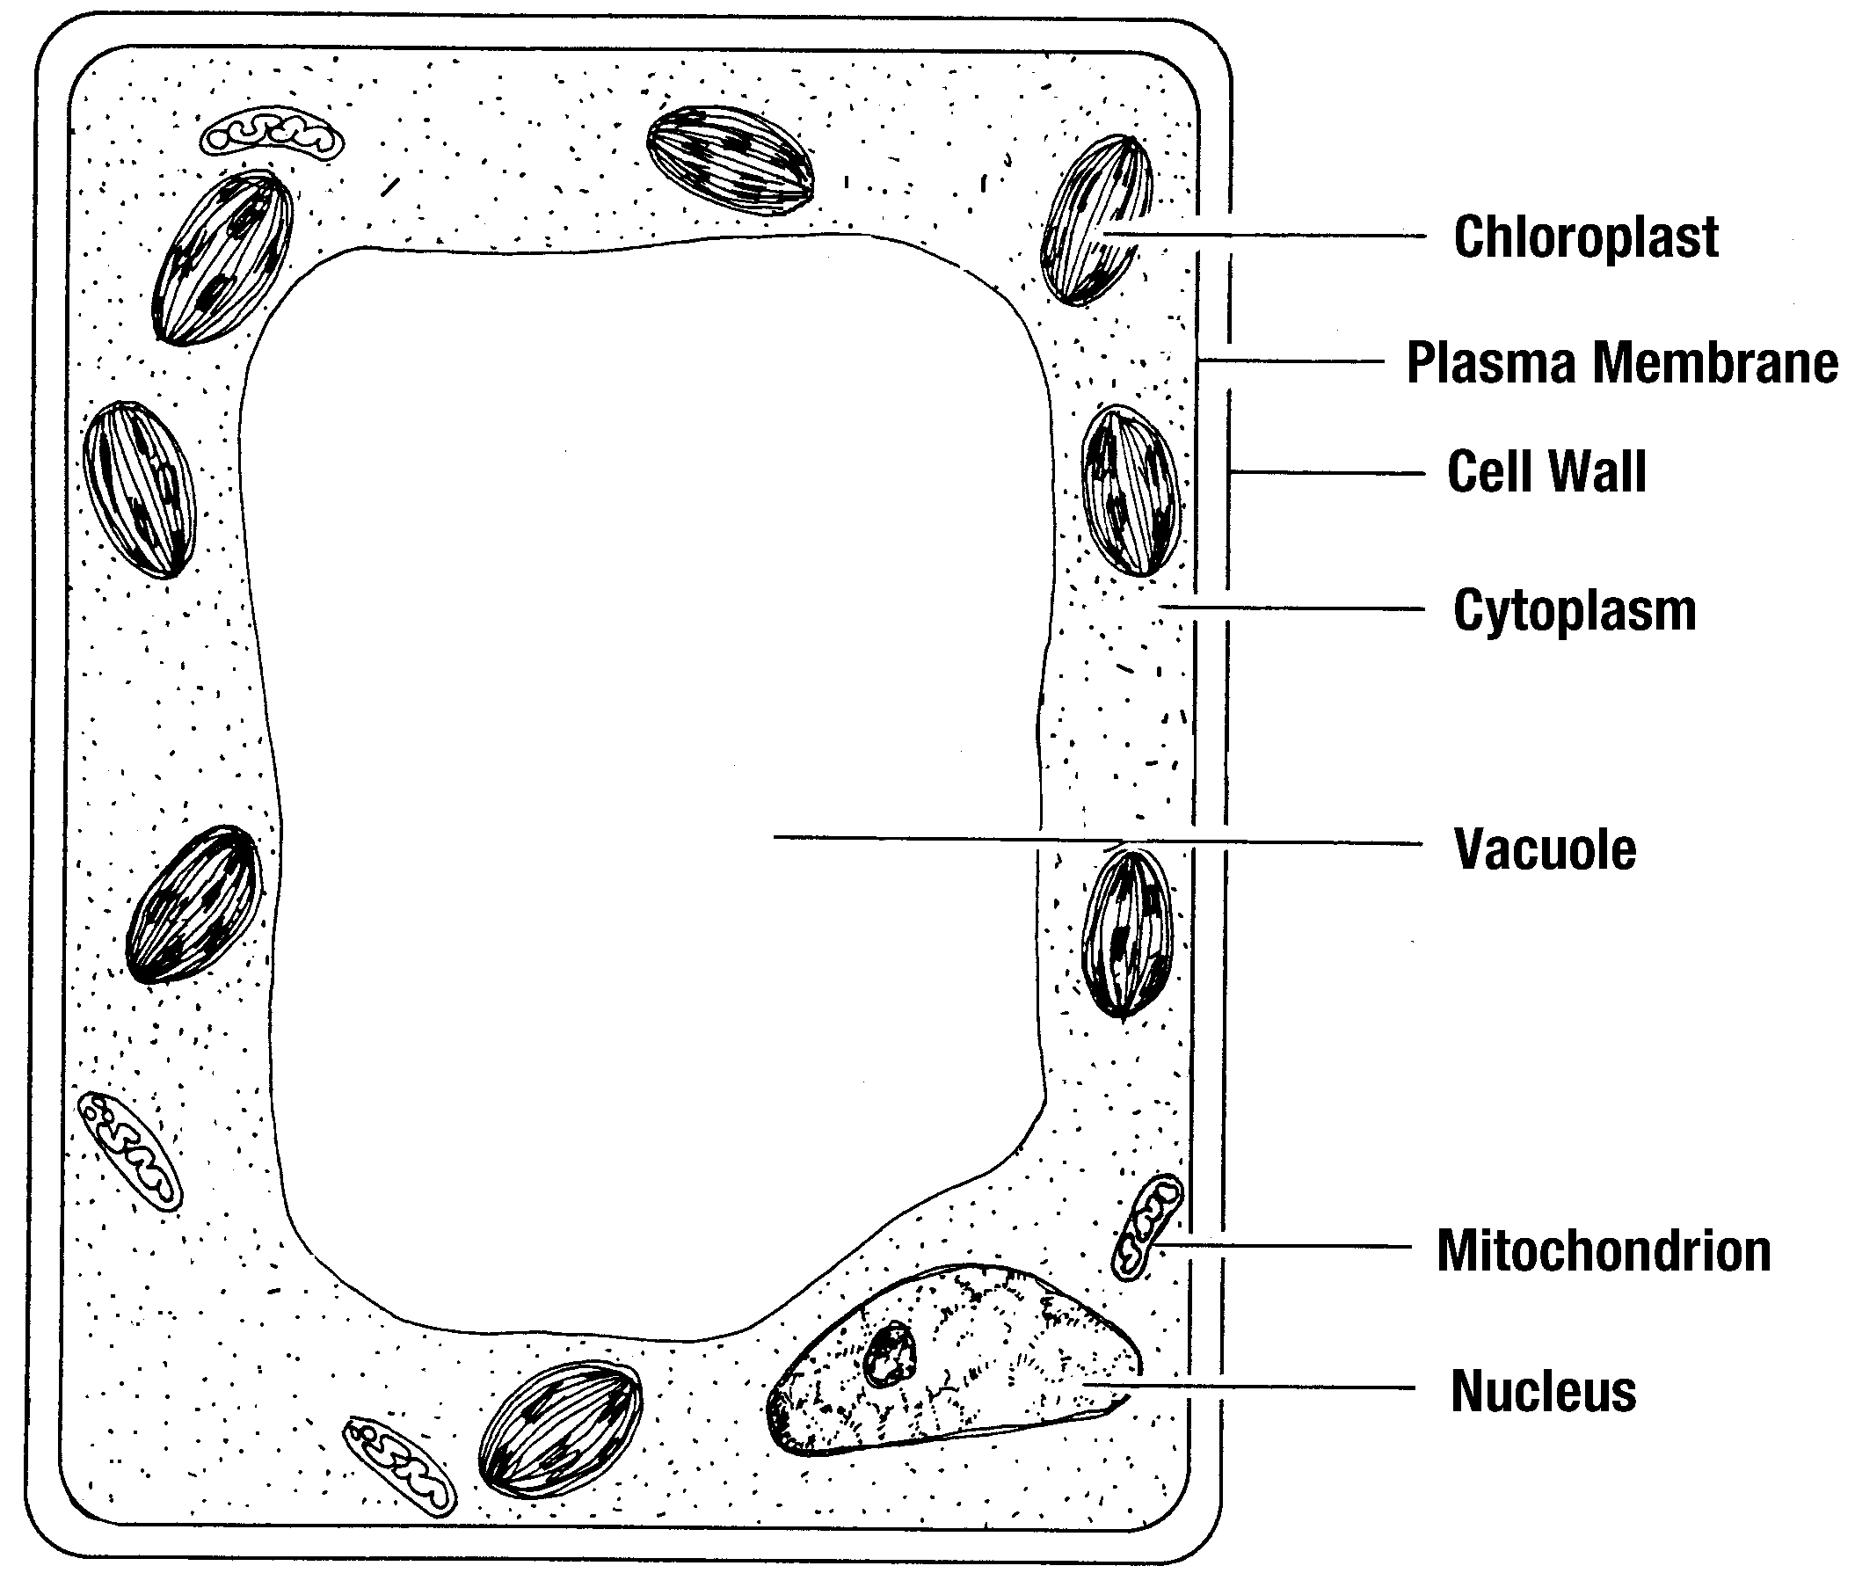

TM 3.2

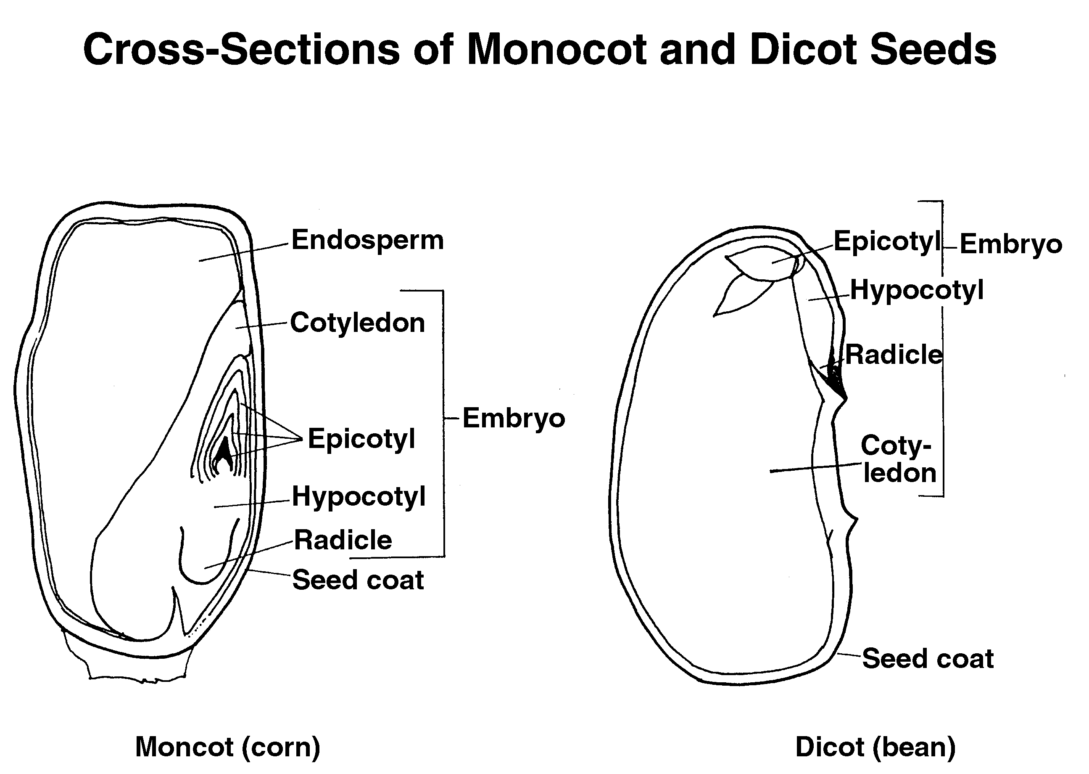

TM 3.3
Monocot vs. Dicot

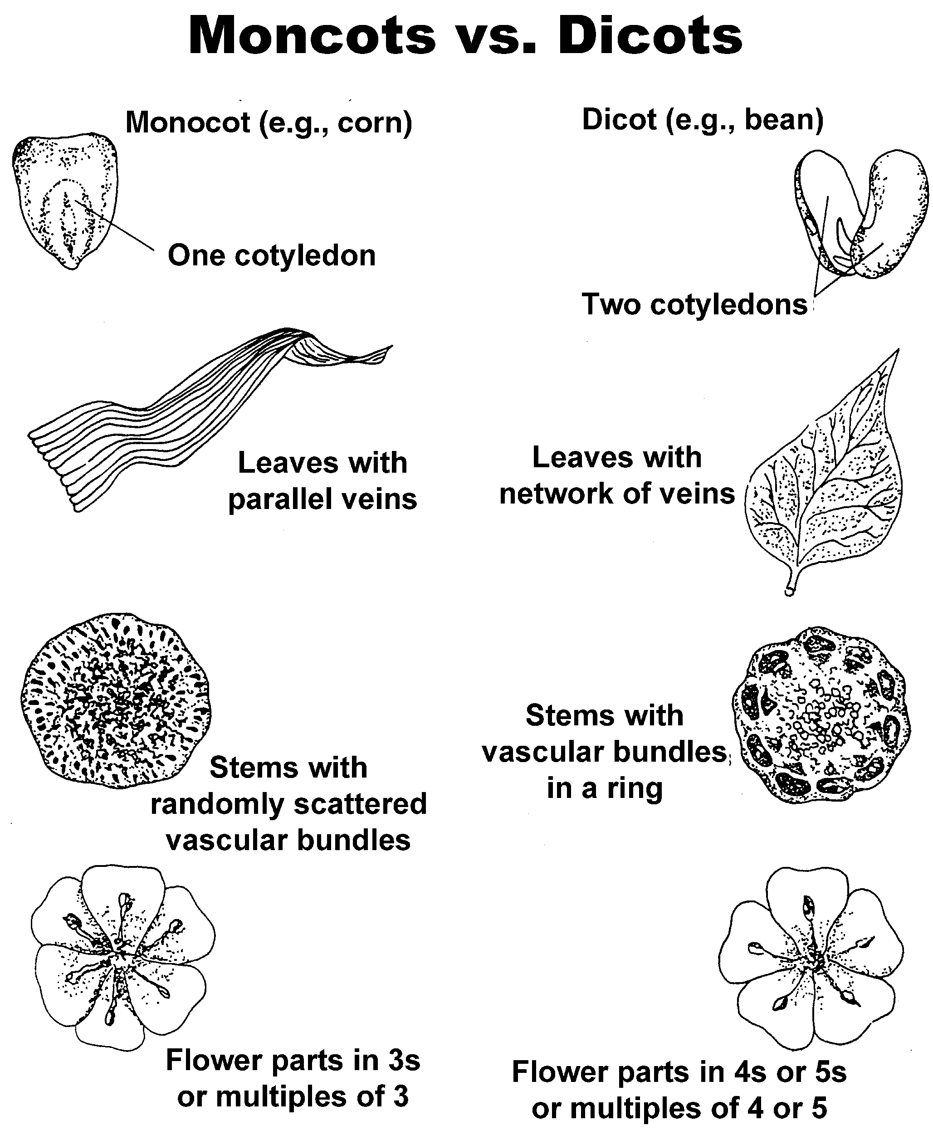

TM 3.4

Parts of a Plant

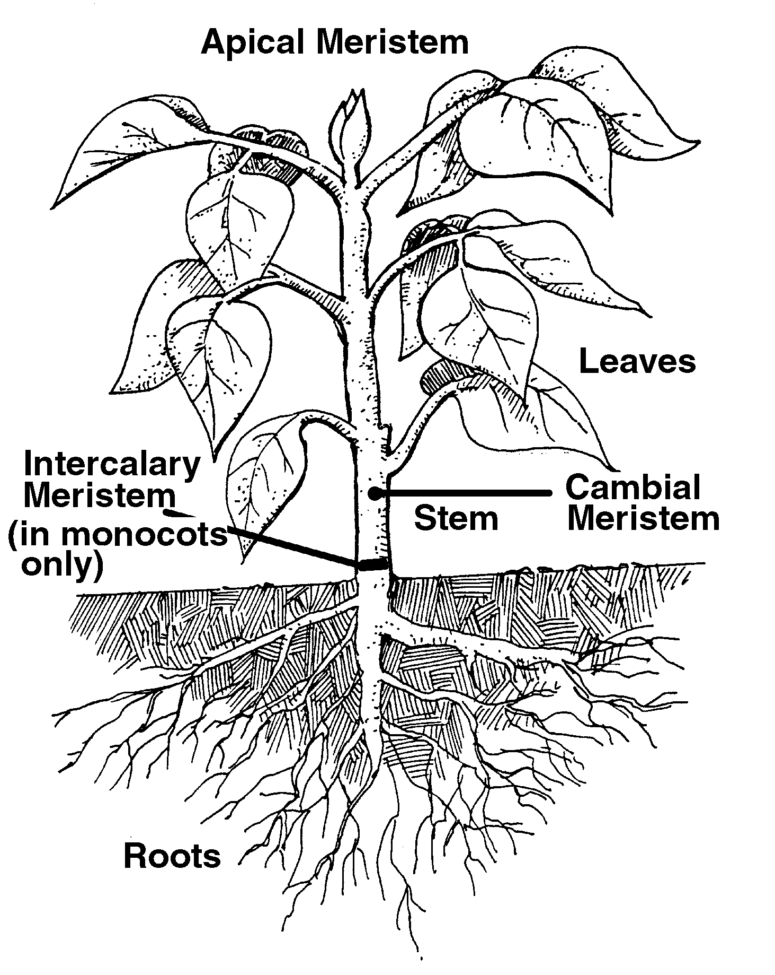

TM 3.5

Types of Roots

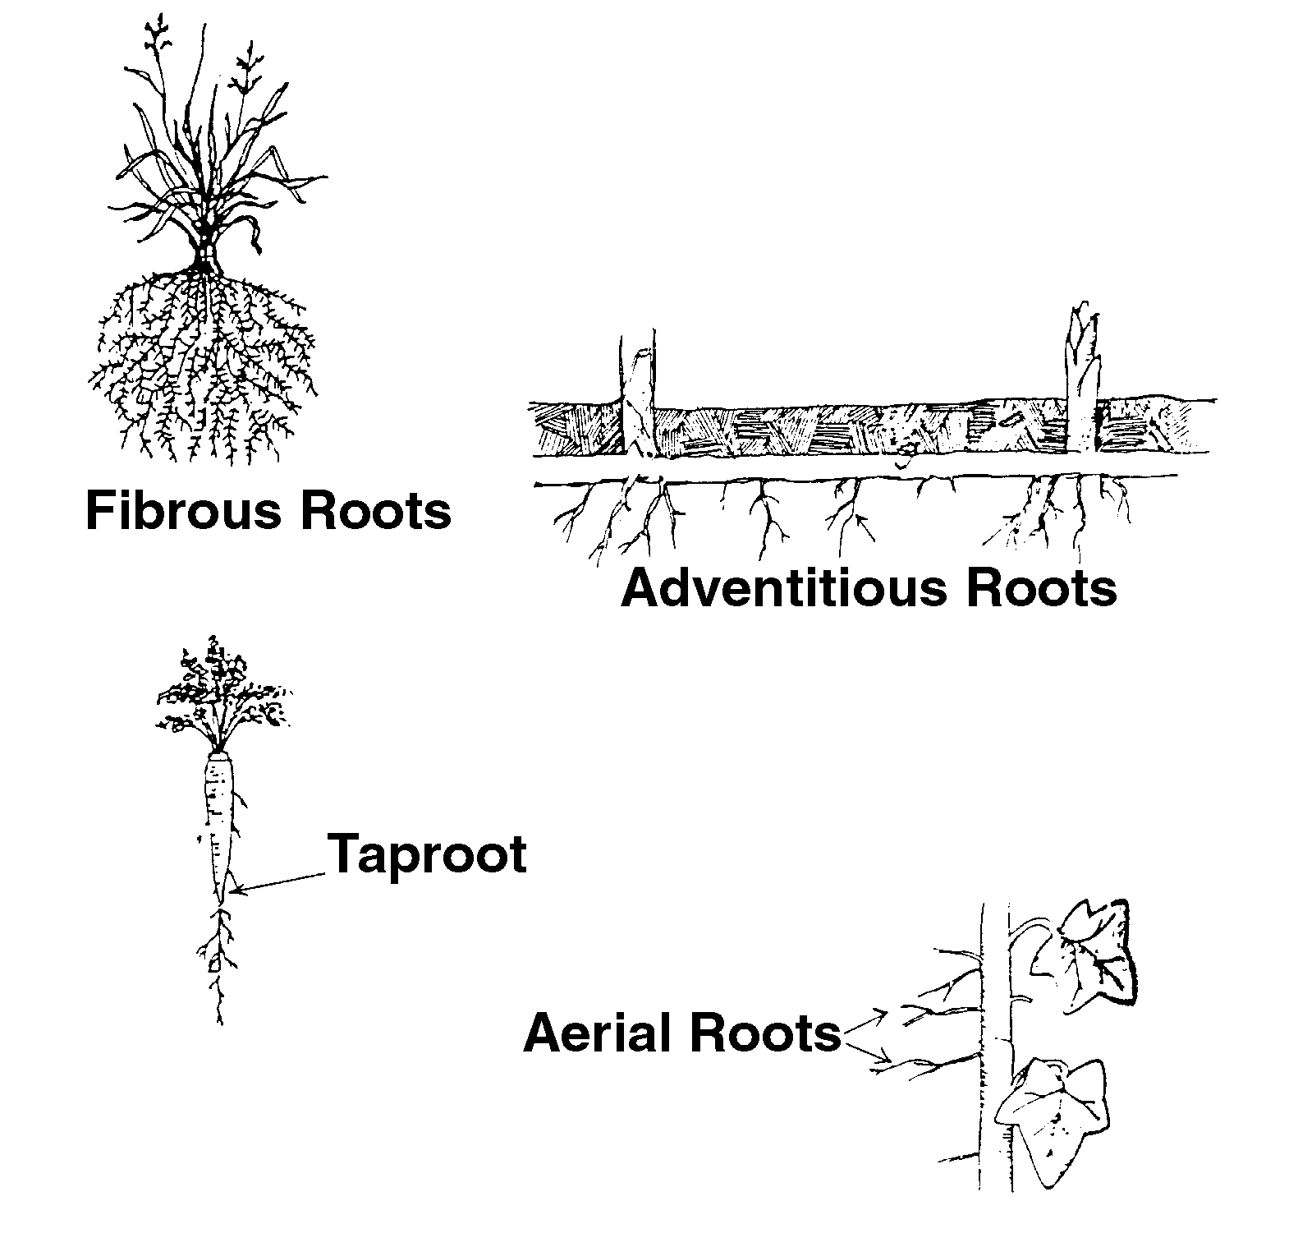

TM 3.6

Specialized Stems

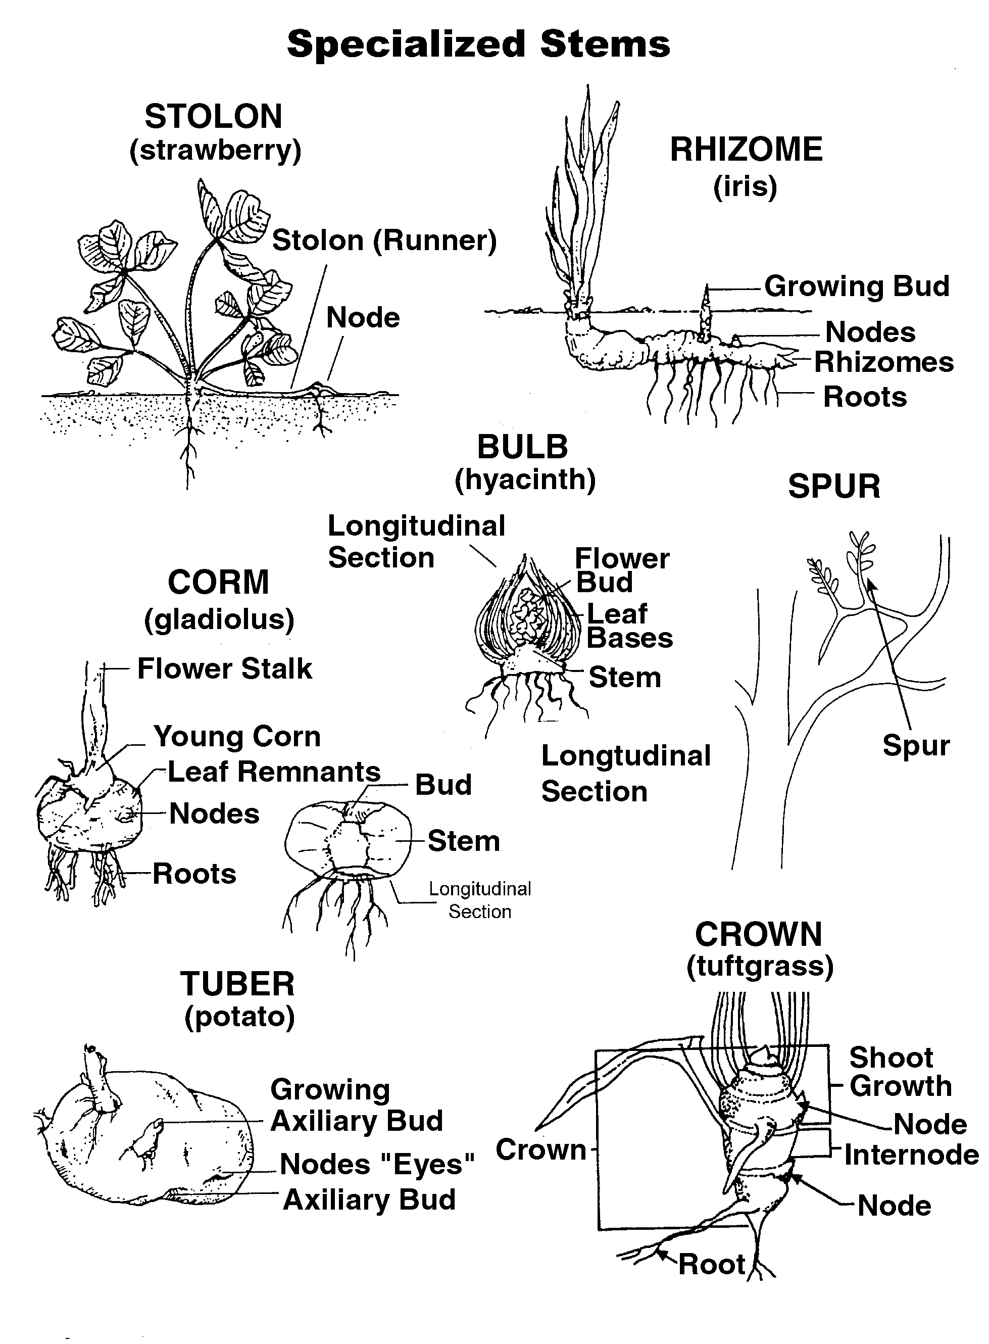

TM 3.7

Cross-Section of a Leaf

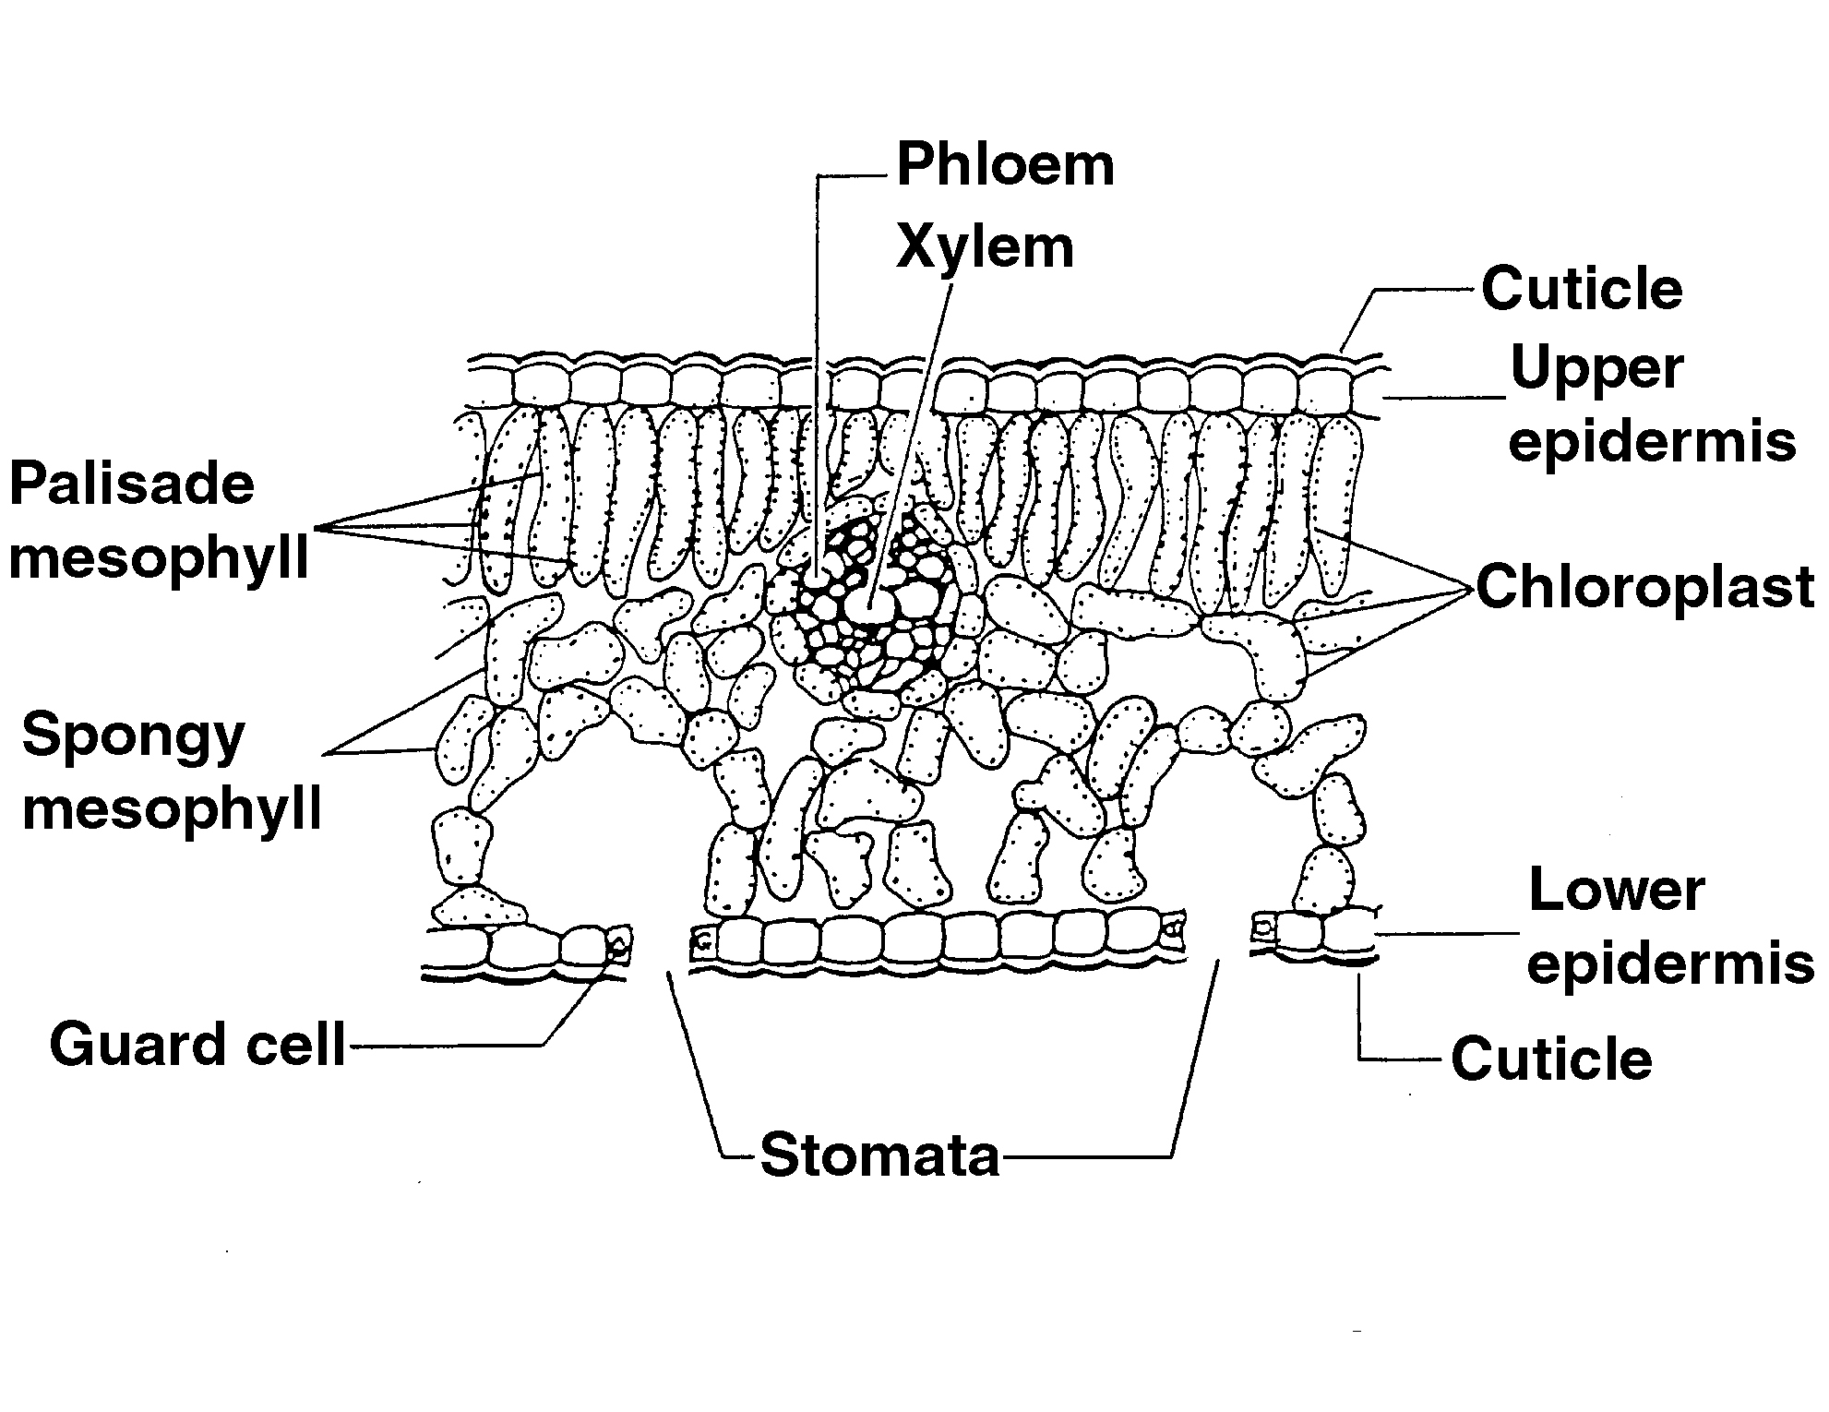

TM 3.8

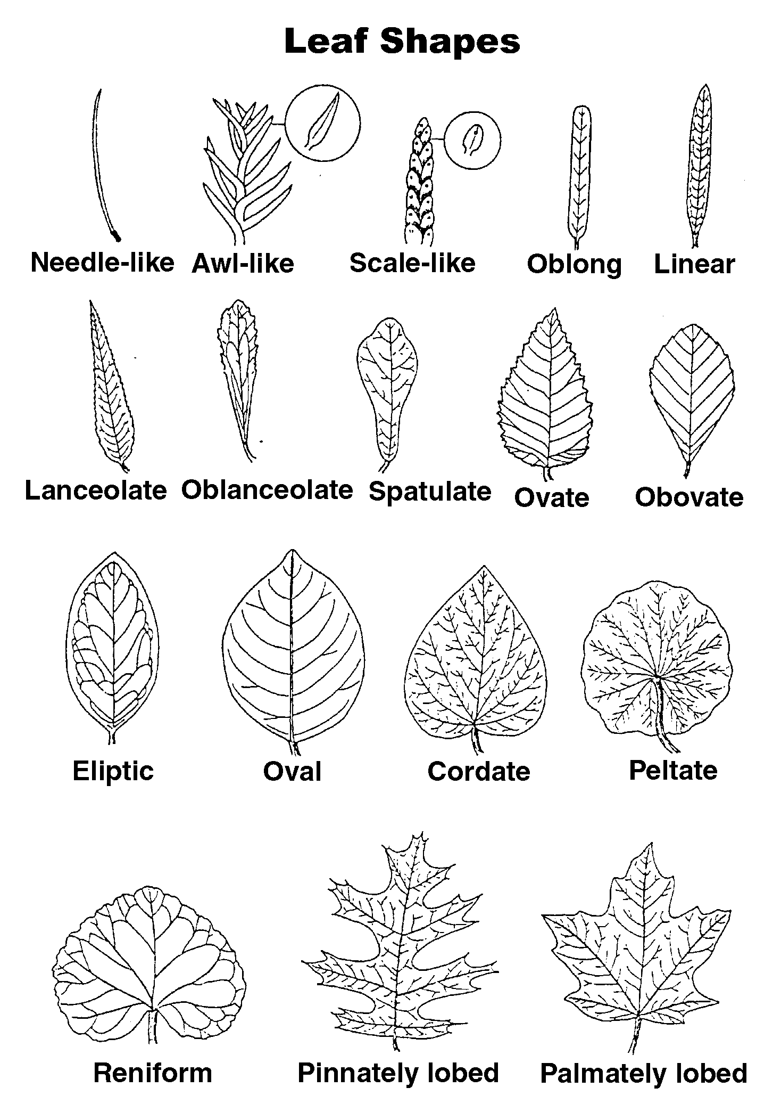

TM 3.9
Leaf Margins

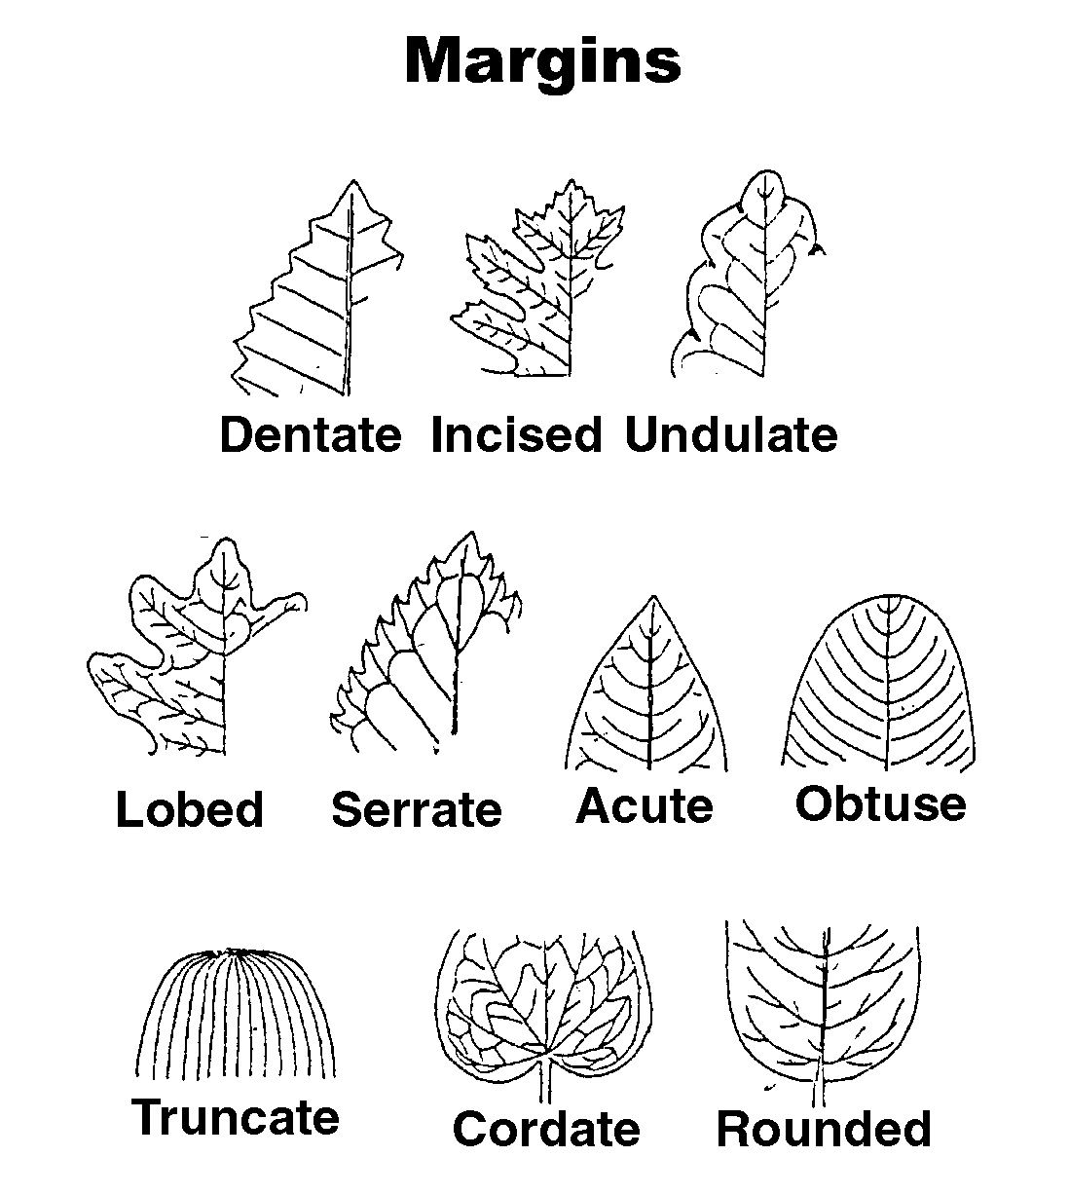

TM 3.10
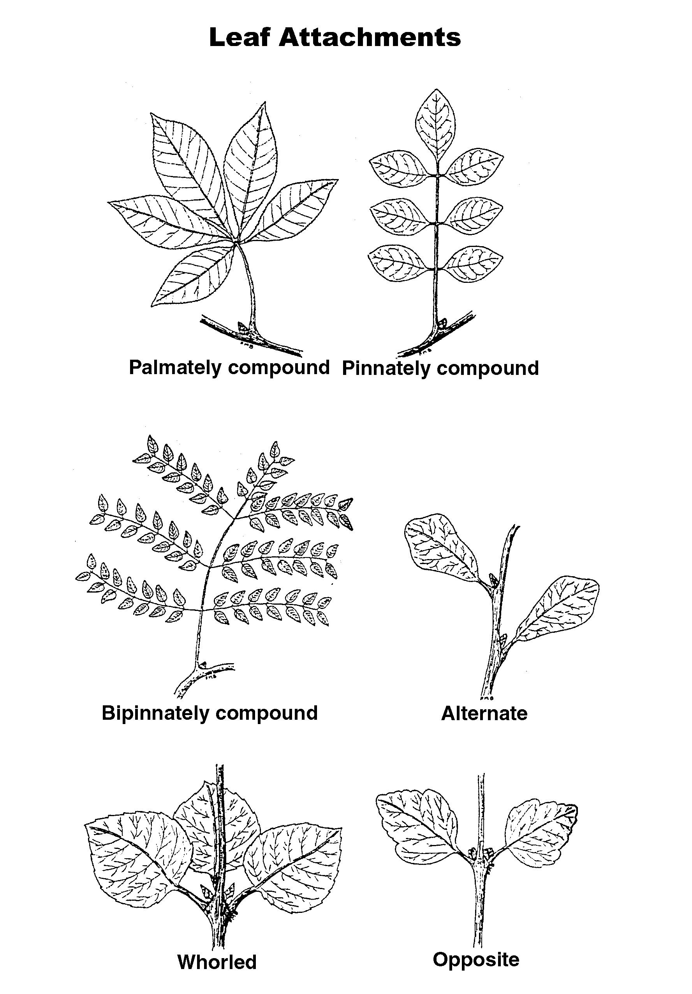

TM 3.11

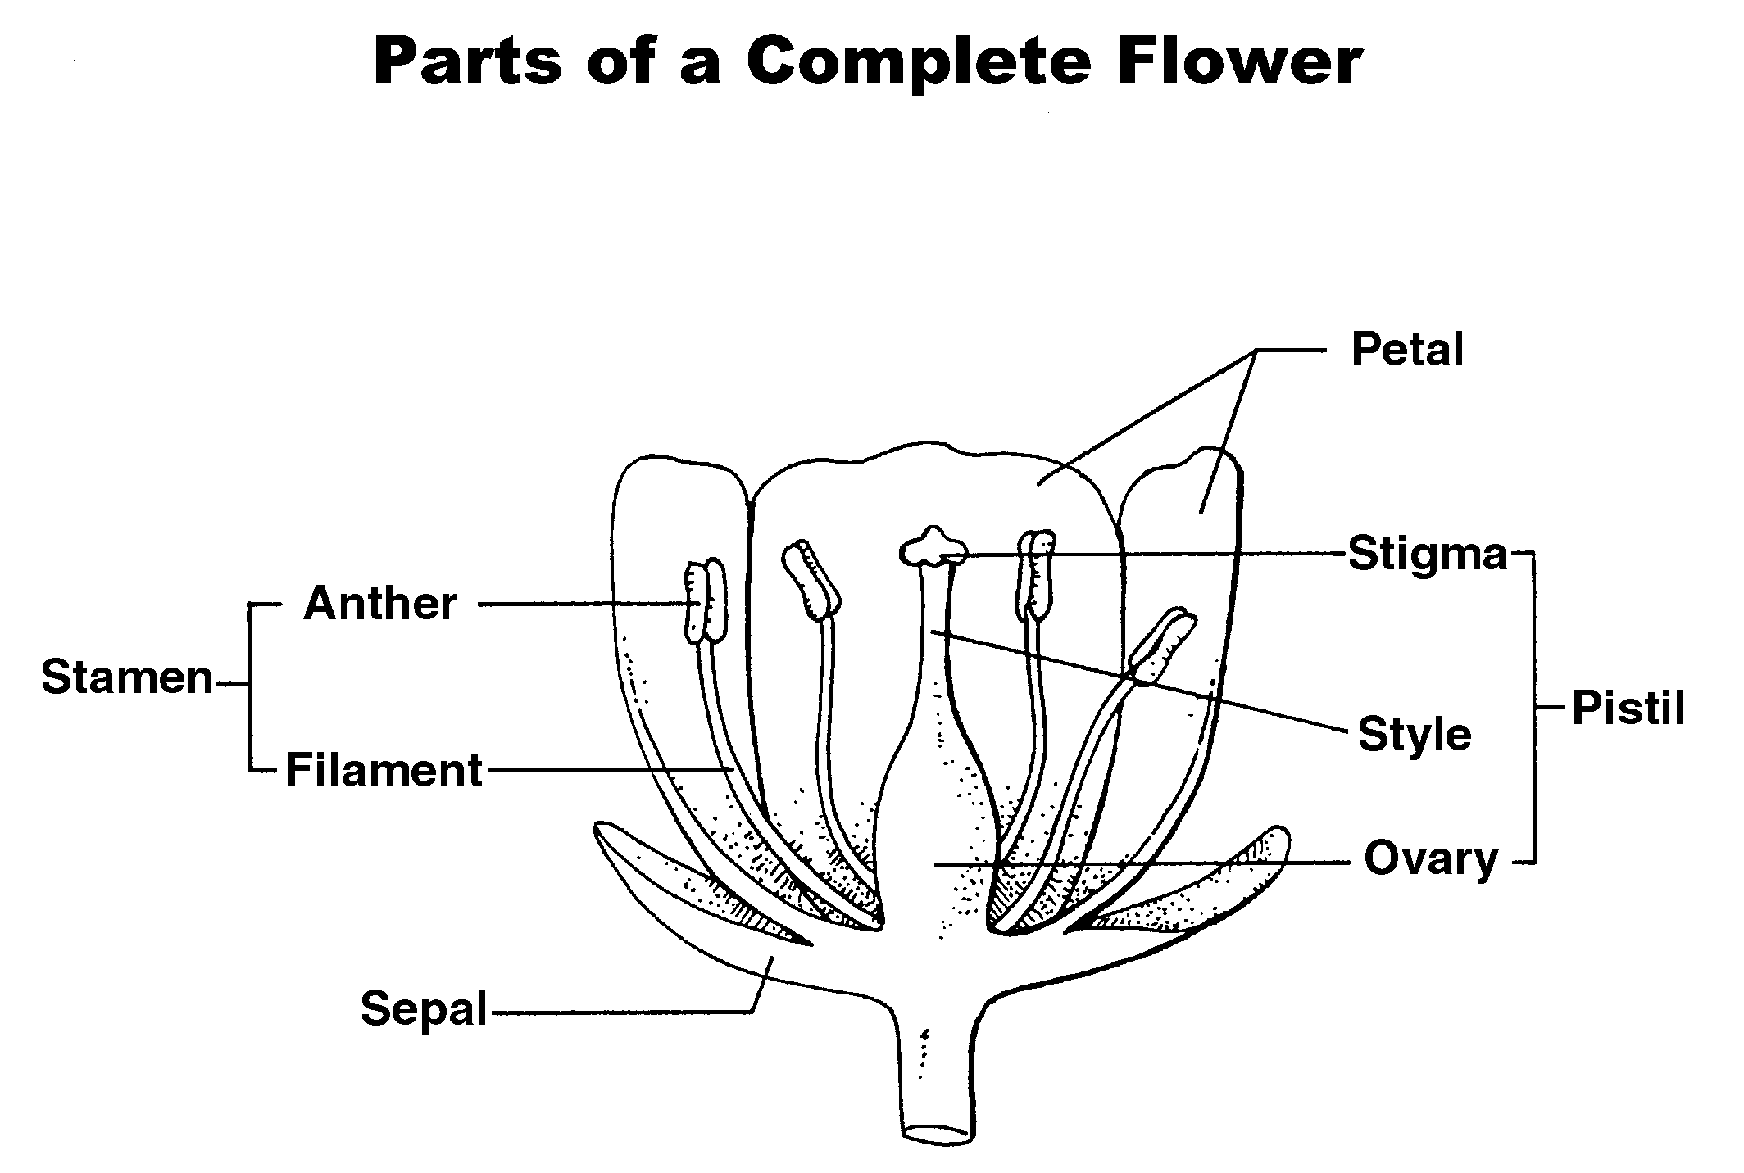

UNIT III: PLANT SCIENCE BASICS AS 3.1

Lesson 1: Plant Parts, Structures, Name__________________ and Functions

Plant Parts, Structures, and Functions WorkSheet

Objective: Identify plant parts, structures, and functions.

Directions: Answer the following questions by using the Student Reference and transparency masters. You may work individually or in small collaborative groups. Use this work sheet as a guide as you examine all of the study questions.

1. Identify the parts of a plant cell.
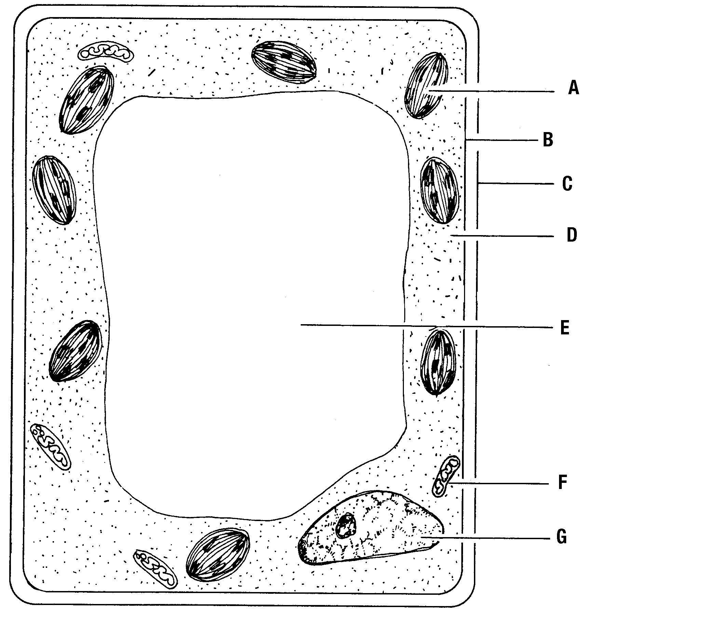

A.

B.

C.

D.

E.

F.

G.

2. What are two functions of the plasma membrane?

A

B.

3. What are the three organelles in the cytoplasm? Identify one function for each organelle.

Organelle Function

A. A.

B. B.

C. C.
4. What are three functions of the nucleus?

A.

B.

C.

5. What are the two basic types of plant tissue?

A.

B.

6. What are the differences between the two basic types of plant tissue?

7. What are the three types of meristems? What are their functions?

Type of Meristem Function

A. A.

B. B.

C. C.

8. What are the two types of permanent plant tissue? What are their characteristics?

Types of Permanent Plant Tissue Characteristics

A. A.

B. B.

9. What are three basic parts of monocot seeds? Describe what each part does or provide a brief description of what the part is.

Seed Part Function/Description

A. A.

B. B.

C. C.

10. Which of the three basic parts of seeds is found only in a monocot?

11. What are the four parts of a seed embryo?

A.

B.

C.

D.

12. What is another term for “seed leaves”?

13. A. What type of plant has one leaf?

B. What type of plant has two leaves?

14. What are three specialized functions of plant roots?

A.

B.

C.

15. What are the five types of roots?

A.

B.

C.

D.

E.

16. What is pith?

17. What is another name for hyposophylls? What does it do?
18. Identify the interior parts of a leaf. (Hint: One interior leaf part is listed twice.)

A.
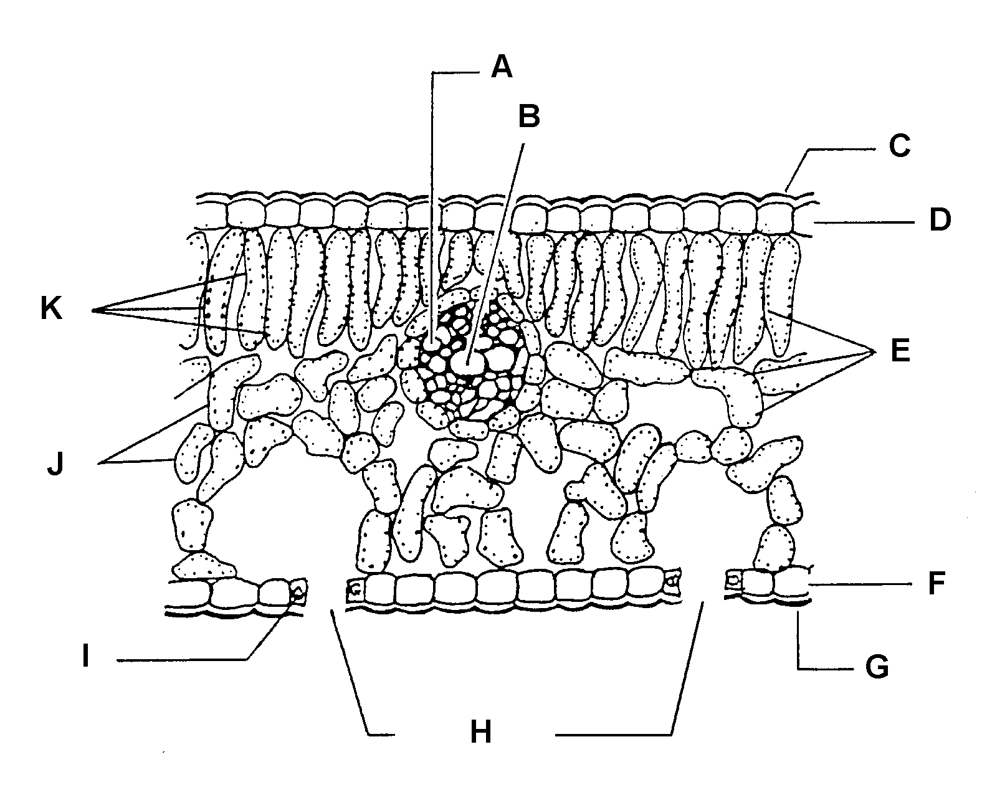

B.

C.

D.

E.

F.

G.

H.

I.

J.

K.

19. What are two basic functions of leaves?

A.

B.

20. Which plants do not have stomata?

21. What are the characteristics of xeromorphic foliage?

22. What type of modified leaf does a Venus flytrap have?

23. What is the corolla? What is its function?

24. Gynoecium refers to what part of a flower?

25. What do head, spike, and umbel refer to?

26. What are three characteristics of perfect flowers?

A.

B.

C.

UNIT III: PLANT SCIENCE BASICS AS 3.2

Lesson 1: Plant Parts, Structures, Name__________________
and Functions

Stem Poster

Objective: Create a visual representation of various stems.

Directions: Bring in samples of stems from your home, school, or the community. In small groups, generate a poster or PowerPoint presentation about the stems you found. Other representations of stems may be photos or drawings. Identify each of the seven stem types and give two examples of each.

UNIT III: PLANT SCIENCE BASICS AS 3.3
Lesson 1: Plant Parts, Structures, Name_____________________
and Functions

Leaf Poster

Objective: Create a visual representation of leaf shapes, margins, and arrangements.

Directions: Bring to class samples of leaves from your home, school, or the community. Individually or in small groups generate a poster or PowerPoint presentation on leaves. Other representations of leaves may be photos or drawings. Identify the type, shape, margin, and typical arrangement of each type of leaf.

UNIT III: PLANT SCIENCE BASICS AS 3.4

Lesson 1: Plant Parts, Structures, Name__________________
and Functions

Identifying Monocot and Dicot Plants

Objective: Identify parts of two plants.

Directions: Choose one monocot and one dicot plant. One of the plants may be a plant sown earlier for the Unit IV activity. Obtain a physical representation of the plants, either a photo or sketch. Answer the following questions and present the information to the class.

1. Which plant is a monocot and which plant is a dicot?

2. What type of root does each plant have? Describe the roots.

3. What type of stem does each plant have? Describe the stem.

4. What is the name of the leaf shape for both plants? Describe the leaf shape.

5. What type of leaf margin and leaf arrangement do both plants have? Describe them.

6. What type of flower does each plant have? Describe each one.

7. Does either plant require pollination?

