GREENHOUSE OPERATION AND MANAGEMENT

Unit III : Plant Science Basics

Lesson 2: Plant Processes

Competency/Objective:

Identify the growth processes of a plant.

Study Questions:

1. What is photosynthesis?

2. What is respiration?

3. How do plants absorb water?

4. What is translocation?

5. What is transpiration?

References/Supplies/Materials

1. Greenhouse Operation and Management (Student Reference). University of Missouri-Columbia, Instructional Materials Laboratory, 2002.

2. Transparency Master

TM 3.12 Photosynthesis

3. Activity Sheet

AS 3.5 The Five Plant Processes

4. Capon, Brian. Botany for Gardeners: An Introduction and Guide, Portland, OR: Timber Press, 1990.
TEACHING PROCEDURES

A. Review

Students now have a better understanding of plant parts, structures and functions. This lesson continues with the information on the five basic processes that signal plant growth.

B. Motivation

Ask students to name the major physical processes all human beings must undergo in order to stay alive. As students identify these life processes, list them on the board. During the following discussion, ask them to draw parallels between plant processes and human processes wherever possible. To be able to grow successful greenhouse crops, it is important to identify basic processes in plant development.

C. Assignment of Study Questions

D. Supervised Study

Lead students in collecting the information needed to answer and discuss the study questions. The instructor may choose to work on one study question at a time or have students answer all the questions before the discussion. Another option is to have students work in a cooperative learning environment and have groups work on different study questions.

E. Discussion

Lead students in a discussion of the study questions. Supplement students’ responses and information with additional materials when needed.

1. What is photosynthesis?

This is the process in which plants convert carbon dioxide and water into sugar and oxygen. Temperature, intensity of light, duration of light, and a plant’s photoperiod affect photosynthesis. (TM 3.12) These environmental qualities are discussed briefly here and in more detail in Unit IV. The stage of a plant’s growth and development also affects this process.

A. Process by which plants, in the presence of light, convert carbon dioxide and water into simple sugars, releasing oxygen in the process
1. Carbon dioxide is a gas that enters the plant through stomata, which are located on the leaves.
2. Then water is absorbed by the plant’s hair roots and enters the leaves through the xylem tissues.
3. Light hits the chlorophyll.
4. Light energy is absorbed and triggers a chemical reaction between carbon dioxide and water.
5. Glucose, a simple sugar, is produced and transported by the phloem tissues to other plant parts.
6. Oxygen is a by-product that is released through the stomata.
7. When the stomata open, water is released.
B. Important chemical reaction that impacts oxygen content of air
C. Environmental factors that affect photosynthesis
1. Temperature
2. Water availability
3. Intensity and duration of light
4. Amount of carbon dioxide
5. Photoperiod
6. Growth
D. Expressed as a formula (CO₂ = carbon dioxide; H₂O = water; C₆H₁₂O₆ = glucose; and
O₂ = oxygen)

6 CO₂ + 6 H₂O chlorophyll > C₆H₁₂O₆ + 6 O₂
light energy

2. What is respiration?

Once CO₂ and water are converted into sugar and oxygen, the energy must be released so that the plant can use the energy to grow. Respiration is the method by which the energy is released and used.

A. Reverse of photosynthesis
B. The controlled breaking down of glucose, releasing energy for plant growth, absorption, translocation, and other metabolic processes
C. A basic life process
1. Enables plant cells to release energy that is then used in many energy-requiring chemical reactions within cells
2. Releases water and CO₂ into the atmosphere

3. How do plants absorb water?

Ask students how they think this process occurs, drawing upon their knowledge of plant parts and functions from the previous lesson.

A. Hair roots take up water and dissolved minerals from the soil through the process of osmosis.
B. Water moves from the roots and through the plant via the xylem vessels.
4. What is translocation?

The vascular system of a plant is a conduit for water and food. Ask the students which tissues move food and which move water.

A. Movement of water and nutrients within plant
B. Occurs within vascular system
a. Xylem tissues pull water upward.
b. Phloem tissues move food from leaves to the rest of the plant.

5. What is transpiration?

Encourage the students to discuss why environmental factors may affect the rate of transpiration. After all of the plant processes are discussed, have students complete AS 3.5.

A. Loss of water from plant
1. Primarily from evaporation
2. Primarily through leaf surfaces (some from stems and petals)
B. Occurs when stomata open to take in CO₂
C. Regulated by guard cells
D. Reduces pressure in plant cells
E. Environmental factors that affect transpiration rate
1. Light
2. Temperature
3. Humidity
4. Wind

F. Other Activities and Strategies

1. To track the path of the vascular system, place several drops of food coloring in a quarter cup of warm water and put a white carnation in the mixture. Make sure the stem is freshly cut and allow the plant to translocate the liquid. Once the color of the flower has changed, remove the flower from the liquid and bisect the stem and flower. Ask students to characterize what has occurred.

2. Show the class the following video, available from CATER (Career & Technical Education Resources), 2 London Hall, University of Missouri-Columbia: Photosynthesis and Respiration (AG V113).

G. Conclusion

Photosynthesis, respiration, absorption, translocation, and transpiration are the five plant processes necessary in the development of healthy plants. It is important to know about these plant processes and how they can be encouraged and manipulated in the greenhouse to produce better plants.

H. Answers to Activity Sheet

Instructor’s discretion

I. Answers to Assessment

1. B
2. E
3. D
4. A
5. C
6. Any four of the following:
A Temperature
B. Light intensity or duration
C. Amount of carbon dioxide
D. Plant’s photoperiod
E. Water availability
F. Plant’s growth cycle affect photosynthesis
7. Light, temperature, humidity and wind.
8. 6 CO₂ + 6 H₂O chlorophyll > C₆H₁₂O₆ + 6 O₂
light energy
9. A. Carbon dioxide is a gas that enters the plant through stomata, which are located on the leaves.
B. Then water is absorbed by the plant’s hair roots and enters the leaves through the xylem tissues.
C. Light hits the chlorophyll.
D. Light energy is absorbed and triggers a chemical reaction between carbon dioxide and water.
E. Glucose, a simple sugar, is produced and transported by the phloem tissues to other plant parts.
F. Oxygen is a by-product that is released through the stomata.
G. When the stomata open, water is released.

UNIT III : PLANT SCIENCE BASICS Name___________________
Lesson 2: Plant Processes Date____________________

ASSESSMENT

Match the statement on the left with the plant process on the right. Write the letter in the space provided.

_____1. Evaporation through leaf surfaces A. Translocation

_____2. Break down and release of glucose B. Transpiration

_____3. Taking up of water and dissolved minerals C. Photosynthesis

_____4. Movement of water and dissolved minerals D. Absorption

_____5. Creation of glucose E. Respiration

Short-Answer Questions: Write the answers in the space provided.

6. What are four environmental factors that affect photosynthesis?

A.

B.

C.

D.

7. What are four environmental factors that affect transpiration?

A.

B.

C.

D.

8. What is the formula for photosynthesis?

9. What seven steps occur during photosynthesis?

A.

B.

C.

D.

E.

F.

G.

TM 3.12

Photosynthesis

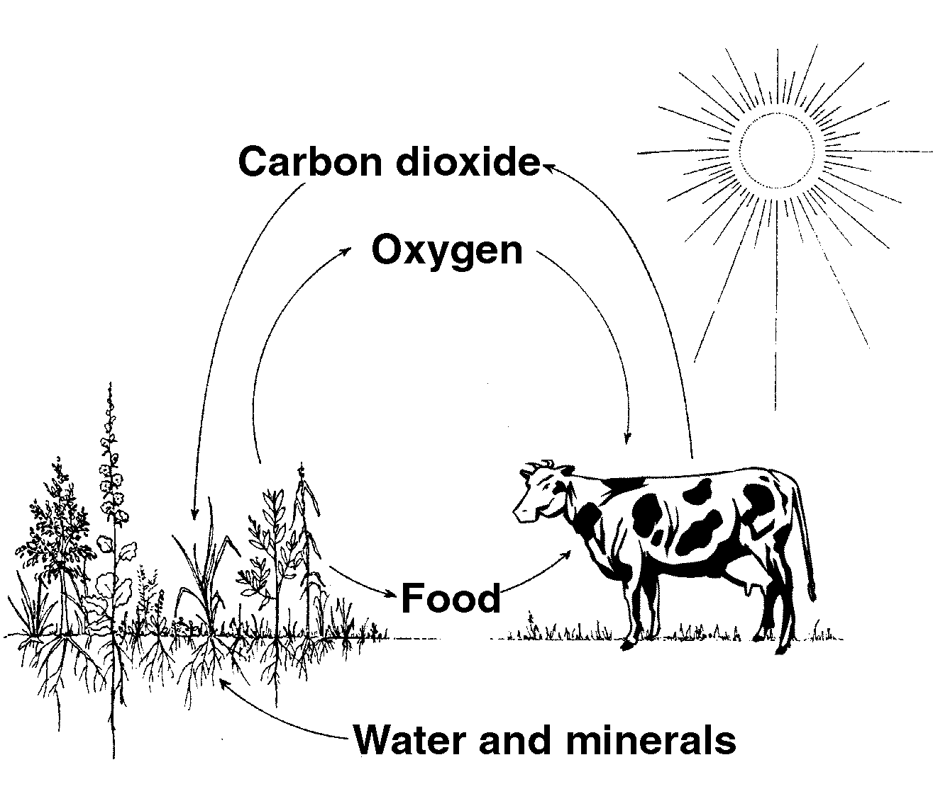

Adapted from Capon, Brian. Botany for Gardeners: An Introduction and Guide, Portland, OR: Timber Press, 1992.

Frp,

F
frp

UNIT III : PLANT SCIENCE BASICS AS 3.5

Lesson 2: Plant Processes Name___________________

The Five Plant Processes

Objective: Relate the five plant processes to the greenhouse environment and design.

Directions: Drawing on your knowledge of plant processes, greenhouse environment, and greenhouse design, answer the following questions for each of the five plant processes. First, list the five plant processes. When answering the two questions below, follow the same A-E sequence as listed below.

A.

B

C.

D.

E.

1. How could a greenhouse owner encourage each of the following plant processes?

A.

B.

C.

D.

E.
2. How could a greenhouse owner discourage each of the following plant processes?

A.

B.

C.

D.

E.

