GREENHOUSE OPERATION AND MANAGEMENT
Unit III : Plant Science Basics

Lesson 3: Plant Classification and Nomenclature

Competency/Objective:

Distinguish plants by characteristics and purpose.

Study Questions

1. How are plants classified?

2. What is the scientific system of classification and naming?

References/Supplies/Materials

1. Greenhouse Operation and Management (Student Reference). University of Missouri-Columbia: Instructional Materials Laboratory, 2002.

2. Transparency Masters

TM 3.13 Stem Growth
TM 3.14 Major Classification Categories

3. Activity Sheets

AS 3.6 Plant Pictionary: Part I
AS 3.7 Plant Pictionary: Part II

4. Magazines with pictures of plants, glue, scissors, and paper to use in the activities

TEACHING PROCEDURES

A. Review

Plants are categorized in terms of physical characteristics and purpose. This lesson applies information students learned earlier in this unit to the classification of plants.

B. Motivation

Ask students if there is an advantage to having a systematic means of classifying and naming plants. What might occur without such a system? By knowing how plants are classified and named, students can begin to identify the physical characteristics of plants when given the scientific names. Ask students to infer how a greenhouse owner would use this information to select suitable specific plants.

C. Assignment of Study Questions

D. Supervised Study

Lead students in collecting the information needed to answer and discuss the study questions. The instructor may choose to work on one study question at a time or have students answer all the questions before the discussion. Another option is to have students work in cooperative learning environment and have groups work on different study questions.

E. Discussion

Lead students in a discussion of the study questions. Supplement students’ responses and information with additional materials when needed.

1. How are plants classified?

Plants are grouped by characteristics or function. Activity 3.6 allows students to practice what they are learning.

A. Classified by plant characteristics
1. Stem type
a. Single main trunk (trees)
b. No main trunk (shrubs)
i. Herbaceous (soft, nonwoody)
ii. Woody
2. Stem growth (TM 3.13)
a. Climbing (creeping)
b. Erect
c. Decumbent
3. Type of fruit
a. Dry
b. Fleshy
4. Life cycle
a. Annual (completes life cycle in 1 year)
b. Biennial (completes life cycle in 2 years)
c. Perennial (continues to grow from year to year)
5. Foliage
a. Deciduous (loses leaves in winter)
b. Evergreen (keeps leaves all year)
6. Hardiness
a. Hardy (withstands temperature extremes)
b. Tender (sensitive to temperature extremes)
B. Classified by plant purpose
1. Edible
2. Ornamental

2. What is the scientific system of classification and naming?

Taxonomy is the science of identifying, naming, and classifying organisms. Botanist Carolus Linnaeus created the system of binomial nomenclature to give each plant a unique name that would be understood universally. AS 3.7 provides an opportunity for students to apply binomial nomenclature when given plant characteristics.

A. Binomial nomenclature (two-word name)
1. Gives each plant a unique scientific name
a. Latin
b. Used throughout the world to identify a specific plant
2. Avoids confusion caused by the wide variety of common names given to a single plant
B. Structure of the scientific name (TM 3.14)
1. Genus
a. First part of name
i. First letter capitalized
ii. In italics
b. Identifies plant group that shares similar characteristics
2. Species
a. Second part of name
i. All lowercase letters
ii. In italics
b. Provides additional information such as geographic location, origin, and physical characteristics
3. Cultivar (variety) - from the words “cultivation” and “variety”
a. Occasionally added to the binomial; enclosed in single quotes or preceded by the abbreviation cv
b. Identifies variations of the species
c. Developed by botanists and agronomists (does not occur in the wild)
d. Hybridization among cultivars of same species

F. Other Activities and Strategies

1. Select two different plants and classify their characteristics.

2. Select two different plants and write their complete taxonomy.

G. Conclusion

By understanding how plants are categorized, the greenhouse operator can make better choices regarding greenhouse crops. Binomial nomenclature is a universal way of identifying plants and promotes clearer communication between greenhouse owners and horticulturalists.

H. Answers to Activity Sheet

Instructor’s discretion

I. Answers to Assessment

1. C
2. C
3. B
4. A
5. D
6. B

UNIT III : PLANT SCIENCE BASICS Name___________________

Lesson 3: Plant Classification and Nomenclature Date____________________

ASSESSMENT

Multiple Choice: Circle the letter of the best answer.

1. What elements are in a binomial nomenclature of a plant?

A. Family and genus
B. Phylum and species
C. Genus and species
D. Phylum and cultivar

2. What are three plant characteristics used to classify plants?

A. Edible, ornamental, type of fruit
B. Stem growth, leaf type, and cultivar
C. Life cycle, foliage, and stem type
D. Foliage, hardiness, and variety

3. What identifies a plant group that shares similar characteristics?

A. Cultivar
B. Genus
C. Species
D. Variety

4. What identifies variations of the species?

A. Cultivar
B. Genus
C. Species
D. Subphylum

5. What identifies the origin, geographical location, and physical characteristics of a plant?

A. Cultivar
B. Genus
C. Phylum
D. Species

6. What characteristics are used to classify plant function?

A. Perennial and biennial
B. Edible and ornamental
C. Species and foliage
D. Cultivar and hardiness

TM 3.13

Stem Growth

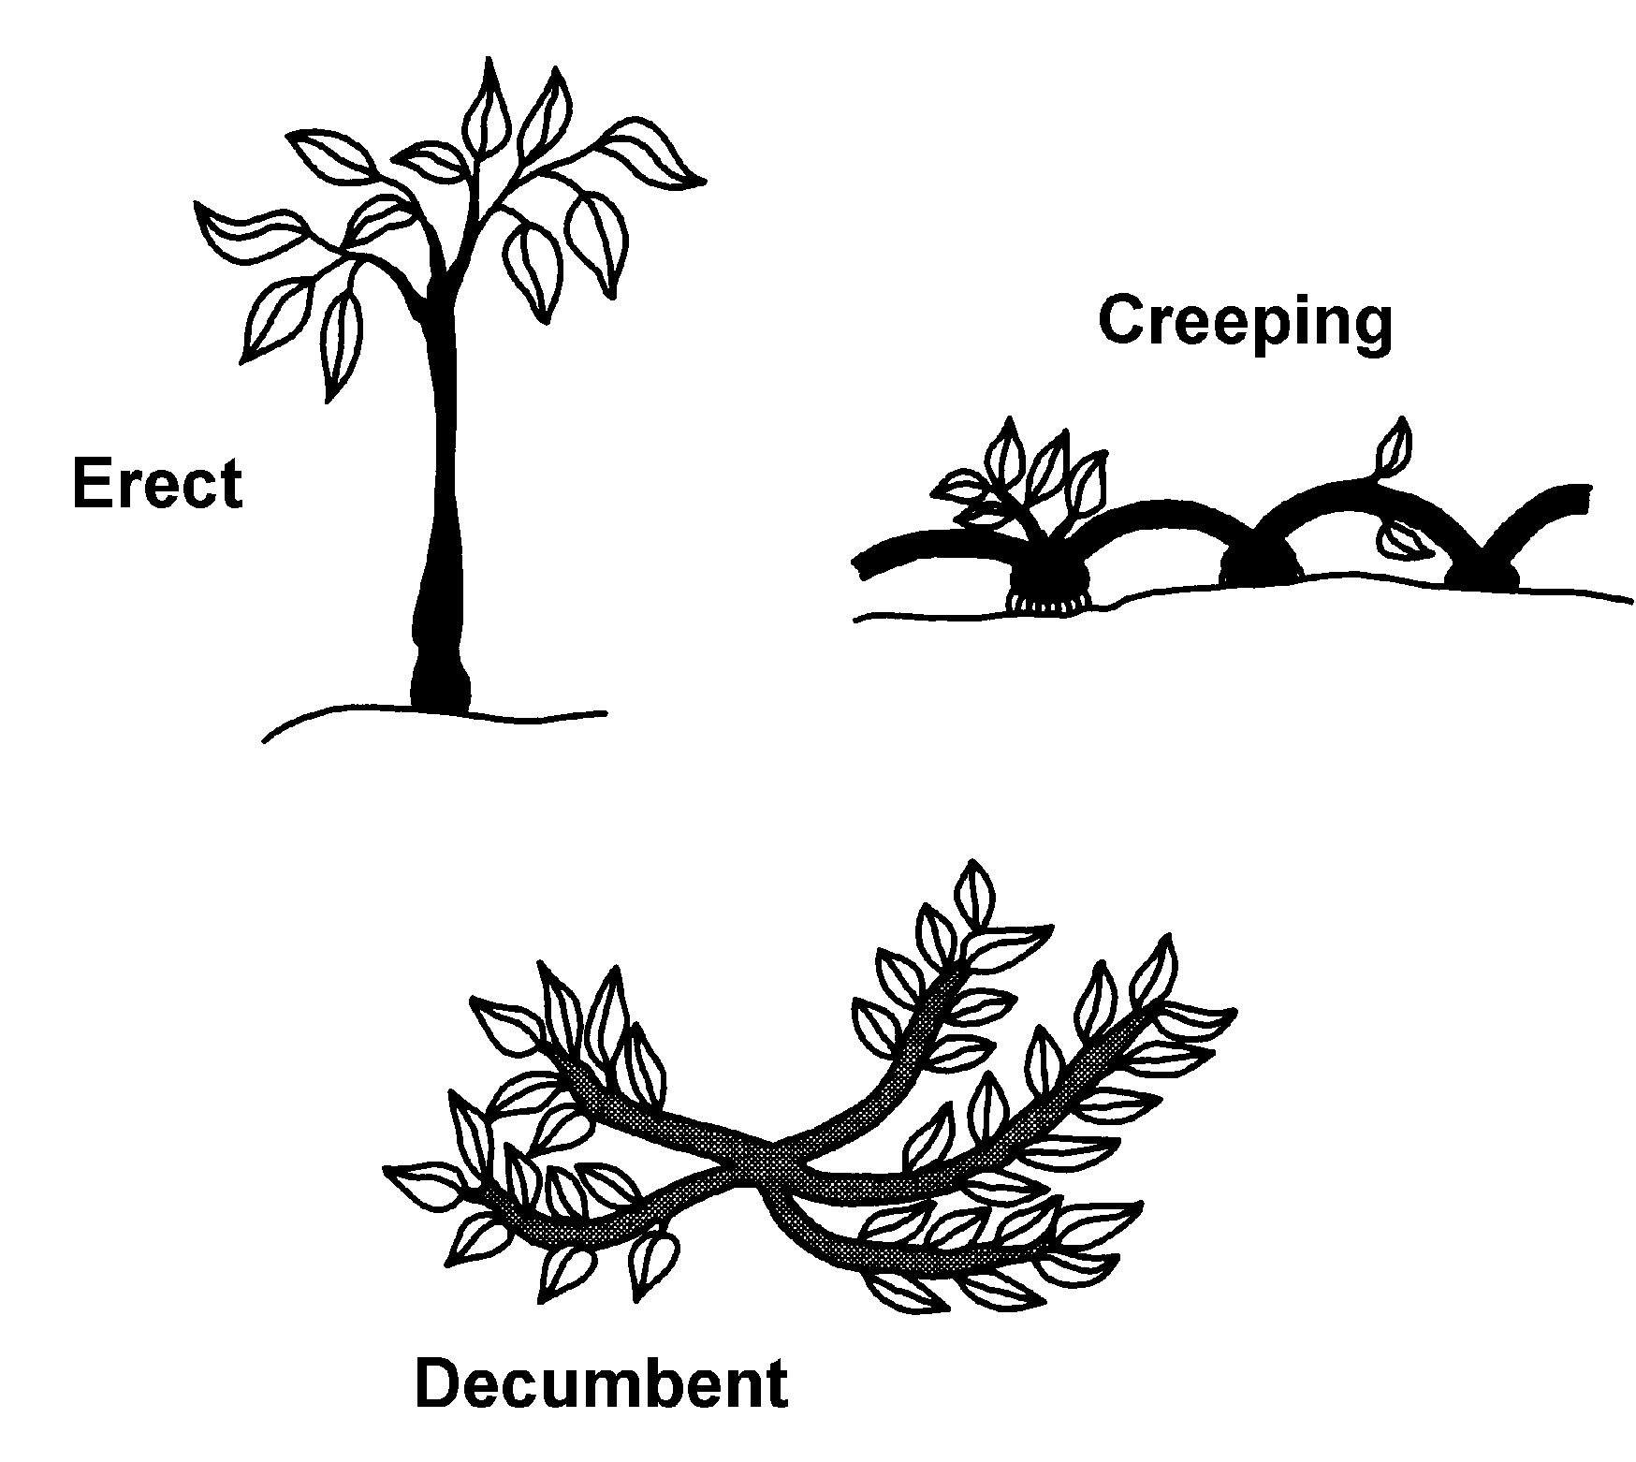

TM 3.14

Major Classification Categories

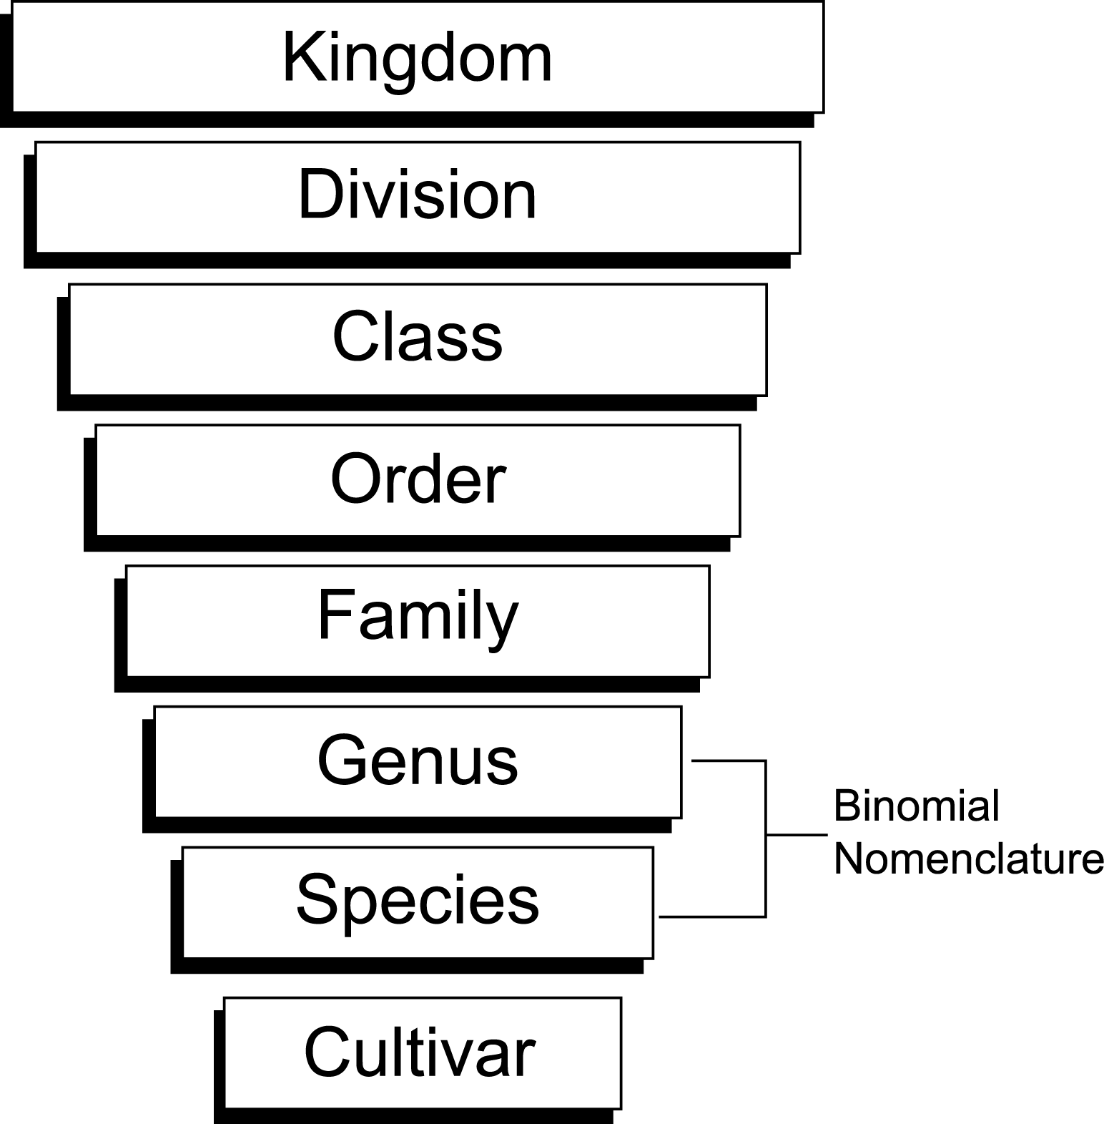

UNIT III: PLANT SCIENCE BASICS AS 3.6

Lesson 3: Plant Classification and Nomenclature Name________________

Plant Pictionary: Part I

Objective: Identify and gather representations of plant characteristics used for classification.

Directions: Divide the class into two groups. Depending on class size, each group either works on half of the characteristics used to classify plants or on all of them. Each group should find at least two examples of each characteristic. Use magazines, seed catalogs, the Internet, or any other available resources.

Groups can create large flashcards or PowerPoint presentations. If flashcards are used, write on the back of the photo or sketch the characteristic (e.g., stem type, woody, or single trunk) and the common name of the plant (e.g., cedar). If the group is collecting examples on the computer, compose a key at the end with the same information.

Group 1 show its flashcards or presentation to Group 2. Group 2 identifies the characteristics used for classification. Do the same with Group 2’s presentation.

UNIT III: PLANT SCIENCE BASICS AS 3.7

Lesson 3: Plant Classification and Nomenclature Name________________

Plant Pictionary: Part II

Objective: Use plant characteristics to identify plants’ binomial nomenclature.

Directions Using the flashcards or presentations from AS 3.2 Leaf Poster, find the scientific name of the plants. Horticulture textbooks, encyclopedia, seed catalogs, and the Internet may be helpful.

Bonus Question: What is the binomial nomenclature for the seed you planted in Unit I?

