GREENHOUSE OPERATION AND MANAGEMENT
Unit IV : Plant Growth

Lesson 1: Environmental Effects

Competency/Objective:

Describe environment necessary for optimal plant growth.

Study Questions

- What environmental factors affect plant growth?

- What is the effect of light in the greenhouse?

- How does light intensity affect plants?

- How does light duration affect plant growth?

- How does light quality affect plant growth?

- How does temperature affect plant growth?

7. What gaseous elements within the greenhouse affect plant growth?

References/Supplies/Materials

1. Greenhouse Operation and Management (Student Reference). University of Missouri-Columbia: Instructional Materials Laboratory, 2002.

2. Transparency Master

TM 4.1 Radiant Light Spectrum

3. Activity Sheets

AS 4.1 Foot-Candle Demonstration
AS 4.2 Effect of Light on Plants
AS 4.3 Photoperiod in Plants
AS 4.4 Greenhouse Air Pollutants

4. A current copy of Hummert’s Helpful Hints

5. Carolina Biological Supply <http://www.carolina.com/general/company/Srv.asp>

6. NASCO catalogs <http://www.enasco.com/prod/Home>

TEACHING PROCEDURES

A. Introduction

This unit introduces students to basic concepts of plant growth: environmental effects, growing media and containers, irrigation, nutrients, and fertilizer. This lesson explains various environmental elements influencing plant growth. Students examine light intensity, duration, and quality, as well as temperature, air quality, and gaseous elements within the greenhouse.

B. Motivation

Students use the plants they have been tending since Unit I to illustrate the importance of light duration. Bring out the plants to initiate a conversation on the subject of light. Can the students recognize which plants have had too little light?

C. Assignment of Study Questions

In preparation for AS 4.6 in Lesson 3: Irrigation in this unit, take one plant from each student and organize them into three groups labeled D, E, and F. For at least 3 weeks, have students water plants in each group using a specific measuring cup. Use a measuring cup that is larger than needed for Group D plants so plants receive too much water. The measuring cup for Group E has the correct amount. Use a measuring cup that is smaller than necessary for Group F so that the plants receive very little water.

To prepare for AS 4.9 in Lesson 5: Fertilizer, split another batch of plants into groups G, H, and I. Have several forms of fertilizer available: slow release, water-soluble concentrate, and granular. Ask students to give plants in each group the following amounts of fertilizer: Group G - no fertilizer, Group H - too much, and Group I - the appropriate amount. As the plants grow, students should characterize how the plants in each group react to fertilizer during three stages of development: seedling/cutting, vegetative, and flowering. Be sure that students identify the type of fertilizer used on each pot.

At the end of Lesson 5, the class will complete a unit activity that relates to all of the activity sheets in Unit IV. Be sure that students keep each activity sheet in each lesson.

D. Supervised Study

Lead students in collecting the information needed to answer and discuss the study questions. The instructor may choose to work on one study question at a time or have students answer all the study questions before the discussion. Another option is to have students work in a cooperative learning environment and have groups work on different study questions.

E. Discussion

Lead students in a discussion of the study questions. Supplement student responses and information with additional materials when needed.

1. What environmental factors affect plant growth?

Ask the students to name the three major environmental factors they have to monitor and control within a greenhouse. These are the basic factors directly related to successful plant growth. Be sure to mention that water is also important. It is discussed in Lesson 3 of this unit.

A. Light
B. Temperature
C. Air quality

2. What is the effect of light in the greenhouse?

Building on knowledge from Plant Processes (Unit III, Lesson 2), encourage students to discuss why light is important for plant growth. Why might artificial light be necessary? Ask students what characteristics of light are important for a greenhouse.

A. Light is necessary in order for photosynthesis to occur.
B. Different light sources are available for greenhouse crops.
1. Solar
2. Artificial (high-intensity discharge or fluorescent lamps)
a. On a winter day
b. On cloudy days
c. To extend length of day
C. Light has various characteristics.
1. Intensity (brightness)
2. Duration (length of day)
3. Quality (spectrum of color)

3. How does light intensity affect plants?

Based on their knowledge of photosynthesis, ask students to identify the benefits of adequate light intensity on greenhouse plants. Ask them to brainstorm what kind of crops might be low-, medium-, and high-intensity plants. To demonstrate the concept of foot-candles, have students perform AS 4.1 Because candles are lit, be sure to supervise carefully. Then to demonstrate the effect of light on plants, have students complete AS 4.2.

A. Measurement of light intensity
1. Light intensity measured in foot-candles (f.c.)
2. One foot-candle: the amount of light striking a surface 1 foot from a standard wax candle
3. Noon on a sunny day: 10,000 f.c.
B. Different plants - different light intensity requirements
1. Low-light intensity plants: 500-1,250 f.c. - e.g., for tropical foliage plants, impatiens,
African violets, ferns
2. Medium-light intensity plants: 1,250-2,500 f.c.
3. High-light intensity plants: more than 2,500 f.c. - e.g., for lilies, roses, geraniums
C. Adequate light intensity
1. Photosynthesis process
2. Provides for healthy plant growth, such as
a. Thicker stems
b. Increased height
c. Greater leaf area
d. Shorter internodes
e. More roots
f. More flowers
g. Larger flowers
h. Increased pigment
D. Inadequate light intensity
1. Reduces rate of photosynthesis
2. Can stunt plant growth
a. Long internodes, weak stems
b. Delayed or no flowering
c. Reduced pigment
d. Less leaf area
3. Too little exposure on one side of plant
a. Plants bend in direction of light (phototropism).
b. Plants develop stems curved in direction of light.
c. Roots turn away from the light.
E. Excessive light intensity
1. Goes beyond plant’s need for photosynthesis
2. High temperature - accelerating plant respiration process and deleting plant food supply
3. Can stunt plant growth
a. Reduce pigment
b. Cause smaller leaves and flowers
c. Burn leaves and flowers
d. Bleach leaves

4. How does light duration affect plant growth?

The length of time a plant receives light affects it on many levels. Discuss how light variations occur both naturally and through human intervention. Split the class into small groups and have them complete AS 4.3.

A. Rate of growth is affected by the amount of light received.
1. Photosynthesis only in presence of light
2. Light duration
a. Varies with latitude and season
b. Can be increased with artificial lights
c. Can be decreased with dark cloths
B. Photoperiodism is the plant’s response to light duration.
1. Flower bud initiation
2. Bulb formation
3. Tuber formation
4. Bract coloration
5. Plantlet formation
C. Different plants have different photoperiod requirements.
1. Short-day plants
a. Need short days to flower
b. Example: poinsettia
2. Long-day plants
a. Need long days to flower
b. Example: asters
3. Indeterminate plants (also called day-neutral plants)
a. Flowering not affected by day length
b. Example: African violet

5. How does light quality affect plant growth?

Demonstrate the light spectrum for the students by using the suggested activity in Section F. Ask students why the quality of light might be important when artificial light is used.

A. Light quality
1. Wavelength (or color) of light
2. Measured in nanometers (nm)
3. Not all wavelengths used during photosynthesis
B. Wavelengths
1. Ultraviolet (UV) light
a. UV light has very short wavelength (less than 400 nm).
b. UV light is invisible.
c. High levels reduce photosynthesis and cause sunscald.
d. Growth is stunted if plants are exposed to high levels of UV light.
e. Some greenhouse coverings screen out different amounts of UV light.
2. White or visible light (combination of violet, blue, green, yellow, orange, and red)
a. Blue light
i. Wavelength: 492 nm
ii. Very high photosynthetic activity
iii. Very evident phototropism
iv. Plant’s response: shorter, dark, hard tissues in plants
b. Green light
i. Wavelength: 535 nm
ii. Very low photosynthetic activity
c. Red light
i. Wavelength: 647-760 nm
ii. Very high photosynthetic activity
iii. Plant’s response: soft growth, long internodes, seed germination, photoperiodic response in long-day plants
3. Far-red light
a. Wavelength: 760-780 nm
b. Plant’s response
i. Promotes flowering of short-day plants
ii. Inhibits flowering of long-day plants
4. Infrared light
a. Wavelength: 780+ nm
b. Invisible
c. Heat effect on plants
d. Plant’s response
i. Causes photosynthesis process to stop
ii. Overheating a cause of stomata closing

6. How does temperature affect plant growth?

Ask students to discuss why temperature is important to plant growth. Is the same temperature necessary for all segments of a single plant’s growth?

A. Temperature levels
1. Minimum temperature level (below which growth does not occur)
2. Maximum temperature level (above which growth does not occur)
3. Optimum temperature level (at which growth is the greatest)
B. Seed germination
1. Greatly affected by temperature
2. Typically, optimum air temperature: 60-70ºF
3. Can increase rate of germination with bottom heating
C. Photosynthesis
1. Minimum temperature variable with plant species
2. Maximum temperature: 95ºF
a. Rate increases as temperature increases until it reaches 95ºF.
b. At temperatures above 95ºF, rate drops quickly then stops (enzymes are deactivated).
3. Optimum temperature in most plants: 50-75ºF
D. Other plant processes
1. Respiration
a. Higher temperatures increase respiration, depleting food needed to fuel cellular metabolism.
b. Low temperatures (32-34ºF) slow respiration, keeping plants, cut flowers, fruits, and vegetables fresh for extended periods.
2. Transpiration
a. The rate of transpiration increases as leaf temperature rises.
b. Leaf temperature can be affected by several factors, as listed below.
i. Warm or cold air currents and drafts
ii. Radiational cold (from sides of greenhouse on cold nights)
iii. Condensation (moisture on leaves that is colder than the air)
E. Vegetative and flowering growth (varies with different plants)
1. Lower than optimum temperature
a. Delayed flowering
b. Slowed growth
c. Intensified color in leaves and flowers
2. Higher than optimum temperature
a. Earlier and smaller flowers
b. Fewer leaves
c. Reduced stem diameter
d. Reduced flower color
e. Inhibited or delayed flowering
f. Shorter life

7. What gaseous elements within the greenhouse affect plant growth?

Air quality is an important issue in the growth cycle of greenhouse plants. Encourage students to discuss both positive and negative gases that may be present. Have students complete AS 4.4.

A. Gases that are essential for plant growth
1. Oxygen
a. Required for plant respiration
b. Adequate amounts occurring naturally
2. Carbon dioxide
a. Required for photosynthesis
b. Promotes plant growth and flowering
c. Adequate amounts occurring naturally (produced by plant respiration and organic matter decay)
d. CO₂ levels in the greenhouse environment
i. Often limited (particularly when greenhouse fans are off)
ii. Can be increased with use of a CO₂ generator (Refer to Unit II, Lesson 2.)
3. Water vapors (humidity)
a. Optimum relative humidity level is 45-85%.
b. High levels (over 85%) promote fungal diseases.
c. Low levels increase transpiration and stunt plant growth.
i. Shorter plants
ii. Fewer new shoots
iii. Less leaf growth
iv. Smaller flowers
v. Stiff, upright stems
d. There are two methods to increase relative humidity.
i. Humidifiers
ii. Water trays under benches
B. Air pollutants that can be detrimental to plant growth
1. Natural gas
2. Ethylene
3. Fluoride
4. Ammonia
5. Chlorine
6. Nitrogen dioxide
7. Sulfur dioxide
8. Mercury
9. Herbicides
10. Wood preservatives (pentachlorophenol, creosote, and some paints)
11. Peroxyacetyl nitrate
12. Ozone

F. Other Activity and Strategy

To demonstrate light quality (see study question 5), use a prism or a clear, plastic disc that comes as a spacer for CD-Rewritable discs to refract sunlight onto a light surface. Reiterate that white light is not just white but a spectrum of color. Humans can discern violet, blue, green, yellow, orange, and red. These colors are important because each color of light has a specific effect on plants.

G. Conclusion

The primary environmental elements that affect plant growth are light, temperature, and air quality. (Water is also critical and is discussed in Lesson 3.) These elements must be monitored and possibly adjusted in all the plants, especially the ones the students are tending.

H. Answers to Activity Sheet

Instructor’s discretion

I. Answers to Assessment

1. B
2. D
3. D
4. B
5. Extreme heat - any one of the following:
A. Earlier and smaller flowers
B. Fewer leaves
C. Reduced stem diameter
D. Reduced flower color
E. Shorter life
Extreme cold - any one of the following:
A. Delayed flowering
B. Slowed growth
C. Intensified color in leaves and flowers
6. A. Blue light - shorter, dark, hard plant tissues
B. Red light - long internodes, seed germination, and soft growth
7. Any two of the following: Not all plants have similar photoperiod requirements.
A. Flower bud initiation
B. Bulb formation
C. Tuber formation
D. Bract coloration
E. Plantlet formation

UNIT IV: PLANT GROWTH Name___________________
Lesson 1: Environmental Effects Date____________________

ASSESSMENT

Multiple Choice: Circle the letter of the best answer.

1. Long internodes and weak stems are signs of what type of light intensity?

A. Adequate light intensity
B. Inadequate light intensity
C. Excessive light intensity
D. Random light intensity

2. In what condition can artificial light can be used to promote growth in a greenhouse?

A. On a windy day
B. On a summer day
C. To promote one’s business
D. To extend length of day

3. What three factors in a greenhouse must be closely monitored to maintain healthy plant growth and production?

A. Light, wavelengths, and temperature
B. Air quality, temperature, and photoperiodism
C. Inflorescence, light, and temperature
D. Temperature, air quality, and light

4. What is the optimum level of relative humidity in a greenhouse?

A. 20-60%
B. 45-85%
C. 50-75%
D. 75-95%

Short Answer Questions: Write the answers in the space provided.

5. What is one consequence of extreme heat and one consequence of extreme cold on greenhouse plants?

A. Extreme heat:

B. Extreme cold:

6. Which two colors of visible light have the greatest effect on plant growth? Describe how plants respond to each light.

Color Plant’ s Response

A. A.

B. B.

7. What are two events that occur during photoperiodism? Do all plants have the same light duration requirements? Why or why not?

A

B.

TM 4.1

Radiant Light Spectrum

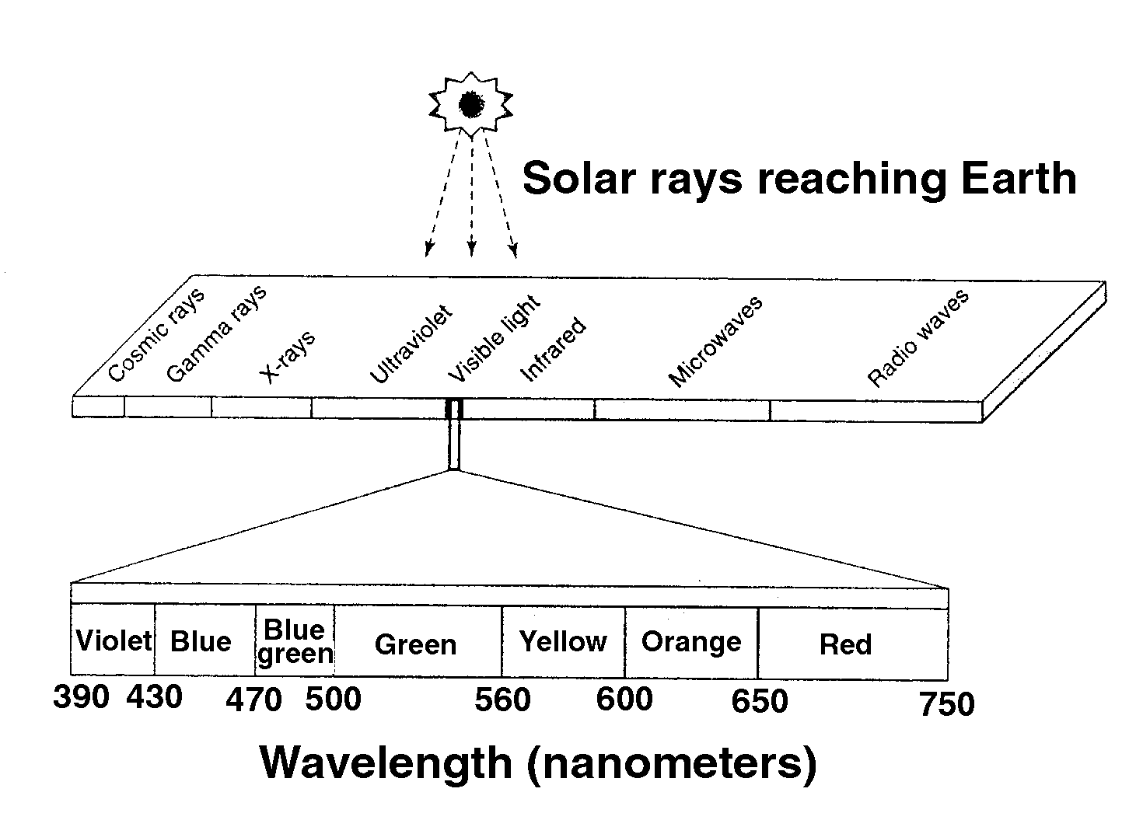

Adapted from Acquaah, George. Horticulture: Principles and Practices. Upper Saddle River, NJ: Prentice Hall, 1999.

UNIT IV: PLANT GROWTH AS 4.1

Lesson 1: Environmental Effects Name___________________

Foot-Candle Demonstration

Objective: Demonstrate how a foot-candle measures light.

Directions: Follow the procedures listed below and answer the questions.

Materials:
16 standard-size candles
Ruler
Sturdy piece of light-colored cardboard
Matches

Procedures:

1. Set one candle on a flat surface.

2. Measure a distance of 1 foot. Place the cardboard parallel to the candle.

3. Light the candle and turn off the overhead light.

4. The light hitting the board represents 1 foot-candle of intensity.

5. Add a second candle.

6. Observe the intensity of the light. Record your findings.

7. Double the number of candles to four.

8. Observe the intensity of the light. Record your findings.

9. Double the number of candles to 16.

10. Observe the intensity of the light. Record your findings.

1. How did the intensity of light change when the second candle was lit?

2. How did the intensity of light change when four candles were lit?

3. How did the intensity of light change when 16 candles were lit?

UNIT IV: PLANT GROWTH AS 4.2
Lesson 1: Environmental Effects Name___________________

Effects of Light on Plants

Objective: Identify the effects of light in greenhouse plants.

Directions: Use the plants that were sown in Unit I, Lesson 1. These plants were assigned to three groups: Group A, Group B, and Group C. Your own plant belongs to one of these three groups. Since the seeds were planted at the beginning of Unit I, the three groups of plants have been exposed to various amounts of light as follows:

- Group A plants received 4 hours of light per day and then were put in a closet or under a cardboard box.

- Group B plants received natural light during normal daylight hours. (Plant was left on a window sill.)

- Group C plants received 17 hours of light per day with additional artificial light (identify type of artificial light).

Observe the groups of plant closely and answer the following questions. Some questions may require further research using various resource materials.

1. What type of plant did you grow?

2. What is the recommended amount of light for that plant?

3. Describe plants in Group A, Group B, and Group C in detail. Be sure to focus on the influence of light.

Group A

Group B

Group C

4. What group is your plant in? How does it look? How much light do you think it received: too much, too little, or the proper amount of light? Why? Be specific.

5. What other factors could affect your plant’s growth?
UNIT IV: PLANT GROWTH AS 4.3
Lesson 1: Environmental Effects Name___________________
Photoperiod in Plants

Objective: Describe photoperiodism and its relation to plants.

Directions: Work in small groups of three or four students. Use the Internet, books, magazines, and science and horticulture textbooks to answer the following questions. When answering the questions listed below, do not use examples given in the text. Relate your findings to the class in a poster, collage, oral presentation, or any other format that answers the questions.

1. List three to five long-day plants.

2. List three to five short-day plants.

3. List three to five plants day-neutral plants.

UNIT IV : PLANT GROWTH AS 4.4
Lesson 1: Environmental Effects Name___________________

Greenhouse Air Pollutants

Objective: Investigate the origin of air pollutants that could occur in greenhouses and point out ways to correct the problem.

Directions: Work in small groups of three or four students. Answer the following questions for three of the pollutants listed in Unit IV, Table 4.2, of the Student Reference. Use the Internet, books, magazines, science and horticulture textbooks to answer the following questions. Relate your findings to the class in a PowerPoint presentation, poster, oral presentation, or any other format that shares information with the class.

Pollutant #1___________________

Pollutant # 2___________________

Pollutant #3 ___________________

1. How could these pollutants enter a greenhouse? Are they naturally occurring substances? Are they a by-product of the greenhouse structure?

2. Do these pollutants affect all organic matter in a greenhouse? What signs do susceptible plants display? Do the pollutants have an effect on humans?

3. How would greenhouse professionals manage the presence of these air pollutants? Give at least two examples.

A.

B.

