GREENHOUSE OPERATION AND MANAGEMENT

Unit IV: Plant Growth

Lesson 3: Irrigation

Competency/Objective:

Explain factors involved in proper greenhouse irrigation.

Study Questions

1. What factors affect the irrigation of greenhouse crops?

2. How often should crops be irrigated?

3. What are some basic irrigation guidelines?

4. How should water be delivered to plants?

References/Supplies/Materials

1. Greenhouse Operation and Management (Student Reference). University of Missouri-Columbia: Instructional Materials Laboratory, 2002.

2. Transparency Masters

TM 4.8 Interaction Between Growing Medium’s Porosity and Depth
TM 4.9 Capillary Action of Water in Growing Medium

3. Activity Sheets

AS 4.8 Over-, Under-, and Proper Watering
AS 4.9 Water Delivery Systems

TEACHING PROCEDURES

A. Review

Light, temperature, and air quality are important factors in aiding plant growth as well as the composition of the growing media and the containers used. The most important factor affecting the health and growth of a greenhouse crop is water. Water delivers essential nutrients to the root system. This lesson provides guidelines for proper irrigation and describes several methods of delivering the water to the plants.

B. Motivation

1. Irrigation is more complicated than just spraying plants with a hose for a few minutes. Ask the students to brainstorm why water is so important for the plants. Use the plants they have been watering to illustrate the significance of water.

2. Saturate a sponge and lay it flat on a screen with space below it so that students can observe that water runs out of it. Turn the sponge up so it rests on its longest edge. (More water runs out of it than it did when it was flat.) Now turn it up so it rests on its narrowest edge. (Even more water runs out of the sponge.) Ask students if the position of the sponge has an effect on how fast it absorbs water. Ask them to predict why.

C. Assignment of Study Questions

D. Supervised Study

Lead students in collecting the information needed to answer and discuss the study questions. The instructor may choose to work on one study question at a time or have students answer all the study questions before the discussion. Another option is to have students work in a cooperative learning environment and have groups work on different study questions.

E. Discussion

Lead students in a discussion of the study questions. Supplement students’ responses and information with additional materials when needed.

1. What factors affect the irrigation of greenhouse crops?

Water delivers valuable nutrients to plants. Students should note that public water might also have additives such as fluoride and salts that can damage plants. Some plants are more sensitive than others.

A. Irrigation is the most important greenhouse practice.
1. Quality water is essential to plant growth.
2. Proper irrigation practices are critical to crop success.
B. Water has a major role in plant growth.
1. Dissolves nutrients and translocates them throughout the plant
2. Supports plant structure when plant cells are filled
C. Several factors contribute to moisture stress in plant.
1. Growing medium - very important factor
a. The growing medium must provide adequate absorption, drainage, and retention.
b. When medium’s capillaries absorb and retain water, the force of gravity drains water from the plant container, creating a conflicting interaction. (TM 4.8)
i. Medium’s porosity and depth resolve this conflicting interaction.
ii. Large particles in the growing medium are porous and facilitate drainage after irrigation.
iii. The depth of the medium relates to the height of the plant’s container.
(a) Water in tall containers pulls easily through the medium; drainage is complete.
(b) Water is retained in short containers because the medium’s capillaries resist the force of gravity.
2. Air temperature
a. Warmer air temperatures increase plant transpiration rate, relative humidity decreases, and water in plant cells is depleted.
b. Air temperature must be monitored and regulated.
D. Irrigation considerations
1. Provide uniform watering.
2. Minimize amount of water/fertilizer runoff.
3. Minimize amount of water on foliage.
4. Consider integrating fertilizer injection system directly into irrigation system.
E. Plants vary in their sensitivity to the elements in some water supplies.
1. Fluoride
a. Added to public water systems for tooth decay prevention
b. Can cause tips of some plants to burn
2. Softened water
a. Contains high levels of sodium
b. Should not be used for plant irrigation

2. How often should crops be irrigated?

When do you water? Discuss the consequences of underwatering and overwatering using the plants the students have been watering. Have students complete AS 4.8.

A. Frequency depends on various factors.
1. Water-holding capacity of growing medium
2. Growing medium and container type
3. Internal environment (greenhouse humidity, temperature, light)
4. External environment (season)
5. Plant itself
a. Species
b. Size
c. Stage of growth
d. Soil depth
B. There are several ways to identify when plants need water.
1. Visual observations
a. Plant starts to wilt.
b. Growing medium becomes dry and lighter in color.
c. Weight of pot is lighter.
2. Stick placed in growing medium and removed
a. If stick is dry, water the plant.
b. If medium clings, do not water the plant.
C. There are several consequences of underwatering.
1. Moisture stress from depriving plant of water
2. Wilting because cells shrink
3. Stomata close up
a. Prevent further loss of moisture
b. Restrict CO₂ from entering leaf
c. Photosynthesis hindered
d. Plant growth stunted
4. No water or minerals to roots
a. Leaves, stem, and emerging flowers are deprived of water and nutrients.
b. Plant develops shorter internodes, smaller leaves, and harder and tougher plant tissue.
D. There are several consequences of overwatering.
1. Especially detrimental for seedlings
2. Affects root system
a. Restricts exchange of gases; limits level of oxygen
b. Damages root tissue
c. Increases risk of disease invasion
3. Wilting
4. Leggy growth
5. Slowed growth

3. What are some basic irrigation guidelines?

Have students discuss the important aspects of growing media related to water: porosity, drainage, and water-holding capacity. Ask students to define leaching, an important aspect of irrigation.

A. Use proper growing media. (See Unit IV, Lesson 2.)
B. Water only when indicated.
C. Water thoroughly each time.
1. Purpose
a. Leaches (flushes) soluble salts and excess nutrients from growing media
b. Buildup of salts and nutrients damaging to root system
2. Method
a. Moisten entire area around roots; do not allow root system to dry out.
b. Do not allow overflowing over top of pot.
c. Water until water drains from bottom.
d. Water early in day to allow water to evaporate from foliage and flowers.
D. Take steps to reduce risk of plant disease.
1. Do not wet foliage or flowers.
2. Keep end of hose off the floor to avoid pathogens that can contaminate plants.
4. How should water be delivered to plants?

The three basic styles of irrigation are overhead delivery, surface delivery, and subsurface delivery. Some plants respond better to specific methods. Ask students to discuss why this might be. Have the class complete AS 4.9 to augment information learned here.

A. Water delivery to plants in the greenhouse through both manual and automated systems (See Unit II, Lesson 2.)
B. Manual method - use of handheld hose and wand
1. Widely used in small greenhouse operations
2. Labor intensive
3. Costly
4. Difficult to water plants uniformly
C. Overhead delivery - foliage-type watering system (automated method)
1. Sprinkler systems
a. Spray stake/nozzle systems mounted near plants, spraying bedding plants from above and on the sides
b. Disadvantages
i. May leave salt residues on foliage if irrigation system contains nutrients
ii. Increased risk of disease from wet foliage
iii. May displace or puddle growing medium
iv. Evaporation from using overhead sprinklers
v. Increased risk of disease from wet foliage
2. Boom irrigation system
a. Water wand hanging above plants and traveling across greenhouse spraying water onto plants
b. Spray stake/nozzle systems mounted near plants, spraying plants from above and from the sides.
c. Custom built to greenhouse’s dimensions
d. Delivers fertilizer during irrigation (fertigation)
e. Saves 40% in water compared to manual techniques
D. Surface delivery (automated method)
1. Applies water under foliage
a. Uniform amount of water is applied at base of plant.
b. Leaves do not get wet; rate of evaporation from foliage and soil is reduced.
c. Growing medium does not get waterlogged.
d. Nutrients do not leach into the soil.
2. Use of drip tubes - delivering water directly to the soil without wetting the foliage
a. Drip emitters have small tubes with weights attached that are placed in individual pots. They slowly dispense drops of water directly to the medium.
b. Ooze tubes have small holes in a double-layer tube and are placed next to rows of plants.
i. Deliver low volume of water; conserve large amounts of water
ii. Used in areas with limited resources of water and where water is expensive
c. Water loops are actually ooze tubes that are wrapped around the stems of plants in individual pots.
E. Subsurface (subirrigation) delivery
1. Delivers water directly to medium without wetting foliage; applies water under pot
2. Capillary mat system (TM 4.9)
a. Plant containers are placed on top of soaked, synthetic mat that rests on level bench.
b. Bench is protected with a sheet of plastic.
c. Dripping water runs off bench, preventing soluble salts from accumulating on mat.
d. Plastic pots are best to use; clay pots lose moisture through sidewalls.
e. A drip tube waters the mat uniformly.
f. Plants are watered from above using a hose.
i. This creates a column of water that extends from growing medium to the mat.
ii. Capillary action pulls water upward from a saturated mat through a drainage hole into the growing medium.
iii. Capillary action occurs because water rises to a given height in “tubes” (capillaries) with narrow diameters. (TM 4.9)
iv. Pore spaces in growing medium function as capillary tubes and carry water from the mat to the roots.
3. Ebb and flood system
a. Flats of plants rest on specially constructed, raised, waterproof benches.
b. Each bench must be absolutely level and have a trench for the nutrient solution and several pipes to carry a given number of gallons of water per minute. The amount of water depends on the size of the greenhouse operation.
c. The irrigation solution (water and nutrients) is pumped from a central storage tank into the bench and spreads quickly and evenly over the growing medium.
d. The solution remains on the bench for a few minutes and then drains back into the storage tank for recycling.
e. Ebb and flood system never wets the foliage (which would promote disease) and it can be applied any time of the day or night. A computer can regulate the entire operation.
f. Ebb and flood is a completely closed recirculating system that does not contaminate the groundwater.

F. Other Activity and Strategy

Have three similar-size pots of the same plant and water each one with tap, reverse osmosis (RO) filtered water, and spring water. Ask students if they see the effects of three types of water on the growth of plants in the classroom. Tap water is water filtered for contaminants and possibly augmented with fluoride. Filtered water is water that has been changed in one of three ways: distilled, deionized, or filtered through RO. These methods are used to eliminate soluble salts and other contaminants like hard metals. These methods can remove minerals and trace metals that plants need for nutrition. It is not an appropriate substitute for public water. Greenhouse growers find that filtered water, especially, is less expensive. RO is useful when applied with water containing essential nutrients. Spring water should be water derived from a natural source without having its mineral content changed. Thus, depending on its source, the water may be alkaline or acidic.
G. Conclusion

Water plays a vital role in the growth and development of greenhouse crops. There are several factors that affect irrigation: the medium’s absorption, drainage, and retention as well as air temperature. Frequency of irrigation depends on several variables and the greenhouse owner can use different techniques to assess the need for watering. Overwatering and underwatering have severe consequences on the health of greenhouse crops. Irrigation may be delivered through manual or automatic systems.

H. Answers to Activity Sheets

AS 4.8 Over-, Under-, and Proper Watering

Instructor’s discretion

AS 4.9 Water Delivery Systems

Instructor’s discretion

I. Answers to Assessment

1. A
2. D
3. C
4. A. Moisten entire area around the roots.
B. Do not let water overflow.
C. Water until water drains from the bottom.
D. Water early in the morning to allow water to evaporate from foliage and flowers.
5. A. Growing medium and container type
B. Internal environment
C. External environment (season)
D. The plant itself
6. A. Water dissolves vital nutrients and translocates them through the plant.
B. Water fills the plant cells allowing the plant to thrive

UNIT IV: PLANT GROWTH Name___________________

Lesson 3: Irrigation Date____________________

ASSESSMENT

Multiple Choice: Circle the letter of the best answer.

1. What does it mean to “leach” a crop?

A. Flush soluble salts and excess nutrients
B. Augment soluble salts and excess nutrients
C. Spray extra nutrients
D. Restrict the amount of water

2. Displacement of growing medium, salt residue on foliage, and increased risk of disease characterize which water delivery system?

A. Subsurface
B. Surface
C. Ebb and flood
D. Overhead

3. What factors must the growing medium provide to prevent moisture stress?

A. Air temperature, absorption, and frequency
B. Transpiration, frequency, and drainage
C. Retention, absorption, and drainage
D. Absorption, transpiration, and frequency

Short-Answer Questions: Write the answers in the space provided.

4. What are the four steps involved in thoroughly watering a plant?

A.

B.

C.

D.
5. What four factors relate to frequency of irrigation?

A.

B.

C.

D.

6. What are two reasons why water is an essential element in plant growth?

A.

B.

TM 4.8

Interaction Between Growing Medium’s Porosity and Depth

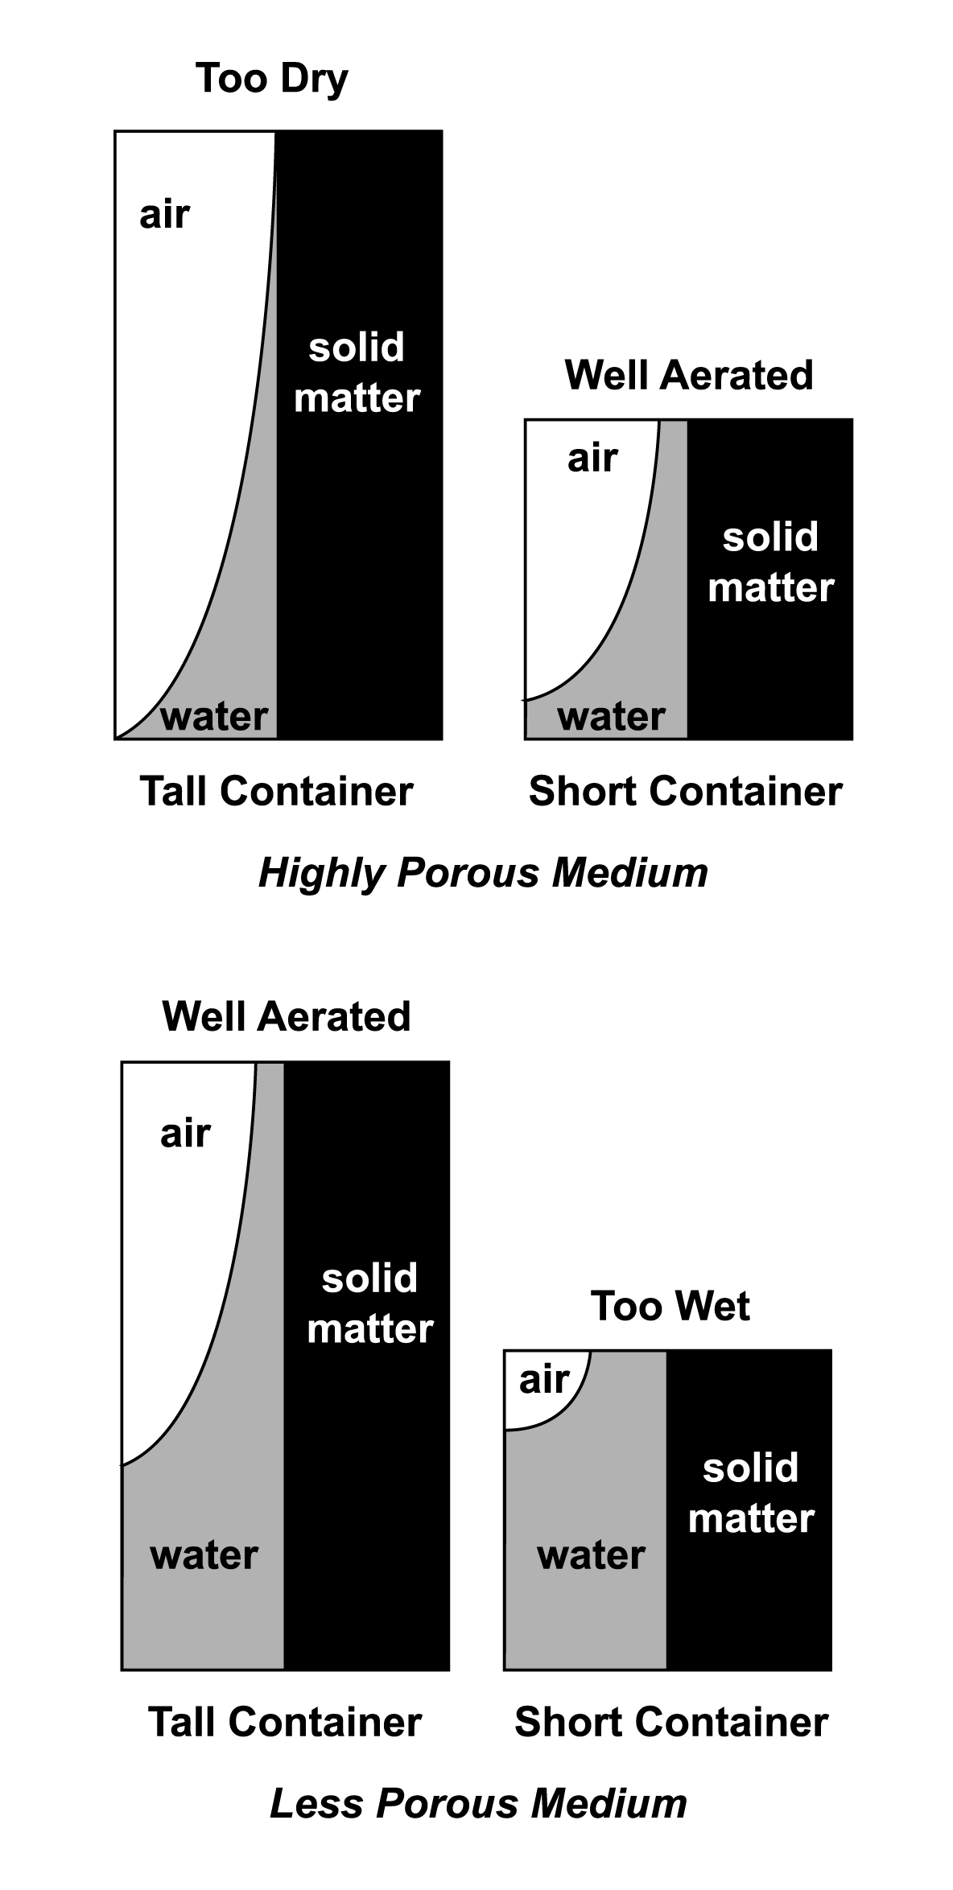

TM 4.9

Capillary Action of Water in Growing Medium

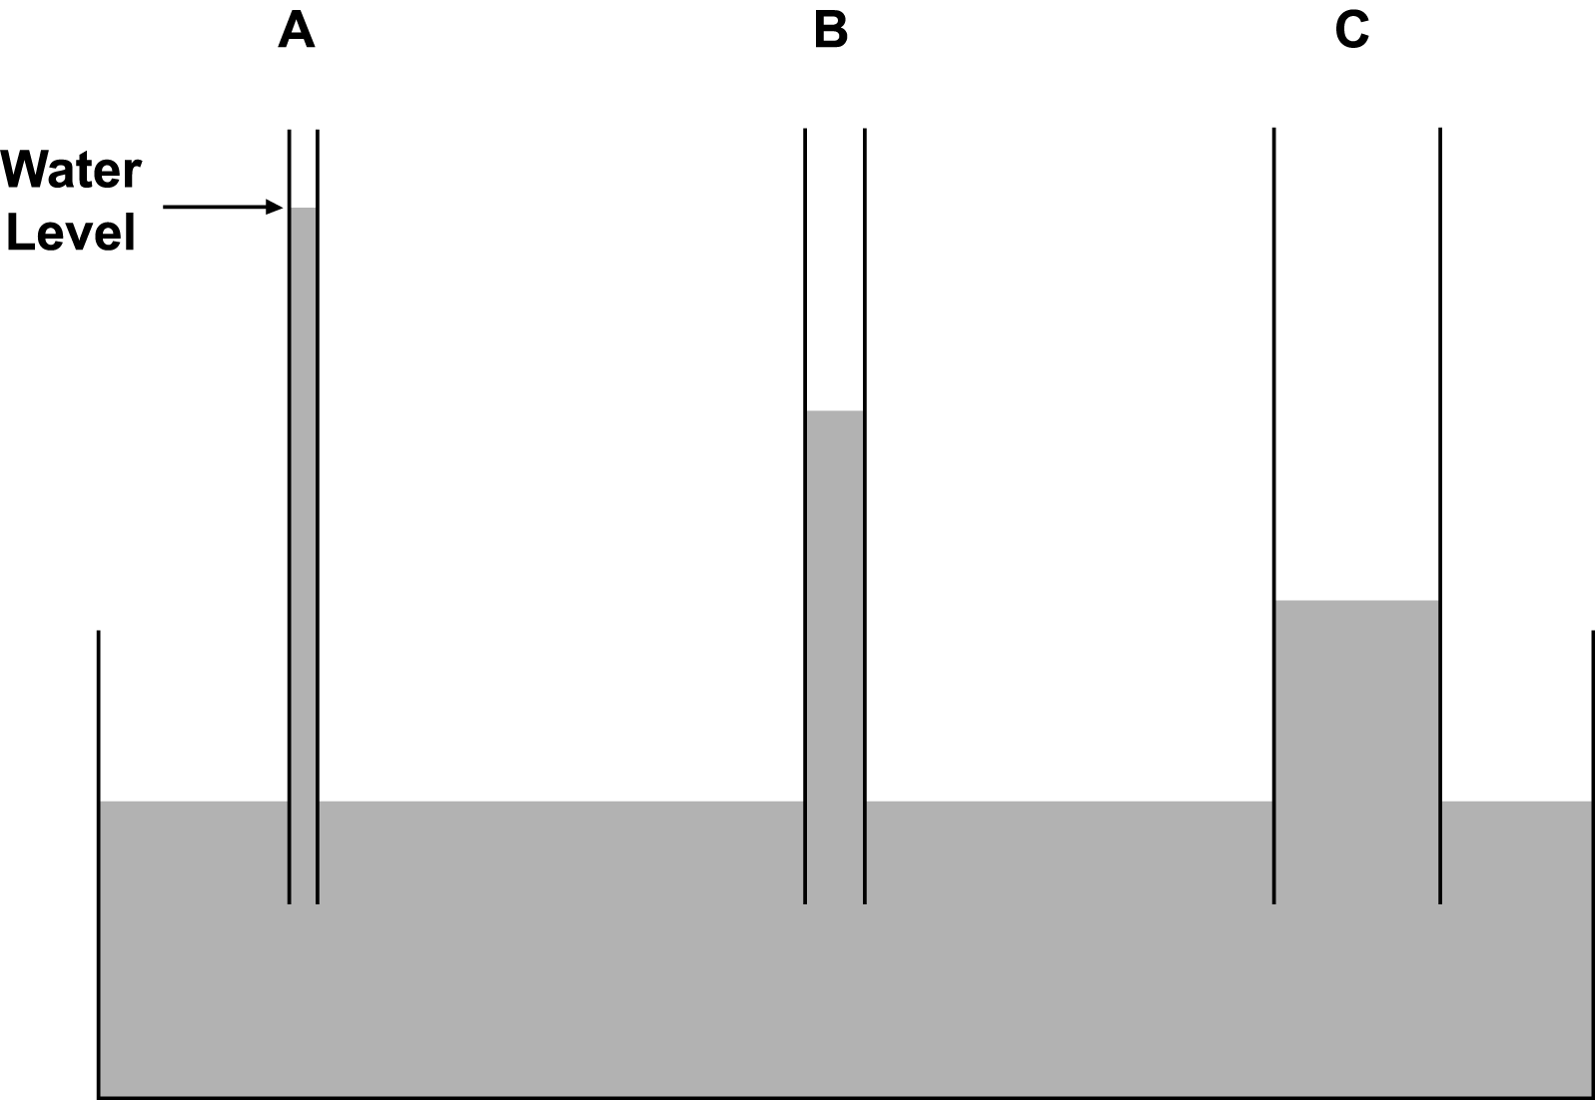

UNIT IV: PLANT GROWTH AS 4.8

Lesson 3: Irrigation Name___________________

Over-, Under-, and Proper Watering

Objective: Identify the characteristics of overwatering, underwatering, and proper watering.

Directions: Using the Unit IV plants (labeled Group D, E, and F), evaluate how well the plants have grown. Also pay attention to the growing media.

1. Which group was underwatered? Overwatered? Watered properly?

2. Describe the conditions of each of the three groups of plants.

3. How does the growing media look? Use as much detail as possible.

4. What is the overall condition of the plants growing in the soil?

UNIT IV: PLANT GROWTH AS 4.9

Lesson 3: Irrigation Name __________________

Water Delivery Systems

Objective: Compare specific types of water delivery systems to classmates.

Directions: Divide into small groups and investigate two water delivery systems listed below. Respond to the following questions. Present your findings to your peers by creating a PowerPoint presentation, poster, or some other visual aid.

- Hand watering

- Spaghetti tube irrigation

- Drip irrigation

- Ebb and flood

- Capillary mat system

- Overhead irrigation

- Perimeter irrigation

- Soaker hose system

- Misting system

- Any others?

1. What type of water delivery system is it?

2. What are the positive aspects of this system?

3. What are the limitations of this system?

4. With what type of plant does this system works best? Give examples.

5. How economical is this system?

6. Does this system present any potential environmental concerns?

