GREENHOUSE OPERATION AND MANAGEMENT

Unit IV: Plant Growth

Lesson 4: Nutrients

Competency/Objective:

Identify nutrients essential for plant growth and development and signs of deficiency or toxicity.

Study Questions

1. How do nutrients affect plant growth?

2. What nutrients are essential for plant growth?

3. How are nutritional deficiencies identified?

4. What are some common symptoms of macronutrient deficiencies?

5. What are some common micronutrient disorders?

6. What factors affect the availability of nutrients?

References/Supplies/Materials

1. Greenhouse Operation and Management (Student Reference). University of Missouri-Columbia: Instructional Materials Laboratory, 2002.

2. Transparency Masters

TM 4.10 Effect of Field Soil’s pH on Nutrient Availability
TM 4.11 Effect of Soilless Medium’s pH on Nutrient Availability

3. Activity Sheet

AS 4.10 Specific Nutrients

TEACHING PROCEDURES

A. Review

Building on the previous lessons concerning the elements needed to grow greenhouse plants, students now explore the nutrients needed for plant growth and development. This lesson examines signs of macronutrient deficiency and micronutrient toxicity.

B. Motivation

Ask students to name the types of nutrients needed for their own growth and development. Where does this nutrition come from? Just as humans, plants require specific nutrients are the building blocks for health and growth. How do plants obtain needed nutrition? Without these basic elements, greenhouse crops would be unable to flourish.

C. Assignment of Study Questions

D. Supervised Study

Lead students in collecting the information needed to answer and discuss the study questions. Instructor may choose to work on one study question at a time or have students answer all the study questions before the discussion. Another option is to have students work in a cooperative learning environment and have groups work on different study questions.

E. Discussion

Lead students in a discussion of the study questions. Supplement students’ responses and information with additional materials when needed.

1. How do nutrients affect plant growth?

The nutritional requirements of greenhouse plants differ from other crops. The greenhouse operator learns to manipulate plants by giving them the appropriate nutrients at the correct time in the development cycle to optimize growth rate and maximize profitability.

A. Nutrients are necessary for all plant growth and development.
1. Plants need adequate levels of minerals to grow at an optimal rate.
2. Both insufficient and excessive amounts of nutrients can have a negative impact on plant growth.
B. Greenhouse plants have higher supplemental nutritional requirements than other agricultural crops.
C. Fertilizers are applied as nutritional supplements to promote plant growth. (See Unit IV, Lesson 5.)
2. What nutrients are essential for plant growth?

There are 18 nutrients necessary for plant development. Six nutrients are needed in large quantities, nine in trace amounts, and three in very large amounts: carbon, hydrogen, and oxygen. The last three are absorbed through the air and water.

A. Macronutrients
1. Primary (fertilizer nutrient)
a. Nitrogen (N)
i. Found in chlorophyll and enzymes
ii. Essential to growth.
iii. Helps the plant resist disease and sustain environmental extremes, such as drought and freezing
iv. Is recycled within the plant
b. Phosphorous (P)
i. Stimulates root growth
ii. Promotes early crop maturity
c. Potassium (K) - contributing to growth of plant tissue
2. Secondary
a. Calcium (Ca)
i. Increases the pH level, which corrects acidity in the growing medium
ii. Key factor in cell development
iii. Affects the roots’ ability to absorb magnesium and potassium
b. Magnesium (Mg) - helps produce chlorophyll, fats, and sugars
c. Sulfur (S)
i. Used in all plants
ii. Is absorbed in some vegetables (e.g., cabbage and onions)
iii. Part of the plant’s vitamins and amino acids
iv. Assists in producing protein
B. Micronutrients - trace elements; in varying quantities affect photosynthesis, protein
synthesis, cell development, flowering, and other plant processes
1. Boron (B)
2. Chlorine (Cl)
3. Copper (Cu)
4. Iron (Fe)
5. Manganese (Mn)
6. Molybdenum (Mo)
7. Nickel (Ni)
8. Sodium (Na)
9. Zinc (Zn)
C. Nonfertilizer nutrients - representing 89% of the plant’s content by dry weight
1. Carbon
2. Hydrogen
3. Oxygen
3. How are nutritional deficiencies identified?

Discuss the importance of having a monitoring system to ensure proper nutrition for greenhouse crops.

A. Establishing and consistently following a nutrient monitoring system
B. Monitoring methods
1. Visual observation
a. Signs of nutritional deficiencies vary greatly with species.
b. Signs are often visible only in later stages and may be too late to save the plant.
2. Analysis of foliage (leaf tissue testing)
3. Analysis of growing medium
a. Level of nutrients
b. Level of elements that affect availability of nutrients
i. pH
ii. Soluble salts
iii. Pests and disease
C. Visual diagnosis
1. Not always clear
2. General terms
a. Chlorosis: gradual yellowing of tissues as green chlorophyll breaks down (interveinal chlorosis - yellowing between leaf veins)
b. Necrosis: dead tissue, brown or black

4. What are some common symptoms of macronutrient deficiencies?

Six macronutrients play important roles in a plant’s development. If there is a paucity of the nutrient, growth is slowed. Each deficiency has visible signs the students can learn to spot.

A. Nitrogen (N) - lost through erosion and leaching
1. Slow growth
2. Spindly, fewer lateral shoots
3. Chlorosis, beginning with older/lower leaves
B. Phosphorous (P)
1. Stunted, spindly growth
2. Deeper green leaves and stems
3. Purplish veins and stems
C. Potassium (K)
1. Slow growth
2. Interveinal chlorosis beginning with older leaves
3. Necrotic or scorched edges beginning with older leaves
D. Calcium (Ca)
1. Yellow, brown, or black new leaf tips
2. Dieback of growing points
3. Roots - short, thick
E. Magnesium (Mg)
1. Interveinal chlorosis of older leaves, usually beginning in center of leaf
2. Necrosis of edges and marginal scorching
F. Sulfur (S)
1. Chlorosis similar to nitrogen deficiency but not necessarily beginning with older leaves
2. May turn orange or red
3. Hardening of stems

5. What are some common micronutrient disorders?

Micronutrients are just as vital as macronutrients but the amount of nutrients needed is much less. This means that a little goes a long way and a little more may be toxic.

A. Micronutrient deficiency
1. Plant develops symptoms that are often similar to macronutrient deficiency.
2. Even minor deficiencies can affect plant growth.
B. Micronutrient toxicity
1. Toxicity occurs when excessive amounts of one nutrient prevent other nutrients from providing available nourishment to the plant.
2. Symptoms are difficult to recognize and can be mistaken for nutritional deficiency.

6. What factors affect the availability of nutrients?

The soil’s pH and soluble salts can slow and even kill a greenhouse crop. Other factors that affect availability of nutrients are pests and diseases, which are addressed further in Unit VI.

A. pH level of field soil
1. Optimal pH for field soil - 5.8-6.5
2. Controls availability of nutrient uptake
3. Correcting pH levels
a. Add lime to soil that is too acidic (increases pH).
b. Add sulfur to soil that is too alkaline (decreases pH).
4. Effect of field soil’s pH on nutrient availability (See TM 4.10.)
B. Soilless media - effect of pH on nutrient availability (See TM 4.11.)
C. Buildup of soluble salts in soil
1. Harms some plants that are more sensitive than others, especially young plants
2. Originates from low-quality irrigation water and fertilizer residues
3. Insufficient amounts - cause of nutrient deficiency and slow plant growth
4. Fertilizers - a form of salt that increases levels of soluble salt in the medium
5. Excessive amounts damaging to root system
a. Increase risk of disease
b. Limit uptake ability
6. Excessive amounts damaging to foliage
a. Salts are translocated through the plant.
b. Injury to plant tissue can range from mild chlorosis to leaf burn.
7. Causes reduction in water intake into the plant, which induces wilting
8. Injury to foliage
9. Ways to avoid and correct buildup of soluble salts
a. Use high-porosity growing media.
b. Maintain adequate moisture level.
c. Leach media by applying large amounts of water and allowing 15-20% to drain out of container.
D. Pests and diseases (See Unit VI, Lesson 1.)
1. Damage roots
2. Prevent plant from efficiently absorbing nutrients

F. Other Activity and Strategy

Have the class test the pH of water. Obtain pH test strips and several types of water: tap water, filtered water (preferably reverse osmosis), and spring water (bottled is fine). You may also augment filtered water with some bicarbonate of soda to change the pH. The optimal pH for irrigation water is 5.5-6.5 (acidic). Ask the students why. (Answer: Essential nutrients are soluble at that pH level.)

G. Conclusion

Greenhouse plants have higher nutritional needs. The greenhouse owner must monitor the plants to ensure that proper care is given. It is advisable to maintain a regular schedule and to test the soil and plants because relying on visual cues alone may be insufficient for saving a crop.

H. Answers to Activity Sheet

Instructor’s discretion

I. Answers to Assessment

1. C
2. B
3. A
4. A
5. A. Add lime.
B. Add sulfur.
6. A. Chlorosis beginning but not necessarily confined to older leaves
B. Leaves turning orange or red
C. Stems hardening
7. A. Slow growth
B. Spindly plants with fewer lateral shoots
C. Chlorosis beginning with older, lower leaves
8. A. Stunted, spindly growth
B. Deeper green leaves and stems
C. Purplish veins and stems
9. B
10. B
11. A
12. A
13. A
14. A
15. B

UNIT IV: PLANT GROWTH Name___________________

Lesson 4: Nutrients Date____________________

ASSESSMENT

Multiple Choice: Circle the letter of the best answer.

1. What is the effect of a buildup of soluble salts in the growing medium?

A. Promotes excessive intake of water
B. Prevents absorption of fertilizer
C. Damages root system
D. Increases development of foliage

2. Which nutrients are absorbed through air and water?

A. Chlorine, iron, and magnesium
B. Carbon, oxygen, and hydrogen
C. Oxygen, nitrogen, and sodium
D. Potassium, phosphorous, and nitrogen

3. When does micronutrient toxicity occur?

A. Excessive amounts of one nutrient
B. Insufficient amounts of trace elements present in growing medium
C. Excessive amounts of macronutrients
D. Buildup of soluble salts

4. What amount is indicated in an analysis of the growing medium?

A. Nutrients
B. Necrotic tissue
C. Chlorosis
D. Root development

Short-Answer Questions: Write the answers in the space provided.

5. A. How is the pH level of acid soil adjusted?

B. How is the pH level of alkaline soil adjusted?
6. What are three symptoms of sulfur deficiency in plants?

A.

B.

C.

7. What are three symptoms of nitrogen deficiency in plants?

A.

B.

C.

8. What are three symptoms of phosphorous deficiency in plants?

A.

B.

C.

Match the nutrient on the left with its classification on the right. Write the letter in the space provided.

9. ____Nickel A. Macronutrient

10. ____Manganese

11. ____Calcium B. Micronutrient

12. ____Sulfur

13. ____Potassium

14. ____Magnesium

15. ____Chlorine

TM 4.10

Effect of Field Soil’s pH on Nutrient Availability

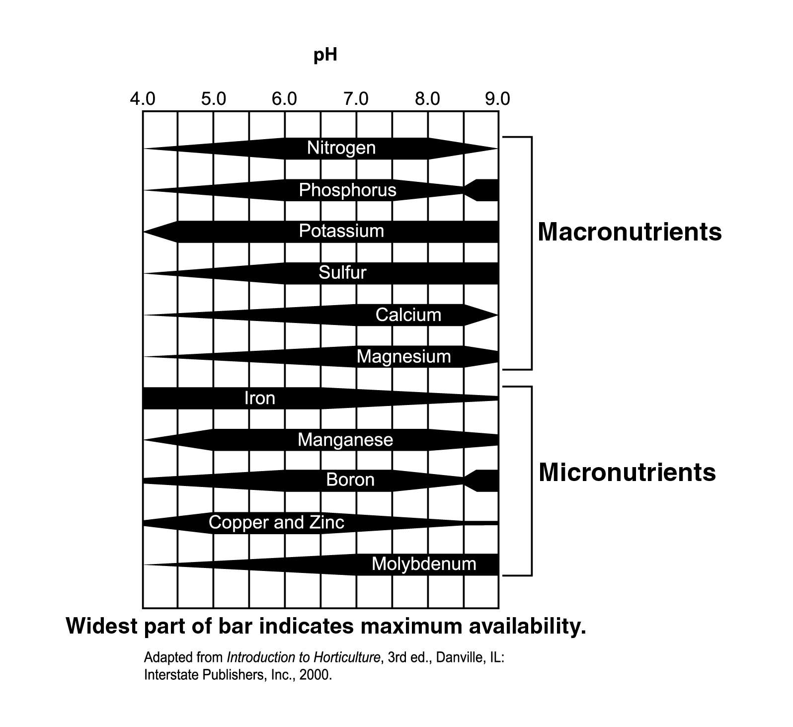

TM 4.11

Effect of Soilless Medium’s pH on Nutrient Availability

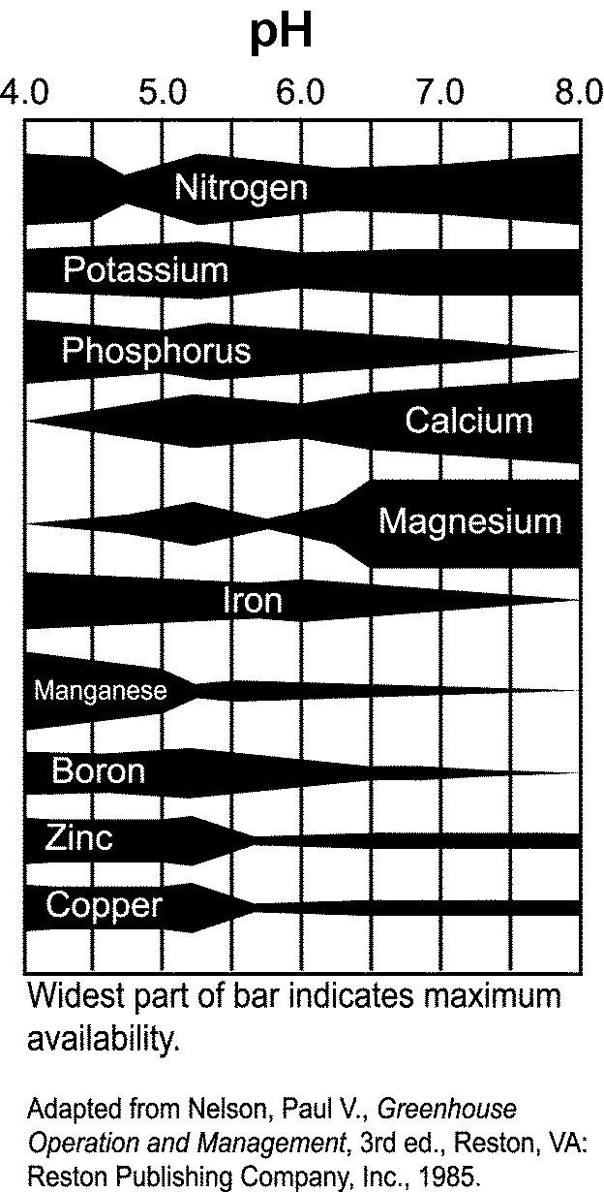

UNIT IV: PLANT GROWTH AS 4.10
Lesson 4: Nutrients Name___________________

Specific Nutrients

Objective: Identify nutrients needed for specific greenhouse crops.

Directions: Work in small groups. Each group examines nutritional requirements for a different crop. Select a crop from one of the following: potted flowering, bedding/garden plants, or foliage plants. Use the Internet, information from books, university Extension publications, or other sources to research the specific nutritional needs of the selected plant. You may bring an example of this plant to class, but this is not required in order to complete the activity. Present your findings to the class as a PowerPoint presentation or create a poster. Respond to the following questions.

1. What pH level of the growing medium does the plant prefer?

2. How do you achieve this pH level if the growing medium is not at the prescribed level?

3. Considering the pH required for optimal growth and development, what nutrients does this plant need?

4. What macronutrients does this plant require?

5. What micronutrients does it need?

6. What are the signs of nutritional deficiency for this plant? How can they be corrected?

