GREENHOUSE OPERATION AND MANAGEMENT

Unit V: Plant Propagation

Lesson 2: Asexual Propagation

Competency/Objective:

Differentiate between various types of asexual propagation procedures.

Study Questions

1. What is asexual propagation?

2. What are general considerations for asexual propagation?

3. How are plants propagated by budding?

4. How are plants propagated by cuttings?

5. How are plants propagated by division?

6. How are plants propagated by grafting?

7. How are plants propagated by layering?

8. How are plants propagated by tissue culture?

References/Supplies/Materials

1. Greenhouse Operation and Management (Student Reference). University of Missouri-Columbia: Instructional Materials Laboratory, 2002.

2. Transparency Masters

TM 5.3 Cutting Locations
TM 5.4 Cuttings
TM 5.5 Division
TM 5.6 Grafting
TM 5.7 Layering

3. Activity Sheets

AS 5.2 Asexual Propagation
AS 5.3 Budding and Tissue Culture

TEACHING PROCEDURES

A. Review

This lesson continues to discuss propagation by describing six alternative methods of propagation. The content of Lesson 2 reinforces students’ knowledge of plants because these techniques rely upon an understanding of which plant parts are cut and why.

B. Motivation

Ask students to justify why a greenhouse grower would want to use propagation methods that did not rely on using seeds. What are the advantages?

C. Assignment of Study Questions

D. Supervised Study

Lead students in collecting the information needed to answer and discuss the study questions. The instructor may choose to work on one study question at a time or have students answer all the study questions before the discussion. Another option is to have students work in a cooperative learning environment and have groups work on different study questions.

E. Discussion

Lead students in a discussion of the study questions. Supplement students’ responses and information with additional materials when needed.

1. What is asexual propagation?

Asexual propagation is plant reproduction without seeds. In other words, asexual propagation uses parts of one plant to create another. It is faster than sexual propagation and because the new plant is a clone, the characteristics of the new plant are the same as the parent or original plant.

A. Asexual propagation uses leaves, stems, or roots of a parent plant to reproduce a new plant.
B. It is a popular means of reproducing plants.
1. Faster than sexual propagation
2. Produces characteristics identical to parent plant (cloning)

2. What are general considerations for asexual propagation?

Tools, sanitation, greenhouse environment, and proper labeling are examined. Ask students why they think sanitation is a bigger factor in asexual propagation than in sexual propagation.

A. Tools
1. Sharp knife
a. To cut parts from plants
b. To divide plants
c. To make wounds in plant materials
2. Dibble (stick) to make holes in growing medium
3. Duster to apply rooting compound
B. Sanitation
1. Keep tools clean and sterile.
a. Disinfect before use.
b. Disinfect knives after each cutting.
2. Place cuttings in sterile container until planted.
3. Sterilize rooting solution after each use.
4. Discard any excess plant debris.
C. Growing medium
D. Lighting
E. Temperature
F. Labeling
1. Labels enable grower to keep track of all plants.
2. Labels should contain detailed information.
a. Plant’s name and variety
b. Date propagated
- Any special treatment
G. Legal issues
1. Federal law - Plant Patent Act of 1930
a. This law covers asexually reproduced plants except for tubers.
b. It precludes others from asexually propagating or selling the plant without prior
permission from the patent holder.
c. Licensing agreements allow growers to grow and sell the specified variety.
d. Patent expires after 20 years.
e. Amendments to the Plant Patent Act were passed in 1998.
i. Explicitly protects the owner of a plant patent against unauthorized sale of plant parts that would be used to propagate the plant
ii. Expands protections on par with those for sexually propagated plants covered by the Plant Variety Protection Act
f. Contact information:
Assistant Commissioner for Patents, Washington, DC 20231
2. State law - Missouri Plant Law
a. This law requires all in the state of Missouri who sell, give away, or transport nursery stock (woody stem plants, perennials, bulbs, roots, crowns, corms, rhizomes, and tubers) to submit to inspection.
b. The purpose of the inspection is for the state entomologist to examine the plants for
insects and diseases.
c. Inspections occur twice a year.
d. Fees for greenhouse inspections are based on the facility’s square foot area under glass.
e. Contact information:
State Entomologist
Missouri Department of Agriculture
P. O. Box 630
Jefferson City, MO 65102-0630
Phone: (573) 751-5507
Fax: (573) 751-0005

3. How are plants propagated by budding?

As one of the techniques of asexual propagation, budding is a specialized form of grafting (discussed below).

A. A single bud from one plant is inserted into the bark or another variety.
- It is similar to grafting but uses only a single bud as the scion.
- A commercial plant propagator usually performs specialized grafting techniques.

4. How are plants propagated by cuttings?

Cuttings taken from the stem or leaves of a parent plant are used in this form of propagation. See TMs 5.3 and 5.4.

A. Cuttings of parent plant rooted to form new plants
B. Types of cuttings
1. Stem cuttings
a. Taken from section or tip of stem
b. Softwood, herbaceous, semihardwood, hardwood, conifer
2. Leaf cuttings
a. Piece or entire leaf
b. Leaf vein
c. Leaf bud
3. Stem cuttings
C. Steps
1. Begin with clean cutting tools, containers, and growing medium.
2. Make cuts according to the type of cutting used.
3. Treat base of cutting with a rooting hormone.
4. Plant the cutting in moist soilless growing medium.
5. Place in high-humidity environment to reduce moisture loss.
a. Enclosed in a plastic bag
b. On misting bench
6. Provide appropriate amounts of sunlight.
7. Keep temperature between 65 and 75°F.
D. Root growth can be encouraged with rooting hormones.
1. Purpose
a. Increases percentage of cuttings that root
b. Helps plants root more quickly and uniformly
c. Stimulates formation of more vigorous roots
2. Methods of application
a. Dust with rooting powder.
i. Apply small amount to base of cutting.
ii. Excessive amounts can cause stem to rot.
b. Dip or spray hormone solutions. Dip base of cutting into solution for short period of time.
c. Be aware that pathogenic organisms can be spread from diseased cuttings to healthy cuttings via the solution. Discard any leftover solution after dipping.

5. How are plants propagated by division?

The term “division” refers to splitting plant parts to grow new plants. Corms, bulbs, rhizomes, tubers, and crowns are excellent examples of division. If possible, bring in one of the above to show the class. (See TM 5.5.)

A. Division is the separation of clumps of a plant into small groups, each having roots, stems, buds, and leaves or the potential to develop these parts.
B. Division is a natural means of reproducing for some plants (e.g., tulips, daffodils).

6. How are plants propagated by grafting?

This procedure involves melding two different plants together. It is most often used for trees and roses. (See TM 5.6.)

A. Buds, twigs, or shoots (known as scions) are taken from one plant and inserted into the stems or roots of a similar plant (known as the rootstock), matching cambiums in the process.
B. There are two types of grafting.
1. Whip (or tongue) grafts join small scion to similar sized rootstock.
2. Cleft and bark grafts join small scion to large rootstock.
C. Grafting is used most often for trees and roses.

7. How are plants propagated by layering?

Layering is a method of propagating that does not split the new plant from the parent until the roots are established. There are six different types of layering. Two of these types are illustrated in TM 5.7. After students have investigated all of the propagation methods (except tissue culture), have them complete AS 5.2.

A. Layering is the process of establishing new roots on the stem while the stem remains attached to the parent plant.
- Layering is a technique commonly used to propagate many houseplants.
- It involves wounding a piece of plant stem and burying it.
D. There are several types of layering.
1. Simple: A portion of the stem is wounded, treated, and buried; the tip is left exposed.
2. Air: A portion of the stem is removed and rooting is induced at the wounded area.
3. Tip: Terminal tip is wounded, treated, and buried.
4. Serpentine or compound: Stem is covered and exposed.
5. Mound: Stem is cut back and buried while dormant.
6. Trench: Entire plant, except for tip, is bent and buried.

8. How are plants propagated by tissue culture?

This is a technical way of cloning plants by using very little plant material but very specific and sterile conditions. Orchids and lilies are two crops grown in this manner. Have students complete AS 5.3.

A. Also referred to as micropropagation
B. Highly technical method
1. Use one or more cells from the tissue of a plant to produce a new plant.
2. Pieces of plants are grown in sterile conditions in artificial media.
3. This allows mass production of plants in a short period of time.

F. Other Activity and Strategy

Show the class videos from CATER (Career & Technical Education Resources), 2 London Hall, University of Missouri-Columbia: Plant Propagation (AG V47) and Plant Tissue Culture Part II (AG V170).

G. Conclusion

Asexual propagation involves several methods and procedures. Each technique provides various alternatives for reproducing plants.

H. Answers to Activity Sheets

AS 5.2 Asexual Propagation

Instructor’s discretion

AS 5.3 Budding and Tissue Culture

Instructor’s discretion

I. Answers to Assessment

1. E
2. D
3. F
4. B
5. A
6. C
7. A. Quicker method of propagation
B. Produces characteristics identical to parent plant
8. A. Simple: Portion of stem is wounded, treated, and buried
B. Air: Portion of stem is removed and rooting is induced at wound
C. Tip: Tip is wounded, treated, and buried.
D. Serpentine or compound: Stem is covered and exposed in several places.
E. Mound: Stem is cut back and buried when dormant.
F. Trench: Entire plant except for tip is bent and buried.
9. Joins scion to a larger rootstock
10. Students may list any two of the following:
A. Use one or more cells to produce new plant.
B. Grow in sterile conditions in artificial media.
C. Mass production in short period of time.
11. Budding is a form of grafting that uses only buds as a scion.
12. Students may list any four of the following:
A. Sharp knife
B. Dibble stick
C. Sterile equipment
D. Proper growing medium
E. Duster
F. Labels
13. Root hormone
14. Tubers
15. Based on square feet under glass in the greenhouse

UNIT V: PLANT PROPAGATION Name___________________

Lesson 2: Asexual Propagation Date____________________

ASSESSMENT

Match the statement on the left with the propagation method on the right. Write the letter in the
space provided.

___1. Bury pieces of plant while still attached to parent plant A. Tissue culture

___2. Attaching a piece of one plant to another B. Budding

___3. Planting a piece of stem or leaf C. Division

___4. Attaching a bud to another plant D. Grafting

___5. Growing plants from cells E. Layering

___6. Separating plant parts F. Cutting

Short-Answer Questions: Write the answers in the space provided.

7. What are two advantages to asexual propagation?

A.

B.

8. What are six types of layering? Describe two of them.

A.

B.

C.

D.

E.

F.

9. What is a cleft and bark graft?

10. What are two features of micropropagation?

A.

B.

11. What is the difference between budding and grafting?

12. What are four tools a greenhouse owner needs to asexually propagate plants?

A.

B.

C.

D.

13. How is root growth encouraged when using cuttings?

14. What type of asexually reproduced plant is not covered by the Plant Patent Act?

15. How is the inspection fee for greenhouses determined under the Missouri Plant Law?

TM 5.3

Cutting Locations

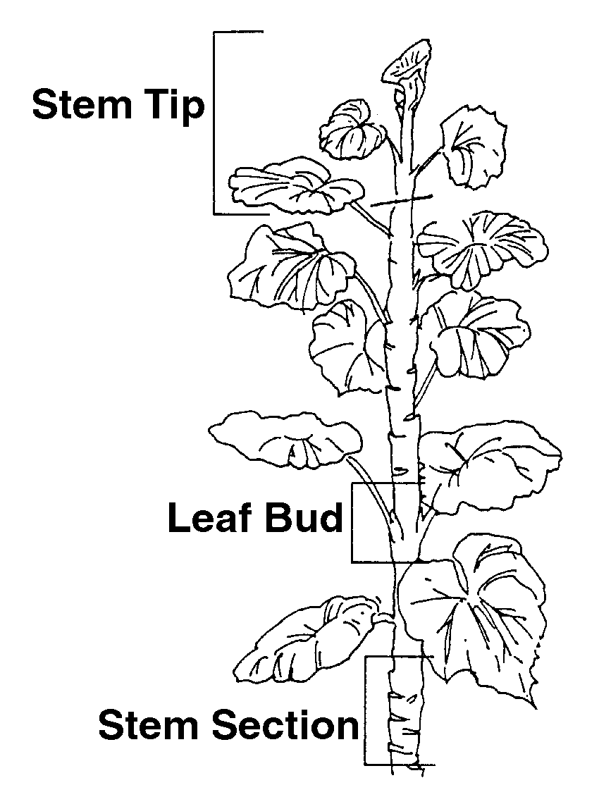

TM 5.4

Cuttings
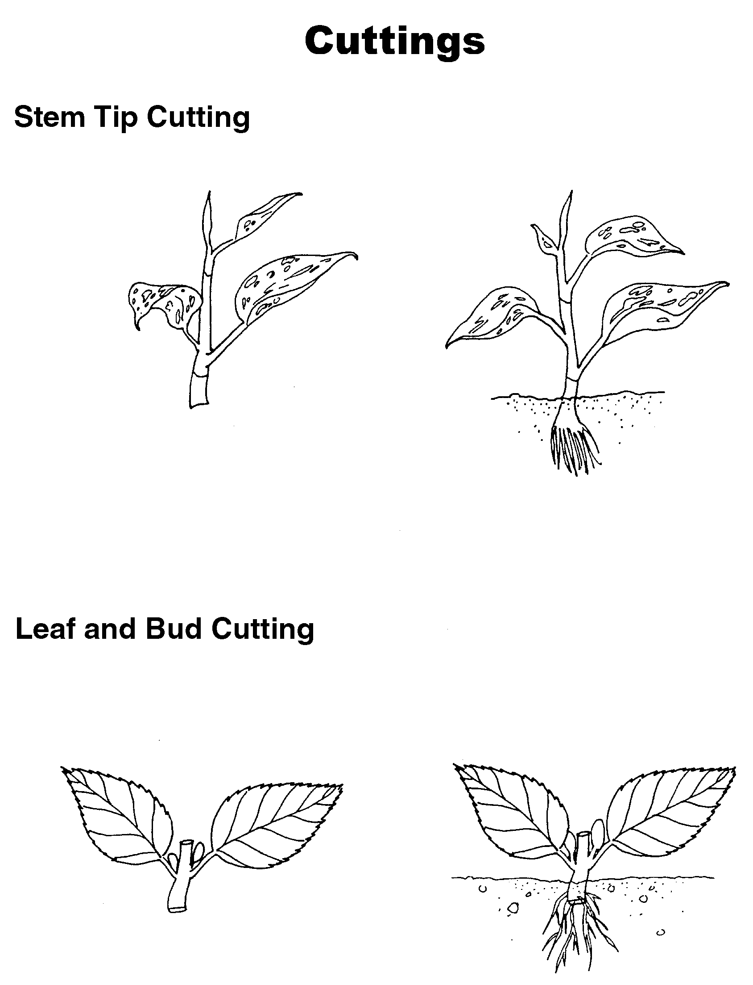

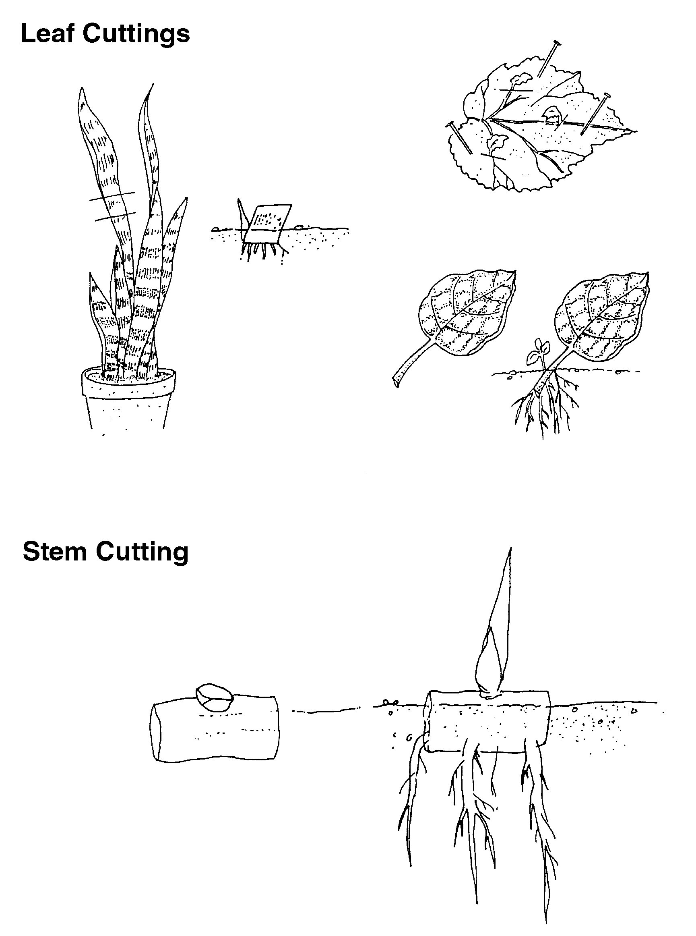

TM 5.5
Division

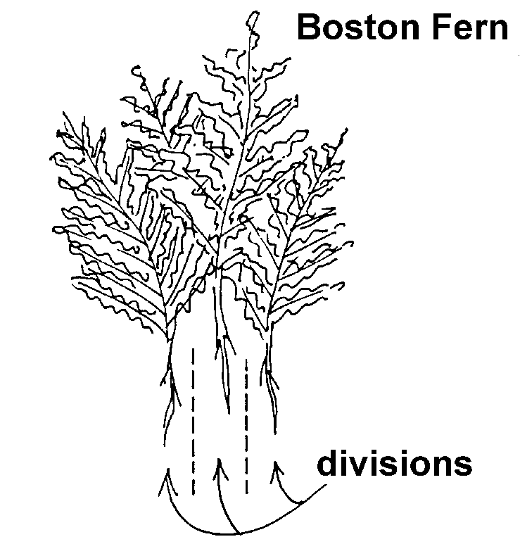

TM 5.6

Grafting

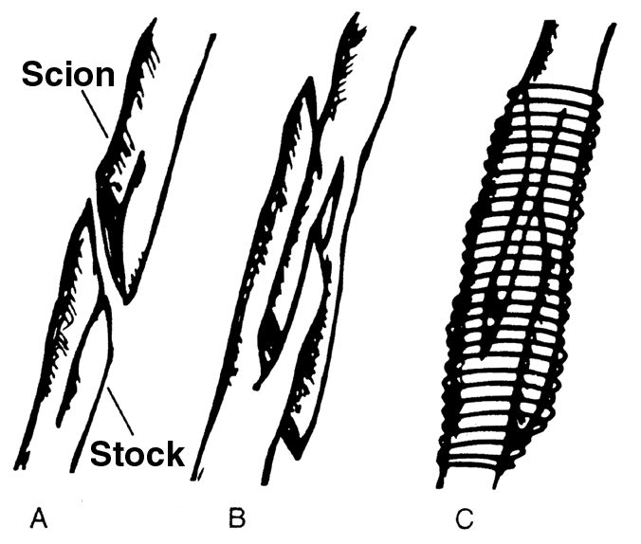

A - Stock and scion are prepared.

B - The two parts are unified.

C. - The graft is wrapped with waxed string.

Adapted from Boodley, James W. The Commercial Greenhouse, 2nd ed. Albany, NY: Delmar Publishers, 1996.

TM 5.7

Layering

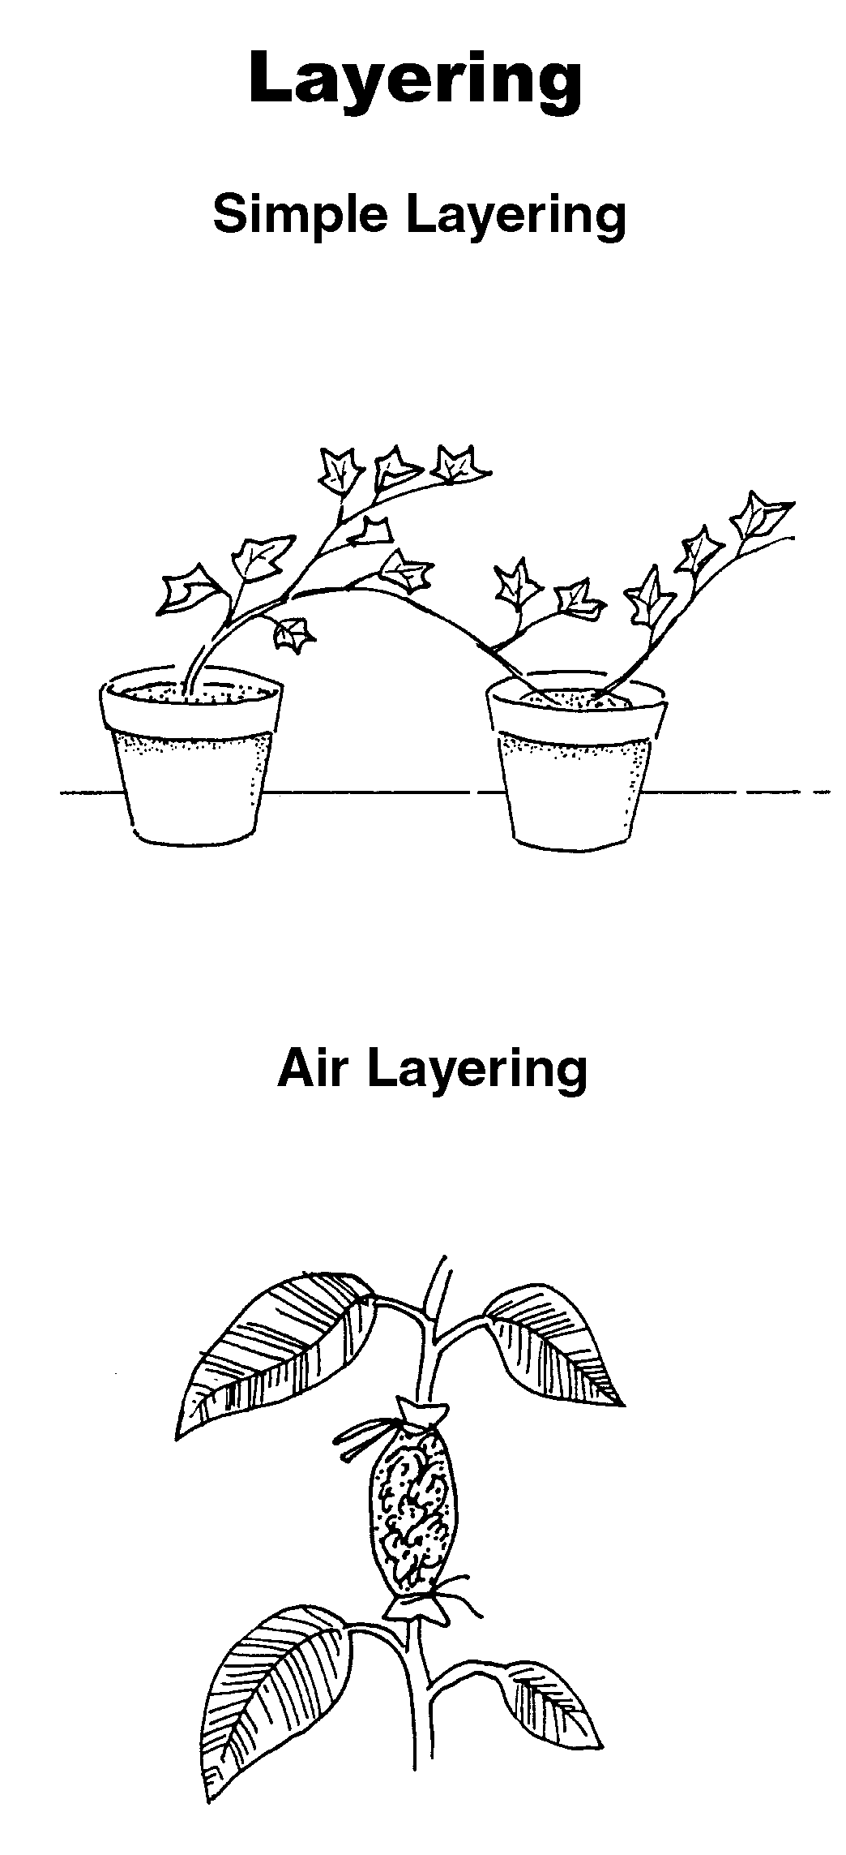

UNIT V: PLANT PROPAGATION AS 5.2

Lesson 2: Asexual Propagation Name___________________

Asexual Propagation

Objective: Demonstrate a method of asexual propagation.

Directions: Select a plant to propagate. Gather the growing medium, root hormone, a bulb duster, sharp knives, and dibble sticks. Label the plant and the method of propagation.

1. What is the common name of the plant?

2. What is its binomial nomenclature?

3. What is the preferred method of propagation for this plant?

4. What method of asexual propagation did you use?

5. What are the steps involved?

6. How long does it take for the plant to propagate?

UNIT V: PLANT PROPAGATION AS 5.3

Lesson 2: Asexual Propagation Name___________________

Budding and Tissue Culture

Objective: Differentiate between budding and tissue culture.

Directions: Answer the following questions about budding and tissue culture.

1. What is budding?

2. What steps are involved?

3. Budding is used on what type of plants? List at least three plants and give both the common name and binomial nomenclature.

Common Name Binomial Nomenclature

A. A.

B. B.

C. C.

4. Is this the only method applicable for this plant?

5. How cost-effective is it?

6. What is tissue culture?

7. What steps are involved?

8. What equipment is needed?

9. Any there other special considerations or needs for this method of propagation?

10. Tissue culture is used on what type of plants? List at least three plants and give both the common name and binomial nomenclature.

Common Name Binomial Nomenclature

A. A.

B. B.

C. C.

11. Is this the only method used for this plant?

12. How cost-effective is it?

13. What equipment is needed?

14. Does this method of propagation require any other special considerations or needs?

