GREENHOUSE MANAGEMENT AND OPERATION
Unit VI: Plant Health

Lesson 1: Greenhouse Pests and Diseases

Competency/Objective:

Identify pests and diseases in the greenhouse and factors that contribute to their presence.

Study Questions

1. What is a pest?

2. What are the most common insect and arachnid pests?

3. How do other pests affect greenhouse crops?

4. How do diseases affect greenhouse plants?

5. What are the most common diseases that affect greenhouse plants?

References/Supplies/Materials

1. Greenhouse Operation and Management (Student Reference). University of Missouri-Columbia: Instructional Materials Laboratory, 2002.

2. Transparency Masters

TM 6.1 Types of Mouth Parts
TM 6.2 Gradual Metamorphosis
TM 6.3 Complete Metamorphosis
TM 6.4 Aphid
TM 6.5 Fungus Gnat
TM 6.6 Mealybug
TM 6.7 Scale
TM 6.8 Thrips
TM 6.9 Whitefly
TM 6.10 Spider Mites
TM 6.11 Other Pests

3. Activity Sheets

AS 6.1 Path of Destruction Part I: Insects and Arachnids
AS 6.2 Path of Destruction Part II: Other Pests and Diseases
4. Entomology Identification Slides, University of Missouri-Columbia: Instructional Materials Laboratory, 1996 (catalog number 10-6110-X).

5. “Greenhouse Crop Pests and Their Natural Enemies.” (Slides and Script). Ohio, 1992. Available from University of Missouri-Columbia: Instructional Materials Laboratory (catalog number 10-6290-X).

6. “Pest Management and Identification.” University of California-Davis. <http://www.ipm.
ucdavis.edu/PMG/crops-agriculture.html>

7. UC IPM Online. <http://www.ipm.ucdavis.edu/>

TEACHING PROCEDURES

A. Introduction

A greenhouse is an artificial environment constructed to maximize prolific and speedy growth of plants. The optimal conditions of a greenhouse also attract unwanted living organisms that can devastate a crop. This unit describes types of pests, methods of control, and pesticide use and safety. Lesson 1 introduces students to the most prevalent pests and diseases that may inhabit a greenhouse.

B. Motivation

Ask students why greenhouses can be susceptible to pests and diseases. Challenge the class to defend why greenhouse owners should be able to identify various pests and diseases. Have students describe the types of pests that have ruined their own garden or crops.

C. Assignment of Study Questions

D. Supervised Study

Lead students in collecting the information needed to answer and discuss the study questions. The instructor may choose to work on one study question at a time or have students answer all the study questions before the discussion. Another option is to have students work in a cooperative learning environment and have groups work on different study question.

E. Discussion

Lead students in a discussion of the study questions. Supplement students’ responses and information with additional materials when needed.
1. What is a pest?

A pest is generally defined as a living organism that encroaches on the health and survival of another living thing, greenhouse crops in this instance. There are the seven types of interlopers most common in greenhouses.

A. A pest can be defined as anything (usually a living organism) that causes plant injury or loss.
B. The seven major pests are as follows.
1. Insects
2. Arachnids (mites, spiders, millipedes, centipedes)
3. Nematodes
4. Rodents and other mammals
5. Mollusks
6. Weeds
7. Disease

2. What are the most common insect and arachnid pests?

Aphids, fungus gnats, mealybugs, scale, thrips, whiteflies, and mites are the most common pests. The pests’ physical characteristics indicate the part of the plant the pest prefers and the type of damage it causes. These characteristics also help students identify the pest. Have students complete AS 6.1.

A. May attack various plant parts (e.g., vascular system, leaves, roots)
1. Interfere with plant function
2. Reduce rate of development
B. Characteristics (See TM 6.1.)
1. Knowing the types of mouth parts helps identify the pest.
a. Chewing
b. Piercing-sucking
c. Rasping-lapping
2. Identifying the life cycle helps the greenhouse owner know when to prevent or treat plants from invasion.
a. Gradual metamorphosis (See TM 6.2.)
b. Complete metamorphosis (See TM 6.3.)
c. No metamorphosis
C. Aphids (See TM 6.4.)
1. Green peach aphids - common greenhouse pest
2. Spread bacteria and viral disease
3. Insect - characteristics
a. Adult size: 1/25 -1/8 in. (1-3 mm)
b. Piercing-sucking mouth parts
4. Plant symptoms
a. New shoots stunted and distorted
b. Tiny yellow spots on foliage
c. Honeydew - food source for black sooty mold
D. Fungus gnats (See TM 6.5.)
1. Larvae, not adults, inflicting damage to plants
2. Can be confused with shore flies
3. Insect characteristics
a. Larvae size: 1/4 in. (6 mm); adult size: 1/8 in. (3 mm)
b. Larvae - chewing mouth parts
4. Plant symptoms
a. Stunted growth, lack of vigor
b. Wilted leaves
c. Leaf drop
d. Yellow foliage
E. Mealybugs (See TM 6.6.)
1. Insect - characteristics
a. Adult size: 1/8-3/8 in. (3-4 mm)
b. Piercing-sucking mouth parts
2. Plant symptoms
a. Loss of vigor
b. Yellow, deformed foliage
c. Leaf drop
d. Give off honeydew
F. Scale (See TM 6.7.)
1. Insect - characteristics
a. Adult size: 5/16 in. (8 mm)
b. Piercing-sucking mouth parts
c. Round, hard shell with waxy, rubbery coating
2. Plant symptoms
a. Lack of vigor; stunted growth
b. Yellowing leaves
c. Leaf drop
d. Give off honeydew
G. Thrips (See TM 6.8.)
1. Spread disease among plants
2. Insect - characteristics
a. Adult size: 1/25 in. (1 mm)
b. Rasping-lapping mouth parts
3. Plant symptoms
a. Malformed new growth and flowers
b. Streaking and browning of flower petals
c. Leaf and flower drop
H. Whiteflies (See TM 6.9.)
1. Spread disease among plants
2. Insect - characteristics
a. Adult size: 1/16 in. (2 mm)
b. Piercing-sucking mouth parts
3. Plant symptom: tiny yellow spots on foliage called honeydew
I. Mites (See TM 6.10.)
1. Difficult to control
2. Cause severe economic damage
3. Arachnid - characteristics
a. Less than 1/50 in. long (0.50 mm)
b. Piercing-sucking mouth parts
4. Plant symptoms
a. Tiny, yellow spots/bronze-colored foliage
b. Curled leaves
c. Tiny webs that brown leaves (spider mites)

3. How do other pests affect greenhouse crops?

Insects and arachnids are not the only pests that attack greenhouse crops. Invertebrates like nematodes, snails, and slugs, mammals such as rodents and birds, as well as weeds may also attack plants. Ask students to predict the type of damage these pests might inflict. See TM 6.11. Have students complete AS 6.2.

A. Nematodes
1. Wormlike invertebrates
2. Plant parasite that lives in soil
3. Usually harmless to plants but may penetrate root cells, giving fungi and bacteria an opportunity to enter
B. Rodents, birds, and other animals
1. May eat plant parts
2. May dig up soil
C. Snails and slugs
1. Nocturnal
2. Feed on leaves and young stems, leaving slimy trail behind
D. Weeds (defined as any unwanted plant growing out of place)
1. Create competition with cultivated plants for space, light, water, and nutrients
2. May harbor pests and disease that can spread to cultivated plants

4. How do diseases affect greenhouse plants?

Diseases in greenhouses can be separated into two varieties: those with cultural causes and those with parasitic causes. Ask the students to differentiate between viruses, bacteria, and fungi. How are these diseases spread?

A. Types of disease
1. Cultural - caused by chemicals, nutrient deficiencies, damage to plant parts, and inadequate environmental conditions
2. Parasitic - caused by microorganisms
B. Organisms that cause disease
1. Viruses
a. Most difficult type of disease to control and treat
b. May cause stunted growth or death
c. Usually attack plants’ vascular system
d. Spread by equipment, sucking insects, asexual propagation
2. Bacteria - entering plant through openings in plant epidermis
3. Fungi
a. Most common source of plant disease
b. Fungal spore growth on and in plants
c. Spread via air, insects, and water
C. Sources of disease
1. Infected soil
2. Debris from previous crops
3. Water
4. Air
5. Plant tissue from cuttings and other plants

5. What are the most common diseases that affect greenhouse plants?

Seedlings, foliage, and roots are the parts of plants that are the most vulnerable to common
greenhouse diseases. Greenhouse owners must be attentive to humidity and excess water, which can
create an environment that is conducive to disease.

A. Damping-off
1. Caused by Phytophthora or Rhizoctonia fungi
2. Common with seedlings
3. Fungi originating in soil or on seed
4. Plant symptoms
a. Preemergence: Seed is destroyed before germination.
b. Postemergence: Seedling is destroyed at soil level.
B. Botrytis blight (gray mold)
1. Caused by fungi
2. Costly disease of greenhouse crops
3. Requires a cool, humid environment to grow
4. Plant symptoms
a. Gray spots appear on foliage.
b. Tissue under spots turns soft, brown, then rotted.
C. Leaf spot and other foliar diseases
1. Caused by bacteria or fungi
2. If caused by fungi, can be treated; if caused by bacteria, must discard plant
3. Grows in humid environments
4. Plant symptoms
a. Discolored leaves
b. Distorted leaves
D. Root rot disease
1. Caused by bacteria or by Pythium and Phytophthora fungi
2. Most common cause of houseplant death
3. Overwatering: allowing fungi and bacteria to enter root system; decreasing uptake of water and dissolved nutrients by root hairs
4. Plant symptoms
a. Roots are brown or black and few in number.
b. Roots are slimy and have a foul odor.
c. Foliage exhibits yellow, wilted leaves and leaf drop.

F. Other Activity and Strategy

Invite an entomologist to discuss various greenhouse pests and to assess whether some are more likely to be found in your location. In addition, ask the scientist to describe any pests not described in this lesson that might live in your area. Request large color photos of the pests, if possible, and a unit of measure to demonstrate how small the pests are.

G. Conclusion

Common pests and diseases can attack plants in greenhouses. Several environmental factors can make the greenhouse susceptible to pests. Each pest and disease affects crops in different ways.

H. Answers to Activity Sheets

AS 6.1 Path of Destruction Part I: Insects and Arachnids

Instructor’s discretion

AS 6.2 Path of Destruction Part II: Other Pests and Diseases

Instructor’s discretion

I. Answers to Assessment

1. Students may list any three of the following:
A. Damping-off; origin - fungi
B. Botrytis blight (gray mold); origin - fungi
C. Foliar diseases, e.g., leaf spot; origin - bacteria or fungi
D. Root rot; origin - bacteria or fungi
2. A. Insects,
B. Arachnids
C. Mollusks
D. Nematodes
3. Students may list any four of the following:
A. Infected soil
B. Debris from previous crop
C. Water
D. Air
E. Infected plant tissue
4. Penetrates root cells, giving fungi and bacteria an entrance to plants.
5. A
6. A
7. B
8. D
9. C
10. B

UNIT VI: PLANT HEALTH Name___________________

Lesson 1: Greenhouse Pests and Diseases Date____________________

ASSESSMENT

Short-Answer Questions: Write the answers in the space provided.

1. What are three common diseases in the greenhouse setting and where do they come from?

Disease Origin

A. A.

B. B.

C. C.

2. Rodents, birds, weeds, and disease can attack greenhouse crops. What are four other pests?

A.

B.

C.

D.

3. What are four sources of disease within the greenhouse environment?

A.

B.

C.

D.

4. What damage can a nematode cause?

Multiple Choice: Circle the letter of the best answer.

5. What symptoms are evident on a plant from an insect with a piercing-sucking mouth part?

A. Yellow foliage and honeydew
B. Honeydew and curled leaves
C. Tiny webs and bronze colored foliage
D. Leaf drop and stunted growth

6. What damage does an insect with rasping-lapping mouth parts leave on a plant?

A. Streaking and browning of flower petals
B. Honeydew and yellow spots on foliage
C. Curled leaves and tiny webs
D. Lack of vigor and leaf drop

7. Which pest is difficult to control and causes economic damage?

A. Thrips
B. Mites
C. Aphids
D. Mealybugs

8. Which disease causes economic hardship for the greenhouse owner?

A. Root rot
B. Damping-off
C. Leaf spot
D. Botrytis

9. What is the most common source of disease in plants?

A. Parasites
B. Viruses
C. Fungi
D. Bacteria

10. What type of pest has chewing mouth parts?

A. Fungus gnat adult
B. Fungus gnat larvae
C. Mealybug adult
D. Mealybug larva

TM 6.1

Types of Mouth Parts

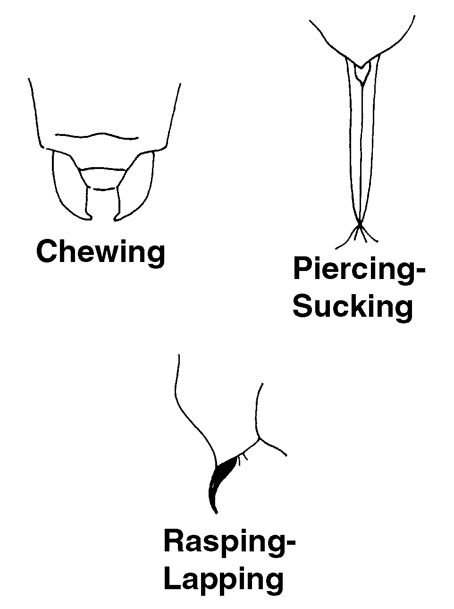

TM 6.2

Gradual Metamorphosis

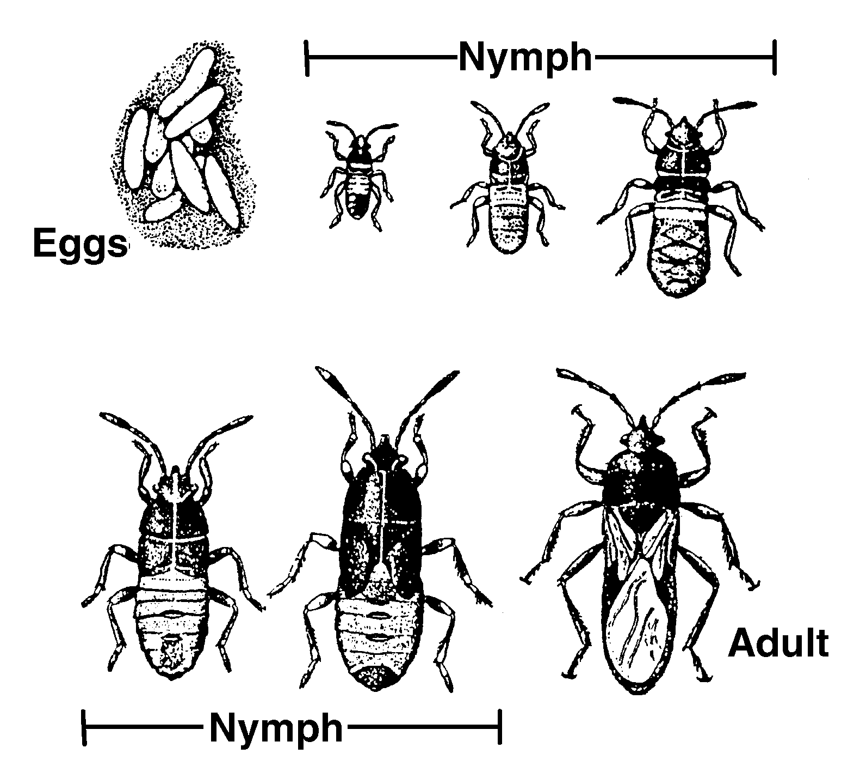

TM 6.3

Complete Metamorphosis

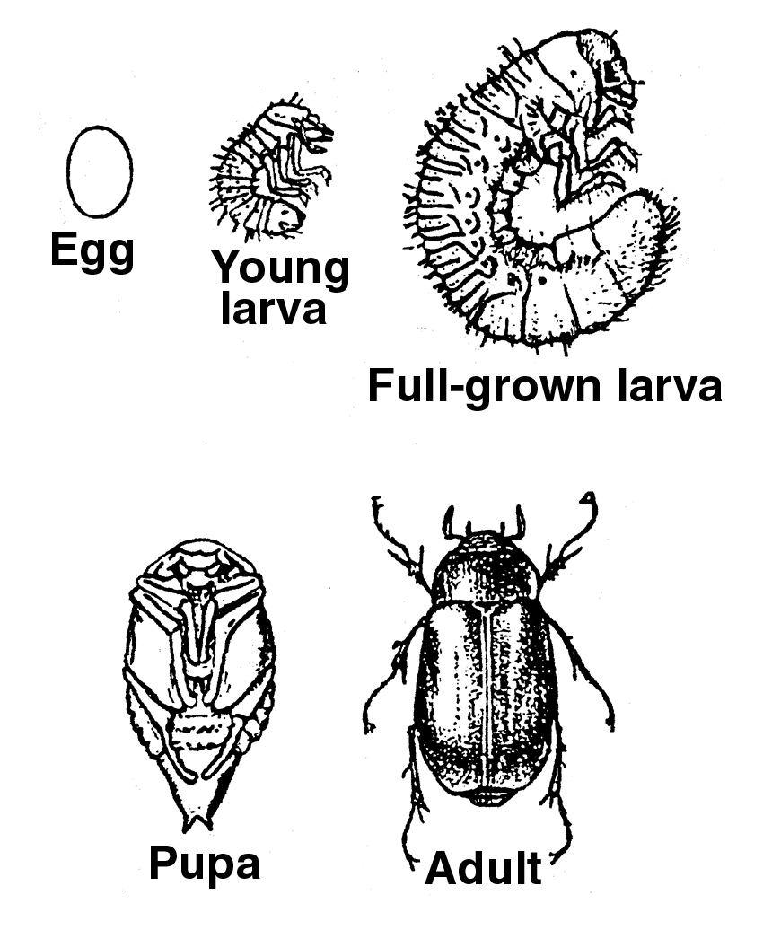

TM 6.4

Aphid

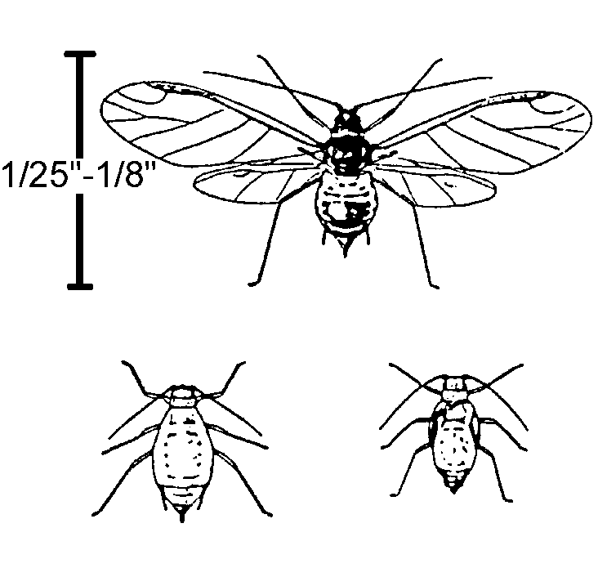

TM 6.5

Fungus Gnat

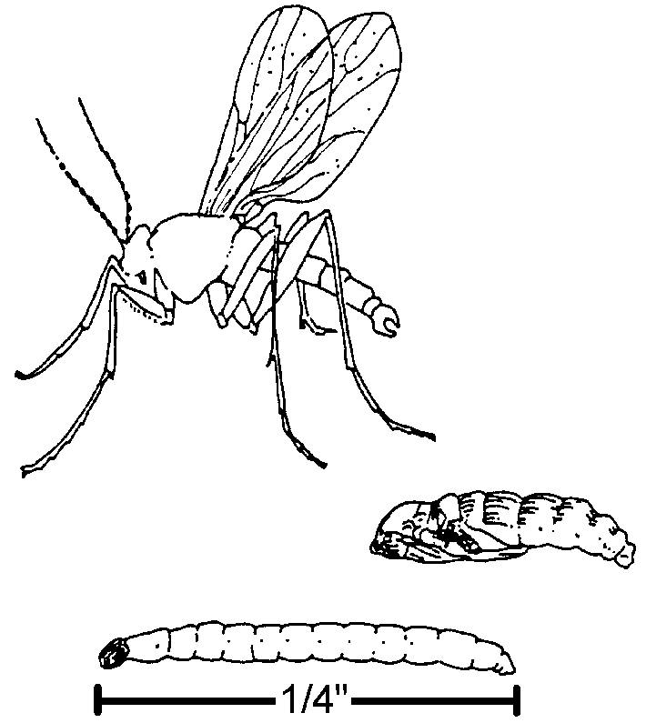

TM 6.6

Mealybug

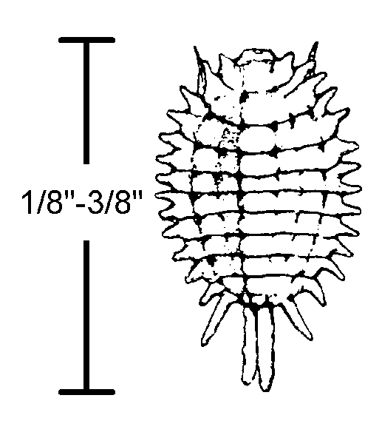

TM 6.7

Scale

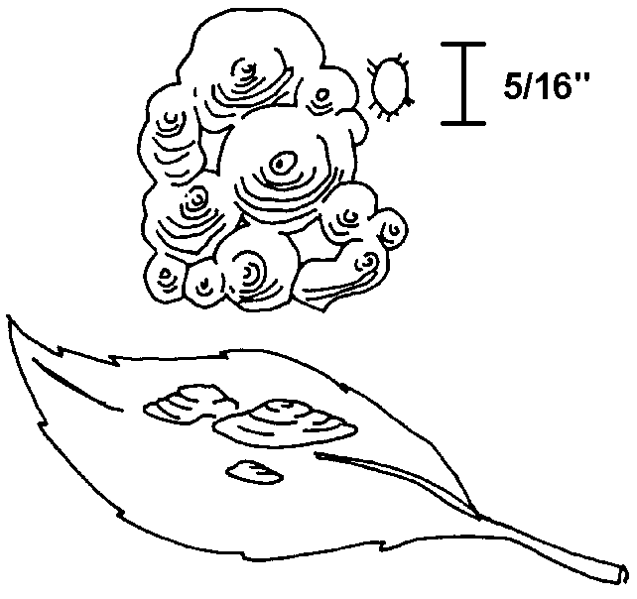

TM 6.8

Thrips

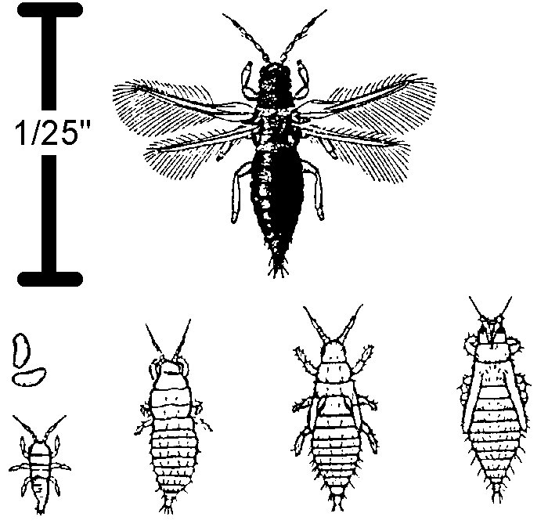

TM 6.9

Whitefly

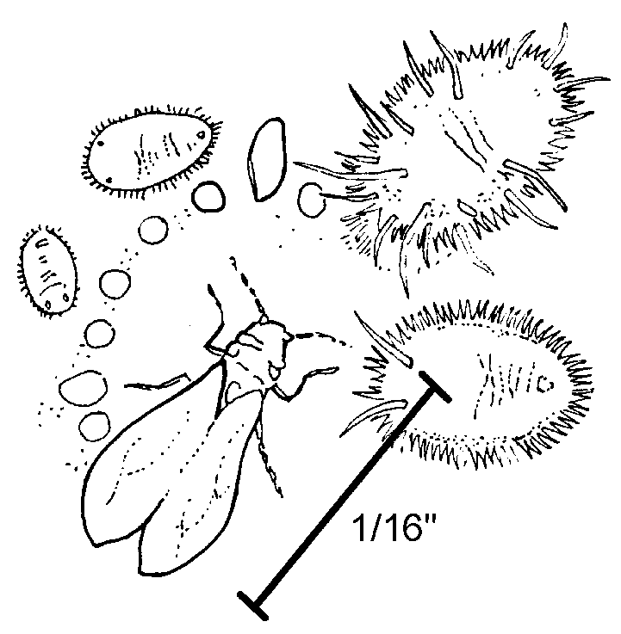

TM 6.10

Spider Mite

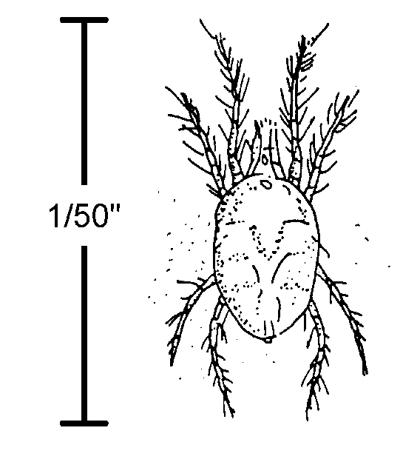

TM 6.11

Other Pests

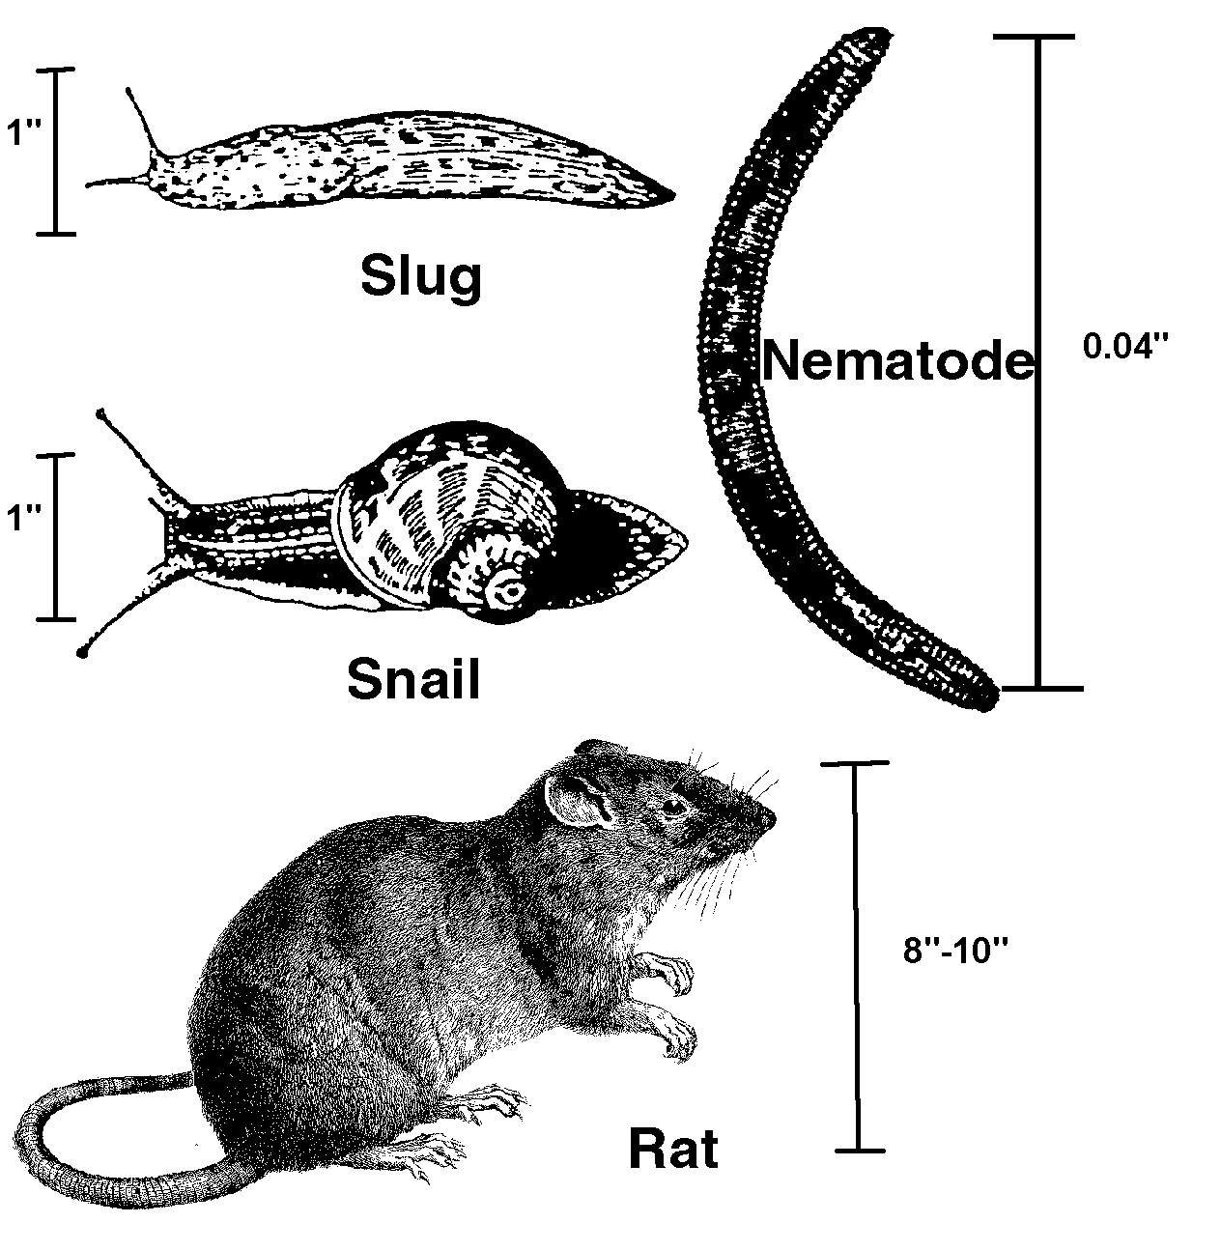

UNIT VI: PLANT HEALTH AS 6.1

Lesson 1: Greenhouse Pests and Diseases Name ________________________

Path of Destruction Part I: Insects and Arachnids

Objective: Compile illustrations of the devastation caused by insects and arachnids on greenhouse-

grown plants.

Directions: In small groups, gather photographs, pictures, or create color illustrations of damage from aphids, mites, whiteflies, thrips, scale, mealybugs, and fungus gnats. You may create a poster or PowerPoint presentation. Please provide the following information for each illustration.

1. What are the common names of the pests?

2. Are these pests arachnids, insects, or mollusks?

3. What type of mouth parts do they have?

4. Write a description of the damage each pest inflicts.

UNIT VI: PLANT HEALTH AS 6.2
Lesson 1: Greenhouse Pests and Diseases Name __________________

Path of Destruction Part II: Other Pests and Diseases

Objective: Compile illustrations of the devastation caused by other pests and diseases on greenhouse-grown plants.

Directions: In small groups, gather photographs, pictures, or create color illustrations of damage from nematodes, rodents, snails, slugs, damping off, Botrytis blight, foliar diseases, and root rot. You may create a poster or PowerPoint presentation. Provide the following information for each illustration.

1. What name or names are the pests or diseases known by?

2. Are the pests nematodes, mammals, mollusks, or diseases?

3. Write a description of the damage each pest or disease inflicts.

4. What are some precautions that can be taken to avoid introducing the pests and diseases into a greenhouse?

