Unit #1 Title: Skills for School Success

Lesson Title: Body Basics Lesson: 1 of 2

Grade Level: K

Length of Lesson: 30 Minutes

Missouri Comprehensive Guidance and Counseling Domain:
AD.6: Developing and monitoring Personal Plan of Study

Grade Level Standard (GLS):
AD.6.A.01.a. Demonstrate the skills needed to be a successful learner.

American School Counselor Association (ASCA) National Standard:
Academic Development
A. Students will acquire the attitudes, knowledge and skills contributing to effective learning in school and across the lifespan.

Materials (include activity sheets and/ or supporting resources)
Lyrics to song
Flash Card Pictures (One set for each pair of students.)
Partnering Bracelets
Song/Flash card sheet for each student

Show Me Standards: Performance Goals (check one or more that apply and identify relevant process standards)
 | Goal 1: Gather, analyze and apply information and ideas
X | Goal 2: Communicate effectively within and beyond the classroom
 | Goal 3: Recognize and solve problems
X | Goal 4: Make decisions and act as responsible members of society

This lesson supports the development of skills in the following academic content areas.
Academic Content Area(s) Specific Skill(s)
X | Communication Arts | 5. Comprehending and evaluating the content and artistic aspects of oral and visual presentations.  6. Participating in formal and informal presentations and discussions of issues and ideas.
 | Mathematics
 | Social Studies
 | Science
 | Health/Physical Education
 | Fine Arts

Enduring Life Skill(s)
 | Perseverance | X | Integrity | X | Problem Solving
 | Courage |  | Compassion |  | Tolerance
X | Respect |  | Goal Setting

Lesson Measurable Learning Objectives:
The student will follow a visual instruction three times.

Lesson Formative Assessment (acceptable evidence):
Assessment should relate to the performance outcome for goals, objectives and GLS’s. Assessment can be question answer, performance activity, etc.

Performance Task: Students will demonstrate their understanding of basic body skills by successfully performing actions written in visual format on flash cards presented by the counselor.

Lesson Preparation
Essential Questions:
What does it look like to be a successful learner?

Engagement (Hook):
Let’s sing London Bridge is Falling Down. (Counselor leads students in singing.) Today we will learn new words to this song.

Procedures
Instructor Procedures/Instructional Strategies:  1. Counselor displays the flash cards for students to reference during teaching of song.  2. Counselor teaches students the Body Basics song. Make up actions for each part of song and use actions while singing. (Eyes on teacher could be making circles with finger and thumb and holding them up to eyes like glasses; Hands to self could be placing hands in lap; Crisscrossed legs could be rhythmically patting hands on knees with legs in crisscrossed position; and raise your hand and wait could be hand raised, etc.)  3. When students are able to perform song independently, counselor places partnering bracelets on students while they continue to sing.  4. Counselor instructs the students to find their partner, and sit with that partner. Students partner themselves by matching symbol bracelets.  For example, students with stars on bracelets partner up and students with circles on bracelets partner up. For example, one partner will have a large symbol of a star and the matching student will have a small symbol of a star. Students will find their partners by matching symbols. After completion of flash card set, the students will switch roles.  5. Counselor passes out the flash cards.  (One set for each pair of students.)  6. Teacher says, “Hold up the flash card titled Eyes on Teacher When She Talks. What do we look like when we remember eyes on teacher?”  7. Counselor proceeds in the same manner with subsequent cards, saying, “What does ‘hands to self’ look like? What does ‘raise your hand’ look like? What do ‘crisscrossed legs’ look like?”  8. Counselor instructs student with larger symbol to pass the flash cards to partner with smaller symbol. Repeat process outlined above (steps 6-8).  9. Counselor collects the cards at the end of the activity and instructs the students to return to group gathering area.  10. Counselor repeats the process holding flash cards for entire group to demonstrate simultaneously. Counselor records number of students with correct response to cards on the scoring chart.  11. After group assessment is completed the Counselor instructs students to sing Body Basics song as a closing activity.  12. Counselor instructs students to return to their seats and leaves students/teacher with color page that consists of the four flash cards for the teacher to display and for the students to color/display/take home. | Student Involvement/Instructional Activities:  1. Students look at flash card pictures.  2. Students learn song, and sing. (Students perform actions for each part of song.)  3. Students sing while teacher is placing bracelets on their wrists.  4. Students sit with (bracelet) partner.  5. Student with larger symbol holds the flash cards. The student with the larger symbol will quiz the student with the smaller symbol first. The student will act out the flash card (using the actions in the song) for a correct response.  6. Students demonstrate their knowledge of what eyes on teacher looks like by looking at the teacher and doing the action learned in song.  7. Students demonstrate each flash card in turn, by doing the actions learned in the song for each flash card.  8. Students repeat process with other partner holding cards.  9. Students give counselor cards and return to group gathering area.  10. Students participate in group assessment.  11. Students sing song.  12. Students return to their seats.

Teacher Follow-Up Activities
1. Students may color flash card pages and they can be used to repeat the flash card game or can be displayed in the classroom as a reminder of the skills of a successful learner.

2. Students may continue to sing the Body Basics song for morning openings with their teacher.

3. Students might choose to take the flash cards home in order to practice Body Basics at the supper table.

4. The teacher may also want to teach the group a Line Basics song to help students walk in the hallways appropriately. Using the same tune, write words that would instruct the students the appropriate skills for walking in the hall; lining up for lunch; etc.

Counselor reflection notes (completed after the lesson)
Body Basics Song:
(Sung to the tune of London Bridge is Falling Down)
Written by: Annie Moffatt

Eyes on teacher when she (he) talks,
when she (he) talks,
when she (he) talks.
Eyes on teacher when she (he) talks,
we are learners.

Crisscrossed legs and hands to self,
hands to self,
hands to self.
Crisscrossed legs and hands to self,
we are learners.

Raise your hand and wait to speak,
wait to speak,
wait to speak,
Raise your hand and wait to speak,
we are learners.

Body Basics Flash Cards

(Option of enlarging on photo-copy machine and adding cardboard backing for strength.)

Eyes on Teacher  When She Talks | Crisscross Legs  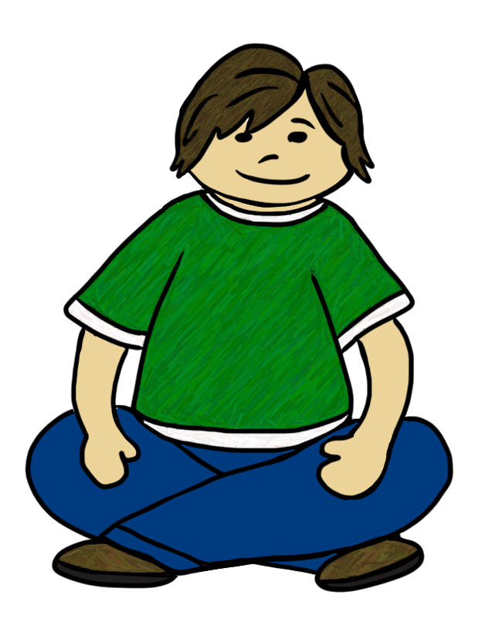
Hands to Self  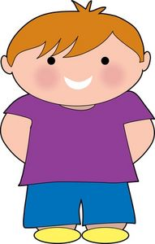 | Raise your Hand and Wait to Speak

Scoring Chart
Body Basics  Behavioral Expectation | Number of Students demonstrating correct response. | Percentage of students with correct response.
Eyes on Teacher
Crisscross Legs
Hands to Self
Raise Hand and Wait

Partnering Bracelets












































❐
❐

