Unit #1 Title: Let’s Investigate

Lesson Title: Putting the Clues Together-- Jonny’s Portfolio Lesson: 2 of 2

Grade Level: 5

Length of Lesson: 45 minutes

Missouri Comprehensive Guidance and Counseling Domain:
CD.9: Applying skills for career readiness and success

Grade Level Standard (GLSs):
CD.9.A.05.a.i: Apply personal, ethical, and work habit skills needed for success in any school or work environment.
CD.9.B.05.a.i: Identify the skills needed to develop a portfolio.

American School Counselor Association (ASCA) National Standard:
Career Development
A: Students will acquire the skills to investigate the world of work in relation to knowledge of self and to make informed career decisions
B: Students will employ strategies to achieve future career goals with success and satisfaction

Materials (include activity sheets and/ or supporting resources)
Example materials for Jonny/Jenny Jones
File folders for example materials
Activity Sheet: How Did Jonny Do?
Folders for students

Show Me Standards: Performance Goals (check one or more that apply)
X | Goal 1: Gather, analyze and apply information and ideas  2. Conduct research to answer questions and evaluate information and ideas
X | Goal 2: Communicate effectively within and beyond the classroom  2. Review and revise communications to improve accuracy and clarity  6. Apply communication techniques to the job search and to the workplace
X | Goal 3: Recognize and solve problems  2. Develop and apply strategies based on ways others have prevented or solved problems  3. Develop and apply strategies based on one’s own experience in preventing or solving problems
X | Goal 4: Make decisions and act as responsible members of society  1. Explain reasoning and identify information used to support decisions  4. Recognize and practice honesty and integrity in academic work and in the workplace  5. Develop, monitor and revise plans of action to meet deadlines and accomplish goals

This lesson supports the development of skills in the following academic content areas.
Academic Content Area(s) Specific Skill(s)
X | Communication Arts | 6. Participating in formal and informal presentations and discussions of issues and ideas
 | Mathematics
 | Social Studies
 | Science
 | Health/Physical Education
 | Fine Arts

Enduring Life Skill(s)
 | Perseverance | X | Integrity | X | Problem Solving
 | Courage |  | Compassion |  | Tolerance
 | Respect |  | Goal Setting

Lesson Measurable Learning Objectives
The students will apply personal, ethical, and work habit skills needed for success in any school or work environment.
The student will identify and apply the skills needed to develop a portfolio.
The student will demonstrate understanding by compiling a personal portfolio that incorporates materials discussed during the unit lessons.

Lesson Formative Assessment (acceptable evidence):
Assessment should relate to the performance outcome for goals, objectives and GLSs. Assessment can be question answer, performance activity, etc.

The student will demonstrate an understanding of personal, ethical, and work habit skills through group discussion.
The student will demonstrate an understanding of the materials commonly stored in a personal portfolio.

Lesson Preparation
Essential Questions:
What are personal, ethical, and work habit skills that students can develop and/or improve upon?
What do the materials in your portfolio say about you?

Engagement (Hook):
The counselor comes into the classroom, looking somewhat harried and distracted. “Students, I have so much to do today. One of my students has asked me to check through his portfolio and let me know what I think about his work so far. I would really appreciate your help with this project.”

NOTE: Before the lesson, prepare portfolios with cut out materials from Jonny Jones. Crumple up one of the papers, and flatten it out so that the paper is creased.

Procedures
Instructor Procedures/Instructional Strategies:  - Divide students into work groups of three to four students each. Give each group a folder, containing the materials for Jonny/Jenny Jones.  “Jonny and Jenny Jones are twins in the fifth grade. Jonny has brought his portfolio folder in for me to review. A portfolio is a folder, binder, or other file that holds a collection. A student portfolio should contain examples of materials that would give someone an idea of what type of student and worker Jonny is.”  - “Our job today is to review the materials in Jonny’s portfolio and decide what story his papers would tell us, if we were thinking about hiring him for an after-school job. A form is enclosed in Jonny’s folder, so that you can take notes on your findings.”  Check for understanding, then have students begin task.  - Once students have completed the task, they will discuss their findings with the class. There may be some disagreement among the groups, such as, was Jenny’s award placed in Jonny’s portfolio by mistake? Or did Jonny take her award?  - Once discussion is complete, review the items commonly found in portfolios. Distribute folders for students to use to begin compiling their own personal portfolios. Designate an area, either in the classroom or the counselor’s office where files will be stored, yet students can still have access. | Student Involvement/Instructional Activities:  - Students will move into work groups and listen to the story of Jonny.  - Students will then complete the activity sheet, How Did Jonny Do?.  - Students will contribute to the discussion.  - Students will list possible items that they may want to place in their portfolios.

Teacher Follow-Up Activities
Remind students that the portfolios are available for them to store copies of important documents.

Counselor reflection notes (completed after the lesson)

How Did Jonny Do?

Most portfolios contain the following items. Does Jonny’s portfolio contain these?
(Check off those you find.)

- Awards and certificates
- Honor Roll information
- Grade reports
- Career inventories and research
- Sample projects/papers

What story do Jonny’s papers tell you?
Work Habits:
1. Is Jonny a careful worker? Yes No
What are your clues?

2. Do you think Jonny will show up to work every day? Yes No
What are your clues?

4. Do you think Jonny takes pride in his work and always tries his best? Yes No
What are your clues?

Personal Skills:
5. Do you think Jonny is a caring person? Yes No
What are your clues?

6. Do you think that Jonny always does the right thing? Yes No
What are your clues?

Ethical Skills:
7. Do you think Jonny is honest? Yes No
What are your clues?

8. Do you think Jonny can be trusted to finish a job? Yes No
What are your clues?

What advice would you give Jonny if he asked you for help?

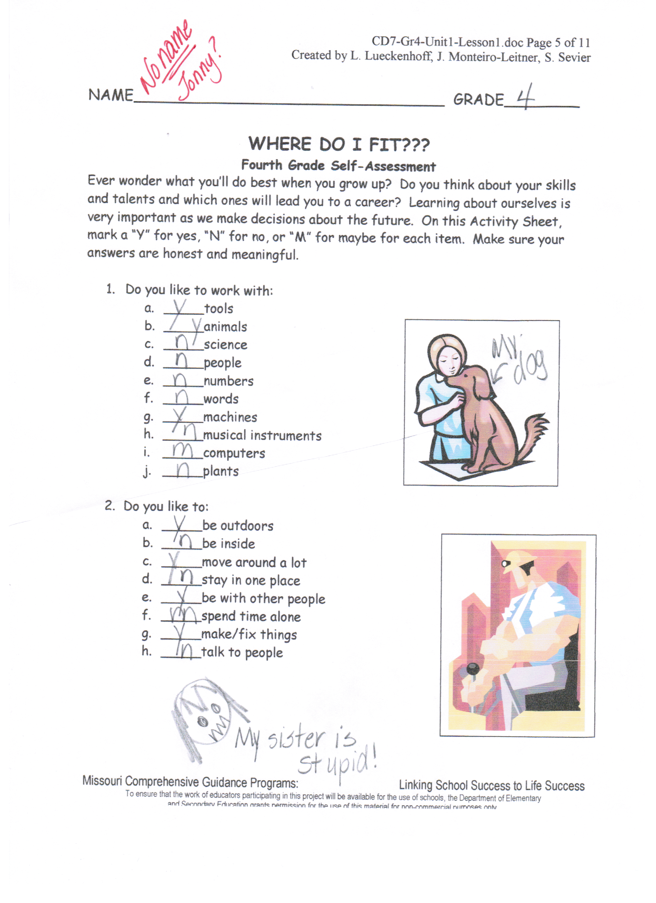
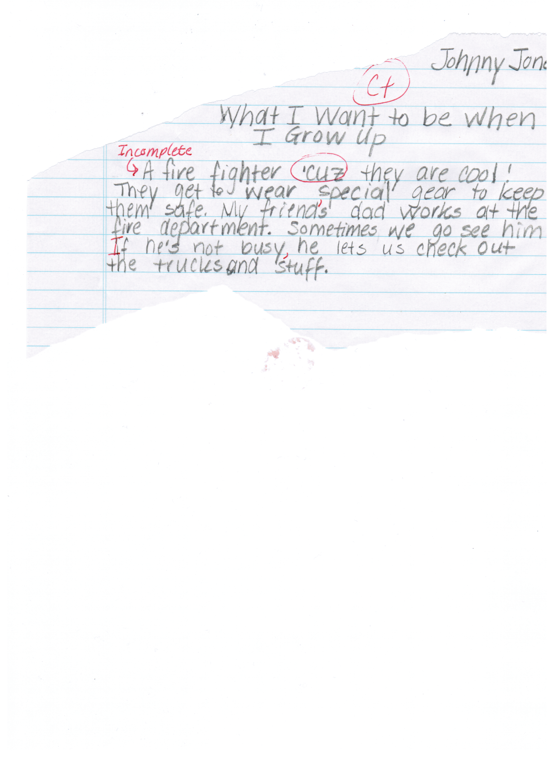

This award is presented to:

Jenny Jones

For

Perfect attendance 1st quarter

Mary Lamb - Principal
1st Quarter Grade Report for:
Jonny Jones

Subject Grade Teacher Comment
Reading B
Language Arts C Late or Missing Assignments
Math D Late or Missing Assignments
Science B
Social Studies B

Attendance: 6 days missed out of 44 days possible

