TABLE OF CONTENTS
STUDENT THINKING PAPERS AND PSC-STUDENT RESOURCES

STRAND: PERSONAL & SOCIAL DEVELOPMENT (PS)
GRADES K-3

This document contains resources to support student learning of the concepts within the Curriculum Framework of the Missouri Comprehensive Guidance Program (MCGP). Each lesson in the series of Missouri Comprehensive Guidance Program Supplemental Lessons includes resources to support student learning; however, the supporting materials are appropriate for use with other classroom guidance lessons teaching the same MCGP concept. This document was developed to allow easy access to the supporting materials. Slight modifications may be required.
The Table of Contents identifies the MCGP Strand, Big Idea and Concept code as well as the title of each lesson. Resources are identified as: PSC Resources (support for Professional School Counselors); Student Thinking Papers (student materials to stretch/apply their thinking skills); Student Resources (Resources for students to keep in a “handy-place” for reference. A few resources are designated as PSC/Student Resources—these are references/guides for both PSCs and students.

K-3 PERSONAL AND SOCIAL DEVELOPMENT

PS.1.B. Experimenting with Anger (2 lessons)
Lesson 1: Recognizing/Understanding Feelings of Anger
No print materials required.
Lesson 2: Feeling Angry is OK: Exploding is NOT!
No print materials required

PS.1.B. I Like to… (1 Lesson)
Materials:
Student Thinking Papers:
My Leisure Time List
Leisure Time: Possibilities

PS.1.B. I’ll Do My Share K-3 (2 Lessons)
Lesson 1: Families/Responsibilities/Roles
No print materials required
Lesson Two: Make a My Share Commitment
Materials:
Student Thinking Paper
My Commitment to Do My Share to Help My Family Have More Free Time

PS.2.B. Circles of Cooperation 1-3 (1 Lesson)
Materials:
Thinking Paper
Learning and Application: Circles of Cooperation

PS.2.B. We Are: Like All Others, Like Some Others AND Different from All Others (1 lesson)
Materials:
Thinking Papers
A Few of My Favorite Things
A Few of Our Favorite Things

PS.2.B. Self-Control K-3 (1 lesson)
No print materials required

PS.3.A. I Know How to Say “NO”, I Say “NO”, I Know the Consequences of Saying “NO” 3-5 (4 Lessons)
Lesson 1: I Can Say “No”
Materials:
Student Resource
How to Say “No"
Lesson 2: I Say “NO!” To My Friends!
No print materials required
Lesson 3: I Said "No" To a Friend! Now What Do I Do?
Materials:
Student Thinking Paper
Potential Consequences of Saying “No"
Lesson 4: The Consequences of the Consequences: How do I Cope?
Materials:
Student Resource
Pocket Guide for “How to Say ‘NO”’ Student Resource

PS.3.A. Creative Choices K-3 (1 Lesson)
No print materials required

PS.3.A. Mistakes K-3 (1 Lesson)
No print materials required

PS.3.A, B, C Where to Turn…Who can Help? (2 lessons)
Lesson 1: Where to Turn/Who Can Help?
Materials:
Student Thinking Paper
Where to Turn
Lesson 2: Calling 911
Materials:
PSC Resources:
Teaching Students to Call 911
Emergency Situations
Student Resources:
Using 911 to Get Help
Calling 911: A Checklist

Concept: PS.1.B Balancing Life Roles (Leisure)

MY LEISURE TIME LIST

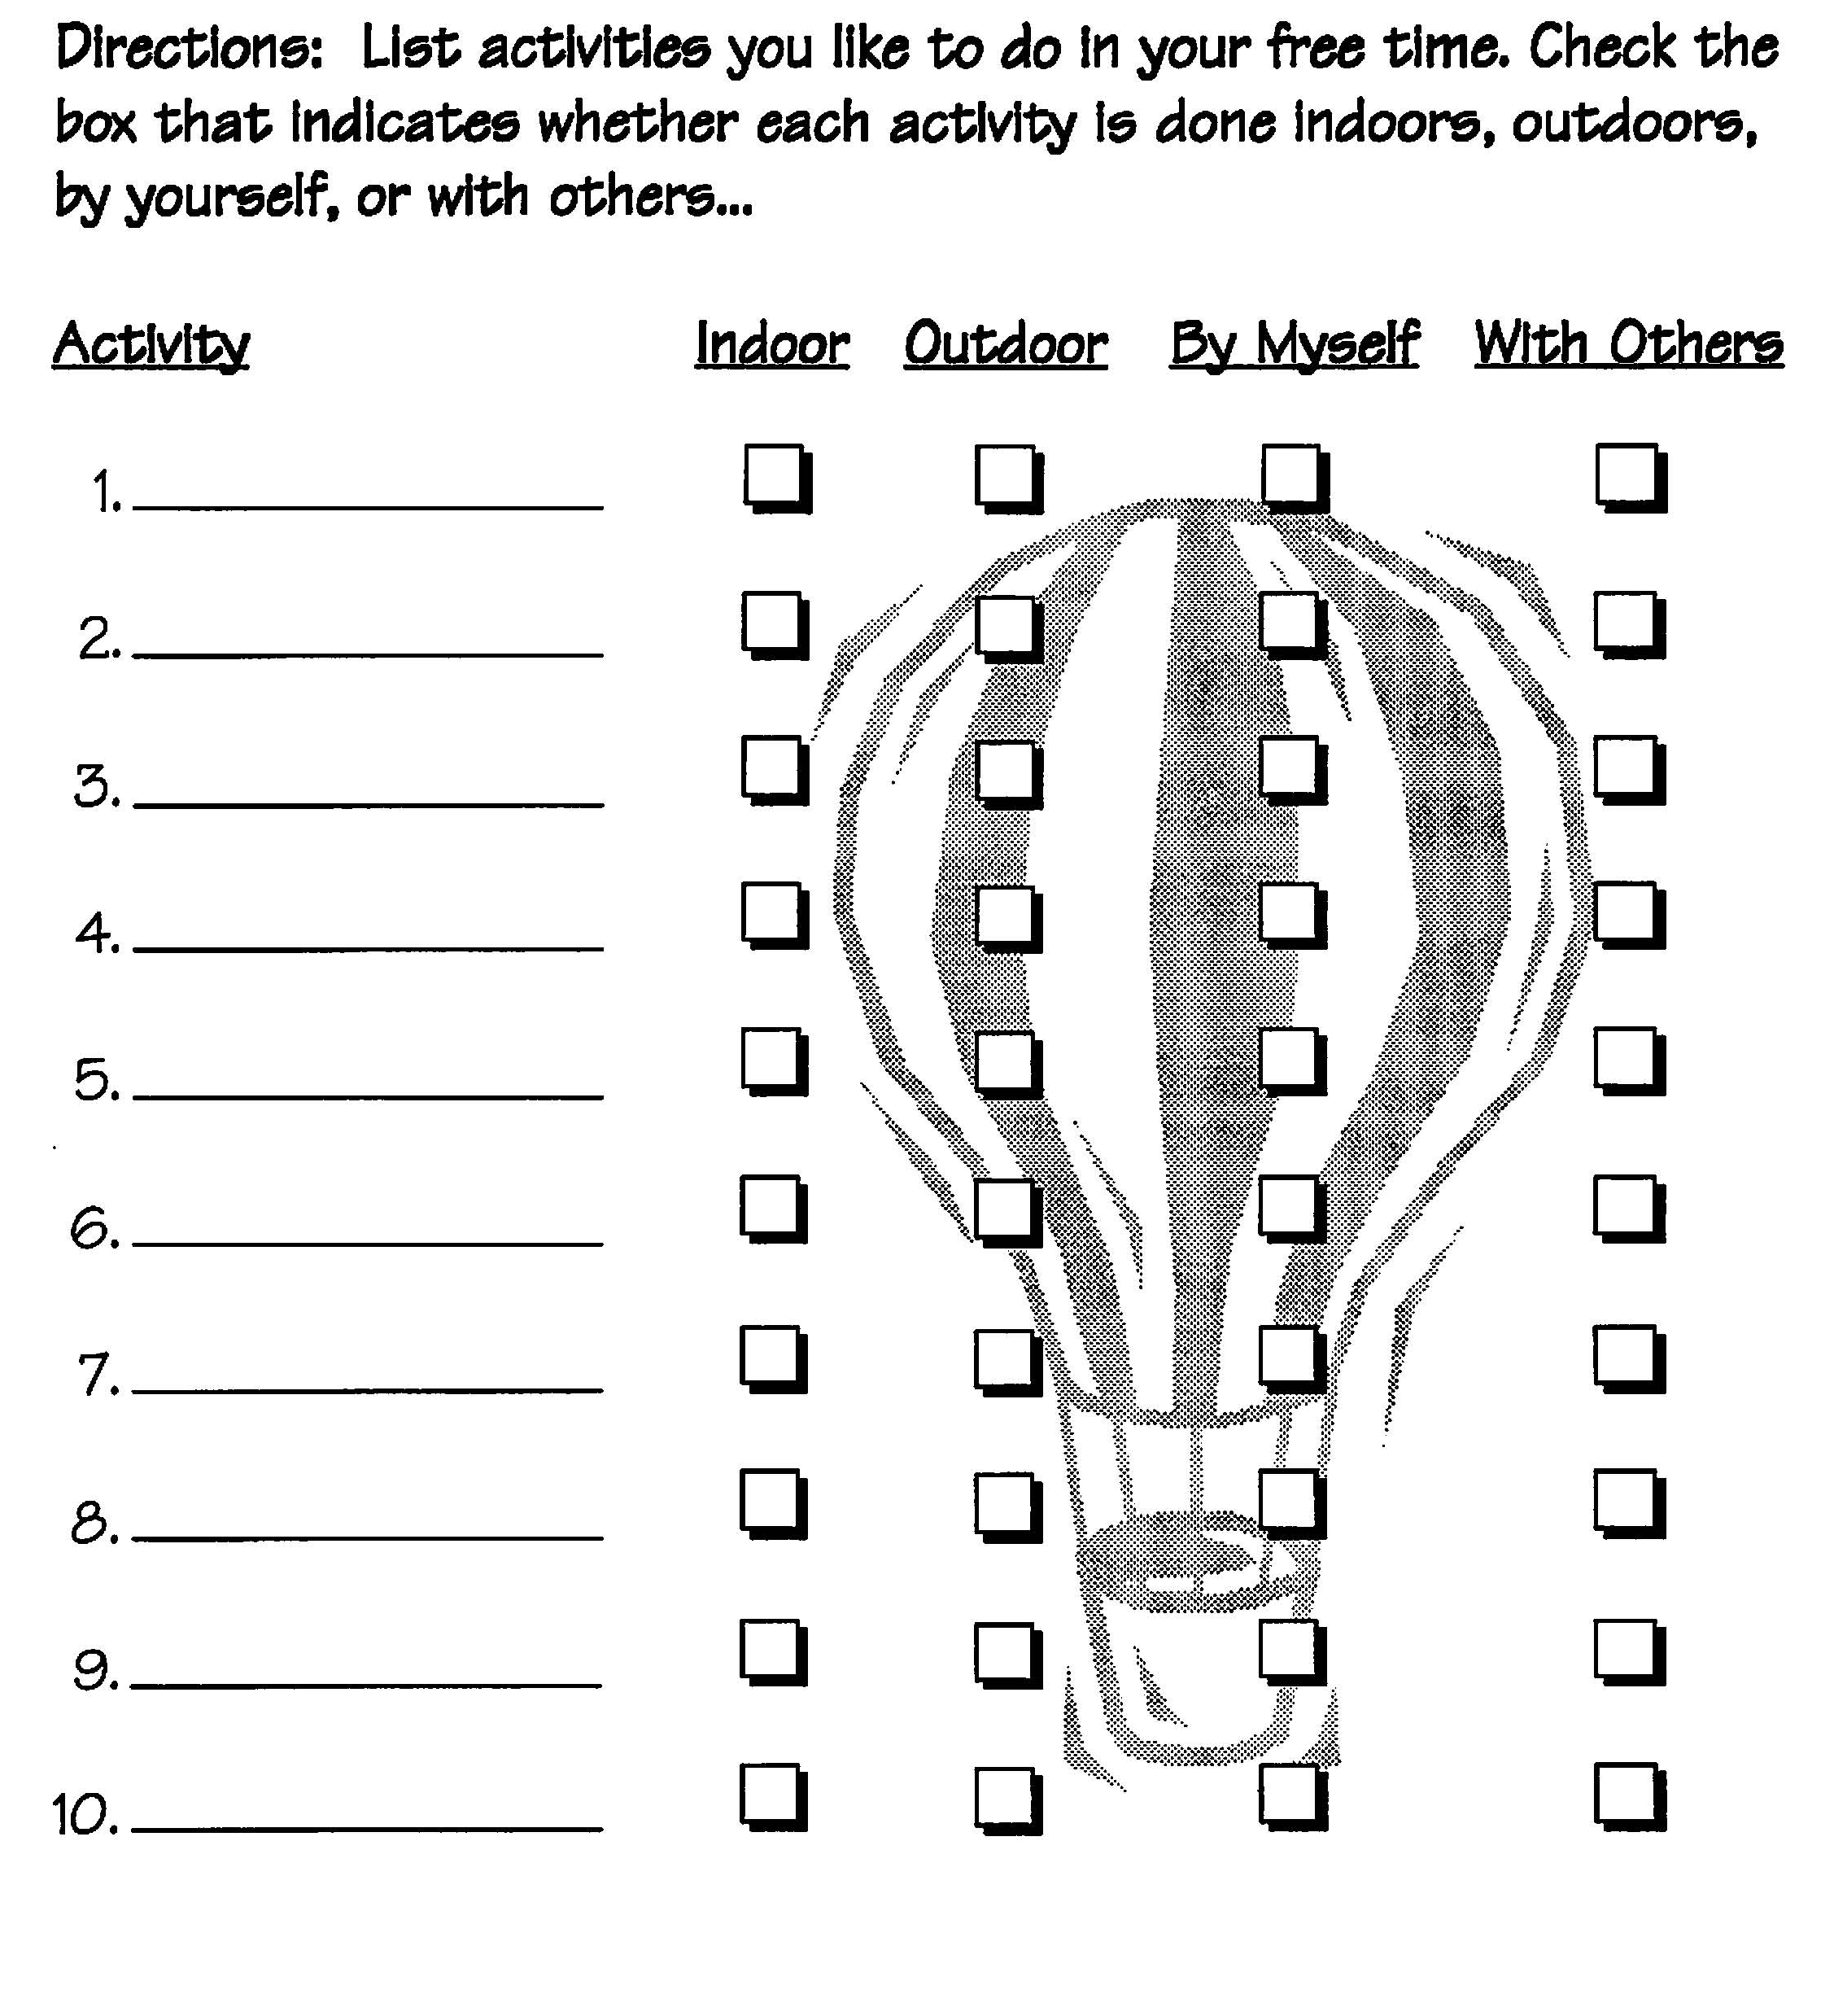
Concept: PS.1.B Balancing Life Roles (Leisure)

LEISURE TIME ACTIVITIES: POSSIBILITIES
Name: ___________________________________ Class: _________Date:_______

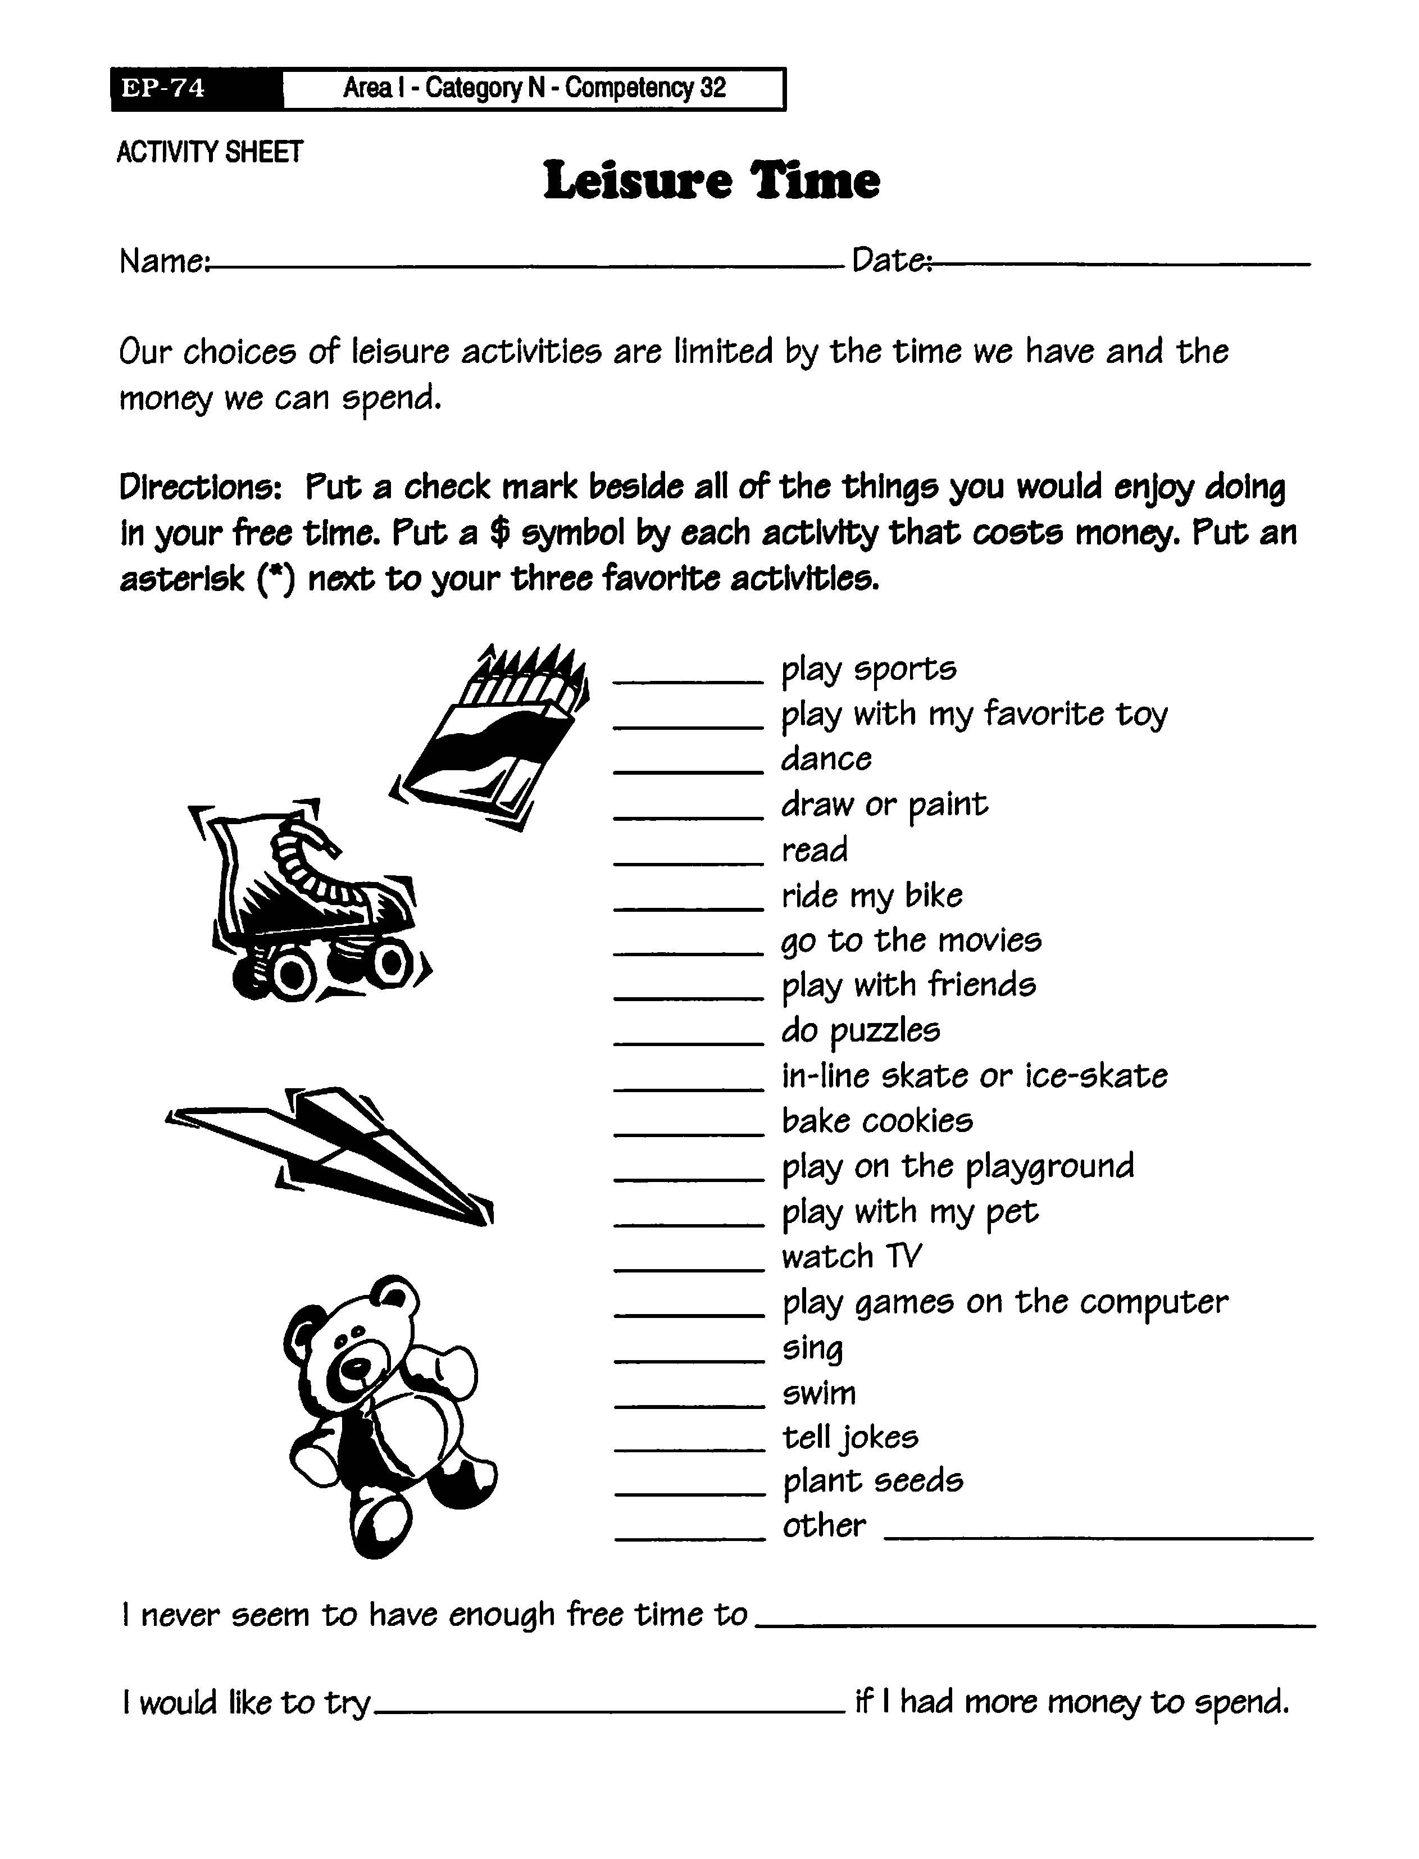
Reflection/Projection: Complete the sentences: (Use the back if more space is needed)
One important thing I learned about leisure time is ____________________________
Three completely new leisure activities I’d like to try: 1. _________; 2. ________ and 3. ________. Two activities I would not enjoy 1. ______________; 2. _______________.
I prefer activities I _____________________________ because ________________.
One way leisure time can help me: __________________________________________.

Concept: PS.1.B Balancing Life Roles (Family Responsibilities)

MY COMMITMENT TO DO MY SHARE TO HELP MY FAMILY HAVE MORE TIME FOR FUN TOGETHER
I, _____________________________, on this day_____________________ commit to doing the following so that my family can have more time for fun together: _________________________________________________________________________
_________________________________________________________________________
I will do this (days/times) _____________________________________________________
My family will know that I have kept my pledge when they see ________________________
_________________________________________________________________________
If I do not keep my pledge here’s what happens ___________________________________
_________________________________________________________________________
My family will celebrate my success by __________________________________________
On ________________ of every week, we will review this commitment to check my progress and determine what, if any, changes need to be made.
Signed by __________________ & __________________ and _______________________
(parents/guardians) (me)
Date ________________________

Concept: PS.2.B. Respect for Self and Others (Learning to Work with Others in Groups)
LEARNING AND APPLICATION: CIRCLES OF COOPERATION
Learning and Application: Circles of Cooperation

Name: ___________________________________ Class: ___________Date: _____________

Directions: Follow your school counselor’s instructions for complete each section.
Section I: Work cooperatively with all members of your learning circle to complete the tasks
Section II: Work independently to complete the Reflection/Projection/Application sentences.

Section 1: Learning to Work in Groups (work as a group—everyone writes the agreed-upon responses on his or her thinking paper):

- List at least 4 reasons your teachers and school counselor want you to learn to work in groups. Write the name of the group member who contributed each reason.

REASON CONTRIBUTOR
- _________________________________________________ ______________
- _________________________________________________ ______________
- _________________________________________________ ______________
- _________________________________________________ ______________
- _________________________________________________ ______________
- _________________________________________________ ______________
Does everyone in your group agree with the reasons listed? □ YES □ NO

We learned that when we work with others in a circle of cooperation, we
_______________________________________________________________________
_______________________________________________________________________
_______________________________________________________________________
Section II: Reflection/Projection/Application (complete independently):

- Rate your learning circle’s cooperative work on the lesson’s tasks.
1_________________________________5__________________________________10
Awful/No Cooperative Work Wonderful/We Fully Cooperated
- How did you help the group learn and accomplish its task? ________________________
_________________________________________________________________________
- Is it easy or hard to work for you to work with other students in a group? □ Easy □ Hard
Explain your response: ____________________________________________________
_______________________________________________________________________
- One personal cooperative group skill I need to improve is: ________________________
To improve this skill, I __________________________________________________________.
Concept: PS.2.B. Respect for Self and Others (Respecting Individual Differences)
Name: __________________________________ Class: ___________Date: _____________

A FEW OF MY FAVORITE THINGS

Directions: Complete the sentences:

- My favorite school subject is _____________________________________.
- My favorite activity at recess is ___________________________________.
- My favorite TV program is _______________________________________.
- My favorite movie is ____________________________________________.
- My favorite sport or leisure activity is _______________________________.
- My favorite kind of music is ______________________________________.
- My favorite song is _____________________________________________.
- My favorite color is _____________________________________________.
- My favorite food is _____________________________________________.
- My favorite book is _____________________________________________.
- My favorite place to visit is _______________________________________.
- My favorite outdoor activity is ____________________________________.

If I had an hour to do anything at all, I would ______________________________
_________________________________________________________________
Concept: PS.2.B. Respect for Self and Others (Respecting Individual Differences)

Name: ___________________________________ Class: ___________Date: _____________
A FEW OF OUR FAVORITE THINGS

Directions:
- Compare your “My Favorite Things” Student Thinking Paper with your partner’s to discover how your favorites are the same and how they are different.
- In the box below, draw a 2-circle Venn diagram that fills the entire box.
- Label one circle “My Favorites”. Label the second circle “(Partner)’s Favorites”. Label the overlapping area “Our Favorites”.
- Write the favorites you have in common in the space where the circles overlap. In the “My Favorites” circle, write your favorites that differ from your partner’s. In the other circle, write your partner’s favorites that differ from yours.
- Complete the sentences below the box.

Am I the same as all other people? Am I the same as some other people? Am I different from everyone else? _________________________________________
From this activity I learned I __________________________________________
_________________________________________________________________.

Concept: PS.3.A. Safe and Healthy Choices (How to Say “NO”! Student Resource)

HOW TO SAY "NO"

There are times when you need to say "NO."
When you know it is the right thing to do,
Saying "NO" can make you feel good.
Saying "NO" is something we must learn.

Stand or sit up straight,
Look directly at the other person
Talk in a normal voice.
Be firm.
Do not say things to hurt the other person's feelings.
Simply say,

"I do not want to do that."

To know WHEN saying “NO” is the right thing to do,
Ask yourself three magic questions:
• Would this make someone angry or disappointed?
• Would this hurt someone’s body or sense of worth?
• Would this damage something?

If you answer "maybe" or "yes" to any of the questions,
You know it is the wrong thing to do!
For example
If your friend wanted to copy your homework, ask yourself:
• Would someone be angry or disappointed? Yes: Your teacher.
• Would this hurt someone’s sense of worth or his or her body?
Yes: YOURS—You are being dishonest.
• Would this damage something? Yes: YOUR REPUTATION as an honest person.

Concept: PS.3.A. Safe and Healthy Choices (How to Say “NO”!)
POTENTIAL CONSEQUENCES OF SAYING "NO"
PART I: As the older-student-leader of your group (or your school counselor) reads the situations, choose the most likely consequence(s). Be realistic when you choose the consequence(s).

- Lose all of your friends
- One friend says you aren’t friends anymore.
- Some friends don't like you anymore
- Friends get mad at you for a short time and then are friends again
- Some friends decide your opinion is right and agree with you
- Everyone likes you better and respects you more
- You know you did the right thing and don’t care about what others think.
- Other _________________________________________________

- You are taking a spelling test. You realize your friend is copying from your paper. You cover up your answers so no one can see them.
- Almost every day, you see several students (one of them your good friend) knock the books out of another student’s hands, push her into the lockers and call her a wicked witch (she’s Wiccan). Finally, you decide to tell your school counselor.
- Your friends want to meet at the convenience store after school. You know they get rowdy and may steal things. You don't have permission to go and you say "no".
- Your best friend wants you to sneak away from the playground at recess. You know it's wrong and you say "no."
- A classmate stole another classmate's lunch money and you were a witness. Your classmate tells you to keep quiet about it. You know this is wrong so you say "no" and tell the teacher.
A friend asks you to take a pill she took from her grandmother's medicine cabinet. You are afraid you will get sick so you say "no" and tell her grandmother what happened.

PART II: Choose the consequence that you think is the worst of all. Consider the “consequences of the consequence”; that is, what will you do next? It hurts to lose friends—or does it?

Of the 7 or 8 consequences listed above, the worst consequence for me would be __________.
If that happened, I would: _______________________________________________________
____________________________________________________________________________
____________________________________________________________________________
Saying “NO” to friends or to something that would be exciting (and unhealthy, unsafe or unwise) is easy----difficult for me because ________________________________________________
____________________________________________________________________________
Concept: PS.3.A. Safe & Healthy Choices (How to Say “NO”!) Student Resource: Pocket Guide: How to Say “NO”

HOW TO SAY "NO"  You know when saying “NO” is the right thing to do!  Saying "NO" can make you feel good.  Saying "NO" is something we must learn.  Stand or sit up straight,  Look directly at the other person  Talk in a normal voice.  Be firm.  Do not say things to hurt the other person's feelings.  Simply say,  "I do not want to do that."  To know WHEN saying “NO” is the right thing to do,  Ask yourself three magic questions:  - Would this make someone angry or disappointed?  - Would this hurt someone’s body/sense of worth?  - Would this damage something?  If you answer "maybe" or "yes" to any of the questions,  You know it is the wrong thing to do! For example:  If your friend wanted to copy your homework, ask:  • Would someone be angry or disappointed?  Yes: Your teacher.  • Would this hurt someone’s body/sense of worth?  Yes: YOURS—You are being dishonest.  • Would this damage something? Yes: YOUR REPUTATION as an honest person. | HOW TO SAY "NO"  You know when saying “NO” is the right thing to do!  Saying "NO" can make you feel good.  Saying "NO" is something we must learn.  Stand or sit up straight,  Look directly at the other person  Talk in a normal voice.  Be firm.  Do not say things to hurt the other person's feelings.  Simply say,  "I do not want to do that."  To know WHEN saying “NO” is the right thing to do,  Ask yourself three magic questions:  - Would this make someone angry or disappointed?  - Would this hurt someone’s body/sense of worth?  - Would this damage something?  If you answer "maybe" or "yes" to any of the questions,  You know it is the wrong thing to do! For example:  If your friend wanted to copy your homework, ask:  • Would someone be angry or disappointed?  Yes: Your teacher.  • Would this hurt someone’s body/sense of worth?  Yes: YOURS—You are being dishonest.  • Would this damage something? Yes: YOUR REPUTATION as an honest person.
HOW TO SAY "NO"  You know when saying “NO” is the right thing to do!  Saying "NO" can make you feel good.  Saying "NO" is something we must learn.  Stand or sit up straight,  Look directly at the other person  Talk in a normal voice.  Be firm.  Do not say things to hurt the other person's feelings.  Simply say,  "I do not want to do that."  To know WHEN saying “NO” is the right thing to do,  Ask yourself three magic questions:  - Would this make someone angry or disappointed?  - Would this hurt someone’s body/sense of worth?  - Would this damage something?  If you answer "maybe" or "yes" to any of the questions,  You know it is the wrong thing to do! For example:  If your friend wanted to copy your homework, ask:  • Would someone be angry or disappointed?  Yes: Your teacher.  • Would this hurt someone’s body/sense of worth?  Yes: YOURS—You are being dishonest.  • Would this damage something? Yes: YOUR REPUTATION as an honest person. | HOW TO SAY "NO"  You know when saying “NO” is the right thing to do!  Saying "NO" can make you feel good.  Saying "NO" is something we must learn.  Stand or sit up straight,  Look directly at the other person  Talk in a normal voice.  Be firm.  Do not say things to hurt the other person's feelings.  Simply say,  "I do not want to do that."  To know WHEN saying “NO” is the right thing to do,  Ask yourself three magic questions:  - Would this make someone angry or disappointed?  - Would this hurt someone’s body/sense of worth?  - Would this damage something?  If you answer "maybe" or "yes" to any of the questions,  You know it is the wrong thing to do! For example:  If your friend wanted to copy your homework, ask:  • Would someone be angry or disappointed?  Yes: Your teacher.  • Would this hurt someone’s body/sense of worth?  Yes: YOURS—You are being dishonest.  • Would this damage something? Yes: YOUR REPUTATION as an honest person.

Concepts: PS.3.A. Safe and Healthy Choices; PS.3.B. Personal Safety…; PS.3.C. Coping Skills (How to Get Help)
Name: ________________________________________________ Date: _________________

WHERE TO TURN? WHO CAN HELP?
Examples of people who can help you:

Parent or another family member

Friend

Teacher

Professional School Counselor

Nurse

Religious Leader (e.g., religion teacher)

Community Youth Services

Other???

DO NOT KNOW OR CAN‘T DECIDE WHERE TO TURN?? SEE YOUR PROFESSIONAL SCHOOL COUNSELOR—HE OR SHE WILL HELP FIND THE BEST HELPER FOR YOU!

Directions: List the names of people you can/will go to for help and how to contact them

PERSON WHO CAN HELP MY FRIENDS & ME | HOW I CAN CONTACT

Concepts: PS.3.A. Safe & Healthy Choices; PS.3.B. Personal Safety…; PS.3.C. Coping Skills (How to Get Help PSC Resource)
TEACHING STUDENTS TO CALL 911
(This page may be modified and used as a Parent Resource)

Teach students when to call 911. Use basic concepts such as when an adult can't wake up, any fire that happens without an adult around, or an intruder in the home. Students may know the number, but they may get confused about when to call—when one is 5, everything seems like an emergency. Older students may intuitively understand when there is an emergency, even though they can't explain it. Encourage students to trust their "gut" feelings, and if in doubt, tell them to call 911.

PROBLEMS VS. EMERGENCIES
Teach students the difference between a problem and an emergency. A problem is something that they need help with, but the situation does not require emergency services. An emergency is a situation that requires immediate assistance from the police or fire department, or requires immediate medical assistance through paramedics or EMTs.

Problems
Teach students how to identify the severity of problems. When students experience a problem, they should decide whether to call an adult family member immediately, call a neighbor, or whether the problem can wait until an adult gets home. For example, parents would probably want a child to call them if the child:
- Feels scared
- Has trouble getting into the house
- Gets home and finds that the electricity is off

Emergencies
Teach students to identify emergency situations and the need to call 911 immediately. The following situations would require an immediate call to 9-1-1:
- A fire
- Evidence of a break-in
- A medical emergency, such as someone being unresponsive or bleeding profusely
- When in doubt…call 911.
PLACING A 9-1-1 CALL
- Teach students to call from a house phone -- not a cell phone. Once the call from a house phone is made and if the individual “freezes”, he or she doesn't HAVE to say anything else to get help. Of course, the more detailed the information, the better/faster the response.
- If a cell phone is the only phone available, teach students to tell dispatcher the name town and state from which they are calling
- Teach students stay on the line until told it’s OK to hang up. In most cases, 911 dispatchers will keep children on the line until responders arrive. This is helpful to children because they want to know someone is on the line if they need help and/or reassurance.
- Teach students the importance of speaking slowly, clearly and loudly enough to be heard by the dispatcher. Stress the importance of speaking in a way that allows the dispatcher to hear and understand accurate information about the emergency.
- Teach students to say their first and last names to the dispatcher. He or she will use the child's name repeatedly.
- Teach students to LISTEN carefully to the dispatcher’s questions. Emphasize the importance of listening to the dispatcher’s questions AND asking the dispatcher to repeat the question if necessary.
- Teach students to feel comfortable saying “I don’t know”. Stress the importance of not making anything up. Children may see the dispatcher’s questions as a quiz, and think they let someone down if they don't know an answer. Encourage saying “I don’t know” or “I’m not sure.”
Practice: At home AND at school, provide frequent opportunities to practice calling 911. Using a teletrainer or unplugged phone, student dials 911 and an adult acts as dispatcher. The dispatcher asks questions about the pretend incident. Students use their checklists (Student Resource: Calling 911) as guides.
Concepts: PS.3.A. Safe & Healthy Choices; PS.3.B. Personal Safety…; PS.3.C. Coping Skills (How to Get Help PSC Resource)
EMERGENCY SITUATIONS

Make enough copies of this page for each pair to have 2 emergency situations; Cut apart prior to class

(NOTE: The maturity level of students will determine the appropriateness of these scenarios. You may want to create less emotional scenarios for younger students)

You are home alone.  Suddenly the smoke alarm goes off and you smell smoke but don’t know the source | You get home from school and the garage door is open. You think you see someone moving inside your house. No cars are in the garage and your parents are supposed to be at work.
You see 2 automobiles crash in front of your house. No one is moving in either car. | You are taking care of your little sister while your mother is gone. Your sister is climbing on a chair, falls and hits her head. There is blood all over and you can see a gash on her head.
When you get home from school, you go to your grandmother’s room to tell her you are home; when you say “I’m home!” she doesn’t answer you. | When you get home from school you decide to cook some bacon—it catches on fire!
You are in your house and you notice a strange car driving through your neighborhood several times. Pretty soon the car stops and the driver tries to get your friend to get into the car. You see your friend run away. | You get home from school and get ready to watch television. Your tv set is gone and you know it was there that morning and there is no reason it should not be there now—then you notice the sliding glass door is open.
Home Alone!  It’s raining cats and dogs outside and the wind is blowing. All of a sudden you hear: CRRRAAAASSSSHHHH!!! Rain starts pouring into your house. | Home Alone!  You are climbing the big maple tree in your front yard. OOPS…you lose your balance and fall to the ground. Your leg hurts and you cannot stand up. Luckily, your cell phone is in your pocket.
Concepts: PS.3.A. Safe & Healthy Choices; PS.3.B. Personal Safety…; PS.3.C. Coping Skills (How to Get Help Student Resource)
USING 911 TO GET HELP IN AN EMERGENCY
Take this page home—talk about the information with an adult

Is It A Problem Or An Emergency?

- A problem is something with which you need help but it does not require IMMEDIATE services.

- An emergency is a situation that REQUIRES IMMEDIATE assistance from the police or fire department, or requires immediate medical assistance through paramedics or Emergency Medical Technicians.

Problems
When you experience a problem, decide whether to call a parent immediately, call a neighbor, or whether the problem can wait until an adult gets home. For example, (unless your parent instructs you otherwise) call a parent if you:
- Feel scared
- Have trouble getting into the house
- Get home and the electricity is off

Emergencies
The following issues require an immediate call to 9-1-1:
- A fire
- Evidence of a break-in
- A medical emergency, such as someone being unresponsive or bleeding a lot.

How to Call 911
- Call from a house phone (land line)—if you MUST use a cell phone, tell the dispatcher the name of the town/state from which you are calling. Calling from a house phone/land line tells the dispatcher where you are in case you don’t remember what to say. Provide detailed information about the incident/location so the dispatcher can contact the right helpers.
- Speak clearly—if you mumble, it will take longer for the dispatcher to know what kind of help you need.
- Say your first AND last names, your address and type of emergency clearly for the dispatcher
- Listen to the dispatcher’s questions carefully; ask the dispatcher to repeat if you do not hear or understand the question.
- If you do not know the answer to a question, say “I don’t know”. NEVER make something up just to answer a question!!!
- Stay on the line unless the dispatcher says it is ok to hang up. He or she will probably want you to stay on the line until help arrives.
- Practice with an adult at home--on an unplugged phone and use a pretend situation. Dial 911 and the adult will be the dispatcher and will ask you questions about the pretend incident.
Concepts: PS.3.A. Safe & Healthy Choices; PS.3.B. Personal Safety…; PS.3.C. Coping Skills (How to Get Help Student Resource)

CALLING 911: A CHECKLIST
(Fill in the basic information and keep checklist beside all the phones at home)

- Call 911 from a house phone (land line) if available.

- Clearly state:
- Your city and state if you are using a cell phone:
City __________________________State _______________
- Your First Name ____________ Last Name ________________
- House Number _____________ Street Name ______________
- or location of emergency if you are not at home
______________________________________________________
- Type of Emergency, e.g., fire, medical emergency ______________________________________________________
- Listen
- Answer question if you know the answer.
- Ask dispatcher to repeat question if you do not understand.
- Say “I don’t know” if you do not know the answer to a question.
- Stay on the line until help arrives or dispatcher tells you to hang up.

- Stay calm and be proud that you are helping the dispatcher get the very best help for the emergency!

Other important information to know (make the list with your family at home):
____________________________________________________________________________
____________________________________________________________________________
____________________________________________________________________________
____________________________________________________________________________
____________________________________________________________________________
____________________________________________________________________________

