|  |
| --- |
| **I LIKE TO…**  *NOTE: The PS.1.B grade 4-6, Leisure, Interests And Hobbies, expands the concept of balancing life roles; those lessons may be helpful if you want to expand the exploration of leisure with younger students.*  **Purpose:** Students become familiar with the terms “leisure time” and “leisure activities” and the importance of leisure in everyone’s life. They review their current leisure activities and the leisure activities they would enjoy.  **Time:** 50 minutes (or 2-30 minute sessions) **Group Size:** small group or class **Grade Level:** 2-3  **Materials:** *My Leisure Time List* and *Leisure Time: Possibilities* Student Thinking Papers  **Missouri Comprehensive Guidance Program (MCGP) Strand/Big Idea/Concept::**  **Strand: Personal And Social Development (PS)**  **Big Idea:** PS 1 Understanding Self as an Individual and as a Member of Diverse Local and Global Communities  **Concept:** PS.1.B. Balancing life roles  American School Counselor Association (ASCA) Standard:  **Personal Social Domain**  **Standard A**: Students will acquire the knowledge, attitudes, and interpersonal skills to help them understand and respect self and others. |

**Link to Sample MCGP Units/Lessons** (Note: this listing does not include all possible related Units/Lessons—they are merely examples of how the activity fits with the MCGP Guidance eLearning Units/Lessons)

|  |
| --- |
| Leisure is not directly addressed in the MCGP primary sample units/lessons; however, interests are addressed in:  Kdg. CD.7.A Unit: [Developing Awareness of Work and Workers](http://missouricareereducation.org/curr/cmd/guidanceplacementG/lessons/dlGuidanceLesson.php?file=CD7-GrK-Unit1.doc)  2nd grade CD 7.A Unit: [Work, Career Paths and Me!](http://missouricareereducation.org/CDs/GuidanceLessons/CD7-Gr1-Unit1.doc) |

**Show Me Standards: Performance Goals (check one or more that apply)**

|  |  |
| --- | --- |
|  | Goal 1: gather, analyze and apply information and ideas |
| X | Goal 2: communicate effectively within and beyond the classroom |
|  | Goal 3: recognize and solve problems |
|  | Goal 4: make decisions and act as responsible members of society |

**This lesson supports the development of skills in the following academic content areas.**

**Academic Content Area(s) Specific Skill(s)**

|  |  |  |
| --- | --- | --- |
| X | Communication Arts | 5: Participating in …and discussions of issues and ideas. |
|  | Mathematics |  |
| X | Social Studies | 7. The use of tools of social science inquiry. |
|  | Science |  |
|  | Health/Physical Education |  |
|  | Fine Arts |  |

**Enduring Life Skill(s)**

|  |  |  |  |  |  |
| --- | --- | --- | --- | --- | --- |
|  | Perseverance |  | Integrity |  | Problem Solving |
| X | Courage |  | Compassion |  | Tolerance |
| X | Respect | X | Goal Setting |  |  |

**Assessment: acceptable evidence of what learners will know/be able to do as a result of this lesson:**

|  |
| --- |
| See Assessment: Content and Assessment: Personalization of Content (following step 8 of lesson) |

## Lesson Preparation/Motivation

|  |
| --- |
| *Essential Questions:* What does “All work and no play makes Jack and Jill dull children” mean? Is there such a thing as working too hard and too long? What if everyone in your families played all day every day?  *Engagement (Hook):* See PSC Procedures |

## Procedures

| *Professional School Counselor Procedures:* | *Student Involvement:* |
| --- | --- |
| **Materials:** *My Leisure Time List* and *Leisure Time: Possibilities* Student Thinking Papers  *Throughout this lesson systematically observe students’ participation in each activity. Be aware of their thinking about leisure time, especially misconceptions. Systematically observe interactions as they work with partners and as they talk publicly about their ideas.*  *Hook:* Enter class bedraggled and yawning. Plop into chair and say something like “I just don’t think I can help you learn anything today! For the last three nights, I have gotten just 2 hours of sleep because I have been working so hard on my plans for next week’s lessons, painting my bedroom and cleaning my house—I’m exhausted and just can’t think about or do one more thing!” *When students are “hooked” …begin the lesson*.   1. Continue your role play saying something like: “I wonder why I can’t think or do anything today. Who has an idea about what could be causing my problems?”  * If students do not mention words/phrases that suggest needing a break from work, ask students to hypothesize about the meaning of the famous phrase “All work and no play makes Jack and Jill dull children”. Connect responses to your problem. Then ask: * Is there such a thing as working too hard and too long? * What if everyone in your families played all day every day?   Emphasize the importance of balance in life.   1. Ask for definitions of “leisure” and “leisure activities”. (Provide opportunities for different students to respond each time…emphasizing that everyone has an important thought and you want each person to hear the ideas of everyone in the class.). 2. Draw a chart with 5 columns; label columns: *Activity, Inside, Outside, Alone, With Others.* Ask students to brainstorm (name) as many leisure activities as they can; write responses in first column. 3. Ask for a volunteer recorder to help you at board. Students decide if an activity is something that can be done inside, outside, alone, or with others. Volunteer helper places checkmarks in appropriate columns as responses are given (may be possible to have a check in each column across the row for a specific activity). 4. Distribute the *My Leisure Time List* Student Thinking Paper and explain the directions—emphasize that they may use pictures/symbols/words to identify activities. Allow approximately 10 minutes for students to complete the Student Thinking Paper. Observe students’ work-styles as they complete activity. 5. *Observe interactions in pairs—you may need to teach students how to talk with each other about what they learned.* In pairs, have students share with partner what they learned about their leisure life—how many activities were checked in each column? Invite 2-3 students to tell the class what they discovered about themselves and their leisure lives with the class. 6. Distribute the *Leisure Time: Possibilities* Student Thinking Paper; Explain the directions, complete the first 3 items as a group, answer questions, and, if developmentally appropriate, students complete the remainder individually—or—complete the entire survey together, encouraging questions/comments as you work through the survey. 7. Discuss the results. Emphasize the need for a balance between active and passive activities. Point out that many of the activities do NOT require $$.   **ASSESSMENT: Content:** Instruct students to turn to a “shoulder-partner” (person sitting next to him or her) and tell about their top 3 activities; compare similarities and differences between their lists  Combine pairs of students into quartettes (4 students in each group). Review the benefits/importance to each individual of leisure activity. SHOW-ME…SHOUT-OUT (one-at-a-time; inside shouts): One reason to make time for leisure activities.  **ASSESSMENT: Personalization of Content:** Students complete the unfinished Reflection/Projection sentences at the bottom of the *Leisure Time: Possibilities* thinking paper.  (FYI: The sentences: *One important thing I learned about leisure time ___. Three completely new leisure activities I’d like to try: 1.___; 2. ___ and 3. ___. Two activities I would not enjoy 1.___; 2. ___. I prefer activities I __ because ___. One way leisure time can help me :___.*)  Model an appropriate response or two for the last statement—using real-life benefits to you as examples.  When students have completed statements, invite volunteers to publicly read one of their sentences.  Use the whip-around process to assess individual’s application of content to his or her life:   * Begin with a specific person and continue to the right (or left), * Each student contributes one benefit of leisure activity to him or her.   Remind students of Pass-With-Responsibility option (ok to pass—must say [something like] “I choose to pass for now”).  **CLOSURE:** End lesson by returning to the “Hook” and asking why a leisure break would have helped you work smarter. Include planning for balance—all work and no play makes your school counselor bedraggled and weary today! Ask:   * What does “All work and no play makes Jack and Jill dull children” mean? * Is there such a thing as working too hard and too long? * What if everyone in your families played all day every day? | Students: During these lesson, courageously volunteer and be sure to speak loudly and clearly enough for everyone to hear your great ideas. Use complete sentences and conventions of standard English in speaking and writing.  *Hook*: Observe your school counselor’s actions/words with wonder and curiosity. What IS he or she doing and why?   1. Volunteer reasons for your school counselor not being able to think or do anything, e.g., not enough sleep, too much to do…   Volunteer definitions/interpretations that include the idea of working too much, taking a break, working too hard makes your brain go to sleep; too much leisure time is not good either.  If you do not volunteer, listen to others’ responses and compare their ideas to your ideas.   1. Volunteer definitions of “leisure” and “leisure activities”. Share the “air-space”, e.g., waiting until several other students have had a chance to talk before making a second or third comment. 2. Follow the rules of brainstorming—many, many ideas, no **positive or negative** evaluation of others’ contributions, any idea is worthy of being posted (within limits of “good-taste”.) 3. With respect and turn-taking, tell volunteer recorder which column(s) to check for each activity. 4. Look over *My Leisure Time List* thinking paper; listen carefully as your school counselor explains the directions; ask clarification questions as needed and complete list with integrity (thoughtfully and honestly). 5. In pairs, tell partners what you learned/discovered about leisure AND yourself, e.g., “Most of my activities are inside activities.” Volunteer to publicly share your discoveries about self. 6. Follow PSC’s instructions. Thoughtfully complete the *Leisure Time: Possibilities* Student Thinking Paper; decide which box best answers the question. 7. Review responses—comment on specific items during discussion, e.g. “I didn’t know if I should put $ symbol by “’play sports’”…It doesn’t cost anything if I play sports in my backyard—but—someone had to buy my ball glove and my bat.   **ASSESSMENT: Content:**:Follow school counselor’s instructions with intentionality: the intention to learn about each other’s preferences.  Join another pair to form a quartette; discuss good reasons (benefits) to take time for leisure activities. Participate in SHOW-ME…SHOUT-OUT (one-at-a-time; inside shouts).  **ASSESSMENT: Personalization of Content:** Locate the Reflection/Projection sentences at the bottom of your *Leisure Time: Possibilities* thinking paper. Look over the statements and ask clarifying questions. Follow your school counselor’s instructions and complete the statements.  Participate in whip-around. Remember: Speak loudly and clearly enough for everyone to hear your great ideas.  Remember, too, the Pass-With-Responsibility option (ok to pass—must say [something like] “I choose to pass for now”).  **CLOSURE:**  Volunteer to identify one way a break would benefit your school counselor (or anyone who has a big task to accomplish).  If you have not volunteered today, courageously volunteer a response to the questions. |

|  |
| --- |
| **Provide the classroom teacher** with a brief overview of lesson and copies of *My Leisure Time List* and *Leisure Time: Possibilities* Student Thinking Papers.  **Summarize systematic observations**: Review systematic observations of students’ participation in each activity, their persistent misconceptions, their interactions as they work with partners and their confidence level when talking publicly about their ideas. Be aware of students who have difficulty with any aspect of the activity—especially those who have a difficult time listing leisure activities and those whose leisure activities are primarily passive.  **Consult with Classroom Teacher:** Discuss your systematic observations. Does he or she validate your observations as being classroom behaviors as well? If so, collaborate with the classroom teacher to further identify the extent of a lack of awareness…is it evidenced in the classroom as self-control of anger directed at self or others, self-control in treatment of other students, e.g., bullying or mean-spiritedness.  **Collaborate** **with Classroom Teacher** to plan appropriate interventions. Interventions might include (and are not limited to) additional classroom guidance activities about leisure time and/or balancing life roles; Responsive Services involvement (e.g., individual/group counseling or parental involvement). |

**Follow-Up Activities (Suggestions for PSC and/or classroom teacher to use to reinforce student learning of Comprehensive Guidance Curriculum concepts)**

*Student Thinking Paper*

**MY LEISURE TIME LIST**

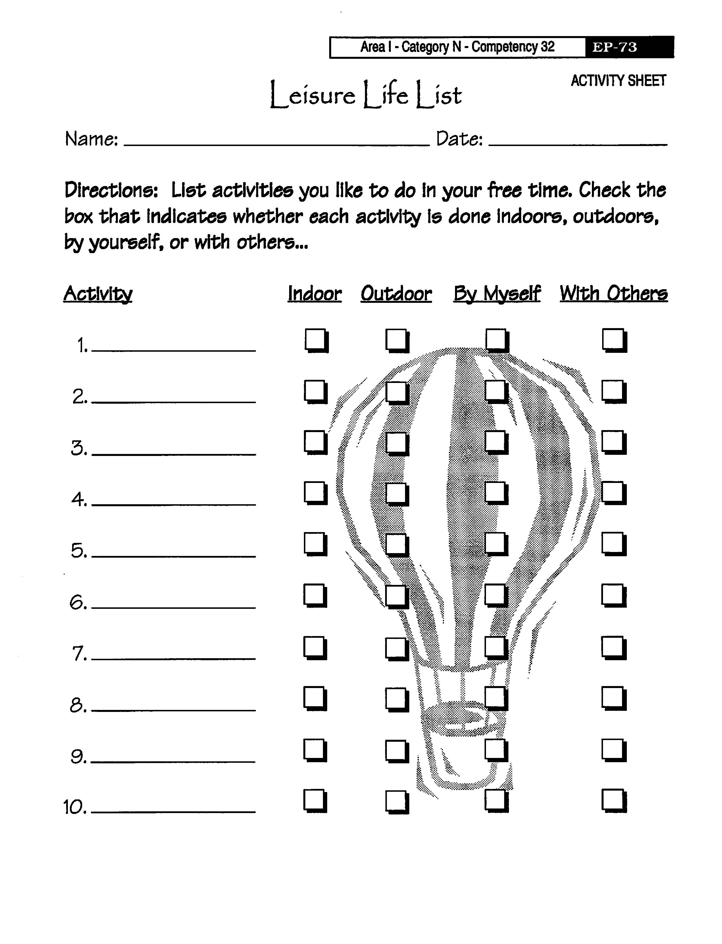

*Student Thinking Paper*

**LEISURE TIME ACTIVITIES: POSSIBILITIES**

**Name: ___________________________________ Class: _________Date:_______**

**Reflection/Projection:** Complete the sentences: (Use the back if more space is needed)

One important thing I learned about leisure time is ____________________________

Three completely new leisure activities I’d like to try: 1. _________; 2. ________ and 3. ________. Two activities I would not enjoy 1. _____________; 2. _____________.

I prefer activities I _____________________________ because ______________.

One way leisure time can help me: ________________________________________.

