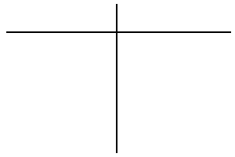
Good Qualities
Bad Qualities

