Country Cultures

Congratulations you are the head of the division that is going to expand the McDonald’s national brand. You will choose which country in which you would like to expand the restaurant. As the lead liaison between corporate and your country you need to be aware of cultural differences. You will research your country and find out about the rules of etiquette. You will also be preparing a sample menu of food items that would be served in your restaurant. All of this information will need to be presented to corporate for approval before expansion can occur.

Your assignment:
- Choose a country listed below – one country per student

- Visit http://www.executiveplanet.com/ and read up on that country’s etiquette rules for the following areas:
  - Appointments
  - Business Dress
  - Conversation
  - First Name or Title ?
  - Gift Giving
  - Let’s Make A Deal
  - Prosperous Entertaining
  - Public Behavior

- Prepare a presentation about that country’s rules of etiquette. Touch on each of the areas listed above. Be prepared to present your plan to the class. (PowerPoint presentations are an AID to your presentation!)

- Prepare a sample menu of dishes that would be served in the restaurant.

- Present to corporate.

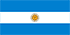 Argentina

Australia

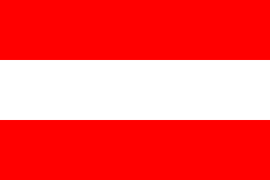 Austria

Belgium

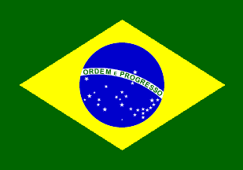 Brazil

Canada

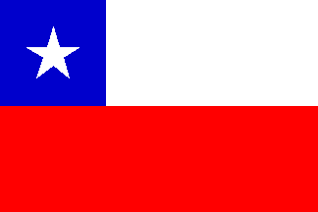 Chile

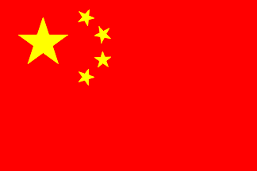 China

Colombia

Denmark
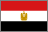 Egypt

France

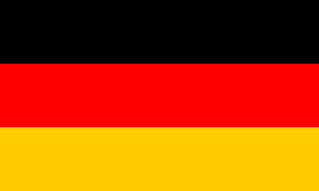 Germany

Hong Kong

India

Indonesia

Ireland

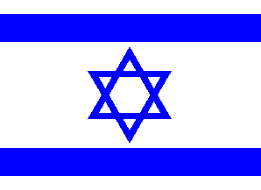 Israel

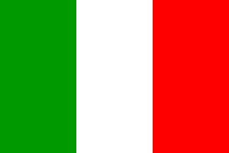 Italy

Japan

Malaysia
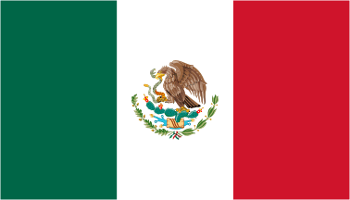 Mexico

Netherlands

Peru

Philippines

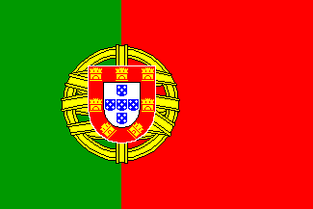 Portugal

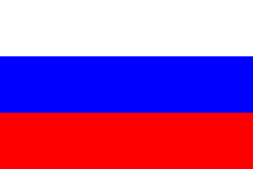 Russia

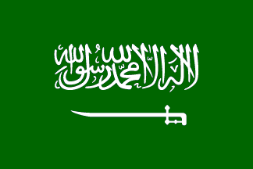 Saudi Arabia

Singapore

South Africa

South Korea
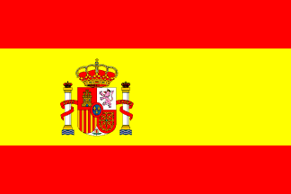 Spain

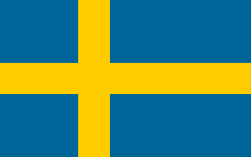 Sweden

Switzerland

Taiwan

Turkey

United Kingdom

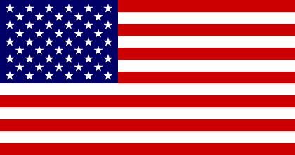 United States

Venezuela

Yemen

