|  |  |
| --- | --- |
| ***On the Trail of Thieves Activity*** |  |
| **Category** | Accounting |
| **Applicable Classes** | Accounting, Business Technology, Computer Applications |
| **NBEA Standard** | Accounting, III, A, 3-4 |
| **Author** | Lisa Hofstetter  Brookfield Area Career Center  Brookfield, Missouri |
| **Purpose/Description** | One of many challenges of traveling in foreign countries is trying to determine how much things actually cost in US dollars, even though we are using the local currency. This activity gives students the opportunity to “travel” around the world trying to determine where Mrs. Hofstetter is and how much she has spent. |
| **Estimated Time Needed** | 1-2 Class Periods |
| **Grade Level** | 10-12, Adult |
| **Materials** | Computer with Internet, word processing, and spreadsheet software. |

### Project Design

**Performance Objective(s)**

Upon completion of this lesson, students will be able to:

1. Acquire information from a variety of sources
2. Demonstrate the ability to comprehend and calculate currency exchange rates
3. Plot a specific route on a world map

**Evaluation/Assessment Methods**

On the answer sheet provided, the students should write down the name of each country associated with the clue date, resource(s) used to determine country, together with the country’s currency name, the exchange rate, and amount spent in that country. Each student will be evaluated on his or her answers.

**Problem-Based Situation**

Mrs. Hofstetter has hired you to keep her banking records, which is not always an easy task! While traveling, someone stole her credit card. You have contacted the credit card company to report the stolen card. Your job is to help track down the thieves through the credit card trail. You will be given information about the countries the thieves have visited and the amount charged on her credit card. When you know the country, find out what the monetary unit is, check the exchange rate, and calculate how many dollars were spent. The credit card company is giving us the information in exchange for your help in tracking down the thieves. All that they ask is help in figuring out the total amount of the dollars that the thieves spent. They are prepared to cancel the total US dollars spent by the thieves. Here are the clues to help you find the thieves. For each of the following, give the country, the foreign currency, the exchange rate, and the dollar amount asked for (or the foreign currency amount, if given the dollar amount). Use the exchange rate for the appropriate day of last month.

Dated clues can be found on student handout.

To calculate foreign currency amounts into American Dollars, take the amount of foreign currency spent and divide by the exchange rate. Current exchange rates can be found in most urban newspapers or at the following web site:

<http://x-rates.com>

**Student Activities**

Students will use the situation and dated clues to determine the total U.S. dollars spent while the thieves went on a spending spree with Mrs. Hofstetter’s credit card. Dated clues will provide information that the student can use various references to determine the country where the credit card was used. Upon determining the country, the student will chart the location on a world map. With the country found, the currency name can be determined as well as the exchange rate. A form is provided to record the information.

Student worksheets follow.

**Teacher Activities**

This activity is perfect when covering foreign travel or accounting concepts dealing with currency conversion.

The teacher should begin by discussing that different countries use different currency and the advantages and disadvantages using U.S. currency vs. local currency. Encourage discussion of when the students think they would ever have a need to use this exchange information. Discussion should include when traveling to a foreign country or doing business with a foreign currency (over the internet, etc.).

Specific dates are not given in the activity so that current information can be utilized. Students are not asked to simply use the current dates exchange rate because it would not be possible that the thief accomplished travel and activities presented in two days.

To calculate foreign currency amounts into American Dollars, take the amount of foreign currency spent and divide by the exchange rate. Current exchange rates can be found in most urban newspapers or at the following web site:

<http://www.x-rates.com>

|  |  |  |  |  |  |  |
| --- | --- | --- | --- | --- | --- | --- |
| Date | Country | Resources Used | Currency Name | Amount Spent | Exchange Rate | U.S. Dollar Equivalent |
| 1st | Canada |  | Dollar | 450 |  |  |
| 2nd | United Kingdom |  | British Pound | 1,100 |  |  |
| 5th | France |  | Franc | 1,500 |  |  |
| 6th | Belgium |  | Franc | 2,100 |  |  |
| 10th | Norway |  | Kroner |  |  | $152.98 |
| 11th | Sweden |  | Krona | 6,000 |  |  |
| 15th | Germany |  | Mark |  |  | $200.00 |
| 17th | Spain |  | Pesetas | 150,000 |  |  |
| 20th | Italy |  | Lira | 45,000 |  |  |
| 22nd | India |  | Rupees |  |  | $175.17 |
| 23rd | Thailand |  | Baht | 600 |  |  |
| 26th | Hong Kong |  | Dollar | 3,300 |  |  |
| 27th | South Korea |  | Won | 250,000 |  |  |
| 27th | Japan |  | Yen |  |  | $212.89 |
| 28th | Australia |  | Dollar | 60,000 |  |  |

Currency rates will vary over time so there is no answer key.

***On the Trail of Thieves***

PE01460_

Mrs. Collins has hired you to keep her banking records, which is not always an easy task! While traveling, someone stole her credit card. You have contacted the credit card company to report the stolen card. Your job is to help track down the thieves through the credit card trail. You will be given information about the countries the thieves have visited and the amount charged on her credit card. When you know the country, find out what the monetary unit is, check the exchange rate, and calculate how many dollars were spent. The credit card company is giving us the information in exchange for your help in tracking down the thieves. All that they ask is help in figuring out the total amount of the dollars that the thieves spent. They are prepared to cancel the total US dollars spent by the thieves. Here are the clues to help you find the thieves. For each of the following, give the country, the foreign currency, the exchange rate, and the dollar amount asked for (or the foreign currency amount, if given the dollar amount). Use the current day’s exchange rate.

1st—The thieves were first spotted in one of this country’s provinces by the RCMP at a lacrosse match. They spent 450 on refreshments and, then, stole a boat.

2nd—The thieves turned up here, where they were spotted eating Fish and Chips at a café in Cardiff. They apparently stayed in a flat which they rented for the time that they were in this country. For the flat, they spent 1100.

5th—The thieves then traveled through the Chunnel and took a TGV to Strasbourg, the tickets costing a total of 1500.

6th—Next, in Flanders at a speech given by King Baudouin I, the thieves apparently gorged on waffles which they charged at a café in the amount of 2100.

10th—Next, the thieves went north to Narvik and bought up a large supply of lutefisk and smalahode to take with them as they skied cross-country. The total food and travel bill was U.S. $152.98. How much in the local currency does this equate?

11th—They crossed the border on their skis and were soon spotted in Goteborg buying lots of warm clothing for which they charged 6000.

15th—Then, the thieves were spotted cruising on the autobahn in this country, decked out in new lederhosen, which were bought in Bavaria at a cost of U.S. $200. How much in local currency did they spend?

17th—The thieves were next seen in Catalonia on their way to Malaga, where they consumed massive quantities of gazpacho and attended several festivals. Altogether during their stay here, they charged 150,000.

20th—The thieves appeared in the Po River valley in this country and went down to Calabria, where they crossed over to Palermo. En route, the thieves bought biscotti and large amounts of parmesan and mozzarella cheese at a total cost of 45,000.

22nd—The thieves could not be found for some time until they appeared in Madras, wearing sarees that they had purchased at a cost of U.S. $175.17. How much in local currency did they spend?

23rd—After Madras, the thieves traveled east and escaped police in samlors following a low speed chase in the city of Chiang Mai. The thieves were very grateful to their salmor driver and after paying the fare, gave him a large tip for a total of 600.

26th—The thieves stayed out of sight until they were spotted playing mah-jongg in Kowloon. The thieves gambled and lost big at mah-jongg, which cost 3,300.

27th—The thieves continued on to Pusan, where they spent 250,000 on Taekwondo lessons. They then left for…

27th—the city of Kobe, where they rode the bullet train the length of the island. Of course, they charged the train tickets at a total cost of U.S. $212.89. How much in local currency?

28th—The criminals were last seen here, bushwalking in the outback, with a large supply of camping equipment they had bought in Darwin for 60,000.

Now, if you have figured out each country and monetary equivalents, you will have the honor of locating the thieves and allowing for their capture. Plot the thieves final destination on a world map and give an accounting of how many U.S. dollars and of foreign currency that they spent.

To calculate foreign currency amounts into American Dollars, use the following website:

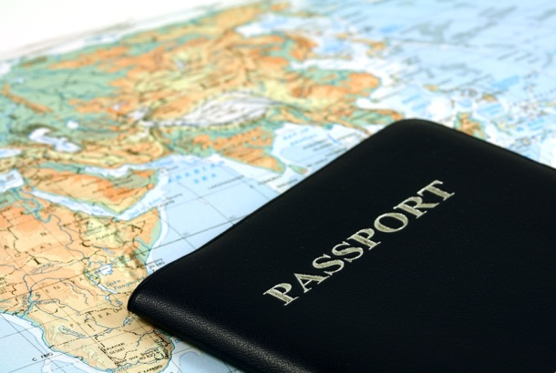[http://www.xe.com/ucc/](http://www.xe.com/ucc/%20)

***On the Trail of Thieves Activity***

As you trail the thieves, record the information you obtain on this form and also chart your final location on the world map. Some resources you may want to use include an atlas, almanac, encyclopedia, globe, or Internet.

|  |  |  |  |  |  |  |
| --- | --- | --- | --- | --- | --- | --- |
| **Date** | **Country** | **Resources Used** | **Currency Name** | **Amount Spent** | **Exchange Rate** | **U.S. Dollar Equivalent** |
| 1st |  |  |  | 450 |  |  |
| 2nd |  |  |  | 1,100 |  |  |
| 5th |  |  |  | 1,500 |  |  |
| 6th |  |  |  | 2,100 |  |  |
| 10th |  |  |  |  |  | $152.98 |
| 11th |  |  |  | 6,000 |  |  |
| 15th |  |  |  |  |  | $200.00 |
| 17th |  |  |  | 150,000 |  |  |
| 20th |  |  |  | 45,000 |  |  |
| 22nd |  |  |  |  |  | $175.17 |
| 23rd |  |  |  | 600 |  |  |
| 26th |  |  |  | 3,300 |  |  |
| 27th |  |  |  | 250,000 |  |  |
| 27th |  |  |  |  |  | $212.89 |
| 28th |  |  |  | 60,000 |  |  |
| Total Amount Spent in U.S. Dollars | | | | | |  |

***Trail of Thieves***

***World Map***

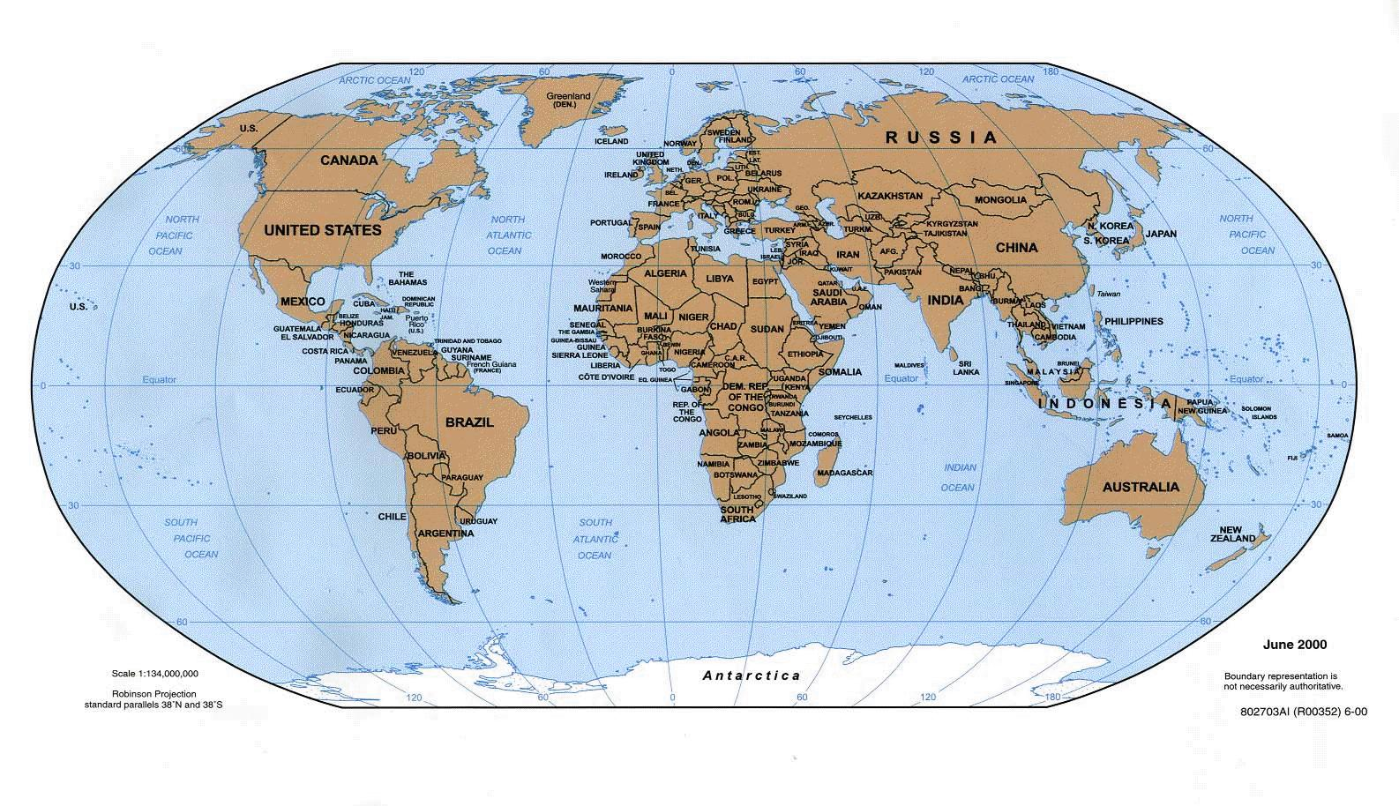

**Materials and Supplies**

* Credit card trail of clues
* International Exchange Rate
  + - <http://www.x-rates.com>
    - other Internet sites are available

### Reference materials

* + - atlas, almanac, encyclopedia, globe, or internet
* Calculator for determining exchange rates
* Answer sheet to record answers
* World map handout for students to plot the thieves final destination
* Foreign currency that you might locate for display

**Resources and References**

Internet

Atlas

Almanac

Encyclopedia

Globe

**On the Trail of Thieves**

**Scoring Guide**

|  |  |  |  |  |
| --- | --- | --- | --- | --- |
| **Criteria to be assessed** | **4 Proficient** | **3 Nearing Proficient** | **2 Progressing** | **1 Step 1** |
| Acquire information from a variety of sources  1.2, 1.4, SS 7 | Correctly identify all countries | Correctly identify most countries | Correctly identify some countries | Assignment attempted but incomplete. |
| Demonstrate the ability to comprehend and calculate currency exchange rates  3.4, SS 4 | All currency exchange rates are correct and calculated correctly | Most currency exchange rates are correct and calculated correctly | Most current exchange rates are correct but not calculated correctly | Shows little understanding of calculation of exchange rates. |
| Plot the final global location on a world map  1.2, 1.4, 3.3, SS 7 | Plotted final location correctly on map | ----------------- | ------------------ | Showed no geographic comprehension of final location |