The following are a collection of non-traditional activities that can be used to help enhance the understanding of concepts and principles covered in an Introduction to Networking course such as the Cisco Networking Academy’s CCNA Exploration 1: Network Fundamentals course.
Many of these activities use non-traditional methodologies including classroom and physical activities. An additional benefit of these types of activities is to break up the monotony, which can help to keep students’ attention during long class sessions.
Below is a list of the activities. The remainder of this document describes the activities in detail.
Activity (CNA1 Ch.*) Activity Type Page
Protocol (1) Physical activity 2
Students try to relate messages without talking to demonstrate the elements of communications.
Ipinip Parcel Service (2) Written assignment 2
Students describe the organization and operation of a parcel service to demonstrate the roles of OSI model layers and protocols.
Presentation (3) In-class activity 3
Students decode encoded messages to demonstrate the role of codes and the presentation layer.
Segmentation (4) Physical activity 5
Students try to transport a stack of blocks across a distance to demonstrate the role of data segmentation.
Ports (4) In-class activity 6
Students assemble jigsaw puzzles to demonstrate the role of port numbers or process IDs.
Hierarchy (5) Physical activity 7
Students pass cards to the person with the matching card to demonstrate the value of hierarchical grouping.
Binarian Money (7) In-class activity 8
Students count money in base two to learn the principles of binary.
MAC (7) Physical activity 9
Students shoot basketballs into a hoop to demonstrate the value of media access control methods.
DA (9) Physical activity 9
Students toss tennis balls around a circle to demonstrate the need for names and identifiers.
Flow (9) Physical activity 10
Students toss tennis balls around a circle to demonstrate the importance of flow control and relegating reliability to upper layer protocols.
General Tips on Leading Post-Activity Reflections 11
* The chapter in the CCNA Exploration 1: Network Fundamentals course of the CNA.
Please feel free to modify these activities to fit your needs or situation. Also, please e-mail me any suggestions for improvements, accommodations, variations or ideas for other activities to me at tepp@pit.edu.
Protocol
Time required: About 45 minutes
Materials required: Four message cards per group
It helps to have a large area for the activity (e.g. an open field)
Preparation:
Divide the class into groups of four students. In each group, have the students pair off into two pairs of users and hosts; i.e. have one student be the first user, the second student be the first student’s host, the third student be the second user, and the fourth student be the third student’s host.
Activity:
In each group, separate the host/user pairs so that they are out of earshot of each other, but still have a clear line of sight to the other pair, about 20 yards apart. (This is where the open field is helpful.) Explain to the groups the following rules:
- One user will be given a message on a card
- The user may talk quietly to his or her host, but may not talk to or otherwise communicate with the other host/user pair (i.e. no gestures, etc.)
- The host must then communicate the message to the other host without talking
- The other host must then tell the message to his or her user
Have the two users then get together and compare the original message with the message received.
Repeat the activity, but this time give the two hosts – and only the hosts – five minutes discussion time before separating the pairs across the field. (Presumably, they will discuss rules, or protocols, for communicating the message.) Switch the roles of sender and receiver, giving the second message card to the user who was the receiving user in the first round.
Gather the class and discuss what worked and what didn’t. Split them back into their groups and repeat the activity, switching the roles of users and hosts, and switching the user/host pairings.
Reflection / Comments:
This is a good first activity for networking. In the reflection after the activity, the students should discuss the elements of communication: the sender, the message, the medium, and the receiver. The students may also discuss the difference in the roles of the user and the host. In the activity, students were used as the sending and receiving hosts, but in a data network, these roles are generally filled with electronic devices. Finally, the students should discuss the need for rules, or protocols, in a communications system. Without the ability for the host students to talk to each other (spoken language is itself a protocol), the students had to develop a different communications protocol to transmit the messages.
Ipinip Parcel Service (IPS)
Time required: Homework (or one class session)
Materials required: One copy of the assignment sheet per student (see Preparation, below)
Pencil and paper, or a word processor.
Preparation: Prepare an assignment sheet much like the one in the appendix.
Note: A copy of the assignment sheet from the appendix is available separately as a Word document on the Cisco Networking Academy Instructor’s File Sharing website or by contacting me at tepp@pit.edu.
Activity: Assign the essay as a written homework assignment or an in-class activity.
Reflection / Comments:
The purpose of this assignment is to have the students reflect on what is required to deliver packages (packets) and correlate those considerations to the functions of the OSI model and the roles of various protocols and networking devices. Analogies can be made between the roles of employees required for the parcel service and the OSI layers, between the equipment and facilities for parcel delivery and networking hardware, and between the various standards and policies of the parcel service and networking protocols. As various model layers and protocols are discussed in more detail throughout the course, those analogies can be refreshed so that the students get a better idea of the necessity and function of those standards and protocols.
Presentation
Time required: About 45 minutes
Materials required: Two or more encoded messages (see Preparation, below)
Four or more decoding keys (see Preparation, below)
Overhead projector or chalk/whiteboard
One box of crayons or colored pencils per group
Large-block graph paper and lined paper
Preparation:
Before class create two or more encoded messages and four or more decoding keys. Each encoded message should have two different meaningful interpretations based on two of the decoding keys, and at two meaningless (“gibberish”) interpretations based on the other keys. Each key should interpret one of the messages meaningfully, and the other message should be meaningless. (See example below.)
The class can be divided into groups of two to four students, or each student can do this activity individually, depending on resources. Give each student or group one decoder key and either lined paper or graph paper according to the key.
Note: A copy of a PowerPoint slideshow with the example messages and solutions plus Word document worksheets with the keys and solution space are available on the Cisco Networking Academy Instructor’s File Sharing website or by contacting me at tepp@pit.edu.
Activity:
Put the first encoded message on the board, and have the students or groups decode the message according to their decoding key. Once they are finished, ask the students what the message decoded to. Discuss why there were different interpretations. Repeat the activity with the second encoded message.
Reflection / Comments:
This activity is a straight-forward example of the decoding process used by the OSI model’s presentation layer. In the reflection, students should correlate the encoded messages to a stream of binary data, and the decoding keys to various file types. Students should discuss the different types of data encoded into binary (text, graphics, audio, video, multimedia, etc.) as well as different formats that these types are encoded into (text: ASCII, EBCDIC, Morse code, etc.; graphics: bitmap, GIF, JPEG, TIFF, PNG, etc.; audio: CD PCM, MP3, etc.; video: WMV, MPEG, AVI, QuickTime, etc.; multimedia: HTML, PDF, Word document, etc.)
Example Keys and Messages:
Key 1: Key 2: Key 3: Key 4:
1 = Black 1 = <Space> 1 = Green 1 = !
2 = Red 2 = H 2 = Black 2 = .
3 = Orange 3 = L 3 = Black 3 = <Space>
4 = Orange 4 = U 4 = Green 4 = B
5 = Red 5 = <Space> 5 = Yellow 5 = G
6 = Black 6 = A 6 = Black 6 = R
7 = Orange 7 = D 7 = Black 7 = A
8 = White 8 = E 8 = Green 8 = C
9 = Red 9 = I 9 = Yellow 9 = H
10 = Orange 10 = M 10 = Red 10 = I
11 = Red 11 = R 11 = Yellow 11 = <Space>
12 = Black 12 = B 12 = Green 12 = D
13 = Orange 13 = E 13 = Yellow 13 = I
14 = Brown 14 = O 14 = Black 14 = T
15 = Orange 15 = W 15 = Yellow 15 = A
16 = Orange 16 = F 16 = Black 16 = C
17 = Orange 17 = O 17 = Green 17 = E
18 = Brown 18 = Y 18 = Black 18 = L
19 = Black 19 = D 19 = Green 19 = N
20 = Orange 20 = G 20 = Yellow 20 = S
21 = Brown 21 = H 21 = Red 21 = T
22 = Black 22 = N 22 = Black 22 = D
23 = Orange 23 = Y 23 = Green 23 = O
24 = Brown 24 = <Space> 24 = Blue 24 = B
25 = White 25 = <Space> 25 = Yellow 25 = C
26 = Red 26 = D 26 = Green 26 = G
27 = Orange 27 = H 27 = Yellow 27 = L
28 = White 28 = I 28 = Black 28 = N
29 = Blue 29 = T 29 = Yellow 29 = U
30 = Orange 30 = . 30 = Black 30 = W
31 = Orange 31 = <Space> 31 = Blue 31 = C
32 = Red 32 = E 32 = Yellow 32 = D
33 = Black 33 = O 33 = Red 33 = N
34 = Orange 34 = R 34 = Black 34 = O
35 = Orange 35 = ? 35 = Green 35 = <Space>
36 = Orange 36 = A 36 = Yellow 36 = E
37 = Orange 37 = T 37 = Red 37 = F
38 = Yellow 38 = P 38 = Black 38 = G
39 = Yellow 39 = M 39 = Yellow 39 = N
40 = Green 40 = P 40 = Green 40 = A
41 = Blue 41 = Y 41 = Yellow 41 = O
Message 1: Message 2:
18 14 24 21 14 24 21 14 12 40 14 7 3 22 17 8
1 6 22 19 1 6 1 12 23 22 13 39 5 11 16 40
17 37 29 3 13 1 33 16 28 11 24 36 11 31 9 7
31 34 4 10 30 31 15 27 18 27 36 39 5 13 39 38
13 11 32 5 26 9 26 31 3 15 33 32 11 37 29 28
37 2 8 25 38 28 11 36 2 11 11 10 21 11 25 7
37 32 5 2 9 26 32 31 19 3 15 27 20 41 3 4
10 23 31 20 17 3 7 35 17 35 30 6 34 28 26 1
For this example, have the students using keys 1 or 3 color it in an 8 × 8 graph paper grid. For students using keys 2 or 4, have them decode the message on lined paper.
Segmentation
Time required: About 20 minutes
Materials required: One strip of cloth per group – preferably not much longer or wider than the
row of blocks
A row blocks per group (each group’s row should be equal in number) –
using alphabet blocks or colored blocks is desirable
It helps to have a large room or area for the activity (e.g. a gymnasium)
Preparation:
Before the activity, arrange each group’s row of blocks on the cloth on one side of the room. If the blocks are distinguishable – e.g. they have different colors or letters – make a note of the sequence. It can make it easier to know the correct sequence if a well-known sequence (like the color spectrum) is used or a message is spelled out.
Divide the class into groups of two or more students (groups of three to six work well) and assign them to one row of blocks.
Activity:
Each group’s goal is to transfer the blocks and the cloth to the opposite end of the room, and re-assemble the blocks on the cloth in the same order as they were at the near end.
Reflection / Comments:
Ideally, the cloth should be short and flimsy enough so as to make carrying the cloth with the blocks on it difficult, though not necessarily impossible (this may be some groups’ chosen method).
During the reflection, the students should discuss different strategies for moving the blocks – both strategies they employed as well as ideas that were ultimately rejected. The best strategy is usually a “bucket brigade”, where the students line up across the room and pass the blocks down the line relay-style. Other strategies that may be discussed include having each student run one or more blocks from end to end (this is particularly exhausting if the row of blocks is very large), dragging the entire cloth across the room with the blocks intact on it, or using the cloth as a “hobo sack” and carrying the cloth with blocks inside to the other end. If the blocks are transported separately without the cloth, the issue of how to get the blocks back onto the cloth should also be discussed. These strategies should be correlated to how data networks handle the transmission of large files. Transmitting the entire file at once would monopolize bandwidth and be prone to errors (one error in transmission and the entire file is useless), therefore data networks segment the data (the name of the activity?). Each segment is transmitted relay-style from end to end hopping from router to router. In addition to segmenting the data, some transport layer protocols like TCP also ensure that all the segments are delivered and reassembled in the proper order (like getting the cloth under the blocks at the far end of the room).
Ports
Time required: About 20 – 30 minutes, depending on complexity of the puzzles
Materials required: Two or more small jigsaw puzzles per group
Enough clear table space for each group to assemble their puzzles
Preparation:
Before class (i.e. without students present) mix the pieces of each group’s puzzles together so that there’s a single pile of pieces comprising of multiple puzzles for each group. Then remove one or two pieces from each group’s pile and place them in a different group’s pile. It helps to put each group’s pile in a box or other storage container for transport if necessary.
Divide the class into groups of three to five students. Have each group gather around an open table and give them the box of pieces. (You may simply have the pile already at the table if resources permit.)
Activity:
Each group’s goal is to assemble their puzzle(s) as fast as possible. Do not tell them that there is more than one puzzle in the pile! Part of the activity’s objective is for them to figure that out.
Reflection / Comments:
The small 12 – 30 piece party-favor-type jigsaw puzzles work well for this activity, but you can also make up your own puzzles – they don’t necessarily have to be durable. It is best if the puzzles have similar backs and piece sizes, so that it is not so obvious which pieces come from which puzzle.
The students will eventually realize that [a] they are working on more than one puzzle, [b] they are missing one or more pieces, and [c] they have one or more pieces that don’t belong to their puzzles. How the groups deal with these issues is part of the learning experience of the activity. Some students will claim that they are finished when they have completed as much of the puzzle as they can with the pieces they were given. Point out to these students that the goal was to complete the puzzles, and they have not done so. Once they realize that, they will probably begin a “scavenger hunt” to find their missing piece(s). As the facilitator, do not let trading and “negotiations” for exchanging pieces get out of hand – ideally each group should freely give their unneeded piece(s) to the group(s) that need them, and get the piece(s) they need from the group(s) that have them. (This is a good reason not to give a reward to the group that finishes first – it will lead to “hostage negotiations” for the needed pieces!)
During the reflection, the students should comment on how they realized that they were working on different puzzles; were there obvious color or pattern differences, or were the differences more subtle? They should also reflect on how they could avoid confusing the pieces in the future. Perhaps they could color or number the backs of the pieces or sort them into separate containers. They should correlate this to how computers differentiate among different data types and different sessions. Computers use file types, like ASCII text, PDF, .doc, JPEG, GIF, MP3, etc., to identify the type and format of information. In networking, the transport layer uses port numbers (like the name of this activity…) to identify different application processes, and other protocols are sometimes used to identify different sessions.
Hierarchy
Time required: About 30 minutes
Materials required: Two sets of “symbol” cards (see preparation, below)
Preparation:
Before class create two identical sets of “symbol” cards. Each set should have as many cards as there are students participating in the activity. Each card in the set should have a unique symbol, and the symbols should have one or more logical ways of sorting them, for example, some letters, some digits, some punctuation marks, etc. Two decks of cards from the game “Set” (a commercial game by Set Enterprises, Inc.) work well, as these cards each have four sortable characteristics: symbol, number, color, and shading.
Have the students spread out in a roughly rectangular pattern, about an arm span apart from each other. Each student should be in arm’s reach of three to six other students.
Activity:
Fist explain the following rules, then give each student a card from the first set.
- The symbol on the first card each student will receive is “their symbol”
- Students cannot show their card to other students or talk during the activity (except when designated)
- Each will be given a second card, which represents a message that needs to be delivered to the person whose symbol is on the message card
- Each student can pass a message card to any other student in arm’s reach, but cannot show the card face to anyone else (for example, they cannot hold it up for all to see, etc.)
- The object of the activity is to get all message cards to their correct recipients as quickly as possible.
Hand each student a message card, and let them start passing them around. Once all the message cards have been successfully delivered or a reasonable time has passed, explain that the activity will be run again (but each student will have a different card) and allow the students time to discuss the activity and come up with a plan.
Collect the student’s original cards, shuffle, and re-distribute the cards. Now each student has a new card. Repeat the activity, but allow them to arrange in any order they choose (presumably based on information gathered in the discussion session). Shuffle the message cards and hand each student a random message card as before. Let them start passing them around, under the same rules and restrictions.
Reflection / Comments:
The students should have discovered the problems associated with flat addressing schemes and discussed possible solutions – presumably organizing into sub-groups with a common characteristic. During the reflection, students should correlate the problems encountered in the first phase of the activity with those of flat network addressing schemes; it is difficult to know where destination devices are, and how to efficiently get packets to them. The second phase of the activity correlates to a hierarchical addressing scheme, organizing the devices into groups, or sub-networks, based on logical characteristics like geography, function, or application.
Binarian Money
Time required: About 30 minutes
Materials required: One copy of the worksheet per student (see Preparation, below)
Binarian currency – $1’s, $2’s, $4’s, $8’s, $16’s, $32’s, $64’s, and $128’s
(the number of each depends on class size - see Preparation, below)
One envelope of Binarian currency per student (see Preparation, below)
One stack of Binarian bills per lab group (see Preparation, below)
Preparation:
Prepare an assignment sheet much like the one in the appendix. The worksheet in the appendix is designed for “lab partners” (pairs of two students), who are then grouped into lab groups of four to six students per group. The activity calls for students to exchange envelopes with their lab partner, and later calls for a student to get a stack of bills for the lab group. You can modify this as needed to accommodate your class situation.
An envelope should be prepared for each student in the class. Each envelope should contain a number of Binarian bills – I’d recommend between three and seven bills per envelope – but no more than one of any particular denomination.
In addition, stacks of “extra” bills should be prepared for each lab group. Each lab group’s stack should have at least one bill of each denomination per student in the group. For example, if the lab groups have four students each, each stack should have at least four $1’s, four $2’s, etc. The students can add the bills from their envelopes to the group’s “bank” once they complete activity steps 1 and 2, so as to have some extra bills in the bank for activity steps 3 to 7.
Note: A copy of the student worksheet, the Binarian Money bills, and the Instructor’s Guide in the appendix are available separately as Word documents on the Cisco Networking Academy Instructor’s File Sharing website or by contacting me at tepp@pit.edu.
Activity:
Group students into partners and group the partners into groups of four to six students each, then hand out the worksheets and envelopes. Prepare the “bank” stacks of extra Binarian bills for when the groups need them for steps 3 to 7.
Reflection / Comments:
One of the more challenging concepts for IT students to grasp is the binary number system. I have often used the analogy of a money system that uses one dollar bills, two dollar bills, four dollar bills, eight dollar bills, etc. instead of the ones, fives, tens, twenties, etc. that we use in the U.S. This activity uses a binary monetary system, complete with play money manipulatives.
During the reflection, the students could discuss methods of binary to decimal conversion. The students can also discuss methods the students used for counting out $200, $95, and $22. You might find that some students used the “subtraction” method of binary to decimal conversion; starting with the largest bill needed and working their way down to the smallest. Other students might have used the “division” method of binary to decimal conversion; starting with a large pile of $1 bills, and trading pairs of $1 bills for $2 bills, then trading pairs of $2 bills for $4 bills, and so on. Still others might have started with arbitrary numbers of various bills, then traded up as necessary. The conclusions reached in the reflection of this activity make a nice transition to a formal examination of the binary number system.
MAC
Time required: About 20 minutes
Materials required: One or more basketball hoops (it helps to have one per group)
Many basketballs or similar-sized balls
Timer (a watch will do)
Whistle (optional)
Preparation:
The balls used for this activity should be large enough so that only one ball will fit through the basketball hoop at a time.
Divide the class into groups of four or more students (groups of six to eight work well). Have each group designate one person as scorekeeper. Give each group a large number of basketballs – at least one per student in the group, more, if available.
Activity:
The object of the activity is to get as many baskets in three minutes as possible. No talking is allowed! The scorekeeper’s job is to count the number of balls that actually go through the hoop – he or she will not participate in shooting the balls for this round. When the groups are ready, blow the whistle and start the timer. After the three minutes have elapsed, blow the whistle again to stop the shooting (and scoring).
Have each group discuss what worked and what didn’t, then repeat the activity, switching the scorekeeper with one of the shooters.
Reflection / Comments:
The best scores in this activity generally occur when the shooters take turns shooting. If everyone shoots at once, the balls will generally deflect off of each other and prevent scoring. The same thing happens on networks. Most network media can only transmit one user’s data at a time. If everyone tries to send data on the network at the same time, we get data collisions (like the balls deflecting each other), and less data is successfully transmitted to its destination. A Media Access Control mechanism will minimize the contention for the media and will increase the throughput of the network. The students can discuss characteristics of different MAC mechanisms and compare the activity’s characteristics to their network counterparts. Deterministic vs. non-deterministic: does each shooter shoot in turn or does anyone shoot when they have a basketball and are ready to shoot? Fair-share (i.e. neutrality) vs. demand-based: should the best shooter be allowed to take more shots, or should everyone get the same number of shots? If the shooters are taking turns, should they wait if one shooter has to chase down a ball and is not ready, or should they skip that person and allow the next student to shoot? These are issues addressed by MAC protocols.
DA
Time required: About 15 minutes
Materials required: One tennis ball per group
Preparation:
Divide the class into groups of five or more students (groups of six to eight work well). Have each group form a circle, about an arm span apart from each other.
Activity:
Give the tennis ball to one person in the group and explain the following rules:
- The person with the ball must toss it to someone else in the group that:
(a) is not standing immediately next to them, and
(b) has not yet received the ball
- As the student tosses the ball, he or she must identify the person it is being tossed to, however, he or she cannot use the student’s name or nickname
- If the ball hits the ground, a student retrieves the ball and starts the activity over
- Once everyone has caught the ball once, the last student tosses the ball back to the first student, identifying him or her without using that student’s name or nickname
- Continue tossing the ball around the circle using the same rules, but this time each student may not toss it to the person they tossed it to in the previous round. If the ball hits the ground, the activity starts over and the count is reset.
- See how many consecutive tosses each group can achieve
Gather the class and discuss what worked and what didn’t. Split them back into their groups and repeat the activity (if time permits).
Reflection / Comments:
It helps if the students do not yet know each other very well when doing this activity; this makes identifying the receiver that much more challenging. In the reflection after the activity, the students should discuss how they identified the other students they were tossing he ball to, and how they knew when the ball was coming to them. The students should reflect on how this correlates to networking; each receiving device needs some sort of identifier – like a Destination Address – so that senders can identify to whom the message is going, and so that the device itself can identify when a message is intended for it. The students can discuss how they probably found many different ways to identify each other, and how that correlates to data networks. Different protocols use different methods to identify receiving devices or data paths, including IP addresses, MAC addresses, HDLC addresses, VLAN IDs, SPIDs, and DLCIs, among others.
Flow
Time required: About 20 – 30 minutes
Materials required: Many tennis balls or similar-sized balls
Preparation:
Divide the class into groups of five or more students (groups of six to eight work well). Have each group form a circle, about an arm span apart from each other. It helps if there is a facilitator for each group who is already familiar with the activity. The instructor could probably act as the facilitator for all groups if there are only a few groups total.
Activity:
Give one tennis ball to one person in the group and explain the following rules:
- The person with the ball must toss it to someone else in the group that:
(a) is not standing immediately next to them, and
(b) has not yet received the ball
- As the student tosses the ball, he or she must identify the person it is being tossed to (this time they can use the student’s name or nickname)
- If the ball hits the ground, a student retrieves the ball and starts the activity over
- Once everyone has caught the ball once, the last student tosses the ball back to the first student, identifying him or her
- Continue tossing the ball around the circle using the same rules, but this time each student tosses the ball to the same person they tossed it to last time, identifying him or her
- Once the group has the pattern set, add a second ball to the sequence; the idea is for the group to keep both balls going using the same rules
- As they get comfortable with two balls, add a third, then a fourth ball, and so on. See how many balls the group can keep in play simultaneously
Note to the facilitator: keep adding additional balls to the circle, even if some of the balls are being missed or dropped – that is part of the objective of the activity!
Gather the class and discuss what worked and what didn’t. Split them back into their groups and repeat the activity (if time permits).
Reflection / Comments:
This activity is a good follow-up to DA, since the rules are similar. In their reflection, the students should realize that in order to keep the flow going, they could not go picking up or chasing dropped or errant balls. When one student stops to pick up or chase a ball, everyone else must stop and wait – and usually someone else ends up getting overloaded with balls. The best strategy is to ignore dropped or errant balls and let the facilitator retrieve them. The discussion should correlate this to flow mechanisms in a data network. At the lower layers (i.e. the physical through network layers of the OSI model), devices don’t worry about dropped or lost packets; they simply focus on forwarding the next incoming packet. It is the upper layers (i.e. the transport through application layers of the OSI model) that deal with replacing lost or damaged packets. This correlates to the role of the facilitator.
General Tips on Leading Post-Activity Reflections
After each of the activities, I lead the class in a post-activity reflection to ensure that the learning objectives of the activity were gained. I do this by asking leading questions, generally in this approximate order:
- What were the stated instructions/goal of the activity?
- What was your (group’s) initial strategy for accomplishing the goal?
- What challenges did you encounter?
- How did you adjust your strategy to overcome the challenges?
- How does this activity relate to networking?
I start by asking them to repeat the stated instructions or goal of the activity. This is a good “ice-breaker” question, as it only asks the students to recall the instructions and does not require higher-order thinking. When they repeat the instructions, I make sure to emphasize any restrictions that were included (no talking, etc.).
I then follow this by asking the students what their initial strategy was. Often, the students simply “dive in”, without developing a strategy. (Some activities deliberately don’t allow the students to plan a strategy the first time.) If there were different strategies employed, I encourage the students to reflect on the advantages and limitations of the various methods used.
Sometimes students will come up with a unique strategy outside of the parameters of the activity. As a facilitator, you have to make a spot judgment as to whether or not to allow the strategy. I generally ask myself, “does this strategy pre-empt the learning objectives of the activity?” If the answer is yes, I will add a restriction and not allow them to use the strategy. But if the answer is no, I will allow them to use their clever solution, rewarding them for their creative thinking.
For example, in the Protocol activity, some groups will try to text the message to the receiving host. While this is not talking, it defeats the objective of having the students come up with a communications protocol, so I don’t allow it. This strategy is becoming more popular recently as texting has become a common communications tool – so much so that I now include the restriction “no electronics allowed.” On the other hand, while running the Segmentation activity, I had a group use a digital camera to take a photo of the initial configuration of the block stack to help rebuild it on the other side correctly. Since that did not subvert the objective of learning the advantages of segmenting the data – and in fact, it proved that they were thinking ahead about reassembly of the data at the receiving end – I allowed them to use that tool.
After discussing their initial strategy, I follow by asking them what challenges they encountered. Most of the activities have built-in challenges that the students have to overcome. In some activities they are part of the restrictions given in the instructions (no talking, can’t use the person’s name, etc.), in others they manifest themselves as the activity unfolds (dropping stacks of blocks, missing puzzle pieces, errant throws of tennis balls, etc.) Sometimes unexpected challenges not built into the activities occur. For example, one time when running the Ports activity, one of my puzzles had a missing piece – not one that was given to another group, but one was lost completely. (I was not aware of that when I was setting up the activity.) During the reflection on how the challenges relate to networking, the class discussed what the difference is between a lost data packet and a lost puzzle piece. (Data packets are actually copies of the original data, and can be replicated with a replacement packet, but the puzzle pieces are the originals and cannot be replaced without purchasing a duplicate puzzle.) I always make sure to let the students know that the challenges are intentional, and part of the learning objectives of the activity.
The last part of the reflection – and the most important – is connecting the tasks and challenges of the activity to principles or protocols in data networking. Students will usually readily see how the manipulatives (blocks, puzzle pieces, etc.) are metaphors for parts of a network or messages on a network. What is important for the students to see and discuss is how the challenges in the activity relate to challenges in data networking, and how their solutions to these challenges are similar to – and how they are different from – how networking protocols address the equivalent challenges presented by data networks. Important points to emphasize in this discussion are covered in the Reflection/Comments section of each activity’s description, above.

Below is a list of the materials provided in the appendix for use with various activities.
Material Page
List of manipulatives and materials for activities A-2
Ipinip Parcel Service assignment sheet A-3
Presentation messages sheet A-4
Presentation student worksheets with decoding keys A-5
Presentation messages decoded A-9
Binarian Money student worksheet A-11
Binarian Money bills A-15
Binarian Money Instructor’s Guide A-19
Manipulative / Material Activity Quantity
Message cards Protocol 4 / group
IPS assignment sheets Ipinip Parcel Service 1 / student
Encoded message slideshow¹ Presentation 1¹
Laptop and projector, chalk- or whiteboard¹ Presentation 1¹
Decoding key worksheets² Presentation 1 / student²
Box of crayons or colored pencils Presentation 1 / group
Strips of cloth Segmentation 1 / group
Set of blocks Segmentation 1 / group
Small jigsaw puzzles Ports 2 / group
Symbol (Set) card sets Hierarchy 2
Binarian Money student worksheet Binarian Money 1 / student
Binarian Money bills Binarian Money ~ 1 set / student³
Envelopes Binarian Money 1 / student
Basketball hoops MAC 1 / group
Basketballs MAC 1⁺ / student
Timer or watch MAC 1
Whistle (optional) MAC 1
Tennis balls DA 1 / group
Flow 1 / student
Notes:
¹ Paper copies of the encoded messages can be used instead of a projected or board version. In that case, have one copy per group of two to four students.
² Large-block graph paper (for the images) and lined paper (for the text messages) can be used instead. In that case, have one or two sheets of the appropriate type of paper per student.
³ Each student’s envelope should have three to seven assorted Binarian bills in it. The rest should be put in “banks” for the student groups to use. It doesn’t hurt to have more bills available.

The Ipinip Parcel Service (IPS)
Imagine that you have been contacted by King Arin of the newly founded kingdom of Ipinip on the island of Arpa. The kingdom has been recently unified from the small baronies that previously controlled the island. The island of Arpa is not small, several hundred miles wide and tens of thousands of square miles in total landmass (about the size of Cuba or Newfoundland). Ipinip has several large cities (with populations in the hundreds of thousands) and many smaller towns and villages (many dozens to a few hundred). In many cases, there are multiple towns of the same name – for example, there are several towns named Springford, Clearfield, etc.
Queen Iana of Ipinip has decided that it would help to unify the new country and to bring it into more modern times if they were to start a national postal and parcel service, along the lines of FedEx, UPS, or the U.S. Postal Service. Thus, King Arin has contacted you, asking you to create and head-up this new IPS – the Ipinip Parcel Service.
Your assignment is to write a two- to three-page essay describing how you would create and operate this service. In your essay, include descriptions the following:
- What equipment and facilities you would need (trucks, bicycles, buildings, etc.)
- What employees you would need (drivers, parcel sorters, etc.)
- How the service would be paid for, and how payments would be kept track of
- How customers are to pack and label packages
- Would there be any differentiation between letters and packages?
- Would there be any restrictions on package size and/or weight?
- How parcel pickup and delivery would be facilitated (do customers have to drop off the packages at the IPS facility, or is there parcel pick-up at the sender’s location? Also, do recipients have to pick up the packages at the facility or is there door-to-door delivery?)
- How destinations would be identified – particularly in the cases where there are several towns with the same name
- How the delivery system would be logically organized to facilitate efficient delivery
- Would there be confirmation to the sender of package delivery? And if so, how would that confirmation process take place?
- What would be the service’s policy on lost or damaged packages?

Message #1
18 14 24 21 14 24 21 14
1 6 22 19 1 6 1 12
17 37 29 3 13 1 33 16
31 34 4 10 30 31 15 27
13 11 32 5 26 9 26 31
37 2 8 25 38 28 11 36
37 32 5 2 9 26 32 31
10 23 31 20 17 3 7 35

Message #2
12 40 14 7 3 22 17 8
23 22 13 39 5 11 16 40
28 11 24 36 11 31 9 7
18 27 36 39 5 13 39 38
3 15 33 32 11 37 29 28
2 11 11 10 21 11 25 7
19 3 15 27 20 41 3 4
17 35 30 6 34 28 26 1
Introduction:
Data in a computer or on a network is encoded. Binary codes can represent alpha-numeric characters, colors, or sounds. In this activity, we will explore codes and decoding.
Directions: Using the key on the left, decode the message your instructor has put on the board.

Key:
1 = Black
2 = Red
3 = Orange
4 = Orange
5 = Red
6 = Black
7 = Orange
8 = White
9 = Red
10 = Orange
11 = Red
12 = Black
13 = Orange
14 = Brown
15 = Orange
16 = Orange
17 = Orange
18 = Brown
19 = Black
20 = Orange
21 = Brown
22 = Black
23 = Orange
24 = Brown
25 = White
26 = Red
27 = Orange
28 = White
29 = Blue
30 = Orange
31 = Orange
32 = Red
33 = Black
34 = Orange
35 = Orange
36 = Orange
37 = Orange
38 = Yellow
39 = Yellow
40 = Green
41 = Blue

Introduction:
Data in a computer or on a network is encoded. Binary codes can represent alpha-numeric characters, colors, or sounds. In this activity, we will explore codes and decoding.
Directions: Using the key on the left, decode the message your instructor has put on the board.

Key:
1 = <Space>
2 = H
3 = L
4 = U
5 = <Space>
6 = A
7 = D
8 = E
9 = I
10 = M
11 = R
12 = B
13 = E
14 = O
15 = W
16 = F
17 = O
18 = Y
19 = D
20 = G
21 = H
22 = N
23 = Y
24 = <Space>
25 = <Space>
26 = D
27 = H
28 = I
29 = T
30 = .
31 = <Space>
32 = E
33 = O
34 = R
35 = ?
36 = A
37 = T
38 = P
39 = M
40 = P
41 = Y

___ ___ ___ ___ ___ ___ ___ ___ ___ ___ ___ ___ ___ ___ ___ ___ ___ ___ ___ ___ ___ ___ ___ ___ ___ ___ ___ ___ ___ ___ ___ ___ ___ ___ ___ ___ ___ ___ ___ ___ ___ ___ ___ ___ ___ ___ ___ ___ ___ ___ ___ ___ ___ ___ ___ ___ ___ ___ ___ ___ ___ ___ ___ ___

Introduction:
Data in a computer or on a network is encoded. Binary codes can represent alpha-numeric characters, colors, or sounds. In this activity, we will explore codes and decoding.
Directions: Using the key on the left, decode the message your instructor has put on the board.

Key:
1 = Green
2 = Black
3 = Black
4 = Green
5 = Yellow
6 = Black
7 = Black
8 = Green
9 = Yellow
10 = Red
11 = Yellow
12 = Green
13 = Yellow
14 = Black
15 = Yellow
16 = Black
17 = Green
18 = Black
19 = Green
20 = Yellow
21 = Red
22 = Black
23 = Green
24 = Blue
25 = Yellow
26 = Green
27 = Yellow
28 = Black
29 = Yellow
30 = Black
31 = Blue
32 = Yellow
33 = Red
34 = Black
35 = Green
36 = Yellow
37 = Red
38 = Black
39 = Yellow
40 = Green
41 = Yellow

Introduction:
Data in a computer or on a network is encoded. Binary codes can represent alpha-numeric characters, colors, or sounds. In this activity, we will explore codes and decoding.
Directions: Using the key on the left, decode the message your instructor has put on the board.

Key:
1 = !
2 = .
3 = <Space>
4 = B
5 = G
6 = R
7 = A
8 = C
9 = H
10 = I
11 = <Space>
12 = D
13 = I
14 = T
15 = A
16 = C
17 = E
18 = L
19 = N
20 = S
21 = T
22 = D
23 = O
24 = B
25 = C
26 = G
27 = L
28 = N
29 = U
30 = W
31 = C
32 = D
33 = N
34 = O
35 = <Space>
36 = E
37 = F
38 = G
39 = N
40 = A
41 = O

___ ___ ___ ___ ___ ___ ___ ___ ___ ___ ___ ___ ___ ___ ___ ___ ___ ___ ___ ___ ___ ___ ___ ___ ___ ___ ___ ___ ___ ___ ___ ___ ___ ___ ___ ___ ___ ___ ___ ___ ___ ___ ___ ___ ___ ___ ___ ___ ___ ___ ___ ___ ___ ___ ___ ___ ___ ___ ___ ___ ___ ___ ___ ___

MESSAGE #1
Key 1:
Key 2:
YO HO HO AND A BOTTLE OF RUM. WHERE DID THE PIRATE HIDE MY GOLD?
Key 3:
Key 4:
LTBTTBTT!RDN!R!DEFU I!NCCOBIWCALI DGGHGCF.CCGN EFDG.HGDCIOCSE A
MESSAGE #2
Key 1:
Key 2:
BPODLNOEYNEM RFPIR AR IDYHAM EMPLWOERTTIHRRMHR DDLWHGYLUO?.ARID
Key 3:
Key 4:
DATA DECODING CAN BE CHALLENGING AND FUN. IT CAN ALSO BE WRONG!
Introduction:
The country of Binaria has a monetary system based on Binarian dollars. For simplicity, the value of the Binarian dollar is set equal to one U.S. dollar. However, instead of one dollar bills, fives, tens, twenties, etc. like we have in the U.S., Binaria has the following denominations:
$1 bills $4 bills $16 bills $64 bills
$2 bills $8 bills $32 bills $128 bills
You and your lab partner have been planning a trip to Binaria, and a relative of yours has given you some Binarian currency (in the envelope you received from your teacher).
In these activities, you will be using the Binarian currency to figure out a variety of transactions. When you are finished with all the activities, return the Binarian currency to your teacher and turn in this activity sheet.
Activities:
1. Count how much money you have.
a. In the boxes below, record how many of each bill denomination you have.
If you have no bills of a particular denomination, record a zero (0) in that box.
$128 | $64 | $32 | $16 | $8 | $4 | $2 | $1
b. Now total the values of the bills.
Total = $ __________
2. Count how much money your lab partner got.
a. Swap envelopes with your lab partner.
b. In the boxes below, record how many of each bill denomination your lab partner got.
If your lab partner has no bills of a particular denomination, record a zero (0) in that box.
$128 | $64 | $32 | $16 | $8 | $4 | $2 | $1
c. Now total the values of those bills.
Total = $ __________
3. Get a stack of Binarian currency to work with from your teacher.
For the next group of activities, it will help to have a “bank” of Binarian currency for your lab group. Have one person from your group get a stack of Binarian bills from your teacher, and arrange it in sorted piles by denomination in the middle of the table so that everyone can reach them as needed.
4. Count out $200 in Binarian currency.
a. You see a new digital camera in Binaria that costs $200. In order to buy it, you need $200 in Binarian currency. From the “bank” piles in the middle of the table, count out $200 in any bill combinations.
b. In the boxes below, record how many of each bill denomination you took. If you did not need bills of a particular denomination, record a zero (0) in that box.
$128 | $64 | $32 | $16 | $8 | $4 | $2 | $1
c. Total the values of those bills to be sure that they add up to $200.
Total = $ __________
d. Now you don’t want to carry more bills than you have to – you don’t want to carry around two hundred $1 bills, for example – so “trade up” bills to reduce the number of bills you need. For example, if you have four $2 bills you can trade them for one $8 bill; if you have two $32 bills you can trade them for one $64 bill, and so on.
e. In the boxes below, record how many of each bill denomination you now have. If you did not need bills of a particular denomination, record a zero (0) in that box.
$128 | $64 | $32 | $16 | $8 | $4 | $2 | $1
f. Total the values of those bills to be sure that they add up to $200.
Total = $ __________
g. In part 4e, did you need more than one of any bill denomination? ______
h. Return the bills to your lab group’s “bank” for the next problem.
5. Count out $95 in Binarian currency.
a. You see a new graphics card in Binaria that costs $95. From the “bank” piles in the middle of the table, count out $95 in any bill combinations.
b. In the boxes below, record how many of each bill denomination you took. If you did not need bills of a particular denomination, record a zero (0) in that box.
$128 | $64 | $32 | $16 | $8 | $4 | $2 | $1
c. Total the values of those bills to be sure that they add up to $95.
Total = $ __________
d. “Trade up” bills to reduce the number of bills you need.
e. In the boxes below, record how many of each bill denomination you now have. If you did not need bills of a particular denomination, record a zero (0) in that box.
$128 | $64 | $32 | $16 | $8 | $4 | $2 | $1
f. Total the values of those bills to be sure that they add up to $95.
Total = $ __________
g. In part 5e, did you need more than one of any bill denomination? ______
h. Return the bills to your lab group’s “bank” for the next problem.
6. Count out $22 in Binarian currency.
a. Lunch at a Binarian “Bytes” restaurant costs $22. From the “bank” piles in the middle of the table, see if you can count out $22 using no more than one of any bill denomination.
b. In the boxes below, record how many of each bill denomination you took. If you did not need bills of a particular denomination, record a zero (0) in that box.
$128 | $64 | $32 | $16 | $8 | $4 | $2 | $1
c. Total the values of those bills to be sure that they add up to $22.
Total = $ __________
d. In part 6b, did you need more than one of any bill denomination? ______
7. Counting in Binarian currency.
a. Try making each combination from $0 to $25 using no more than one of any bill denomination. Write your results in the boxes below.
 | $128 | $64 | $32 | $16 | $8 | $4 | $2 | $1 |  | $128 | $64 | $32 | $16 | $8 | $4 | $2 | $1
$0 = |  |  |  |  |  |  |  |  | $13 =
$1 = |  |  |  |  |  |  |  |  | $14 =
$2 = |  |  |  |  |  |  |  |  | $15 =
$3 = |  |  |  |  |  |  |  |  | $16 =
$4 = |  |  |  |  |  |  |  |  | $17 =
$5 = |  |  |  |  |  |  |  |  | $18 =
$6 = |  |  |  |  |  |  |  |  | $19 =
$7 = |  |  |  |  |  |  |  |  | $20 =
$8 = |  |  |  |  |  |  |  |  | $21 =
$9 = |  |  |  |  |  |  |  |  | $22 =
$10 = |  |  |  |  |  |  |  |  | $23 =
$11 = |  |  |  |  |  |  |  |  | $24 =
$12 = |  |  |  |  |  |  |  |  | $25 =
b. Were you able to make all the values from $0 to $25? ______
c. Can you find a pattern developing? ______
d. Can you continue the pattern and count to $50? ______
… to $100? ______
… to $200? ______
… to $300? ______
e. What is the highest value you can count to using no more than one of each bill denomination? $ ______
f. If the Binarian treasury were to print more bill denominations, what do you think that the next eight denominations would be?
$ ______ $ ______ $ ______ $ ______ $ ______ $ ______ $ ______ $ ______
g. What would be the highest value you could count to using no more than one of each bill denomination including the “new” ones from step 7f? $ __________
8. Return Binarian currency to your teacher and turn in this worksheet.


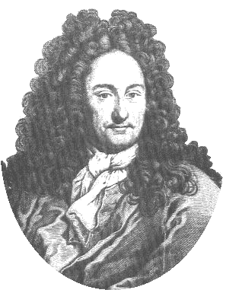
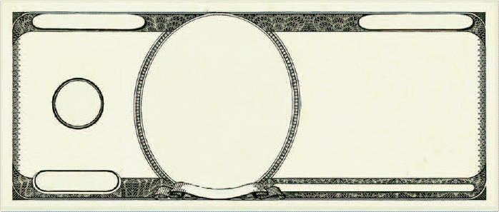
Democratic Republic
of Binaria
THIS NOTE IS NOT LEGAL TENDER IN ANY KNOWN COUNTRY
B 6432168421
One Dollar
One Dollar
1
ONE
1
G. Leibniz
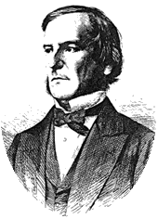
Democratic Republic
of Binaria
THIS NOTE IS NOT LEGAL TENDER IN ANY KNOWN COUNTRY
B 6432168421
Two Dollars
Two Dollars
10
TWO
2
G. Boole
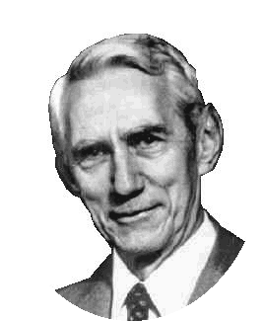
Democratic Republic
of Binaria
THIS NOTE IS NOT LEGAL TENDER IN ANY KNOWN COUNTRY
B 6432168421
Four Dollars
Four Dollars
100
FOUR
4
C. Shannon
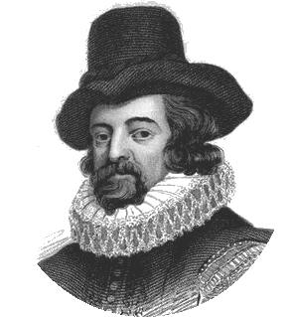
Democratic Republic
of Binaria
THIS NOTE IS NOT LEGAL TENDER IN ANY KNOWN COUNTRY
B 6432168421
Eight Dollars
Eight Dollars
1000
EIGHT
8
F. Bacon
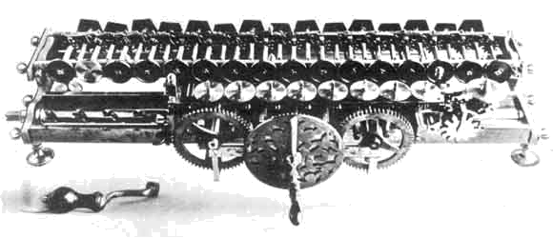

Democratic Republic of Binaria
One Dollar
1
1
1
1
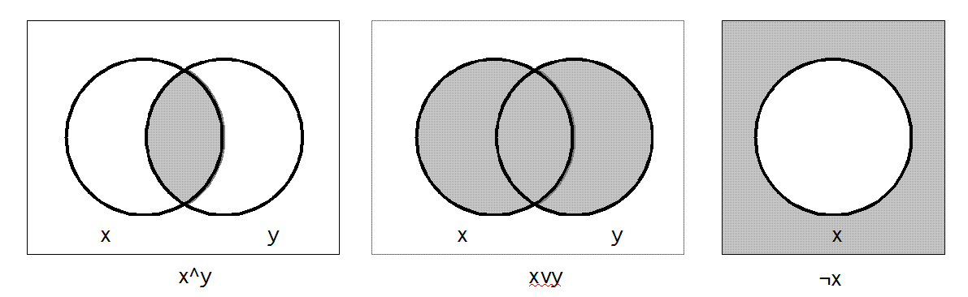
Democratic Republic of Binaria
Two Dollars
2
2
2
2
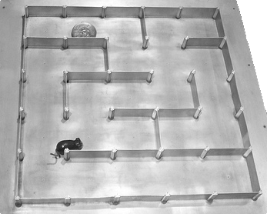
Democratic Republic of Binaria
Four Dollars
4
4
4
4

Democratic Republic of Binaria
Eight Dollars
8
8
8
8
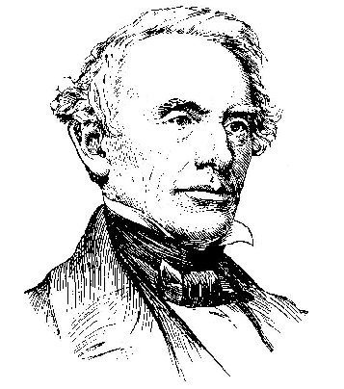

Democratic Republic
of Binaria
THIS NOTE IS NOT LEGAL TENDER IN ANY KNOWN COUNTRY
B 6432168421
Sixteen Dollars
Sixteen Dollars
1 0000
SIXTEEN
16
S. Morse

Democratic Republic
of Binaria
THIS NOTE IS NOT LEGAL TENDER IN ANY KNOWN COUNTRY
B 6432168421
32 Dollars
32 Dollars
10 0000
Thirty-Two
32
S. Yong
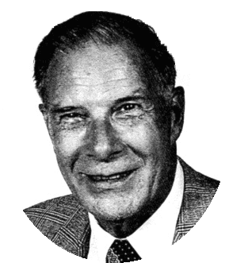
Democratic Republic
of Binaria
THIS NOTE IS NOT LEGAL TENDER IN ANY KNOWN COUNTRY
B 6432168421
64 Dollars
64 Dollars
100 0000
Sixty-Four
64
R. Hamming

Democratic Republic
of Binaria
THIS NOTE IS NOT LEGAL TENDER IN ANY KNOWN COUNTRY
B 6432168421
128 Dollars
128 Dollars
1000 0000
One Hundred
Twenty-Eight
128
J. Tukey

Democratic Republic of Binaria
Sixteen Dollars
16
16
16
16
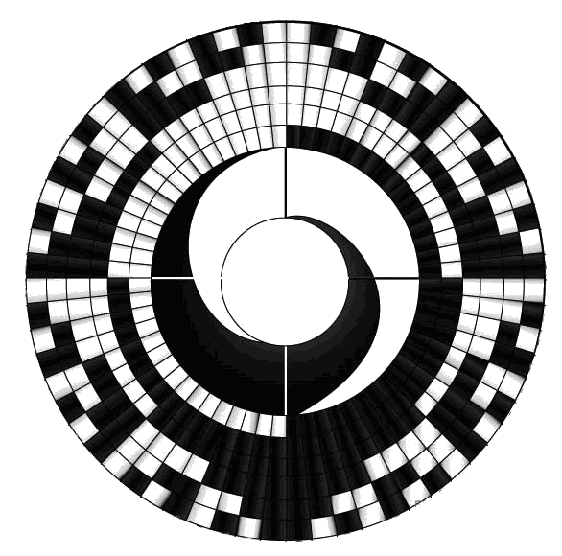
Democratic Republic of Binaria
Thirty-Two Dollars
32
32
32
32
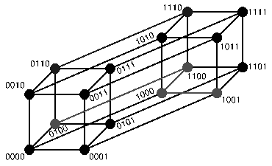
Democratic Republic of Binaria
Sixty-Four Dollars
64
64
64
64
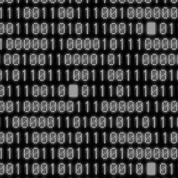
Democratic Republic of Binaria
One Hundred Twenty-Eight Dollars
128
128
128
128

Introduction:
One of the more challenging concepts for IT students to grasp is the binary number system. I have often used the analogy of a money system that uses one dollar bills, two dollar bills, four dollar bills, eight dollar bills, etc. instead of the ones, fives, tens, twenties, etc. that we use in the U.S. Instead of just talking about such a system (or writing examples on the board), I decided to create an activity that uses a binary monetary system, complete with play money manipulatives. My experience has been that the more senses they engage, the better the students grasp and understand the material. By adding play money manipulatives, I have added the sense of touch to the senses of sight and hearing.
This activity makes an imaginary trip to the fictitious country of Binaria, where the monetary system is based on the binary number system (though the values are still written in decimal). The students will count out stacks of Binarian money – converting binary to decimal, and count to specified values in Binarian currency – converting decimal to binary. They will then count from 0 to 25 in binary, figure out how high they can count using eight bits, determine the next eight place values, and figure out how high they can count using 16 bits.
Materials Required:
- Binarian currency – $1’s, $2’s, $4’s, $8’s, $16’s, $32’s, $64’s, and $128’s
(the number of each depends on class size - see Setup, below)
- 1 envelope of Binarian currency per student (see Setup, below)
- 1 stack of Binarian bills per lab group (see Setup, below)
- 1 Binarian Money activity sheet per student
Setup:
This activity is designed for “lab partners” (pairs of two students), who are then grouped into lab groups of four to six students per group. The activities call for the students to exchange envelopes with their lab partner, and later call for a student to get a stack of bills for the lab group. You can modify these as needed to accommodate your class situation.
An envelope should be prepared for each student in the class. Each envelope should contain a number of Binarian bills – I’d recommend between three and seven bills per envelope – but no more than one of any particular denomination. (The bills represent the binary bits, and a bit can only be a 0 or a 1.)
In addition, stacks of “extra” bills should be prepared for each lab group. Each lab group’s stack should have at least one bill of each denomination per student in the group. For example, if the lab groups have four students each, each stack should have at least four $1’s, four $2’s, etc. The students can add the bills from their envelopes to the group’s “bank” once they complete activity steps 1 and 2, so as to have some extra bills in the bank for activity steps 3 to 7.
Comments on Activity Steps:
1-2. Steps 1 and 2 have the students count out the bills in their and their lab partner’s envelopes, and record it in a chart. What they are doing is writing down a binary number, and recording it in a chart with the weights, or place values, written above the digits. When they are totaling the value of the bills, what the students are doing is converting a binary number (the counts of each bill denomination) to decimal (the dollar value).
After the activity, you might have a class discussion on methods of binary to decimal conversion. Using the “multiplication” method, you multiply each digit by its place value then add the products. (This method works with any base, since it does not require only a 0 or a 1 for the digits.) Using the “cross-out” method, you cross out place values above digits that are 0’s, then add the remaining (un-crossed out) place values. (This method only works with binary, since it only works when the digits are only 0’s or 1’s. If the digit were more than 1, the place value would have to be added multiple times.)
4-6. In Steps 4 through 6, the students are asked to get a certain value in bills, then “trade up” to reduce the number of bills needed. Ultimately, they should not need more than one of any bill denomination. When they record the number of each bill needed, they are converting a decimal number (the price of the item) to binary (the number of each bill denomination needed).
After the activity, you might have a class discussion on methods the students used for these steps. You might find that some students used the “subtraction” method of binary to decimal conversion; starting with the largest bill needed and working their way down to the smallest. Other students might have used the “division” method of binary to decimal conversion; starting with a large pile of $1 bills, and trading pairs of $1 bills for $2 bills, then trading pairs of $2 bills for $4 bills, and so on. Still others might have started with arbitrary numbers of various bills, then traded up as necessary.
7. Step 7 has the students think more generally about the binary system. In part a, it has the students come up with the binary values for 0 to 25, while steps b and c ask them to seek out the pattern developed. Steps d and e have them determine the limits of 8-bit binary values, and steps f and g have them expand the system to 16-bit values.
Some notes (pardon the pun) about the Binarian currency:
Perhaps the most fun part of developing this activity was creating the Binarian bills themselves. While generally modeled after the U.S. dollar bills and similar designs, I had great pleasure in coming up with the various elements of the bills themselves.
The Binarian emblem is the two-headed eagle, similar to ones in the coats of arms of many European countries that date back to the Byzantine and Holy Roman Empires. On the chest of the eagle is a character similar to the Greek letter phi. It is, in fact, a 1 and a 0 written in archaic script fonts (German and Old English) superimposed on each other.
The serial number on the bills (it was too difficult to put unique serial numbers on each bill individually) is B32168421; B for binary, while the digits 32, 16, 8, 4, 2, and 1 are the first six place values in binary.
The busts on the bills are of people who made significant contributions to the study of binary or its application. They are as follows:
$1 – Gottfried Wilhelm Leibniz (1646 – 1716). The modern binary number system was first fully documented by Leibniz in the 17th century in his article Explication de l'Arithmétique Binaire. Leibniz’s system used digits 0 and 1, like the modern binary number system.
$2 – George Boole (1815 – 1864). The inventor of Boolean algebra, the basis of all modern computer logic. Boole is regarded as one of the founders of the field of computer science.
$4 – Claude Elwood Shannon (1916 – 2001). Called the “father of information theory”, his 1937 master’s thesis A Symbolic Analysis of Relay and Switching Circuits, proved that Boolean algebra and binary arithmetic could be used to simplify the arrangement of relays in telephone routing switches, and also proved that it is possible to use arrangements of relays to solve Boolean algebra problems.
$8 – Sir Francis Bacon (1561 – 1626). Francis Bacon described a system by which letters of the alphabet could be reduced to sequences of binary digits, which could then be encoded as variations in the font in any random text. Though he did not describe a specific code (and the binary number system as we know it had not yet been described), he was the first to propose that letters could be encoded in a binary system. Recognizing the binary nature of the system, he added that this method could be used with any objects, provided those objects be capable of a twofold difference.
$16 – Samuel Finley Breese Morse (1791 – 1872). Developed the Morse code, a binary-based character encoding that uses two symbols. Morse, along with his partner Alfred Vail, developed his code for use on the single wire telegraph Morse invented and patented.
$32 – Shao Yong (1011 – 1077). Yong developed a method for generating a full set of eight trigrams and 64 hexagrams, analogous to the 3-bit and 6-bit binary numerals, used in the ancient Chinese text I Ching.
$64 – Richard Wesley Hamming (1915 – 1998). Creator of the Hamming code – an error correcting code which makes use of a Hamming matrix, the Hamming window, Hamming numbers, Sphere-packing (also called the Hamming bound) and the Hamming distance, all of which advance the theories of computer science and telecommunications.
$128 –John Wilder Tukey (1915 – 2000). A statistician, Tukey’s main contribution to the study of binary is the coining of the term “bit”, a contraction of “binary digit.”
The following people were also considered for appearance on Binarian notes, but did not make the final cut for one reason or another:
Pingala (~200 BC). Ancient Indian writer who described binary patterns in prosody (poetry). Though he did not describe it mathematically, the fact that his work predates all others on this list by over a millennium merited him consideration. One main reason for his ultimate exclusion was the lack of a good portrait to use.
William Henry Eccles (1875 – 1966). Co-inventor, along with Frank W. Jordan, of the flip-flop circuit, a solid-state circuit capable of retaining one of two states after the input signal is removed. The flip-flop is the foundation of modern computer memory.
Frank Gray (~1891 – ?). Though he did not invent the family of reflected binary codes commonly called Gray codes – they had already been used as a tool to solve particular types of mathematical puzzles – he was the first to systematically describe them and their application and advantages in data communications in his 1953 patent for pulse code communication systems. He would surely have made the cut, but I could not find a suitable protrait of him, either.
Jean-Maurice-Ėmile Baudot (1845 – 1903). Baudot created the Baudot code, the first fixed-length character encoding system. He developed the code for the printing telegraph, which he also invented. Previous codes, like the Morse code, represented characters with variable lengths of bits, and were therefore not suitable for automated decoding.

